DEVELOPMENT OF AN INCLUSIVE DISABILITY SUPPORT INFORMATION MANAGEMENT SYSTEM FOR RURAL COMMUNITIES
A Case Study of Kamonyi District, Southern Province, Rwanda

By
NTARE ELIE
Registration Number: 2305001183
Supervisor: Dr. Eustache Uwimana

A research proposal submitted to the University of Kigali in partial fulfilment of the requirements for the award of a Degree with Honours in Bachelor of Business Information Technology, School of Computing and Information Technology.

July 2026

Declaration
I, NTARE Elie, declare that this research proposal entitled “Development of an Inclusive Disability Support Information Management System for Rural Communities” is my own original academic work and has been prepared for the award of a Degree with Honours in Bachelor of Business Information Technology at the University of Kigali. This proposal has not been submitted to another university or institution for the award of a degree or equivalent qualification. All sources used have been acknowledged in the text and reference list.

Signed: ________________________________ Date: ________________________________

Approval
This is to certify that the research proposal entitled “Development of an Inclusive Disability Support Information Management System for Rural Communities” has been prepared by Ntare Elie under academic supervision and is submitted for examination with approval. The proposal has been reviewed in accordance with the requirements for research proposal writing at the University of Kigali.

Supervisor: Dr. Eustache Uwimana
Signed: ________________________________ Date: ________________________________

Table of Contents
Declaration i
Approval ii
Table of Contents iii
Abstract vii
List of Figures viii
List of Tables ix
List of Abbreviations x
CHAPTER 1: GENERAL INTRODUCTION AND BACKGROUND OF THE STUDY 1
1.0 Introduction 1
1.1 Background of the Study 1
1.1.1 Case Study Context 3
1.2 Statement of the Problem 4
1.3 Objectives of the Study 5
1.3.1 General Objective 5
1.3.2 Specific Objectives 5
1.4 Research Questions 6
1.5 Significance of the Study 6
1.5.1 Significance to Persons with Disabilities and Their Guardians 6
1.5.2 Significance to Local Officers and Local Government 7
1.5.3 Significance to Support Providers 7
1.5.4 Significance to Policy Makers and the National Council of Persons with Disabilities 7
1.5.5 Significance to the Researcher and Future Scholars 7
1.6 Scope of the Study 8
1.6.1 Time Scope 8
1.6.2 Geographical Scope 8
1.6.3 Content Scope 8
1.6.4 System Boundary 9
1.7 Limitations of the Study 9
CHAPTER 2: LITERATURE REVIEW 11
2.0 Introduction 11
2.1 Definition of Key Concepts 11
2.1.1 Disability 11
2.1.2 Persons with Disabilities 11
2.1.3 Inclusive Development 12
2.1.4 Information Management System 12
2.1.5 Beneficiary Registry 12
2.1.6 Support Request and Distribution 12
2.1.7 Support Provider 13
2.1.8 Read-Only Verified Profile 13
2.1.9 Digital Accessibility 13
2.1.10 Role-Based Access Control 13
2.1.11 Rural Community 13
2.1.12 Sensitive Personal Data 14
2.2 Body of the Literature Review 14
2.2.1 Disability Data and the Requirements of a Centralised Registry 14
2.2.2 Registration, Authentication and Accessible Beneficiary Dashboards 15
2.2.3 Support Request, Coordination and Transparent Distribution 16
2.2.4 Announcements, Reporting, Accessibility, Security and Data Governance 17
2.3 Empirical Review 18
2.4 Theoretical Review 19
2.4.1 The Social Model of Disability 19
2.4.2 The Capability Approach 20
2.4.3 Technology Acceptance Model 20
2.4.4 Information Systems Success Model 20
2.5 Summary of the Research Gap 21
2.6 Conceptual Framework and Proposed Model 22
2.6.1 Existing System 23
2.6.2 Proposed System 25
2.6.3 Proposed System Architecture 26
CHAPTER 3: RESEARCH METHODOLOGY 28
3.0 Introduction 28
3.1 Research Design 28
3.1.1 Research Approach 28
3.1.2 Study Variables and Operational Measures 29
3.2 Population and Selection of the Sample 30
3.2.1 Target Population 30
3.2.2 Population and Sample Selection 30
3.2.3 Sampling Techniques 31
3.3 Tools for Data Collection / Instrumentation 31
3.3.1 Beneficiary Questionnaire 32
3.3.2 Semi-Structured Interview Guide 33
3.3.3 Registry Data Specification 33
3.3.4 Prototype Review Instruments 33
3.4 Collection of Data 34
3.4.1 Preparation and Permission 34
3.4.2 Pilot Study 34
3.4.3 Primary Human Data Collection 34
3.4.4 System and Records Data Collection 35
3.4.5 Secondary Data Collection 35
3.5 Presentation of Data and Analysis of Data 35
3.5.1 Quantitative Survey Analysis 35
3.5.2 Qualitative Analysis 36
3.5.3 System Design and Database Modelling 36
3.5.4 System Development and Iterative Prototyping 36
3.5.5 Evaluation Metrics 37
3.5.6 Integration of Findings 38
3.6 Validity and Reliability 39
3.6.1 Validity of Human Instruments 39
3.6.2 Reliability of Human Instruments 39
3.6.3 Validity of the System Evaluation 39
3.6.4 System Reliability 40
3.7 Ethical Considerations 40
3.8 System Requirements Analysis 41
3.9 Testing and Prototype Validation Plan 43
3.9.1 Functional and Integration Testing 43
3.9.2 Accessibility and Compatibility Testing 44
3.9.3 Security and Privacy Testing 44
3.9.4 Performance, Usability and Acceptance Testing 44
References 45

Abstract
Support for persons with disabilities in rural Rwandan communities is coordinated through fragmented paper registers and private spreadsheets, with the result that there is no single authoritative record of who the beneficiaries are, what each of them needs, and what assistance they have already received. The consequence is documented: persons with disabilities are largely excluded from social protection, and reliable data about them is lacking. The two facts are connected, because a support system cannot reach a person it has not recorded. This proposal presents the design, development and planned validation of an Inclusive Disability Support Information Management System, using Kamonyi District in the Southern Province of Rwanda as the case study. The web-based system enables local officers to register beneficiaries and record disability details, daily challenges and support needs; automatically creates an account and issues login credentials by email; and provides beneficiaries and guardians with an accessible read-only verified profile showing their record, the status of support requests, and announcements, jobs, scholarships and training opportunities. Support providers search the registry by recorded need and submit targeted offers, officers coordinate distribution and record each decision with its reason, and a complete and traceable support history is preserved for reporting. The study adopts a design-oriented mixed-methods case-study strategy. A planned sample of 350 persons with disabilities, guardians, local officers, support providers and administrators, together with document review and examination of existing records, will inform requirements and evaluation. The system will be built through iterative prototyping and evaluated on registration coverage, record completeness, data accuracy, duplication, distribution traceability, turnaround time, beneficiary access, usability and acceptance. Accessibility to WCAG 2.1 level AA, tested with users who have visual, hearing, motor and cognitive impairments, together with security, consent and data protection under Law No. 058/2021, are treated as functional requirements rather than afterthoughts. The expected contribution is a locally grounded, accessible and governance-aware system that makes omission and duplication visible, and support traceable, in a rural district.
Keywords: Disability inclusion, information management system, beneficiary registry, support coordination, digital accessibility, rural communities, social protection, Rwanda.

List of Figures
Figure 1: Conceptual Framework 22
Figure 2: Existing Manual Disability Support Workflow 23
Figure 3: Proposed Inclusive Disability Support System Workflow 26
Figure 4: Layered Architecture of the Proposed System 27
Figure 5: Research, System Development and Prototype Validation Procedure 43

List of Tables
Table 1: Selected Studies and Sources Related to Disability Support Information Systems 18
Table 2: Comparison of the Existing and Proposed Systems 24
Table 3: Target Population and Sample Selection 30
Table 4: Data-Collection Instruments and Their Purpose 32
Table 5: Planned System Evaluation Measures 37
Table 6: Functional and Non-Functional Requirements of the Proposed System 41

List of Abbreviations
API: Application Programming Interface
CRPD: Convention on the Rights of Persons with Disabilities
DBMS: Database Management System
DPO: Organisation of Persons with Disabilities
ERD: Entity-Relationship Diagram
HTTPS: HyperText Transfer Protocol Secure
ICF: International Classification of Functioning, Disability and Health
ICT: Information and Communication Technology
IMS: Information Management System
LODA: Local Administrative Entities Development Agency
MINALOC: Ministry of Local Government
MIS: Management Information System
NCPD: National Council of Persons with Disabilities
NGO: Non-Governmental Organisation
NISR: National Institute of Statistics of Rwanda
PwD: Person with a Disability
RBAC: Role-Based Access Control
RPHC: Rwanda Population and Housing Census
SDG: Sustainable Development Goal
SDLC: System Development Life Cycle
SMS: Short Message Service
SQL: Structured Query Language
SUS: System Usability Scale
TAM: Technology Acceptance Model
TLS: Transport Layer Security
UAT: User Acceptance Testing
UI: User Interface
UX: User Experience
VUP: Vision 2020 Umurenge Programme
W3C: World Wide Web Consortium
WCAG: Web Content Accessibility Guidelines
WG-SS: Washington Group Short Set of Questions on Disability
WHO: World Health Organization

CHAPTER 1: GENERAL INTRODUCTION AND BACKGROUND OF THE STUDY

1.0 Introduction
This chapter introduces the proposed Inclusive Disability Support Information Management System and establishes why the study is necessary. It presents the global, African and Rwandan context of disability inclusion, defines the practical problem to be addressed, and states the objectives and research questions that guide the work. The chapter also explains the value of the study to persons with disabilities, local officers, support providers, policy makers and future researchers, before defining the time, geographical and content boundaries of the proposal.
Supporting persons with disabilities is not a single act of delivering assistance to an individual. It is a continuing coordination process in which a community must know who its members with disabilities are, understand what each of them actually needs, match that need to an available form of support, deliver it fairly, and keep a record of what was done so that the next decision is better informed than the last. A useful system must therefore balance completeness of registration, fairness of distribution, transparency to the beneficiary, protection of sensitive personal data and accessibility to users who may have visual, hearing, motor or cognitive impairments. The present study treats the information system as a coordination and accountability instrument within a human support process; it does not treat software as a substitute for the officers, providers and families who deliver the support itself.

1.1 Background of the Study
Disability is not a marginal condition affecting a small minority. The World Health Organization estimates that approximately 1.3 billion people, or about 16 percent of the world's population, experience a significant disability today, and it documents that they face persistent inequities in health, education, employment and social participation (World Health Organization, 2022). The United Nations Convention on the Rights of Persons with Disabilities, which Rwanda ratified in 2008, frames these inequities not as unfortunate consequences of individual impairment but as failures of the environments and systems that surround the person (United Nations, 2006). This distinction is the foundation of the present study, because it locates the problem in a system that can be redesigned rather than in a body that cannot.
Rwanda has established an unusually strong policy and institutional framework for disability inclusion. The National Council of Persons with Disabilities was created by Law No. 03/2011 with a mandate to coordinate activities that advance persons with disabilities, gather and examine their views, advocate on issues affecting their rights, build their capacity and monitor the application of the laws that protect them (Republic of Rwanda, 2011). The National Policy of Persons with Disabilities and Disability Inclusion affirms their dignity and rights and aligns national practice with the Constitution and the Convention (Ministry of Local Government, 2021). Social protection instruments, notably the Vision 2020 Umurenge Programme, provide a channel through which vulnerable households can receive assistance.
The persistent difficulty lies not in the policy but in its implementation, and specifically in information. Analysis of social protection and disability in Rwanda has found that the majority of persons with disabilities, including many with severe disabilities, are likely to be excluded from social protection schemes, and it observes that reliable data on this population is lacking (Development Pathways, 2019). The second observation explains the first. A support system cannot reach a person whose existence, location and specific need it has not recorded. Where registration is fragmented across paper registers, private spreadsheets and the personal knowledge of individual officers, the resulting picture is incomplete, inconsistent and impossible to aggregate, and inclusion becomes a matter of chance rather than of entitlement.
The rural dimension sharpens the problem. The Fifth Rwanda Population and Housing Census recorded a national disability prevalence of approximately 5 percent, and found that prevalence is higher in rural areas than in urban ones, at 5 percent against 3 percent (National Institute of Statistics of Rwanda, 2023). Rural communities therefore carry a greater share of the need while having the least developed information infrastructure to record it. Distance compounds this: a person with a mobility impairment who must travel to a sector office to ask about a support decision bears a cost that an able-bodied applicant does not, and that cost falls precisely on those least able to absorb it.
The international literature on social protection points toward the solution. Integrated beneficiary registries and social registries consolidate information about eligible individuals into a single authoritative record, enabling programmes to identify who is eligible, avoid duplication, coordinate between providers and report reliably (Leite et al., 2017). Where a disability registry is connected to such a system, persons with disabilities can be included in broader social protection rather than being served by whichever programme happens to find them. The value of a registry lies not in the database itself but in what it makes possible: verified identity, visible need, traceable delivery and accountable reporting.
Technology alone, however, does not produce inclusion, and it can easily reproduce exclusion in a new form. A digital system that persons with disabilities cannot themselves use has replaced a paper barrier with an electronic one. The Web Content Accessibility Guidelines require content to be perceivable, operable, understandable and robust, and set graded conformance levels for that purpose (W3C, 2018). A system serving this population must therefore meet accessibility standards as a functional requirement rather than a courtesy. Equally, disability status is sensitive personal data whose disclosure can expose a person to stigma or discrimination, and its processing is governed by Rwanda's Law No. 058/2021 relating to the protection of personal data and privacy (Republic of Rwanda, 2021). The proposed system is accordingly designed so that registration, coordination, accessibility, transparency and data protection are treated as requirements from the outset rather than as later additions.

1.1.1 Case Study Context
Kamonyi District, in the Southern Province of Rwanda, is adopted as the case study for this proposal. It is a predominantly rural district in which local government structures at sector and cell level are the principal point of contact between persons with disabilities and the support available to them, and in which the National Council of Persons with Disabilities operates through local representation. It is an appropriate case because it contains the three elements the proposed system requires: a dispersed rural population of persons with disabilities, local officers who already carry the responsibility of registering and assisting them, and support providers whose assistance currently reaches beneficiaries through informal and largely unrecorded channels.
The choice of this case study does not assume that local officers are failing in their duties. It assumes only that an officer working with paper registers, serving a large and dispersed caseload, cannot maintain a complete, current and shareable record of every person with a disability and every item of support they have received. All statements about current practice in this proposal are analytical and provisional. Authorised fieldwork, document review and interviews will establish which elements of the described workflow actually apply, and the findings will be reported as they are found rather than as they are assumed.

1.2 Statement of the Problem
Support for persons with disabilities in rural Rwandan communities is coordinated through fragmented and largely manual records. Registration is conducted on paper or in private spreadsheets held by individual officers; support requests are communicated informally; and the record of what assistance a person has received, if it is kept at all, remains in a local file that no other officer or provider can see. There is consequently no single authoritative record of who the beneficiaries are, what each of them needs, and what has already been done for them.
This information failure produces concrete harm. A person with a disability who is never registered receives nothing, and no report will ever reveal the omission, because a person absent from the records is also absent from the statistics. A person known to one officer may receive assistance repeatedly while another, equally eligible, receives none, and neither the duplication nor the omission is visible to anyone. A support provider willing to help cannot identify who most needs it, and must rely on whichever officer they happen to contact. The beneficiary, meanwhile, has no visibility at all: they cannot see whether they are registered, what their recorded needs are, whether a request is progressing, or what opportunities exist, and to ask any of these questions they must physically travel to an office. The consequence is the documented pattern in which persons with disabilities are largely excluded from social protection while reliable data about them is lacking (Development Pathways, 2019).
Existing digital solutions do not close this gap. General-purpose social registries are not designed around the specific information a disability support process requires, namely the nature of the impairment, the daily challenges it creates and the particular support it calls for. Systems designed for administrators typically give the beneficiary no access at all, which preserves the very opacity that the beneficiary experiences as exclusion. Many systems also fail the accessibility requirements of the population they serve, so that a person with a visual impairment cannot read their own record. Few connect registration, support coordination, opportunity announcement and reporting within a single accountable workflow.
This study therefore proposes the development of an Inclusive Disability Support Information Management System: a web-based platform on which local officers register beneficiaries and record their disability details, daily challenges and support needs; beneficiaries and guardians receive credentials and view a read-only verified profile together with announcements, jobs, scholarships and training opportunities; support providers search the registry and submit targeted support offers; officers coordinate distribution and record completion; and administrators generate the reports on which decisions depend. If the problem is not addressed, support for persons with disabilities in rural communities will continue to depend on who happens to be known to which officer, rather than on who is entitled to it and who needs it most.

1.3 Objectives of the Study

1.3.1 General Objective
The general objective of this study is to design, develop and evaluate an inclusive web-based Disability Support Information Management System that establishes a centralised registry of persons with disabilities, improves the fair and transparent coordination of support between local officers, beneficiaries and support providers, provides beneficiaries with accessible information on their own records and on available opportunities, and generates reliable reports for decision making in rural communities, using Kamonyi District as the case study.

1.3.2 Specific Objectives
The specific objectives of the study are:
1. To identify the data and information requirements for a centralised registry of persons with disabilities, including disability details, daily challenges and support needs, in rural communities.
2. To design and develop a web-based system providing beneficiary registration, automatic account creation with credentials issued by email, and an accessible read-only personal dashboard for beneficiaries and guardians.
3. To design a support request and distribution module that allows support providers to identify beneficiaries and submit offers, enables officers to coordinate and approve assistance, and records a transparent and traceable support history.
4. To design and evaluate the announcements and opportunities module, the reporting and analytics function, and the accessibility, security and data-governance requirements needed for the responsible operation of the proposed system.

1.4 Research Questions
The study is guided by the following research questions, which correspond directly to the specific objectives:
1. Which data elements are necessary and feasible to collect for a centralised registry of persons with disabilities in rural communities, and how should disability, daily challenges and support needs be recorded?
2. How can beneficiary registration, automatic account creation and an accessible read-only dashboard be designed so that beneficiaries and guardians, including those with sensory and cognitive impairments, can use them?
3. How can support requests be coordinated between officers and providers so that distribution is fair, traceable and visible to the beneficiary, and so that support history is preserved?
4. Which announcement, reporting, accessibility, security and data-governance requirements are necessary for the system to operate responsibly and to be accepted by officers, beneficiaries and support providers?

1.5 Significance of the Study

1.5.1 Significance to Persons with Disabilities and Their Guardians
Persons with disabilities are the primary beneficiaries. Registration in an authoritative registry converts an individual from someone an officer happens to know into someone the system formally recognises, which is the precondition of any entitlement. A read-only personal dashboard allows a beneficiary or guardian to see their own recorded profile, the status of a support request and the opportunities available, without undertaking a journey that may itself be difficult, costly or painful. Visibility of one's own record is also the basis of the right to have it corrected when it is wrong.

1.5.2 Significance to Local Officers and Local Government
Local officers gain a single, current and searchable record in place of paper registers that cannot be aggregated, shared or protected against loss. The system reduces the administrative burden of manual searching, makes duplication and omission visible rather than invisible, and preserves institutional memory when an officer is transferred or replaced, which is precisely the point at which a paper-based caseload is most often lost. Local government gains reliable data on which planning and budgeting can rest.

1.5.3 Significance to Support Providers
Support providers, including non-governmental organisations, cooperatives, employers and donors, gain the ability to identify who genuinely needs a particular form of assistance rather than relying on informal contacts. A traceable record of what has already been delivered prevents the concentration of support on the most visible beneficiaries and its absence from the least visible. Providers can also publish jobs, scholarships and training opportunities directly to the population they intend to reach.

1.5.4 Significance to Policy Makers and the National Council of Persons with Disabilities
The study supports the mandate of the National Council of Persons with Disabilities to coordinate interventions, advocate on behalf of persons with disabilities and monitor the application of protective law, since each of these depends on data that does not currently exist in aggregated form. It offers policy makers a concrete mechanism for addressing the documented lack of reliable data that underlies the exclusion of persons with disabilities from social protection, and it demonstrates how such a system can be operated in compliance with Law No. 058/2021.

1.5.5 Significance to the Researcher and Future Scholars
The study contributes a documented, context-specific design and evaluation of an accessible information system for a rural African setting, an area in which much of the published work on beneficiary registries is written from the perspective of administrators rather than of the people registered. By reporting its requirements, design decisions, accessibility conformance and limitations explicitly, it provides a basis on which future researchers can replicate, criticise or extend the work. For the researcher, it develops applied competence in systems analysis, database design, accessible web development and research methodology.

1.6 Scope of the Study

1.6.1 Time Scope
The study will be conducted between July 2026 and June 2027. This period covers the literature review, instrument development and piloting, ethical clearance and institutional permission, data collection, requirements analysis, database and interface design, iterative prototype development, accessibility, security and usability testing, and final reporting.

1.6.2 Geographical Scope
The study is geographically limited to Kamonyi District in the Southern Province of Rwanda, and specifically to persons with disabilities and their guardians, local officers, support providers and district administrators associated with the district. Kamonyi is selected because it is a predominantly rural, agriculture-based district whose dispersed settlements, travel distances and uneven connectivity reproduce the conditions the system is intended to address, while its accessibility from Kigali makes repeated fieldwork and iterative prototype testing with beneficiaries practicable within the study period. Findings will be interpreted within this boundary and will not be presented as representative of all districts in Rwanda.

1.6.3 Content Scope
The content of the study is limited to the information management of disability support. It covers beneficiary registration and the recording of disability details, daily challenges and support needs; authentication and account creation with credentials issued by email; the read-only beneficiary dashboard; support request, coordination and distribution with traceable support history; announcements and the publication of jobs, scholarships and training opportunities; notifications; reports and analytics; and the associated accessibility, security and data-governance controls. The study does not address medical diagnosis or the clinical assessment of impairment, the determination of statutory eligibility for national social protection benefits, the disbursement of cash transfers, or the procurement of assistive devices.

1.6.4 System Boundary
The deliverable of this study is a working, validated prototype together with its evaluation evidence, not a production deployment integrated with national systems. The prototype will operate on consented and, where appropriate, anonymised data within a controlled environment. It supports decision making by officers and providers and will not itself determine a person's legal entitlement to a benefit or replace the officer's verification of a claim. Human decision making is retained at every point at which a record could materially affect a person.

1.7 Limitations of the Study
The following limitations are acknowledged, together with the measures adopted to reduce their effect:
- Sensitivity of the data. Disability status is sensitive personal data whose disclosure can expose a person to stigma. Some respondents may decline to participate or may under-report their condition. Informed consent, anonymised reporting, and the option to decline any question will be applied, and the resulting effect on completeness will be reported rather than concealed.
- Connectivity and device access. Rural connectivity is uneven and many beneficiaries do not own a smartphone or computer, so a beneficiary dashboard cannot be assumed to be reachable by everyone it is designed for. The study will measure actual access during fieldwork, will design for low bandwidth, and will treat guardian-mediated and officer-mediated access as legitimate rather than exceptional paths.
- Digital literacy. A system that a beneficiary cannot operate has not included them. Usability and accessibility testing will be conducted with persons with actual visual, hearing, motor and cognitive impairments rather than with proxies, and any group for whom the system proves unusable will be reported as such.
- Data quality at entry. The registry inherits the accuracy of what officers record, and a registry populated with inaccurate records may entrench error rather than correct it. Validation rules, duplicate detection and a beneficiary right of correction will be built into the design, and residual error will be measured and reported.
- Prototype scale. A prototype validated in one district with a defined sample cannot establish performance at national scale, under full production load, or across all disability categories. Scalability and reliability will be tested, but conclusions will be stated within the tested boundary.
- Participation and response bias. Voluntary participation may over-represent beneficiaries who are already registered, already receiving support, or more able to travel and communicate, which risks producing a picture drawn precisely from those the system least needs to find. Stratified sampling, home-based data collection where permitted and transparent reporting of response rates will be used to limit and disclose this effect.

CHAPTER 2: LITERATURE REVIEW

2.0 Introduction
This chapter reviews concepts, empirical studies, theories and system designs related to information management for disability support. The review is organised around the four specific objectives of the study: the data required for a centralised disability registry; registration, authentication and accessible beneficiary dashboards; support request, coordination and distribution; and announcements, reporting, accessibility, security and data governance. It then identifies the gap addressed by the proposal and presents the conceptual framework, the existing workflow, the proposed workflow and the system architecture.
The review distinguishes three kinds of evidence. Official institutional sources are used for prevalence data, law, policy and standards. Peer-reviewed research and evaluation reports are used to explain system designs, implementation experience and measured outcomes. Foundational publications are used for established theories and methods. This distinction is important because a census statistic, a legal requirement and an implementation evaluation answer different research questions and should not be treated as interchangeable evidence.

2.1 Definition of Key Concepts

2.1.1 Disability
Disability is understood in this study through the biopsychosocial model of the International Classification of Functioning, Disability and Health, in which it arises from the interaction between a health condition and personal and environmental factors rather than from impairment alone (World Health Organization, 2001). This definition matters operationally: if disability is produced partly by the environment, then an inaccessible information system is itself a disabling factor, and improving the environment is a legitimate intervention.

2.1.2 Persons with Disabilities
Persons with disabilities are those who have long-term physical, mental, intellectual or sensory impairments which, in interaction with various barriers, may hinder their full and effective participation in society on an equal basis with others (United Nations, 2006). The term denotes people first and impairment second, and the system is designed accordingly: a beneficiary is a rights-holder with a record, not a case with a category.

2.1.3 Inclusive Development
Inclusive development is development that deliberately ensures that marginalised groups participate in and benefit from its processes and outcomes, rather than assuming that general progress will reach them automatically. It underlies the principle of leaving no one behind, and it implies that a support process must be able to demonstrate who it has reached, which in turn requires records.

2.1.4 Information Management System
An information management system is an organised combination of people, processes, data and technology that collects, stores, processes and disseminates information to support coordination, decision making and accountability within an organisation. The emphasis on people and processes is deliberate, because a database that no officer uses and no beneficiary can see is not an information system in any useful sense.

2.1.5 Beneficiary Registry
A beneficiary registry is an authoritative record of the individuals recognised as eligible for a programme, together with the attributes on which eligibility and need are assessed. Integrated registries consolidate such records across programmes so that a person may be identified once and served by many, avoiding duplication and enabling coordination (Leite et al., 2017). The registry is the foundation of the proposed system, because a person absent from it is invisible to every process that follows.

2.1.6 Support Request and Distribution
Support request and distribution is the process through which a need recorded in the registry is matched with an available form of assistance, approved by an authorised officer, delivered by a provider and confirmed as completed. Recording each of these steps is what converts a private act of charity into a traceable and auditable public process.

2.1.7 Support Provider
A support provider is any organisation or individual offering assistance to persons with disabilities, including non-governmental organisations, cooperatives, faith-based organisations, employers, training institutions and donors. In the proposed system a provider may search the registry, submit targeted offers, publish opportunities and report deliveries, but may not alter an official beneficiary record.

2.1.8 Read-Only Verified Profile
A read-only verified profile is the beneficiary's view of their own official record, which they may see and query but not edit. The design separates the right to know from the right to alter: transparency to the beneficiary is preserved while the integrity of an official record used for resource allocation is protected. A correction is requested through the officer rather than made directly, and the request itself is recorded.

2.1.9 Digital Accessibility
Digital accessibility is the property of a system that allows people with disabilities to perceive, understand, navigate and interact with it. The Web Content Accessibility Guidelines organise this under four principles, that content be perceivable, operable, understandable and robust, with conformance levels A, AA and AAA (W3C, 2018). For a system whose users are persons with disabilities, accessibility is a functional requirement rather than an enhancement.

2.1.10 Role-Based Access Control
Role-based access control assigns permissions to roles rather than to individuals, so that each user obtains only the access their function requires. In the proposed system it enforces the fundamental separation on which the design rests: an officer may create and update records, a beneficiary may read only their own, a provider may search and offer but not edit, and an administrator may configure the system without silently altering beneficiary data.

2.1.11 Rural Community
A rural community in this study is a settlement outside urban centres, characterised by dispersed population, longer travel distances to administrative offices, uneven electricity and internet connectivity, and lower device ownership. These conditions are not incidental context: they determine whether a system can be reached at all, and they justify designing for low bandwidth, offline-tolerant workflows and mediated access.

2.1.12 Sensitive Personal Data
Sensitive personal data is information whose disclosure exposes the individual to a heightened risk of harm or discrimination, and disability status falls squarely within this category. Its processing is governed in Rwanda by Law No. 058/2021 relating to the protection of personal data and privacy, which establishes requirements for lawful basis, minimisation, security and the rights of the data subject (Republic of Rwanda, 2021).

2.2 Body of the Literature Review

2.2.1 Disability Data and the Requirements of a Centralised Registry
The first requirement of a registry is a defensible definition of what it records. The literature warns that a registry which records only a diagnostic label is of limited operational value, because a label does not indicate what a person can do, what they struggle with, or what would help. The International Classification of Functioning provides the conceptual alternative by describing functioning across body function, activity and participation, in interaction with environmental factors (World Health Organization, 2001). This directly shapes the data model of the proposed system, in which the record captures the nature of the impairment, the daily challenges it creates and the support the person actually needs, rather than a diagnosis alone.
For identification at scale, the Washington Group Short Set of questions has become the international standard, asking about difficulty in seeing, hearing, walking, remembering or concentrating, self-care and communication, with graded response options. Its adoption in censuses, including Rwanda's, means that a registry using compatible questions can be reconciled with national statistics rather than producing an incompatible parallel count. This is a practical argument for aligning the registration instrument with the census rather than inventing new categories.
The literature also identifies what a registry must capture beyond the person: identification and location sufficient to find them, household and guardian details where a guardian mediates access, socio-economic status for prioritisation, and the record of support already received. This last element is the one most often missing in practice, and its absence is what makes duplication and omission simultaneously possible and invisible. Evidence from Rwanda indicates precisely this deficiency, reporting that persons with disabilities are largely excluded from social protection while reliable data about them is lacking (Development Pathways, 2019).
Finally, the literature is clear that registration is not a one-off event. Impairments change, households move, needs evolve and people die, so a registry that is not maintained decays into a record of the past. Update procedures, verification cycles and duplicate detection are therefore treated in this proposal as functional requirements rather than as operational afterthoughts.

2.2.2 Registration, Authentication and Accessible Beneficiary Dashboards
Research on beneficiary-facing systems distinguishes sharply between systems that inform the administrator and systems that also inform the beneficiary. The great majority of social protection management information systems fall into the first category: they are designed so that officials can see the population, but the population cannot see itself. The consequence is that a beneficiary cannot verify their own record, cannot discover why they were excluded and cannot detect an error made about them, which reproduces in digital form exactly the opacity that characterised the paper process.
The read-only dashboard adopted in this proposal is the design response to that finding, and the balance it strikes is deliberate. Granting beneficiaries edit rights over an official record used to allocate scarce resources would create an obvious integrity risk; granting them no visibility at all preserves their exclusion. Read access with a mediated right of correction resolves the tension: the beneficiary can see everything recorded about them and can challenge it, while the authority to change an official record remains with the verifying officer and every change is logged.
Authentication in a low-connectivity, low-device-ownership rural setting is a genuine design problem rather than a routine implementation detail. Automatic account creation with credentials issued by email, as specified in the project design, is efficient and auditable, but it assumes an email address and a device, and a substantial proportion of rural beneficiaries with disabilities will have neither. The literature on digital identity in developing contexts consistently finds that a channel assumed to be universal excludes precisely the most marginalised. The design consequence adopted here is that guardian-mediated and officer-mediated access are treated as legitimate first-class paths, and that fieldwork will measure actual email and device access rather than assuming it.
Accessibility determines whether the dashboard delivers on its purpose. A beneficiary with a visual impairment requires screen-reader compatibility, sufficient contrast and text alternatives; a beneficiary with a motor impairment requires full keyboard operation and adequate target sizes; a beneficiary with a cognitive impairment requires simple language, predictable navigation and clear error messages. The Web Content Accessibility Guidelines organise these requirements systematically, and conformance at level AA is adopted in this proposal as the standard (W3C, 2018). A system for persons with disabilities that they cannot use is not merely imperfect; it has failed at its purpose.

2.2.3 Support Request, Coordination and Transparent Distribution
The coordination problem is fundamentally one of matching: a provider has assistance to give, a beneficiary has a need, and neither can reliably find the other. In the manual process this matching is performed by the personal knowledge of an individual officer, which is why the support tends to reach the beneficiaries who are best known rather than those who are most in need. A searchable registry replaces personal knowledge with recorded need as the basis of matching, which is the core mechanism by which the proposed system improves fairness.
The literature on beneficiary registries emphasises that the value of consolidation lies in what becomes visible once records are shared: duplication, gaps in coverage, and the concentration of assistance on a subset of recipients (Leite et al., 2017). None of these is detectable when each provider and officer holds a separate list. A shared support history is therefore not merely an administrative convenience but the instrument through which inequitable distribution becomes observable and thus correctable.
Workflow research on approval processes indicates that the credibility of a distribution system depends on the traceability of its decisions. A request that is approved, deferred or declined without a recorded reason invites suspicion of favouritism, particularly in a small community where beneficiaries know one another and can compare outcomes. The proposed workflow therefore records the officer's decision, its reason and its timestamp, and displays the status to the beneficiary. The obligation to record a reason is a modest requirement with a disproportionate effect, because a decision that must be explained is a decision that must be justifiable.
Finally, the literature on service delivery to persons with disabilities cautions that a request-driven system serves those able to make a request. A person with a severe communication impairment, without a literate guardian, in a remote location, may never initiate one. The proposed system therefore retains officer-initiated registration and allows providers to search for beneficiaries by recorded need, so that assistance can be directed toward a person who has not asked, which is frequently the person who most requires it.

2.2.4 Announcements, Reporting, Accessibility, Security and Data Governance
Access to information about opportunities is itself a form of inclusion. Jobs, scholarships and training programmes intended for persons with disabilities routinely fail to reach them, not because the opportunities do not exist but because the information does not travel to a dispersed rural population. A single portal through which officers, providers and administrators publish announcements and opportunities directly to registered beneficiaries addresses a distribution failure that no amount of additional funding would solve on its own.
Reporting converts individual records into the evidence on which policy rests. The mandate of the National Council of Persons with Disabilities to coordinate interventions, advocate and monitor the application of protective law depends on aggregate data that does not presently exist in reliable form (Republic of Rwanda, 2011; Development Pathways, 2019). Coverage by sector, distribution of disability types, support delivered against support requested, and turnaround times are the measures through which a district can identify where its provision is failing. Reporting is therefore treated in this proposal as a functional requirement rather than as an output.
Security and data protection carry unusual weight here, because disability status is sensitive personal data and its exposure can result in stigma, exclusion from employment or social harm. Rwanda's Law No. 058/2021 establishes requirements for lawful processing, minimisation, security and data-subject rights (Republic of Rwanda, 2021). The design consequences adopted are concrete: role-based access so that a support provider can identify a candidate for assistance without reading a beneficiary's full personal history; encryption in transit and at rest; audit logging of every access to a record; consent recorded at registration; and retention limited to the approved period. A registry that is breached does not merely leak data; it exposes an already vulnerable population.
Data governance closes the loop. A registry accumulates authority precisely because decisions are made from it, and an inaccurate record therefore causes real harm to a real person by denying them support they are entitled to. Validation at entry, duplicate detection, periodic verification, a beneficiary right of correction and an audit trail of every change are the mechanisms through which the registry is held to the accuracy that its authority demands.

2.3 Empirical Review
Empirical research and evaluation evidence demonstrate both the potential of information systems for disability support and the reasons that many such systems fail to deliver inclusion in practice. The following sources were selected because they address disability prevalence, exclusion from social protection, registry design, accessibility or the local context.
Table 1: Selected Studies and Sources Related to Disability Support Information Systems
Source | Data / Context | Main Finding | Relevance to This Proposal
World Health Organization (2022) | Global report on health equity for persons with disabilities | About 1.3 billion people, roughly 16 percent of the world's population, have a significant disability and face systemic inequities. | Establishes the scale of the population and the systemic nature of exclusion.
NISR (2023) | Fifth Rwanda Population and Housing Census, 2022 | National disability prevalence about 5 percent, and higher in rural areas (5 percent) than urban (3 percent). | Confirms that the rural setting carries the greater share of need.
Development Pathways (2019) | Social protection and disability in Rwanda | Most persons with disabilities are likely excluded from social protection schemes, and reliable data is lacking. | Identifies the information deficit as the mechanism of exclusion; the central premise of this study.
Leite et al. (2017) | World Bank study of social registries across countries | Integrated registries enable identification, reduce duplication and support coordination between programmes. | Provides the design rationale for a centralised, shared registry.
W3C (2018) | Web Content Accessibility Guidelines 2.1 | Content must be perceivable, operable, understandable and robust; graded conformance at levels A, AA and AAA. | Supplies the accessibility standard adopted as a functional requirement.
United Nations (2006) | Convention on the Rights of Persons with Disabilities | Disability arises from the interaction of impairment with barriers; access to information is a right. | Frames beneficiary visibility and accessibility as entitlements, not features.
Republic of Rwanda (2011) | Law No. 03/2011 establishing the NCPD | Mandates coordination, advocacy, capacity building and monitoring of laws protecting persons with disabilities. | Establishes the institutional demand for the aggregate data the system would produce.
Source: Researcher’s compilation (2026).
The evidence converges on a consistent conclusion. The exclusion of persons with disabilities from support in Rwanda is not primarily a failure of law, policy or institutional mandate, each of which is comparatively well developed; it is a failure of information. Persons with disabilities are excluded from social protection while reliable data about them is lacking, and these two facts are causally connected rather than merely coincident (Development Pathways, 2019). At the same time, the international literature on registries demonstrates that consolidation makes duplication and omission visible, and the accessibility literature demonstrates that a digital system can reproduce exclusion if it is not designed for the people it serves. The present proposal sits at the intersection of these findings: it treats the registry as the mechanism of inclusion and accessibility as the condition under which that mechanism actually reaches its intended users.

2.4 Theoretical Review

2.4.1 The Social Model of Disability
The social model distinguishes impairment, a characteristic of the body, from disability, which is the disadvantage imposed by a society organised without regard to people who have that impairment (Oliver, 1990). Its implication for this study is direct and structural: if a person cannot obtain support because the register is on paper in an office they cannot easily reach, the obstacle is the process, not their body. The model therefore locates the intervention correctly, in the redesign of the information system rather than in the individual, and it also imposes an obligation on the system itself, since an inaccessible dashboard would simply relocate the barrier rather than remove it.

2.4.2 The Capability Approach
Sen's capability approach evaluates well-being in terms of what a person is actually able to do and to be, rather than the resources they nominally possess (Sen, 1999). This is important for a support system because it explains why the same item of assistance produces very different outcomes for different people, and why a record of need must describe daily challenges rather than merely list a diagnosis. It also justifies the emphasis on access to information about opportunities: a scholarship that exists but is unknown to the person it was created for expands no one's capability. The approach thus supports both the data model and the announcements module.

2.4.3 Technology Acceptance Model
The Technology Acceptance Model proposes that perceived usefulness and perceived ease of use influence a person's intention to use a system (Davis, 1989). This is decisive here because the system's success depends on voluntary adoption by busy local officers who currently manage with paper and by beneficiaries who may have limited digital experience. An officer who finds registration slower than the paper register will quietly continue using the register, and the registry will be incomplete regardless of its design quality. Perceived usefulness and ease of use are therefore measured during prototype evaluation for each user role separately.

2.4.4 Information Systems Success Model
The DeLone and McLean Information Systems Success Model links system quality, information quality, service quality, use, user satisfaction and net benefits (DeLone & McLean, 2003). For this study, system quality includes accessibility, reliability and response time; information quality includes the accuracy, completeness and currency of the registry; service quality includes officer support and responsiveness to correction requests; and net benefits include registration coverage, equitable distribution and reliable reporting. The model prevents evaluation from being reduced to whether the software runs, and insists that a system which is not used, not trusted or not acted upon has not succeeded.

2.5 Summary of the Research Gap
The first gap is contextual. International literature on social registries is written largely from the perspective of national administrators in large-scale cash-transfer programmes, while Rwandan evidence documents the exclusion of persons with disabilities and the absence of reliable data without proposing an operational system to address it. Publicly available research remains limited on an end-to-end disability support information system designed for a rural Rwandan district and aligned with the mandate of the National Council of Persons with Disabilities and the national data-protection framework.
The second gap is beneficiary visibility. Most comparable systems are designed to inform officials rather than the people they record. A person who cannot see their own registration, the status of their request or the opportunities available to them remains dependent on travel and on the personal attention of an officer, which is the very dependency that the system exists to remove. The read-only verified profile addresses this gap directly.
The third gap is accessibility. Systems intended for persons with disabilities are frequently built without conformance to accessibility standards and without testing by users with actual impairments, so that the digital system reproduces the exclusion of the paper one. The proposal adopts conformance to the Web Content Accessibility Guidelines at level AA as a functional requirement and tests with users who have visual, hearing, motor and cognitive impairments.
The fourth gap is traceability and governance. Where support history is not recorded and shared, duplication and omission cannot be detected, distribution cannot be shown to be fair, and reporting cannot be reliable; and where sensitive disability data is consolidated without strong protection, the registry becomes a source of risk to the population it serves. The proposal treats transparent support history, recorded decision reasons, role-based access, audit logging, consent and retention as functional and non-functional requirements. This combination of local context, beneficiary visibility, accessibility and governance defines the contribution of the study.

2.6 Conceptual Framework and Proposed Model
The conceptual framework places the Inclusive Disability Support Information Management System at the centre and arranges its four principal user roles around it. The arrangement shows that disability support is a coordinated information process rather than a series of isolated transactions. The central system maintains the centralised registry, coordinates and tracks support requests, publishes announcements and opportunities, and generates reports for decision making.
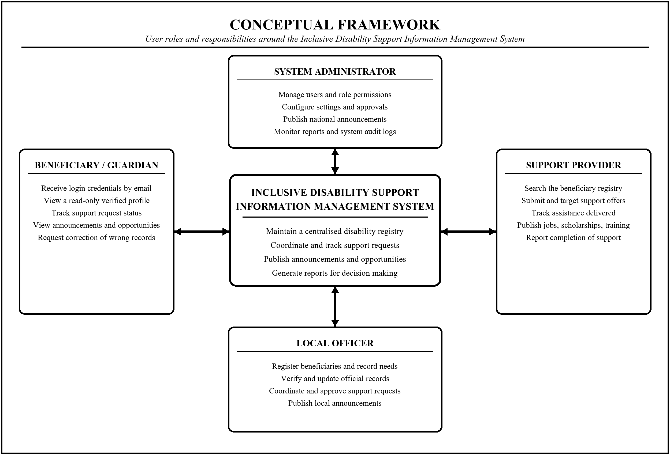
Figure 1: Conceptual Framework
Source: Researcher’s design (2026).
The local officer registers beneficiaries and records their disability details, daily challenges and support needs, verifies and updates official records, coordinates and approves support requests, and publishes local announcements. The beneficiary or guardian receives login credentials by email, views a read-only verified profile, tracks the status of support requests, views announcements and opportunities, and may request correction of an incorrect record. The support provider searches the registry, submits targeted support offers, tracks assistance delivered, publishes jobs, scholarships and training opportunities, and reports completion. The system administrator manages users and role permissions, configures settings and approvals, publishes national announcements, and monitors reports and audit logs. Bidirectional arrows show that each role supplies information to the system and receives authorised information from it.

2.6.1 Existing System
A typical existing workflow begins when a person with a disability, or a guardian on their behalf, travels to the sector office. An officer records the details in a paper register or a private spreadsheet, and the support need is noted on the file and kept locally. If a support provider subsequently offers assistance, the officer searches the paper files by hand to identify candidates, and support is allocated informally with no shared record of who received what. Where no provider comes forward, the record simply remains inactive and unseen. Outcomes are frequently not recorded at all, and where they are, they are noted in a local file that no other officer or provider can access. This representation is a generic analytical model; authorised fieldwork will determine which parts apply to Kamonyi District.
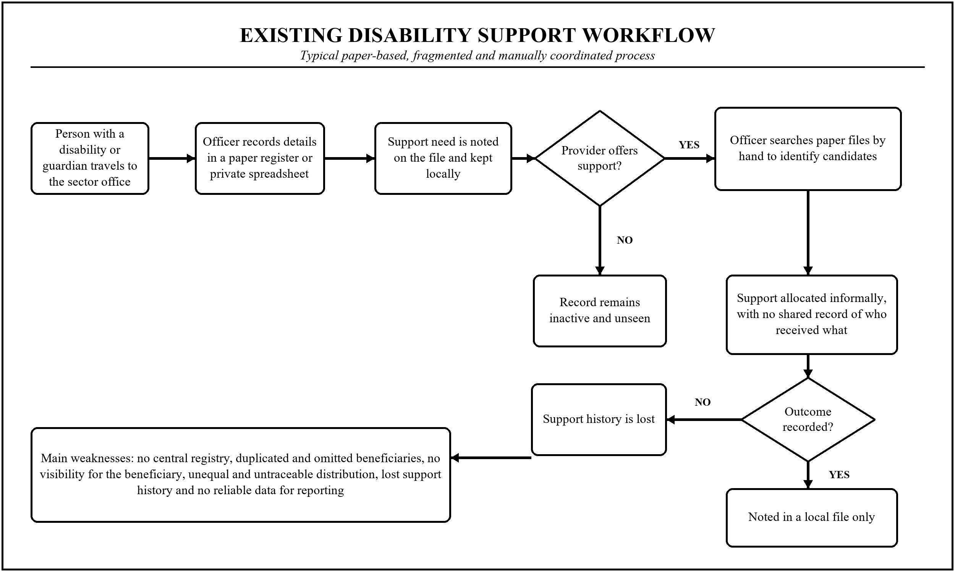
Figure 2: Existing Manual Disability Support Workflow
Source: Researcher’s design (2026).
The existing approach has genuine strengths that should not be dismissed. It requires no electricity, connectivity or device; it depends on officers who know their communities personally; and it is trusted and understood locally. Its weaknesses emerge as soon as information must move beyond the individual officer. A record on paper cannot be searched at scale, aggregated into a report, shared with a provider, protected against loss or fire, or shown to the beneficiary without a journey. Because no consolidated view exists, duplication and omission are not merely possible but undetectable, and because outcomes are unrecorded, the same questions are asked again at every cycle. The proposed design retains the officer's central role and local verification, but places the record in a shared, searchable and auditable form.
Table 2: Comparison of the Existing and Proposed Systems
Area | Existing Manual Approach | Proposed System
Registry | Paper registers and private spreadsheets held per officer | Single centralised registry, searchable and shared by authorised roles
Coverage | Duplication and omission are invisible and undetectable | Duplicate detection and coverage reporting make gaps visible
Beneficiary visibility | Beneficiary must travel to an office to learn anything | Read-only verified profile showing record, status and opportunities
Matching support | Officer's personal knowledge determines who is considered | Providers search by recorded need, so matching rests on data not acquaintance
Decisions | Approval or refusal is often unexplained | Decision, reason and timestamp are recorded and shown to the beneficiary
Support history | Kept locally, if at all, and lost when an officer moves | Complete support history stored, preserved and auditable
Opportunities | Jobs, scholarships and training rarely reach rural beneficiaries | Single portal publishing opportunities directly to registered beneficiaries
Reporting | Aggregation is manual, slow and unreliable | Reports and analytics generated on demand from the live registry
Data protection | Physical files with limited access control | Role-based access, encryption, consent, audit logs and retention limits
Source: Researcher’s compilation (2026).

2.6.2 Proposed System
In the proposed system, the local officer registers the beneficiary and records the disability details, the daily challenges the person experiences and the support they require. The system validates the record, checks for an existing duplicate, stores it in the centralised registry, creates an account and sends login credentials by email to the beneficiary or guardian. The beneficiary logs in to a read-only verified profile, where they can see the record held about them, the status of any support request, and announcements, jobs, scholarships and training opportunities relevant to them. Where a beneficiary has no email address or device, guardian-mediated and officer-mediated access are supported as legitimate paths rather than treated as failures.
A support provider searches the registry by recorded need and submits a targeted support offer. The officer reviews eligibility and need and records a decision with its reason. An urgent case is escalated for priority support; a standard case is queued for scheduled distribution; an ineligible request is recorded and the beneficiary notified with the reason, and a right of correction and appeal is preserved. The officer then coordinates distribution with the provider and confirms completion, at which point the beneficiary's dashboard is updated and the support history is stored. Support history, officer decisions and provider deliveries are recorded with an audit trail, and coverage, duplication, turnaround time, equity of distribution and data quality are monitored and reported.
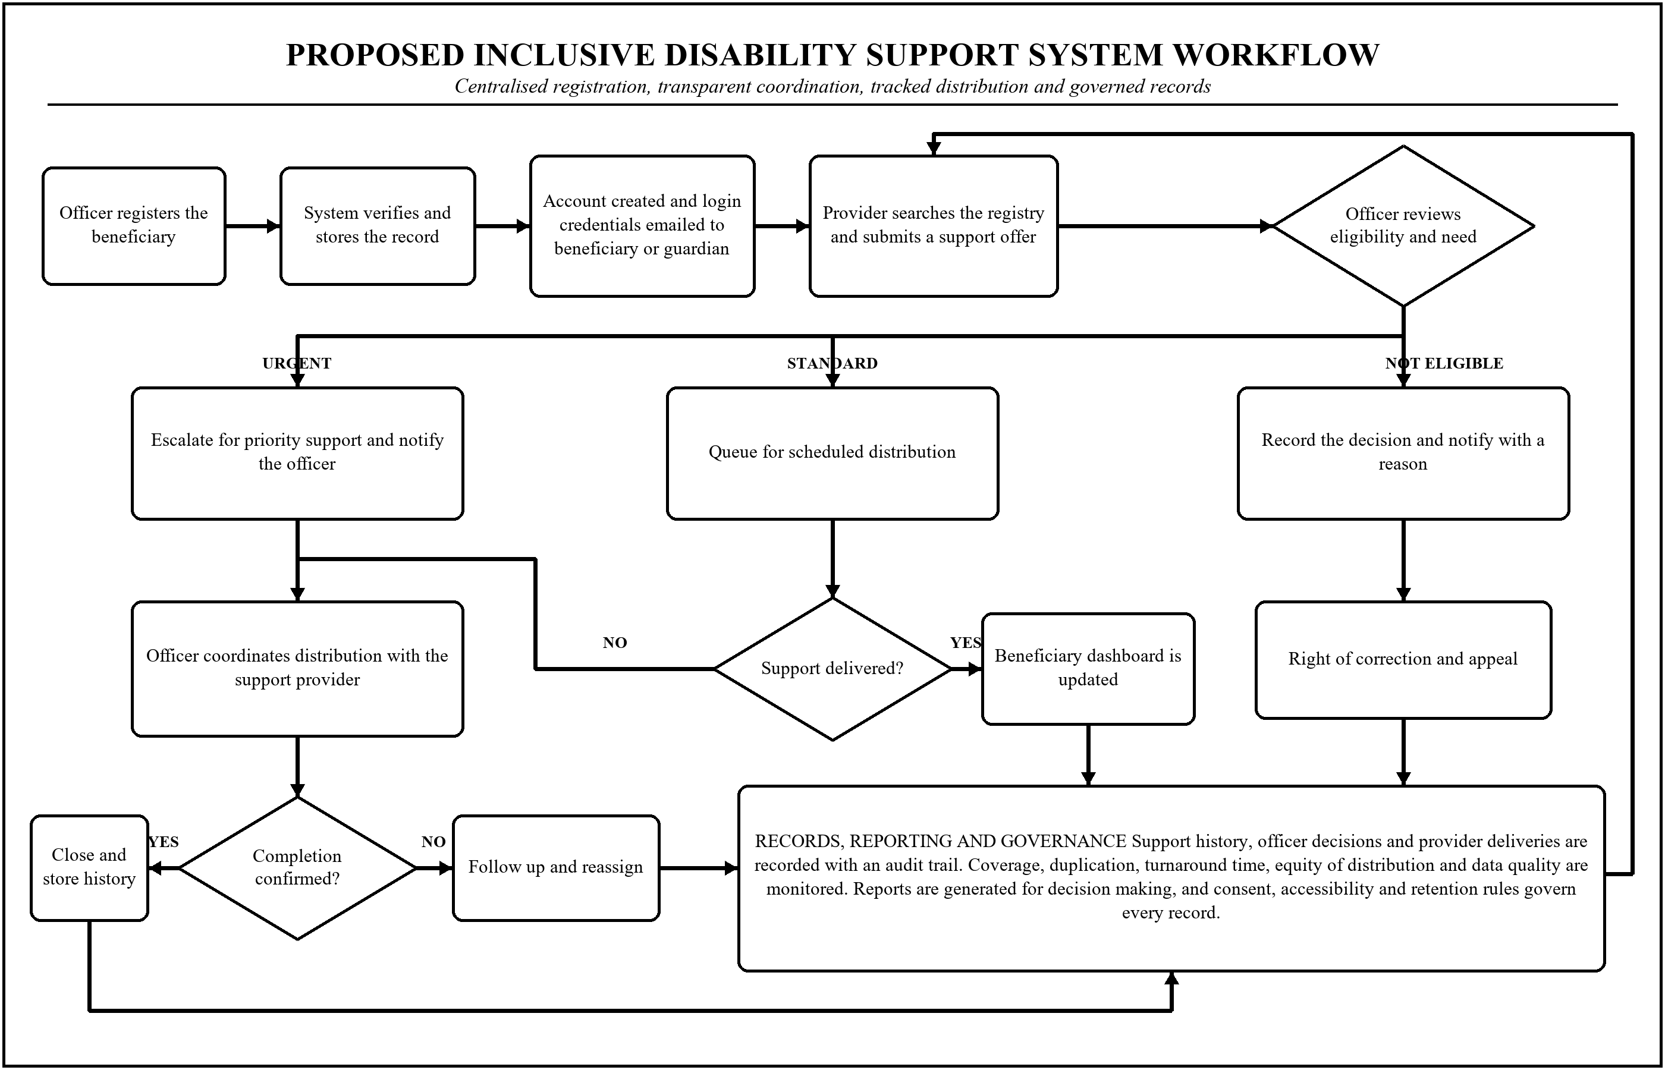
Figure 3: Proposed Inclusive Disability Support System Workflow
Source: Researcher’s design (2026).

2.6.3 Proposed System Architecture
The proposed architecture separates access, application services, data and integration, reporting and notification, and governance. This separation permits individual components to be tested, supports least-privilege access and allows the interface to be adapted for accessibility without altering the underlying data. Beneficiaries, local officers, support providers and administrators each interact through a role-specific interface. The application services layer provides authentication and email login, beneficiary registration, support request and distribution, and announcements and opportunities. The data and integration layer holds the beneficiary registry and the support history store, and connects to the email and messaging gateway. The reporting and notification layer produces reports, coverage dashboards, notifications and data exports.
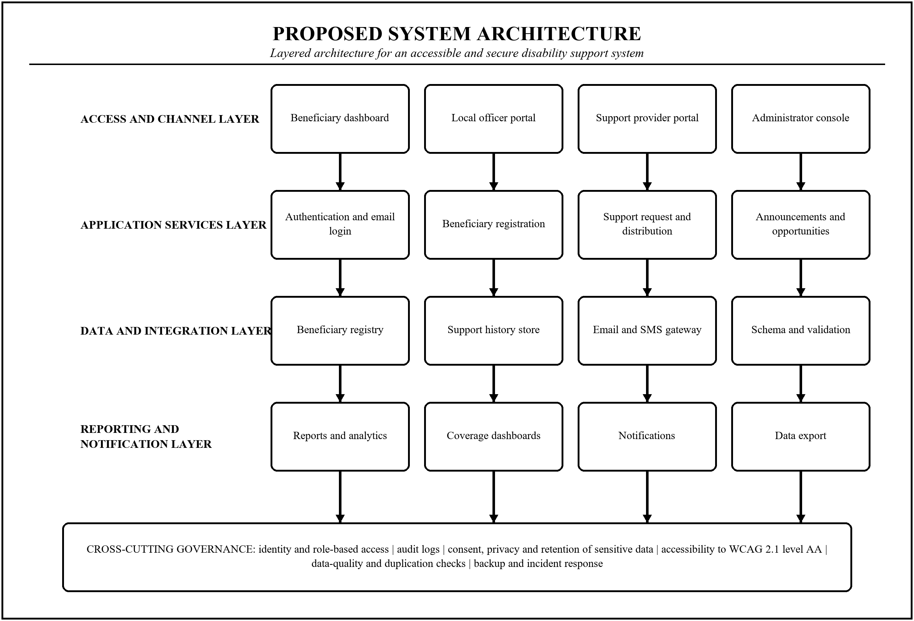
Figure 4: Layered Architecture of the Proposed System
Source: Researcher’s design (2026).
Cross-cutting controls apply to every layer: identity and role-based access, audit logs, consent, privacy and retention of sensitive data, accessibility conformance to the Web Content Accessibility Guidelines at level AA, data-quality and duplication checks, and backup and incident response. A production version would additionally require high availability, disaster recovery, capacity planning, secure key management and independent security review. The architecture in this proposal establishes the prototype boundary and the interfaces that later development should preserve.

CHAPTER 3: RESEARCH METHODOLOGY

3.0 Introduction
This chapter describes how the study will be conducted. It states the research design and approach, defines the target population and the sample, specifies the instruments and the procedure for collecting data, and explains how the data will be analysed. It then sets out the strategy for developing and validating the system, the measures adopted to protect validity and reliability, the ethical considerations arising from the processing of sensitive disability data, the system requirements derived from the study, and the plan for testing and validating the prototype.
The methodology is organised so that each specific objective is answered by identifiable evidence. Objective one is answered through document review, interviews and the registry requirements analysis. Objective two is answered through the design, development and accessibility testing of the registration and dashboard modules. Objective three is answered through the design and testing of the support request and distribution workflow. Objective four is answered through requirements analysis, expert review, security testing and usability evaluation. No conclusion will be drawn from a single source where triangulation is possible.

3.1 Research Design
The study adopts a design-oriented mixed-methods case-study design. It is design-oriented because the principal output is an artefact, namely a working and validated system, together with the evidence of its performance; it is mixed-methods because the research questions require both measurement and explanation; and it is a case study because Kamonyi District provides a bounded, real context within which the artefact is designed and evaluated (Creswell & Creswell, 2023). A purely experimental design was rejected because the study must first establish what the system should do before it can test how well it does it, and a purely descriptive survey was rejected because it cannot produce or evaluate an artefact.

3.1.1 Research Approach
The approach is pragmatic and sequential, and it is deliberately participatory. Qualitative evidence from document review and interviews with local officers, support providers, district administrators and, critically, persons with disabilities themselves is collected first, in order to establish the current workflow, the data available, the barriers experienced and the constraints on any digital solution. This evidence informs the questionnaire, the registry data model and the system requirements. Quantitative evidence is then collected through the survey and used to characterise registration coverage, support experience and access to devices and connectivity. The system is developed iteratively, with prototypes reviewed by users at each cycle, and is finally evaluated for accessibility, usability, security and acceptance. Persons with disabilities participate as evaluators of the system and not merely as subjects of the survey, because a system designed for them without them will reproduce the assumptions it was meant to correct.

3.1.2 Study Variables and Operational Measures
The independent variables are the design features of the system: the structure of the registry data model, the mode of authentication and account access, the design of the support request and approval workflow, and the accessibility features of the interface. The dependent variables are registration coverage and completeness, data accuracy and duplication, the transparency and traceability of support distribution, the turnaround time of a support request, and beneficiary access to information. Mediating variables include perceived usefulness and perceived ease of use, which the Technology Acceptance Model predicts will determine whether officers actually adopt the system in place of the paper register.
Each variable is given an operational measure so that it can be observed rather than merely asserted. Registration coverage is measured as the proportion of the estimated population of persons with disabilities in the study area that appears in the registry. Completeness is measured as the proportion of registry records containing all mandatory fields. Accuracy is measured through verification of a sample of records against the beneficiary, and duplication as the proportion of records identified as duplicates. Traceability is measured as the proportion of support deliveries with a recorded requester, approver, reason and completion status. Turnaround time is measured in days from request to recorded completion. Beneficiary access is measured as the proportion of registered beneficiaries able to reach their own record, whether directly, through a guardian or through an officer.

3.2 Population and Selection of the Sample

3.2.1 Target Population
The target population comprises the people whose knowledge or experience the study requires: persons with disabilities and their guardians resident in Kamonyi District; local officers at cell and sector level responsible for registration and social affairs; support providers including non-governmental organisations, cooperatives, employers and donors active in the district; district and National Council of Persons with Disabilities administrators; and health, rehabilitation and social-protection staff who interact with the same population. Persons with disabilities and their guardians constitute the great majority of the population because the system exists for them, while the other categories are smaller but hold knowledge that is concentrated and not substitutable.

3.2.2 Population and Sample Selection
Table 3: Target Population and Sample Selection
Category | Population Targeted | Sample Selected
Persons with disabilities and guardians | 2,400 | 300
Local officers (cell and sector level) | 160 | 20
Support providers (NGOs, cooperatives, employers) | 120 | 15
District and NCPD administrators | 80 | 10
Health, rehabilitation and social-protection staff | 40 | 5
Total | 2,800 | 350
Source: Researcher’s compilation (2026).
The sample size is calculated using Yamane’s finite-population formula (Yamane, 1967): n = N / [1 + N(e²)], where n is the required sample size, N is the target population and e is the acceptable margin of error. Using N = 2,800 and e = 0.05 gives: n = 2,800 / [1 + 2,800(0.05²)] = 2,800 / 8 = 350 respondents.
The 350 respondents are distributed proportionately using nₕ = (Nₕ / N) × n, where Nₕ is the population of each category. For example, the beneficiary sample is (2,400 / 2,800) × 350 = 300. The same calculation produces 20 local officers, 15 support providers, 10 district and NCPD administrators, and 5 health, rehabilitation and social-protection staff. The final sampling frame will be confirmed with the district authorities and the National Council of Persons with Disabilities before data collection; if the verified population differs, the same formula will be reapplied and the change reported.

3.2.3 Sampling Techniques
Where an authorised list of registered persons with disabilities is available, stratified random sampling will be used, stratified by sector and by disability type, so that the sample is not dominated by the most numerous or most visible category. Sampling by disability type is essential rather than optional: a sample drawn without it would under-represent persons with severe communication or cognitive impairments, who are precisely those least likely to be registered and most likely to be excluded, and the study would then reproduce the bias it was designed to detect.
Purposive selection will be used within the specialist categories, because relevant knowledge is concentrated in defined roles: a sector social affairs officer knows how registration is actually performed, and a support provider knows how beneficiaries are currently identified, and neither is known equally by all employees (Saunders, Lewis, & Thornhill, 2019). Participation will remain voluntary, and supervisors will nominate eligible roles rather than dictate individual answers.
Because the population most relevant to the study is also the population least able to travel, data collection will be brought to the respondent wherever permission and resources allow, through home or cell-level visits rather than by requiring attendance at a central point. A sample drawn only from those who can reach an office would systematically exclude those with the most severe mobility impairments. Where a respondent cannot communicate directly, a guardian or a sign-language interpreter will assist, and the mediated nature of the response will be recorded so that it can be accounted for in the analysis.

3.3 Tools for Data Collection / Instrumentation
Multiple instruments will support triangulation and link each source to a research objective. Instruments will be version-controlled, piloted and stored securely. They will be available in Kinyarwanda, will be readable aloud to respondents who cannot read them, and will not request medical records, diagnostic details beyond what the registry requires, or any personal identifier that the analysis does not need.
Table 4: Data-Collection Instruments and Their Purpose
Instrument | Information Collected | Objective Supported
Beneficiary questionnaire | Registration status, disability type and daily challenges, support received and requested, access to devices and connectivity, information needs, willingness to use a dashboard | Objectives 1, 2 and 4
Semi-structured interview guide | Current registration and coordination workflow, record keeping, provider matching, decision making, reporting and governance constraints | Objectives 1, 3 and 4
Observation / workflow checklist | Actual registration steps, records held, role hand-offs and prototype task completion | Objectives 1 and 3
Document-review matrix | Law, national policy, NCPD mandate, census data, existing registers, standards and technical literature | All objectives
Registry data specification | Required fields, disability classification, validation rules, duplicate criteria, consent and retention | Objectives 1 and 2
Accessibility conformance checklist | WCAG 2.1 level AA success criteria, screen-reader and keyboard operation, contrast and language | Objectives 2 and 4
Prototype usability and expert-review checklist | Task success, dashboard clarity, request traceability, report usefulness, access control and completeness | Objectives 2, 3 and 4
Source: Researcher’s compilation (2026).

3.3.1 Beneficiary Questionnaire
The questionnaire will contain screening, background, experience and acceptance sections. Disability will be identified using questions compatible with the Washington Group Short Set, which asks about difficulty in seeing, hearing, walking, remembering or concentrating, self-care and communication, so that the resulting data can be reconciled with national census figures rather than producing an incompatible parallel classification. Further items will ask what daily challenges the respondent experiences, what support they have requested and received, whether they know what is recorded about them, whether they own or can access a phone or computer, whether they have an email address, and how they currently learn about opportunities. Most attitudinal items will use a five-point Likert scale, presented verbally where necessary.

3.3.2 Semi-Structured Interview Guide
Interviews will use open questions mapped to the specific objectives. Topics include how a person with a disability is currently registered and by whom, what records are kept and where, how a support provider is matched to a beneficiary, how an approval decision is made and whether a reason is recorded, how completion is confirmed, how reports are compiled, how many beneficiaries one officer serves, what happens to the records when an officer is transferred, and what access, consent and retention rules apply to disability data. Follow-up questions will seek concrete examples at a general process level.

3.3.3 Registry Data Specification
The specification will define every field of the beneficiary record, its type, permitted values, whether it is mandatory, its purpose and its sensitivity classification. It will define the disability classification to be used, the recording of daily challenges and support needs, the guardian relationship where one exists, the criteria by which two records are judged to be duplicates, the validation rules applied at entry, the consent captured at registration, and the retention period. An authorised data owner will approve the specification before any data are entered, and the principle of minimisation will be applied so that no field is collected merely because it might one day be useful.

3.3.4 Prototype Review Instruments
Prototype evaluation will use a task-based usability protocol, an accessibility conformance checklist and an expert-review checklist. Beneficiaries and guardians will attempt tasks such as logging in, locating their recorded profile, checking the status of a support request and finding an opportunity. Officers will attempt to register a beneficiary, detect a duplicate, approve a request with a reason and generate a report. Providers will attempt to search by recorded need and submit an offer. Testing will be conducted with participants who have visual, hearing, motor and cognitive impairments, using their own assistive technology where they have it, because conformance to a checklist is evidence of compliance and not evidence of usability. Task success, time on task, errors and requests for help will be recorded, and the System Usability Scale (Brooke, 1996) together with Technology Acceptance Model items will be administered afterwards.

3.4 Collection of Data

3.4.1 Preparation and Permission
Before any data are collected, ethical clearance will be obtained from the University of Kigali and written permission will be sought from Kamonyi District, the National Council of Persons with Disabilities and each participating organisation. The purpose of the study, the categories of data requested, the retention period, the security measures and the intended outputs will be stated in writing. Data collection will begin only after these approvals have been granted.

3.4.2 Pilot Study
A pilot will be conducted with approximately thirty beneficiaries and five specialist respondents who are not part of the main sample, and it will deliberately include participants with different impairment types. The pilot will test the clarity of the wording in Kinyarwanda, the ordering of items, the completion time, the practicality of administering the instrument to a respondent who cannot read or speak, and the internal consistency of the scales. Items that are ambiguous, intrusive or consistently misunderstood will be revised or removed, and the reasons for each change will be documented.

3.4.3 Primary Human Data Collection
Questionnaires will be administered face to face, at the respondent's home or at a cell-level location, by trained enumerators, and will be read aloud or interpreted where required. Interviews with officers, providers and administrators will be conducted individually at a time and place of the respondent's choosing, will last approximately forty-five minutes, and will be audio-recorded only with explicit consent and transcribed under pseudonym. Observation of the existing workflow will occur only where the district has authorised it and will record process steps rather than the performance of identifiable individuals.

3.4.4 System and Records Data Collection
Existing registration records, whether in paper registers or spreadsheets, will be reviewed with authorisation in order to establish the fields currently captured, the completeness of the existing data, the extent of duplication and the availability of support history. Records will be examined in aggregate and no individual will be identified in any output. This review is a substantive source of evidence rather than a preliminary formality, because the state of the existing records is itself the primary finding regarding the information deficit the study seeks to address.

3.4.5 Secondary Data Collection
Secondary data will be collected through structured document review. Sources will include the Fifth Rwanda Population and Housing Census, the National Policy of Persons with Disabilities and Disability Inclusion, Law No. 03/2011 establishing the National Council of Persons with Disabilities, Law No. 058/2021 on personal data protection, the Convention on the Rights of Persons with Disabilities, the Web Content Accessibility Guidelines, and peer-reviewed literature on social registries, disability inclusion and accessible system design. Each document will be recorded in the document-review matrix with its source, date, status and the objective it informs.

3.5 Presentation of Data and Analysis of Data

3.5.1 Quantitative Survey Analysis
Questionnaire responses will be cleaned, coded and analysed using descriptive statistics including frequencies, percentages, means and standard deviations, and presented in tables and charts. Inferential analysis will examine relationships relevant to the research questions, for example whether registration status is associated with distance from the sector office, whether support received differs by disability type, or whether access to a device differs by sex and age. Chi-square tests, correlation and regression will be used as appropriate to the measurement level of the variables, and the assumptions of each test will be checked and reported rather than assumed.

3.5.2 Qualitative Analysis
Interview transcripts, open-ended responses and document extracts will be analysed thematically following the six-phase procedure described by Braun and Clarke (2006): familiarisation, initial coding, searching for themes, reviewing themes, defining and naming themes, and reporting. Coding will be conducted with the aid of qualitative analysis software, an audit trail of coding decisions will be kept, and a subset of transcripts will be double-coded to assess consistency. Themes will be reported with illustrative anonymised quotations, and disconfirming evidence will be reported alongside supporting evidence.

3.5.3 System Design and Database Modelling
Requirements gathered from the survey, interviews and document review will be consolidated into functional and non-functional requirements, and modelled using use-case diagrams for each of the four roles, an entity-relationship diagram for the registry and support history, and data-flow diagrams for the registration and support workflows. The database will be normalised to third normal form so that a beneficiary, a support request and a delivery are represented once and referenced rather than repeated, which is what makes duplication detectable and support history reliable.
Two design decisions are treated as structural rather than incidental. First, the record must distinguish the impairment from the daily challenge and from the support need, because a system that stores only a disability category cannot express what a person actually requires and will therefore be unable to match them to appropriate support. Second, the official record and the beneficiary's view of it are the same data under different permissions, not two separate stores, since maintaining a separate beneficiary-facing copy would allow the two to diverge and would defeat the transparency the design exists to provide.

3.5.4 System Development and Iterative Prototyping
The system will be developed using an iterative and incremental approach, in which a working increment is produced in each cycle and reviewed with users before the next begins. This approach is chosen deliberately over a linear waterfall model because the requirements of an accessible system for users with diverse impairments cannot be fully specified in advance: whether a dashboard is genuinely operable by a person using a screen reader is discovered by testing with that person, not by writing a specification. Each cycle therefore concludes with a review session involving officers, beneficiaries and providers, and the resulting findings feed back into the next cycle.
Development will use a standard web stack with a relational database, and the interface will be built to conform to the Web Content Accessibility Guidelines at level AA from the first increment rather than being retrofitted, because accessibility introduced late is typically accessibility introduced badly. The system will be designed for low bandwidth, with lightweight pages and tolerance of intermittent connectivity, and will support guardian-mediated and officer-mediated access alongside direct beneficiary login. Version control, a documented deployment procedure and a defect log will be maintained throughout.

3.5.5 Evaluation Metrics
Evaluation will address the registry, the workflow and the system, because a system that runs correctly is not the same thing as a system that produces inclusion. The planned measures are summarised below.
Table 5: Planned System Evaluation Measures
Measure | Metric | Question It Answers
Registration coverage | Registered beneficiaries as a proportion of the estimated population | Whether the registry actually finds the people it exists to serve
Record completeness | Proportion of records with all mandatory fields populated | Whether the registry holds enough to act on
Data accuracy | Agreement between a sample of records and verification with the beneficiary | Whether decisions rest on correct information
Duplication rate | Proportion of records identified as duplicates | Whether the registry is a single authoritative record
Distribution traceability | Proportion of deliveries with recorded requester, approver, reason and outcome | Whether support can be shown to be fair rather than merely asserted
Turnaround time | Days from support request to recorded completion | Whether coordination is faster than the manual process
Beneficiary access | Proportion of beneficiaries reaching their record directly, via guardian or via officer | Whether transparency reaches the beneficiary in practice
Accessibility conformance | WCAG 2.1 level AA success criteria met; screen-reader and keyboard task success | Whether persons with disabilities can actually use the system
Usability | System Usability Scale, task success and time on task, per role | Whether officers will adopt it in place of the paper register
Acceptance | TAM perceived usefulness and perceived ease of use, per role | Whether the system will be used at all once the study ends
Performance and reliability | Page response time, report generation time, uptime and error rate | Whether the system is dependable under rural conditions
Source: Researcher’s compilation (2026).
No single metric will be reported as the result of the study. In particular, a technically sound system that officers do not adopt, or that beneficiaries cannot access, will not be reported as a success merely because its functions execute correctly, and any group of users for whom the system proves unusable will be identified explicitly rather than absorbed into an average.

3.5.6 Integration of Findings
Qualitative and quantitative findings will be integrated at the interpretation stage through a joint display that places each research question alongside the survey evidence, the interview evidence, the records review and the prototype-evaluation results. Convergence between sources strengthens a conclusion; divergence is treated as a finding in its own right and is investigated rather than averaged away. For example, if officers report that the system is useful while usage logs show that they continue to maintain the paper register in parallel, the discrepancy is itself the result and would indicate that a requirement has not been met.

3.6 Validity and Reliability

3.6.1 Validity of Human Instruments
Content validity will be established by mapping every item to a specific objective and by submitting the instruments to the supervisor, to subject-matter experts and to representatives of organisations of persons with disabilities for review, since the people the instrument describes are best placed to judge whether it describes them correctly. Construct validity for the acceptance scales will be supported by adapting items from the validated Technology Acceptance Model instrument (Davis, 1989), and disability identification will use questions compatible with the internationally validated Washington Group Short Set. Face validity and clarity in Kinyarwanda will be tested in the pilot.

3.6.2 Reliability of Human Instruments
Internal consistency of multi-item scales will be assessed using Cronbach’s alpha, with a value of 0.70 treated as the minimum acceptable threshold (Cronbach, 1951). Scales falling below this threshold will be revised or reported as unreliable rather than silently retained. Enumerators will be trained to a common protocol so that an item is administered identically to a respondent who reads it and to one who has it read aloud. Interview reliability will be supported by a consistent guide, verbatim transcription, an audit trail of coding decisions, and double-coding of a subset of transcripts.

3.6.3 Validity of the System Evaluation
The principal threat to validity in the system evaluation is that it is conducted with the wrong people under the wrong conditions. Accessibility tested by a developer simulating impairment, rather than by a person who has one, produces a false assurance, and usability tested on a fast office connection tells nothing about a rural cell with intermittent connectivity. The evaluation will therefore be conducted with participants who have actual impairments, using their own assistive technology, under representative connectivity, and on realistic data volumes. Evaluation tasks will be defined in advance to prevent the selective reporting of tasks that succeeded, and any task that fails will be reported as a failure rather than reframed.

3.6.4 System Reliability
Prototype reliability will be assessed through repeated execution of defined test cases, measurement of uptime during the evaluation period, error and exception logging, recovery testing after induced failure including loss of connectivity mid-transaction, and verification that concurrent updates by two officers do not corrupt a record. Backup and restore will be tested rather than assumed, because a registry that consolidates records which previously existed only on paper concentrates risk as well as value, and an unrecoverable failure would destroy the very information the study set out to create.

3.7 Ethical Considerations
The study processes sensitive personal data about a vulnerable population, and it involves participants who may face barriers to giving or withholding consent freely. Ethical obligations are therefore substantive rather than procedural, and the following measures will be applied:
- Approval and permission. Ethical clearance will be obtained from the University of Kigali and written authorisation from Kamonyi District and the National Council of Persons with Disabilities before any data are collected.
- Accessible informed consent. Consent information will be provided in Kinyarwanda, read aloud or interpreted where required, and expressed in plain language. Where a participant cannot give consent independently, the consent of a guardian will be obtained together with the assent of the participant, and a participant who indicates unwillingness will not be enrolled regardless of guardian consent.
- Voluntary participation without coercion. Participation is voluntary and may be withdrawn at any time. It will be stated explicitly, and repeated, that participation has no bearing whatsoever on a person's current or future eligibility for support, because a respondent who believes that refusal may cost them assistance is not consenting freely.
- Confidentiality of sensitive data. Disability status can expose a person to stigma and discrimination. Direct identifiers will be removed or pseudonymised in the research data, respondents will be reported under codes, no individual will be identifiable in any output, and findings will be reported at aggregate level.
- Data protection. Processing will comply with Law No. 058/2021 relating to the protection of personal data and privacy (Republic of Rwanda, 2021). Data will be minimised to what the analysis requires, stored encrypted with access restricted to authorised persons, retained only for the approved period and then securely destroyed.
- No raising of false expectations. Participants will be told clearly that the study produces a prototype and does not itself confer, increase or guarantee any support, so that no one participates in the mistaken belief that doing so will bring them assistance.
- Dignity and non-stigmatisation. Instruments will avoid intrusive or demeaning questions, will refer to persons with disabilities rather than to their impairments, and will not require a participant to demonstrate or describe their impairment beyond what the registry requires. Any participant who shows distress will be free to stop.
- Fair representation. Persons with severe communication, cognitive or mobility impairments are the most likely to be excluded from research about them. The sampling and data-collection procedures are designed to include them, and any group that remains under-represented will be reported as a limitation rather than passed over in silence.

3.8 System Requirements Analysis
The requirements below are derived from the literature review, the conceptual framework, the project design and the anticipated findings of the fieldwork. They will be refined once data collection is complete, and any requirement that the evidence does not support will be revised or removed.
Table 6: Functional and Non-Functional Requirements of the Proposed System
Type | Requirement | Description
Functional | Authentication and email login | Authenticate users by role and issue login credentials by email on registration
Functional | Beneficiary registration | Register a beneficiary with disability details, daily challenges and support needs
Functional | Duplicate detection | Detect and flag a probable duplicate record before it is created
Functional | Beneficiary dashboard | Provide a read-only verified profile with support status and opportunities
Functional | Correction requests | Allow a beneficiary to request correction of a record, recorded and routed to an officer
Functional | Support request and distribution | Allow providers to search by need, submit offers, and officers to approve with a recorded reason
Functional | Support history | Store a complete, traceable history of support requested, approved and delivered
Functional | Announcements and opportunities | Publish announcements, jobs, scholarships and training to registered beneficiaries
Functional | Notifications | Notify users of decisions, deliveries and new opportunities by email or message
Functional | Reports and analytics | Generate coverage, distribution, turnaround and data-quality reports on demand
Non-functional | Accessibility | Conform to WCAG 2.1 level AA, with screen-reader and full keyboard operation
Non-functional | Performance | Return a page within 3 seconds and a standard report within 10 seconds under rural bandwidth
Non-functional | Security | Enforce role-based access control, encryption in transit and at rest, and audit logging
Non-functional | Privacy | Apply consent, data minimisation, pseudonymisation and approved retention limits
Non-functional | Availability | Sustain 99 percent availability during the evaluation period, with tested backup and recovery
Non-functional | Usability | Achieve a System Usability Scale score of at least 70 for each user role
Non-functional | Localisation | Provide the interface in Kinyarwanda and English
Source: Researcher’s compilation (2026).

3.9 Testing and Prototype Validation Plan
Testing will proceed from components to the integrated system and finally to acceptance by users, so that a failure is located before it is compounded. The overall research, system-development and validation procedure is summarised in Figure 5.
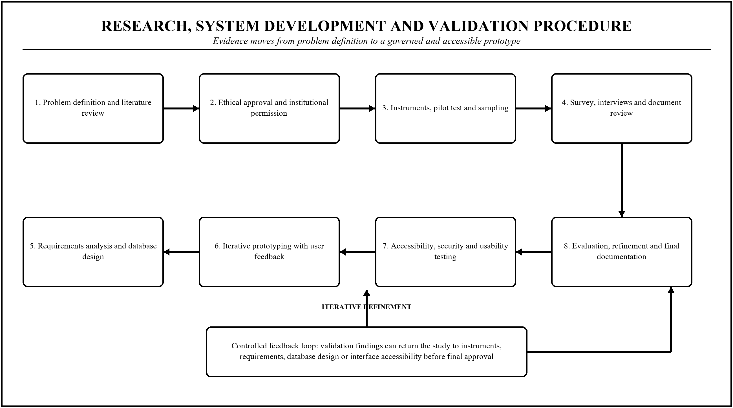
Figure 5: Research, System Development and Prototype Validation Procedure
Source: Researcher’s design (2026).

3.9.1 Functional and Integration Testing
Unit tests will verify each component in isolation, including registration validation, duplicate detection, credential generation and emailing, request approval, status update and report generation. Integration tests will verify the end-to-end path from registration through account creation, provider search, officer approval, delivery and completion to the updated beneficiary dashboard. Test cases will include boundary conditions that a naive implementation typically fails: a beneficiary with multiple impairments, a beneficiary with no email address, a guardian acting for several beneficiaries, two officers updating the same record simultaneously, a duplicate registration attempt, and a support request for a beneficiary who has since died, which the system must handle with dignity rather than with an error.

3.9.2 Accessibility and Compatibility Testing
Accessibility will be tested against the Web Content Accessibility Guidelines at level AA using both automated tooling and, decisively, manual testing with users who have visual, hearing, motor and cognitive impairments, operating the system with their own assistive technology. Automated tools detect only a minority of accessibility defects and can certify as compliant a page that is in practice unusable, so automated conformance will be treated as a necessary but insufficient condition. Compatibility will be tested across common low-cost Android devices and browsers, under constrained bandwidth, since the system must work on the devices its users actually own rather than on those the developer owns.

3.9.3 Security and Privacy Testing
Security testing will verify authentication, role-based access control, session management, input validation and audit logging, and will confirm that a user of one role cannot obtain data belonging to another. Specifically, it must be demonstrated that a support provider can identify a candidate for assistance without being able to read a beneficiary's full personal record, that one beneficiary cannot view another's profile, and that no user can alter an official record outside their permissions. Privacy testing will verify that consent is recorded and enforced, that data are minimised, that audit logs capture every access to a sensitive record, and that retention and deletion operate as specified.

3.9.4 Performance, Usability and Acceptance Testing
Performance testing will measure page response and report generation under representative rural bandwidth and realistic data volumes, reporting the 95th percentile rather than the mean, because a slow response experienced by a minority of users is still a failure for those users. Usability testing will follow the task-based protocol described in Section 3.3.4 and will report task success, time on task and System Usability Scale scores separately for each role, since a system that is easy for an administrator and unusable for a beneficiary has not succeeded. Acceptance testing will confirm with beneficiaries, officers, providers and administrators that the delivered system meets the agreed requirements, and any requirement not met will be reported as unmet rather than reinterpreted.

References
The reference list combines current official evidence, Rwandan law and policy, international standards, peer-reviewed studies, established research methods and foundational theories used in the three chapters.
Braun, V., & Clarke, V. (2006). Using thematic analysis in psychology. Qualitative Research in Psychology, 3(2), 77–101. https://doi.org/10.1191/1478088706qp063oa
Brooke, J. (1996). SUS: A quick and dirty usability scale. In P. W. Jordan, B. Thomas, B. A. Weerdmeester, & I. L. McClelland (Eds.), Usability evaluation in industry (pp. 189–194). Taylor & Francis.
Creswell, J. W., & Creswell, J. D. (2023). Research design: Qualitative, quantitative, and mixed methods approaches (6th ed.). SAGE.
Cronbach, L. J. (1951). Coefficient alpha and the internal structure of tests. Psychometrika, 16(3), 297–334. https://doi.org/10.1007/BF02310555
Davis, F. D. (1989). Perceived usefulness, perceived ease of use, and user acceptance of information technology. MIS Quarterly, 13(3), 319–340. https://doi.org/10.2307/249008
DeLone, W. H., & McLean, E. R. (2003). The DeLone and McLean model of information systems success: A ten-year update. Journal of Management Information Systems, 19(4), 9–30. https://doi.org/10.1080/07421222.2003.11045748
Development Pathways. (2019). Social protection and disability in Rwanda. https://www.developmentpathways.co.uk/publications/social-protection-and-disability-in-rwanda/
Leite, P., George, T., Sun, C., Jones, T., & Lindert, K. (2017). Social registries for social assistance and beyond: A guidance note and assessment tool (Social Protection and Labor Discussion Paper No. 1704). World Bank. https://documents1.worldbank.org/curated/en/698441502095248081/pdf/117971-REVISED-PUBLIC-Discussion-paper-1704.pdf
Ministry of Local Government. (2021). National policy of persons with disabilities and disability inclusion. Republic of Rwanda. https://www.minaloc.gov.rw/fileadmin/user_upload/Minaloc/National_Policy_on_Disability_and_Inclusion_final.pdf
National Institute of Statistics of Rwanda. (2023). Fifth Rwanda population and housing census, 2022: Thematic report on socio-economic status of people with disabilities. https://www.statistics.gov.rw/
Oliver, M. (1990). The politics of disablement. Macmillan.
Republic of Rwanda. (2011). Law No. 03/2011 of 10/02/2011 establishing the National Council of Persons with Disabilities and determining its mission, organisation and functioning. Official Gazette of the Republic of Rwanda.
Republic of Rwanda. (2021). Law No. 058/2021 of 13/10/2021 relating to the protection of personal data and privacy. Official Gazette of the Republic of Rwanda.
Saunders, M., Lewis, P., & Thornhill, A. (2019). Research methods for business students (8th ed.). Pearson.
Sen, A. (1999). Development as freedom. Oxford University Press.
Sommerville, I. (2016). Software engineering (10th ed.). Pearson.
United Nations. (2006). Convention on the rights of persons with disabilities. https://www.un.org/development/desa/disabilities/convention-on-the-rights-of-persons-with-disabilities.html
W3C. (2018). Web content accessibility guidelines (WCAG) 2.1. World Wide Web Consortium. https://www.w3.org/TR/WCAG21/
World Health Organization. (2001). International classification of functioning, disability and health (ICF). https://www.who.int/standards/classifications/international-classification-of-functioning-disability-and-health
World Health Organization. (2022). Global report on health equity for persons with disabilities. https://www.who.int/publications/i/item/9789240063600
Yamane, T. (1967). Statistics: An introductory analysis (2nd ed.). Harper & Row.

