# Image processing course – homework #4 imageprocessinghaifau@gmail.com

You are given 8 bad images to enhance/clean/restore.

You are free to use a method of your choosing, the marks will be given based on the optimality of your method/result.

**Notes:**

* You can use anything we learned: Gamma corrections, Histogram equalization, filters convolutions (gradient, median, bilateral, sharpening… etc), Fourier transform and manipulations in frequency domain.
* Implement each cleaning method inside the function for it.
* You can use built in functions from cv2.
* More hints will be given to those who ask in the forum.
* Use the script to visualize your results – do not submit it.

**My Results with hints:**

There are 3 images, utilize **all three**:

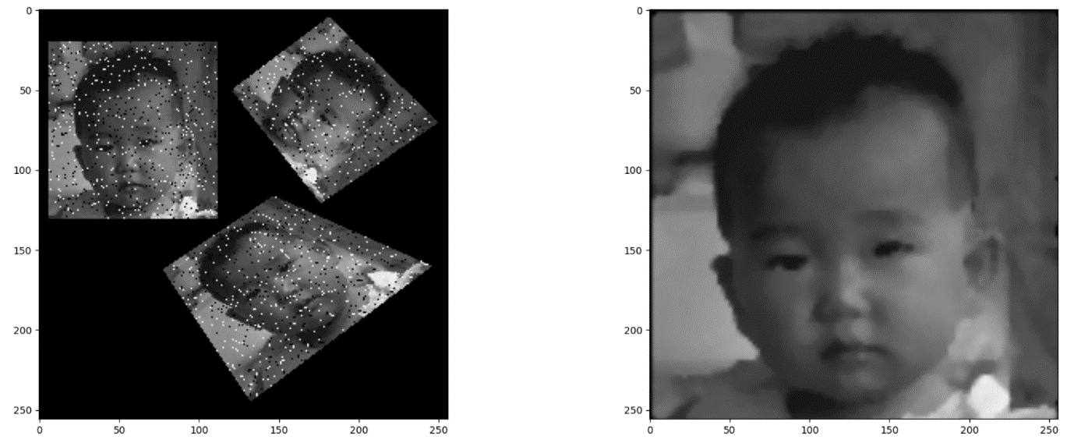

This is an image with a noise of a very specific frequency:

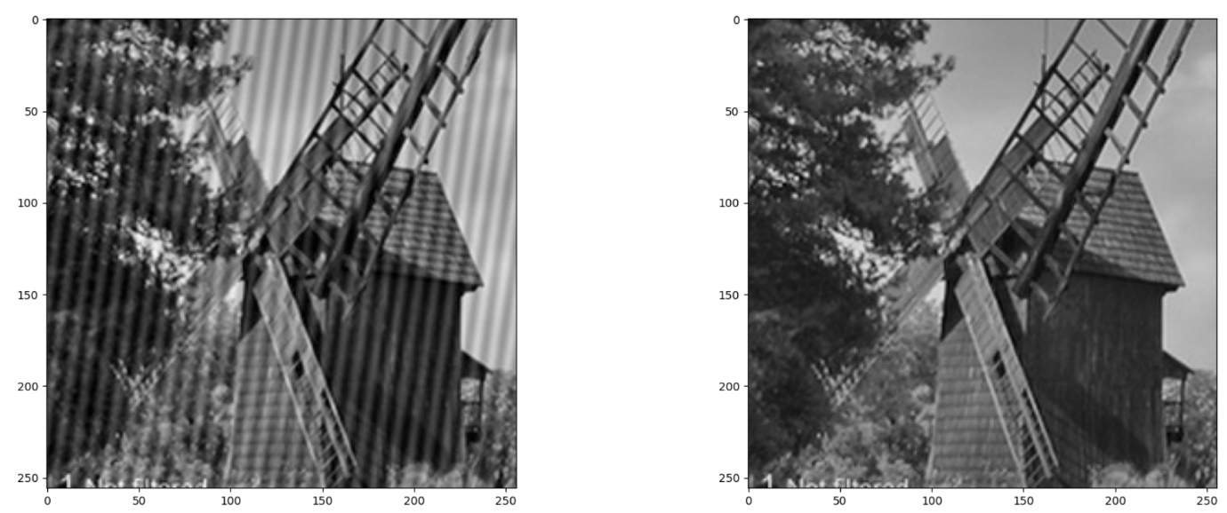

Which filter sharpens an image (Went over this in the tutorial):

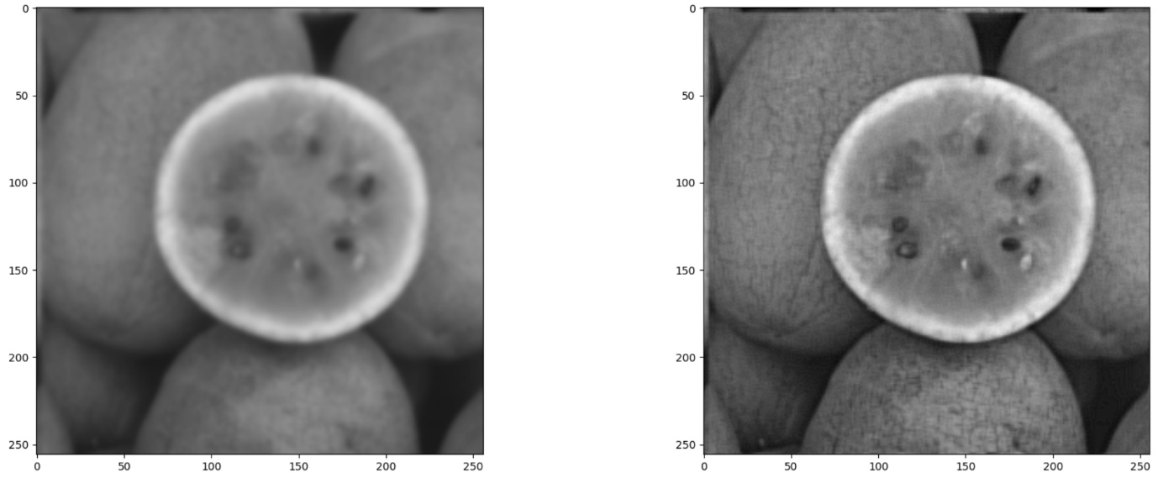

The noised image is a result of an average between original image and a shift of the original image:

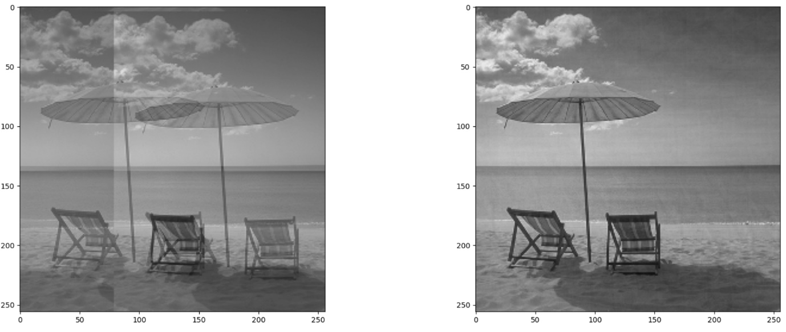

Clean me:

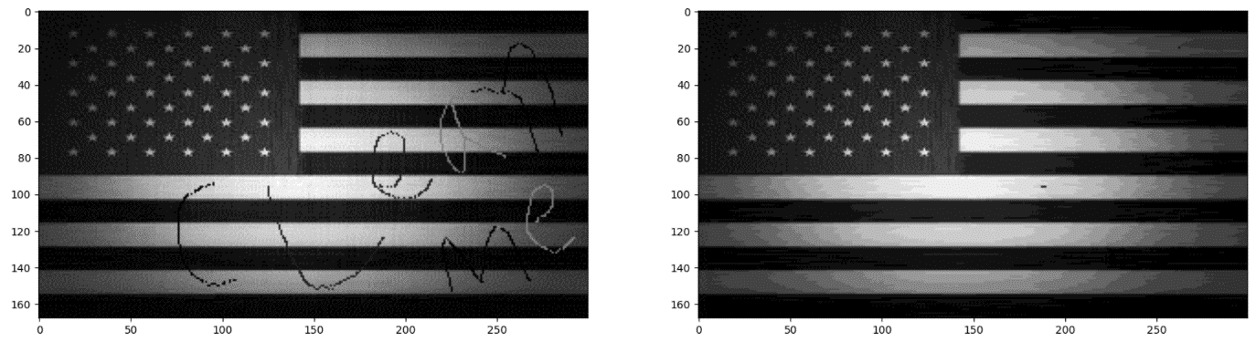

No idea what pattern the noise is, but it sure moves fast:

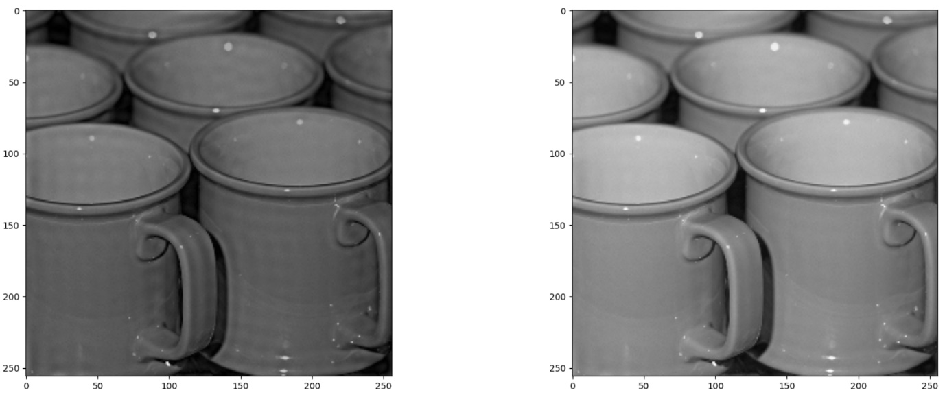

Someone took 10 images of a house while moving (motion blur), the result is 10 shifted images averaged in one:

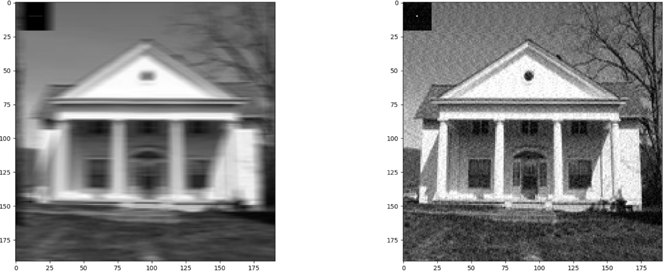

Pretty dark in here, like all the gray values are low:

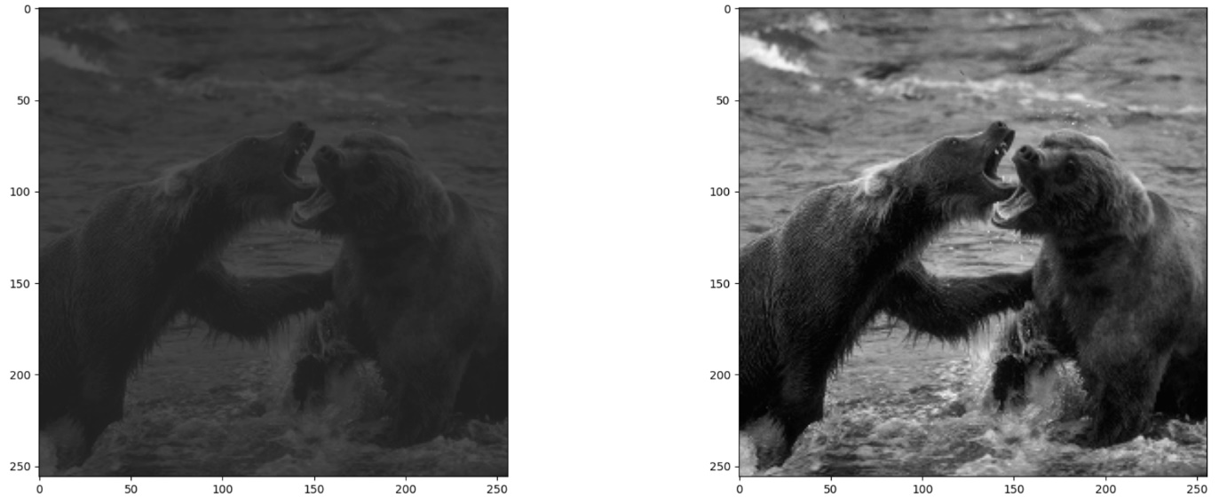

**Submission**

Please submit one .py file with the functions implemented

Name the file **hw4_123456789.py** (or in case of pair: **hw4_123456789_987654321.py**)

**(Replace 123456789, 987654321 with your ids)**

## Good luck!