Working Case
(Sender Process)

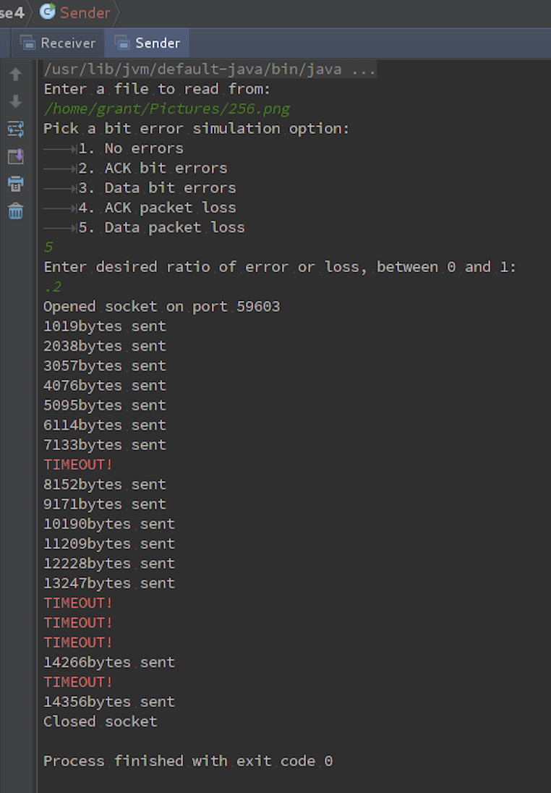

(receiver process) (unchanged)
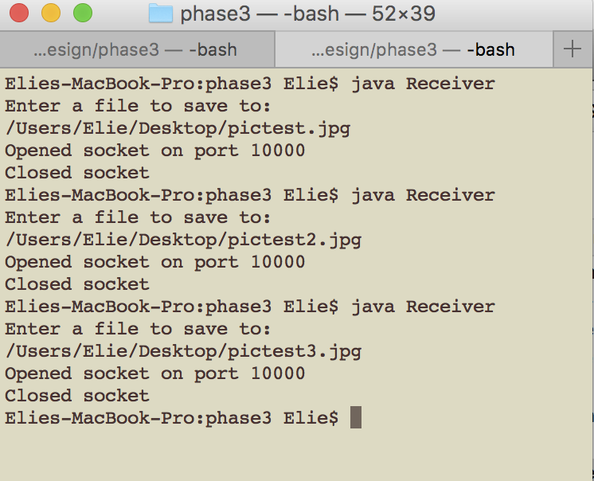

Design – classes and purposes

StateMachine – sets up the generic state machine class that is needed for both receiver and Sender
ReceiverStateMachine – establishes a state machine for the receiver, establishes where the incoming packet will be saved, collects the packet from the incoming messages, checks the checksum and sequence number and extracts the data. The receiver state machine takes each incoming packet as an “event” that it will then use to decide what to do and what state to change to using function .delta)
Receiver – instantiates a receiver process, establishes where the incoming file will be saved, boots up a receiveManager process
receiveManager – opens the socket to listen for packets. Declares a new ReceiverStateMachine and a new receivedPacket, then advances through the states of the receiving machine
receivedPacket – make a checksum for the received packet, compares it to the given checksum in the header to see corruption,
SendingStateMachine – does the same as receiverStateMachine, but in addition, it also, manipulates the received ack and the sent data to simulate a bit error. Also uses user inputted data loss ratio to decided whether or not to “drop” the data packet, aka whether it should send it at all, which simulates the loss.
Sender- instantiates a sender process, what file should be sent, establishes how much bit error, if any, there will be boots up a sendManager process
SendManager – establishes the socket to listen on, instantiates a SendingStatemachine. Also uses user inputted ack loss ratio to decided whether or not to “drop” the incoming ack packet, aka whether it should send it to the state machine, which simulates and ack loss, causing a timeout.
ServerReceived- checks the checksum of the ack as well as the sequence number, checks if it’s corrupted, decides what to do next

