# COSC 8312 – Assignment 2

Linux System Report

Student: IRADUKUNDA Oscar (ID: 26281)

Date: September 28, 2025

## Q1: File System Security

Explored main Linux directories. Found risks: attackers can replace binaries (/bin), edit configs (/etc), hide logs (/var/log), or use /tmp for attacks. Security depends on protecting these areas.

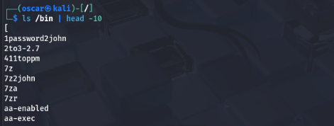

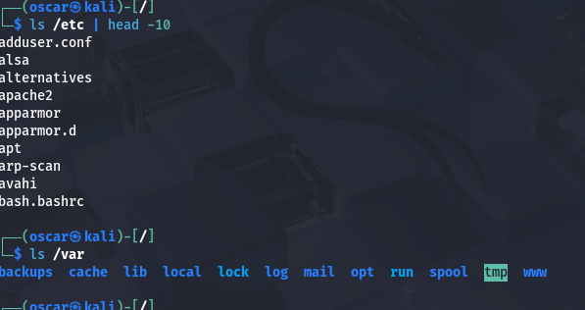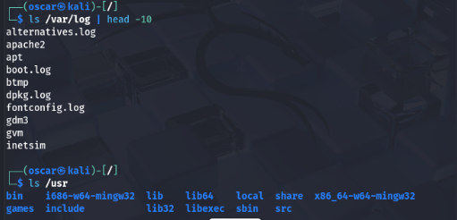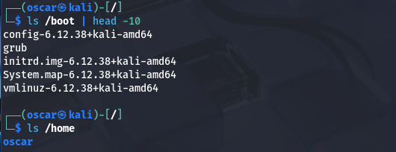

## Q2: Directory Structure

Created project folders (client, personal, shared) with mkdir -p and brace expansion. Efficiently built complex structure with few commands.

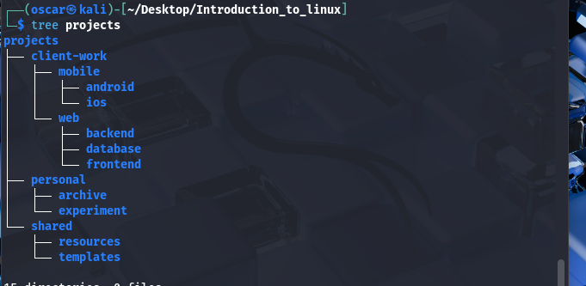

## Q3: Navigation

Practiced moving between directories using relative paths only. Used ../ to go up and down.

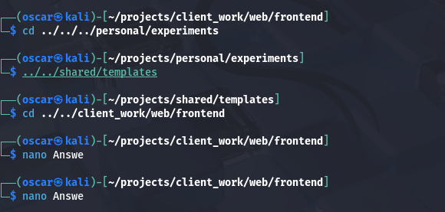

## Q4: Web Project Structure

Built project with 49 files (HTML, CSS, JS, backups). Used patterns and brace expansion for fast creation.

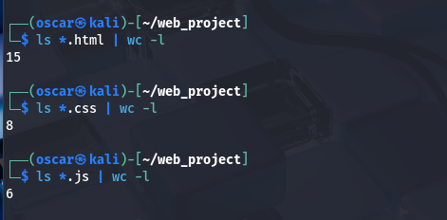

## Q5: Wildcards & File Ops

Practiced moving, copying, and finding files with wildcards. Learned patterns: *, ???.*, [!aeiou]*, etc.

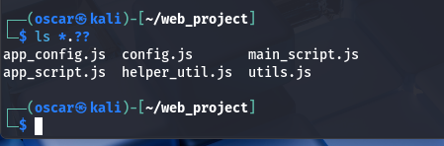

## Q6: Brace Expansion

Created over 100 files in seconds with nested brace commands. Showed efficiency in automation.

## Q7: File Comparison

Compared Linux vs Windows line endings. Learned differences cause issues in scripts/configs.

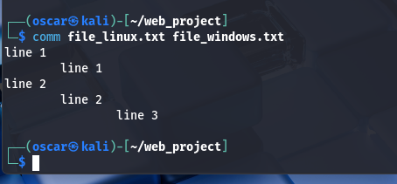

## Q8: Security Audit (find)

Used find to locate large, recent, world-writable, and backup files. Found vulnerabilities like world-writable files.

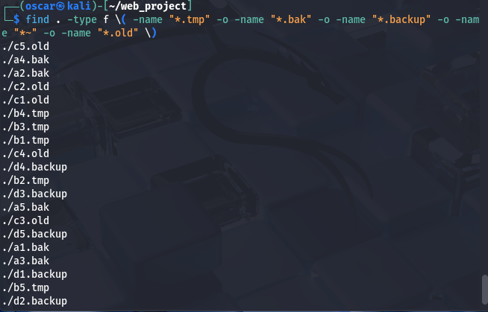

## Q9: Log File Analysis

Created large log, searched for errors with grep, tail, less. Learned why context and line numbers matter in troubleshooting.

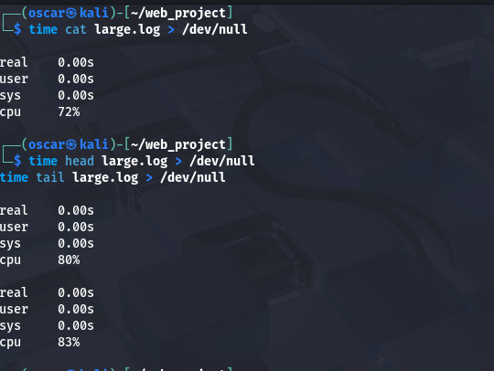

## Q10: Automating Maintenance

Automated file cleanup and permission fixes with find -exec. Ensured preview before changes.

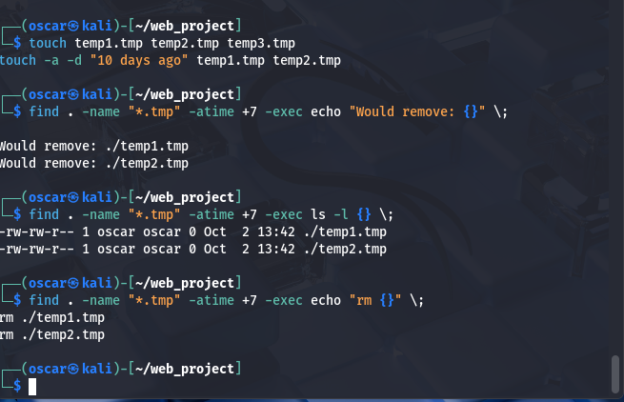

## Q11: Compression Analysis

Compared gzip, bzip2, xz, zip. gzip = fastest, xz = smallest, no point compressing already-compressed files.

## Q12: Archives

Safely listed, extracted, updated, and handled corrupted archives. Practiced merging archives.

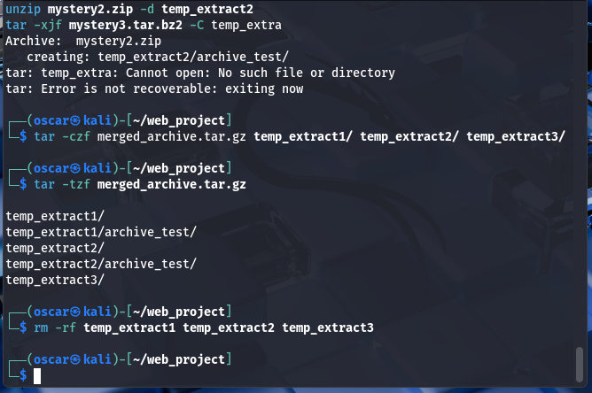

## Q13: Backup Rotation

Designed daily, weekly, monthly backups with retention rules. Used checksums for integrity.

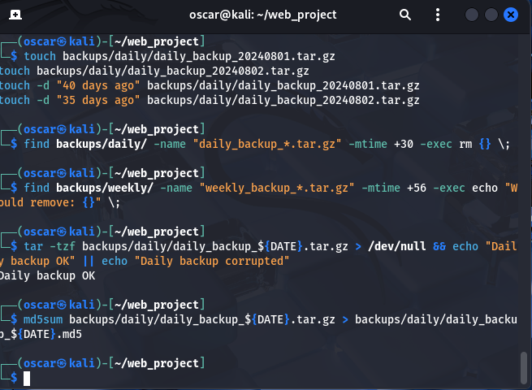

## Q14: User Access

Compared system vs regular users. Saw how misconfigured groups create privilege risks.

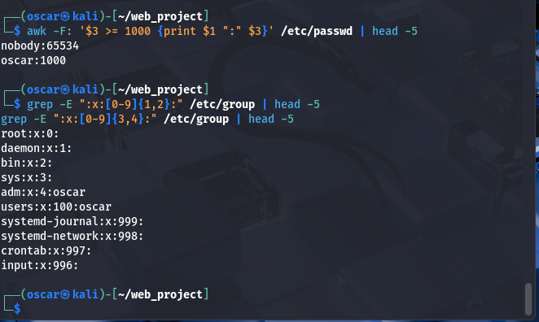

## Q15: Groups

Found which groups give access to logs, sudo, web, or Docker. Reinforced least-privilege principle.

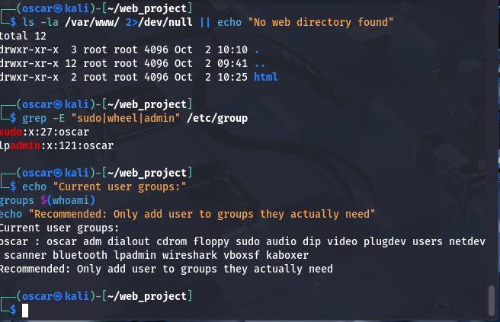

## Q16: Privilege Escalation

Tested sudo, sudo -i, sudo su, sudo su -. Identified risks of weak sudo policies.

## Q17 (Bonus): Forensics

Created different files, links, permissions, archives. Showed what investigators check for compromise signs.

## Conclusion

Learned Linux file system, permissions, automation, backups, and security auditing. Faced Git Bash limits, solved by moving to Kali Linux VM. Skills useful for security response, system admin, backups, and troubleshooting.