Names: NIYOMUFASHA Olive

ID: 26033

1.1. Using Relative Path **cd ../../../** : the command cd stands for change directory ../ is relative path that refers to the parent directory .

from P3 to the Login (olive) ,we need to go up 3 levels .



* 1. Using Absolute Path **cd /home/olive** : This command takes you directly to the olive directory from any location in file system

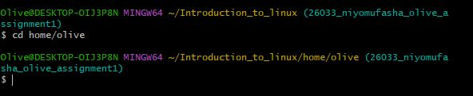

* 1. Using Relative path **ls -l ../P1/Hi/Hello/P3/Here :** The ls command is used to list directory contents. The -l flag provides a "long listing" format, which includes details like permissions, owner, and file size. Starting from the Command directory, ../ moves up one level to Practice. The rest of the path, P1/Hi/Hello/P3/Here, is the relative path from there to the Here directory.

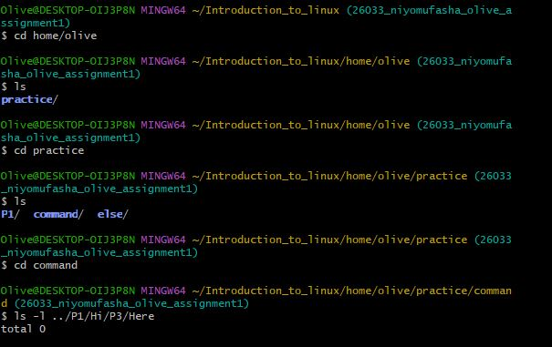

* 1. Using Absolute Path **ls -l /home/mcbishop/Practice/P1/Hi/Hello/P3/Here :** This command uses the full, absolute path from the root directory to list the contents of the Here directory. This command will work regardless of your current working directory**.**

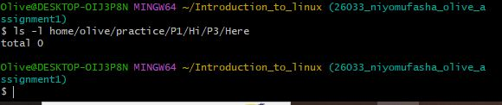

**3.1** Using Absolute Path if you are in the P2 directory: **cp -r ../P1/Hi/Hello/P3 ../Command**

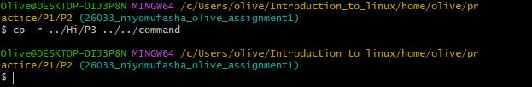

**3.2** Using Relative Path if you are in P3 directory : **cp -r . ../../../Command**

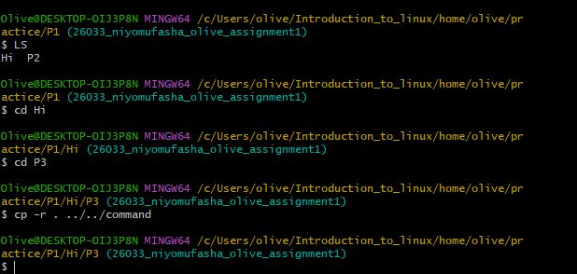

**3.3 Using Relative Path if you are in Command directory: cp -r ../P1/Hi/Hello/P3 .**

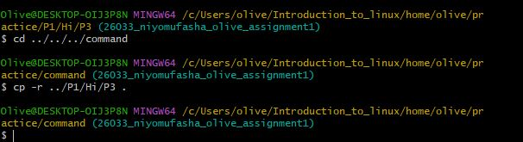

**3.4** Using an absolute path **: cp -r /home/olive/practice/P1/Hi/Hello/P3** /home/olive/practice/command

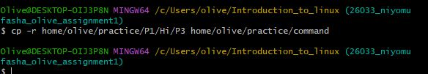

Explanations:The cp command is used to copy files and directories.The -r flag stands for "recursive" and is required to copy a directory and all its contents.

4.1 Using a relative path if you are in the P2 directory: **cp ../P1/Hi/Hello/P3/* ../Command/**

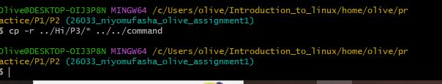

4.2 Using a relative path if you are in the P3 directory: **cp * ../../../command/**

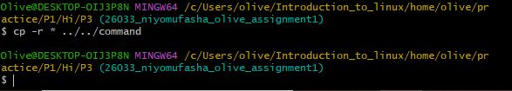

4.3 Using a relative path if you are in the Command directory: **cp ../P1/Hi/Hello/P3/* .**

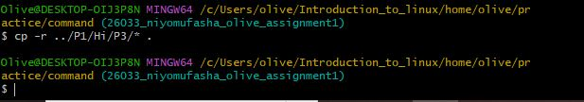

4.4 Using an absolute path: **cp /home/olive/practice/P1/Hi/Hello/P3/* /home/olive/practice/command/**

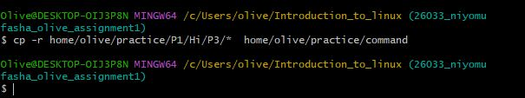

Explanation: This command uses cp to copy only the contents of the P3 directory.

The asterisk (*) is a wildcard that matches all files inside the source directory.The / at the end of the destination path ensures that the files are copied into the Command directory itself, not as a sub-directory.

**5**. Question 3 copies the entire P3 directory itself into the Command directory. This results in a new sub-directory named

P3 inside the Command directory (Command/P3). While

Question 4 copies only the contents (files) that are inside the P3 directory directly into the Command directory. The

P3 directory itself is not copied.

**6**. Blue color Represent Directory While Yellow Represent Files and

HereWeAre Represent File in directory