QUESTION 4 :

1) The optimal learning rate is 0.1 with a final accuracy on the test set of 0.8238

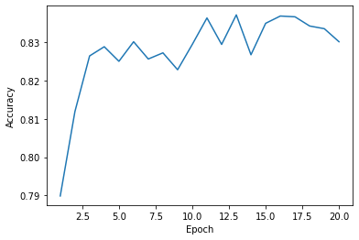
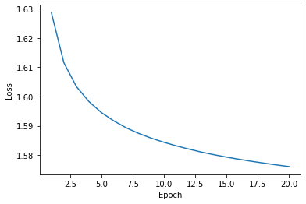
2) The best configuration is obtained with the following parameters :

Dropout : 0.3
Activation : ReLu
Hidden size : 200
Learning rate : 0.001
Optimization :SGD
Batch Size : 1
Number of Epochs : 20
Final test accuracy : 0.8705
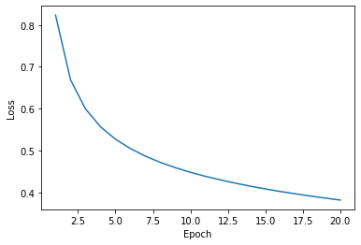
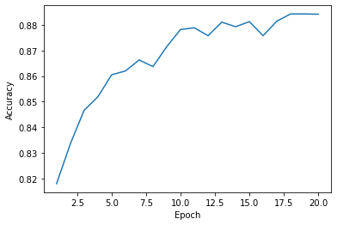
3) With 2 hidden layers, Final test accuracy : 0.8721

With 3 hidden layers, Final test accuracy : 0.8731

