Question 1)

1) - Between the input layer and the first convulotional: (8*5*5*3) Weights + 8 Biases

- The pooling layer in itself does not ahve any parameters

- Between the pooling layer and the linear output layer : (10*11*11*8) Weights + 10 Biases

For a total of 10 298 parameters

2) - Between the input layer and the first hidden layer : (28*28*3*100) Weights + 100 Biases

- Between the hidden layer and the linear output layer : (100*10) Weights + 10 Biases

For a total of 236 310 parameters.

We can see that because of the size of the image as well as the « fully connectness » of the Feed forward Neural netword architecture we have much more parameters to estimate in the second case than in the first one.

Question 2)

1) Convolutional layers are very good to capture translational invariances. Indeed, no matters where a given form is on the picture, the kernel will capture it as it is convolving and the compressed representation will be somewhere on the convolutional layer. When it comes to rotating and scaling invariance, CNN in general can capture some of them given that the training set is composed with enough images including rotations and different scales for a given form to be recognized.

2) The best accuracy equals to 0.9084 and is obtained with learning rate equals to 0.01 :

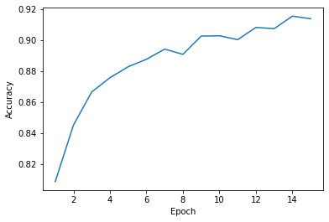

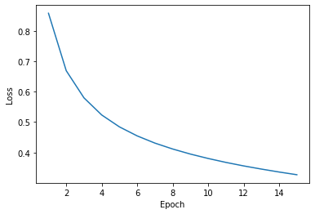

3)

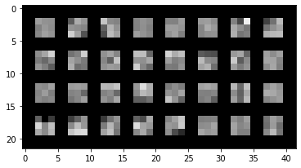

On the first conv layers, it will be simpler pattern and features that would be learned such as corners, edges, lines, while in the last layers it will be more complex features, for instance nose, eyes and ears in the case of face recognition.

