HOUSE ROCKET

Abstract
The aim of the project is to define the best transactions opportunities within the House Rocket portfolio. To find what houses should be bought, two approach were taken. First, a general comparison between houses with same condition and same region was done. With this approach the expected profit was, in average, from 15% up to 63%. The second approach takes the effects of the features of the houses to refine the analysis trying to find high profitable opportunities. Based in the houses features, 10 hypothesis were checked, and for the validated hypothesis the expected profit, in average, was %. The best time to sold the houses were defined in the historical prices, considering the four year seasons. For houses near to water the summer time is the best time to sold, with increase of XX% in the profit in comparison with the same house sold in the winter time.

1. Introduction

Business understanding.
There are about 21k houses with

2 . Methodology
Was adopted a criterion to defines a trade opportunities as following: the trade opportunities are all the houses that have the price lower than the median price, attending the premise ahead:

Premises and assumptions:
1 - The price comparison will be made only for houses with same condition and in the same region (zip code).
2 - The outliers will be removed from the data frame considering the price column, and will not be analyzed.
3 – The profit was estimated considering the houses should be sold by the median price.

The trade opportunities were selected using two different approach. The first one, was to get the total data frame grouped the data by condition and region and evaluate the median price for each case. Then, the price of each house was compared with the median price, for a given condition and region , and selecting the trade opportunities. In the second approach a set of hypothesis, based in the houses features, was checked trying to find specifics and high profitable opportunities. The set of hypothesis are in the table bellow.

Table 1: Set of hypothesis.
Number | Hypothesis description
H1 | Houses with waterfront are, in average, 20% more expensive.
H2 | Houses with year built lower than 1950 are, in average, 20% cheaper
H3 | Houses with basement are, in average, 40% more expensive.
H4 | The YoY price, for year built, increase, in average, 10%.
H5 | House with more than one bathroom are, in average, 15% more expensive
H6 | Houses near to water, but without waterfront, are, in average, 20% cheaper than houses with waterfront.
H7 | Houses with only one floor are, in average, 20% more expensive. Due to people likes houses without ladders
H8 | Houses price increase with the increase of the living room area.
H9 | Houses with year built higher than 2010 are, in average, 30% more expensive.
H10 | Houses price increase with the increase of the lot area.

For the hypothesis that weren’t refuted the profit was estimated with the criterion presented above.

3 . Results.
Median price per condition
As there are five different house conditions, it is important to know how the prices behaves depends the houses conditions and the number of houses per condition. Lets visualize that.

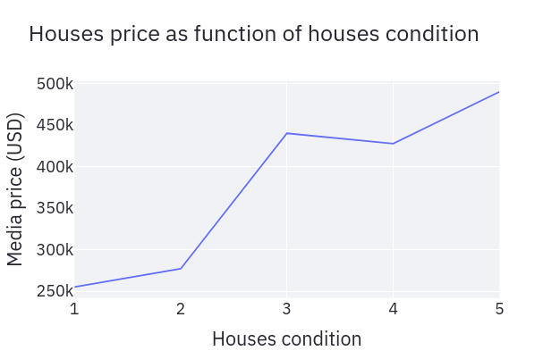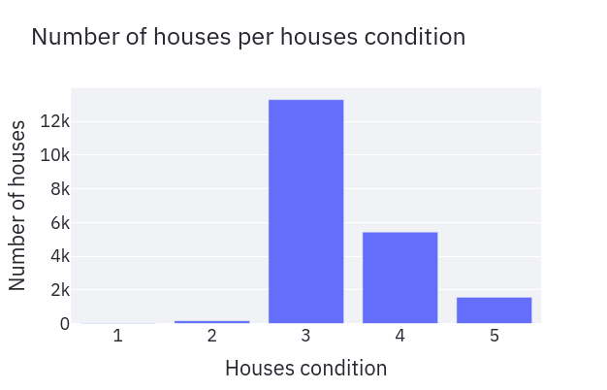
Figure 1: Median prices and number of houses per houses condition.

As wee can see, the house's price increases with the increase of the number that represents the house condition, indicating that the highest number the better house condition. The major part of the houses are in condition 3 and 4.

3.1 House to be bought in the first approach.
Using the grouped data by condition and regions, lets define two new features for the houses:
Status: that defines if a house should be bought or not.
x% lower: that shows the discount, in other words, how much the house's price is lower the than median price for a given condition and region.
See below the data over view with the these two new features.
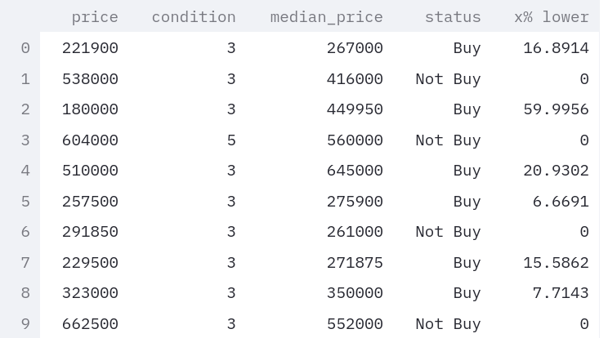

3.1.1 Mapping the best opportunities.
Applying a filter in the data, taken only houses with status equal but, let's visualize the distribution of opportunities.
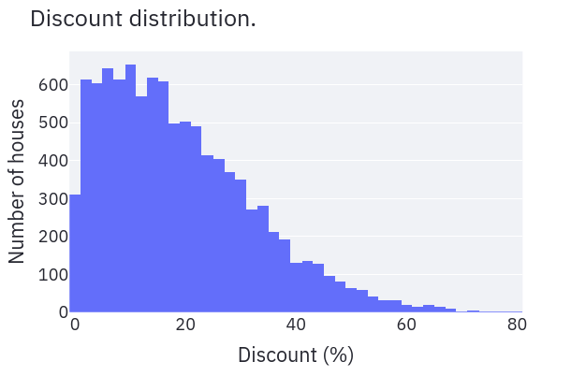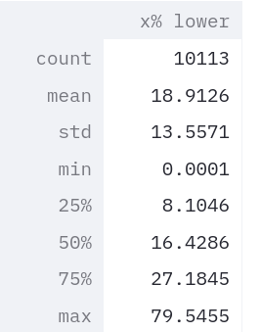
Figure 2: Discount distribution of houses that should be bought.

By the chart and the table we can conclude:
- There are 10113 houses with price lower than the median prices.
- For these 10113 houses, in average, the prices are about 19% lower than the median prices.
- 25% of the houses are with prices equal or lower than 27% of the median prices.

Based in the above conclusions, the data status will gain a new definition as follow:
- If the discount is 27% or higher, the status will be changed to Buy_SRP, that means Strongly Recommended Purchase.
- The set of houses out of the set of best opportunities, was called regular opportunities.

See below the data over view of this new definition
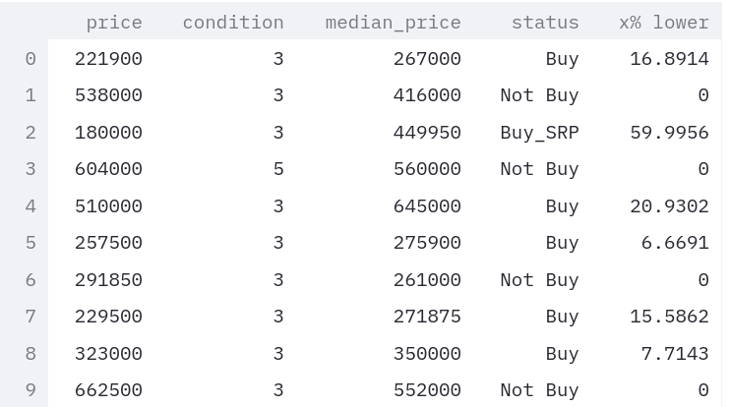

3.1.2 Profit estimation
Estimating the profit, considering the houses should be sold by the median price.
Regular opportunities:
Minimal profit = 0%
Max profit = 37%
Averaged profit = 15%
Best opportunities:
Minimal profit = 37%
Max profit = 389%
Averaged profit = 65%

3.2 House to be bought in the second approach.
Now, let’s check the set of hypothesis. The aim of these hypothesis is to refine the analysis and try to find specific high profitable opportunities.

H1 - Houses with waterfront are, in average, 20% more expensive.
Value found = 97%
H1 confirmed
Actually, the prices of houses with waterfront are, in the average, about 97% higher than prices of houses without waterfront. Let's check price distribution for houses with waterfront.

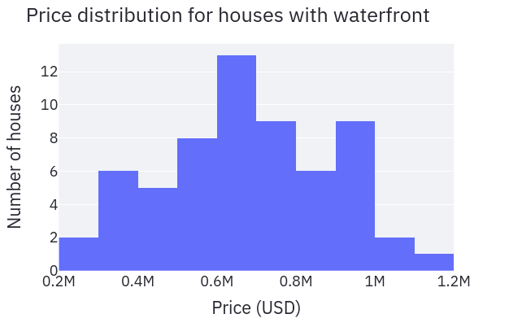
Figure 3: Distribution of houses with water front.

Considering only houses with waterfront and follows the premises defined in the methodology, let’s estimate the profit.

Profit estimation
Minimal profit = 2%
Max profit = 112%
Averaged profit = 25%

H2 - Houses with year built lower than 1950 are, in average, 20% cheaper.
Value found = 10%
H2 refuted

H3 - Houses with basement are, in average, 40% more expensive.
Value found = 17%
H3 refuted

H4 - The YoY price, for year built, increase, in average, 10%.
Value found = 5%
H4 refuted

H5 - House that have more than one bathroom are, in average, 15% more expensive.
Value found = 44%
H5 Confirmed

Lets see how many houses there are in the portfolio for each amount of bathrooms.

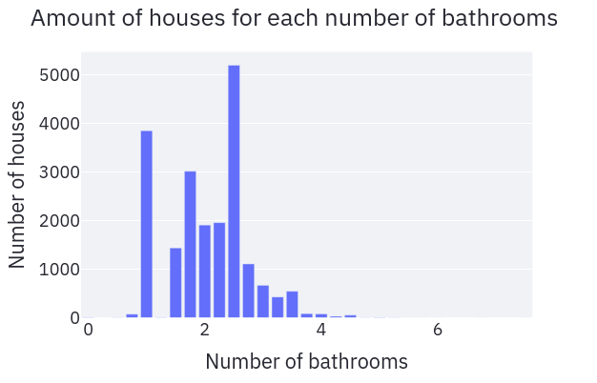
Figure 4: Amount of houses for each amount of bathrooms.

By the chart, we can see that the amount of houses where the number of bathrooms is higher or equal 1 and less or equal than 2.25 represents the major part of the houses, indicating people prefer these kind of houses. The recommendation is to buy this kind of houses, due to will be easier to trade.
Let’s estimate the profit comparing houses in the same region, with same condition and with same number of bathrooms.

Profit estimation
Minimal profit = 0%
Max profit = 300%
Averaged profit = 21%

H6 - Houses near to water, but without waterfront, are, in average, 20% cheaper than houses with waterfront.
There aren't houses that attends the hypothesis six.
H6 refuted

The idea of this hypothesis was to check if exists houses near to water, but without waterfront. That could be a good trade opportunity, once house with water front are, in average, 97% more expensive. So, would be interesting to buy a house in that condition, applies a renovation that convert the houses to have waterfront and sold after renovation.
To check the hypothesis six, o view in the map was done using green markers for houses with water front and blue markers for houses that attend the hypothesis six. As wee can see in the figure ahead, there aren’t houses that attend the hypothesis six.

 Houses with waterfront  Houses of H6

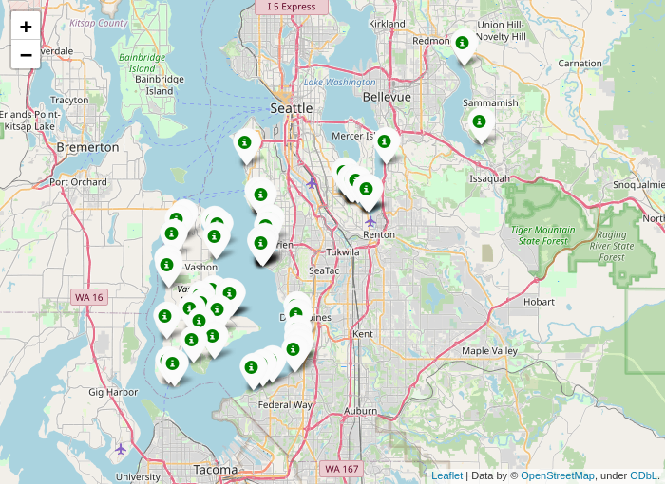

Figure 5: Map showing the location of houses with waterfront.

H7 - Houses with only one floor are, in average, 20% more expensive. Due to people likes houses without ladders.
Value found: -15 %
H7 refuted

H8 - Houses price increase with the increase of the living room area.
To check that hypothesis let’s visualize the trend of the price as function of the living room area.

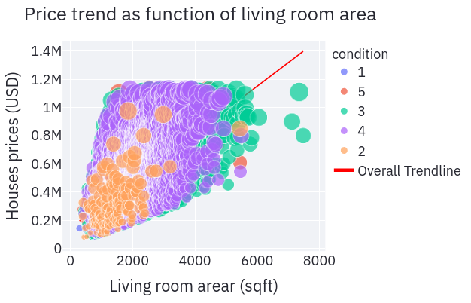
Figure 6: Price relationship with the living room area.

H8 confirmed.
In this case the profit was estimated with a different approach. It was considered that the house were bought when the prices were lower than the value of the trend line, considering same condition and region, and then sold by the price of the trend line.
Profit estimation
Minimal profit = 0%
Max profit = 258%
Averaged profit = 43%

H9 - Houses with year built higher than 2010 are, in average, 30% more expensive.
Value found: 28 %
H9 refuted

Although the hypothesis was refuted, there are opportunities to be considered, once the averaged prices, for houses built after 2010, are about 28% higher than averaged price for houses built before 2010. Lets visualize it.
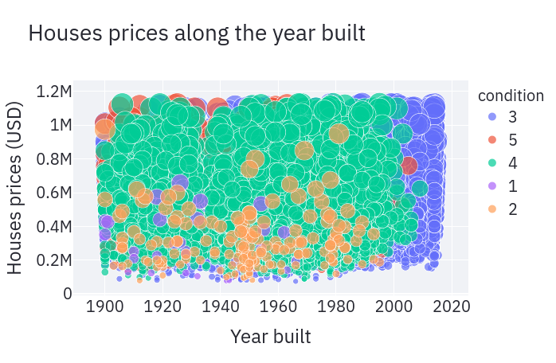
Figure 7: Houses price along the year built.

From the chart is possible see that the condition of house built after 2010 are in major 3, but the prices of these houses can be higher than the price of houses built before 2010, even with better condition. Let's estimate the profit buying only houses with year built 2010 and higher, making the general estimation.

Profit estimation
Minimal profit = 0%
Max profit = 170%
Averaged profit = 21%

H10 - Houses price increase with the increase of the lot area.
H10 refuted
See the chart below

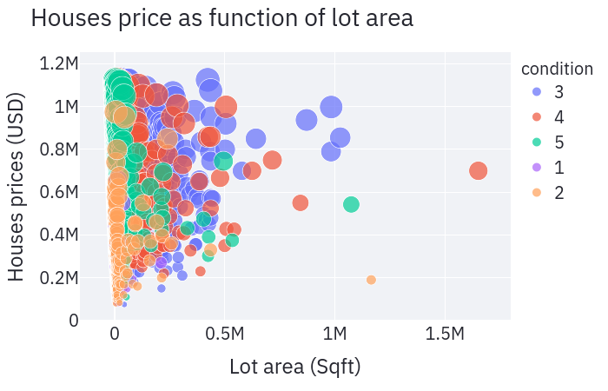
Figure 8: Relationship between houses prices and lot area.

3.3 Building a dataset with houses that attends the hypothesis that was confirmed.
The table ahead shows the hypothesis that were confirmed, the number of houses that attend each hypothesis and the averaged estimated profit.

Hypothesis | Number of houses | AVG estimated Profit
H1 | 24 | 25%
H5 | 8314 | 21%
H8 | 10927 | 42%
H9* | 284 | 21%
* The H9 hypothesis was refuted but the data were analyzed due to potential profitable characteristics found.

Now let’s discuss the results a lite bit. If you remember, in the general approach were found 10113 houses, as good trade opportunities. So, the number of houses found in hypothesis H5 and H8 are, in most part, or probably in total, inside the set of houses taken for the first approach. So, for those hypothesis will be taken only the 50 must profitable houses.
All data from the first and second approach are in the appendix as houses to be considered as good trade opportunities, being one table for each case. The tables were sorted from the highest to lowest averaged estimate profit.
For all table, general approach and hypothesis approach, the data were sorted from the highest to the lowest profitable opportunity. Doing in this way wee don’t need to separate the best opportunities.

5. Conclusion.
There more opportunities by trade houses with condition 3 and 4.
The averaged estimated profit for the first approach was 65%, for the best opportunities and 37% for the regular opportunities.
Considering only houses with waterfront the averaged estimated profit found was 41%.

5. Next Steps.
fsdfsd

6 . Appendix.

id | Price  (USD) | median_price  (USD) | estimate_profit  (USD) | estimate_profit  (%) | hypothesis
3523029041 | 290000.0 | 615000.0 | 325000.0 | 112.1 | H1
2013802030 | 357000.0 | 650000.0 | 293000.0 | 82.1 | H1
7631800110 | 380000.0 | 685000.0 | 305000.0 | 80.3 | H1
5216200090 | 385000.0 | 615000.0 | 230000.0 | 59.7 | H1
2781600195 | 285000.0 | 370000.0 | 85000.0 | 29.8 | H1
6329000185 | 540000.0 | 695750.0 | 155750.0 | 28.8 | H1
1922039062 | 480000.0 | 615000.0 | 135000.0 | 28.1 | H1
222029026 | 340000.0 | 429592.0 | 89592.0 | 26.4 | H1
2013802060 | 500000.0 | 597500.0 | 97500.0 | 19.5 | H1
7003200120 | 528000.0 | 615000.0 | 87000.0 | 16.5 | H1
2123039032 | 369900.0 | 429592.0 | 59692.0 | 16.1 | H1
9536600010 | 520000.0 | 597500.0 | 77500.0 | 14.9 | H1
7129303070 | 735000.0 | 842475.0 | 107475.0 | 14.6 | H1
8073000495 | 700000.0 | 790000.0 | 90000.0 | 12.9 | H1
8073000491 | 700000.0 | 790000.0 | 90000.0 | 12.9 | H1
121039042 | 425000.0 | 464000.0 | 39000.0 | 9.2 | H1
2923039243 | 340000.0 | 370000.0 | 30000.0 | 8.8 | H1
6329000050 | 641500.0 | 695750.0 | 54250.0 | 8.5 | H1
6102400166 | 649000.0 | 685000.0 | 36000.0 | 5.5 | H1
7567600030 | 750000.0 | 787500.0 | 37500.0 | 5.0 | H1
3222049087 | 570000.0 | 597500.0 | 27500.0 | 4.8 | H1
8096000060 | 655000.0 | 685000.0 | 30000.0 | 4.6 | H1
1822039138 | 600000.0 | 615000.0 | 15000.0 | 2.5 | H1
7558800620 | 600000.0 | 615000.0 | 15000.0 | 2.5 | H1

