|  |  |  |
| --- | --- | --- |
| Checkpoint V | Checkpoint V: Third Prototype | |
| Group: | 30 |
| Date: | <2024/10/19> |
|  |  |

# Prototype Architecture

# We added two new js files, the one creating the list (list.js) and the one for the sankey slider (sliderLegend.js). The main file has been updated to react to these new idioms and enable interactivity. The new elements have been added to this diagram.

# 

# A screenshot of a computer Description automatically generatedA grey and white background with different colors Description automatically generated with medium confidenceDashboard Layout

# This week we implemented a lot of new elements: the adaptative list, which is working incredibly well, even showing us the photo of the movie or TVShow. Three buttons have also been added at the top: “Home” “TV Shows” and “Movies”, currently only the “Home” button is working. The design of the Sankey diagram has also been changed, with a legend next to the idiom to avoid surcharge. A small slider is also available, it allows to change the percentage threshold at of the “Genre” shown on the Sankey Diagram.

# Data Processing

# For this milestone we didn’t need any data processing. All the additional computation for the list is done on the fly.

# A screen shot of a television show Description automatically generatedChart Interaction



# You can now select how many movies and shows you want to see on the list (between 3 and 15) and the genre. We also have interaction when clicking on/ hovering over the box of the list. For example, a “onclick” event is triggered when clicking on the bar chart on the right of each row, which permits you to see the bar char better.

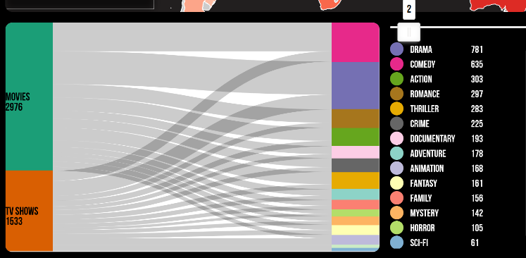The Sankey diagram also adds a new interaction, which permits to control the number of node display on the idiom. The smaller the number on the slider is the more content is displayed (may need to be changed to a more intuitive way).



We still need to work on more interactions in between the idioms.

# Chart Integration

# The integration is currently the same as last week.