Person B — Sprint 1 report draft (Marc Bteich)

Person B report draft (Marc Bteich)
Security Incident Detection and Response Management System — Sprint 1. Team: Elie Medawar and Marc Bteich. Prepared from the implemented backend and actual local tests on 20 October 2026. These are Marc’s assigned sections, to review and combine with Elie’s title page, contents, validation, authentication, GitHub sections and evidence. No claim is made that this draft has been personally reviewed or accepted by the instructor.

3. Introduction (Marc Bteich)
The system provides a backend for recording and investigating security incidents, identifying affected organizational assets, maintaining threat indicators, tracking vulnerabilities and following response procedures. A central record of users, incidents, assets, audit events and notifications supports coordinated security work. This sprint implements REST endpoints, persistent storage, authentication, role-based permissions, validation and reproducible API tests; a frontend is outside the professor’s required scope.
The objectives are to separate responsibilities into independent services, preserve relationships through database constraints, restrict operations to authorized roles, record security-relevant changes and produce statistics from service APIs. Marc owns Assets, Threat Intelligence, Vulnerabilities, Playbooks/Actions, three reports, the shared schema/sample data and documentation integration. Elie owns Users, Incidents, Audit Logs, Notifications, the shared foundation and the other three reports.

4. System Architecture (Marc Bteich)
Nine Flask applications run independently on ports 5001–5009. They share one SQLite database and common Python infrastructure. Each service uses model classes for persistence, a service/validator layer for business rules and thin routes for authorization and responses. SQLAlchemy binds values rather than concatenating client input into SQL. SQLite development is permitted by the team plan; MySQL execution has not been verified.
Public requests carry Bearer JWTs containing user_id, username, role and expiry. Shared role checks distinguish admin, analyst, user and auditor. Internal HTTP requests carry X-Service-Key. Assets verifies owners through Users; Incidents and Vulnerabilities verify assets through Assets; Playbooks verifies assigned users through Users. Every successful mutation requests an audit event. Critical threat/vulnerability creation identifies all admins through Users and requests notifications through Notifications.
The Reports app registers both owners’ blueprints. It calls source /internal/stats endpoints through the existing get_service/ReportBuilder helpers and does not read source tables for report calculations. A missing required source yields 503. Logs and Notifications use the shared best-effort HTTP clients; normal writes can succeed if these recipients are unavailable. Playbook deletion is stricter: execution-history events must be acknowledged by Logs before actions can be cascaded away.
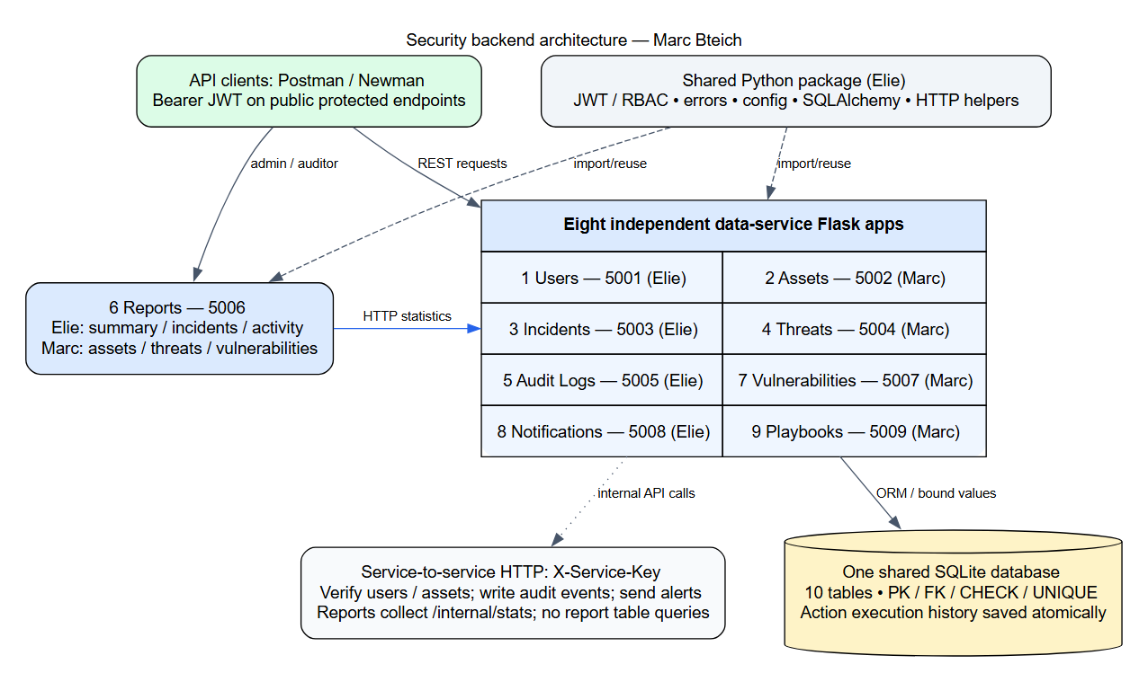

5. Implementation Details (Marc Bteich)

Assets (Marc Bteich)
AssetValidator validates required strings, type, IP, owner ID, criticality and status. AssetService normalizes IPv4/IPv6, verifies the owner over HTTP and performs ORM writes and queries. Admins write; admins/auditors list; analysts can retrieve/search. Search filters combine with AND and escape LIKE wildcards. Incidents survive asset deletion with a null asset link; existing vulnerabilities block deletion with 409. The original Assets behavior is retained.

Threat Intelligence (Marc Bteich)
ThreatValidator canonicalizes IP addresses, domains (lowercase and no terminal dot), and hexadecimal hashes. Hash lengths identify MD5/SHA1/SHA256 formats; malware-signature/Other values must be nonempty strings. A unique constraint on threat_type/threat_value protects against duplicates including concurrent inserts. Admins write; analysts read/search; auditors read lists/details. The detailed Service 4 matrix is followed for auditor search, and the existing shared enum uses Other.

Vulnerability Management (Marc Bteich)
VulnerabilityValidator checks required fields, a CVE-YYYY-NNNN+ identifier, finite numeric CVSS 0–10 and a real asset. Only admins create/delete, while analysts may update. Status advances one step at a time through Open, Under Investigation, In Progress, Resolved and Closed. The server records resolution_date on Resolved. Invalid transitions are rejected before applying any field changes, so a rejected update cannot partially save a description.

Playbooks and Response Actions (Marc Bteich)
Playbooks organize response procedures by incident category and severity. Actions have unique positive step numbers within each playbook and are returned in order. Admins manage playbooks; admins/analysts add and progress actions. Pending advances to In Progress and then Completed; execution requires an active assigned user. completion_date is generated automatically. An append-only JSON execution_history field records actor, timestamp, prior/next status, assignment and completion. The JSON list is saved in the same transaction as the action. Before deletion, history is archived through Logs; a failed archive returns 503 and preserves the playbook. Deletion cascades to actions only after archival.

Reports and service communication (Marc Bteich)
The asset report returns total/critical assets and counts by type; the threat report returns total, counts by severity/type and the latest five records; the vulnerability report returns total/critical vulnerabilities and counts by severity/status. Source services calculate grouped counts with ORM aggregate queries. Admins and auditors may generate reports; analysts and regular users receive 403. Elie’s summary/incidents/activity routes are integrated unchanged.

6. Database Design (Marc Bteich)
The schema contains exactly ten tables with integer primary keys. Foreign keys enforce ownership, reporting/assignment, affected assets, notes, notifications and response actions. Enum CHECK constraints restrict known roles, statuses, categories and severities; UNIQUE constraints protect usernames/emails, threat indicator pairs and playbook step numbers. CVSS and action-step bounds are checked by the database. IP/CVE formats and status transitions are validated by services because a membership CHECK cannot express an ordered lifecycle.
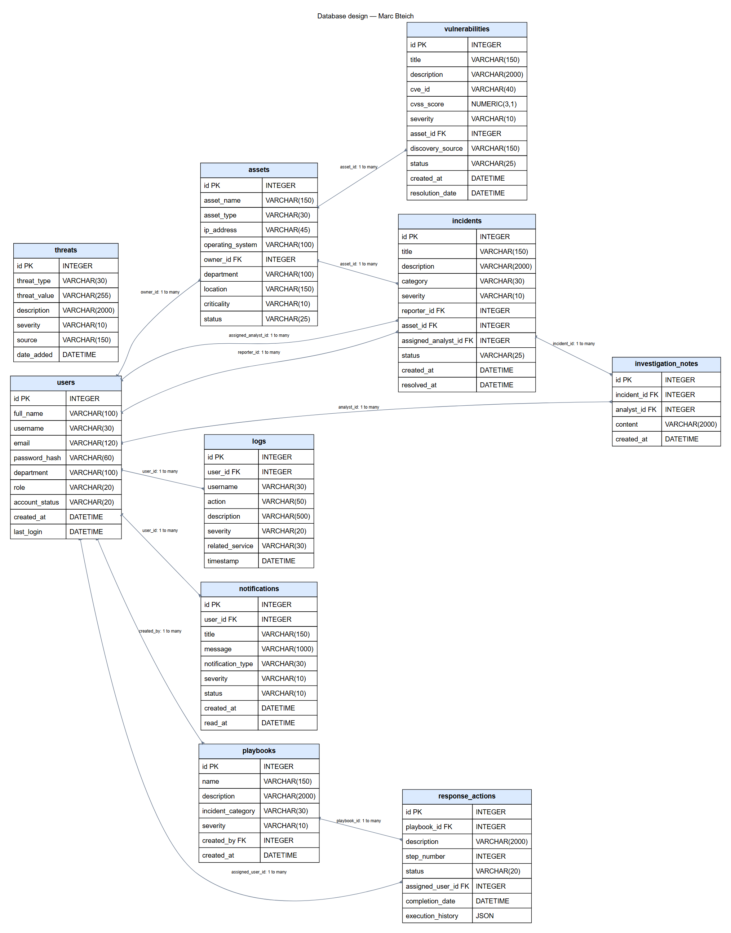
Users→Assets is one-to-many through owner_id; Users→Incidents uses reporter_id and optional assigned_analyst_id; Assets→Incidents and Assets→Vulnerabilities identify affected resources; Incidents→Investigation Notes is one-to-many; Users→Logs/Notifications identifies actors and recipients; Users→Playbooks identifies creators; Playbooks→Response Actions is ordered one-to-many; Users→Response Actions identifies assignees. Departments are fields rather than an extra table, preserving the agreed ten-table design.
Deletion choices preserve useful records: incident asset/analyst links and log user links become null; log usernames remain as snapshots; incident notes and user notifications cascade with their parents; an asset owner and a vulnerable asset cannot be deleted while required references exist. Playbook actions cascade after their execution history is archived. Action-history schema migration adds one column to an existing table without dropping data. All ten ORM column definitions were compared with schema.sql.

Tables and field definitions (Marc Bteich)

assets (Marc Bteich)
Field | Type | Constraint / relationship
id | INTEGER | PK
asset_name | VARCHAR(150) | NOT NULL
asset_type | VARCHAR(30) | NOT NULL
ip_address | VARCHAR(45) | NOT NULL
operating_system | VARCHAR(100) | nullable
owner_id | INTEGER | NOT NULL; FK → users.id; delete NO ACTION
department | VARCHAR(100) | NOT NULL
location | VARCHAR(150) | nullable
criticality | VARCHAR(10) | NOT NULL
status | VARCHAR(25) | NOT NULL

incidents (Marc Bteich)
Field | Type | Constraint / relationship
id | INTEGER | PK
title | VARCHAR(150) | NOT NULL
description | VARCHAR(2000) | NOT NULL
category | VARCHAR(30) | NOT NULL
severity | VARCHAR(10) | NOT NULL
reporter_id | INTEGER | NOT NULL; FK → users.id; delete NO ACTION
asset_id | INTEGER | nullable; FK → assets.id; delete SET NULL
assigned_analyst_id | INTEGER | nullable; FK → users.id; delete SET NULL
status | VARCHAR(25) | NOT NULL
created_at | DATETIME | NOT NULL
resolved_at | DATETIME | nullable

investigation_notes (Marc Bteich)
Field | Type | Constraint / relationship
id | INTEGER | PK
incident_id | INTEGER | NOT NULL; FK → incidents.id; delete CASCADE
analyst_id | INTEGER | nullable; FK → users.id; delete SET NULL
content | VARCHAR(2000) | NOT NULL
created_at | DATETIME | NOT NULL

logs (Marc Bteich)
Field | Type | Constraint / relationship
id | INTEGER | PK
user_id | INTEGER | nullable; FK → users.id; delete SET NULL
username | VARCHAR(30) | nullable
action | VARCHAR(50) | NOT NULL
description | VARCHAR(500) | NOT NULL
severity | VARCHAR(20) | NOT NULL
related_service | VARCHAR(30) | NOT NULL
timestamp | DATETIME | NOT NULL

notifications (Marc Bteich)
Field | Type | Constraint / relationship
id | INTEGER | PK
user_id | INTEGER | NOT NULL; FK → users.id; delete CASCADE
title | VARCHAR(150) | NOT NULL
message | VARCHAR(1000) | NOT NULL
notification_type | VARCHAR(30) | NOT NULL
severity | VARCHAR(10) | NOT NULL
status | VARCHAR(10) | NOT NULL
created_at | DATETIME | NOT NULL
read_at | DATETIME | nullable

playbooks (Marc Bteich)
Field | Type | Constraint / relationship
id | INTEGER | PK
name | VARCHAR(150) | NOT NULL
description | VARCHAR(2000) | NOT NULL
incident_category | VARCHAR(30) | NOT NULL
severity | VARCHAR(10) | NOT NULL
created_by | INTEGER | NOT NULL; FK → users.id; delete NO ACTION
created_at | DATETIME | NOT NULL

response_actions (Marc Bteich)
Field | Type | Constraint / relationship
id | INTEGER | PK
playbook_id | INTEGER | NOT NULL; FK → playbooks.id; delete CASCADE
description | VARCHAR(2000) | NOT NULL
step_number | INTEGER | NOT NULL
status | VARCHAR(20) | NOT NULL
assigned_user_id | INTEGER | nullable; FK → users.id; delete SET NULL
completion_date | DATETIME | nullable
execution_history | JSON | NOT NULL; SQL default '[]'

threats (Marc Bteich)
Field | Type | Constraint / relationship
id | INTEGER | PK
threat_type | VARCHAR(30) | NOT NULL
threat_value | VARCHAR(255) | NOT NULL
description | VARCHAR(2000) | NOT NULL
severity | VARCHAR(10) | NOT NULL
source | VARCHAR(150) | NOT NULL
date_added | DATETIME | NOT NULL

users (Marc Bteich)
Field | Type | Constraint / relationship
id | INTEGER | PK
full_name | VARCHAR(100) | NOT NULL
username | VARCHAR(30) | NOT NULL
email | VARCHAR(120) | NOT NULL
password_hash | VARCHAR(60) | NOT NULL
department | VARCHAR(100) | NOT NULL
role | VARCHAR(20) | NOT NULL
account_status | VARCHAR(20) | NOT NULL
created_at | DATETIME | NOT NULL
last_login | DATETIME | nullable

vulnerabilities (Marc Bteich)
Field | Type | Constraint / relationship
id | INTEGER | PK
title | VARCHAR(150) | NOT NULL
description | VARCHAR(2000) | NOT NULL
cve_id | VARCHAR(40) | NOT NULL
cvss_score | NUMERIC(3,1) | NOT NULL
severity | VARCHAR(10) | NOT NULL
asset_id | INTEGER | NOT NULL; FK → assets.id; delete NO ACTION
discovery_source | VARCHAR(150) | NOT NULL
status | VARCHAR(25) | NOT NULL
created_at | DATETIME | NOT NULL
resolution_date | DATETIME | nullable

Sample data and design decisions (Marc Bteich)
database.seed is additive and idempotent. It creates synthetic lab scenarios spanning all roles, account statuses, asset types/statuses, threat types/severities, incident/vulnerability lifecycles, notification types/read states and action statuses. Passwords are generated randomly, hashed with the existing User method and stored privately in .local/seed-credentials.json for local test access. No existing password is reset. Seeded lifecycle states/history are explicitly labelled scenario snapshots; HTTP tests separately demonstrate real transitions.

8. API Documentation (Marc Bteich)
The merged endpoint reference is API_DOCUMENTATION.md. SIDRMS.postman_collection.json combines both students’ requests without altering Elie’s source collections or scripts; collection-level hooks are preserved as folder hooks. Marc’s individual collections exercise positive and negative cases and automatically create/clean relationship fixtures. Actual Newman results and redacted request/response records are in evidence/.

11. References and AI-use Disclosure (Marc Bteich)
Professor’s Sprint1-Brief.docx; team PLAN.md and PROMPT_PERSON_B.md (kept outside Git). Flask documentation: https://flask.palletsprojects.com/en/stable/ . SQLAlchemy cascades: https://docs.sqlalchemy.org/en/20/orm/cascades.html . Python ipaddress: https://docs.python.org/3/library/ipaddress.html . Postman Newman: https://learning.postman.com/docs/reference/newman-cli/command-line-integration-with-newman/ . Accessed 20 October 2026.
AI-use disclosure for Marc to review: OpenAI Codex assisted with interpreting the team contract, implementing Person B services and database scripts, writing/running automated and Newman tests, debugging integration, and preparing diagrams/documentation/evidence reports. Generated code and prose require Marc’s personal review, adaptation and understanding. Execution results come from actual local runs; synthetic seed data is labelled. No screenshots are represented as a Postman GUI session when they are browser captures of Newman execution reports.

Appendix: Evidence and submission review (Marc Bteich)
Review evidence/index.html, the PNG execution-report captures, database-inspection output and SCREENSHOT_CHECKLIST.md. The DOCX draft embeds selected genuine report screenshots. If the instructor requires the Postman desktop interface specifically, repeat those cases in Postman and replace/add GUI screenshots; Newman CLI results are clearly labelled. Combine these sections with Elie’s report and regenerate the common contents/page numbers. Both students must attend CREATES at least three days before the deadline, disclose AI assistance and personally upload the agreed final package after review.

Actual execution evidence (Marc Bteich)

Marc Bteich – Create asset – POST /assets, HTTP 201
Browser capture of an actual Newman execution report; not a Postman GUI screenshot.
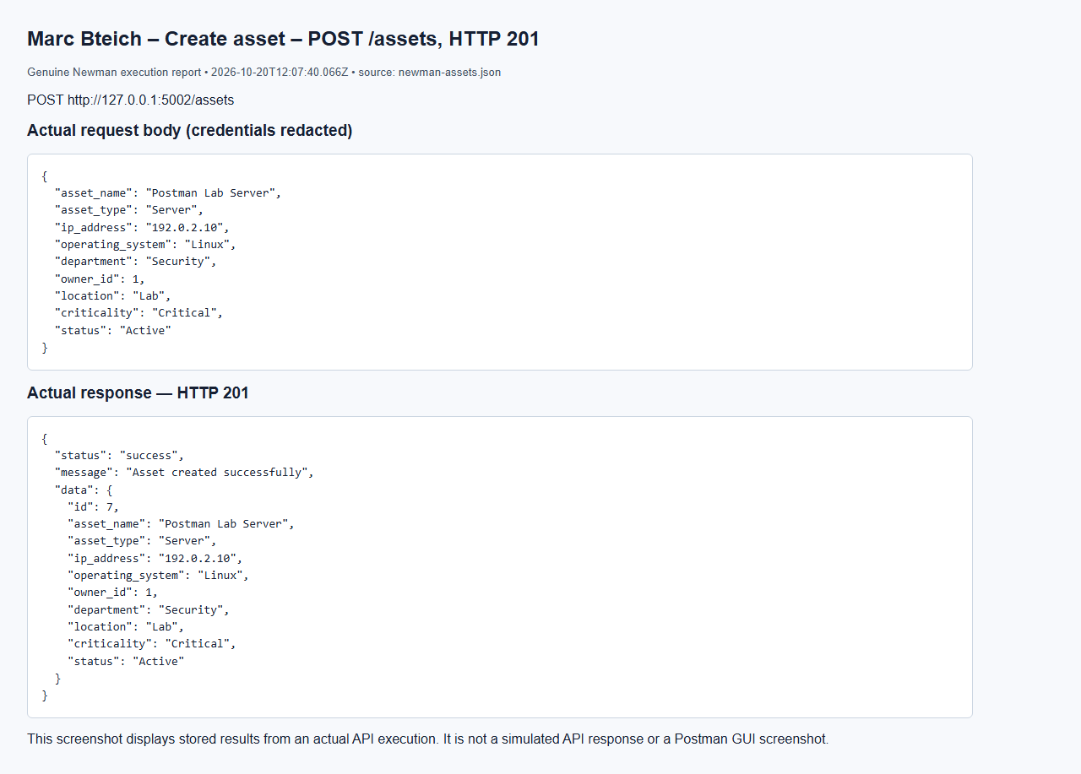

Marc Bteich – List assets (auditor) – GET /assets, HTTP 200
Browser capture of an actual Newman execution report; not a Postman GUI screenshot.
Full request/response capture: screenshots/marc/newman-assets-11.png

Marc Bteich – Update asset (admin) – PUT /assets/7, HTTP 200
Browser capture of an actual Newman execution report; not a Postman GUI screenshot.
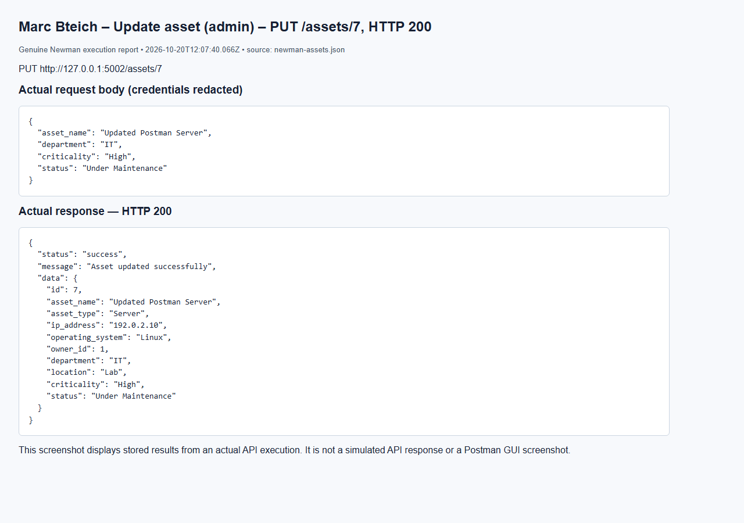

Marc Bteich – Search by name – GET /assets/search, HTTP 200
Browser capture of an actual Newman execution report; not a Postman GUI screenshot.
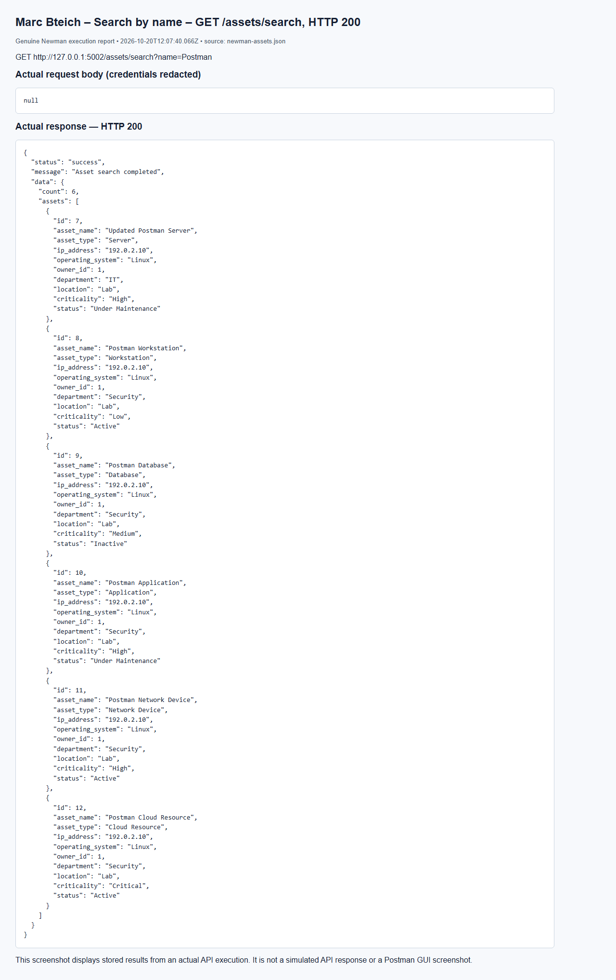

Marc Bteich – Inspect Assets audit records – GET /logs/search, HTTP 200
Browser capture of an actual Newman execution report; not a Postman GUI screenshot.
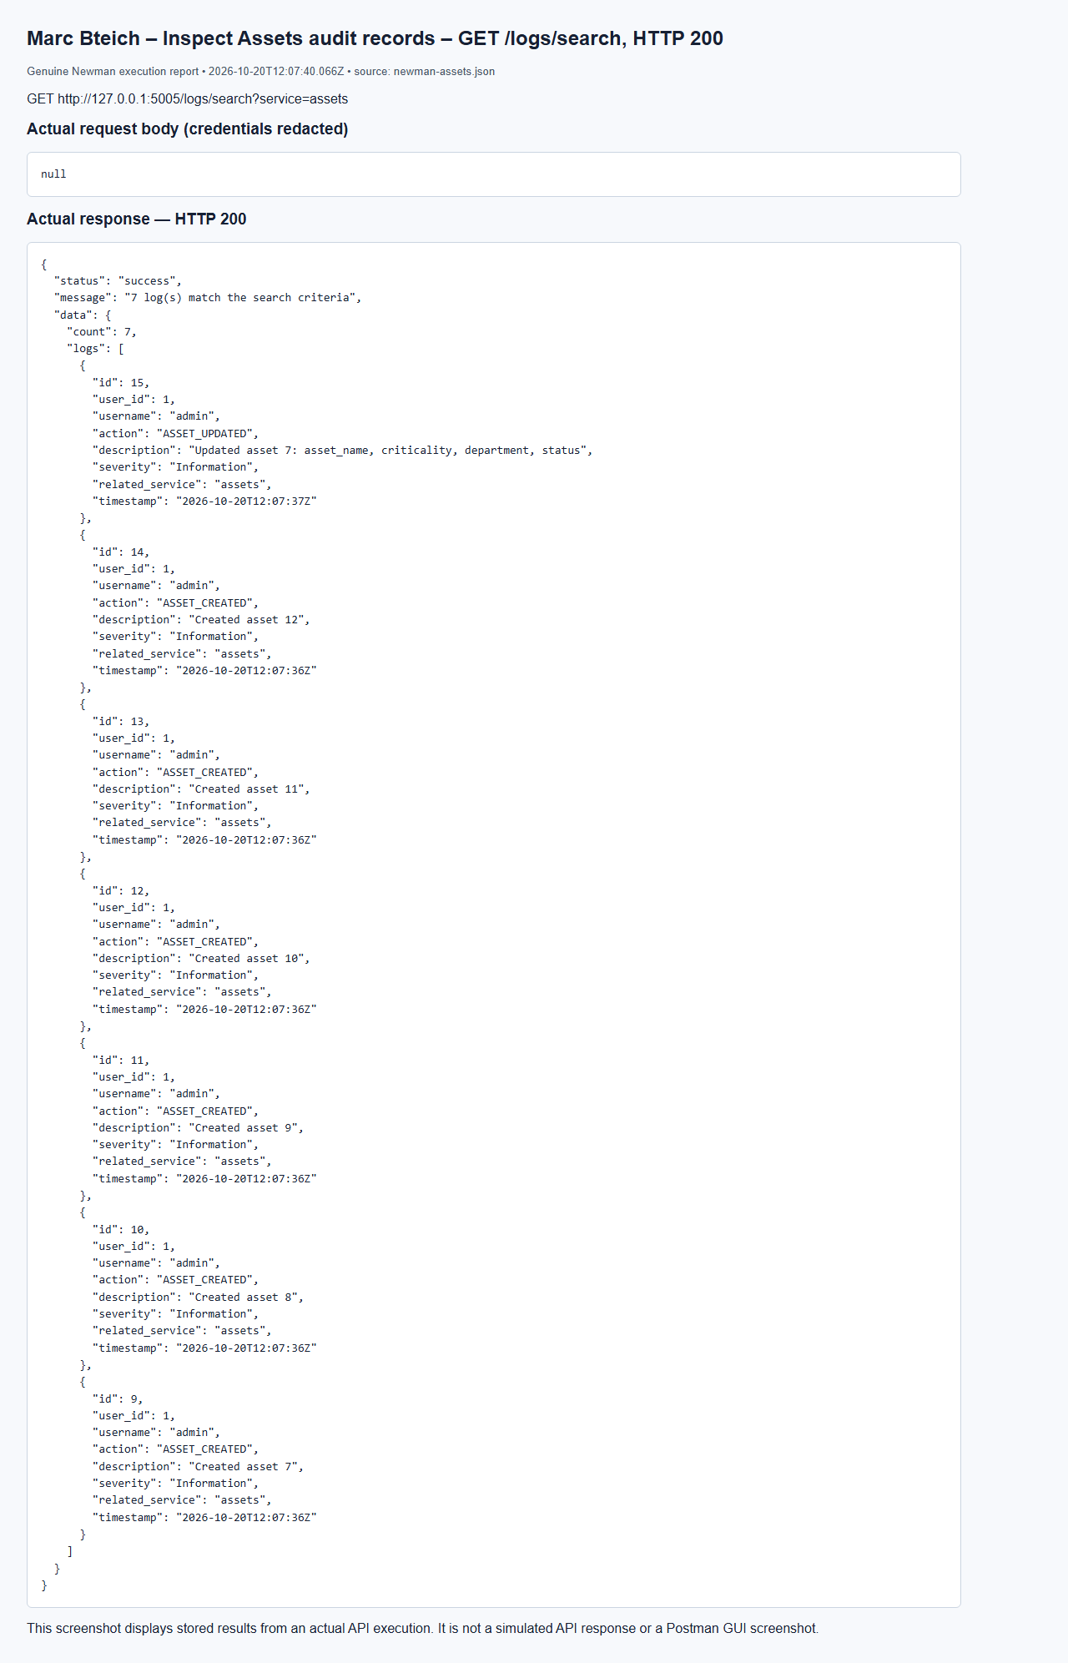

Marc Bteich – Missing token – GET /assets, HTTP 401
Browser capture of an actual Newman execution report; not a Postman GUI screenshot.
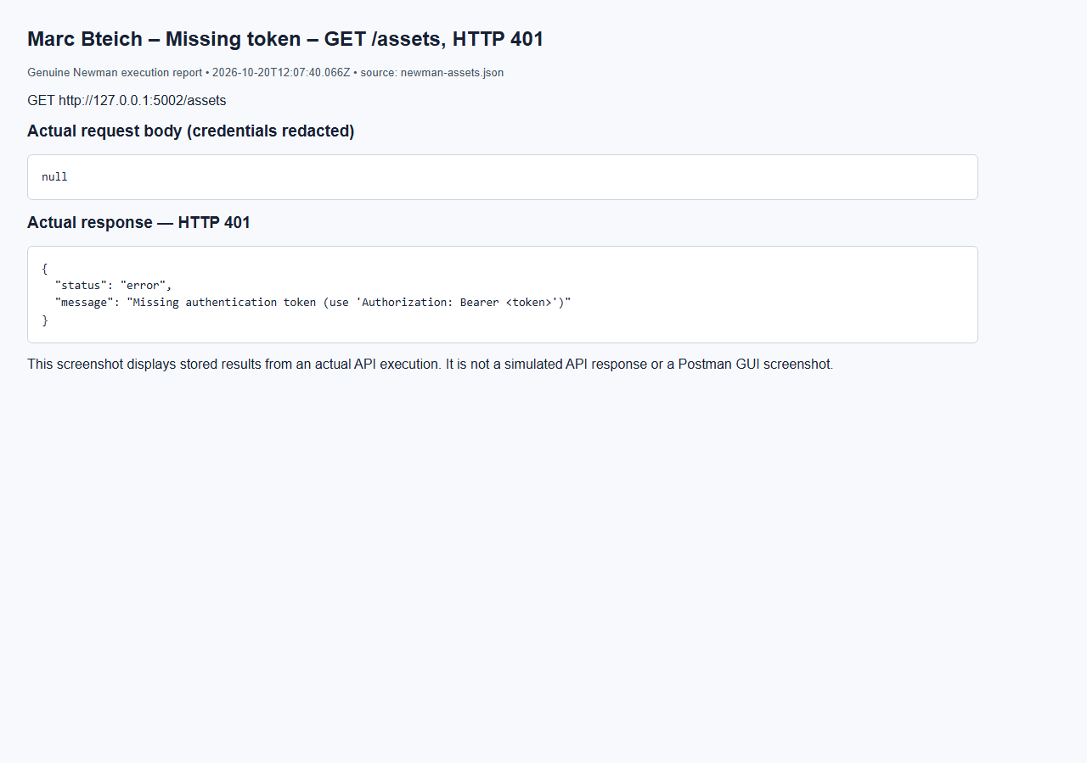

Marc Bteich – Employee forbidden – GET /assets/7, HTTP 403
Browser capture of an actual Newman execution report; not a Postman GUI screenshot.
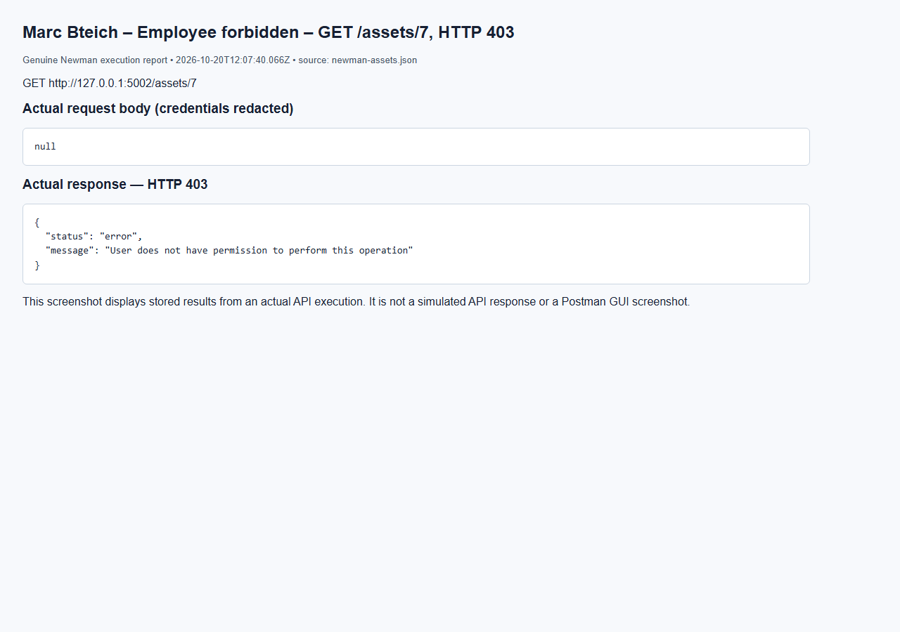

Marc Bteich – Auditor cannot update – PUT /assets/7, HTTP 403
Browser capture of an actual Newman execution report; not a Postman GUI screenshot.
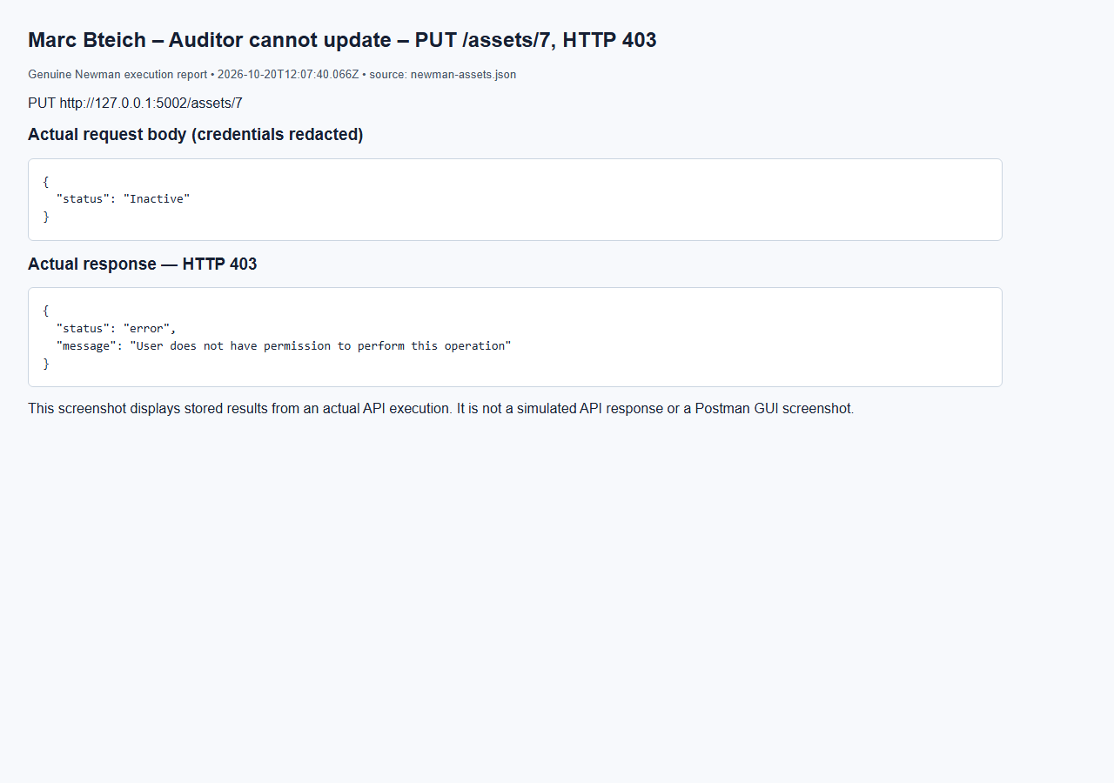

Marc Bteich – Analyst cannot delete – DELETE /assets/7, HTTP 403
Browser capture of an actual Newman execution report; not a Postman GUI screenshot.
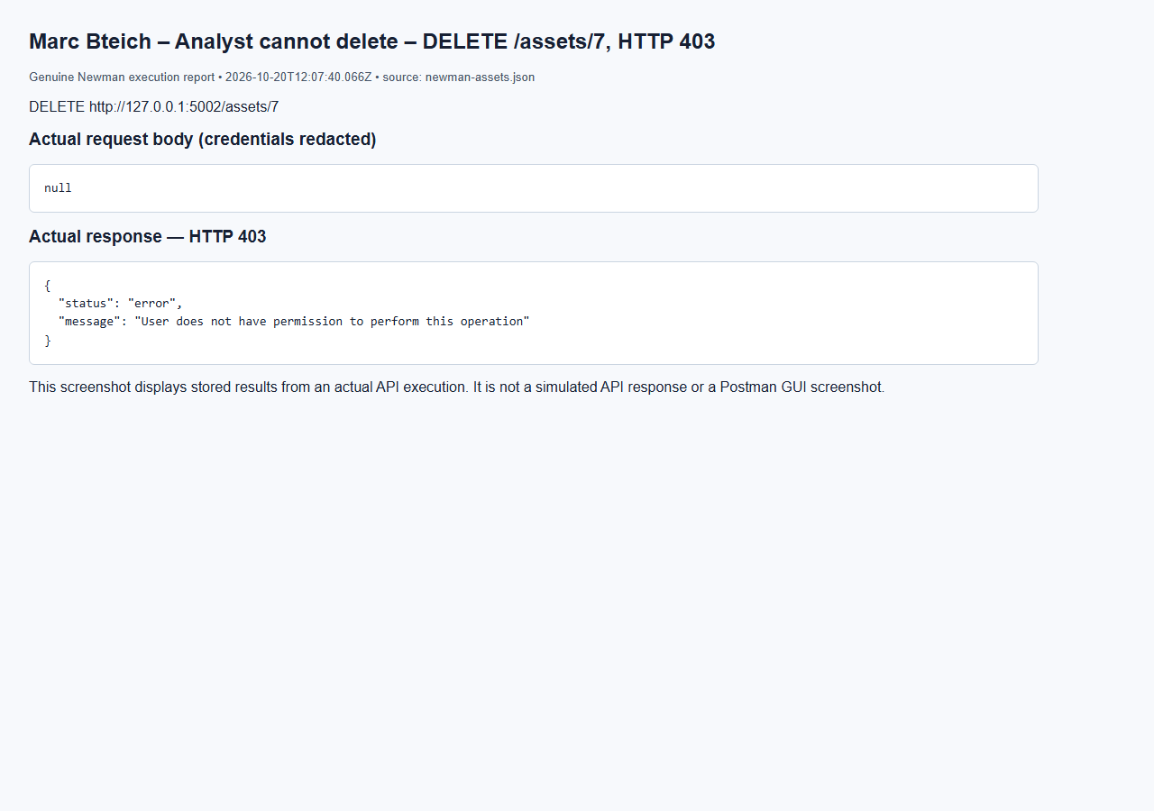

Marc Bteich – Missing asset – GET /assets/2147483647, HTTP 404
Browser capture of an actual Newman execution report; not a Postman GUI screenshot.
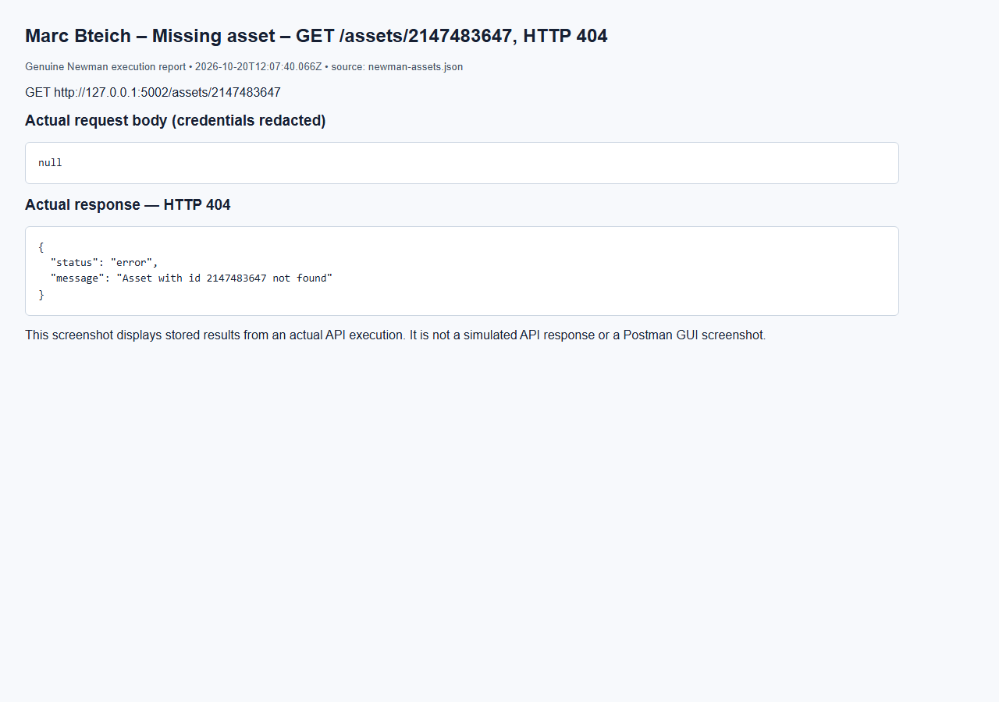

Marc Bteich – Missing asset update – PUT /assets/2147483647, HTTP 404
Browser capture of an actual Newman execution report; not a Postman GUI screenshot.
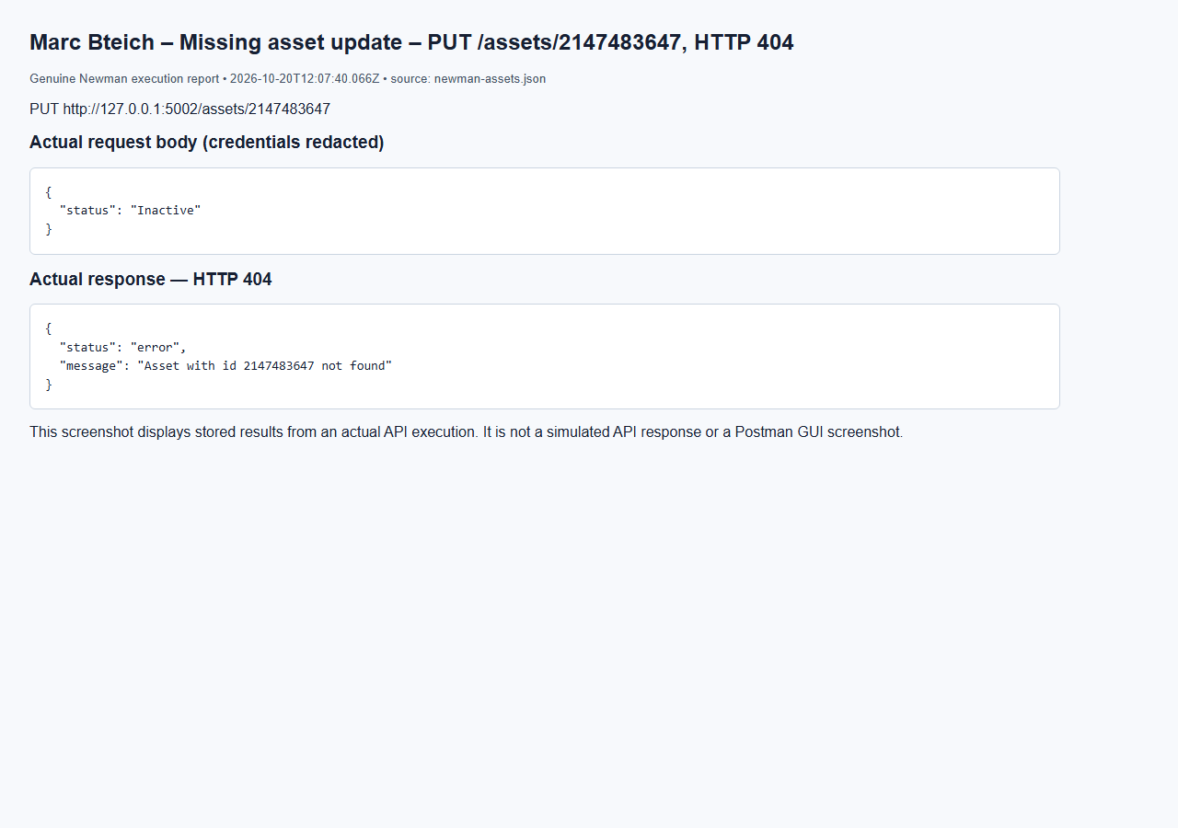

Marc Bteich – Missing asset deletion – DELETE /assets/2147483647, HTTP 404
Browser capture of an actual Newman execution report; not a Postman GUI screenshot.
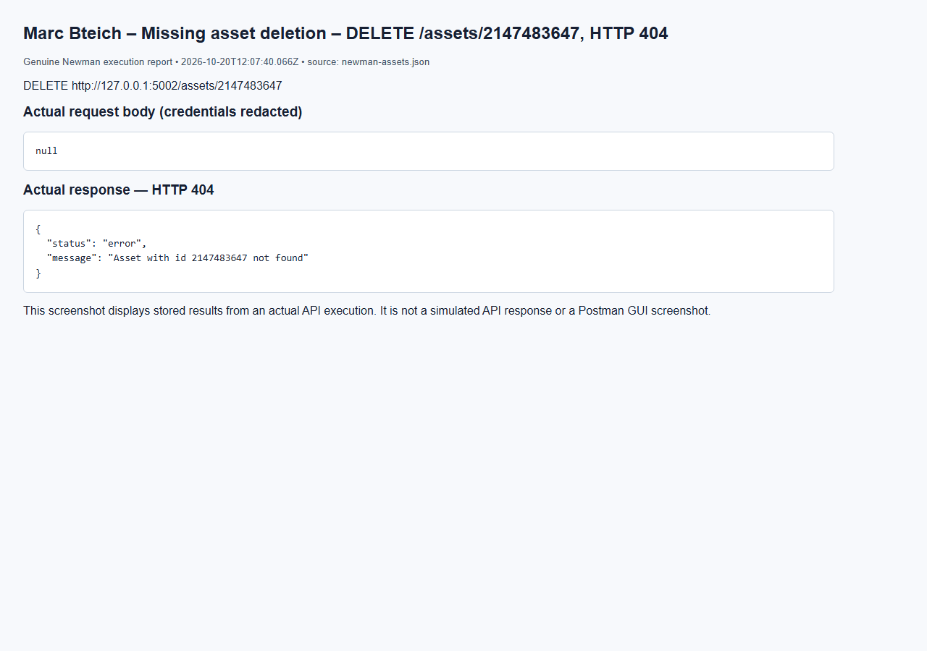

Marc Bteich – Empty body – POST /assets, HTTP 400
Browser capture of an actual Newman execution report; not a Postman GUI screenshot.
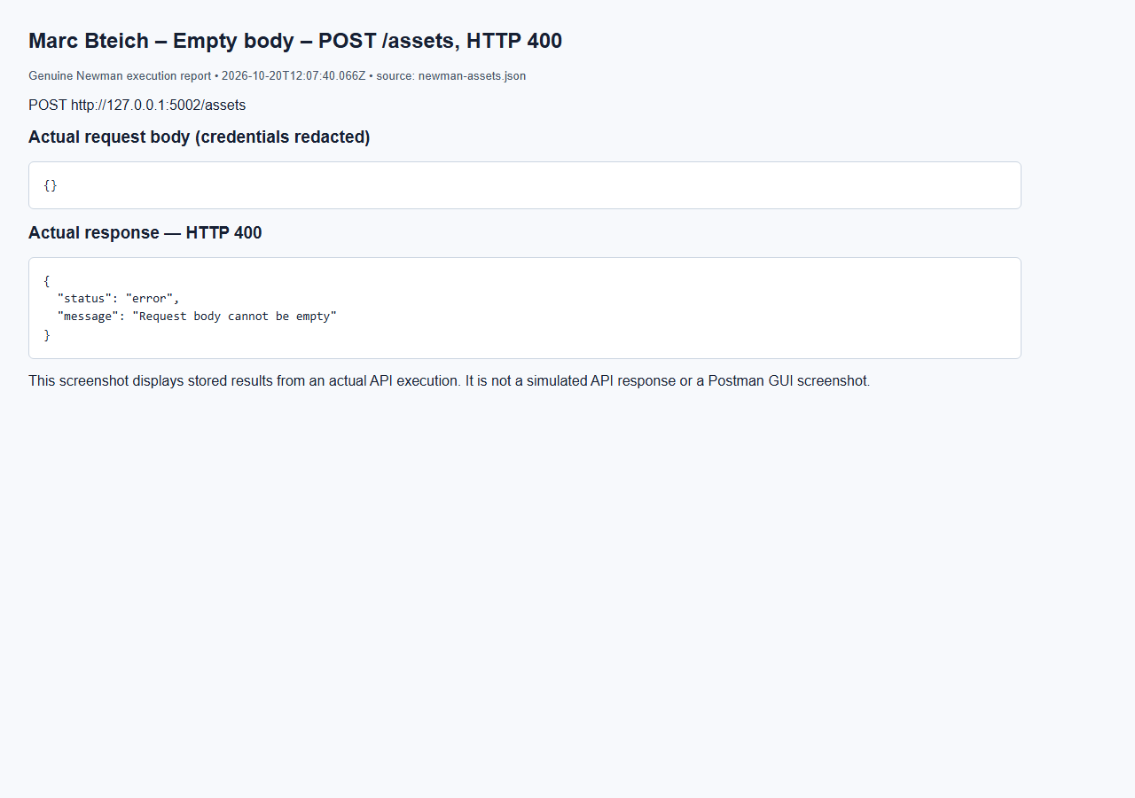

Marc Bteich – Reject empty search – GET /assets/search, HTTP 400
Browser capture of an actual Newman execution report; not a Postman GUI screenshot.
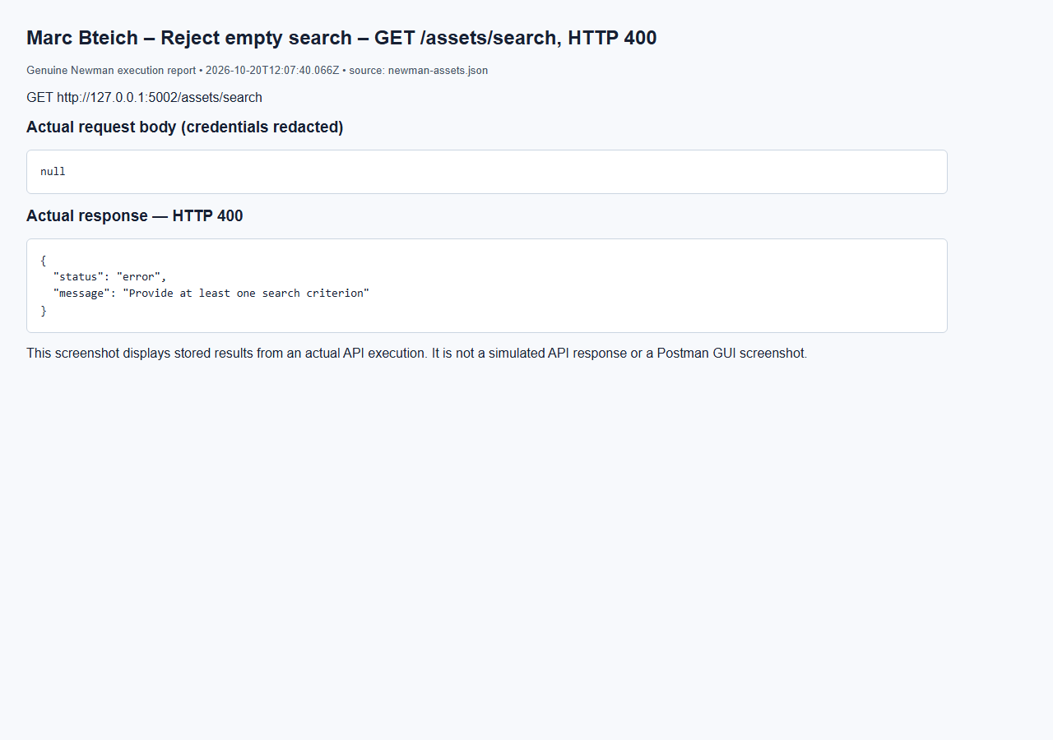

Marc Bteich – Delete asset (admin) – DELETE /assets/7, HTTP 200
Browser capture of an actual Newman execution report; not a Postman GUI screenshot.
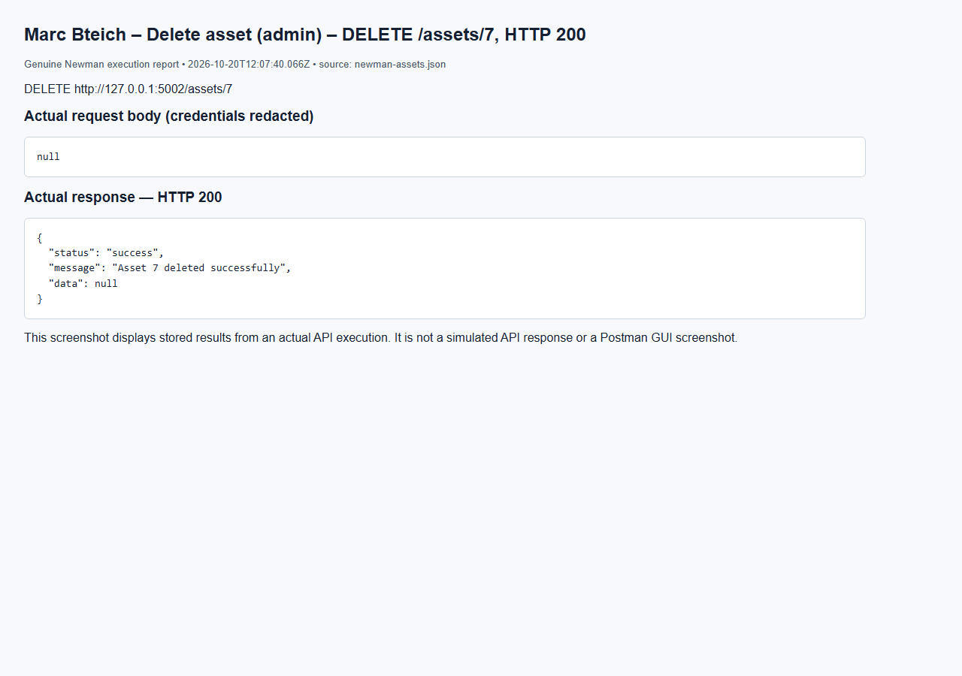

Marc Bteich – Link vulnerability – POST /vulnerabilities, HTTP 201
Browser capture of an actual Newman execution report; not a Postman GUI screenshot.
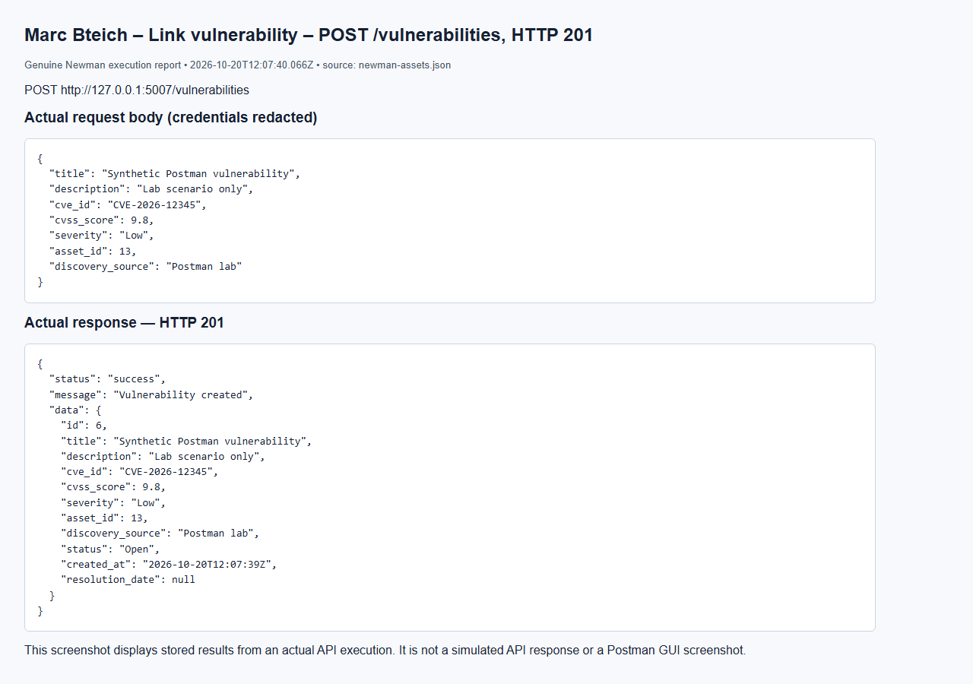

Marc Bteich – Linked vulnerability prevents deletion – DELETE /assets/13, HTTP 409
Browser capture of an actual Newman execution report; not a Postman GUI screenshot.
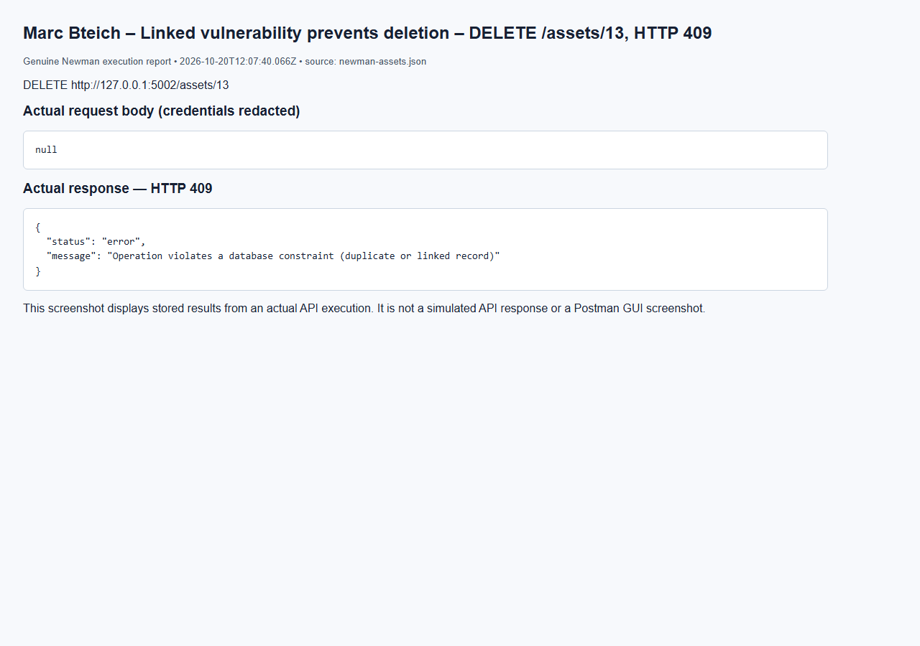

Marc Bteich – Remove fixture vulnerability – DELETE /vulnerabilities/6, HTTP 200
Browser capture of an actual Newman execution report; not a Postman GUI screenshot.
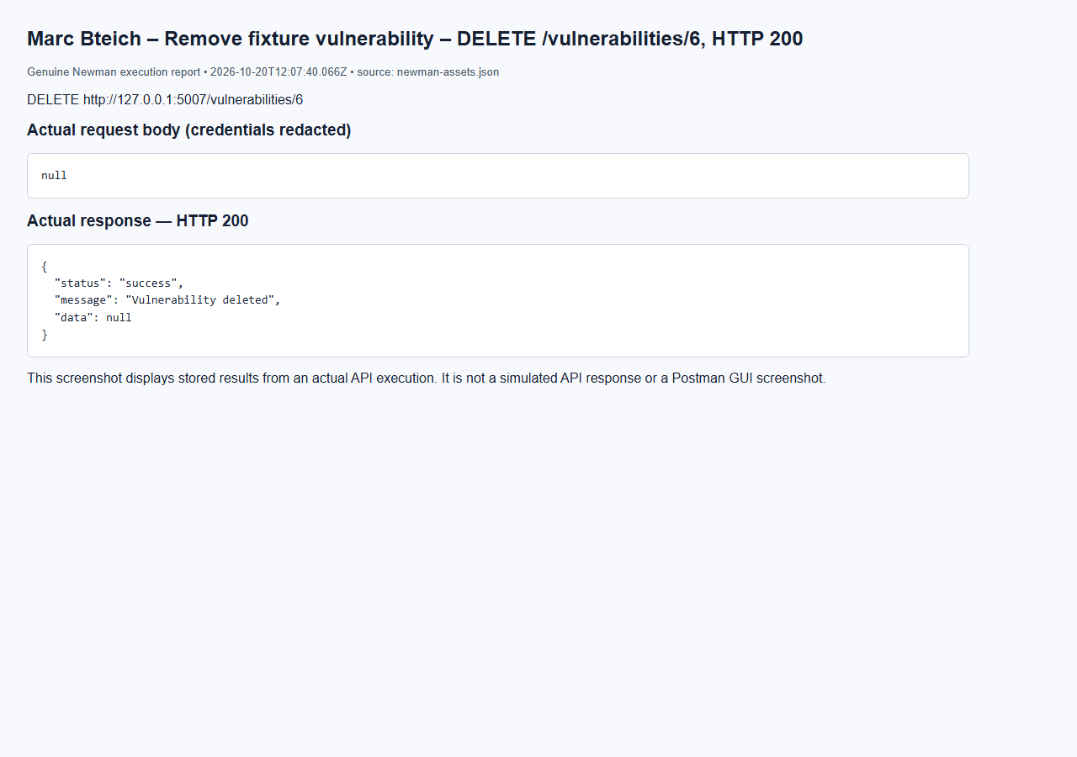

Marc Bteich – Create playbook – POST /playbooks, HTTP 201
Browser capture of an actual Newman execution report; not a Postman GUI screenshot.
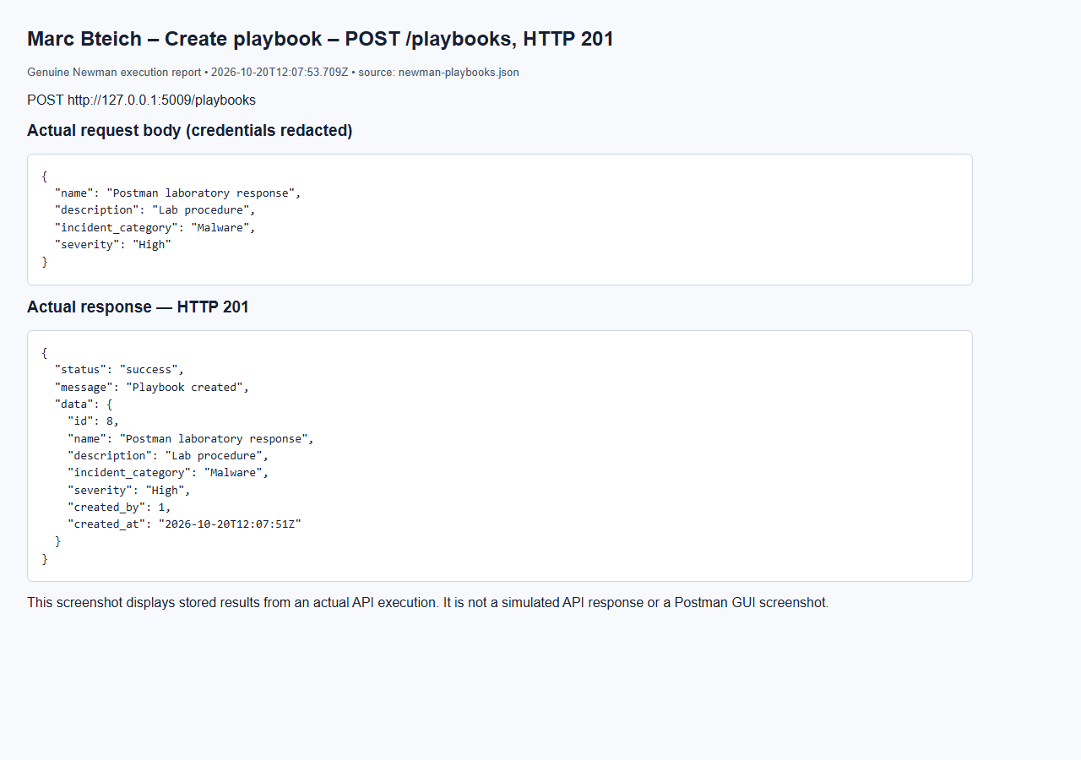

Marc Bteich – List playbooks – GET /playbooks, HTTP 200
Browser capture of an actual Newman execution report; not a Postman GUI screenshot.
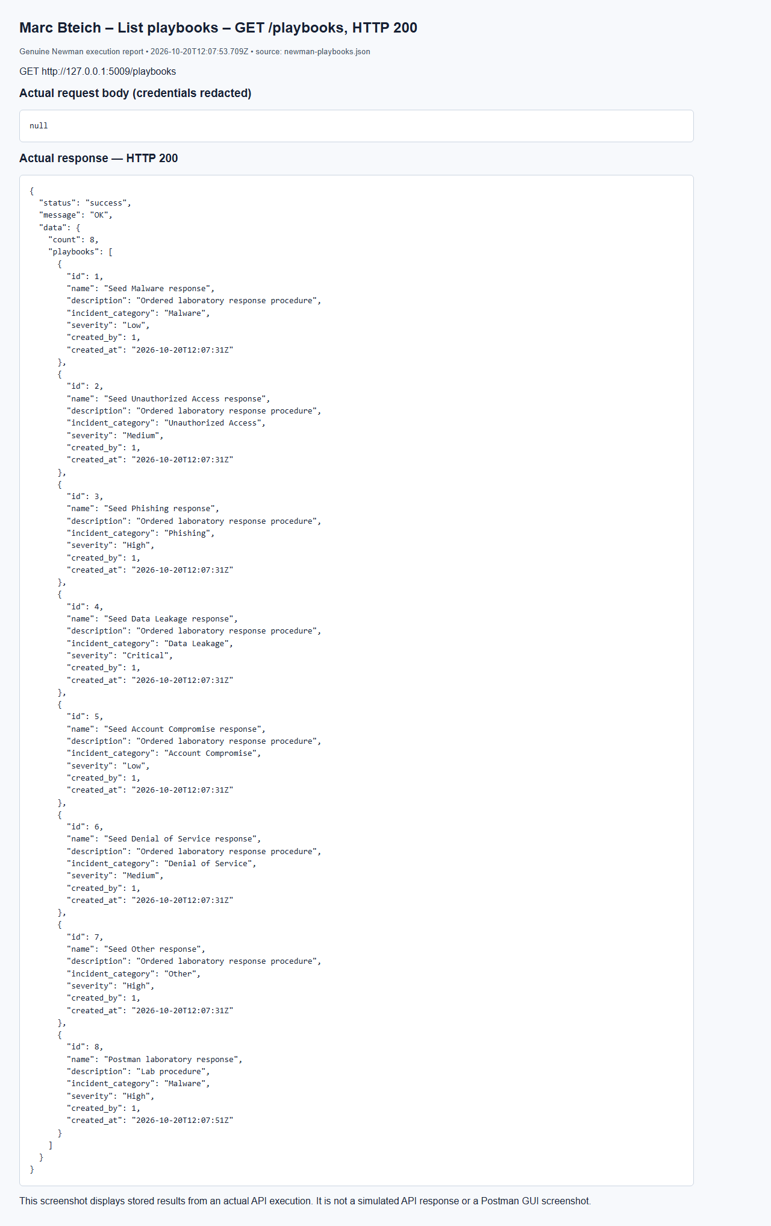

Marc Bteich – Duplicate step rejected – POST /playbooks/8/actions, HTTP 409
Browser capture of an actual Newman execution report; not a Postman GUI screenshot.
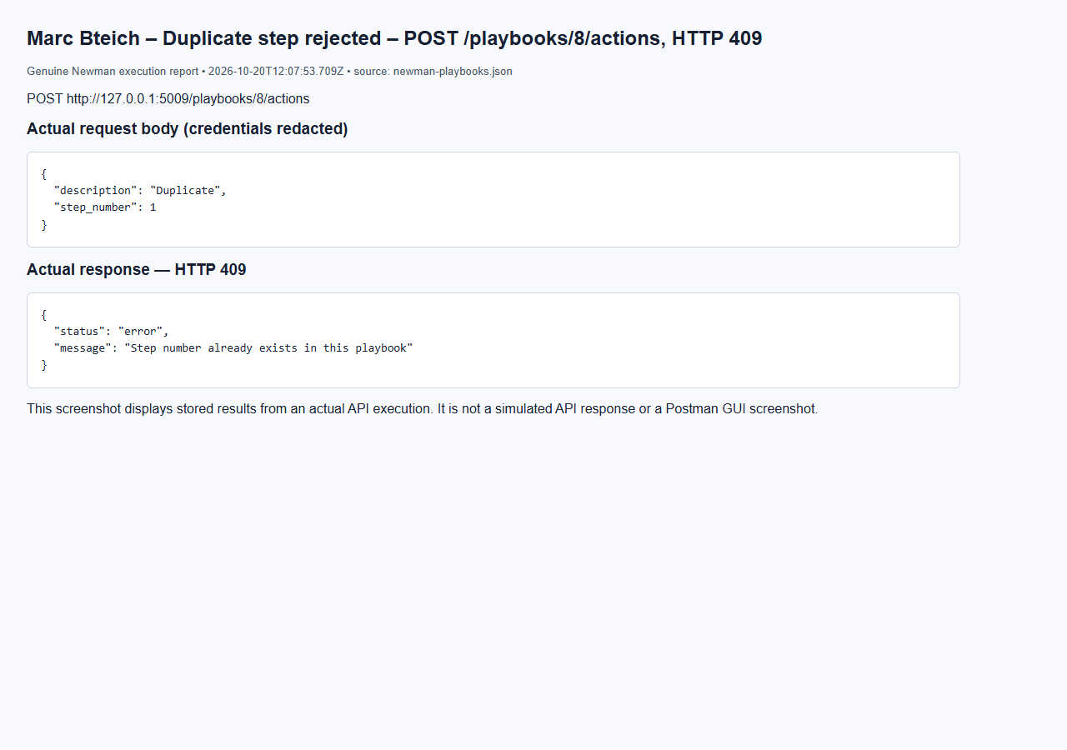

Marc Bteich – Cannot skip Pending – PUT /actions/23/status, HTTP 400
Browser capture of an actual Newman execution report; not a Postman GUI screenshot.
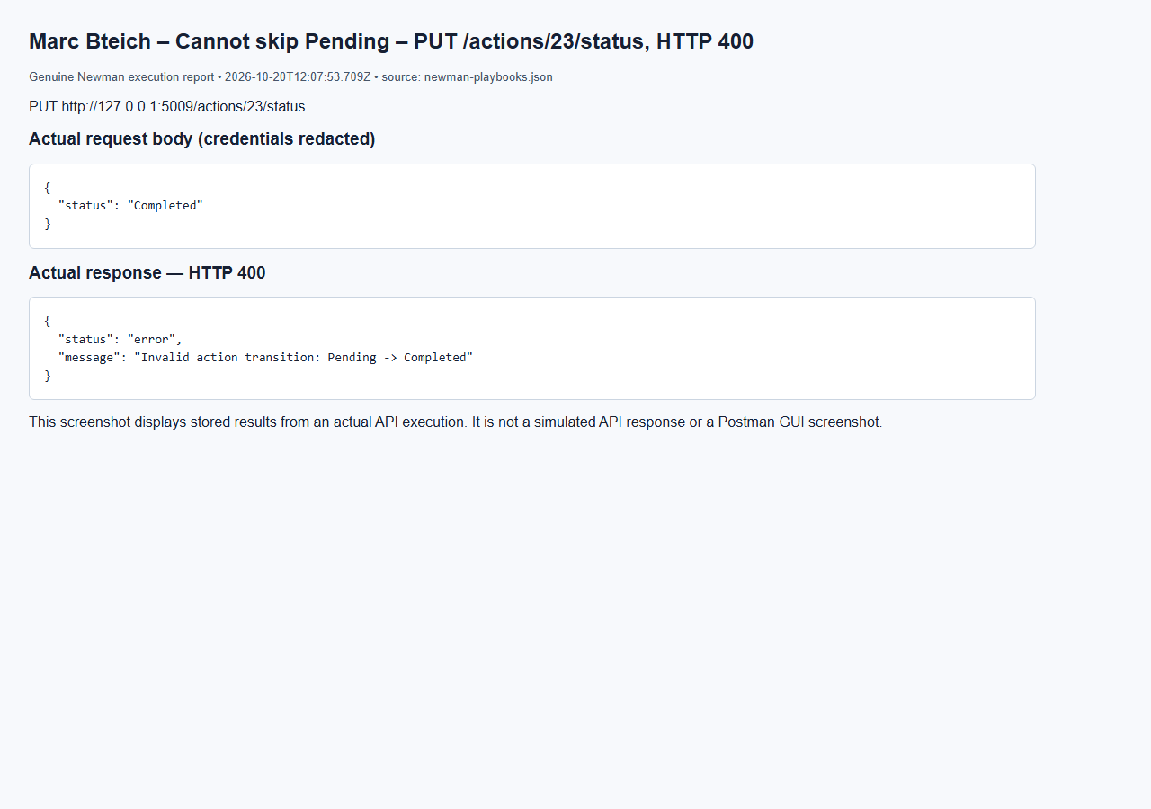

Marc Bteich – Start assigned action – PUT /actions/23/status, HTTP 200
Browser capture of an actual Newman execution report; not a Postman GUI screenshot.
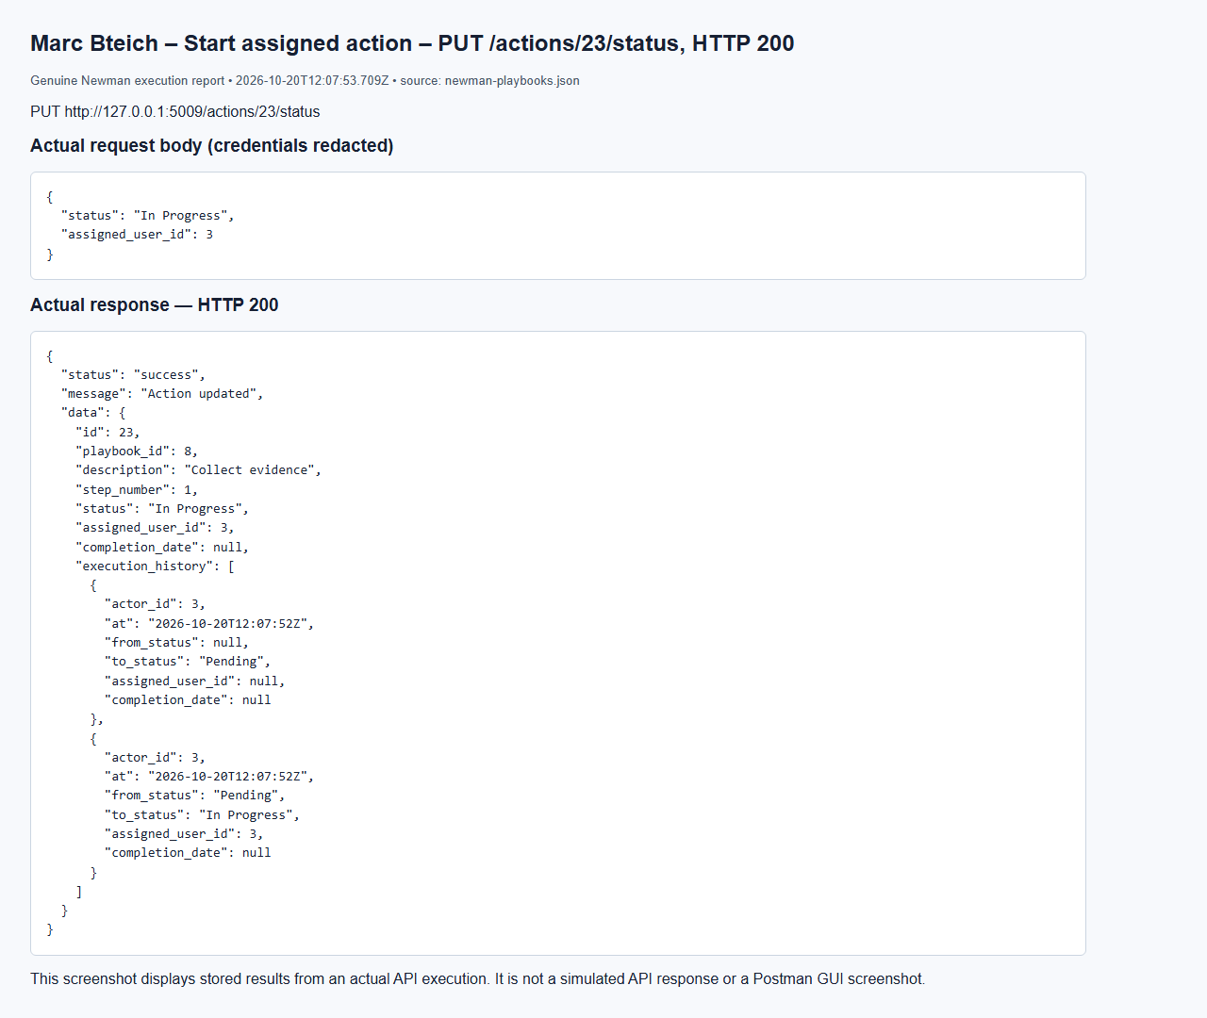

Marc Bteich – No token – GET /playbooks, HTTP 401
Browser capture of an actual Newman execution report; not a Postman GUI screenshot.
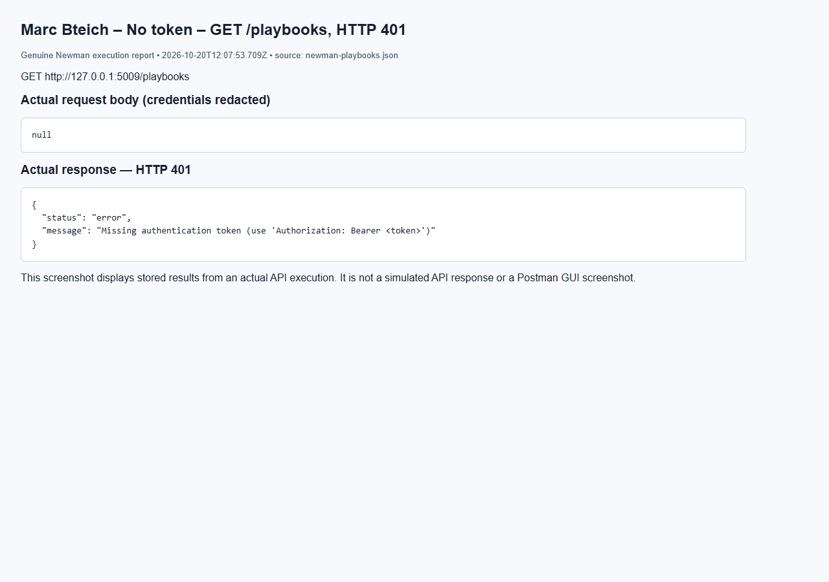

Marc Bteich – User denied – GET /playbooks, HTTP 403
Browser capture of an actual Newman execution report; not a Postman GUI screenshot.
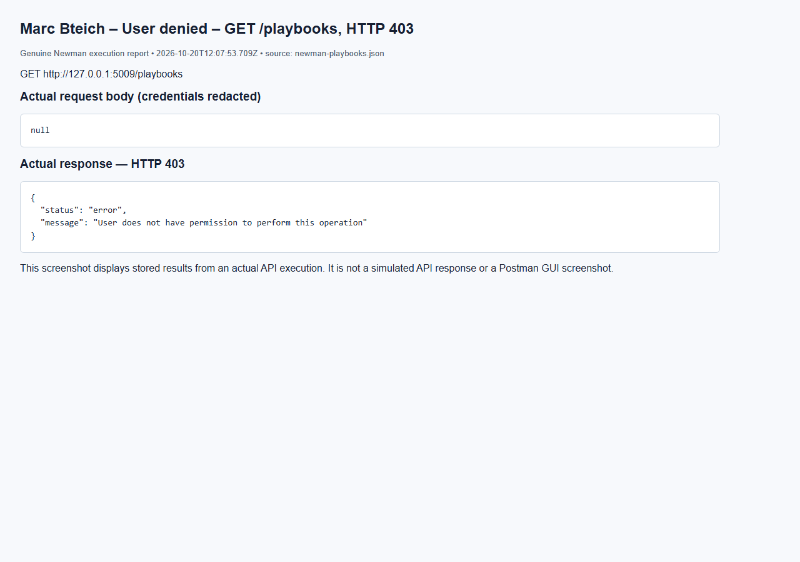

Marc Bteich – Analyst create denied – POST /playbooks, HTTP 403
Browser capture of an actual Newman execution report; not a Postman GUI screenshot.
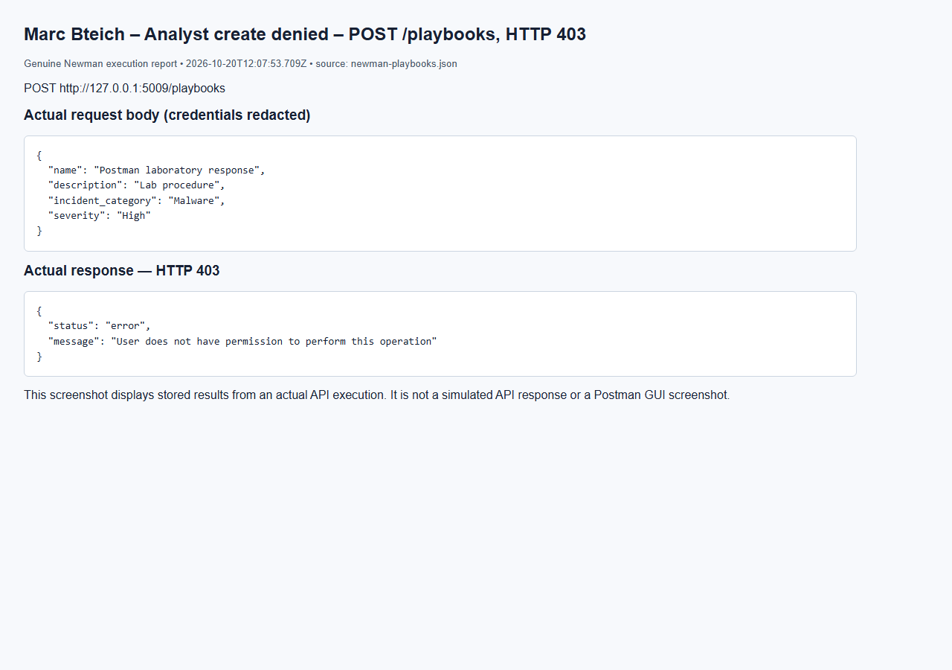

Marc Bteich – Missing playbook – GET /playbooks/2147483647, HTTP 404
Browser capture of an actual Newman execution report; not a Postman GUI screenshot.
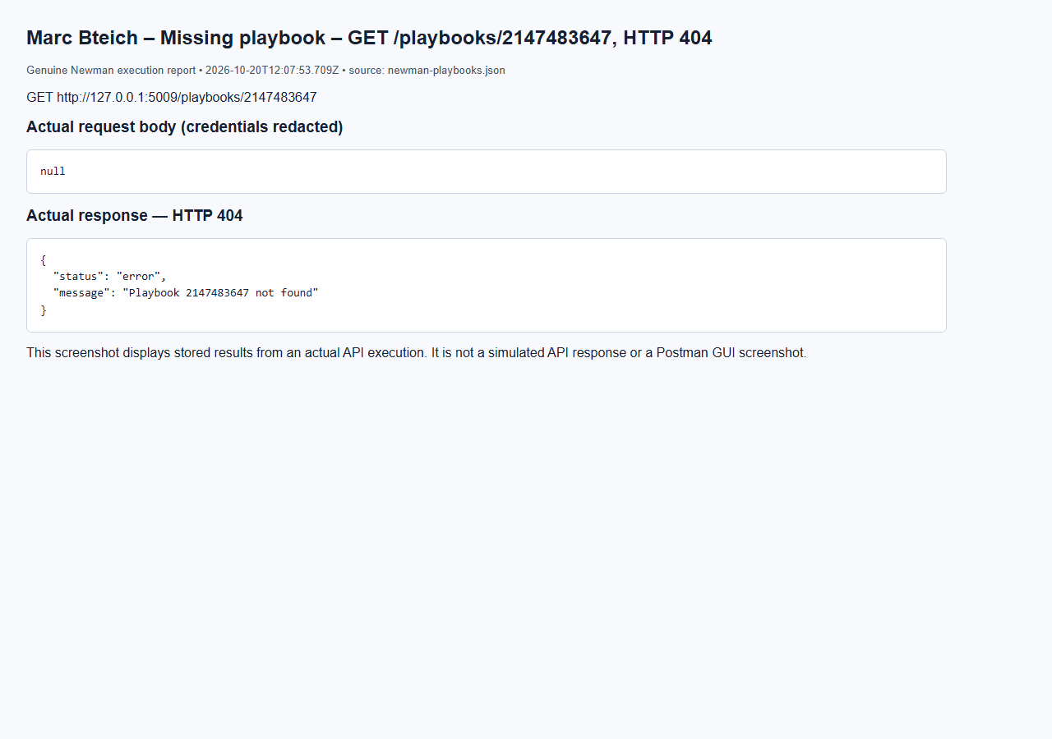

Marc Bteich – Missing action – PUT /actions/2147483647/status, HTTP 404
Browser capture of an actual Newman execution report; not a Postman GUI screenshot.
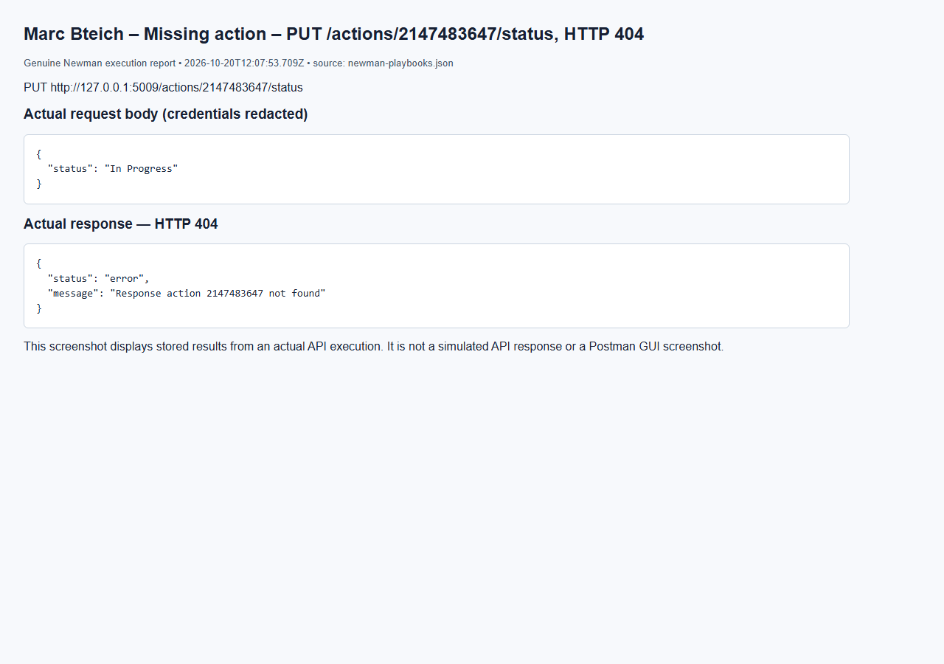

Marc Bteich – Invalid step – POST /playbooks/8/actions, HTTP 400
Browser capture of an actual Newman execution report; not a Postman GUI screenshot.
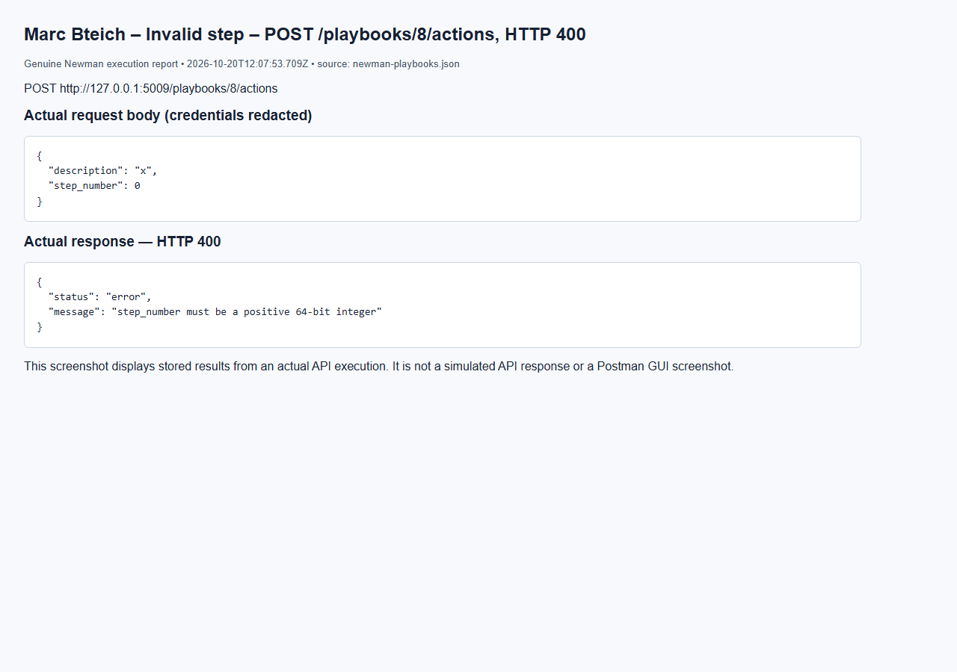

Marc Bteich – Delete playbook – DELETE /playbooks/8, HTTP 200
Browser capture of an actual Newman execution report; not a Postman GUI screenshot.
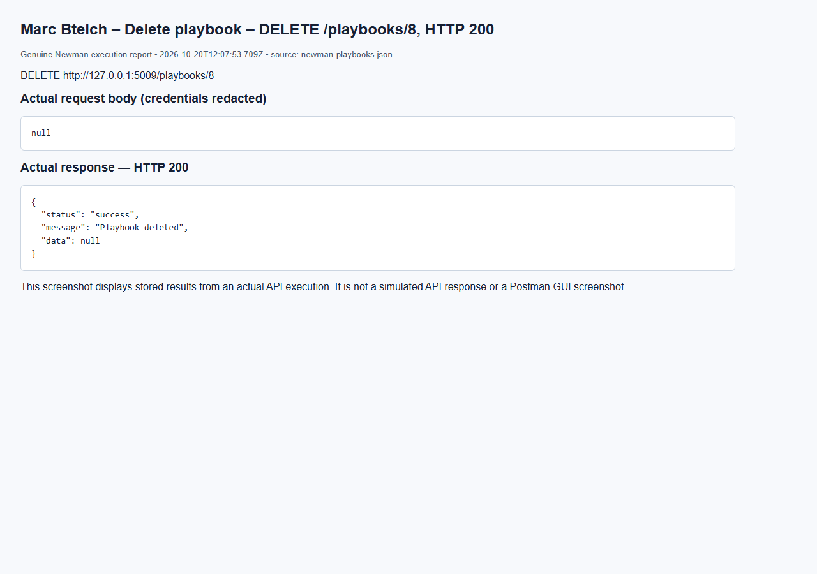

Marc Bteich – Generate assets report (admin) – GET /reports/assets, HTTP 200
Browser capture of an actual Newman execution report; not a Postman GUI screenshot.
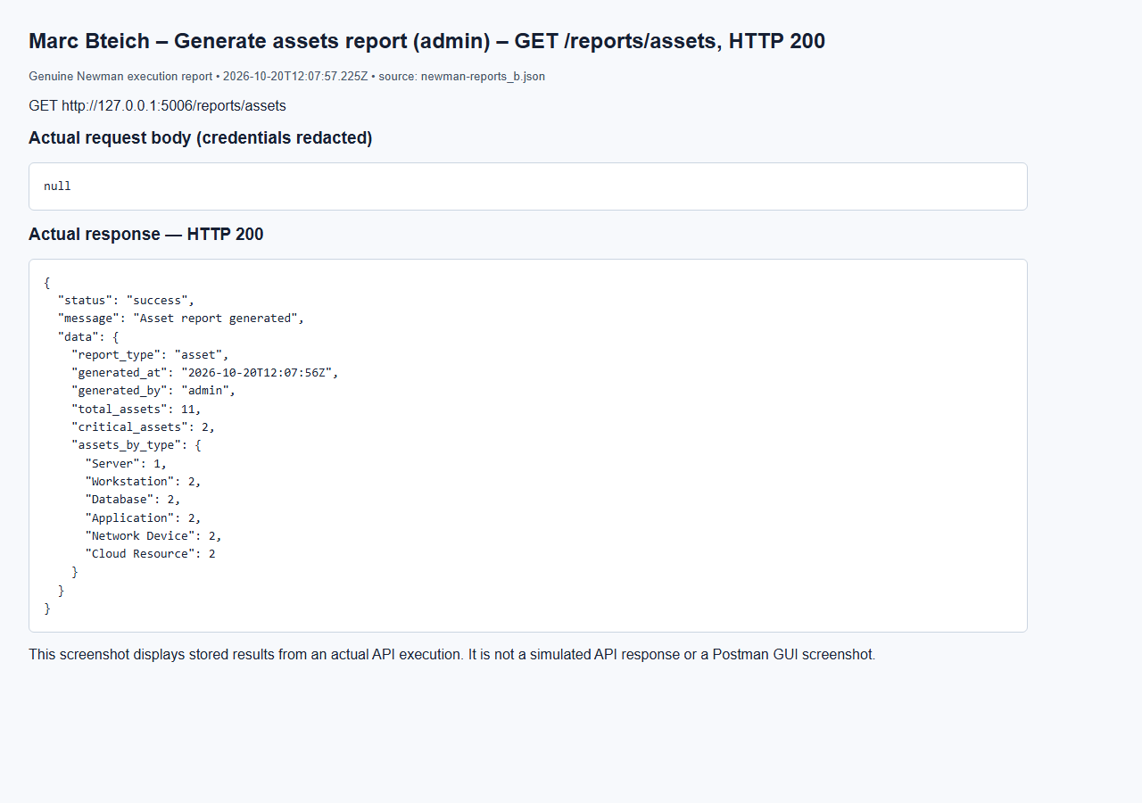

Marc Bteich – No token assets – GET /reports/assets, HTTP 401
Browser capture of an actual Newman execution report; not a Postman GUI screenshot.
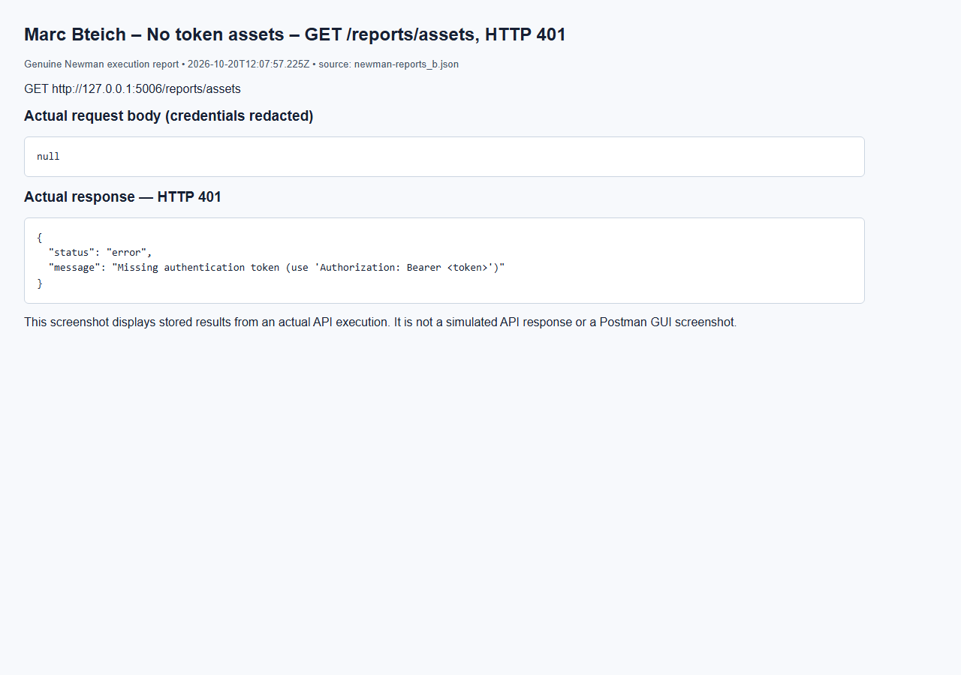

Marc Bteich – Analyst denied assets – GET /reports/assets, HTTP 403
Browser capture of an actual Newman execution report; not a Postman GUI screenshot.
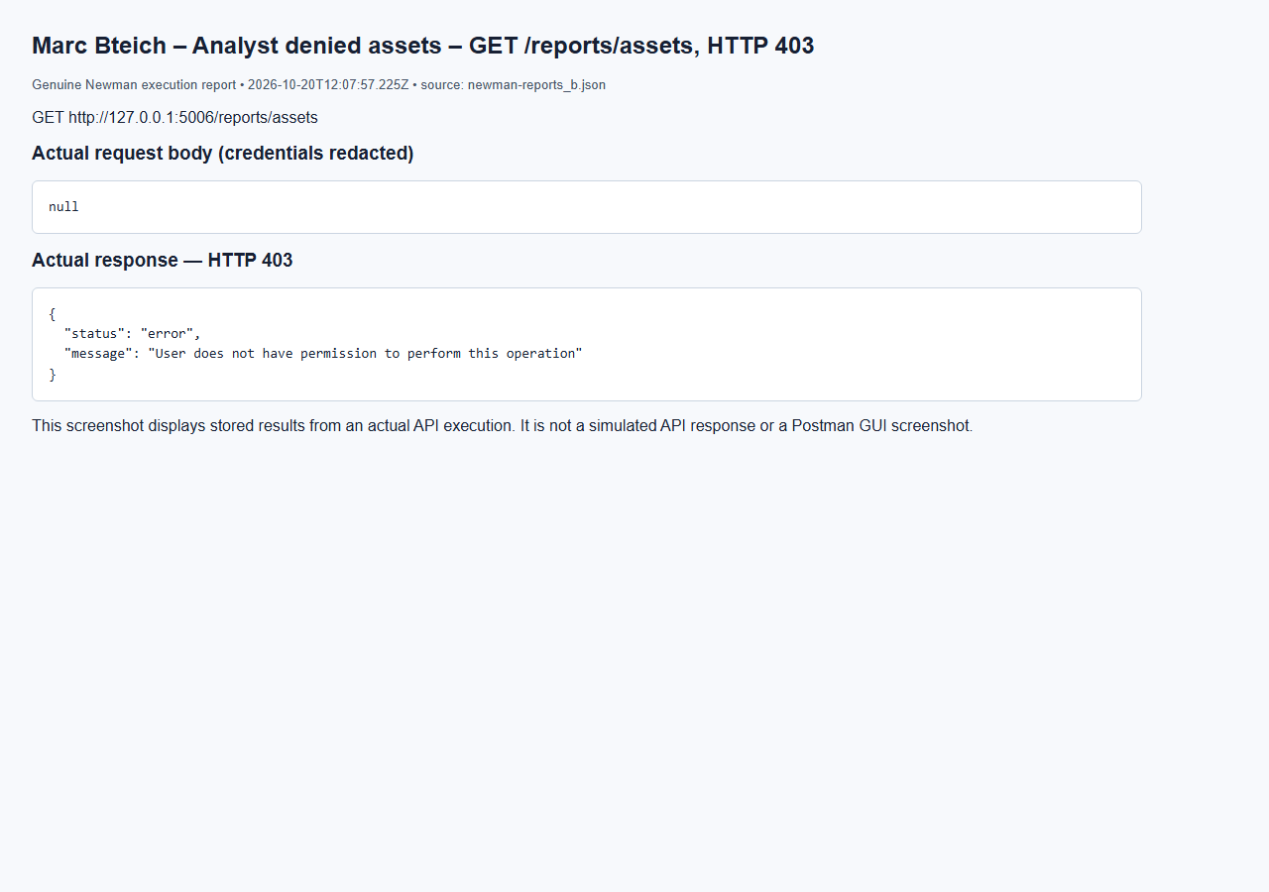

Marc Bteich – Generate threats report (admin) – GET /reports/threats, HTTP 200
Browser capture of an actual Newman execution report; not a Postman GUI screenshot.
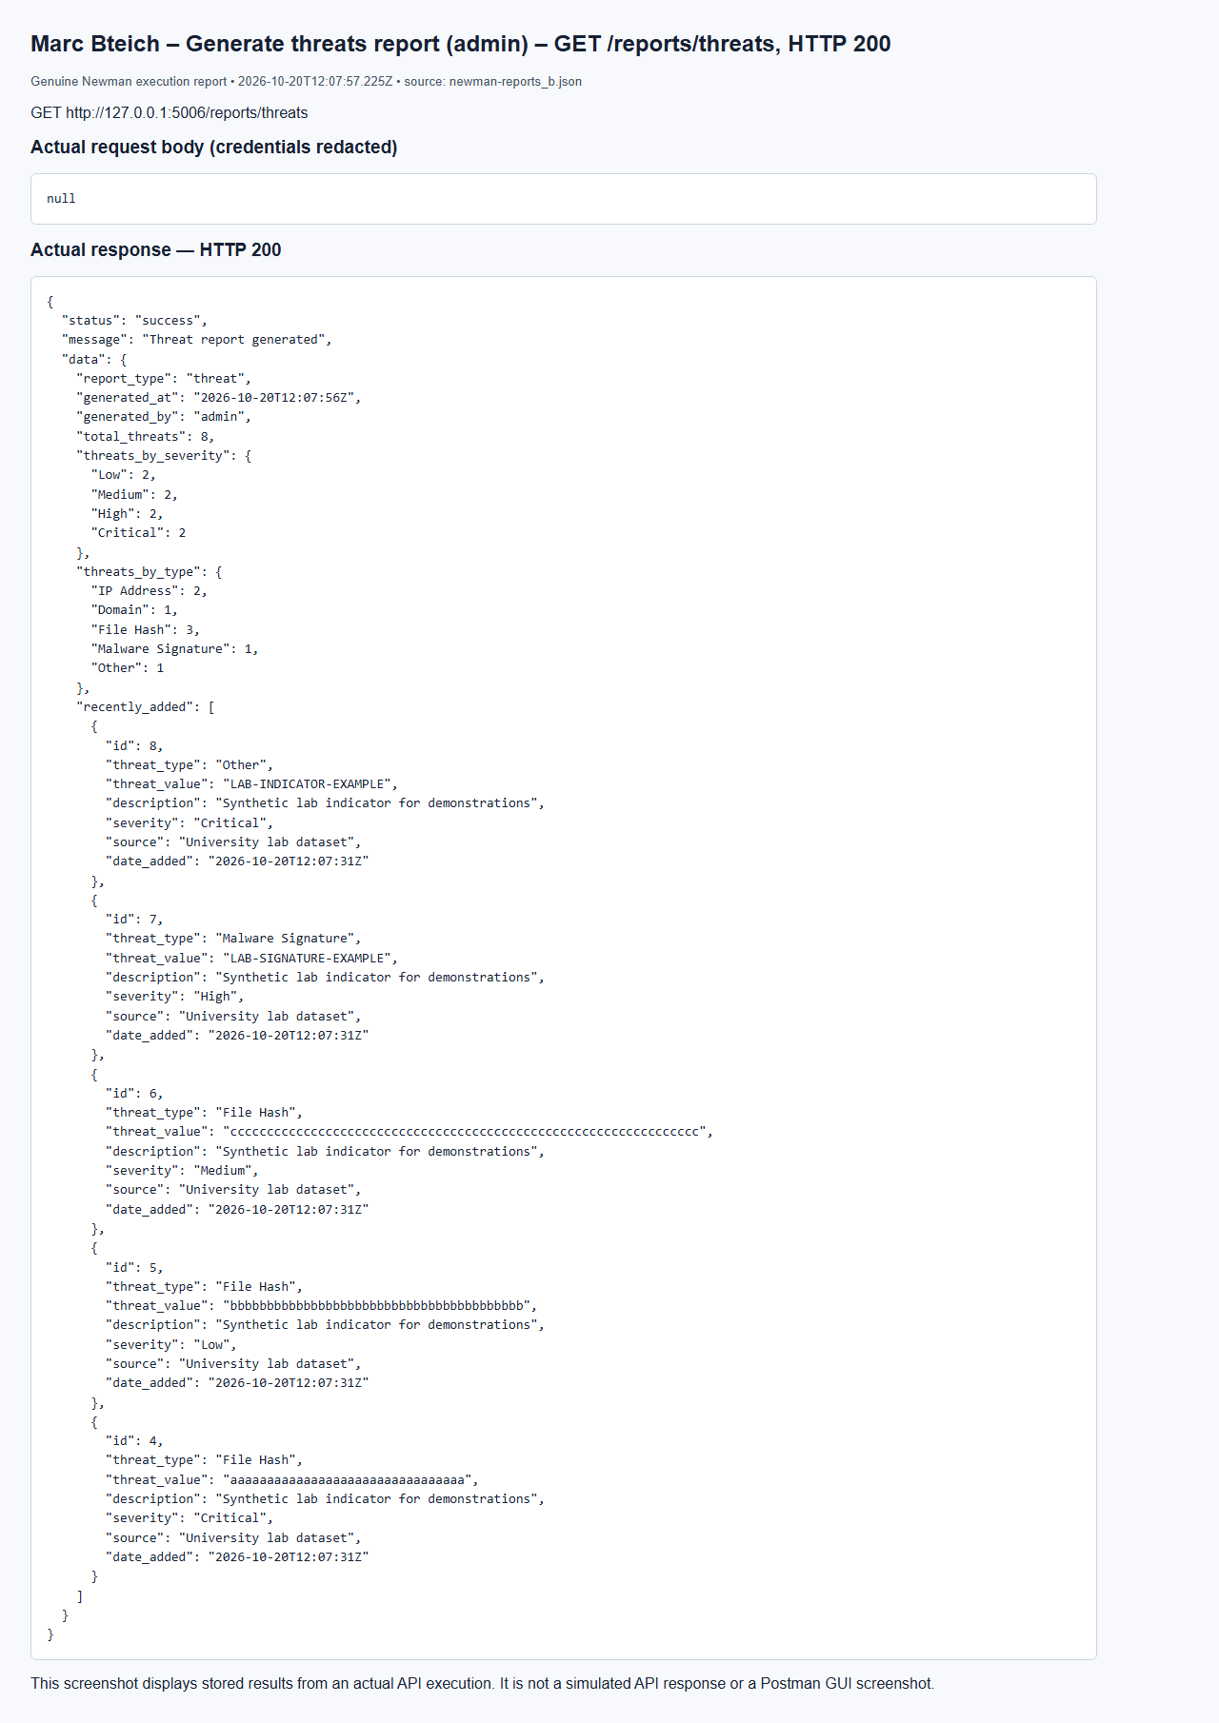

Marc Bteich – No token threats – GET /reports/threats, HTTP 401
Browser capture of an actual Newman execution report; not a Postman GUI screenshot.
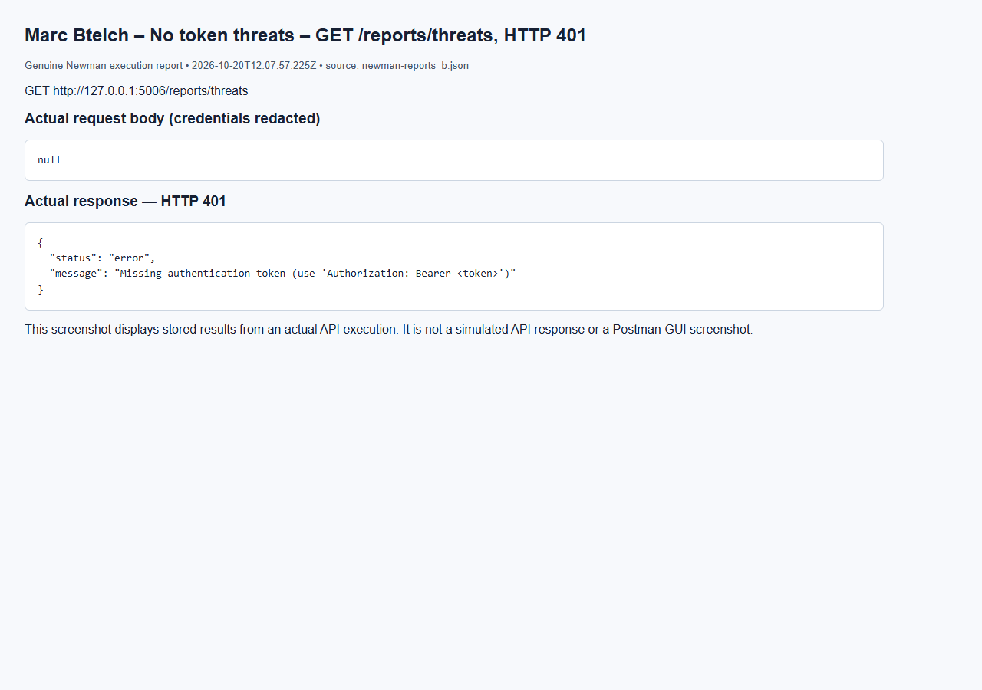

Marc Bteich – Analyst denied threats – GET /reports/threats, HTTP 403
Browser capture of an actual Newman execution report; not a Postman GUI screenshot.
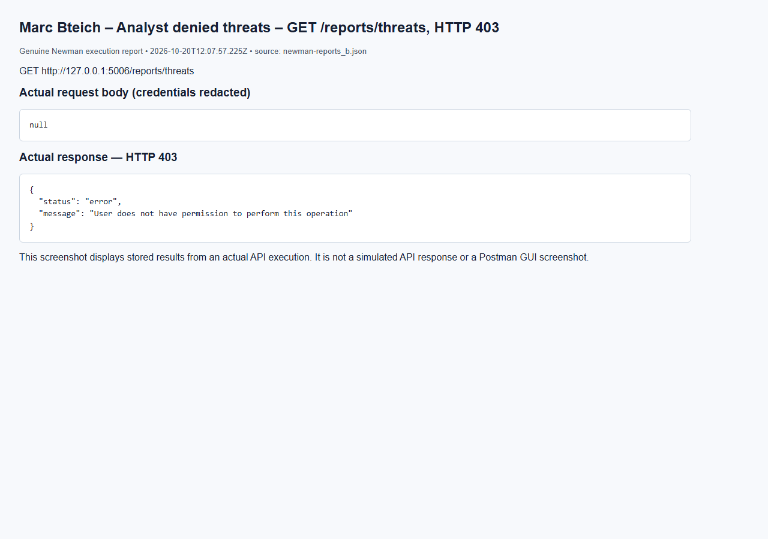

Marc Bteich – Generate vulnerabilities report (admin) – GET /reports/vulnerabilities, HTTP 200
Browser capture of an actual Newman execution report; not a Postman GUI screenshot.
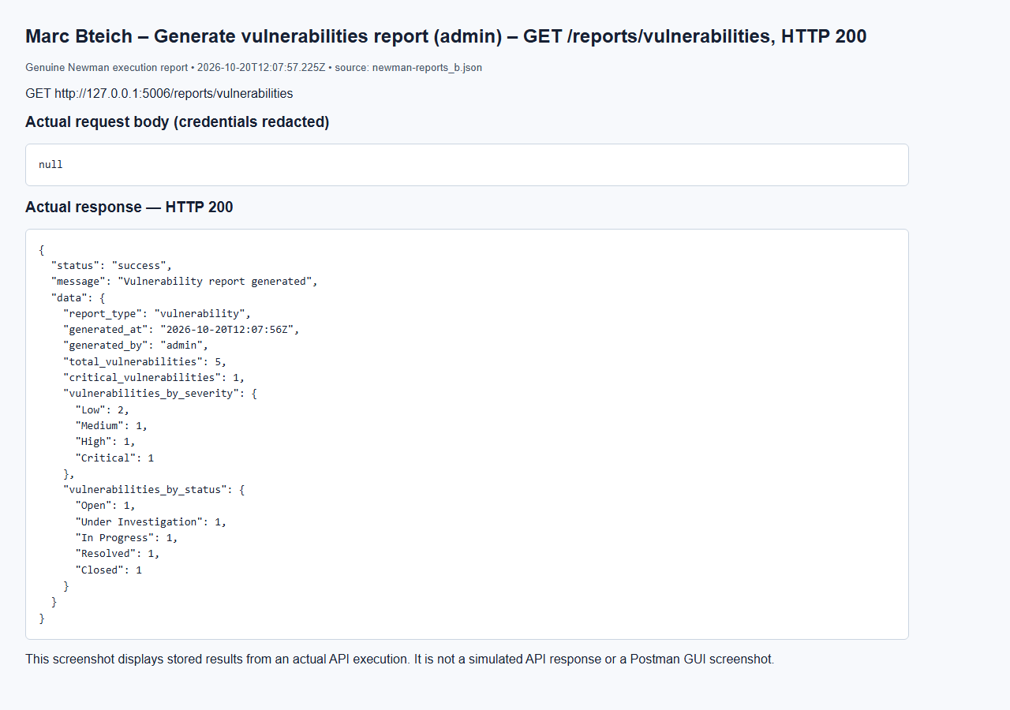

Marc Bteich – No token vulnerabilities – GET /reports/vulnerabilities, HTTP 401
Browser capture of an actual Newman execution report; not a Postman GUI screenshot.
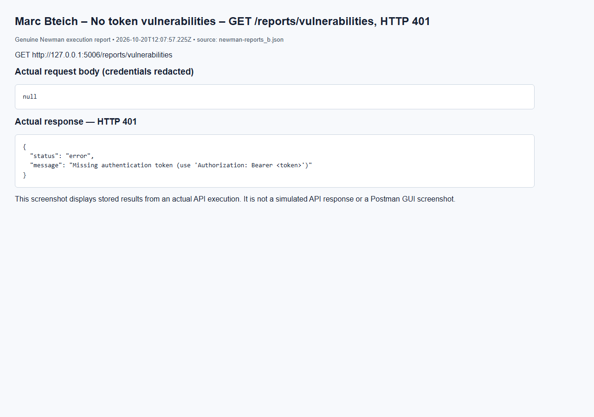

Marc Bteich – Analyst denied vulnerabilities – GET /reports/vulnerabilities, HTTP 403
Browser capture of an actual Newman execution report; not a Postman GUI screenshot.
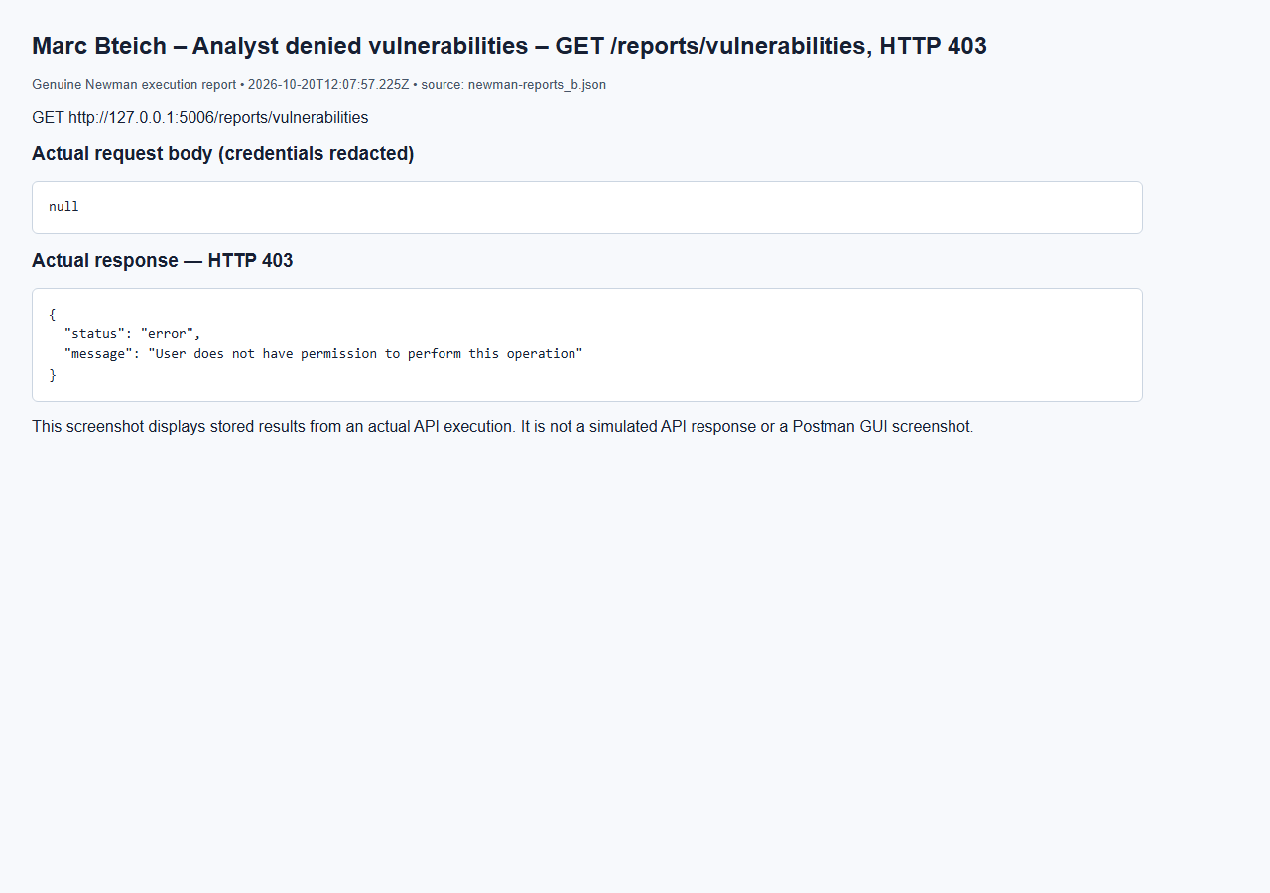

Marc Bteich – Create Critical threat – POST /threats, HTTP 201
Browser capture of an actual Newman execution report; not a Postman GUI screenshot.
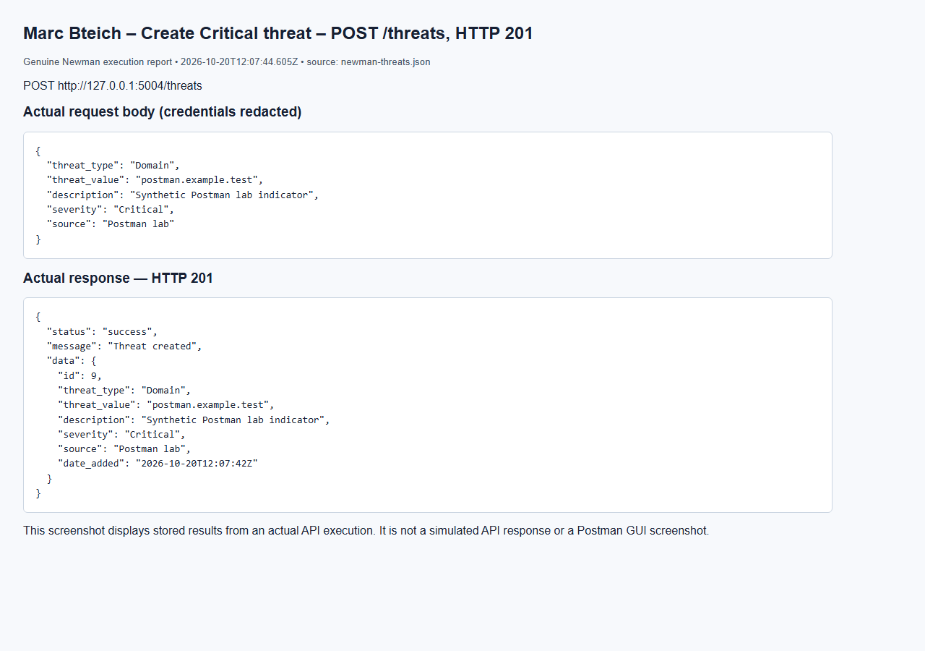

Marc Bteich – Duplicate normalized threat – POST /threats, HTTP 409
Browser capture of an actual Newman execution report; not a Postman GUI screenshot.
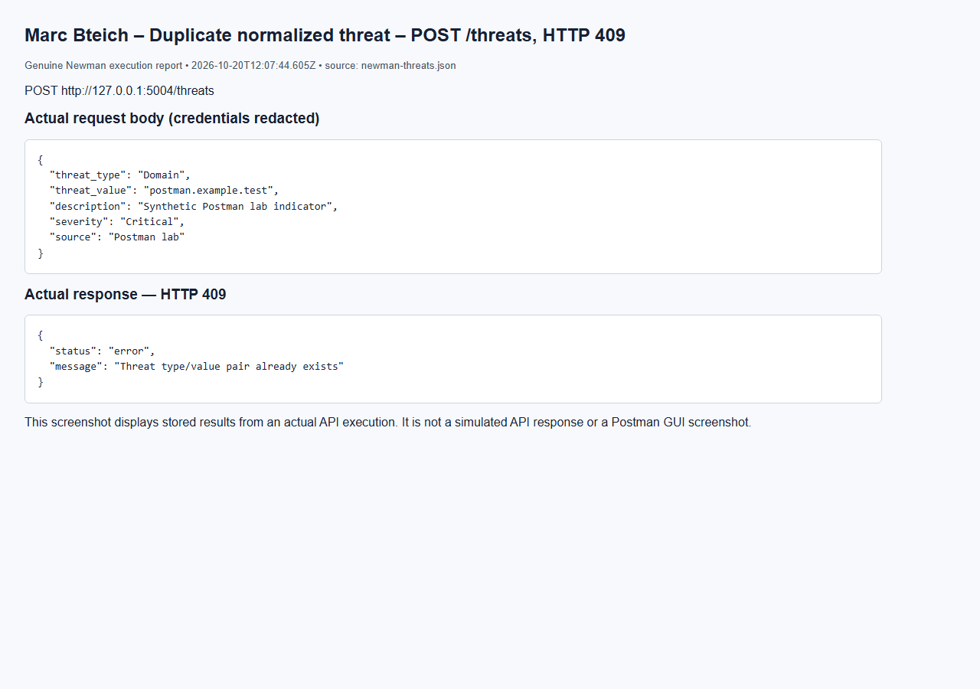

Marc Bteich – List threats – GET /threats, HTTP 200
Browser capture of an actual Newman execution report; not a Postman GUI screenshot.
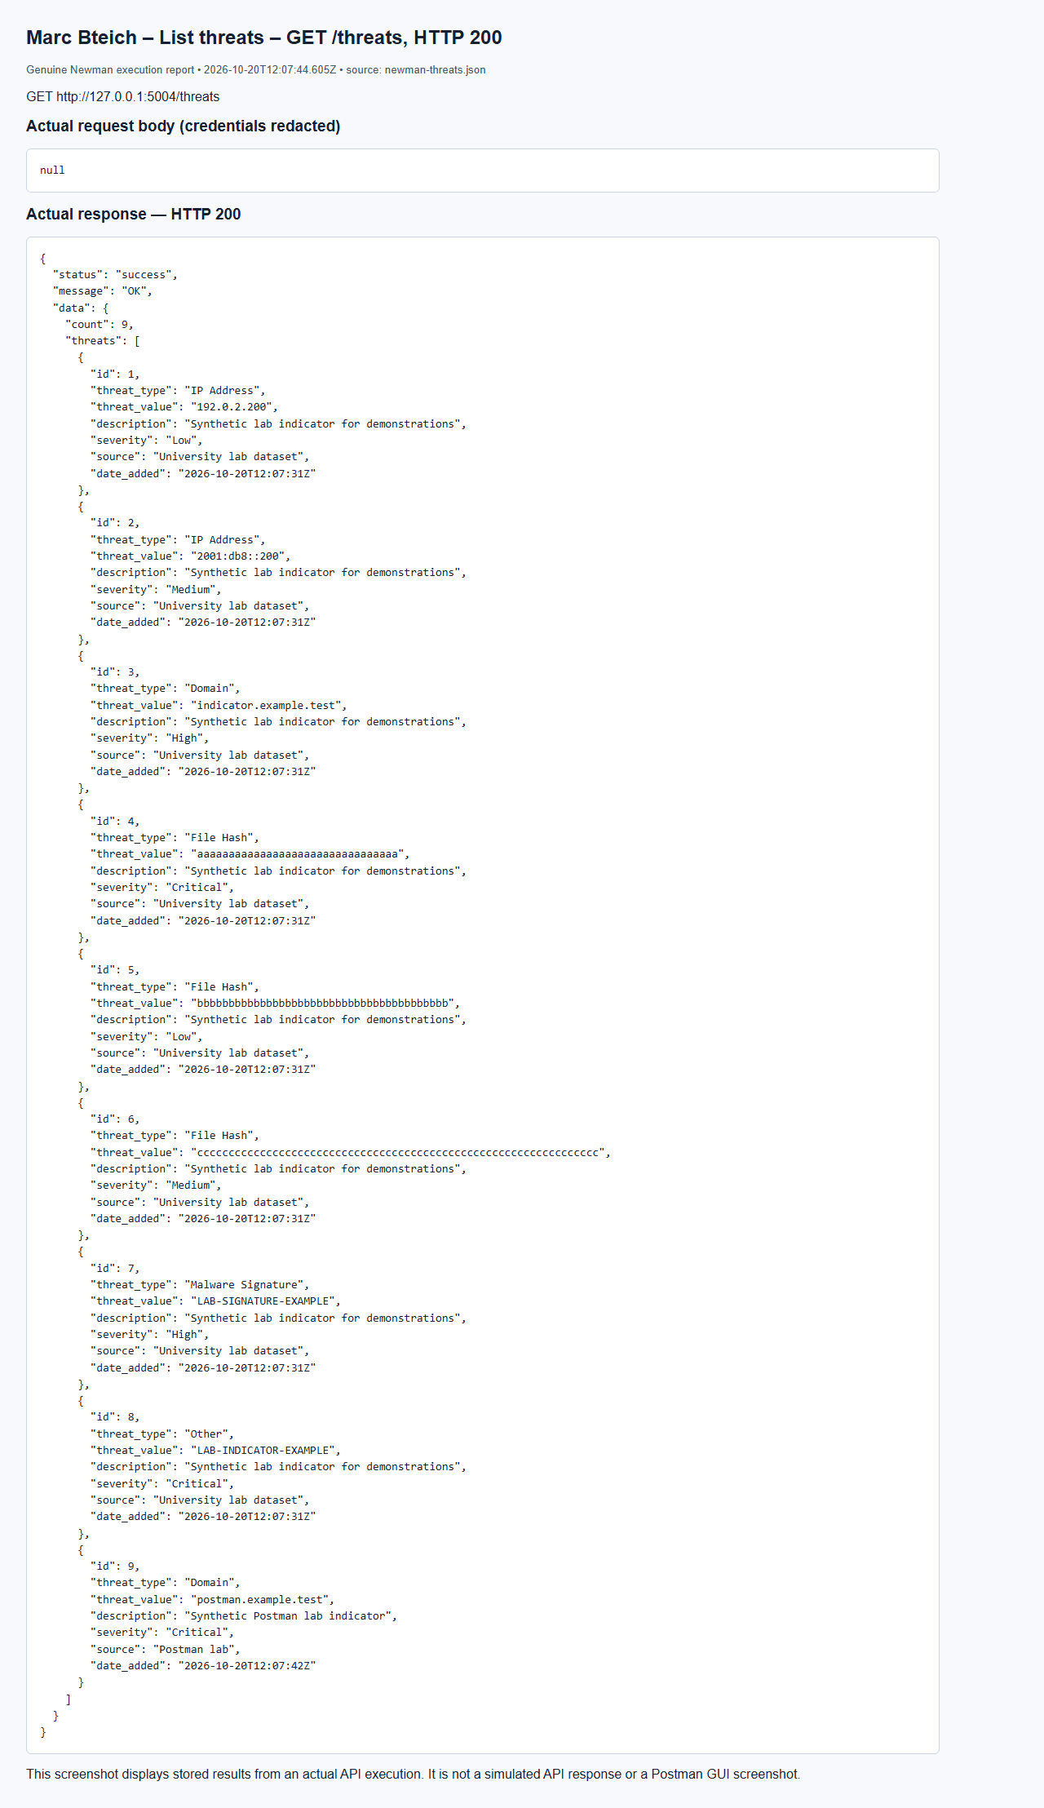

Marc Bteich – Search type=Domain – GET /threats/search, HTTP 200
Browser capture of an actual Newman execution report; not a Postman GUI screenshot.
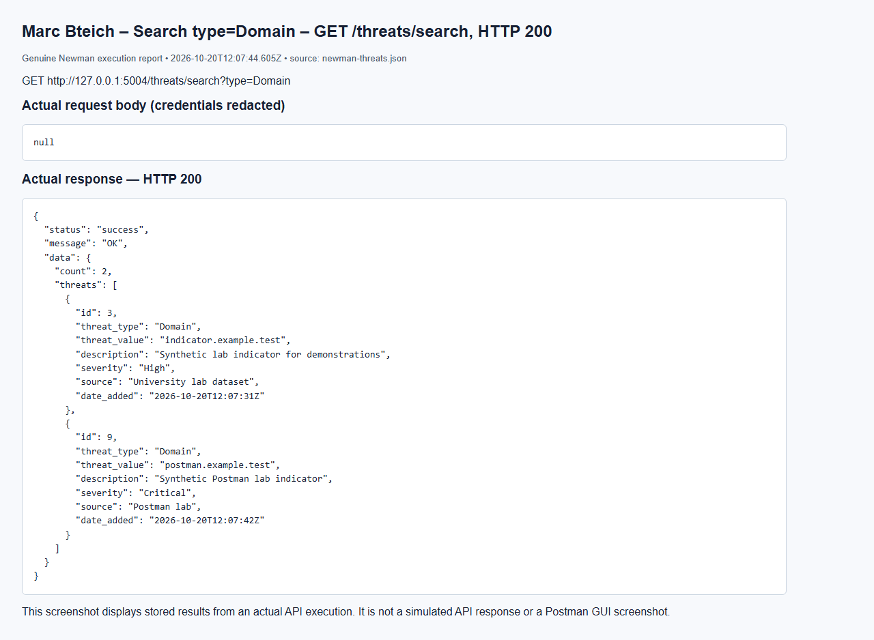

Marc Bteich – Update threat – PUT /threats/9, HTTP 200
Browser capture of an actual Newman execution report; not a Postman GUI screenshot.
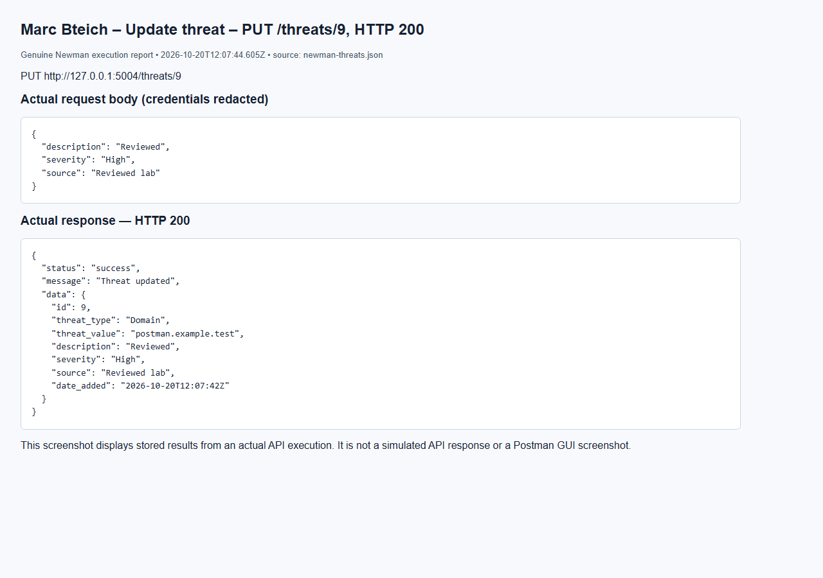

Marc Bteich – Critical threat notification – GET /notifications/search, HTTP 200
Browser capture of an actual Newman execution report; not a Postman GUI screenshot.
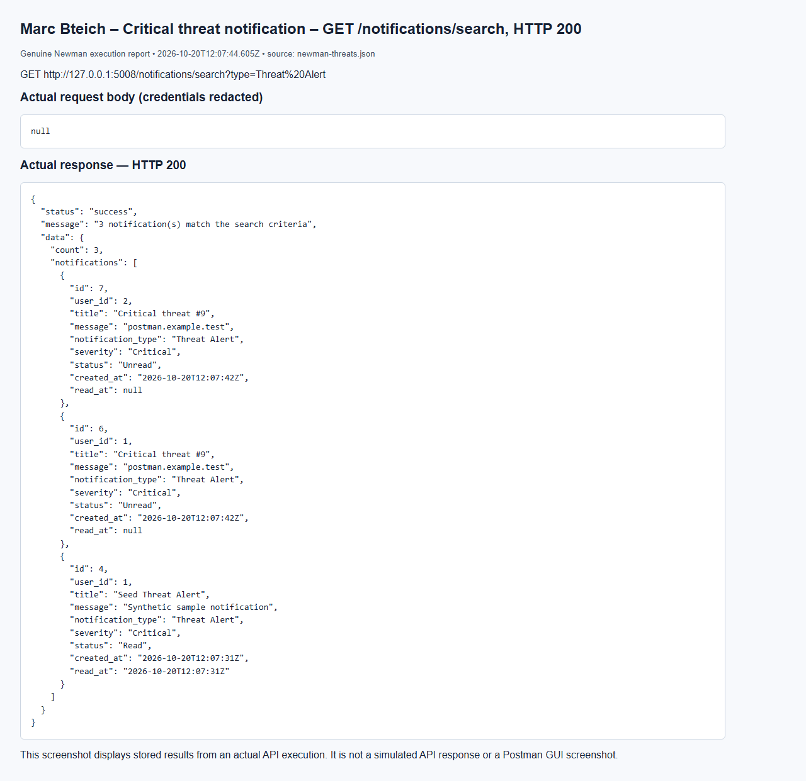

Marc Bteich – No token – GET /threats, HTTP 401
Browser capture of an actual Newman execution report; not a Postman GUI screenshot.
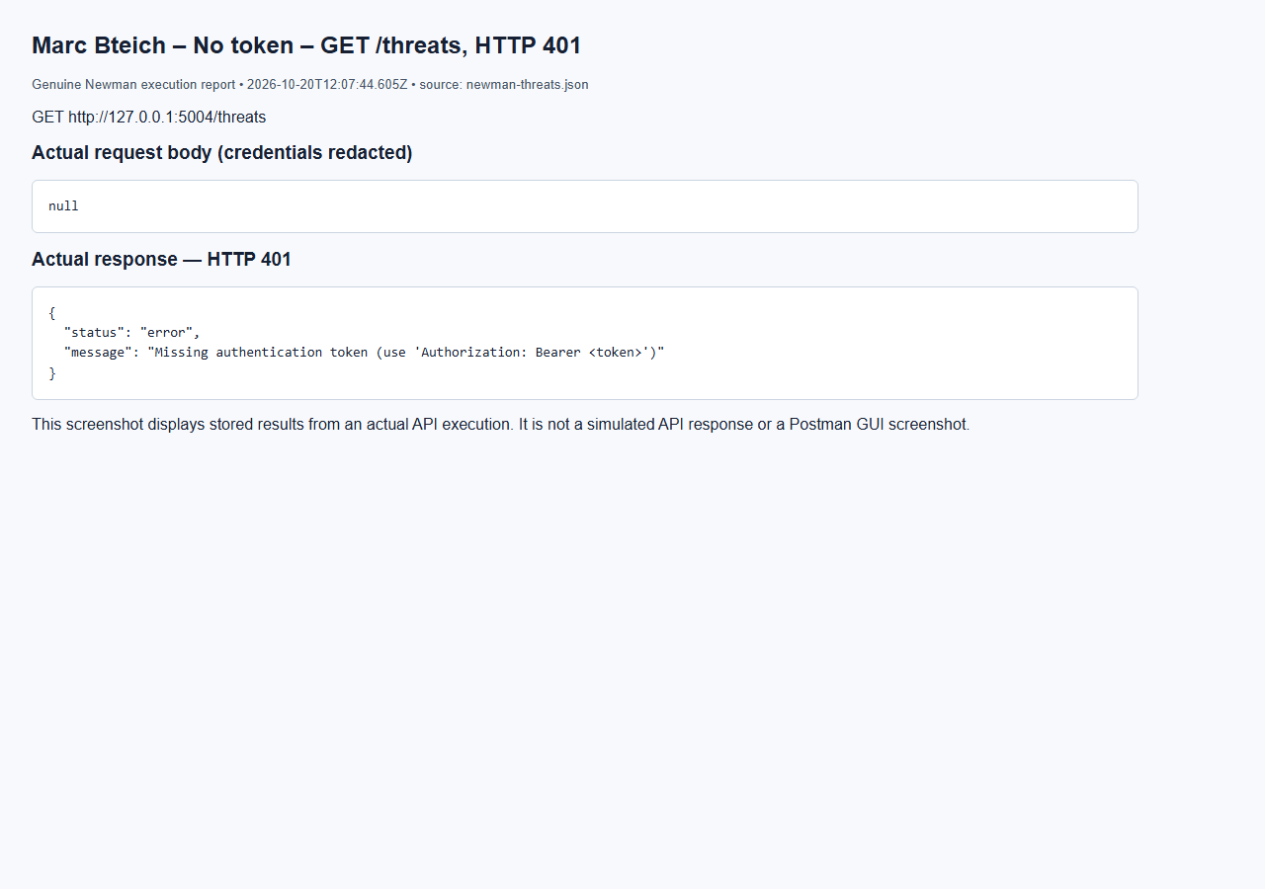

Marc Bteich – User denied – GET /threats, HTTP 403
Browser capture of an actual Newman execution report; not a Postman GUI screenshot.
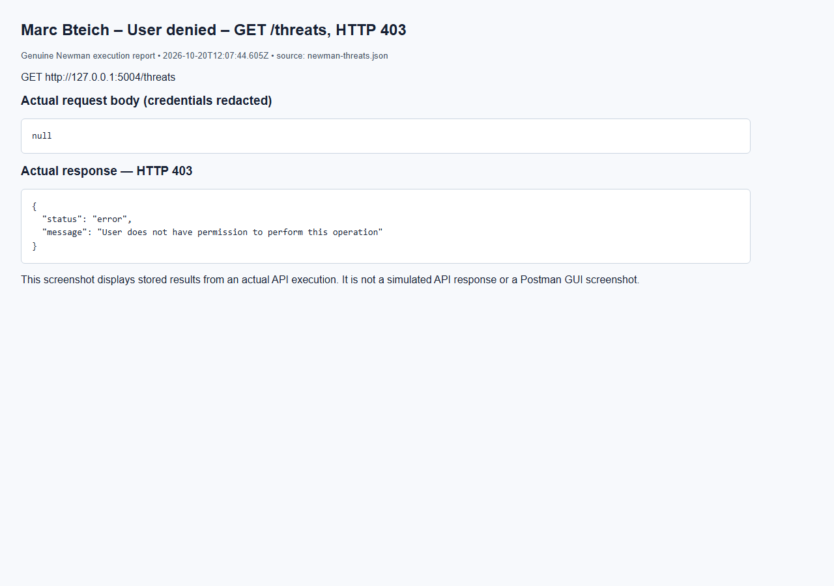

Marc Bteich – Auditor search denied – GET /threats/search, HTTP 403
Browser capture of an actual Newman execution report; not a Postman GUI screenshot.
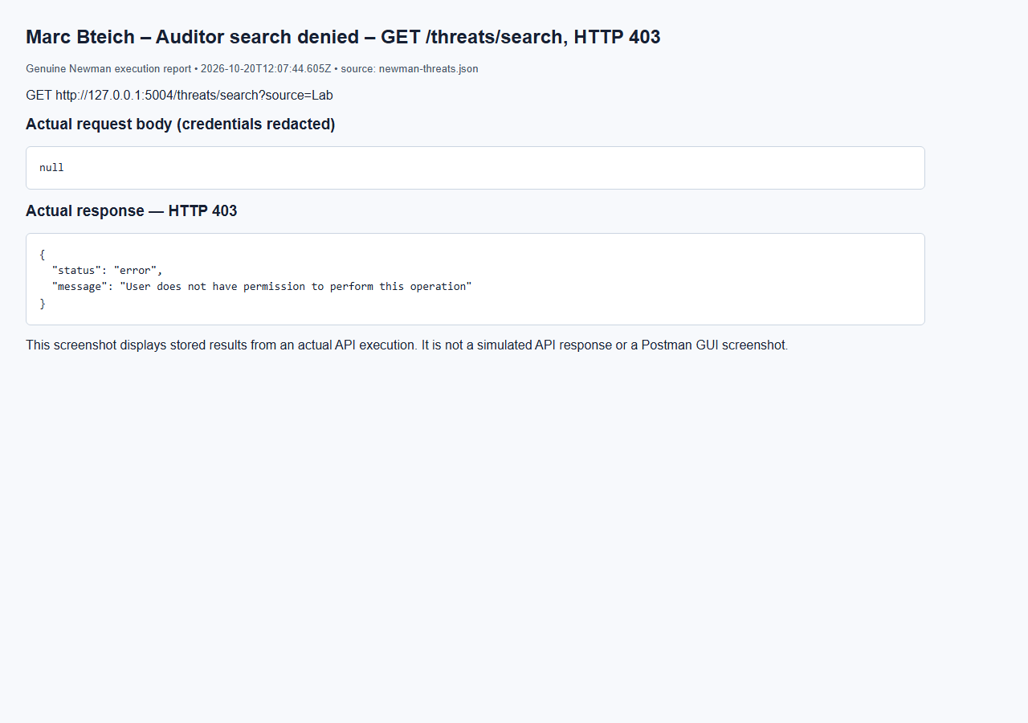

Marc Bteich – Analyst update denied – PUT /threats/9, HTTP 403
Browser capture of an actual Newman execution report; not a Postman GUI screenshot.
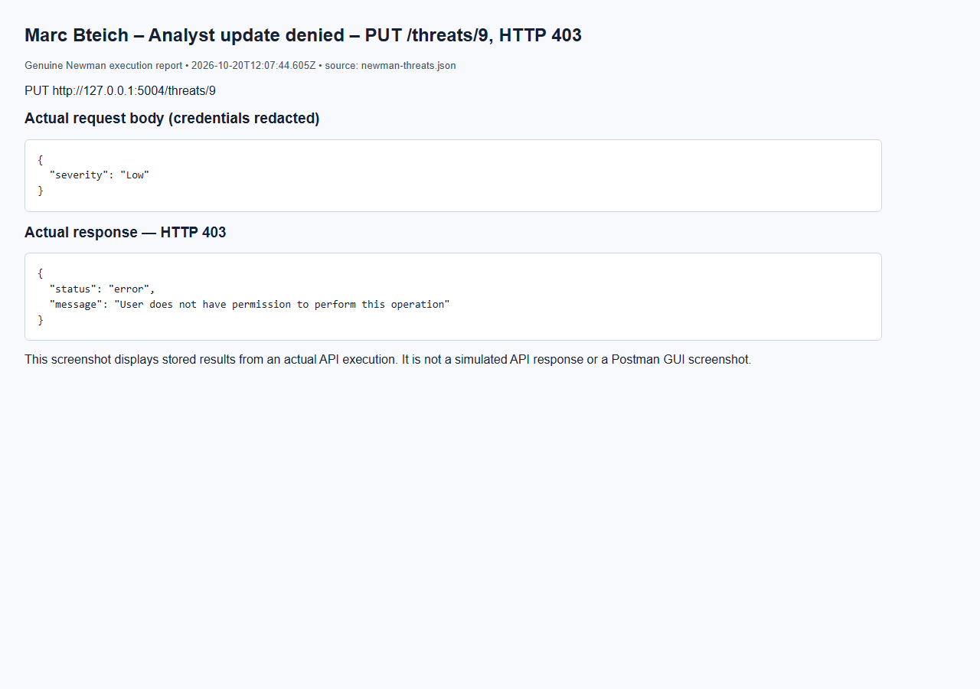

Marc Bteich – Missing threat – GET /threats/2147483647, HTTP 404
Browser capture of an actual Newman execution report; not a Postman GUI screenshot.
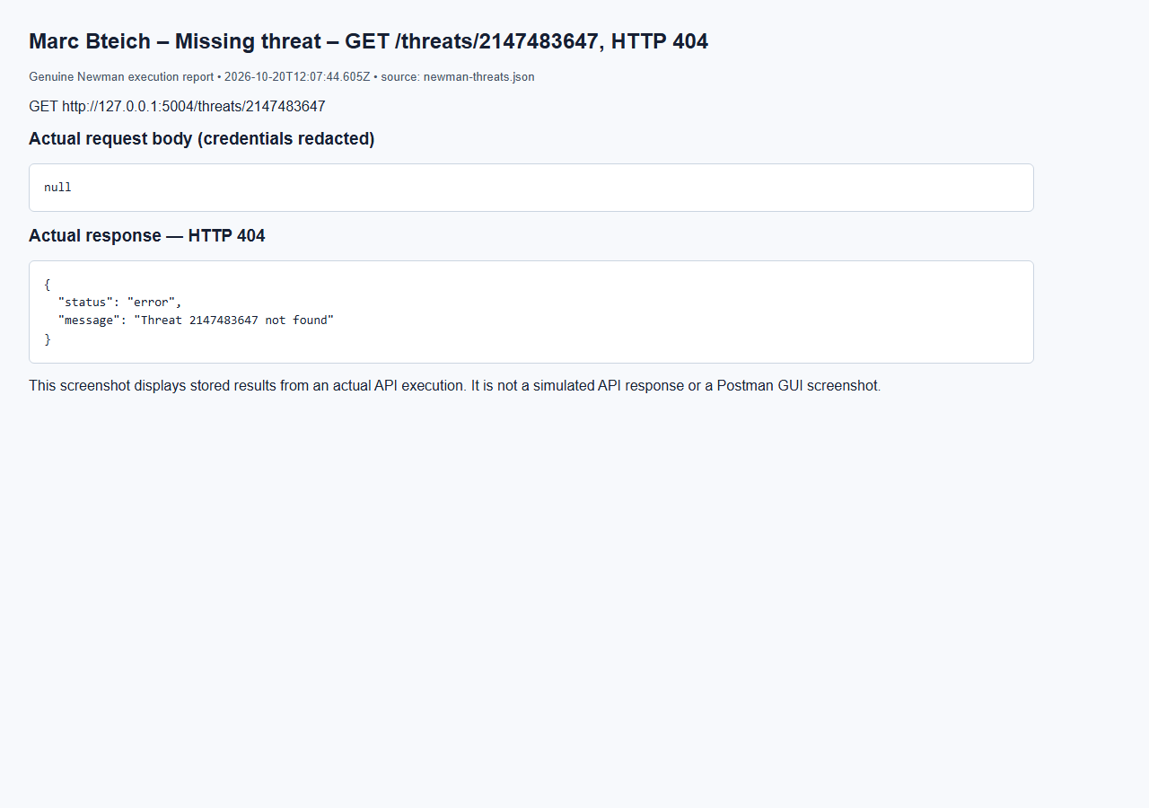

Marc Bteich – Empty body – POST /threats, HTTP 400
Browser capture of an actual Newman execution report; not a Postman GUI screenshot.
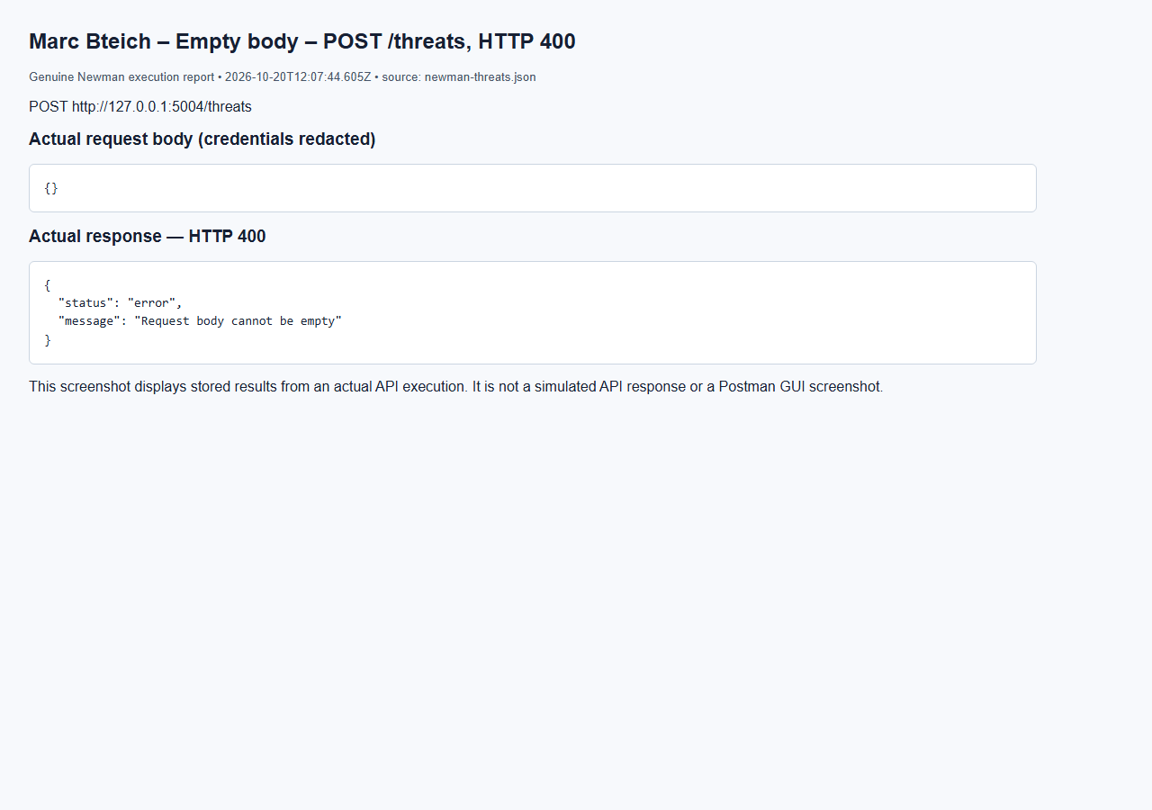

Marc Bteich – Invalid search – GET /threats/search, HTTP 400
Browser capture of an actual Newman execution report; not a Postman GUI screenshot.
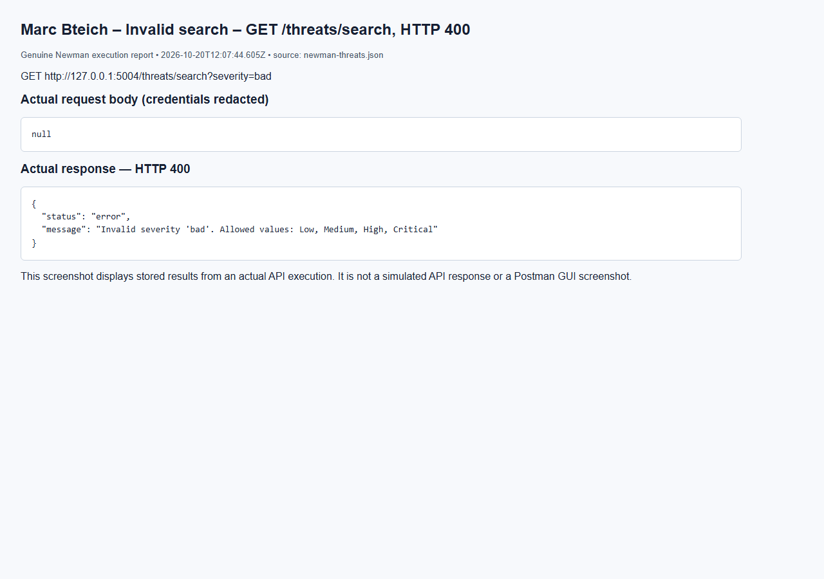

Marc Bteich – Delete threat – DELETE /threats/9, HTTP 200
Browser capture of an actual Newman execution report; not a Postman GUI screenshot.
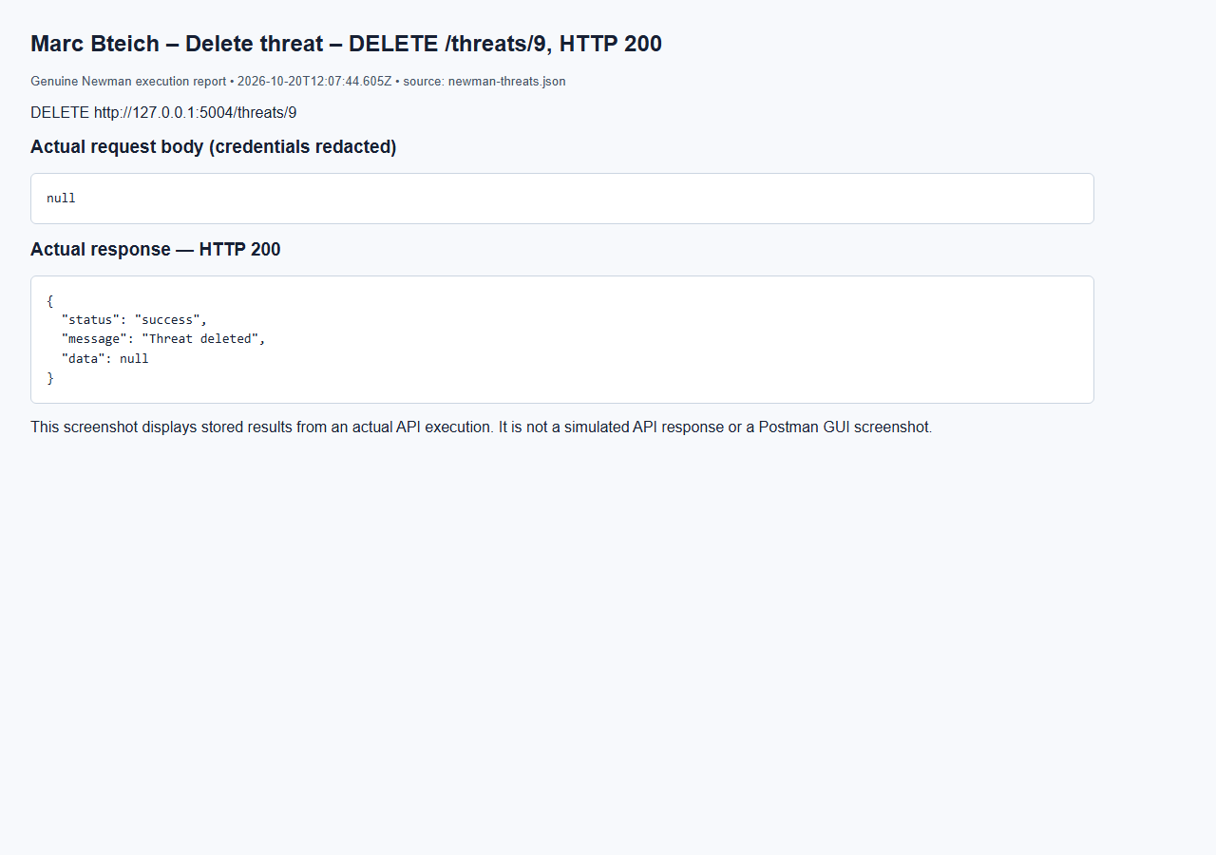

Marc Bteich – List vulnerabilities – GET /vulnerabilities, HTTP 200
Browser capture of an actual Newman execution report; not a Postman GUI screenshot.
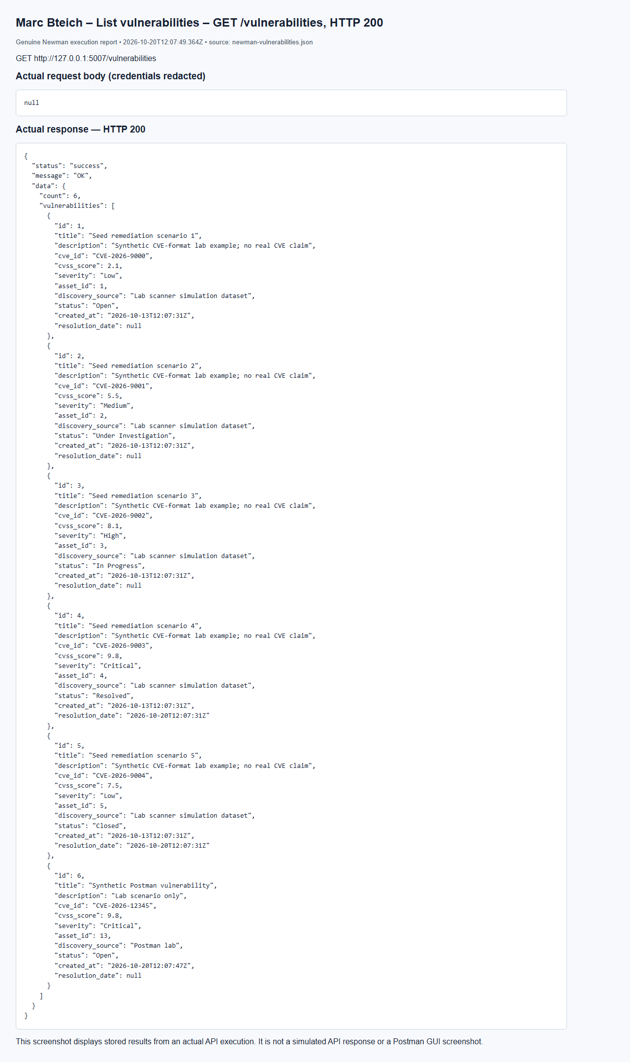

Marc Bteich – Search cve=CVE-2026-12345 – GET /vulnerabilities/search, HTTP 200
Browser capture of an actual Newman execution report; not a Postman GUI screenshot.
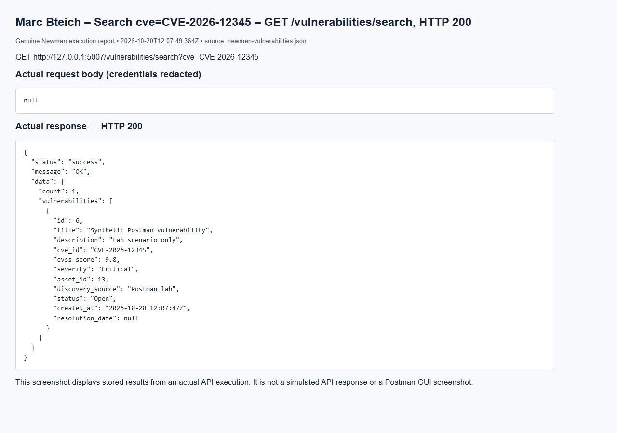

Marc Bteich – Cannot skip lifecycle – PUT /vulnerabilities/6, HTTP 400
Browser capture of an actual Newman execution report; not a Postman GUI screenshot.
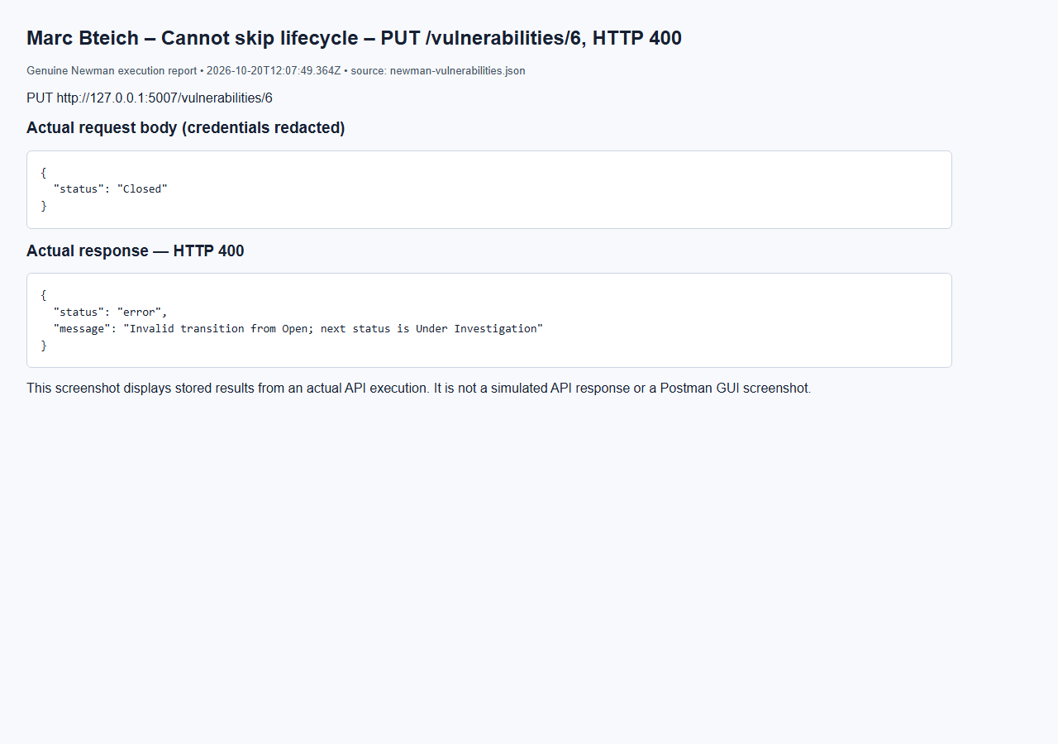

Marc Bteich – Transition Under Investigation – PUT /vulnerabilities/6, HTTP 200
Browser capture of an actual Newman execution report; not a Postman GUI screenshot.
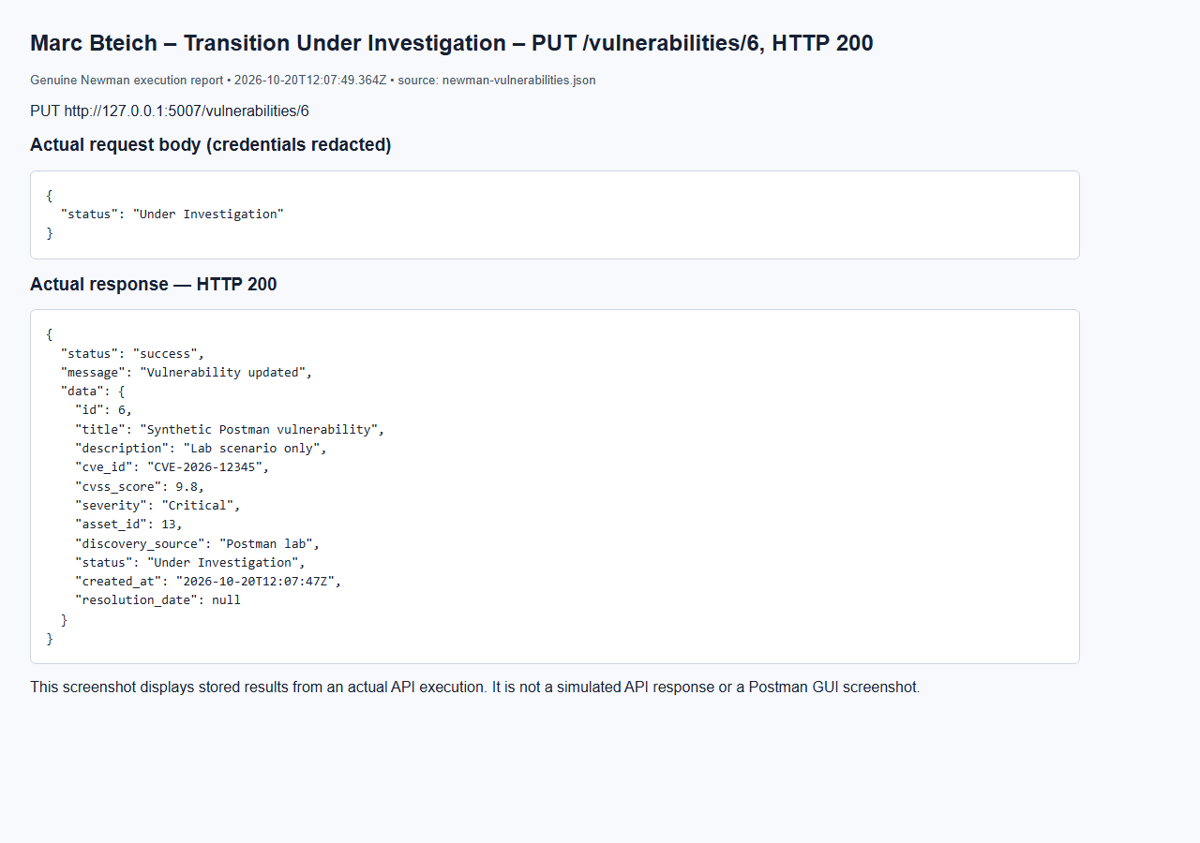

Marc Bteich – No token – GET /vulnerabilities, HTTP 401
Browser capture of an actual Newman execution report; not a Postman GUI screenshot.
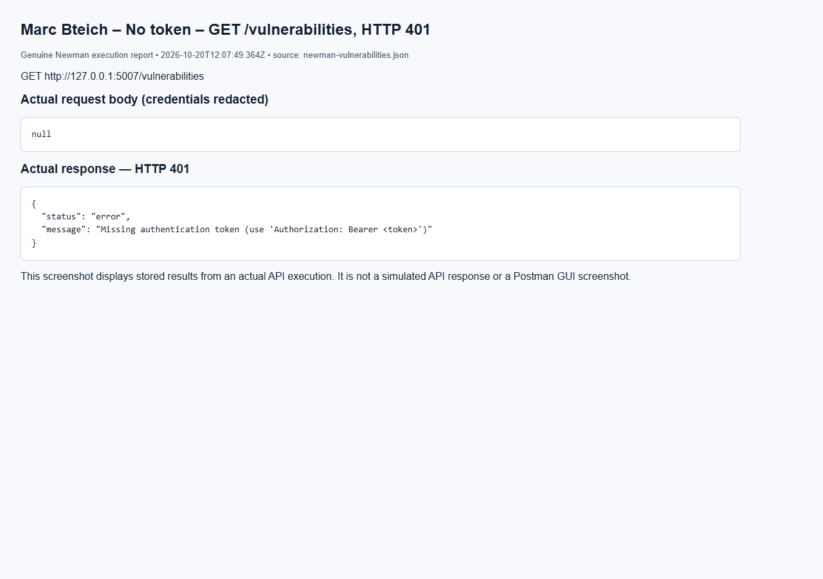

Marc Bteich – User denied – GET /vulnerabilities, HTTP 403
Browser capture of an actual Newman execution report; not a Postman GUI screenshot.
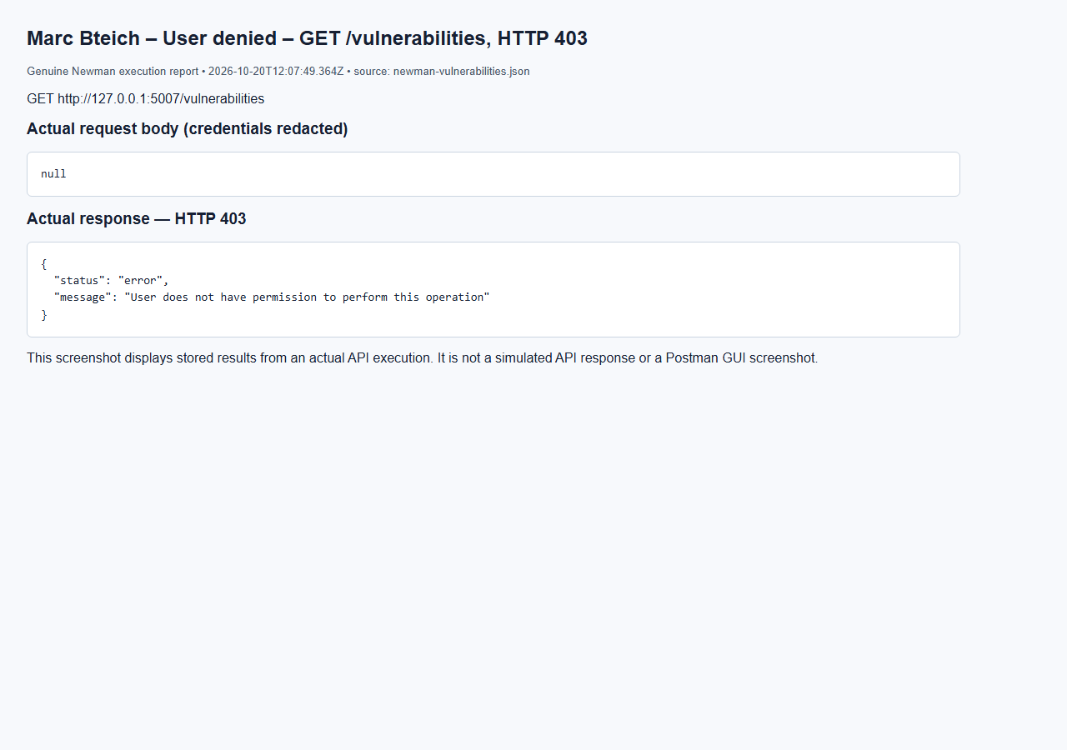

Marc Bteich – Analyst create denied – POST /vulnerabilities, HTTP 403
Browser capture of an actual Newman execution report; not a Postman GUI screenshot.
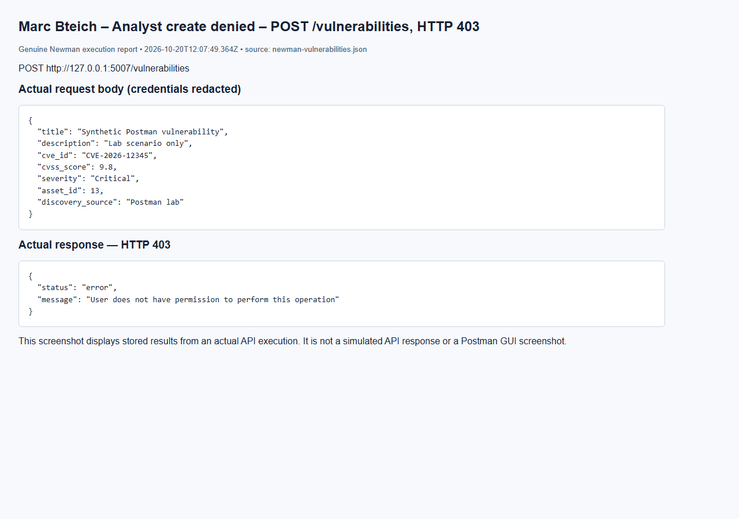

Marc Bteich – Auditor update denied – PUT /vulnerabilities/6, HTTP 403
Browser capture of an actual Newman execution report; not a Postman GUI screenshot.
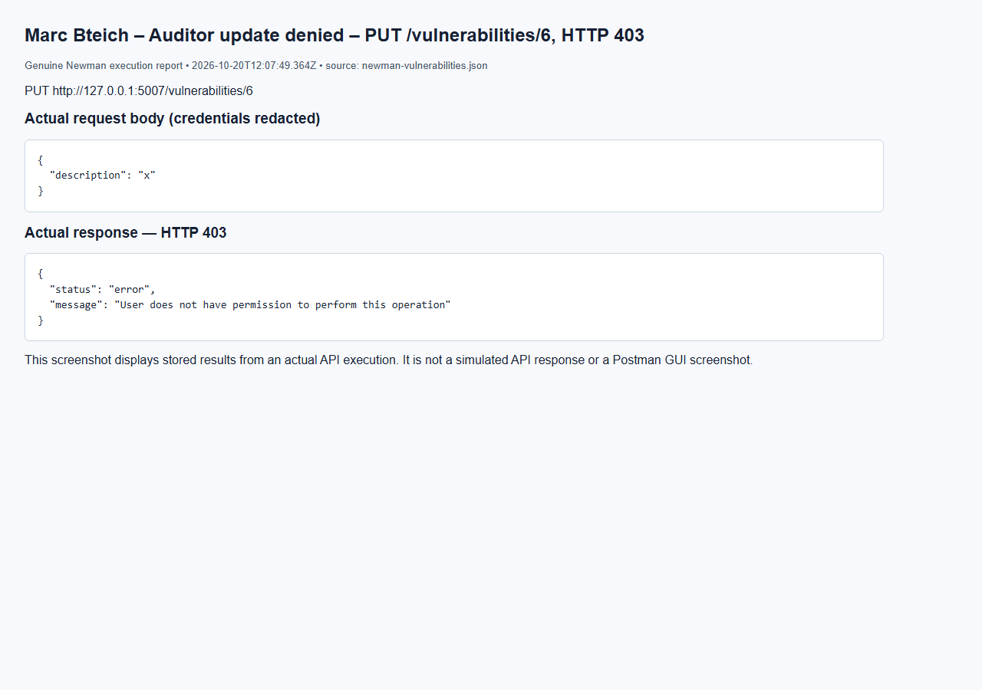

Marc Bteich – Missing vulnerability – GET /vulnerabilities/2147483647, HTTP 404
Browser capture of an actual Newman execution report; not a Postman GUI screenshot.
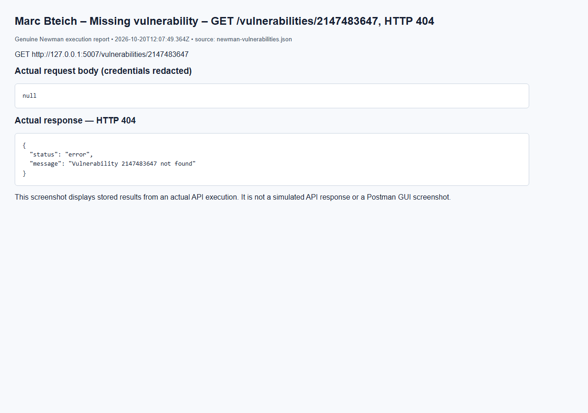

Marc Bteich – Empty body – POST /vulnerabilities, HTTP 400
Browser capture of an actual Newman execution report; not a Postman GUI screenshot.
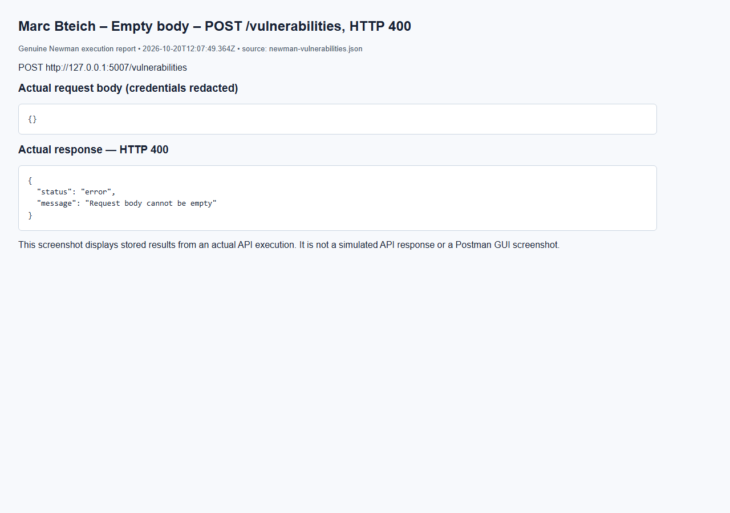

Merged API reference (Marc Bteich)

8. Merged API Documentation (Marc Bteich)
The following endpoint inventory is extracted from the actual route source. Request examples and negative tests are in the merged Postman collection. Roles shown are the route-level checks; object-level checks in Elie’s services still apply.
Public authentication uses Authorization: Bearer <JWT>. Internal endpoints require X-Service-Key. JSON writes use Content-Type: application/json. Success: {status: success, message, data}; errors: {status: error, message}. Typical errors: 400 invalid input, 401 absent/invalid credentials, 403 insufficient permission, 404 missing record, 409 database conflict, 503 unavailable dependency. A 409 is only expected when an applicable constraint exists.

Users (Marc Bteich)

POST /users/register (Marc Bteich)
Purpose: register user. Access: public. Authentication: Public.
Postman example: `POST {{base_users}}/users/register`.
Request body example (template; credentials remain private):
{
"full_name": "Rami Haddad",
"username": "rami",
"email": "rami@corp.com",
"password": "{{user_password}}",
"department": "Finance",
"role": "user"
}
Executed response example: HTTP 201; Newman request "Register - regular user (self-registration)". Credentials are redacted.
{
"status": "success",
"message": "User registered successfully",
"data": {
"id": 2,
"full_name": "Rami Haddad",
"username": "rami",
"email": "rami@corp.com",
"department": "Finance",
"role": "user",
"account_status": "Active",
"created_at": "2026-10-20T12:08:48Z",
"last_login": null
}
}

POST /users/login (Marc Bteich)
Purpose: login. Access: public. Authentication: Public.
Postman example: `POST {{base_users}}/users/login`.
Request body example (template; credentials remain private):
{
"username": "{{admin_username}}",
"password": "{{admin_password}}"
}
Executed response example: HTTP 200; Newman request "Login - admin (success)". Credentials are redacted.
{
"status": "success",
"message": "Login successful",
"data": {
"token": "[REDACTED]",
"token_type": "[REDACTED]",
"user": {
"id": 1,
"full_name": "Local test admin",
"username": "admin",
"email": "admin@example.test",
"department": "Lab",
"role": "admin",
"account_status": "Active",
"created_at": "2026-10-20T12:08:43Z",
"last_login": "2026-10-20T12:08:48Z"
}
}
}

PUT /users/{user_id} (Marc Bteich)
Purpose: update user. Access: admin,user. Authentication: Bearer JWT.
Path parameters: user_id. IDs must identify existing records.
Postman example: `PUT {{base_users}}/users/{{user_id}}`.
Request body example (template; credentials remain private):
{
"department": "Accounting",
"full_name": "Rami Haddad"
}
Executed response example: HTTP 200; Newman request "Update own info - regular user". Credentials are redacted.
{
"status": "success",
"message": "User updated successfully",
"data": {
"id": 2,
"full_name": "Rami Haddad",
"username": "rami",
"email": "rami@corp.com",
"department": "Accounting",
"role": "user",
"account_status": "Active",
"created_at": "2026-10-20T12:08:48Z",
"last_login": "2026-10-20T12:08:50Z"
}
}

DELETE /users/{user_id} (Marc Bteich)
Purpose: delete user. Access: admin. Authentication: Bearer JWT.
Path parameters: user_id. IDs must identify existing records.
Postman example: `DELETE {{base_users}}/users/{{temp_user_id}}`.
Executed response example: HTTP 200; Newman request "Delete user - admin (success)". Credentials are redacted.
{
"status": "success",
"message": "User 5 deleted successfully",
"data": null
}

GET /users (Marc Bteich)
Purpose: get all users. Access: admin,auditor. Authentication: Bearer JWT.
Postman example: `GET {{base_users}}/users`.
Executed response example: HTTP 200; Newman request "Get all users - admin". Credentials are redacted.
{
"status": "success",
"message": "Users retrieved successfully",
"data": {
"count": 5,
"users": [
{
"id": 1,
"full_name": "Local test admin",
"username": "admin",
"email": "admin@example.test",
"department": "Lab",
"role": "admin",
"account_status": "Active",
"created_at": "2026-10-20T12:08:43Z",
"last_login": "2026-10-20T12:08:48Z"
},
{
"id": 2,
"full_name": "Rami Haddad",
"username": "rami",
"email": "rami@corp.com",
"department": "Finance",
"role": "user",
"account_status": "Active",
"created_at": "2026-10-20T12:08:48Z",
"last_login": "2026-10-20T12:08:50Z"
},
{
"id": 3,
"full_name": "Lara Khoury",
"username": "lara",
"email": "lara@corp.com",
"department": "SOC",
"role": "analyst",
"account_status": "Active",
"created_at": "2026-10-20T12:08:49Z",
"last_login": "2026-10-20T12:08:50Z"
},
{
"id": 4,
"full_name": "Nadia Saab",
"username": "nadia",
"email": "nadia@corp.com",
"department": "Compliance",
"role": "auditor",
"account_status": "Active",
"created_at": "2026-10-20T12:08:49Z",
"last_login": "2026-10-20T12:08:51Z"
},
{
"id": 5,
"full_name": "Temp Employee",
"username": "temp.employee",
"email": "temp@corp.com",
"department": "HR",
"role": "user",
"account_status": "Active",
"created_at": "2026-10-20T12:08:49Z",
"last_login": null
}
]
}
}

GET /users/{username} (Marc Bteich)
Purpose: get user by username. Access: admin,auditor,user. Authentication: Bearer JWT.
Path parameters: username. IDs must identify existing records.
Postman example: `GET {{base_users}}/users/lara`.
Executed response example: HTTP 200; Newman request "Get user by username - existing". Credentials are redacted.
{
"status": "success",
"message": "User retrieved successfully",
"data": {
"id": 3,
"full_name": "Lara Khoury",
"username": "lara",
"email": "lara@corp.com",
"department": "SOC",
"role": "analyst",
"account_status": "Active",
"created_at": "2026-10-20T12:08:49Z",
"last_login": "2026-10-20T12:08:50Z"
}
}

GET /internal/users/{user_id} (Marc Bteich)
Purpose: internal get user. Access: internal service only. Authentication: Service key.
Path parameters: user_id. IDs must identify existing records.

GET /internal/users (Marc Bteich)
Purpose: internal list users. Access: internal service only. Authentication: Service key.

GET /internal/stats (Marc Bteich)
Purpose: internal stats. Access: internal service only. Authentication: Service key.
Postman example: `GET {{base_assets}}/internal/stats`.
Executed response example: HTTP 200; Newman request "Internal statistics". Credentials are redacted.
{
"status": "success",
"message": "OK",
"data": {
"total_assets": 6,
"critical_assets": 1,
"by_type": {
"Server": 1,
"Workstation": 1,
"Database": 1,
"Application": 1,
"Network Device": 1,
"Cloud Resource": 1
}
}
}

Assets (Marc Bteich)

POST /assets (Marc Bteich)
Purpose: create asset. Access: admin. Authentication: Bearer JWT.
Postman example: `POST {{base_assets}}/assets`.
Request body example (template; credentials remain private):
{
"asset_name": "Postman Lab Server",
"asset_type": "Server",
"ip_address": "192.0.2.10",
"operating_system": "Linux",
"department": "Security",
"owner_id": {{owner_id}},
"location": "Lab",
"criticality": "Critical",
"status": "Active"
}
Executed response example: HTTP 201; Newman request "Create asset". Credentials are redacted.
{
"status": "success",
"message": "Asset created successfully",
"data": {
"id": 1,
"asset_name": "Postman Lab Server",
"asset_type": "Server",
"ip_address": "192.0.2.10",
"operating_system": "Linux",
"owner_id": 1,
"department": "Security",
"location": "Lab",
"criticality": "Critical",
"status": "Active"
}
}

PUT /assets/{asset_id} (Marc Bteich)
Purpose: update asset. Access: admin. Authentication: Bearer JWT.
Path parameters: asset_id. IDs must identify existing records.
Postman example: `PUT {{base_assets}}/assets/{{asset_id}}`.
Request body example (template; credentials remain private):
{
"asset_name": "Updated Postman Server",
"department": "IT",
"criticality": "High",
"status": "Under Maintenance"
}
Executed response example: HTTP 200; Newman request "Update asset (admin)". Credentials are redacted.
{
"status": "success",
"message": "Asset updated successfully",
"data": {
"id": 1,
"asset_name": "Updated Postman Server",
"asset_type": "Server",
"ip_address": "192.0.2.10",
"operating_system": "Linux",
"owner_id": 1,
"department": "IT",
"location": "Lab",
"criticality": "High",
"status": "Under Maintenance"
}
}

DELETE /assets/{asset_id} (Marc Bteich)
Purpose: delete asset. Access: admin. Authentication: Bearer JWT.
Path parameters: asset_id. IDs must identify existing records.
Postman example: `DELETE {{base_assets}}/assets/{{asset_id}}`.
Executed response example: HTTP 200; Newman request "Delete asset (admin)". Credentials are redacted.
{
"status": "success",
"message": "Asset 1 deleted successfully",
"data": null
}

GET /assets (Marc Bteich)
Purpose: list assets. Access: admin,auditor. Authentication: Bearer JWT.
Postman example: `GET {{base_assets}}/assets`.
Executed response example: HTTP 200; Newman request "List assets (auditor)". Credentials are redacted.
{
"status": "success",
"message": "Assets retrieved successfully",
"data": {
"count": 6,
"assets": [
{
"id": 1,
"asset_name": "Postman Lab Server",
"asset_type": "Server",
"ip_address": "192.0.2.10",
"operating_system": "Linux",
"owner_id": 1,
"department": "Security",
"location": "Lab",
"criticality": "Critical",
"status": "Active"
},
{
"id": 2,
"asset_name": "Postman Workstation",
"asset_type": "Workstation",
"ip_address": "192.0.2.10",
"operating_system": "Linux",
"owner_id": 1,
"department": "Security",
"location": "Lab",
"criticality": "Low",
"status": "Active"
},
{
"id": 3,
"asset_name": "Postman Database",
"asset_type": "Database",
"ip_address": "192.0.2.10",
"operating_system": "Linux",
"owner_id": 1,
"department": "Security",
"location": "Lab",
"criticality": "Medium",
"status": "Inactive"
},
{
"id": 4,
"asset_name": "Postman Application",
"asset_type": "Application",
"ip_address": "192.0.2.10",
"operating_system": "Linux",
"owner_id": 1,
"department": "Security",
"location": "Lab",
"criticality": "High",
"status": "Under Maintenance"
},
{
"id": 5,
"asset_name": "Postman Network Device",
"asset_type": "Network Device",
"ip_address": "192.0.2.10",
"operating_system": "Linux",
"owner_id": 1,
"department": "Security",
"location": "Lab",
"criticality": "High",
"status": "Active"
},
{
"id": 6,
"asset_name": "Postman Cloud Resource",
"asset_type": "Cloud Resource",
"ip_address": "192.0.2.10",
"operating_system": "Linux",
"owner_id": 1,
"department": "Security",
"location": "Lab",
"criticality": "Critical",
"status": "Active"
}
]
}
}

GET /assets/{asset_id} (Marc Bteich)
Purpose: get asset. Access: admin,analyst,auditor. Authentication: Bearer JWT.
Path parameters: asset_id. IDs must identify existing records.
Postman example: `GET {{base_assets}}/assets/{{asset_id}}`.
Executed response example: HTTP 200; Newman request "Get asset before update (analyst)". Credentials are redacted.
{
"status": "success",
"message": "Asset retrieved successfully",
"data": {
"id": 1,
"asset_name": "Postman Lab Server",
"asset_type": "Server",
"ip_address": "192.0.2.10",
"operating_system": "Linux",
"owner_id": 1,
"department": "Security",
"location": "Lab",
"criticality": "Critical",
"status": "Active"
}
}

GET /assets/search (Marc Bteich)
Purpose: search assets. Access: admin,analyst,auditor. Authentication: Bearer JWT.
Postman example: `GET {{base_assets}}/assets/search?name=Postman`.
Search parameters demonstrated: criticality, department, ip, name, type; consult field rules below for allowed keys.
Executed response example: HTTP 200; Newman request "Search by name". Credentials are redacted.
{
"status": "success",
"message": "Asset search completed",
"data": {
"count": 6,
"assets": [
{
"id": 1,
"asset_name": "Updated Postman Server",
"asset_type": "Server",
"ip_address": "192.0.2.10",
"operating_system": "Linux",
"owner_id": 1,
"department": "IT",
"location": "Lab",
"criticality": "High",
"status": "Under Maintenance"
},
{
"id": 2,
"asset_name": "Postman Workstation",
"asset_type": "Workstation",
"ip_address": "192.0.2.10",
"operating_system": "Linux",
"owner_id": 1,
"department": "Security",
"location": "Lab",
"criticality": "Low",
"status": "Active"
},
{
"id": 3,
"asset_name": "Postman Database",
"asset_type": "Database",
"ip_address": "192.0.2.10",
"operating_system": "Linux",
"owner_id": 1,
"department": "Security",
"location": "Lab",
"criticality": "Medium",
"status": "Inactive"
},
{
"id": 4,
"asset_name": "Postman Application",
"asset_type": "Application",
"ip_address": "192.0.2.10",
"operating_system": "Linux",
"owner_id": 1,
"department": "Security",
"location": "Lab",
"criticality": "High",
"status": "Under Maintenance"
},
{
"id": 5,
"asset_name": "Postman Network Device",
"asset_type": "Network Device",
"ip_address": "192.0.2.10",
"operating_system": "Linux",
"owner_id": 1,
"department": "Security",
"location": "Lab",
"criticality": "High",
"status": "Active"
},
{
"id": 6,
"asset_name": "Postman Cloud Resource",
"asset_type": "Cloud Resource",
"ip_address": "192.0.2.10",
"operating_system": "Linux",
"owner_id": 1,
"department": "Security",
"location": "Lab",
"criticality": "Critical",
"status": "Active"
}
]
}
}

GET /internal/stats (Marc Bteich)
Purpose: internal stats. Access: internal service only. Authentication: Service key.
Postman example: `GET {{base_assets}}/internal/stats`.
Executed response example: HTTP 200; Newman request "Internal statistics". Credentials are redacted.
{
"status": "success",
"message": "OK",
"data": {
"total_assets": 6,
"critical_assets": 1,
"by_type": {
"Server": 1,
"Workstation": 1,
"Database": 1,
"Application": 1,
"Network Device": 1,
"Cloud Resource": 1
}
}
}

GET /internal/assets/{asset_id} (Marc Bteich)
Purpose: internal get asset. Access: internal service only. Authentication: Service key.
Path parameters: asset_id. IDs must identify existing records.
Postman example: `GET {{base_assets}}/internal/assets/{{asset_id}}`.
Executed response example: HTTP 200; Newman request "Internal asset lookup". Credentials are redacted.
{
"status": "success",
"message": "OK",
"data": {
"id": 1,
"asset_name": "Updated Postman Server",
"asset_type": "Server",
"ip_address": "192.0.2.10",
"operating_system": "Linux",
"owner_id": 1,
"department": "IT",
"location": "Lab",
"criticality": "High",
"status": "Under Maintenance"
}
}

Incidents (Marc Bteich)

POST /incidents (Marc Bteich)
Purpose: create incident. Access: admin,user. Authentication: Bearer JWT.
Postman example: `POST {{base_incidents}}/incidents`.
Request body example (template; credentials remain private):
{
"title": "Phishing email received",
"description": "Employee clicked a link in a fake invoice email",
"category": "Phishing",
"severity": "Medium",
"asset_id": {{asset_id}}
}
Executed response example: HTTP 201; Newman request "Create - regular user (Medium)". Credentials are redacted.
{
"status": "success",
"message": "Incident created successfully",
"data": {
"id": 1,
"title": "Phishing email received",
"description": "Employee clicked a link in a fake invoice email",
"category": "Phishing",
"severity": "Medium",
"reporter_id": 2,
"asset_id": 7,
"assigned_analyst_id": null,
"status": "Open",
"created_at": "2026-10-20T12:08:59Z",
"resolved_at": null
}
}

GET /incidents (Marc Bteich)
Purpose: get all incidents. Access: admin,auditor. Authentication: Bearer JWT.
Postman example: `GET {{base_incidents}}/incidents`.
Executed response example: HTTP 200; Newman request "Get all - admin". Credentials are redacted.
{
"status": "success",
"message": "Incidents retrieved successfully",
"data": {
"count": 4,
"incidents": [
{
"id": 4,
"title": "Port scan detected",
"description": "Firewall blocked a port scan",
"category": "Other",
"severity": "Low",
"reporter_id": 2,
"asset_id": 7,
"assigned_analyst_id": null,
"status": "Open",
"created_at": "2026-10-20T12:08:59Z",
"resolved_at": null
},
{
"id": 3,
"title": "Brute force on HR database",
"description": "Thousands of failed logins from one IP",
"category": "Unauthorized Access",
"severity": "High",
"reporter_id": 1,
"asset_id": 7,
"assigned_analyst_id": null,
"status": "Open",
"created_at": "2026-10-20T12:08:59Z",
"resolved_at": null
},
{
"id": 2,
"title": "Ransomware on web server",
"description": "Files encrypted, ransom note found",
"category": "Malware",
"severity": "Critical",
"reporter_id": 1,
"asset_id": 7,
"assigned_analyst_id": null,
"status": "Open",
"created_at": "2026-10-20T12:08:59Z",
"resolved_at": null
},
{
"id": 1,
"title": "Phishing email received",
"description": "Employee clicked a link in a fake invoice email",
"category": "Phishing",
"severity": "Medium",
"reporter_id": 2,
"asset_id": 7,
"assigned_analyst_id": null,
"status": "Open",
"created_at": "2026-10-20T12:08:59Z",
"resolved_at": null
}
]
}
}

GET /incidents/{incident_id} (Marc Bteich)
Purpose: get incident. Access: admin,auditor,analyst,user. Authentication: Bearer JWT.
Path parameters: incident_id. IDs must identify existing records.
Postman example: `GET {{base_incidents}}/incidents/{{incident_id}}`.
Executed response example: HTTP 200; Newman request "Get - reporter views own incident". Credentials are redacted.
{
"status": "success",
"message": "Incident retrieved successfully",
"data": {
"id": 1,
"title": "Phishing email received",
"description": "Employee clicked a link in a fake invoice email",
"category": "Phishing",
"severity": "Medium",
"reporter_id": 2,
"asset_id": 7,
"assigned_analyst_id": null,
"status": "Open",
"created_at": "2026-10-20T12:08:59Z",
"resolved_at": null,
"investigation_notes": []
}
}

PUT /incidents/{incident_id}/assign (Marc Bteich)
Purpose: assign incident. Access: admin. Authentication: Bearer JWT.
Path parameters: incident_id. IDs must identify existing records.
Postman example: `PUT {{base_incidents}}/incidents/{{incident_id}}/assign`.
Request body example (template; credentials remain private):
{
"analyst_id": {{analyst_id}}
}
Executed response example: HTTP 200; Newman request "Assign - admin to analyst". Credentials are redacted.
{
"status": "success",
"message": "Incident assigned successfully",
"data": {
"id": 1,
"title": "Phishing email received",
"description": "Employee clicked a link in a fake invoice email",
"category": "Phishing",
"severity": "Medium",
"reporter_id": 2,
"asset_id": 7,
"assigned_analyst_id": 3,
"status": "Open",
"created_at": "2026-10-20T12:08:59Z",
"resolved_at": null
}
}

PUT /incidents/{incident_id}/status (Marc Bteich)
Purpose: update incident status. Access: admin,analyst. Authentication: Bearer JWT.
Path parameters: incident_id. IDs must identify existing records.
Postman example: `PUT {{base_incidents}}/incidents/{{incident_id}}/status`.
Request body example (template; credentials remain private):
{
"status": "Under Investigation"
}
Executed response example: HTTP 200; Newman request "Open -> Under Investigation". Credentials are redacted.
{
"status": "success",
"message": "Incident status updated to 'Under Investigation'",
"data": {
"id": 1,
"title": "Phishing email received",
"description": "Employee clicked a link in a fake invoice email",
"category": "Phishing",
"severity": "Medium",
"reporter_id": 2,
"asset_id": 7,
"assigned_analyst_id": 3,
"status": "Under Investigation",
"created_at": "2026-10-20T12:08:59Z",
"resolved_at": null
}
}

POST /incidents/{incident_id}/notes (Marc Bteich)
Purpose: add investigation note. Access: admin,analyst. Authentication: Bearer JWT.
Path parameters: incident_id. IDs must identify existing records.
Postman example: `POST {{base_incidents}}/incidents/{{incident2_id}}/notes`.
Request body example (template; credentials remain private):
{
"content": "Analysis: ransomware strain identified as LockBit"
}
Executed response example: HTTP 201; Newman request "Add note - assigned analyst". Credentials are redacted.
{
"status": "success",
"message": "Investigation note added successfully",
"data": {
"id": 2,
"title": "Ransomware on web server",
"description": "Files encrypted, ransom note found",
"category": "Malware",
"severity": "Critical",
"reporter_id": 1,
"asset_id": 7,
"assigned_analyst_id": 3,
"status": "Open",
"created_at": "2026-10-20T12:08:59Z",
"resolved_at": null,
"investigation_notes": [
{
"id": 1,
"incident_id": 2,
"analyst_id": 3,
"content": "Analysis: ransomware strain identified as LockBit",
"created_at": "2026-10-20T12:09:01Z"
}
]
}
}

GET /internal/stats (Marc Bteich)
Purpose: internal stats. Access: internal service only. Authentication: Service key.
Postman example: `GET {{base_assets}}/internal/stats`.
Executed response example: HTTP 200; Newman request "Internal statistics". Credentials are redacted.
{
"status": "success",
"message": "OK",
"data": {
"total_assets": 6,
"critical_assets": 1,
"by_type": {
"Server": 1,
"Workstation": 1,
"Database": 1,
"Application": 1,
"Network Device": 1,
"Cloud Resource": 1
}
}
}

Threats (Marc Bteich)

POST /threats (Marc Bteich)
Purpose: create. Access: admin. Authentication: Bearer JWT.
Postman example: `POST {{base_threats}}/threats`.
Request body example (template; credentials remain private):
{
"threat_type": "Domain",
"threat_value": "{{indicator_domain}}",
"description": "Synthetic Postman lab indicator",
"severity": "Critical",
"source": "Postman lab"
}
Executed response example: HTTP 201; Newman request "Create Critical threat". Credentials are redacted.
{
"status": "success",
"message": "Threat created",
"data": {
"id": 1,
"threat_type": "Domain",
"threat_value": "postman.example.test",
"description": "Synthetic Postman lab indicator",
"severity": "Critical",
"source": "Postman lab",
"date_added": "2026-10-20T12:09:03Z"
}
}

GET /threats (Marc Bteich)
Purpose: list all. Access: admin,analyst,auditor. Authentication: Bearer JWT.
Postman example: `GET {{base_threats}}/threats`.
Executed response example: HTTP 200; Newman request "List threats". Credentials are redacted.
{
"status": "success",
"message": "OK",
"data": {
"count": 1,
"threats": [
{
"id": 1,
"threat_type": "Domain",
"threat_value": "postman.example.test",
"description": "Synthetic Postman lab indicator",
"severity": "Critical",
"source": "Postman lab",
"date_added": "2026-10-20T12:09:03Z"
}
]
}
}

GET /threats/{record_id} (Marc Bteich)
Purpose: get. Access: admin,analyst,auditor. Authentication: Bearer JWT.
Path parameters: record_id. IDs must identify existing records.
Postman example: `GET {{base_threats}}/threats/{{threat_id}}`.
Executed response example: HTTP 200; Newman request "Get threat". Credentials are redacted.
{
"status": "success",
"message": "OK",
"data": {
"id": 1,
"threat_type": "Domain",
"threat_value": "postman.example.test",
"description": "Synthetic Postman lab indicator",
"severity": "Critical",
"source": "Postman lab",
"date_added": "2026-10-20T12:09:03Z"
}
}

GET /threats/search (Marc Bteich)
Purpose: search. Access: admin,analyst. Authentication: Bearer JWT.
Postman example: `GET {{base_threats}}/threats/search?type=Domain`.
Search parameters demonstrated: severity, source, type, value; consult field rules below for allowed keys.
Executed response example: HTTP 200; Newman request "Search type=Domain". Credentials are redacted.
{
"status": "success",
"message": "OK",
"data": {
"count": 1,
"threats": [
{
"id": 1,
"threat_type": "Domain",
"threat_value": "postman.example.test",
"description": "Synthetic Postman lab indicator",
"severity": "Critical",
"source": "Postman lab",
"date_added": "2026-10-20T12:09:03Z"
}
]
}
}

PUT /threats/{record_id} (Marc Bteich)
Purpose: update. Access: admin. Authentication: Bearer JWT.
Path parameters: record_id. IDs must identify existing records.
Postman example: `PUT {{base_threats}}/threats/{{threat_id}}`.
Request body example (template; credentials remain private):
{
"description": "Reviewed",
"severity": "High",
"source": "Reviewed lab"
}
Executed response example: HTTP 200; Newman request "Update threat". Credentials are redacted.
{
"status": "success",
"message": "Threat updated",
"data": {
"id": 1,
"threat_type": "Domain",
"threat_value": "postman.example.test",
"description": "Reviewed",
"severity": "High",
"source": "Reviewed lab",
"date_added": "2026-10-20T12:09:03Z"
}
}

DELETE /threats/{record_id} (Marc Bteich)
Purpose: delete. Access: admin. Authentication: Bearer JWT.
Path parameters: record_id. IDs must identify existing records.
Postman example: `DELETE {{base_threats}}/threats/{{threat_id}}`.
Executed response example: HTTP 200; Newman request "Delete threat". Credentials are redacted.
{
"status": "success",
"message": "Threat deleted",
"data": null
}

GET /internal/stats (Marc Bteich)
Purpose: stats. Access: internal service only. Authentication: Service key.
Postman example: `GET {{base_assets}}/internal/stats`.
Executed response example: HTTP 200; Newman request "Internal statistics". Credentials are redacted.
{
"status": "success",
"message": "OK",
"data": {
"total_assets": 6,
"critical_assets": 1,
"by_type": {
"Server": 1,
"Workstation": 1,
"Database": 1,
"Application": 1,
"Network Device": 1,
"Cloud Resource": 1
}
}
}

Logs (Marc Bteich)

POST /logs (Marc Bteich)
Purpose: create log. Access: admin. Authentication: Bearer JWT.
Postman example: `POST {{base_logs}}/logs`.
Request body example (template; credentials remain private):
{
"user_id": {{user_id}},
"action": "ACCOUNT_REVIEW",
"description": "Quarterly review of account activity",
"severity": "Information",
"related_service": "users"
}
Executed response example: HTTP 201; Newman request "Create log - admin (Information)". Credentials are redacted.
{
"status": "success",
"message": "Log record created successfully",
"data": {
"id": 79,
"user_id": 2,
"username": "rami",
"action": "ACCOUNT_REVIEW",
"description": "Quarterly review of account activity",
"severity": "Information",
"related_service": "users",
"timestamp": "2026-10-20T12:09:07Z"
}
}

GET /logs (Marc Bteich)
Purpose: get all logs. Access: admin,auditor. Authentication: Bearer JWT.
Postman example: `GET {{base_logs}}/logs`.
Executed response example: HTTP 200; Newman request "Get all logs - admin". Credentials are redacted.
Full response is retained without truncation in evidence/newman-combined.json for that request; large list output is omitted here for readability.

GET /logs/search (Marc Bteich)
Purpose: search logs. Access: admin,auditor,analyst. Authentication: Bearer JWT.
Postman example: `GET {{base_logs}}/logs/search?service=assets`.
Search parameters demonstrated: action, date, date_from, date_to, service, severity, user; consult field rules below for allowed keys.
Executed response example: HTTP 200; Newman request "Inspect Assets audit records". Credentials are redacted.
{
"status": "success",
"message": "7 log(s) match the search criteria",
"data": {
"count": 7,
"logs": [
{
"id": 30,
"user_id": 1,
"username": "admin",
"action": "ASSET_UPDATED",
"description": "Updated asset 1: asset_name, criticality, department, status",
"severity": "Information",
"related_service": "assets",
"timestamp": "2026-10-20T12:08:54Z"
},
{
"id": 29,
"user_id": 1,
"username": "admin",
"action": "ASSET_CREATED",
"description": "Created asset 6",
"severity": "Information",
"related_service": "assets",
"timestamp": "2026-10-20T12:08:54Z"
},
{
"id": 28,
"user_id": 1,
"username": "admin",
"action": "ASSET_CREATED",
"description": "Created asset 5",
"severity": "Information",
"related_service": "assets",
"timestamp": "2026-10-20T12:08:54Z"
},
{
"id": 27,
"user_id": 1,
"username": "admin",
"action": "ASSET_CREATED",
"description": "Created asset 4",
"severity": "Information",
"related_service": "assets",
"timestamp": "2026-10-20T12:08:54Z"
},
{
"id": 26,
"user_id": 1,
"username": "admin",
"action": "ASSET_CREATED",
"description": "Created asset 3",
"severity": "Information",
"related_service": "assets",
"timestamp": "2026-10-20T12:08:54Z"
},
{
"id": 25,
"user_id": 1,
"username": "admin",
"action": "ASSET_CREATED",
"description": "Created asset 2",
"severity": "Information",
"related_service": "assets",
"timestamp": "2026-10-20T12:08:54Z"
},
{
"id": 24,
"user_id": 1,
"username": "admin",
"action": "ASSET_CREATED",
"description": "Created asset 1",
"severity": "Information",
"related_service": "assets",
"timestamp": "2026-10-20T12:08:53Z"
}
]
}
}

GET /logs/user/{user_id} (Marc Bteich)
Purpose: get logs by user. Access: admin,auditor. Authentication: Bearer JWT.
Path parameters: user_id. IDs must identify existing records.
Postman example: `GET {{base_logs}}/logs/user/{{user_id}}`.
Executed response example: HTTP 200; Newman request "Logs by user - user with logs". Credentials are redacted.
Full response is retained without truncation in evidence/newman-combined.json for that request; large list output is omitted here for readability.

GET /logs/{log_id} (Marc Bteich)
Purpose: get log. Access: admin,auditor,analyst. Authentication: Bearer JWT.
Path parameters: log_id. IDs must identify existing records.
Postman example: `GET {{base_logs}}/logs/search?service=assets`.
Executed response example: HTTP 200; Newman request "Get log by id - admin". Credentials are redacted.
{
"status": "success",
"message": "Log retrieved successfully",
"data": {
"id": 79,
"user_id": 2,
"username": "rami",
"action": "ACCOUNT_REVIEW",
"description": "Quarterly review of account activity",
"severity": "Information",
"related_service": "users",
"timestamp": "2026-10-20T12:09:07Z"
}
}

DELETE /logs/{log_id} (Marc Bteich)
Purpose: delete log. Access: admin. Authentication: Bearer JWT.
Path parameters: log_id. IDs must identify existing records.
Postman example: `DELETE {{base_logs}}/logs/{{log_id}}`.
Executed response example: HTTP 200; Newman request "Delete log - admin (success)". Credentials are redacted.
{
"status": "success",
"message": "Log 79 deleted successfully",
"data": null
}

GET /internal/stats (Marc Bteich)
Purpose: internal stats. Access: internal service only. Authentication: Service key.
Postman example: `GET {{base_assets}}/internal/stats`.
Executed response example: HTTP 200; Newman request "Internal statistics". Credentials are redacted.
{
"status": "success",
"message": "OK",
"data": {
"total_assets": 6,
"critical_assets": 1,
"by_type": {
"Server": 1,
"Workstation": 1,
"Database": 1,
"Application": 1,
"Network Device": 1,
"Cloud Resource": 1
}
}
}

Reports (Marc Bteich)

GET /reports/summary (Marc Bteich)
Purpose: security summary report. Access: admin,auditor. Authentication: Bearer JWT.
Postman example: `GET {{base_reports}}/reports/summary`.
Executed response example: HTTP 200; Newman request "Summary - admin". Credentials are redacted.
{
"status": "success",
"message": "Security summary report generated",
"data": {
"report_type": "security summary",
"generated_at": "2026-10-20T12:09:21Z",
"generated_by": "admin",
"users": 4,
"assets": 6,
"incidents": 4,
"open_incidents": 3,
"critical_incidents": 1,
"threats": 0,
"critical_threats": 0
}
}

GET /reports/incidents (Marc Bteich)
Purpose: incident report. Access: admin,auditor. Authentication: Bearer JWT.
Postman example: `GET {{base_reports}}/reports/incidents`.
Executed response example: HTTP 200; Newman request "Incident report - admin". Credentials are redacted.
{
"status": "success",
"message": "Incident report generated",
"data": {
"report_type": "incident",
"generated_at": "2026-10-20T12:09:22Z",
"generated_by": "admin",
"total_incidents": 4,
"open_incidents": 3,
"unassigned_open_incidents": 2,
"incidents_by_severity": {
"Low": 1,
"Medium": 1,
"High": 1,
"Critical": 1
},
"incidents_by_status": {
"Open": 3,
"Under Investigation": 0,
"Mitigated": 0,
"Resolved": 0,
"Closed": 1
},
"incidents_by_category": {
"Malware": 1,
"Unauthorized Access": 1,
"Phishing": 1,
"Data Leakage": 0,
"Account Compromise": 0,
"Denial of Service": 0,
"Other": 1
}
}
}

GET /reports/activity (Marc Bteich)
Purpose: activity report. Access: admin,auditor. Authentication: Bearer JWT.
Postman example: `GET {{base_reports}}/reports/activity`.
Executed response example: HTTP 200; Newman request "Activity report - admin". Credentials are redacted.
{
"status": "success",
"message": "Activity report generated",
"data": {
"report_type": "activity",
"generated_at": "2026-10-20T12:09:22Z",
"generated_by": "admin",
"total_user_activities": 144,
"login_attempts": 38,
"successful_logins": 36,
"failed_login_attempts": 2,
"failed_login_rate_percent": 5.3,
"unauthorized_access_attempts": 44,
"activities_by_severity": {
"Information": 92,
"Warning": 50,
"Error": 0,
"Critical": 2
},
"activities_by_service": {
"assets": 18,
"incidents": 20,
"logs": 9,
"notifications": 12,
"playbooks": 13,
"reports": 3,
"threats": 6,
"users": 52,
"vulnerabilities": 11
},
"most_performed_actions": [
{
"action": "UNAUTHORIZED_ACCESS",
"count": 44
},
{
"action": "LOGIN_SUCCESS",
"count": 36
},
{
"action": "ASSET_CREATED",
"count": 9
},
{
"action": "ACTION_HISTORY_ARCHIVED",
"count": 4
},
{
"action": "INCIDENT_CREATED",
"count": 4
}
]
}
}

GET /reports/assets (Marc Bteich)
Purpose: assets. Access: admin,auditor. Authentication: Bearer JWT.
Postman example: `GET {{base_reports}}/reports/assets`.
Executed response example: HTTP 200; Newman request "Generate assets report (admin)". Credentials are redacted.
{
"status": "success",
"message": "Asset report generated",
"data": {
"report_type": "asset",
"generated_at": "2026-10-20T12:09:24Z",
"generated_by": "admin",
"total_assets": 6,
"critical_assets": 1,
"assets_by_type": {
"Server": 1,
"Workstation": 1,
"Database": 1,
"Application": 1,
"Network Device": 1,
"Cloud Resource": 1
}
}
}

GET /reports/threats (Marc Bteich)
Purpose: threats. Access: admin,auditor. Authentication: Bearer JWT.
Postman example: `GET {{base_reports}}/reports/threats`.
Executed response example: HTTP 200; Newman request "Generate threats report (admin)". Credentials are redacted.
{
"status": "success",
"message": "Threat report generated",
"data": {
"report_type": "threat",
"generated_at": "2026-10-20T12:09:24Z",
"generated_by": "admin",
"total_threats": 0,
"threats_by_severity": {
"Low": 0,
"Medium": 0,
"High": 0,
"Critical": 0
},
"threats_by_type": {
"IP Address": 0,
"Domain": 0,
"File Hash": 0,
"Malware Signature": 0,
"Other": 0
},
"recently_added": []
}
}

GET /reports/vulnerabilities (Marc Bteich)
Purpose: vulnerabilities. Access: admin,auditor. Authentication: Bearer JWT.
Postman example: `GET {{base_reports}}/reports/vulnerabilities`.
Executed response example: HTTP 200; Newman request "Generate vulnerabilities report (admin)". Credentials are redacted.
{
"status": "success",
"message": "Vulnerability report generated",
"data": {
"report_type": "vulnerability",
"generated_at": "2026-10-20T12:09:25Z",
"generated_by": "admin",
"total_vulnerabilities": 0,
"critical_vulnerabilities": 0,
"vulnerabilities_by_severity": {
"Low": 0,
"Medium": 0,
"High": 0,
"Critical": 0
},
"vulnerabilities_by_status": {
"Open": 0,
"Under Investigation": 0,
"In Progress": 0,
"Resolved": 0,
"Closed": 0
}
}
}

Vulnerabilities (Marc Bteich)

POST /vulnerabilities (Marc Bteich)
Purpose: create. Access: admin. Authentication: Bearer JWT.
Postman example: `POST {{base_vulnerabilities}}/vulnerabilities`.
Request body example (template; credentials remain private):
{
"title": "Synthetic Postman vulnerability",
"description": "Lab scenario only",
"cve_id": "CVE-2026-12345",
"cvss_score": 9.8,
"severity": "Low",
"asset_id": {{linked_asset_id}},
"discovery_source": "Postman lab"
}
Executed response example: HTTP 201; Newman request "Link vulnerability". Credentials are redacted.
{
"status": "success",
"message": "Vulnerability created",
"data": {
"id": 1,
"title": "Synthetic Postman vulnerability",
"description": "Lab scenario only",
"cve_id": "CVE-2026-12345",
"cvss_score": 9.8,
"severity": "Low",
"asset_id": 7,
"discovery_source": "Postman lab",
"status": "Open",
"created_at": "2026-10-20T12:08:57Z",
"resolution_date": null
}
}

GET /vulnerabilities (Marc Bteich)
Purpose: list all. Access: admin,analyst,auditor. Authentication: Bearer JWT.
Postman example: `GET {{base_vulnerabilities}}/vulnerabilities`.
Executed response example: HTTP 200; Newman request "List vulnerabilities". Credentials are redacted.
{
"status": "success",
"message": "OK",
"data": {
"count": 1,
"vulnerabilities": [
{
"id": 1,
"title": "Synthetic Postman vulnerability",
"description": "Lab scenario only",
"cve_id": "CVE-2026-12345",
"cvss_score": 9.8,
"severity": "Critical",
"asset_id": 8,
"discovery_source": "Postman lab",
"status": "Open",
"created_at": "2026-10-20T12:09:11Z",
"resolution_date": null
}
]
}
}

GET /vulnerabilities/{record_id} (Marc Bteich)
Purpose: get. Access: admin,analyst,auditor. Authentication: Bearer JWT.
Path parameters: record_id. IDs must identify existing records.
Postman example: `GET {{base_vulnerabilities}}/vulnerabilities/{{vulnerability_id}}`.
Executed response example: HTTP 200; Newman request "Get vulnerability". Credentials are redacted.
{
"status": "success",
"message": "OK",
"data": {
"id": 1,
"title": "Synthetic Postman vulnerability",
"description": "Lab scenario only",
"cve_id": "CVE-2026-12345",
"cvss_score": 9.8,
"severity": "Critical",
"asset_id": 8,
"discovery_source": "Postman lab",
"status": "Open",
"created_at": "2026-10-20T12:09:11Z",
"resolution_date": null
}
}

PUT /vulnerabilities/{record_id} (Marc Bteich)
Purpose: update. Access: admin,analyst. Authentication: Bearer JWT.
Path parameters: record_id. IDs must identify existing records.
Postman example: `PUT {{base_vulnerabilities}}/vulnerabilities/{{vulnerability_id}}`.
Request body example (template; credentials remain private):
{
"status": "Closed"
}
Executed response example: HTTP 200; Newman request "Transition Under Investigation". Credentials are redacted.
{
"status": "success",
"message": "Vulnerability updated",
"data": {
"id": 1,
"title": "Synthetic Postman vulnerability",
"description": "Lab scenario only",
"cve_id": "CVE-2026-12345",
"cvss_score": 9.8,
"severity": "Critical",
"asset_id": 8,
"discovery_source": "Postman lab",
"status": "Under Investigation",
"created_at": "2026-10-20T12:09:11Z",
"resolution_date": null
}
}

GET /vulnerabilities/search (Marc Bteich)
Purpose: search. Access: admin,analyst,auditor. Authentication: Bearer JWT.
Postman example: `GET {{base_vulnerabilities}}/vulnerabilities/search?cve=CVE-2026-12345`.
Search parameters demonstrated: asset, cve, severity, status; consult field rules below for allowed keys.
Executed response example: HTTP 200; Newman request "Search cve=CVE-2026-12345". Credentials are redacted.
{
"status": "success",
"message": "OK",
"data": {
"count": 1,
"vulnerabilities": [
{
"id": 1,
"title": "Synthetic Postman vulnerability",
"description": "Lab scenario only",
"cve_id": "CVE-2026-12345",
"cvss_score": 9.8,
"severity": "Critical",
"asset_id": 8,
"discovery_source": "Postman lab",
"status": "Open",
"created_at": "2026-10-20T12:09:11Z",
"resolution_date": null
}
]
}
}

DELETE /vulnerabilities/{record_id} (Marc Bteich)
Purpose: delete. Access: admin. Authentication: Bearer JWT.
Path parameters: record_id. IDs must identify existing records.
Postman example: `DELETE {{base_vulnerabilities}}/vulnerabilities/{{linked_vulnerability_id}}`.
Executed response example: HTTP 200; Newman request "Remove fixture vulnerability". Credentials are redacted.
{
"status": "success",
"message": "Vulnerability deleted",
"data": null
}

GET /internal/stats (Marc Bteich)
Purpose: stats. Access: internal service only. Authentication: Service key.
Postman example: `GET {{base_assets}}/internal/stats`.
Executed response example: HTTP 200; Newman request "Internal statistics". Credentials are redacted.
{
"status": "success",
"message": "OK",
"data": {
"total_assets": 6,
"critical_assets": 1,
"by_type": {
"Server": 1,
"Workstation": 1,
"Database": 1,
"Application": 1,
"Network Device": 1,
"Cloud Resource": 1
}
}
}

Notifications (Marc Bteich)

POST /notifications (Marc Bteich)
Purpose: create notification. Access: admin. Authentication: Bearer JWT.
Postman example: `POST {{base_notifications}}/notifications`.
Request body example (template; credentials remain private):
{
"user_id": {{user_id}},
"title": "Security awareness training",
"message": "Mandatory training on Friday",
"notification_type": "System Notification",
"severity": "Low"
}
Executed response example: HTTP 201; Newman request "Create - system notification". Credentials are redacted.
{
"status": "success",
"message": "Notification created successfully",
"data": {
"id": 9,
"user_id": 2,
"title": "Security awareness training",
"message": "Mandatory training on Friday",
"notification_type": "System Notification",
"severity": "Low",
"status": "Unread",
"created_at": "2026-10-20T12:09:15Z",
"read_at": null
}
}

GET /notifications/user/{user_id} (Marc Bteich)
Purpose: get user notifications. Access: admin,analyst,user,auditor. Authentication: Bearer JWT.
Path parameters: user_id. IDs must identify existing records.
Postman example: `GET {{base_notifications}}/notifications/user/{{user_id}}`.
Executed response example: HTTP 200; Newman request "User's own notifications". Credentials are redacted.
{
"status": "success",
"message": "6 notification(s) found for user 2",
"data": {
"count": 6,
"notifications": [
{
"id": 10,
"user_id": 2,
"title": "Malicious IP blocked",
"message": "185.220.101.4 tried to reach your laptop",
"notification_type": "Threat Alert",
"severity": "High",
"status": "Unread",
"created_at": "2026-10-20T12:09:15Z",
"read_at": null
},
{
"id": 9,
"user_id": 2,
"title": "Security awareness training",
"message": "Mandatory training on Friday",
"notification_type": "System Notification",
"severity": "Low",
"status": "Unread",
"created_at": "2026-10-20T12:09:15Z",
"read_at": null
},
{
"id": 6,
"user_id": 2,
"title": "Incident #1 is now Closed",
"message": "The status of your reported incident 'Phishing email received' changed from Resolved to Closed.",
"notification_type": "System Notification",
"severity": "Medium",
"status": "Unread",
"created_at": "2026-10-20T12:09:01Z",
"read_at": null
},
{
"id": 5,
"user_id": 2,
"title": "Incident #1 is now Resolved",
"message": "The status of your reported incident 'Phishing email received' changed from Mitigated to Resolved.",
"notification_type": "System Notification",
"severity": "Medium",
"status": "Unread",
"created_at": "2026-10-20T12:09:01Z",
"read_at": null
},
{
"id": 4,
"user_id": 2,
"title": "Incident #1 is now Mitigated",
"message": "The status of your reported incident 'Phishing email received' changed from Under Investigation to Mitigated.",
"notification_type": "System Notification",
"severity": "Medium",
"status": "Unread",
"created_at": "2026-10-20T12:09:01Z",
"read_at": null
},
{
"id": 3,
"user_id": 2,
"title": "Incident #1 is now Under Investigation",
"message": "The status of your reported incident 'Phishing email received' changed from Open to Under Investigation.",
"notification_type": "System Notification",
"severity": "Medium",
"status": "Unread",
"created_at": "2026-10-20T12:09:01Z",
"read_at": null
}
]
}
}

GET /notifications/search (Marc Bteich)
Purpose: search notifications. Access: admin,analyst,auditor. Authentication: Bearer JWT.
Postman example: `GET {{base_notifications}}/notifications/search?type=Threat%20Alert`.
Search parameters demonstrated: severity, status, type, user; consult field rules below for allowed keys.
Executed response example: HTTP 200; Newman request "Critical threat notification". Credentials are redacted.
{
"status": "success",
"message": "1 notification(s) match the search criteria",
"data": {
"count": 1,
"notifications": [
{
"id": 7,
"user_id": 1,
"title": "Critical threat #1",
"message": "postman.example.test",
"notification_type": "Threat Alert",
"severity": "Critical",
"status": "Unread",
"created_at": "2026-10-20T12:09:03Z",
"read_at": null
}
]
}
}

GET /notifications/{notification_id} (Marc Bteich)
Purpose: get notification. Access: admin,analyst,user,auditor. Authentication: Bearer JWT.
Path parameters: notification_id. IDs must identify existing records.
Postman example: `GET {{base_notifications}}/notifications/search?type=Threat%20Alert`.
Executed response example: HTTP 200; Newman request "Get - owner". Credentials are redacted.
{
"status": "success",
"message": "Notification retrieved successfully",
"data": {
"id": 9,
"user_id": 2,
"title": "Security awareness training",
"message": "Mandatory training on Friday",
"notification_type": "System Notification",
"severity": "Low",
"status": "Unread",
"created_at": "2026-10-20T12:09:15Z",
"read_at": null
}
}

PUT /notifications/{notification_id}/read (Marc Bteich)
Purpose: mark notification read. Access: admin,analyst,user. Authentication: Bearer JWT.
Path parameters: notification_id. IDs must identify existing records.
Postman example: `PUT {{base_notifications}}/notifications/{{notification_id}}/read`.
Executed response example: HTTP 200; Newman request "Mark read - owner". Credentials are redacted.
{
"status": "success",
"message": "Notification marked as read",
"data": {
"id": 9,
"user_id": 2,
"title": "Security awareness training",
"message": "Mandatory training on Friday",
"notification_type": "System Notification",
"severity": "Low",
"status": "Read",
"created_at": "2026-10-20T12:09:15Z",
"read_at": "2026-10-20T12:09:16Z"
}
}

DELETE /notifications/{notification_id} (Marc Bteich)
Purpose: delete notification. Access: admin. Authentication: Bearer JWT.
Path parameters: notification_id. IDs must identify existing records.
Postman example: `DELETE {{base_notifications}}/notifications/{{notification_id}}`.
Executed response example: HTTP 200; Newman request "Delete - admin". Credentials are redacted.
{
"status": "success",
"message": "Notification 9 deleted successfully",
"data": null
}

Playbooks (Marc Bteich)

POST /playbooks (Marc Bteich)
Purpose: create. Access: admin. Authentication: Bearer JWT.
Postman example: `POST {{base_playbooks}}/playbooks`.
Request body example (template; credentials remain private):
{
"name": "Postman laboratory response",
"description": "Lab procedure",
"incident_category": "Malware",
"severity": "High"
}
Executed response example: HTTP 201; Newman request "Create playbook". Credentials are redacted.
{
"status": "success",
"message": "Playbook created",
"data": {
"id": 1,
"name": "Postman laboratory response",
"description": "Lab procedure",
"incident_category": "Malware",
"severity": "High",
"created_by": 1,
"created_at": "2026-10-20T12:09:18Z"
}
}

GET /playbooks (Marc Bteich)
Purpose: list all. Access: admin,analyst,auditor. Authentication: Bearer JWT.
Postman example: `GET {{base_playbooks}}/playbooks`.
Executed response example: HTTP 200; Newman request "List playbooks". Credentials are redacted.
{
"status": "success",
"message": "OK",
"data": {
"count": 1,
"playbooks": [
{
"id": 1,
"name": "Postman laboratory response",
"description": "Lab procedure",
"incident_category": "Malware",
"severity": "High",
"created_by": 1,
"created_at": "2026-10-20T12:09:18Z"
}
]
}
}

GET /playbooks/{record_id} (Marc Bteich)
Purpose: get. Access: admin,analyst,auditor. Authentication: Bearer JWT.
Path parameters: record_id. IDs must identify existing records.
Postman example: `GET {{base_playbooks}}/playbooks/{{playbook_id}}`.
Executed response example: HTTP 200; Newman request "Verify ordered actions". Credentials are redacted.
{
"status": "success",
"message": "OK",
"data": {
"id": 1,
"name": "Postman laboratory response",
"description": "Lab procedure",
"incident_category": "Malware",
"severity": "High",
"created_by": 1,
"created_at": "2026-10-20T12:09:18Z",
"actions": [
{
"id": 2,
"playbook_id": 1,
"description": "Collect evidence",
"step_number": 1,
"status": "Pending",
"assigned_user_id": null,
"completion_date": null,
"execution_history": [
{
"actor_id": 3,
"at": "2026-10-20T12:09:18Z",
"from_status": null,
"to_status": "Pending",
"assigned_user_id": null,
"completion_date": null
}
]
},
{
"id": 1,
"playbook_id": 1,
"description": "Contain host",
"step_number": 2,
"status": "Pending",
"assigned_user_id": null,
"completion_date": null,
"execution_history": [
{
"actor_id": 3,
"at": "2026-10-20T12:09:18Z",
"from_status": null,
"to_status": "Pending",
"assigned_user_id": null,
"completion_date": null
}
]
}
]
}
}

POST /playbooks/{record_id}/actions (Marc Bteich)
Purpose: add action. Access: admin,analyst. Authentication: Bearer JWT.
Path parameters: record_id. IDs must identify existing records.
Postman example: `POST {{base_playbooks}}/playbooks/{{playbook_id}}/actions`.
Request body example (template; credentials remain private):
{
"description": "Contain host",
"step_number": 2
}
Executed response example: HTTP 201; Newman request "Add second step first". Credentials are redacted.
{
"status": "success",
"message": "Action created",
"data": {
"id": 1,
"playbook_id": 1,
"description": "Contain host",
"step_number": 2,
"status": "Pending",
"assigned_user_id": null,
"completion_date": null,
"execution_history": [
{
"actor_id": 3,
"at": "2026-10-20T12:09:18Z",
"from_status": null,
"to_status": "Pending",
"assigned_user_id": null,
"completion_date": null
}
]
}
}

PUT /actions/{record_id}/status (Marc Bteich)
Purpose: update action. Access: admin,analyst. Authentication: Bearer JWT.
Path parameters: record_id. IDs must identify existing records.
Postman example: `PUT {{base_playbooks}}/actions/{{action_id}}/status`.
Request body example (template; credentials remain private):
{
"status": "Completed"
}
Executed response example: HTTP 200; Newman request "Start assigned action". Credentials are redacted.
{
"status": "success",
"message": "Action updated",
"data": {
"id": 2,
"playbook_id": 1,
"description": "Collect evidence",
"step_number": 1,
"status": "In Progress",
"assigned_user_id": 3,
"completion_date": null,
"execution_history": [
{
"actor_id": 3,
"at": "2026-10-20T12:09:18Z",
"from_status": null,
"to_status": "Pending",
"assigned_user_id": null,
"completion_date": null
},
{
"actor_id": 3,
"at": "2026-10-20T12:09:19Z",
"from_status": "Pending",
"to_status": "In Progress",
"assigned_user_id": 3,
"completion_date": null
}
]
}
}

DELETE /playbooks/{record_id} (Marc Bteich)
Purpose: delete. Access: admin. Authentication: Bearer JWT.
Path parameters: record_id. IDs must identify existing records.
Postman example: `DELETE {{base_playbooks}}/playbooks/{{playbook_id}}`.
Executed response example: HTTP 200; Newman request "Delete playbook". Credentials are redacted.
{
"status": "success",
"message": "Playbook deleted",
"data": null
}

Person B field rules and responses (Marc Bteich)
Service | Required create fields | Allowed updates / behavior
Assets | asset_name, asset_type, ip_address, owner_id, department, criticality | name, owner, department, criticality, status; optional operating_system/location on create; status defaults Active
Threats | threat_type, threat_value, description, severity, source | description, severity, source; canonical IP/domain/hash; unique type/value; recent means latest five by date/id
Vulnerabilities | title, description, cve_id, cvss_score, severity, asset_id, discovery_source | description, severity, CVSS, next status only; Open initially; resolution_date automatic on Resolved
Playbooks | name, description, incident_category, severity | add actions with description/positive step_number and optional assigned_user_id; update action with next status and/or assigned_user_id; completion_date automatic
Reports | no body | HTTP source stats only; admin/auditor; unavailable source returns 503
Assets types: Server, Workstation, Database, Application, Network Device, Cloud Resource. Threat types follow common/enums.py exactly: IP Address, Domain, File Hash, Malware Signature, Other. File hashes accept 32/40/64 hex characters. CVEs match CVE-[four digits]-[at least four digits]. CVSS is a finite JSON number 0–10 with at most one decimal place, matching NUMERIC(3,1). Severity/criticality: Low, Medium, High, Critical.
Vulnerability lifecycle: Open → Under Investigation → In Progress → Resolved → Closed. Action lifecycle: Pending → In Progress → Completed. Same-state, skipped and backward transitions are rejected. Assign an active user before action execution. Client-supplied history, completion dates and resolution dates are rejected.
Search: Assets name/type/ip/department/criticality; Threats type/value/severity/source; Vulnerabilities cve/severity/asset/status. Text fragments match literally and case-insensitively; other values are exact. Multiple filters combine with AND. Empty searches, duplicate parameters, unknown fields and invalid values return 400. No matches return an empty list with 200.
List/search responses use data: {count, assets|threats|vulnerabilities|playbooks: [...]}. Single resources return data containing their fields and id. A playbook detail includes actions sorted by step_number; action responses include execution_history. Reports contain report_type/generated_at/generated_by plus named totals/groupings. See the actual redacted request/response evidence for executed examples.

