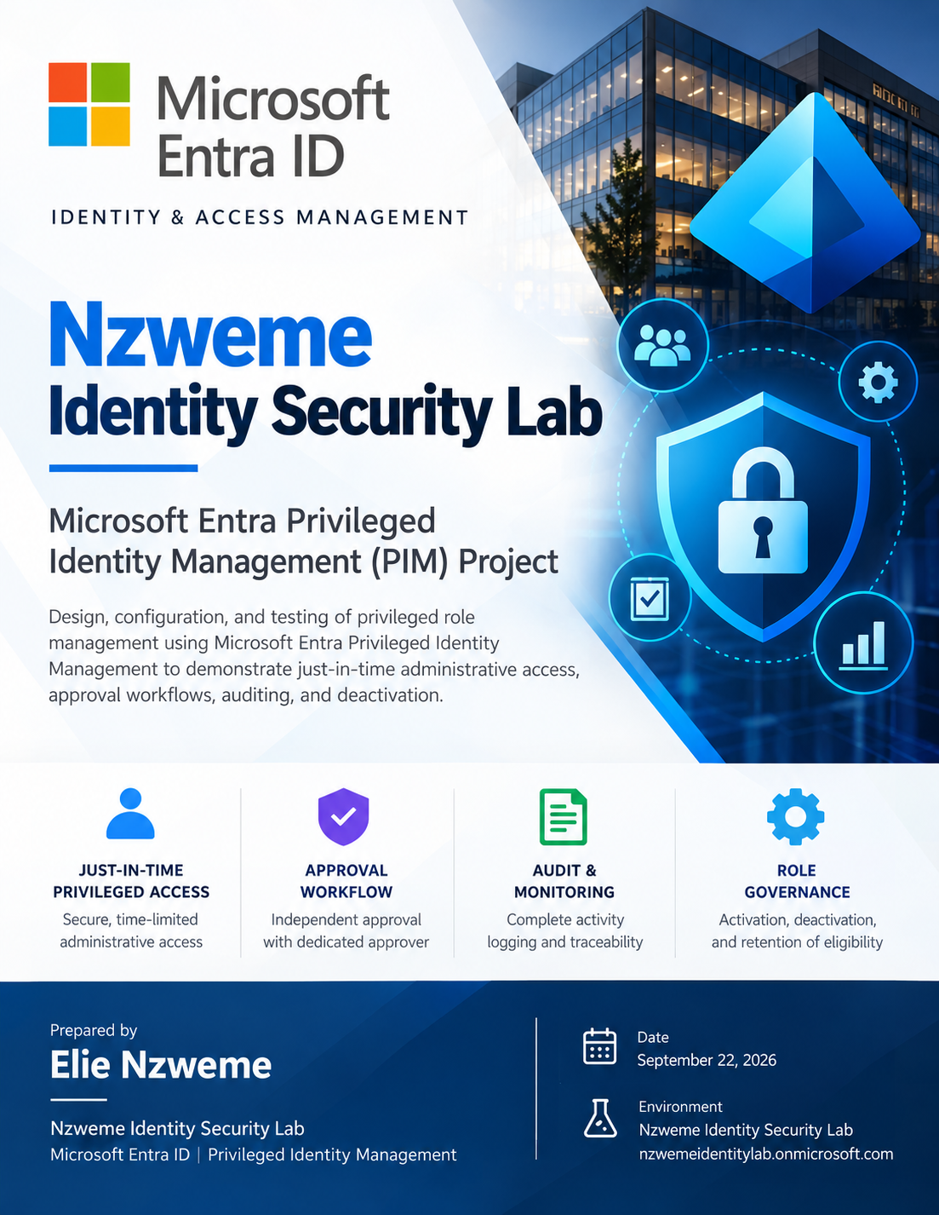

Microsoft Entra Identity Security & Privileged Identity Management Lab
Implementation record • September 22, 2026 • Prepared by Elie Nzweme
Evidence-ready project report | Insert screenshots at the labeled placeholders. Configuration details not visible in the supplied evidence are identified for verification.

1. Executive summary
This project established a Microsoft Entra identity security lab and demonstrated just-in-time privileged administration using Microsoft Entra Privileged Identity Management (PIM). The completed PIM exercise covered eligible Global Administrator assignment, activation policy, a separate approver, a one-hour activation request, approval, audit verification, and successful early deactivation. The lab also includes foundational tenant, custom-domain, emergency-access, and authentication-method work. Some broader identity-security controls remain planned rather than verified.

2. Objectives and scope
- Establish an isolated Microsoft Entra tenant for identity security practice.
- Identify lab tenant and PIM-specific accounts and responsibilities.
- Reduce standing administrative privileges by using eligible rather than permanently active Global Administrator access.
- Require MFA, justification, and independent approval before privilege activation.
- Validate traceability of the request, approval, activation, and deactivation lifecycle.
- Prepare evidence for a portfolio and subsequent Conditional Access, Identity Protection, and governance work.

3. Lab environment and identities
Component | Purpose / observed status
Tenant | Nzweme Identity Security Lab; tenant domain nzwemeidentitylab.onmicrosoft.com (as shown in screenshots).
Custom domain (not used in this documented exercise) | Not used or evidenced in this project. The screenshots show nzwemeidentitylab.onmicrosoft.com.
labadmin | Administrative configuration and resource-audit verification.
elie.admin | PIM-eligible Global Administrator; requester and temporary role holder.
pim.approver | Separate user designated as approver for Global Administrator activation; no direct role assignments shown on user overview.
Emergency-access accounts (outside evidence scope) | No screenshots supplied for this exercise; configuration and authentication methods not verified here.
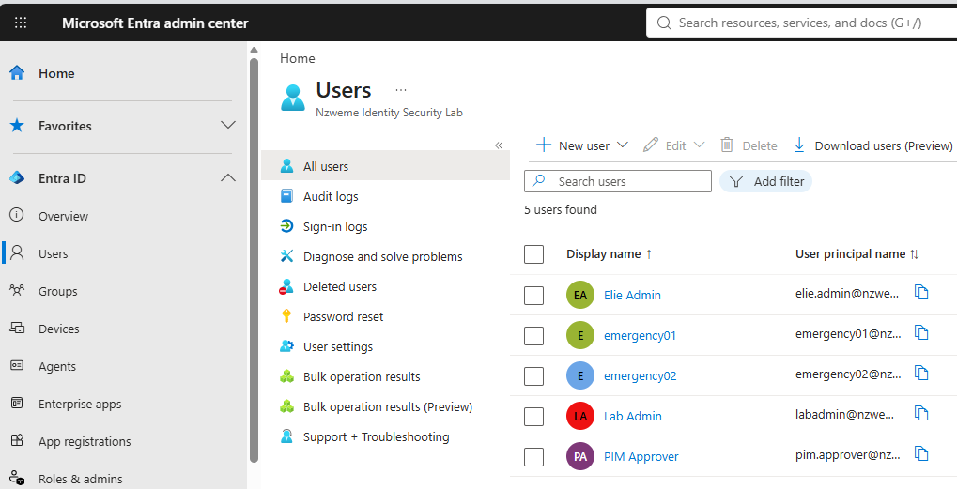

4. Tenant and foundational identity setup

4.1 Tenant and domain
Created and configured the Entra lab tenant, verified the custom domain elienzweme.com using Cloudflare, and tested email routing. The screenshots provided for this report chiefly document PIM; add tenant/domain screenshots to substantiate the earlier setup.
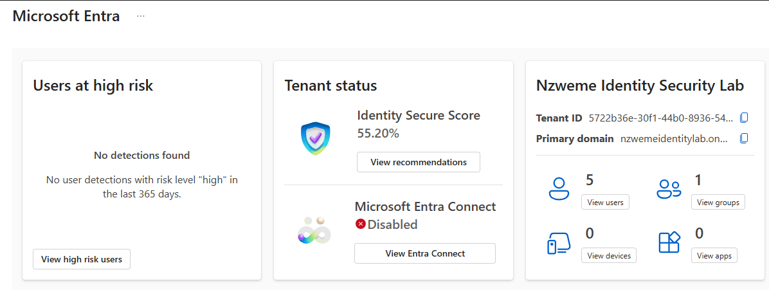

4.2 Emergency-access accounts
Created two emergency-access accounts, Emergency Access 01 and 02. Worked through Temporary Access Pass (TAP) and passwordless/authentication registration, including Windows Hello/passkey troubleshooting and phone-based authentication discussions. Emergency accounts are intended for recovery if normal privileged access is unavailable. Confirm current authentication methods, assigned roles, monitoring, and Conditional Access exclusions before claiming production-ready break-glass coverage.
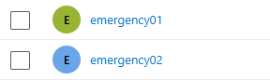

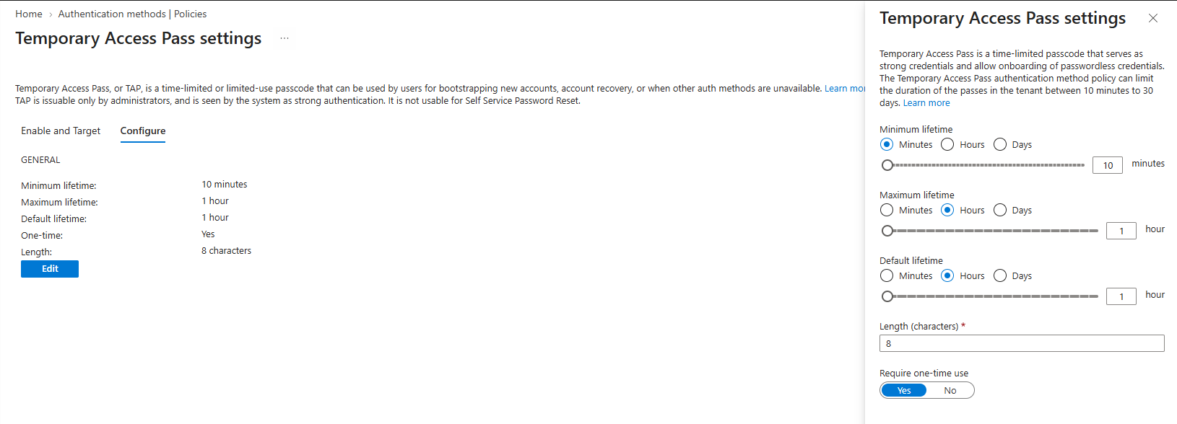
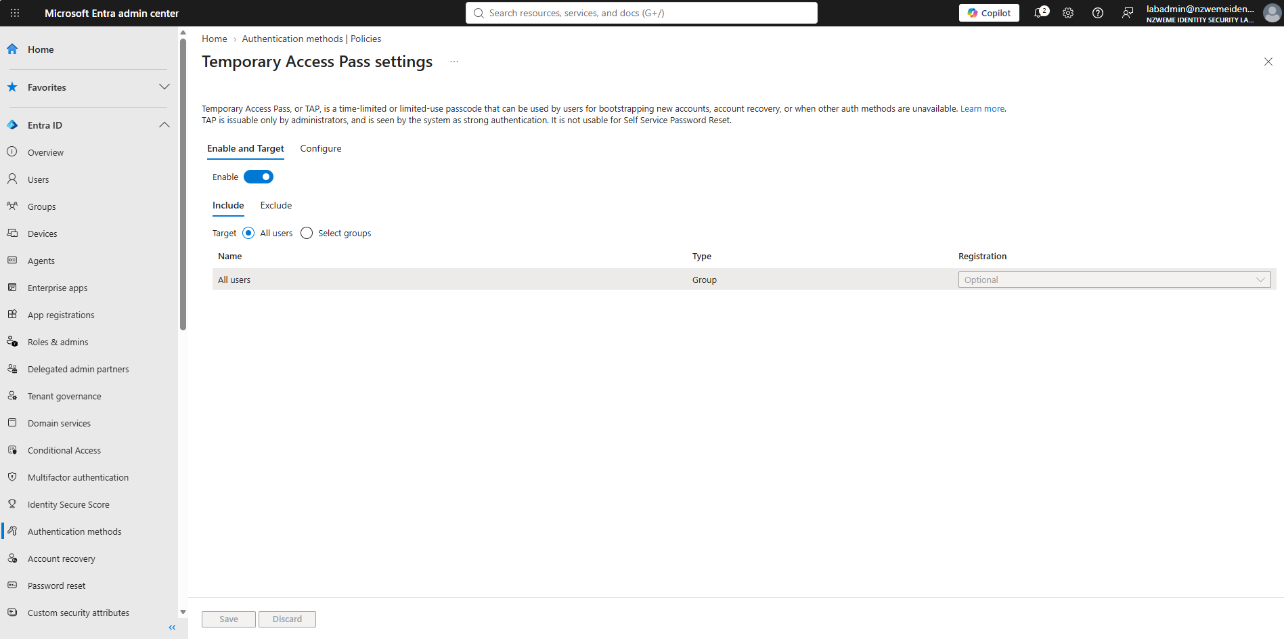
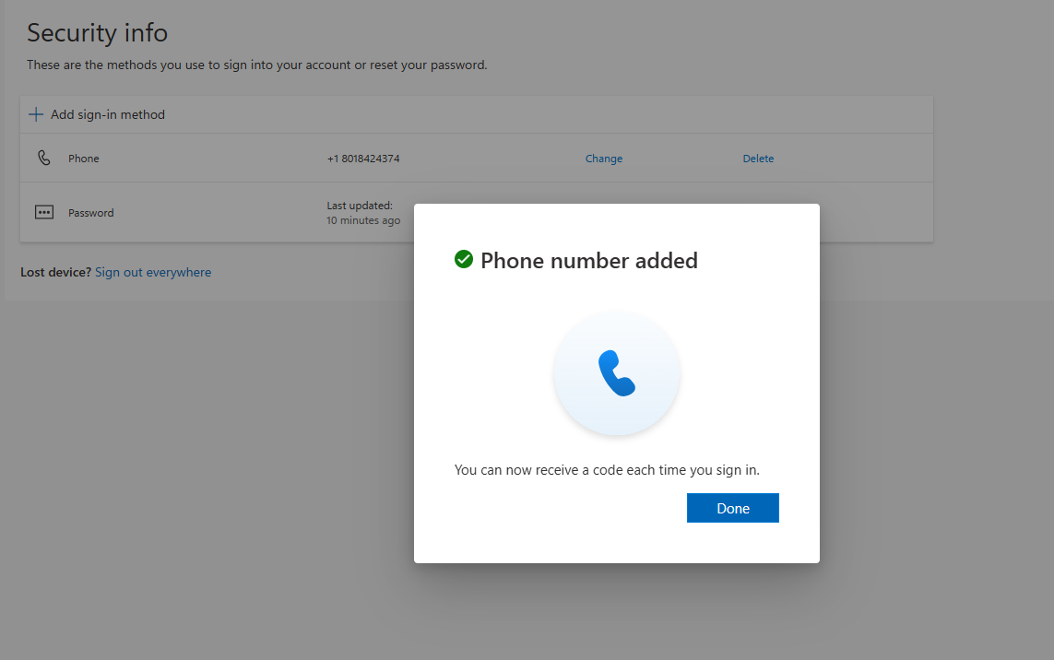
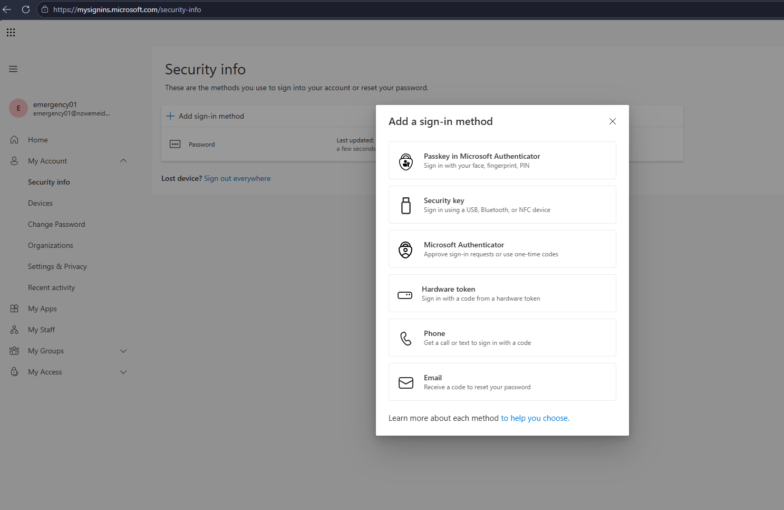

4.3 Authentication and Conditional Access baseline
Reviewed the proposed CA001 “Require MFA – All Users” policy and the need to exclude emergency-access accounts. The final enabled/report-only state and exact exclusion list are not demonstrated by the PIM screenshots and should be documented with policy screenshots. PIM activation was configured to require Azure MFA; this does not independently establish that every Conditional Access policy is enabled.

5. Privileged Identity Management implementation

5.1 Eligible Global Administrator assignment
Using an administrative session, assigned elie.admin as eligible for the Global Administrator role. The My roles view displayed Global Administrator under Eligible assignments with Direct membership, a Permanent eligibility end time, and an Activate action. “Permanent” describes the eligibility assignment, not a permanently active administrator role.
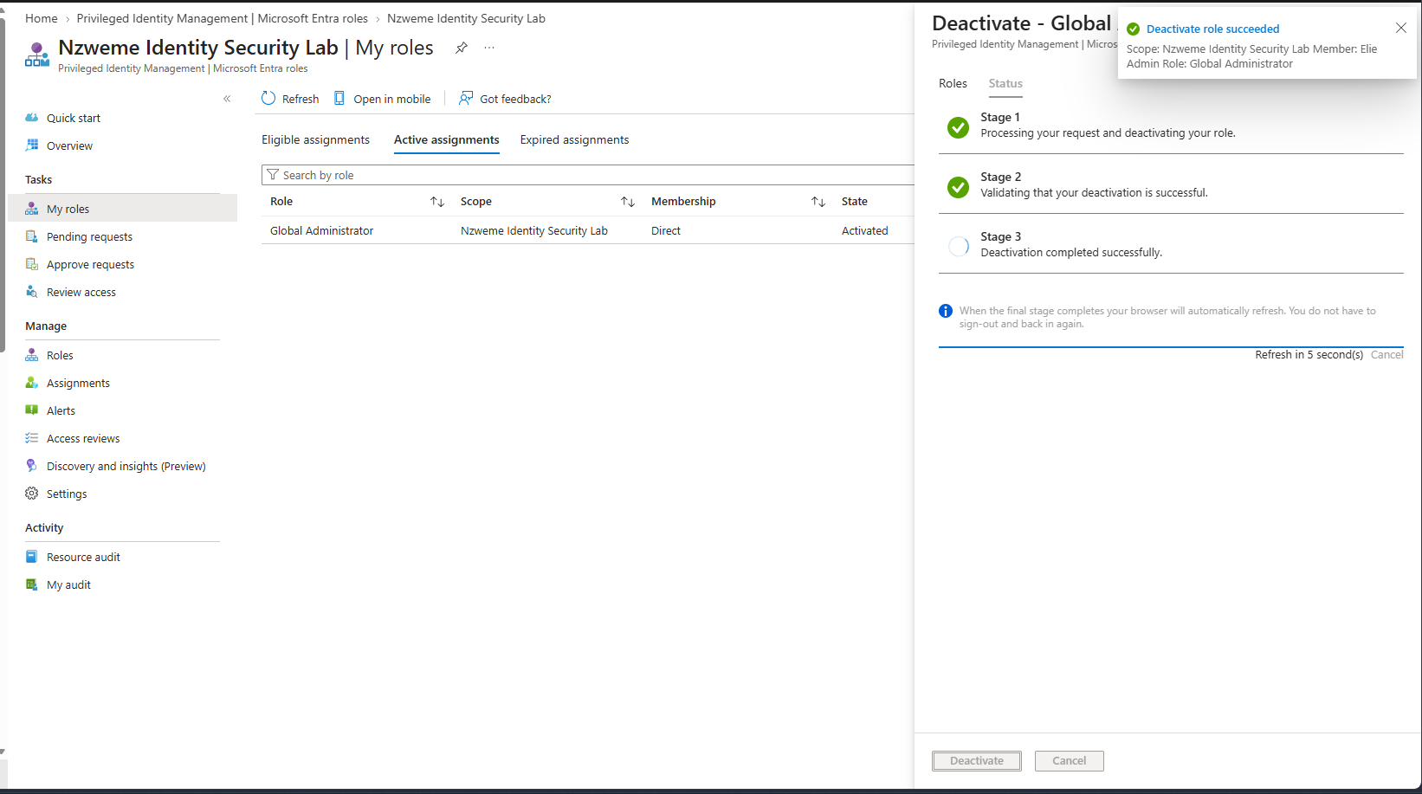

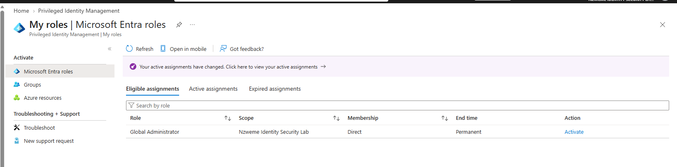

5.2 Activation policy
Configured Global Administrator PIM activation with a maximum duration of 1 hour, Azure MFA, required justification, and required approval. Ticket information and preview pre-/post-approval extensions were not selected in the captured policy. The configured approver was the separate pim.approver user.
Setting | Observed value
Maximum activation duration | 1 hour
On activation, require | Azure MFA
Justification | Required
Ticket information | Not required
Approval | Required
Selected approver | PIM Approver (pim.approver@ nzwemeidentitylab.onmicrosoft.com; remove space when entering)
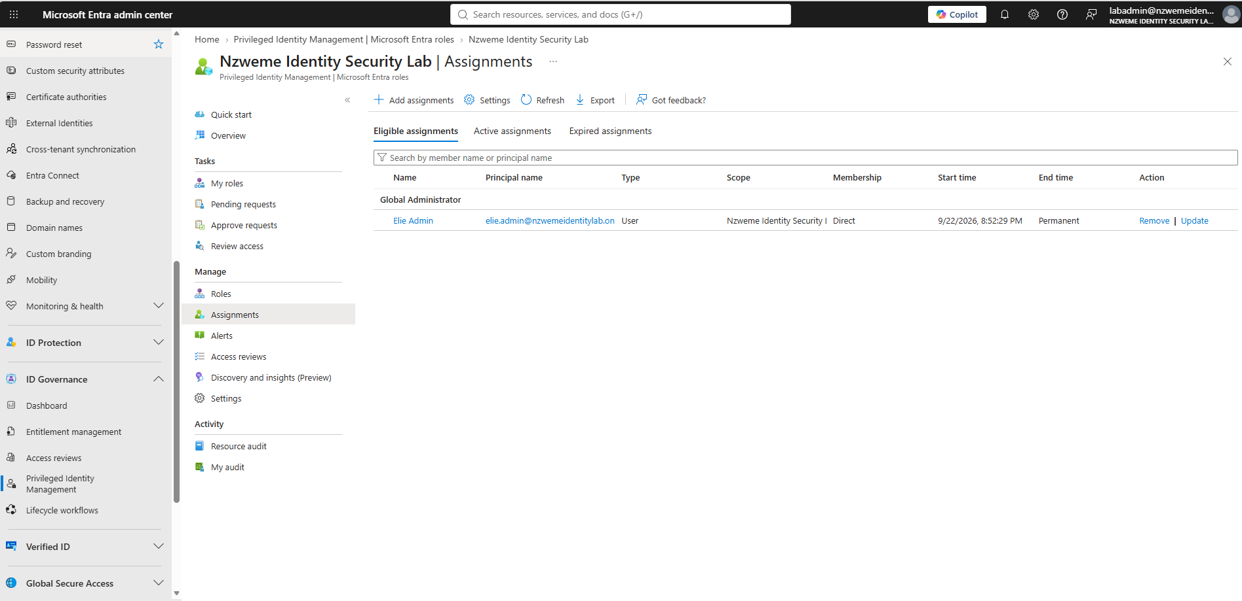

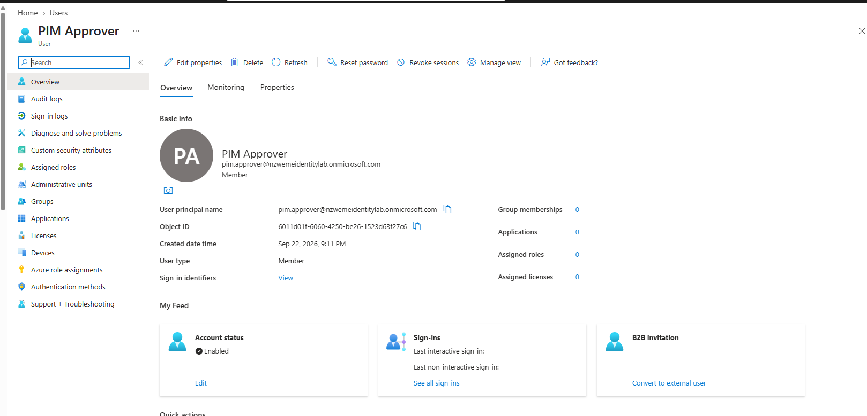

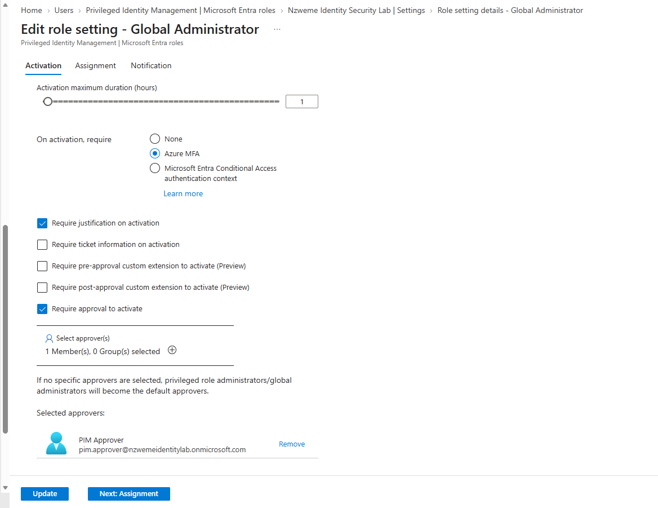

5.3 Requesting elevation
Signed in as elie.admin, opened PIM → My roles → Microsoft Entra roles → Eligible assignments, and selected Activate for Global Administrator. Entered the reason: “Authorized IAM lab administration to validate Microsoft Entra Privileged Identity Management, just-in-time Global Administrator activation, MFA enforcement, and privileged access audit logging.” Submitted the one-hour request. The portal indicated that the activation request was scheduled/pending approval.
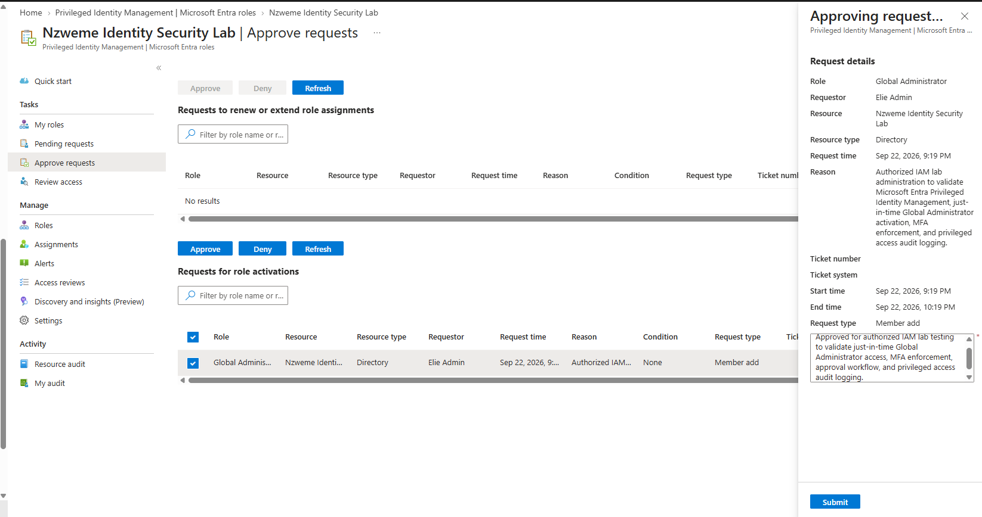

5.4 Independent approval
Signed in as pim.approver, navigated to PIM → Approve requests, and selected the request for role activation from Elie Admin. Reviewed the role, resource, request time, reason, and one-hour window. Entered an approval reason describing authorized IAM lab testing and submitted the approval. The portal displayed “Request(s) approved successfully.”
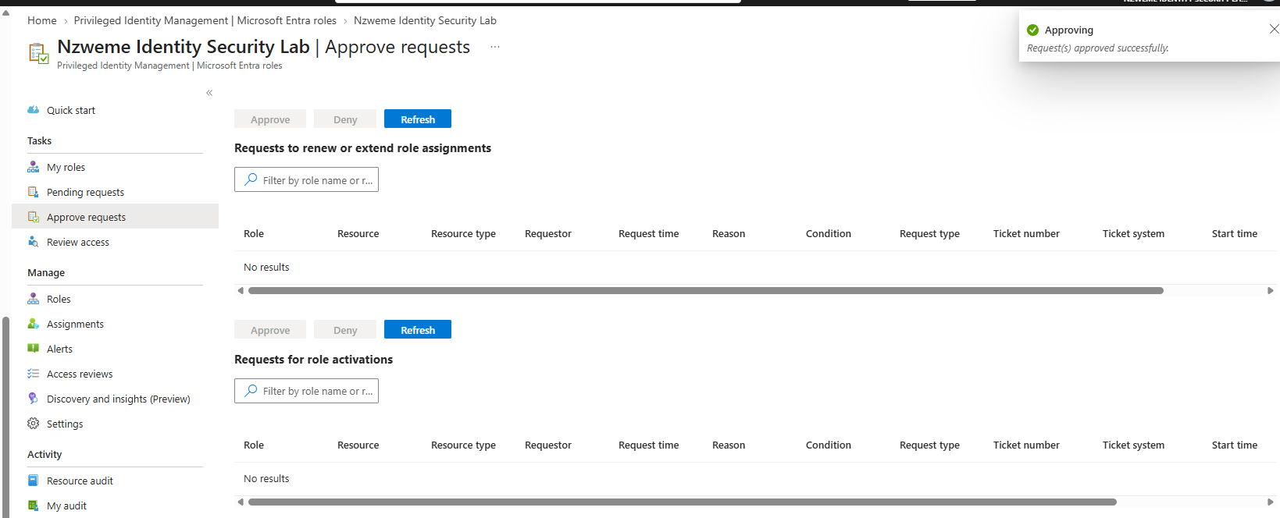

5.5 Successful activation
Returned to elie.admin and refreshed My roles. Global Administrator appeared under Active assignments with state Activated, Direct membership, and an end time of September 22, 2026, 10:32:08 PM. This verified the temporary role assignment in PIM.
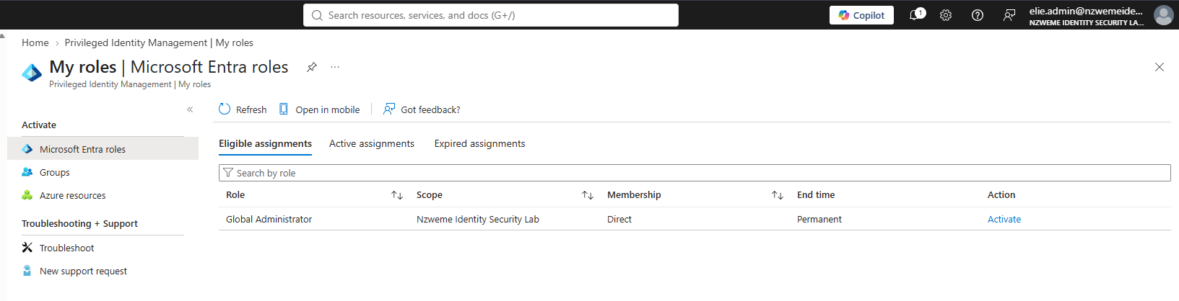

6. Audit evidence and timeline
Using labadmin, opened PIM → Resource audit, selected the relevant records, and inspected the audit details. The observed records below establish the sequence for the completed approval-controlled activation.
Local timestamp (Sept 22, 2026) | Requester / actor | Recorded action
9:19:03 PM | Elie Admin | Add member to role requested (PIM activation)
9:19:10 PM | Elie Admin | Add member to role approval requested
9:32:08 PM | PIM Approver | Add member to role request approved
9:32:16 PM | Elie Admin | Add member to role completed (PIM activation)
The activation audit detail showed status Succeeded, subject Elie Admin, target Global Administrator, and expiry at 10:32:08 PM. Earlier entries also showed PIM policy changes, eligibility assignment, a previous activation/deactivation cycle, and one unsuccessful time-bound request; these should not be conflated with the final successful approval test.
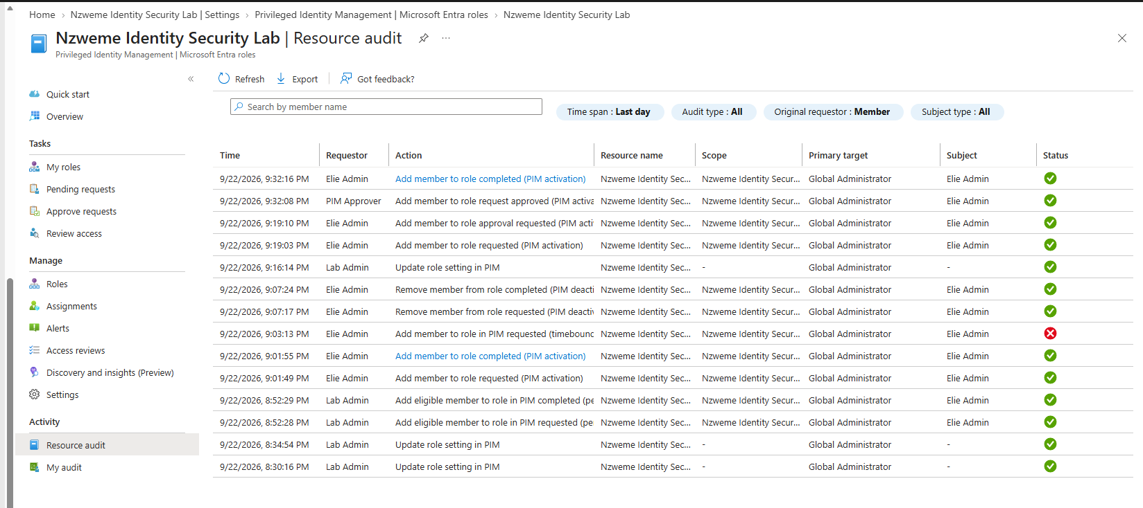

7. Deactivation and post-test validation
In the elie.admin session, opened PIM → My roles → Active assignments and selected Deactivate. The portal reported successful deactivation across three stages. After refresh, Active assignments displayed “No results”; Eligible assignments still listed Global Administrator with an Activate action. This confirmed removal of the temporary PIM role activation without deleting the underlying eligible assignment.
Important limitation: PIM state changes do not by themselves prove immediate invalidation of all previously issued access tokens. For sensitive validation, reauthenticate or obtain a fresh token and test privileged operations after deactivation.
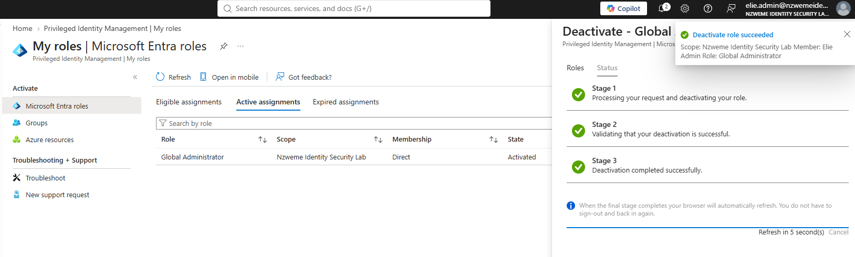

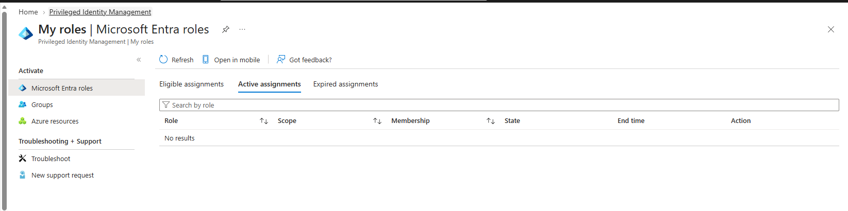

8. Results and acceptance criteria
Acceptance criterion | Result
Eligible role configured | Verified
MFA / justification / approval configured | Verified in role settings
Separate approver selected | Verified
Request submitted and approved | Verified
Temporary Global Administrator activation | Verified
Request, approval and activation audit events | Verified
Early deactivation | Verified
Eligibility preserved after deactivation | Verified
Emergency access and tenant-wide CA settings verified | Not assessed; outside supplied PIM evidence

9. Security design and lessons learned
- Separate requester, approver, and administrative configuration accounts to demonstrate separation of duties.
- Use time-limited privileged access rather than standing active Global Administrator permissions.
- Record a meaningful business justification and review audit trails for privileged actions.
- Treat emergency-access identities differently from routine administrator accounts and test recovery safely.
- Distinguish PIM audit events, Conditional Access enforcement, and token/session behavior; each requires its own verification.

10. Follow-on work
- If extending this project, configure and separately document Conditional Access policies, exclusions, and test results.
- If extending this project, separately document emergency-access accounts, authentication methods, alerts, and recovery tests.
- Configure and test Identity Protection and self-service password reset where licensing permits.
- Implement access reviews for privileged role eligibility and selected groups.
- Extend the lab with Entra governance and hybrid identity integration; document design and testing separately.
- Export and securely archive PIM audit logs; remove sensitive account identifiers or secrets before publishing publicly.

11. Evidence index and publication checklist
Replace each placeholder with a screenshot and caption. Blur personal identifiers, tenant IDs where appropriate, QR codes, Temporary Access Passes, tokens, and any credentials. For every screenshot, include account context, navigation path, date, observed outcome, and whether the evidence is from the final test.
Document status: The PIM workflow was completed and verified on September 22, 2026. This report is limited to the tenant identity and PIM actions supported by the supplied screenshots.

