Project by: Elie Bou Saba and Alexandre Medawar

Human Resource Management:

A brief summary:

Mainly the project is about managing employees and vacancies in the government ministries. These vacancies are offered to citizens that sign up to our website and fill an application including all information with their CV included.

Textual description:

* For citizen: Our website offers viewing all ministries, vacancies and employees in details that exists in our government. The user can sign up by filling an application so that all his information which includes also his CV will be saved in a specific table in the database.
* Admin side: The admin which in our case is an HR employee possess the privileges to add, update or delete an employee in a ministry and also have access to add, update or delete vacancies in our government.

Database modelling:

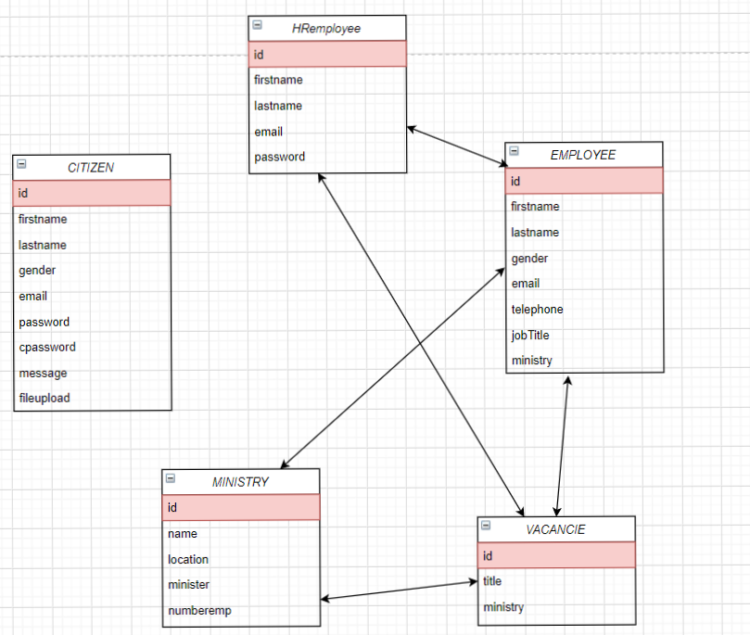

Screenshots for some pages:

* Login: The login button will take us to this login form where the HR employee (admin) can log in and also the citizen can log in. If the citizen did not have a user yet he will register to fill an application.

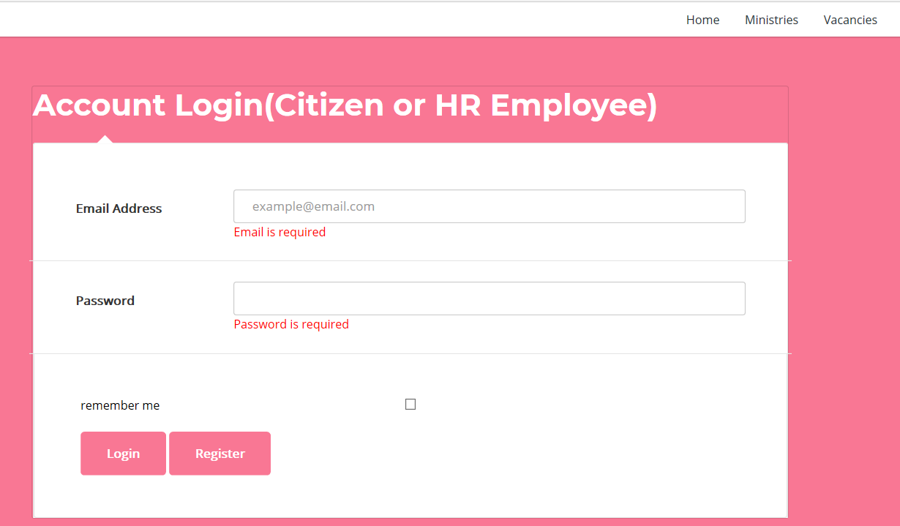

* Register: The register button will take us to the form that the citizen will fill which includes his own info and he uploads his CV which we save it in the table citizen in the database.

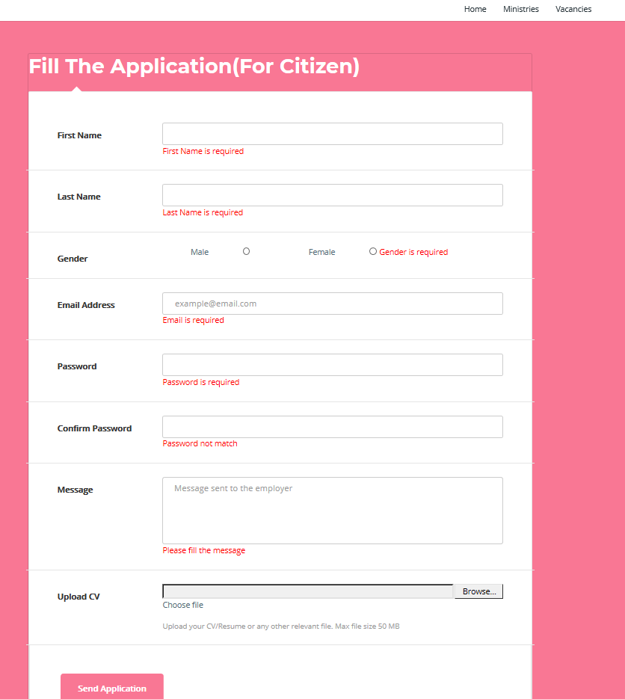

* Ministries: This page contains all ministries in our government and each ministry when we click it will bring from the database the info of this specific ministry and will show it on the page.

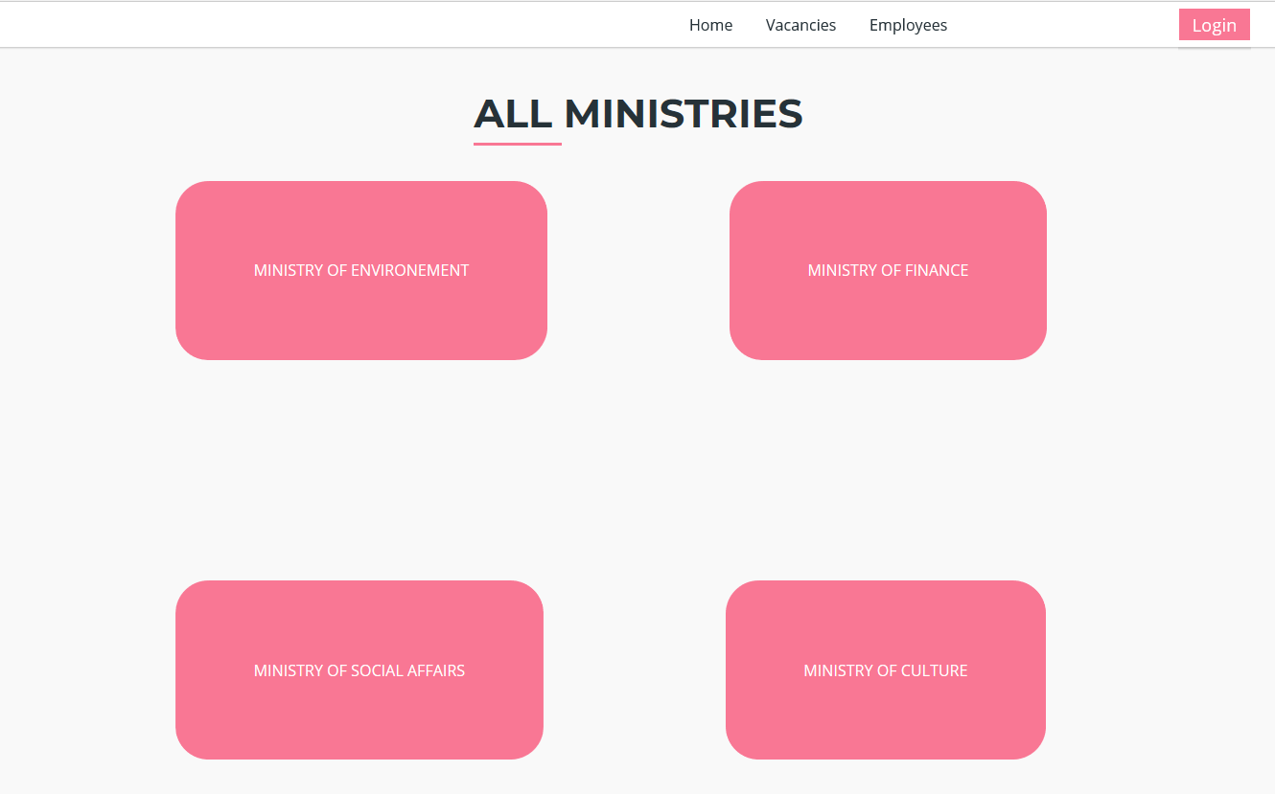

* Example of a ministry: To get the number of employee in this ministry a query was made on the employee table in this database to know how many employees are associated to this ministry

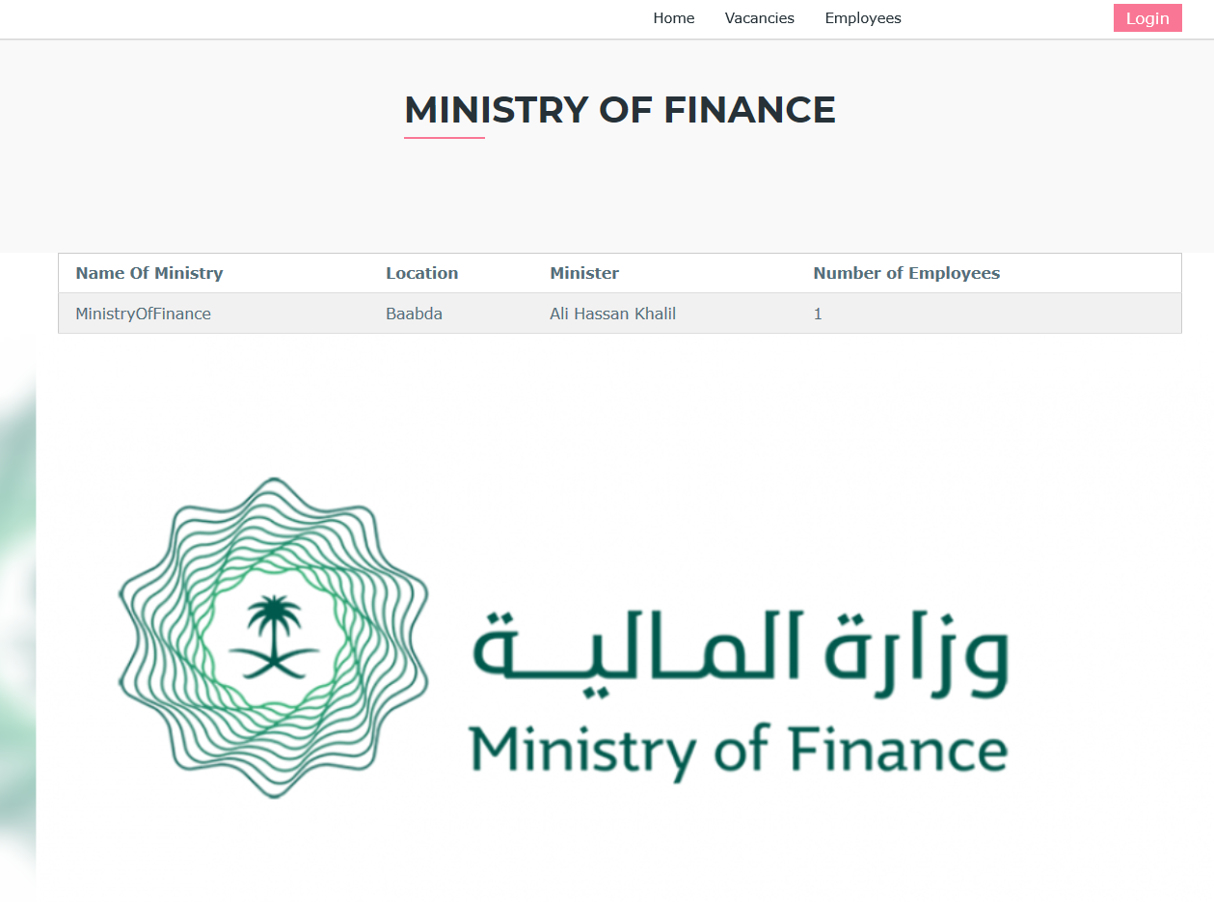

* Vacancies: In this section we offer the vacancies related to the ministries with a filter that filters vacancies in which ministry the user want to see. When the user clicks on a ministry in this table we will take him to the info related to this ministry.

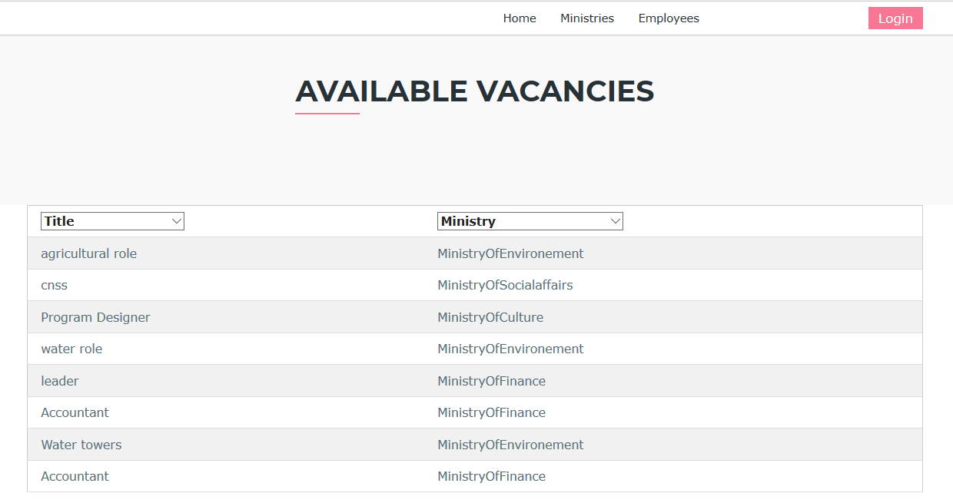

* Employee: In this section we bring from the table employee in the database all the info about all employees and we output it.

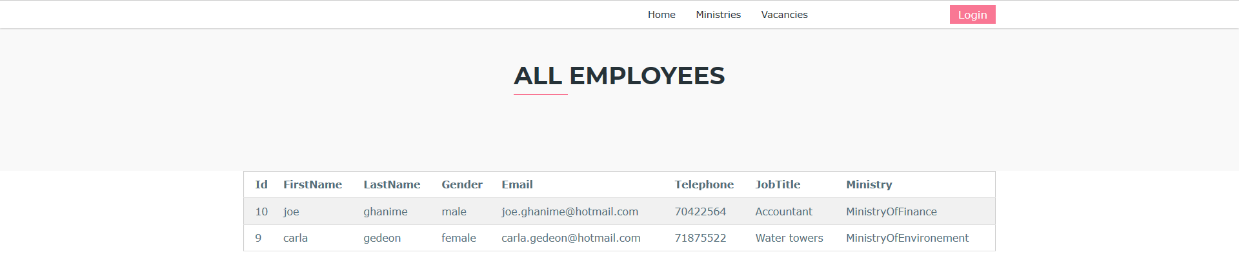

* Citizen Logged in: After the citizen has logged in we will take him to the home page while logged to the website and he could see his profile by clicking the view profile in the navigation bar.

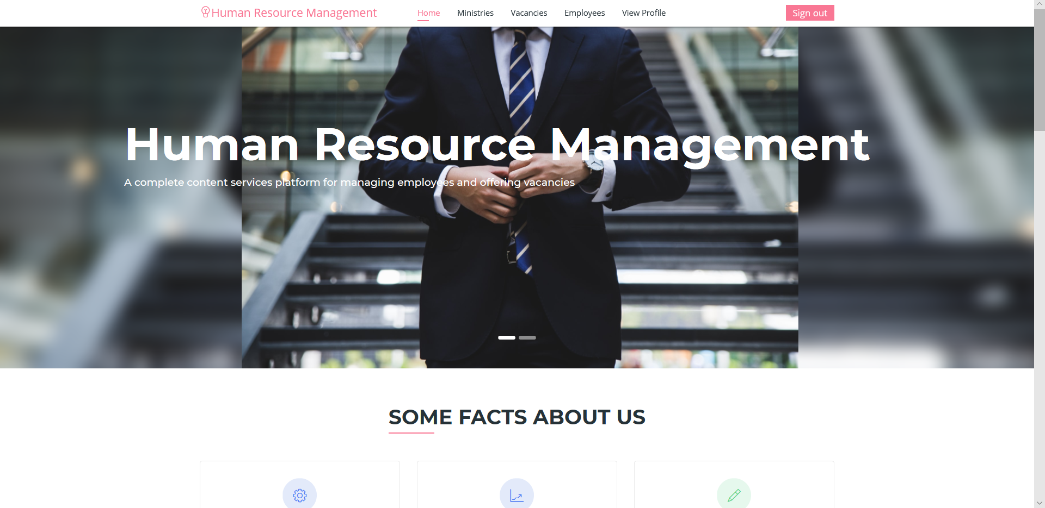

* Admin (HR employee) logged in: After the admin has logged in we will take him to a page where he could manage all employees and all vacancies in the government.

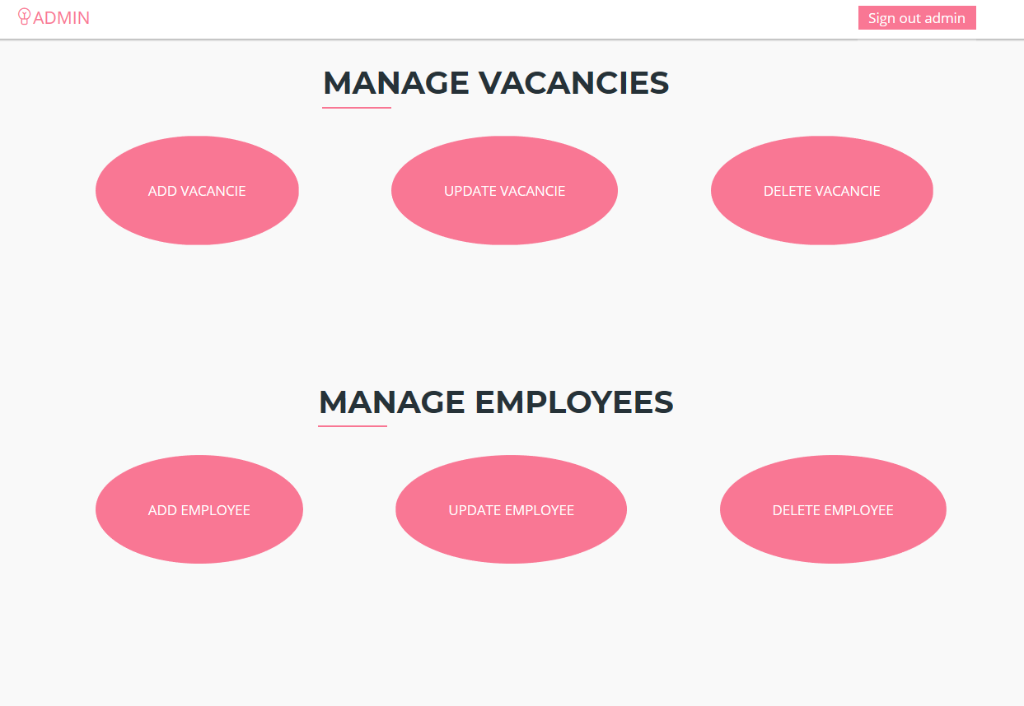

* Add vacancies: the HR employee will be able to add a vacancies while filling a form.

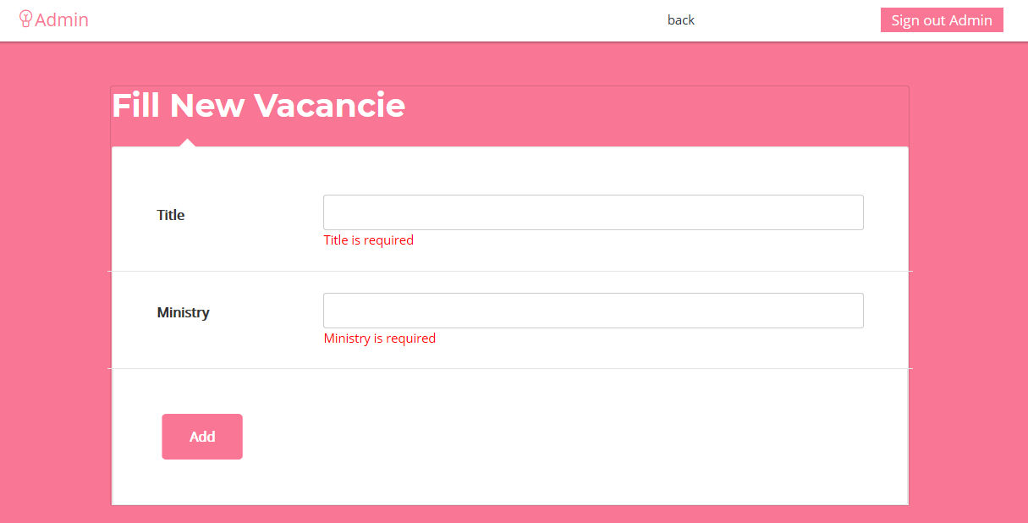

* Update/Delete vacancies: the HR employee will be able to update or delete vacancies.

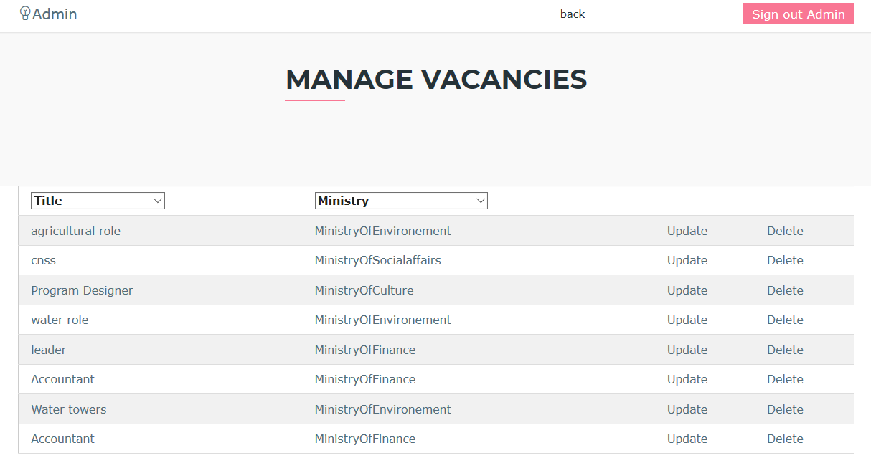

* Add employee: the HR employee will be able to add employees while filling a form.

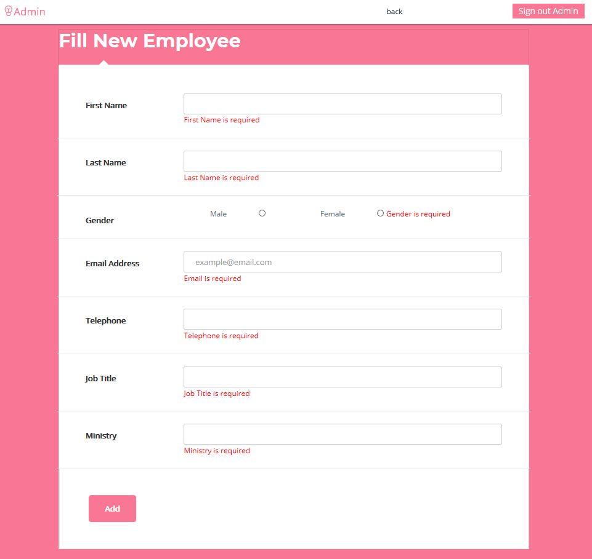

* Update/Delete employees: the HR employee will be able to update or delete employees.

