What should a Hong Kong host charge?
A machine-learning pricing benchmark for short- and mid-term rentals
IS3240 Advanced Business Programming in Python · Group Project report · Group: [Group name] · Members: [names and SIDs] · 18 November 2026

Executive summary
The decision. Hong Kong hosts and property managers must set a nightly price for every listing, but the market is really two markets: 43% of listings require a stay of 28+ nights (monthly rentals), which are priced at a fraction of a tourist night. Most operators price by eyeballing a few comparable listings. We ask whether machine learning in Python can give them a better, explainable price benchmark, and whether following it matters commercially.
What we did. We combined Inside Airbnb's Hong Kong listings (snapshot of 25 Sep 2026) and 122,715 guest reviews with MTR-station locations collected from OpenStreetMap. After documented cleaning we modelled 5,555 bookable listings from 1,175 hosts. We compared a comparable-listings baseline with ridge regression, random forest and gradient boosting, validating on hosts the model had never seen.
What we found.
- The benchmark works, with honest limits. On unseen hosts, the random forest model cuts the pricing error by 21% versus comparable-listings pricing (MAE 280 vs 354 HKD; 95% CI 16%–27%); the typical miss is 25% and 43% of listings are predicted within ±20%. A price band that is nominally 80% covers 79% of unseen listings.
- Stay length is the master variable. A monthly-stay policy is associated with a price 37% lower per night after controlling for everything else (the stay policy is the largest single gain in accuracy, worth 13 points of typical error), and weekend check-ins with roughly 10–30% higher prices on short stays. Whole homes carry a +52% premium.
- Transit access is not what the market prices. With a median listing only 290 m from an MTR station, distance to the MTR and to Central adds almost nothing once district and property are known (-0.6% per +500 m, not significant). District, size and who the host is matter far more.
- The commercial risk sits above the benchmark. 52% of listings are in line, 21% are ≥25% above and 27% ≥20% below. Each +10% above benchmark is associated with about 6%–7% fewer reviews (a demand proxy): the priciest quintile (about 65% above) gets 5.1 reviews a year against 9.7 for listings in line, while discounts of 23%–42% below benchmark bring only 11.5 and 10.1 – little extra demand for a lot of foregone price.
What we recommend. Price with a benchmark band rather than a single number, separate weekday, weekend and monthly prices, treat the price-gap audit as a trigger for review (especially listings far above benchmark), and use the segment map to choose where to compete. The notebook ships the benchmark as a reusable function and a listing-level price audit file.

1. Business problem and motivation
Short-term rental platforms have turned thousands of Hong Kong flats into accommodation, from spare rooms to whole flats run by professional operators (hosts with five or more listings own 73% of all listings; the largest runs 344). Every operator faces the same recurring question: what nightly price should this listing carry? Too high and the listing sits empty; too low and revenue is given away on every night booked. The question is harder here than in most cities for two reasons. First, the market is two markets: Hong Kong requires a licence for accommodation let for fewer than 28 consecutive days (Hotel and Guesthouse Accommodation Ordinance, Cap. 349), and 43% of listings set a minimum stay of 28 nights or more. Second, price depends on many interacting attributes (district, size, transit, amenities, host type), and operators typically fall back on looking at a handful of 'comparable' listings.
Our objective is a pricing benchmark that (i) predicts a fair asking price and a plausible band from information available before the first guest arrives, (ii) explains what drives price and by how much, (iii) flags listings priced far from the benchmark, and (iv) tests whether being priced above or below it is associated with demand. The users are hosts and property managers (set and review prices, decide on upgrades), investors (choose segments and districts) and, indirectly, platforms and policy makers (size of the monthly segment). Machine learning is appropriate because the relationship between attributes and price is non-linear and interacting, the data are rich (91 columns, 122k reviews), and the benefit of better pricing recurs with every listing and every night. The report follows the story-telling logic of the course – why the question is valuable, which factors matter and why, how they are computed, why the models are suitable, and how well they perform – and then turns the result into decisions.

2. Data and preparation
Sources. (1) Inside Airbnb detailed listings for Hong Kong: 6,614 listings × 91 columns, scraped 25 Sep 2026. (2) Inside Airbnb reviews: 122,715 comments on 3,731 listings (2011–2026). (3) 98 Hong Kong MTR stations that we collected from OpenStreetMap through the Overpass API (a web-data-collection step using requests and JSON, as in Week 4), removing Shenzhen stations and Light Rail stops and caching the result for reproducibility. The summary listings file was only used for checks (its price agrees with the detailed file for just 39% of listings, so the files are not mixed).
Two properties of the data shape the whole project. First, the price field is the price per night of a price quote for a specific stay; the quoted length equals the host's minimum nights for 92% of listings. A nightly price is therefore not comparable between a 1-night and a 30-night stay, so stay length must be a core factor. Second, the license column is completely empty, so the legal status of listings cannot be analysed and we do not pretend to.
Table 1 – Data preparation: every removal is counted.
Cleaning step | Listings left | Removed | Business reason
Listings in the detailed file | 6,614 | – | –
Drop listings without a price quote (mostly not bookable) | 5,603 | 1,011 | 66% cannot be booked (availability 0); rest have no quote
Drop listings without minimum-nights policy | 5,584 | 19 | Cannot be assigned to a stay regime
Drop implausible prices (< 50 or > 7,534 HKD) | 5,555 | 29 | Data errors (e.g. a 0.73 HKD tent) and the top 0.5% (> 7,534 HKD): outside typical host pricing

The modelling sample therefore has 5,555 listings (84% of the file) with a median price of 471 HKD per night. The price is strongly right-skewed (skewness 3.1), so we model log-price, which makes errors percentages – the way a host thinks ("I am 20% above market").

3. Understanding the market before modelling
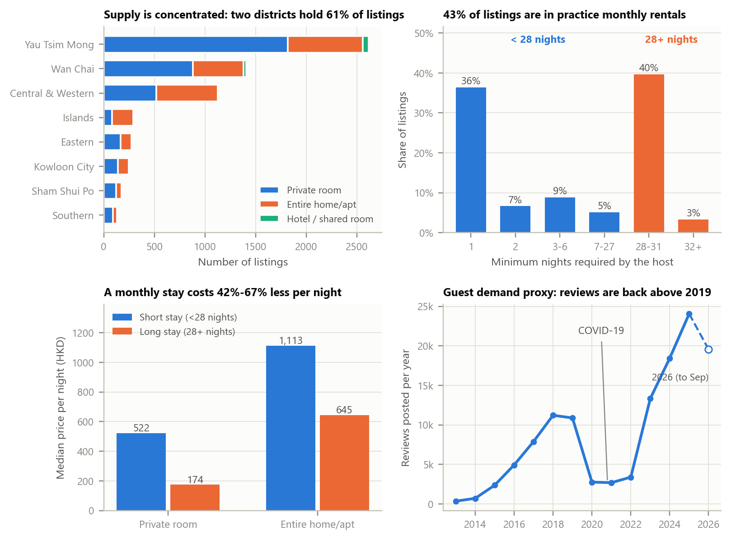
Figure 1 – The market at a glance. (a, b, d) all 6,614 listings / all reviews; (c) the modelling sample. Source: Inside Airbnb, 25 Sep 2026; authors' analysis.
Figure 1 gives four facts that structure the analysis. Supply is concentrated: Yau Tsim Mong and Wan Chai hold 61% of listings, and private rooms are 61% of all listings. Monthly rentals are a market of their own: 43% of listings require 28+ nights, and their nightly price is 67% lower for private rooms and 42% lower for whole homes. Demand has recovered: review activity (a demand proxy) fell during COVID-19 and is now above 2019. Finally, raw geography is a weak signal: because supply is built where transit is, half of all listings are within 300 m of an MTR station, and median prices relative to similar listings are flat across distance bands (about -1% within 250 m versus 6% at 1–2 km). Premiums appear mainly outside the urban core. This warns that location effects are entangled with the type of property offered, which is why a multivariate model is needed.
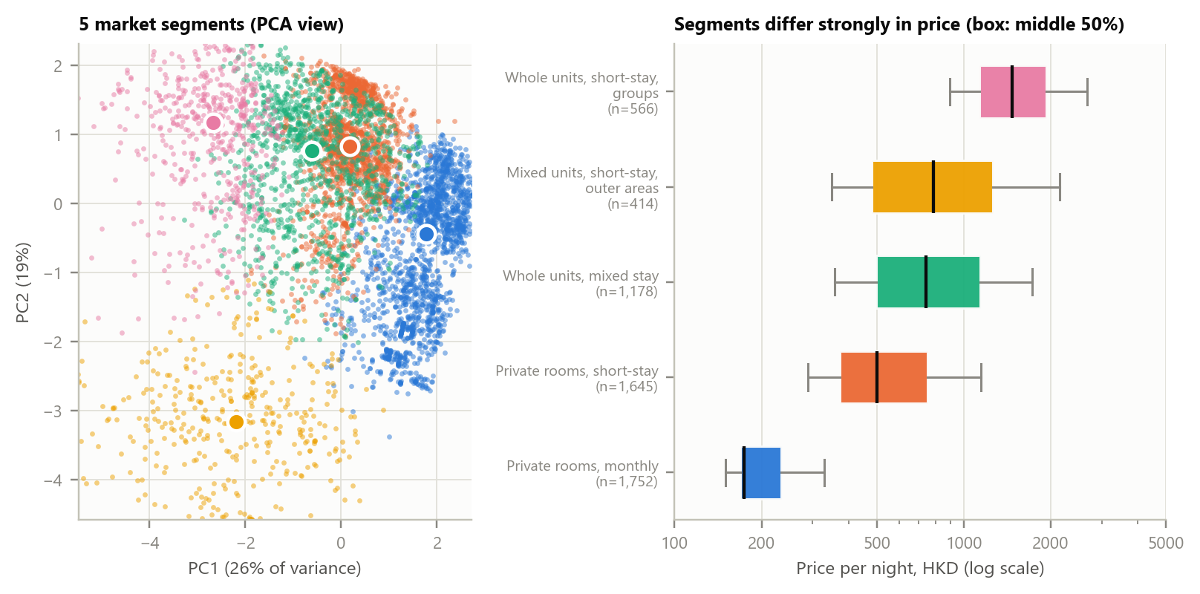
Figure 2 – Five market segments found with KMeans (k chosen by silhouette, every segment ≥ 3% of listings; price was not an input) and their price distributions.
Table 2 – Market segments.
Segment (KMeans) | Share | Median price (HKD) | Monthly stays | Median guests | Pro hosts (5+)
Private rooms, monthly | 32% | 174 | 97% | 1 | 98%
Private rooms, short-stay | 30% | 500 | 4% | 2 | 83%
Whole units, mixed stay | 21% | 739 | 37% | 2 | 61%
Whole units, short-stay, groups | 10% | 1,470 | 16% | 7 | 55%
Mixed units, short-stay, outer areas | 7% | 787 | 16% | 2 | 25%

The segmentation reveals an industrial structure hidden behind the word 'Airbnb': the largest segment (private rooms, monthly, 32% of listings) consists of single-guest rooms rented by the month at a median of 174 HKD per night, and 98% of them are run by professional hosts – a co-living-style business, not tourism. A host should benchmark against their own segment, and an investor should choose a segment before choosing a district.

4. Method: from useful factors to a benchmark you can trust
Factors and why they should matter. We follow hedonic pricing theory (Rosen, 1974): a listing is a bundle of attributes and its price reflects what guests pay for each. We built 66 launch-time factors in eight families, each with a business rationale (Table 3); all are computed in Python from the raw files (regular expressions for bathrooms and text, JSON parsing and flags for amenities, haversine/BallTree distances to MTR stations and hubs). A separate set of ratings and review-text factors exists only after a listing has guests; it is excluded from the benchmark for new listings and used in a second model for existing ones. We deliberately excluded the quote's lead time because it partly reflects demand (leakage).
Table 3 – Launch-time factor families.
Family | # factors | Examples and rationale
Property & capacity | 8 | Room/property type, guests, bedrooms, baths, shared bathroom – space and privacy are what guests buy
Stay policy & quote | 4 | 28+ night policy, quoted nights, weekend check-in – defines the customer and the quote being priced
Location | 4 | District, region, coordinates – neighbourhood prestige
Transit & centrality | 5 | Distance to nearest MTR, stations within 1 km, distance to Central/TST – Hong Kong is a transit city
Local competition | 2 | Listings within 500 m / 1 km – substitutes vs. proven tourist area
Amenities | 31 | 30 most common amenities + count – convenience guests trade money for
Host profile | 2 | Professional host (5+ listings), host lives in HK – operators price differently (richer host-history variables were tested and dropped: they did not generalise to unseen hosts)
Listing text | 10 | Keyword flags (luxury, view, MTR…) and length – how the listing is marketed

Models and evaluation design. The benchmark every model must beat is what hosts do today: the median price of comparable listings (same district, room type and stay regime). We compare it with ridge regression (transparent linear logic), random forest and gradient boosting (non-linear effects and interactions without hand-made terms) and a blend. Three design decisions protect credibility: (1) we split and cross-validate by host (80/20 on 1,175 hosts; no host appears on both sides), because a professional host's near-identical listings would otherwise let the model memorise them and inflate accuracy; the hold-out was chosen among 300 host-level splits for composition (stay regime, room type, price level) only, since one host owns 344 listings; (2) all preprocessing lives inside a scikit-learn Pipeline (imputation, one-hot encoding, scaling are learned on training folds only); (3) models are selected by cross-validation on training data and the 1,169-listing test set is used once. Metrics are business-first: MAE in HKD, median absolute % error, and the share of listings predicted within ±20%.
Table 4 – Key analytical decisions.
Decision | Why (business or statistical reason)
Treat stay length as a core factor and segmentation (28+ nights) | The price is a quote for a specific stay and monthly stays cost a fraction per night; it is the largest single gain in accuracy
Drop un-priced listings; trim prices < 50 HKD or above the 99.5th percentile | A benchmark is about bookable listings; removes data errors and a few luxury outliers that dominate squared error (Table 1)
Model log-price | Errors become percentages (how hosts think) and skewness falls from 3.1 to 0.4
Split and cross-validate by host; choose a representative hold-out by composition only | Prevents memorising professional hosts; one host owns 344 listings, so a random split can be badly unbalanced
All preprocessing in a Pipeline; select by CV; use the test set once | No leakage; the test result is an honest estimate
Benchmark = comparable-listings pricing | The business question is 'better than what I do today?', not 'better than the global median'
Keep only two host flags; exclude quote lead time and, for new listings, ratings and reviews | Host-history variables did not generalise to unseen hosts; lead time leaks demand; new hosts have no reviews
Segment with KMeans without price; k by silhouette with segments ≥ 3% of listings | Price differences between segments are findings, and every segment is big enough to act on
Interpret with a hedonic regression, clustered by host; say association | Observational data; a host's listings are not independent; no causal claims
Report a band and verify its coverage; drop the amenity-uplift ranking | Avoids false precision; amenity 'uplifts' were unstable and mostly mark listing type, so we show levers on one realistic profile instead

5. Results

5.1 The benchmark beats comparable-listings pricing
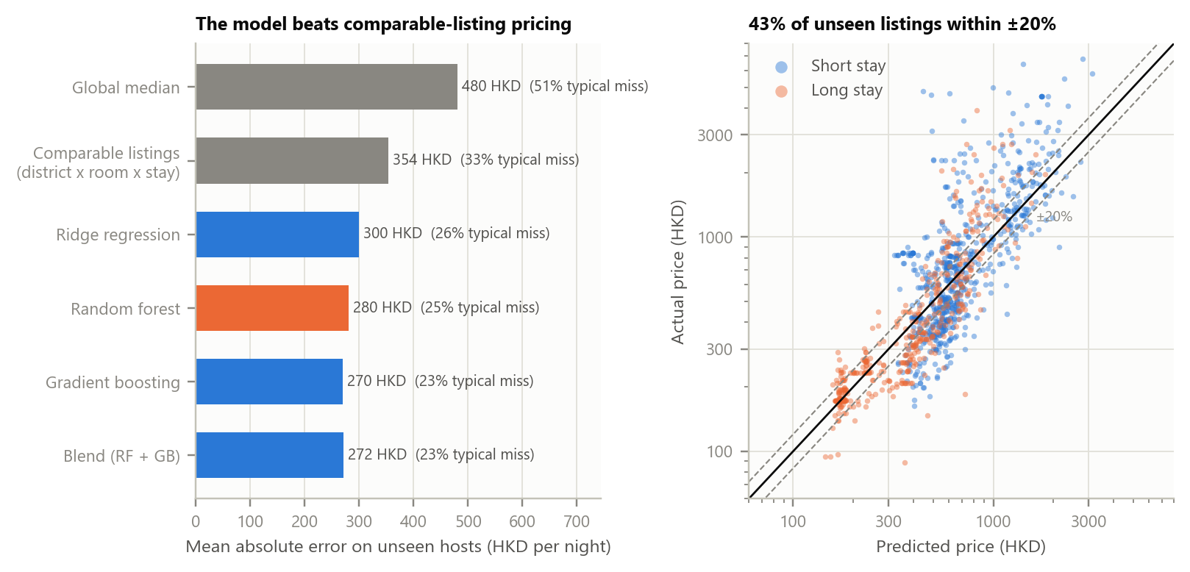
Figure 3 – Performance on 1,169 unseen listings (235 hosts not used in training). Left: mean absolute error; right: predicted vs. actual price (dashed lines ±20%).
Table 5 – Model comparison on held-out hosts. The model selected by cross-validation is highlighted.
Model (test set) | MAE (HKD) | RMSE (HKD) | Median % error | Within ±20% | R² (log price)
Global median | 480 | 870 | 51.4% | 19% | -0.03
Comparable-listings baseline | 354 | 714 | 32.6% | 33% | 0.51
Ridge | 300 | 626 | 26.0% | 40% | 0.68
Random forest | 280 | 590 | 24.7% | 43% | 0.72
Gradient boosting | 270 | 558 | 22.8% | 44% | 0.73
Blend (RF + GB) | 272 | 571 | 23.3% | 44% | 0.73

The random forest was selected by cross-validation on the training hosts and reduces MAE by 21% against comparable-listings pricing (95% host-bootstrap CI 16%–27%); gradient boosting is on par (MAE 270), so the conclusion does not hinge on the model family. On all 5,555 listings, host-grouped cross-validation gives the same picture (MAE 258 vs 335 HKD; typical error 21.0%). A typical miss of about a quarter is not a precise price – asking prices are noisy and many hosts price by habit – which is why the tool reports a band, and why we are explicit that this is a benchmark, not an oracle. Accuracy varies: monthly private rooms are predicted best (median error 11%), short-stay private rooms worst (32%), and thin districts such as Sai Kung are unreliable (few listings).

5.2 Where does the accuracy come from?
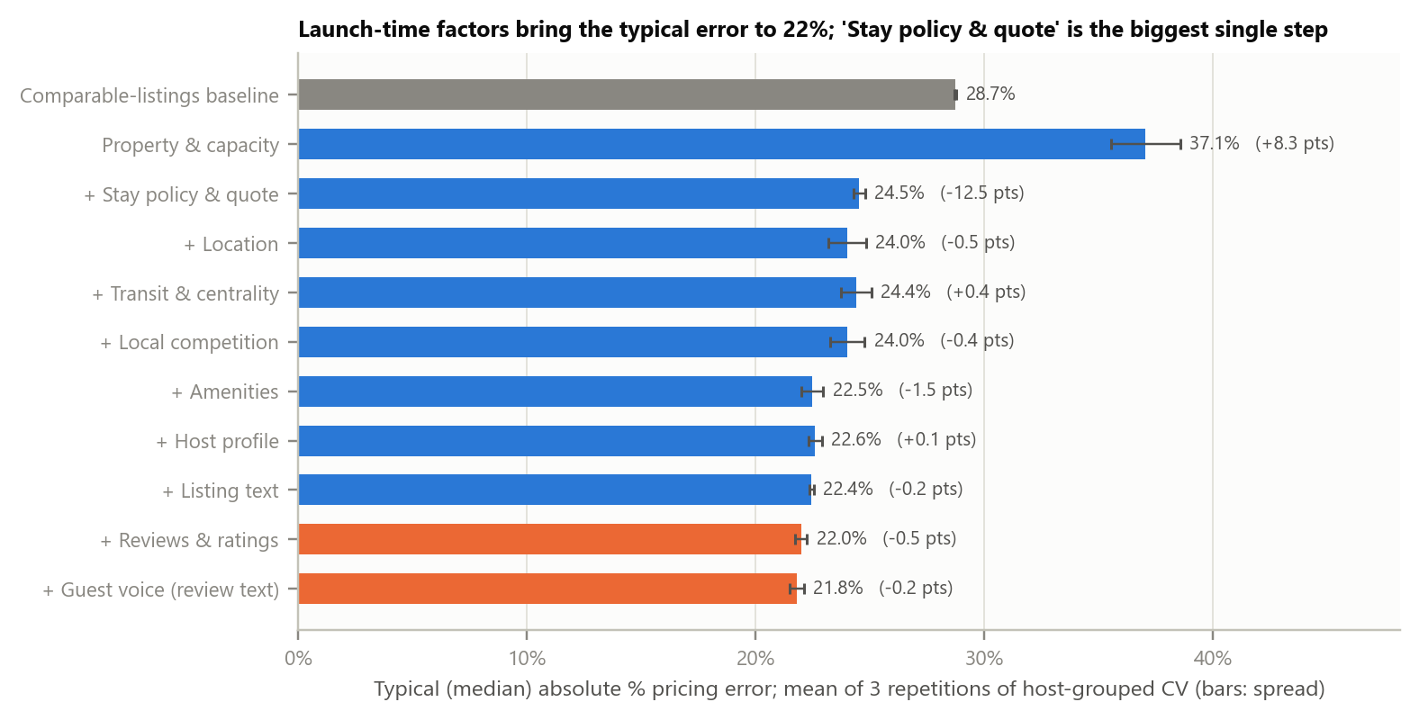
Figure 4 – Ablation: typical pricing error as factor families are added (gradient boosting; 3 repetitions of host-grouped 5-fold CV on all listings; blue = known at launch, orange = only after guests).
Property attributes alone give a typical error of 37% – worse than the comparable-listings baseline (29%) – because they cannot tell a tourist night from a monthly rental. Adding the stay policy fixes this and is by far the largest step (Stay policy & quote, 12.5 points); the launch-time model ends at 22%. Later steps are small and some are within noise (location +0.5, transit -0.4, competition +0.4, amenities +1.5, host flags -0.1 points). Grouped permutation importance on unseen hosts ranks the families the same way from the other side: property & capacity (error up 21 log-points – roughly percentage points – when scrambled), stay policy & quote (17) and amenities (11) far ahead of location (1.9) and transit (1.3); amenities rank high mainly because they mark the type of listing. Ratings and review text add little (0.5 and 0.2 points; on test hosts with reviews the median error moves from 27% to 25%): price is mostly decided by what the listing is, how long guests stay and who runs it – not by reputation or by transit proximity.

5.3 What the market pays for
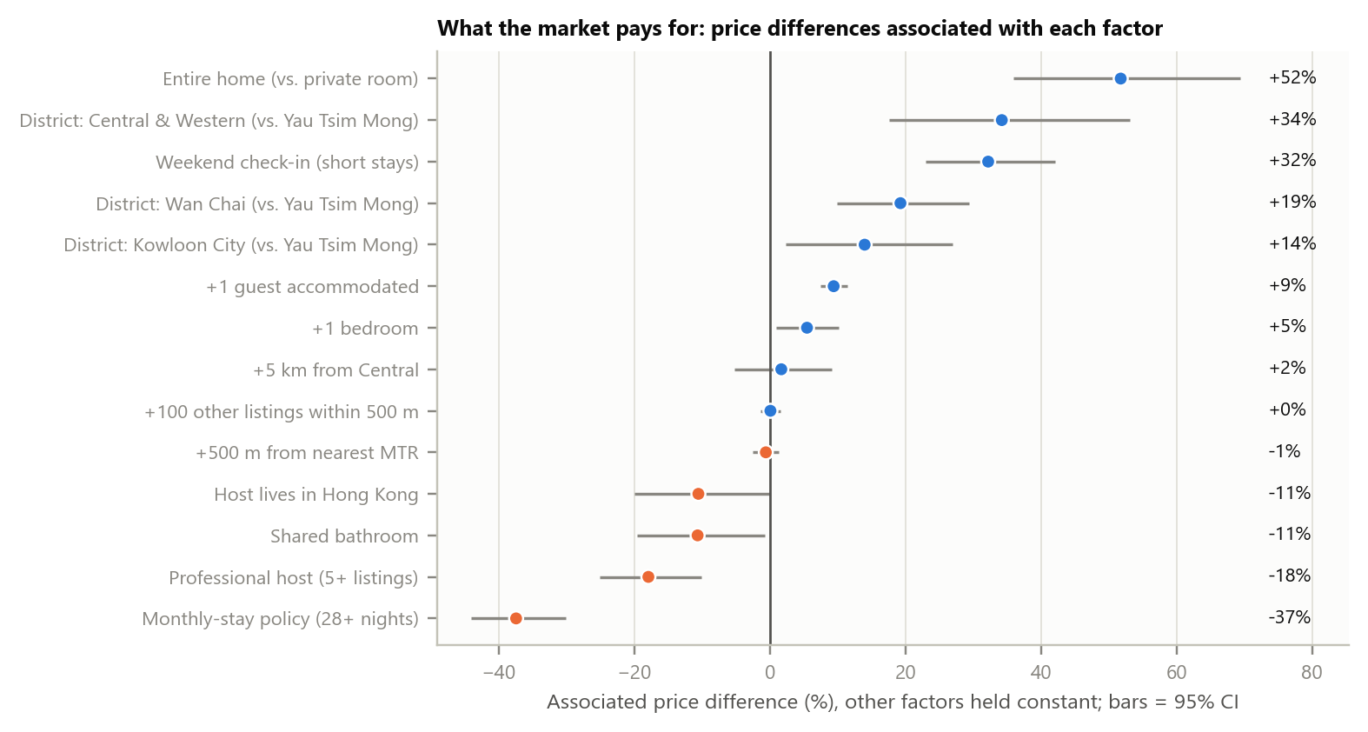
Figure 5 – Hedonic regression on log-price (n = 5,555, R² = 0.70; standard errors clustered by host; association, not causation; 10 amenity controls not shown).
The interpretable regression complements the black-box model. Holding other factors constant: monthly stays are 37% cheaper per night (95% CI -44% to -30%); weekend check-ins cost +32% more on short stays; whole homes +52% over private rooms; each extra guest +9% and bedroom +5%; a shared bathroom -11%. Against Yau Tsim Mong, Central & Western is +34% and Wan Chai +19%. Two findings are less intuitive: professional hosts price 18% below comparable individual hosts (volume strategy), and distance to the MTR (-0.6% per +500 m) and to Central (+1.7% per +5 km) are not significantly priced once district and property are controlled – transit is everywhere, so it does not differentiate.

5.4 A price audit: who is priced away from the benchmark, and does it cost them guests?
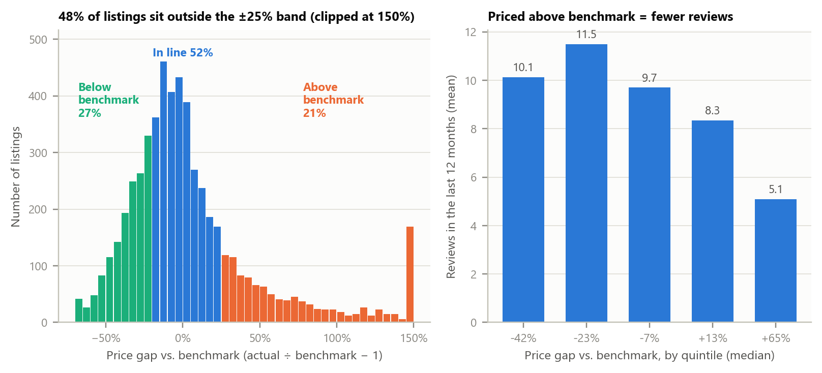
Figure 6 – Price gap vs. out-of-fold benchmark, and reviews in the last 12 months by price-gap quintile (2,412 listings with at least a year of history).
Using out-of-fold predictions (each listing predicted by a model that never saw its host), 52% of listings are in line with their benchmark, 21% are at least 25% above and 27% at least 20% below. Reviews in the last 12 months are a demand proxy. In a Poisson model with controls for stay regime, room type, district and size, +10% above benchmark is associated with 5.9% fewer reviews (95% CI 3.1%–8.7%), or 6.9% fewer when also controlling for the review rating; Inside Airbnb's own occupancy estimate gives 8.3% fewer occupied nights. The most expensive quintile (about 65% above benchmark) averages 5.1 reviews against 9.7 for listings in line, whereas listings about 23% and 42% below benchmark average 11.5 and 10.1: overpricing clearly loses demand, while discounts buy at most a modest gain, and the deepest discount none beyond the moderate one. Guest text adds nuance: above-benchmark listings have higher average review sentiment (0.72 vs 0.68) and fewer complaints about size (12% vs 16%) – part of their premium is unobserved quality – yet fewer mentions of 'good value' (7% vs 10%). These are exploratory, Bonferroni-corrected comparisons on listings with enough English reviews.

6. Using the benchmark: decision tool and recommendations
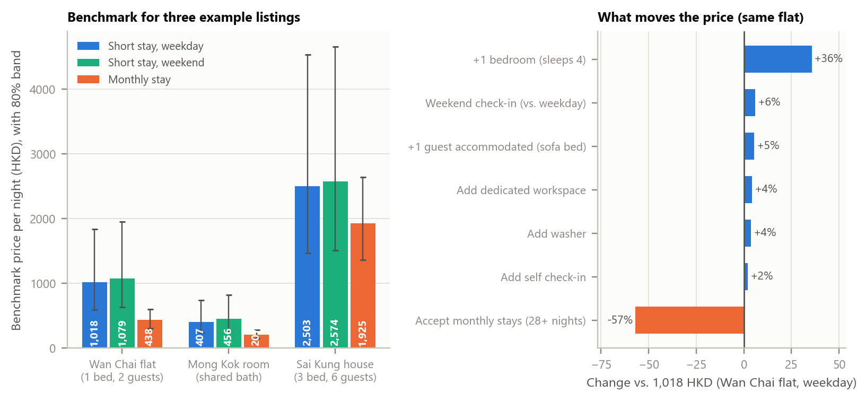
Figure 7 – The decision tool. Left: benchmark and 80% band for three example listings under three stay types. Right: how the benchmark of one Wan Chai flat moves when a lever is changed (model-implied associations, not guaranteed returns).
The notebook exposes the benchmark as a function: a host enters district, room and property type, guests, bedrooms, bathrooms, coordinates, stay type and amenities; the tool computes the transit and competition factors and returns a benchmark price with an 80% band (from out-of-fold errors, separately for short and long stays). The band is validated: it covers 79% of unseen listings. For a one-bedroom flat 150 m from Wan Chai station the benchmark is 1,018 HKD on a weekday short stay (band 597–1,842), 1,079 for a weekend check-in and 438 for a monthly tenant; a shared-bathroom room in Mong Kok is 407 / 456 / 207; a three-bedroom Sai Kung house for six is 2,503 / 2,574 / 1,925. The band is wide on purpose (the 80% band spans roughly ×3.1 for short stays): asking prices are noisy, and honest uncertainty is part of the product. On the lever panel, one more bedroom moves the benchmark most (+36%), accepting monthly stays cuts the nightly price by 57% for this flat, while individual amenities (self check-in +2%, washer +4%, workspace +4%) are small next to the band. Levers are model- and profile-dependent: the weekend premium is 13% on average across short-stay listings in the random forest, 10%–18% across the three models and 32% in the regression, so we read it as 'roughly 10–30%'.
Recommendations
- Hosts and property managers. (1) Price a new listing inside its benchmark band and move within it using what only you know (view, floor, condition). (2) Run separate weekday, weekend and monthly prices: expect a weekend premium of roughly 10–30% on short stays and a monthly discount of about 37% on average (up to 57% for a whole flat that was priced for tourists), and decide on monthly stays by comparing the lower nightly rate with the occupancy you can sustain – occupancy is not observable here. (3) Use the price audit (outputs/listing_price_audit.csv) as a trigger: review first any listing more than 25% above benchmark, because that is where demand falls; for listings far below benchmark, test gradual increases, since the deepest discounts show no extra demand. (4) Spend on capacity and listing type rather than on small amenities: they dominate both the model and the regression.
- Investors. Choose the segment first: whole units for groups (median 1,470 HKD) and short-stay rooms behave very differently from the monthly-room segment (median 174 HKD), and professional operators dominate the latter. District premiums are real (Central & Western +34%) but transit distance is not priced separately.
- Platforms and policy makers. 43% of listings are in practice monthly rentals. Because the licence field is empty, regulators and platforms cannot see licensed versus unlicensed supply in public data; publishing it would make the market auditable.

7. Limitations and ethical considerations
- Asking price, one snapshot. The price is a quote for one stay on one date, not a transaction or revenue; seasonality beyond weekend/weekday is not modelled, and listings without a price (mostly unbookable) and above the 99.5th percentile are out of scope.
- Association, not causation. Premiums and the price-gap→demand result are observational; unobserved quality (photos, view, floor) may drive both price and demand. Reviews are only a proxy for bookings.
- Data gaps and proxies. Licence status is empty; straight-line distances ignore hills and routes; MTR data come from a volunteer map; review text analysis covers English-like comments with keyword topics; thin districts have few listings.
- Ethics and privacy. We use public, aggregated listing data released by Inside Airbnb; no host names, photos or reviewer identities are used or reproduced, and the audit file contains only listing ids. A price benchmark can homogenise prices if everyone follows it; it should inform, not replace, a host's judgement.

8. Conclusion
A machine-learning benchmark built in Python can price Hong Kong rentals 21% more accurately than comparable-listings pricing on unseen hosts, and – more importantly for decisions – it explains the market: stay length, listing type and the operator matter most; transit proximity does not differentiate; and the commercial risk lies in pricing above the benchmark, not below it. The next steps are to add transaction or occupancy data to move from asking prices to revenue, and to refresh the model periodically.

References
Hong Kong SAR Government. Hotel and Guesthouse Accommodation Ordinance (Cap. 349).
Hutto, C. J., & Gilbert, E. (2014). VADER: A parsimonious rule-based model for sentiment analysis of social media text. Proceedings of ICWSM.
Inside Airbnb (2026). Hong Kong listings and reviews data, scraped 25 September 2026. http://insideairbnb.com
OpenStreetMap contributors. Railway station data retrieved via the Overpass API. https://www.openstreetmap.org
Pedregosa, F., et al. (2011). Scikit-learn: Machine learning in Python. Journal of Machine Learning Research, 12, 2825–2830.
Rosen, S. (1974). Hedonic prices and implicit markets: Product differentiation in pure competition. Journal of Political Economy, 82(1), 34–55.
Xu, J. J., Chen, D., Chau, M., Li, L., & Zheng, H. (2022). Peer-to-peer loan fraud detection: Constructing features from transaction data. MIS Quarterly, 46(3), 1777–1792.

Appendix A – Reproducibility and hyper-parameters
Files. Code GroupName IS3240.ipynb runs end-to-end (data in data/; MTR stations cached in data/mtr_stations.csv; results in outputs/). Random seed 42; host-split seed 197. Libraries: pandas, NumPy, scikit-learn, statsmodels, matplotlib, VADER, requests.
Model | Tuned hyper-parameters (randomised search, 5-fold host-grouped CV on training data) | CV MAE (log)
Ridge | alpha=161.56 | 0.363
Random forest | min_samples_leaf=2, max_features=0.5, max_depth=20 | 0.308
Gradient boosting | min_samples_leaf=40, max_leaf_nodes=31, max_iter=350, max_depth=6, learning_rate=0.03, l2_regularization=0 | 0.309

Appendix B – Accuracy by group (test set, selected model)
Group | n | Median price | MAE (HKD) | Median % error | Within ±20%
Entire home/apt | long stay | 177 | 676 | 312 | 28% | 37%
Entire home/apt | short stay | 227 | 1,288 | 494 | 25% | 42%
Other | short stay | 21 | 410 | 180 | 42% | 24%
Private room | long stay | 319 | 207 | 47 | 11% | 67%
Private room | short stay | 423 | 549 | 333 | 32% | 30%
Private rooms, monthly | 319 | 207 | 50 | 11% | 65%
Private rooms, short-stay | 401 | 520 | 281 | 29% | 32%
Whole units, mixed stay | 281 | 730 | 349 | 28% | 38%
Mixed units, short-stay, outer areas | 69 | 940 | 591 | 40% | 26%
Whole units, short-stay, groups | 99 | 1,650 | 603 | 21% | 45%

Appendix C – Geography of price
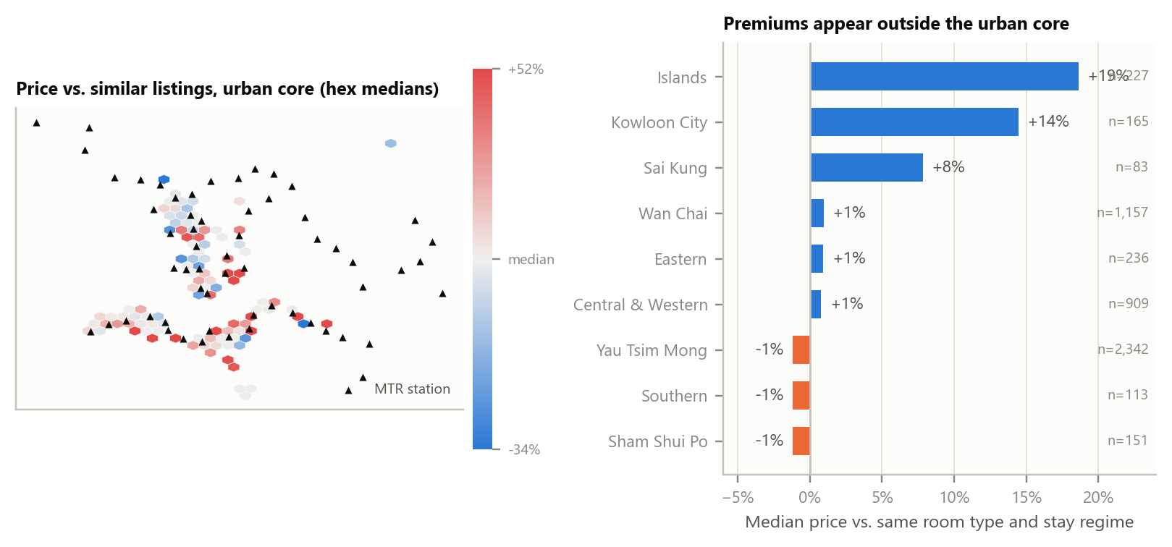
Figure A1 – Price relative to similar listings (same room type and stay regime): hex-binned map of the urban core and median relative price by district.

