Bootstrap 1. Data analysis of the Kiabi figures
Project: Fittybird x Kiabi, 360° Framework
Handed in with: checkpoint 1a (annex)
Sources: Kiabi dashboard in the bootstrap brief (360framework-bootstrap.pdf, printed pages 2 to 4) and the Kiabi data deck (bootstrap-kiabi.pptx, slides 2 to 7). Page and slide numbers are given next to each figure so the team can check them.

1. The figures we use

Online against in store
Metric | Online | In store | Source
Items return rate | 26.5% | 3.7% | Brief p.3
Average shopping cart | 67.53 € | 29.08 € | Brief p.3
Monthly traffic | 8,792 unique visitors on the e-store | 1,238 visits (average store) | Brief p.3, see note 1
Customer grade for fitting (out of 10) | 3 | 8 | Brief p.4
Customer grade for return (out of 10) | 3.2 | 6.6 | Brief p.4
Customer grade for payment and checkout (out of 10) | 7.4 | 5 | Brief p.4
Customer grade for fidelity card advantages (out of 10) | 4.8 | 7.3 | Brief p.4
Customer grade for global experience (out of 10) | 7 | 6.5 | Brief p.4
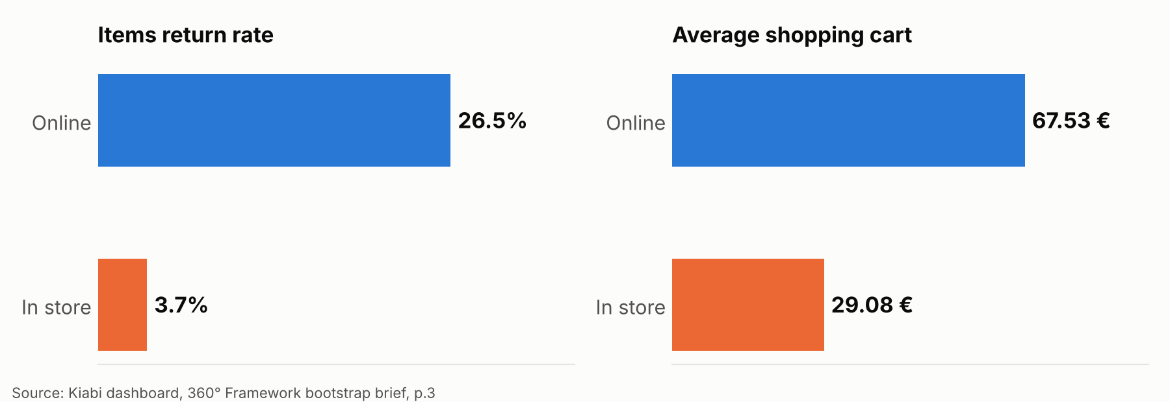
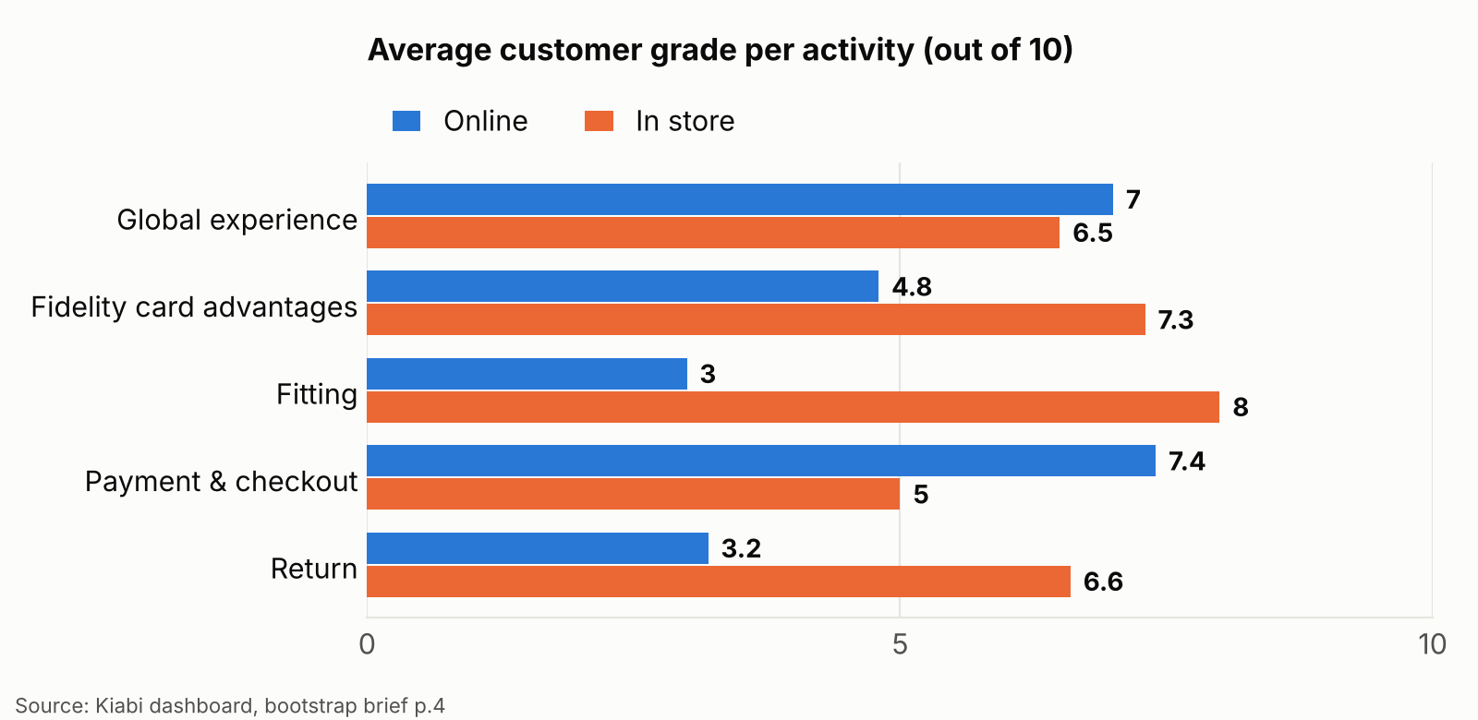

Network and customer base
Metric | Value | Source
Stores in France | 85, of which 75 offer Click & Collect | Brief p.3
Checkout per customer per year | 500 € | Brief p.3
Checkouts per customer per year | 13 | Brief p.3
Articles per customer per year | 26 | Brief p.3
Customers over 15 years old | 91.5% | Brief p.3
Share of ready-to-wear turnover | Women 53%, men 32%, children 15% | Brief p.3
Cross-channel profitability | A cross-channel customer is 3 times more profitable than a single-channel one (Cyril Olivier, e-commerce and marketing director, Kiabi, quoted in LSA) | Deck slide 6
Note 1. The dashboard labels the store figure "monthly average visits in stores", and its chart is titled "average stores visits". We read 1,238 as the monthly visits of an average store, not of the whole network. Visitors (online) and visits (stores) are not the same unit, so we do not compare them directly. To confirm with Kiabi.
Note 2. The dashboard shows "average checkout per customer 19.20 €". Dividing 500 € by 26 articles gives 19.23 €, while dividing by 13 checkouts gives 38.46 €. The label most likely describes the average price per article. To confirm with Kiabi.

2. What the data says
# | Finding | Calculation | Why it matters
F1 | Online returns are about 7 times store returns | 26.5 / 3.7 = 7.2 | Returns are the clearest cost gap between the channels
F2 | Online fitting is the weakest stage of the online journey: 13% satisfaction and a grade of 3 out of 10, against 75% and 8 out of 10 in store | 75 − 13 = 62 points | A customer cannot judge fit on a screen. This is the problem Fittybird solves
F3 | An online cart is 2.3 times larger than a store cart | 67.53 / 29.08 = 2.3 | Each online return costs a bigger basket
F4 | Value sent back per average cart: about 17.90 € online against 1.08 € in store | 67.53 × 26.5% and 29.08 × 3.7%, assuming returns are proportional to value | The exposure per online cart is about 17 times higher
F5 | The fidelity card is rated 7.3 in store and 4.8 online. The brief adds that the NFC tag only counts shop entries | Brief p.1 and p.4 | The card is a ready identity link between channels that nothing uses yet
F6 | In store, research (20% satisfied) and payment (19%) are the weak stages | Brief p.3 | Fitting in store is already strong, so the store value of Fittybird is elsewhere (see journey maps)
F7 | Online turnover is roughly one fifth of the total | Charts p.2: about 420 K€ per month online at the end of the year, about 19 K€ per month for an average store, times 85 stores, about 1,615 K€ | Approximate, read from the charts. It shapes the web-first trade-off
F8 | The lockdown year moved traffic online | Charts p.2: store visits fall to about 300 in March then settle near 1,300. E-shop visitors rise from about 2,000 in April and May to about 10,000 in June and a peak near 14,500 in November | Online traffic stays high after the lockdown, so the online pain is lasting
Findings F7 and F8 are read from line charts without data labels, so treat them as orders of magnitude.

3. What the data does not say
These gaps matter because the solution is justified by returns. We do not invent them. We request them.
Missing figure | Needed for | Data request to Kiabi | Owner (proposed) | Due
Cost to process one returned item (reverse logistics, handling, lost resale value) | Value of one avoided return | Average cost per online return and per store return | Hadeed | Sprint 1, week 1
Share of returns caused by size or fit | How much of the 26.5% Fittybird can reach | Return reason codes, split by size, fit, quality, other | Hadeed | Sprint 1, week 1
Online orders per month and conversion rate | Size of the pilot, baseline for the funnel | Orders and visitor-to-order rate per month | Hadeed | Sprint 1, week 1
Size charts for the pilot articles | The fit engine (US-09, US-10) | Size chart per pilot article | Muhammad | Sprint 1, week 2
Meaning of the 19.20 € and 1,238 figures | Reading the dashboard correctly | Written confirmation of both definitions | Elie | Sprint 1, week 1

4. How the figures justify the solution
Fittybird targets the weakest online stage (fitting, 13%) and its main cost (returns, 26.5%).
The value of the solution is one formula:
Saving per month = online items sold x reduction in return rate x cost of one return
Two of the three terms are open (items sold, cost of one return). The third is our hypothesis, anchored on the baseline:
- Pilot hypothesis: the return rate on pilot articles falls from 26.5% to 23.5% (3 points) for shoppers who tried the article on. That is 11% fewer returned items (3 / 26.5) and 30 fewer returns per 1,000 items sold online.
- How we test it: a control group of shoppers without try-on, same articles, same weeks (backlog item US-22 and the measurement rules in the roadmap).
- What would change our mind: if the data request shows that size and fit cause only a small share of returns, the target moves from the return rate to the fitting satisfaction score (13% baseline), and the business case is re-written before sprint 3.
The 3-point target is a hypothesis to test, not a Kiabi figure.

