Final deliverable B. Project methodology and rituals
Project: Fittybird x Kiabi, 360° Framework
Deliverable: B, Period 4 (implementation process)
Terms: shared/glossary.docx

1. Method chosen: Scrum with a Kanban board
The team works in two-week Scrum sprints and manages the flow on a Kanban board with a limit on work in progress.
Why Scrum | Why a Kanban board
Fixed review and retro dates match what Kiabi and the school expect | A limit on work in progress stops four people from starting everything at once
A sprint goal keeps the team on the riskiest items first | A visible flow shows blockers early
Alternatives considered: pure Kanban (no fixed review dates, so Kiabi gets no regular demo) and pure Scrum (no work-in-progress limit, which risks half-finished stories). Logged as decision D13.

2. The sprint loop and its rituals
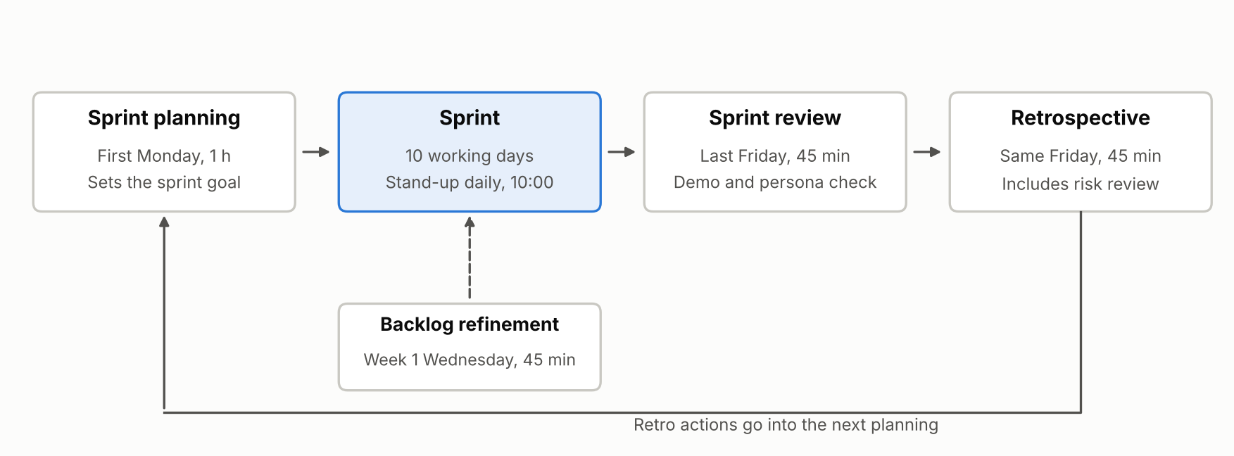
Ritual | When | Length | Who | Output
Sprint planning | First Monday of a sprint | 1 hour | Whole team | Sprint goal and stories. Each story names a persona
Daily stand-up | Every working day, 10:00 | 15 minutes | Whole team | Yesterday, today, blockers
Backlog refinement | Wednesday of week 1 | 45 minutes | Whole team | Stories that meet the Definition of Ready
Sprint review | Last Friday | 45 minutes | Team and Kiabi sponsor when available | Demo through one persona's journey, KPI report, feedback
Retrospective | Same Friday, after the review | 45 minutes | Whole team | Up to 3 actions with owners
Risk review | Inside the retro | 15 minutes | Whole team | Risks re-scored by the team, each with its class (Resolved, Owned, Accepted or Managed) and an owner (3b-risks/risk-management.docx)
Checkpoint review | Before each Gandalf hand-in | 30 minutes | Whole team | Decisions written in C-backlog/decision-log.docx

3. First version of the board
Column | Holds | Rule
Backlog | All stories, ordered by priority and risk | Only the product manager reorders
Ready | Stories that meet the Definition of Ready | Pulled in at sprint planning
In progress | Stories being built | At most 4 at a time
In review | Built stories waiting for a second pair of eyes | Review within one working day
Done | Stories that meet the Definition of Done | Shown at the sprint review
A blocked story gets a Blocked tag and is raised at the next stand-up. Sprint 1 starts with SP-01, SP-02, OPS-01, PRIV-01, TECH-01, TECH-03, US-01, US-02 and US-03 in Ready, and the work in progress limit decides the order they are pulled. The board tool is chosen in sprint 1, with the repository host in mind.

4. Definitions
Definition | Conditions
Ready | The story names a persona and the Kiabi data behind it. It has acceptance criteria, a size and no unanswered dependency. A technical or privacy item names the persona whose need it protects
Done | Acceptance criteria pass. A second person reviewed the work. It runs in staging. The product manager has seen it in a sprint review. Events needed for its KPI are tracked. Anything that handles photos follows the privacy checklist (PRIV-01)

5. Indicators to monitor
Targets are proposals. The team adjusts them after sprint 2.
Indicator | What it tells | Target | Reported by
Sprint goal reached | Whether planning is realistic | 5 of 6 sprints | Elie
Velocity | Person-days of Done stories per sprint | About 20 to 24. Under 20 in sprint 1 or 2 triggers a capacity decision (R18, D15) | Elie
Open red risks | Whether risks are being retired | Falls every sprint | Elie
Technical share of the load | Whether enablers (TECH, PRIV, SP-02) take the capacity of stories | About 18% of planned person-days (20.5 of 112). Above 25% triggers a re-plan (R18) | Muhammad
Avatar success rate | Share of test photo sets that give a usable avatar | 80% by the end of sprint 2 | Muhammad
Size match | Share of testers whose advised size is their real size | 80% from sprint 3 | Hadeed
Stories with a persona | Whether the user's point of view is kept | 100% | Boyu
Return rate on pilot articles | The business effect, against the 26.5% baseline | Fall of 3 points against the control group | Hadeed

6. How the method keeps the user in view
- Each story names one persona, so a developer always knows who the work is for (2a-personas/personas.docx).
- Each sprint review replays one persona's journey end to end.
- Each retro includes a risk review, so risks are not scored by one person.
- Each checkpoint review updates the decision log, so choices stay traceable.
- Each technical or privacy item names the persona it protects, so enabling work does not lose sight of the user.

