Bootstrap 2. Customer journey maps: online and in store
Project: Fittybird x Kiabi, 360° Framework
Handed in with: checkpoint 1a (annex)
Sources: satisfaction per stage and grades per activity from the Kiabi dashboard (bootstrap brief, printed pages 3 and 4). Cross-channel paths from the Kiabi deck, slide 7. Pains that the data does not show are marked to validate: they come from our reading and must be tested in interviews (sprint 1).
The two journeys are kept apart on purpose. The dashboard measures them separately, they peak at opposite stages, and the solution does not play the same role in each.

1. Online journey
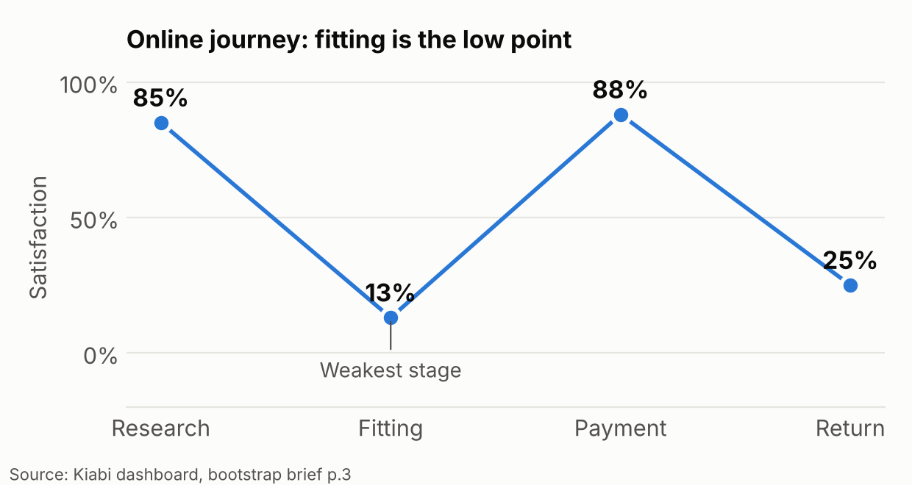
Stage | Satisfaction | Grade (out of 10) | What the customer does | Pain | Fittybird touchpoint | KPI
Research | 85% | not graded | Browses the e-store or app, filters, uses the wishlist | Little: this is the best-rated online stage. Source of the pain downstream: the product page cannot show fit | Catalog with a try-on entry on each article (US-07) | Share of sessions that open a try-on
Fitting | 13% | 3 | Guesses a size from a chart, sometimes orders two sizes | Cannot judge how the item fits or looks on their own body. Weakest stage of the whole online journey (evidence) | Avatar, try-on and fit view per body zone (US-04 to US-10) | Fitting grade and satisfaction among users who tried on, against the 3 out of 10 baseline
Payment | 88% | 7.4 | Checks out on Kiabi | Little. Strongest online stage | None. The cart hands off to Kiabi checkout and Fittybird does not touch payment (US-12) | Hand-off rate from fit view to cart
Return | 25% | 3.2 | Sends items back, mostly for a wrong size (to validate: the size share of returns is not in the data) | 26.5% of items come back, and the return experience is rated 3.2 (evidence) | Return reason captured after purchase (US-15), size advice that cuts avoidable returns | Online return rate on pilot articles, against the 26.5% baseline
Reading the map: the online customer is happy to search and to pay, and unhappy in the middle (fitting) and at the end (return). The two weak stages are linked: a poor fitting step creates the returns. Fittybird acts on the first to reduce the second.

2. In-store journey
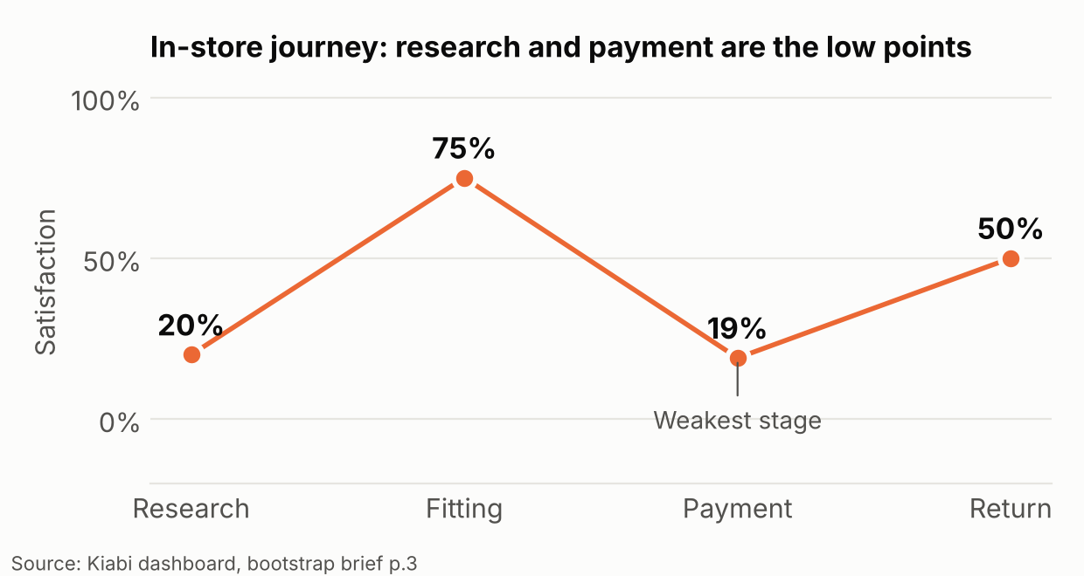
Stage | Satisfaction | Grade (out of 10) | What the customer does | Pain | Fittybird touchpoint | KPI
Research | 20% | not graded | Looks for an item or a size on the shelves, may use an in-store terminal that shows the whole collection (about 6,000 items per season, deck slide 19) | Low satisfaction (evidence). Cause not in the data: to validate (finding the item, finding the size, no link to online wishlist) | Mirror loads the avatar after the phone scans its pairing QR code (US-13) and shows the catalog | Share of pairing scans that open a mirror session
Fitting | 75% | 8 | Tries items in the renovated cabin. The cabin screen lets the customer ask a staff member for another size or color | Little. This is the strongest in-store stage and Kiabi's differentiator (brief p.1) | Fit view in the cabin and a size request that carries the fit context (US-14, US-17) | Wrong-size fetches avoided (to measure in the pilot)
Payment | 19% | 5 | Pays at the checkout. Kiabi is deploying self-checkout and looking at mobile payment from the customer's own device (deck slide 20) | Low satisfaction (evidence). Cause not in the data | Out of scope. Kiabi's self-checkout work already targets it | None
Return | 50% | 6.6 | Brings items back to the shop. Only 3.7% of items are returned in store | Fair. Few returns | Return reason capture after purchase (US-15) | In-store return rate
Reading the map: the in-store customer is happy to try things on and unhappy before (finding the item) and at the end (paying). Fitting is already good, so the value of Fittybird in store is not "better fitting". It is a faster start (research, identity) and fewer trips to fetch another size.

3. Cross-channel moments
The deck (slide 7) lists the paths where a customer crosses channels. These are the moments where one shared avatar tied to the loyalty card is useful.
Direction | Kiabi path (deck, slide 7) | Fittybird role
Web to store | Click and collect, e-reservation, returns in store, product locator, store locator | The avatar and chosen size follow the customer into the shop (pairing QR code in the first pilot, one-time card link D18)
Store to web | Connected terminals, tablets for sellers, showrooming | Items tried in the cabin appear in the customer's saved looks for later online purchase
Social | Live shopping | Not in scope for version 1
Kiabi's director of e-commerce and marketing says a cross-channel customer is 3 times more profitable than a single-channel one (deck, slide 6). Nothing in the data tells us how many customers are cross-channel today. That figure is in the data request (see 01-data-analysis.docx, section 3).

4. What the two maps tell the roadmap
Observation | Decision it supports
Online fitting is the lowest score in either journey (13%, grade 3) | Build web first (see 03-growth-levers-and-web-first.docx)
In-store fitting is already 75% | The store pilot proves identity and speed, not fit. Its success criteria are different from the web ones
In-store payment and online returns are weak but outside the product's reach or secondary | We do not promise to fix payment. We measure returns

