Final deliverable A. Three-month roadmap
Project: Fittybird x Kiabi, 360° Framework
Deliverable: A, Period 4 (sketch the path to project initiation)
Terms: shared/glossary.docx
The roadmap covers 12 working weeks, from Mon 2026-11-09 to Fri 2027-02-12, with a two-week holiday break. It is web first (sprints 1 to 3), then the store pilot (sprints 4 to 6), as decided in 00-bootstrap/03-growth-levers-and-web-first.docx. Beyond three months there are too many unknowns, so nothing is planned past 2027-02-12.
The riskiest and most valuable items come first: privacy basics, the build-or-buy question and the avatar prototype are in the first four weeks.
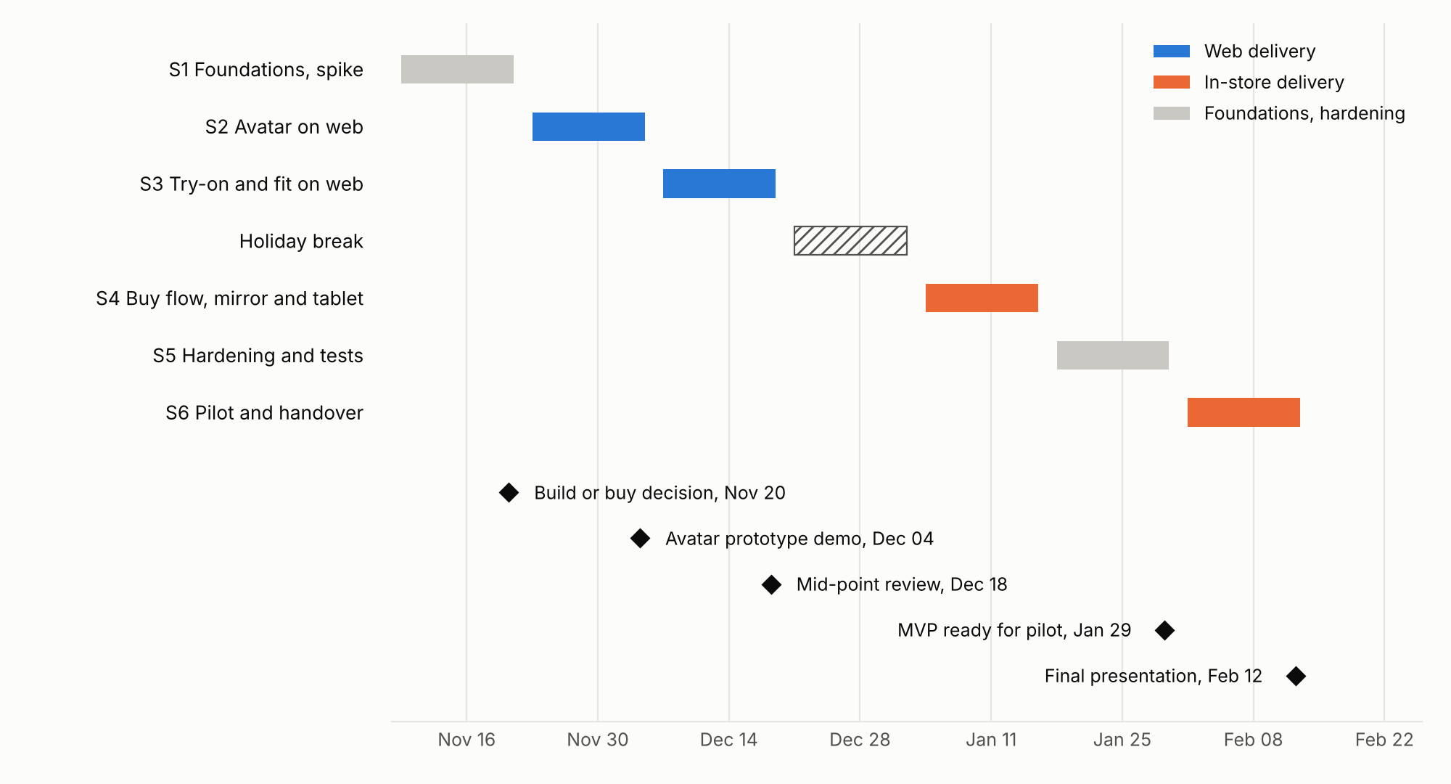

1. Sprint goals and victories
Sprint | Dates | Focus | Goal | Stories | Victory to celebrate
1 | Nov 9 to Nov 20 | Web | Prove the riskiest parts: privacy basics, sign-in, the avatar and try-on approaches, Kiabi data, and the platform they run on | SP-01, SP-02, OPS-01, PRIV-01, TECH-01, TECH-03, US-01, US-02, US-03 | Build-or-buy decision made. Try-on approach chosen. First avatar from a test photo set. Four environments running
2 | Nov 23 to Dec 4 | Web | A working avatar in the app, with tracking | US-04, US-05, US-06, US-22, TECH-02 | Each team member creates their own avatar end to end
3 | Dec 7 to Dec 18 | Web | Try-on and fit | US-07, US-08, US-09, US-10 | A garment on a real avatar with its fit view, shown at the mid-point review
Break | Dec 21 to Jan 1 | None | Rest | None | None
4 | Jan 4 to Jan 15 | Web and store | Buy flow and the in-store mirror and tablet | US-11, US-12, US-13, US-14, US-23, OPS-02 | A size requested on the mirror appears on the staff tablet
5 | Jan 18 to Jan 29 | Web and store | Feedback, dashboard, monitoring, hardening, full privacy review | US-15, US-17, US-18, PRIV-02, TECH-04 | MVP ready for the pilot
6 | Feb 1 to Feb 12 | Store | Pilot, bug fixing, handover. No new stories | None | Real shoppers use it. Final presentation

2. Estimates of macro items
Relative sizes: S is about 1.5 person-days, M about 4, L about 8. Stories marked Later (US-16, compare two sizes) are not included. Privacy and Platform are new epics for the work added at the 3a and 3b reviews (D15, D22): 24.5 person-days in all, less 4 for US-16 moved to Later.
Epic | Stories | Person-days
Start | US-01, US-02, US-03 | 7
Avatar | SP-01, US-04, US-05, US-06, US-11 | 21.5
Browse | US-07 | 4
Try on | SP-02, US-08 | 9.5
Fit | US-09, US-10 | 12
Buy | US-12 | 4
Store | US-13, US-14, US-23, US-17 | 16
After purchase | US-15 | 1.5
Dashboard | US-18 | 8
Operations and data | OPS-01, US-22, OPS-02 | 9.5
Privacy | PRIV-01, PRIV-02 | 5.5
Platform | TECH-01, TECH-02, TECH-03, TECH-04 | 13.5
Total |  | 112

Capacity check
Item | Person-days
Capacity assumed: 4 people, about 3 days a week each, 6 days each per sprint, 24 per sprint, sprints 1 to 5 | 120
Work planned in sprints 1 to 5 | 112
Slack | 8 (7%)
The capacity assumption must be confirmed by each member. Planned load by sprint:
Sprint | Planned person-days | Capacity | Load
1 | 23.5 | 24 | 98%
2 | 21.5 | 24 | 90%
3 | 24 | 24 | 100%
4 | 24 | 24 | 100%
5 | 19 | 24 | 79%
Sprints 1, 3 and 4 are full or nearly full, and total slack is only 8 person-days (7%). If sprint 1 slips, TECH-03 and SP-02 move first, because the avatar spike and the data request come before them. If sprint 3 slips, US-10 or US-09 loses the safety margin first. That is why US-11 (a Should) sits in sprint 4, not sprint 3. Sprint 5 has 5 days of room, which is where US-16 can return if the velocity check allows (R18). Sprint 6 has no new stories, so it absorbs slips.

3. Obstacles to watch
Obstacle | Link | What we do
Kiabi data or access arrives late | R2, R13, R15 | Send the data request in week 1 (OPS-01), with garment images, a card-number check and the privacy contact. Fallback: 20 hand-prepared articles
The avatar looks wrong on real photos | R7 | The spike and sprint 2 exist to find this out early
Holidays and exams cut sprint 4 capacity | R11 | Re-plan at the start of sprint 4
No pilot shop confirmed | R14 | Ask Kiabi in sprint 1. Fallback: staff-only demo
Privacy question blocks the pilot | R9 | Privacy checklist in sprint 1 (PRIV-01), before any photo from outside the team. Full privacy review in sprint 5 (PRIV-02) before real shoppers (D10, D22)
Technical work takes the capacity planned for stories | R18, R19 | Check velocity in sprints 1 and 2. If it is under 20 person-days, keep US-16 in Later and name a back-end backup (D15)
The pilot shop network is too weak for the mirror and the tablet | R17 | Signal test before sprint 4 (OPS-02), polling fallback (D20). Last fallback: staff-only demo

4. How the pilot is measured
Rule | Detail
Control group | Shoppers who see the same articles without try-on, same weeks
Main metric | Return rate on pilot articles against the 26.5% baseline
Second metric | Fitting grade among users who tried on, against the 3 out of 10 baseline
Reported | At each sprint review, by Hadeed

5. Gandalf checkpoint calendar
The school's dates are not in the brief. Fill them in when they are known.
Checkpoint | File | Gandalf deadline
1a | submission/1a_product-manifesto.pdf | [DATE]
1b | submission/1b_team-and-rituals.pdf | [DATE]
2a | submission/2a_personas.pdf | [DATE]
2b | submission/2b_storymap.pdf | [DATE]
3a | submission/3a_target-architecture.pdf | [DATE]
3b | submission/3b_risk-management.pdf | [DATE]
A | submission/A_roadmap.pdf | [DATE]
B | submission/B_methodology.pdf | [DATE]
C | submission/C_backlog-and-decision-log.pdf | [DATE]

