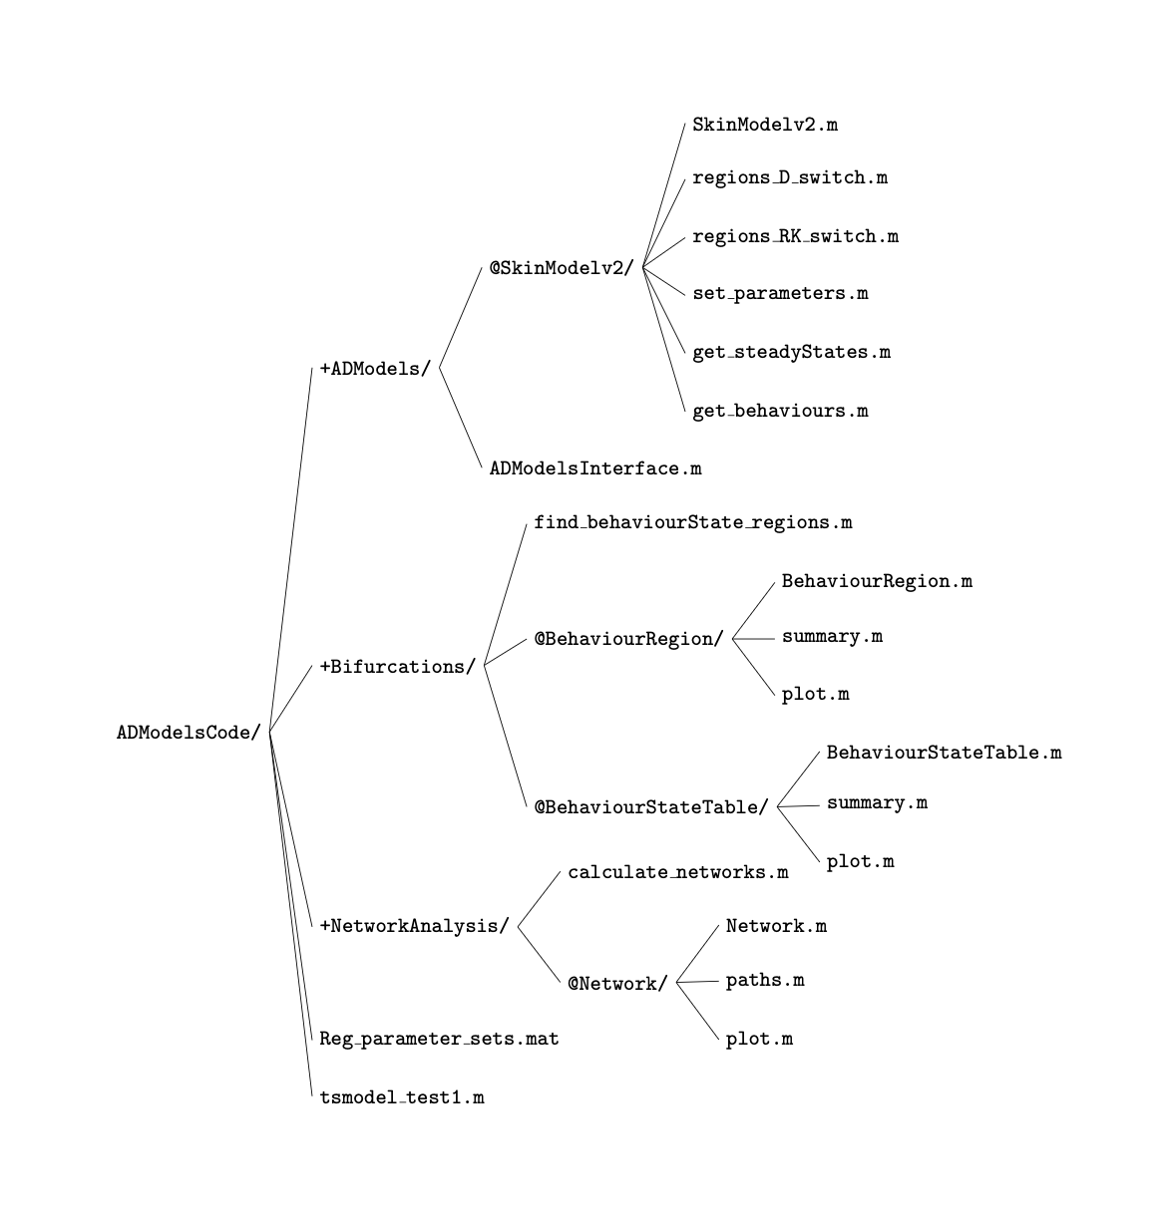
Repository structure overview

- Start here if you’re new
- File guide – brief summary of scripts
- Pipeline for producing the bifurcation diagram, network plots and heatmap
- Customisation & extension

1. Start here if you’re new
If you are new to this codebase, start by running the main pipeline script (tsmodel_test1.m). It loads a parameter set, generates bifurcation diagrams, builds behaviour–state tables and transition networks, and produces example network and heatmap plots.
Once you are comfortable with the pipeline, you can explore the individual components using the file guide below.

2. File guide – brief summary of scripts
2.1. ADModels
- SkinModelv2.m: the main model class, defines state variables, parameters, switches, and core dynamics.
- set_parameters.m: loads ODE and switch parameters into model object(s).
- get_steadyStates.m: computes steady states under a given parameter set and switch state.
- get_behaviours.m: classifies qualitative switch behaviours (Aoff, Hd, Ac, Aon) from steady states for given switch states combinations.
- regions_RK_switch.m: generates RK-switch region polygons (with $D_{off}$/$D_{on}$) in the $\left(κ_{M},α_{M}\right)$ plane.
- regions_D_switch.m: same idea as above but for D switch.
- ADModelsInterface.m: abstract base class providing a unified interface for AD models.
2.2. Bifurcations
- BehaviourRegion.m: represents a polygonal region in parameter space where switch behaviour is constant.
- BehaviourStateTable.m: organises precomputed switches behaviour regions into a behaviour-state table mapping switch configurations to qualitative behaviours.
- find_behaviourState_regions.m: pairs RK and D behaviour regions and assembles the resulting combinations into BehaviourStateTable objects.
2.3. NetworkAnalysis
- Network.m: a class for storing and analysing the 8-state switch transition network derived from a behaviour-state table.
- paths.m: lists and formats state paths through the transition network for visualisation.
- calculate_networks.m: converts each behaviour-state table into one or more 8-state transition Network objects, splitting when race conditions apply.
2.4. Reg_parameter_sets.mat: contains four parameter sets (p1-p4), each storing an ODE parameter struct and corresponding switchParameters.
2.5. tsmodel_test1.m: end-to-end demo script, runs the full pipeline (parameters → bifurcation diagrams → behaviour-state tables → networks → paths) for one chosen parameter set and produces the main figures.

3. Main scripts used to produce bifurcation diagrams, networks, and heatmaps
All analyses in this codebase start from a parameterised SkinModelv2 object. A parameter set is first loaded and assigned using set_parameters.m, after which different analysis pipelines branch off.
- Bifurcation diagrams (RK or D)
→ regions_RK_switch.m or regions_D_switch.m
→ BehaviourRegion.m
→ plot.m in the BehaviourRegion folder
- Behaviour–state tables
→ find_behaviourState_regions.m
→ BehaviourStateTable.m
- Heatmaps
→ find_behaviourState_regions
→calculate_networks
→ paths.m
→ imagesc (a MATLAB plotting function that displays a matrix as an image)

4. Customization & extension
The methods in this repository are model-agnostic and can be applied to other biological systems that exhibit switch-like behaviour. Adapting the pipeline mainly involves defining a new system-specific model (ODEs, switches, thresholds etc.) and corresponding parameter sets, while reusing the existing bifurcation, behaviour–state, and network analysis code.

