First Methodist Church

Our Mission: “Together, we’re reaching up to God,

within to each other, and beyond to others.”

September 27th - 18th Sunday after Pentecost

Prelude
“I Will Stand” Screen

Welcome & Announcements Associate Pastor Mara Garrido

Prayer of Invocation Associate Pastor Mara Garrido

Children’s Time “Jesus Loves Me” MH #191

*Call to Worship Music
“I Choose to Praise You” Screen

First Scripture Lesson
Philippians 2:1-11 Associate Pastor Mara Garrido

Preparation for Prayer
“Lord, Listen to Your Children Praying” Screen

Pastoral Prayer Associate Pastor Mara Garrido

Response Giving of Ourselves and Substance
Special “In the Beauty of Holiness”
*Doxology “Praise God, from Whom All Blessings”

*Praise and Worship
“In Jesus Name” Screen

*Second Scripture Lesson
John 13:3-15 Pastor Eliezer Garrido

Sermon
“The Last Supper Lesson" Pastor Eliezer Garrido

*Benediction Pastor Eliezer Garrido

*Music of Response
“I Give You My Heart” Screen

* Please stand as you are able.
Our World Wide Web address is: https://www.dimmittearthmethodistchurch.com/
CCLI# 62959

Church Staff
Sr. Pastor ~ Eliezer Garrido
Associate Pastor ~ Mara Garrido
Rosalia Saenz ~ Secretary
Worship Leaders
Dr. Daniel “Skip” Skinner – Music Minister

Opportunities for Worship, Ministry, and Fellowship
Morning Worship Sundays 10:45 a.m.
Church School Sundays 9:45 a.m.
Children & Youth Fellowship Wednesdays 6:00 p.m.
Methodist Women 1st Wednesday 9:30 a.m.
Methodist Men Tuesdays 6:00 a.m.

Opportunities to Give
FMC Budget Fund, FMC Youth, FMC Outreach, and FMC Worship

Grace and Hope Groups
Monday, October 5th
Sandy Baker’s Home -Women

Tuesday, October 20th
Fellowship Hall-Women

Wednesday, October 21st
Parlor-Men



First Methodist Church
110 S.W. 3rd St.
Dimmitt, TX 79027
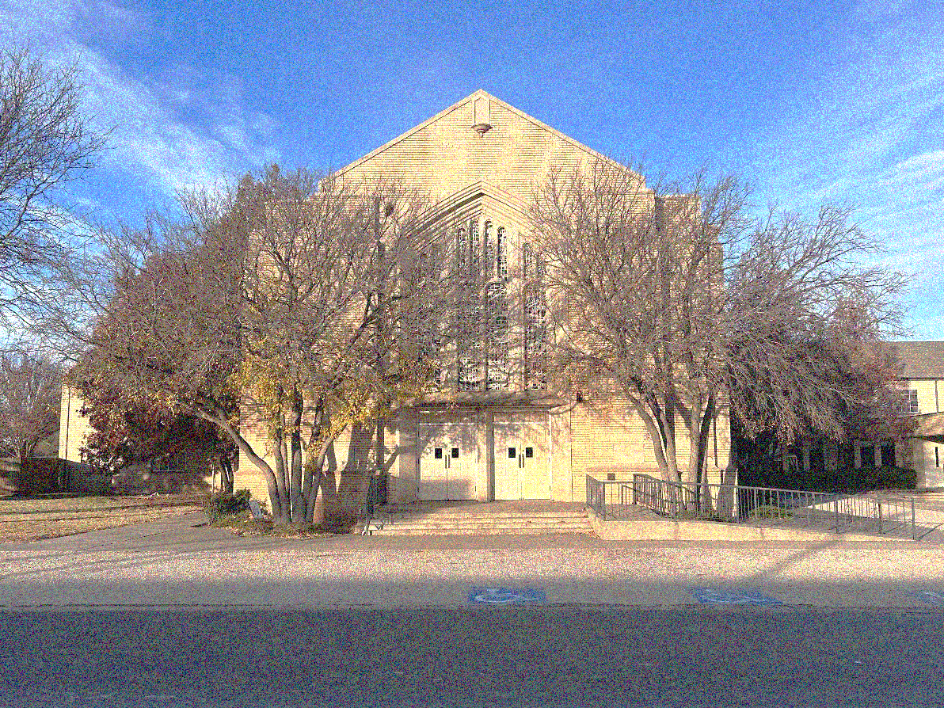

Sr.Pastor: Eliezer Garrido
Associate Pastor: Mara Garrido
FMC Dimmitt: (806) 647-4106
Earth Methodist Church: (806) 257-2061

September 27, 2026



Continued Prayers Prayers Needed
Eliezer Garrido Michael Swinburn
Isadro Rodriguez Jr.
Jose Lopez
Kathy Warren
Polly Porter
Ben Sides
Guy Warren
Daniel Sanchez
Dorthy Gilbreath
Becca Stewart
Gene Bradley Family

In care homes: They would love you to visit!!
Joyce Bolton-Castro County Nursing & Rehab, Dimmitt
Marylu Smithson- Homebound, Dimmitt
Lois Wales-Country View Living
Dorthy Gilbreath- Country View Living

Continued Prayers Prayers Needed
Eliezer Garrido Michael Swinburn
Isadro Rodriguez Jr.
Jose Lopez
Kathy Warren
Polly Porter
Ben Sides
Guy Warren
Daniel Sanchez
Dorthy Gilbreath
Becca Stewart
Gene Bradley Family

In care homes: They would love you to visit!!
Joyce Bolton-Castro County Nursing & Rehab, Dimmitt
Marylu Smithson- Homebound, Dimmitt
Lois Wales-Country View Living
Dorthy Gilbreath- Country View Living

The Last Supper Lesson
Main Scripture:
John 13:1–17
1. True Greatness Is Found in Humble Service
On the night before the cross, Jesus did something no one expected. He took a towel, knelt before His disciples, and washed their feet. The One who was Lord became the servant. Jesus shows us that greatness in God's kingdom is not measured by position, recognition, or how many people serve us. It is measured by our willingness to humble ourselves and serve others. Following Jesus means being willing to take the lower place and do what love requires, even when no one notices.
Verses: John 13:3–5; Mark 10:43–45; Philippians 2:3–7; 1 Peter 4:10
2. Love Expresses Itself Through Sacrificial Action
Jesus did not simply tell His disciples that He loved them—He showed them. Washing their feet was more than a ritual; it was a demonstration of love. Biblical love is more than words or feelings. It serves when serving is inconvenient, gives when giving costs something, and chooses humility over pride. Jesus calls us to a love that moves from what we say to what we do. Washing feet today means choosing to love even when it costs us our pride, comfort, or convenience.
Verses: John 13:12–15; John 13:34–35; 1 John 3:16–18; Philippians 2:4
3. Washing Feet Today Means Living as a Community of Grace
Jesus told His disciples to follow His example. For us, washing feet is not only about the physical act—it is a picture of the kind of community Jesus calls His church to become. We choose grace over pride, service over status, and unity over division. The church should be a place where people serve one another, forgive one another, carry one another's burdens, and extend the same grace they have received from Christ. When we live this way together, we show the world what Jesus is like.
Verses: John 13:14–17; Galatians 5:13; Galatians 6:2; Colossians 3:12–14
The Last Supper lesson is this: we find greatness in service, love in sacrifice, and community in grace. Jesus exchanged the throne for a towel and showed us what His kingdom looks like. When we humble ourselves, love when it costs us, and serve one another with grace, we walk as Christ walked.
The Last Supper Lesson
Main Scripture:
John 13:1–17
1. True Greatness Is Found in Humble Service
On the night before the cross, Jesus did something no one expected. He took a towel, knelt before His disciples, and washed their feet. The One who was Lord became the servant. Jesus shows us that greatness in God's kingdom is not measured by position, recognition, or how many people serve us. It is measured by our willingness to humble ourselves and serve others. Following Jesus means being willing to take the lower place and do what love requires, even when no one notices.
Verses: John 13:3–5; Mark 10:43–45; Philippians 2:3–7; 1 Peter 4:10
2. Love Expresses Itself Through Sacrificial Action
Jesus did not simply tell His disciples that He loved them—He showed them. Washing their feet was more than a ritual; it was a demonstration of love. Biblical love is more than words or feelings. It serves when serving is inconvenient, gives when giving costs something, and chooses humility over pride. Jesus calls us to a love that moves from what we say to what we do. Washing feet today means choosing to love even when it costs us our pride, comfort, or convenience.
Verses: John 13:12–15; John 13:34–35; 1 John 3:16–18; Philippians 2:4
3. Washing Feet Today Means Living as a Community of Grace
Jesus told His disciples to follow His example. For us, washing feet is not only about the physical act—it is a picture of the kind of community Jesus calls His church to become. We choose grace over pride, service over status, and unity over division. The church should be a place where people serve one another, forgive one another, carry one another's burdens, and extend the same grace they have received from Christ. When we live this way together, we show the world what Jesus is like.
Verses: John 13:14–17; Galatians 5:13; Galatians 6:2; Colossians 3:12–14
The Last Supper lesson is this: we find greatness in service, love in sacrifice, and community in grace. Jesus exchanged the throne for a towel and showed us what His kingdom looks like. When we humble ourselves, love when it costs us, and serve one another with grace, we walk as Christ walked.

