Another model that we tried on the dataset is VGG16. VGG16 Convolutional Neural Network is a model proposed by two professors namely Simonyan and Zisserman from the University of Oxford and it won the ILSWRC challenge in 2014. The model can be easily tested using keras.applications module. A brief summary of VGG16 model can be found in the picture below.

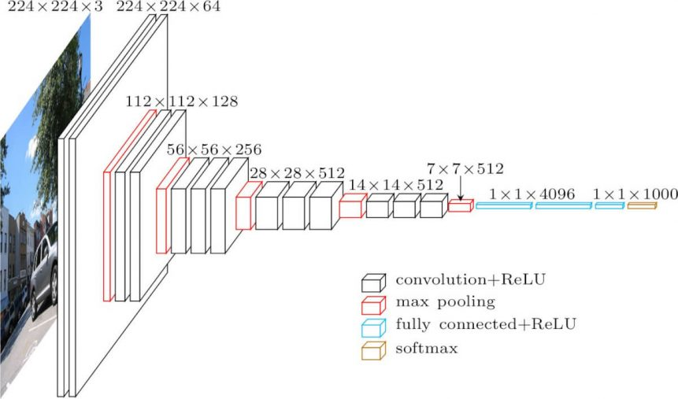

Firstly, the model has been executed with the image size (200, 200, 3) by flattening and adding a softmax activation layer at the end. Later on, it has been fitted with the train/validation split ratio as 0.2, batch size as 32 and number of epochs as 5. The accuracy has been taken as 97.71% on validation data and 97.22% on test data.

Secondly, the image size has been changed to (100, 100, 3). In this case, the validation accuracy increased to 98.97% and the test accuracy increased to 98.001%.

In addition to change in the image size, we added a dense layer with 128 units and ReLU as the activation function before the last layer. The validation accuracy decreased to 96.86%.

Finally, we added data augmentation with rotation range 20, zoom range 0.1 and horizontal flip. The validation accuracy decreased to 80.52%.

Another thing to mention is that the model requires too much time to train as a disadvantage as stated by the other users. Especially before changing the image size, it takes approximately 5000 seconds per epoch without using GPU and 2400 seconds with GPU.

As a result, the highest accuracy score was taken using the VGG16 model with the image size (100, 100, 3) without adding dense layer or augmenting the data.