Playing Card Detection and Identification

ELİF DURAN

Department of Computer Engineering, Eskişehir Technical University, Eskişehir

Elif_duran@anadolu.edu.tr

*Abstract*—In this paper i present processes for playing card detection and identification. I implement all algorithms in MATLAB and it is achieved through thresholding, edge detection, line detection.

Keywords-digital image processing, playing card detection, thresholding, edge detection, line detection

# Introduction *(Heading 1)*

Playing card recognition is one of the important existing process in image processing nowadays. It is used for security and a solution for many fraud problems also. In this project, I highlighted card boundaries and extract cards from background to detect.

# Algorıthm

Some algorithms which is used in processes:

1. Contrast enhancement

2. Binary image thresholding

3. Noise Removaling

4. Region detection

5.Canny edge detection

6. Line Detection

## Contrast Enhancement

Histogram equalization is used to enhance the contrast of card images. Histogram equalization is used to eliminate color distribution due to the fact that the equivalent values in the image are clustered in certain place.

## Binary Image thresholding

Binary thresholding was performed using Otsu’s method. Adaptive thresholding was considered but rejected as our ultimate goal was to determine the card outline; further detail provided by adaptive thresholding would have been unnecessary and cluttered the image.

## Noise Removaling

After image binarization, the noises are occurred in the image. Gaussian filter and median filter are used to remove all noises over background of card images.

## Region Detection

Regionprops is used to enclose cards with boundary box. Each card which is located in image extracted by boundary boxes. Regionprops has Convex Hull, Area, Centroid, Orientation, Bounding Box properties to use in process. Bounding box property is used to find each card in image.

## Canny Edge Detection

It helps to find the edges of card within the boundary boxes. It is not cropped with regionprop exactly so canny edge detection is used to find edges of all card in the boundary boxes. Thresholding is choosed 0.5 for detection.

## Line Detection

Hough Transform is used to detect lines and the output is a parametric description of the lines in an image. Theta and rho are the vectors returned by Hough Transformation and peaks are the lines contains information about extracted line segments.

Identify applicable sponsor/s here. *(sponsors)*

# Implementatıon

Firstly, by applying histogram equalization, the equality distribution disorders were eliminated and the contras were increased. Otsu's method was used for Binary Thresholding. Thus, cards with a black background became visible. Graythresh and imbinarize are used for binary thresholding as a built-in function. fspecial() and medfilt2 are used to remove noises in the background of image. Then, the binary image is labeled using bwlabel.

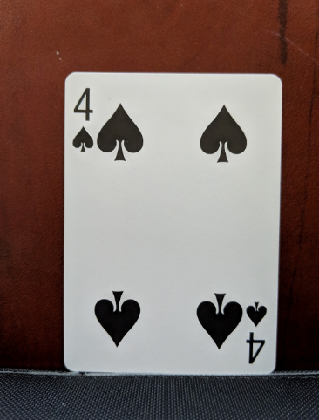

Fig. 1 Original image

The image following contrast enhancement and binary thresholding is shown in Figure 2.

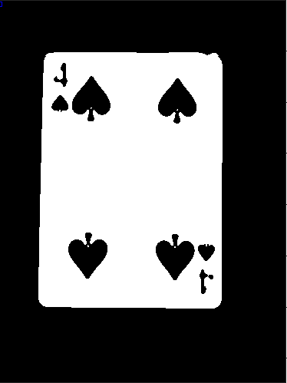

Fig. 2 Image after thresholding

Subsequent processing occurs individually on a per-region basis. Each card is spereated by bounding box and cropped from image. Canny edge detection is used to find edges of each card within boundary boxes with 0.5 thresholding. Hough Transformation is used after canny edge detection to find the lines of cards. Orientation property of regionprops is used to find the angle of each card in boundary boxes to rotate. According to angle of each card, rotation is implemented. Then, the card is cropped in boundary box again and is reached exact boundary of cards.

The image following shows the card within boundary box in Figure 3.

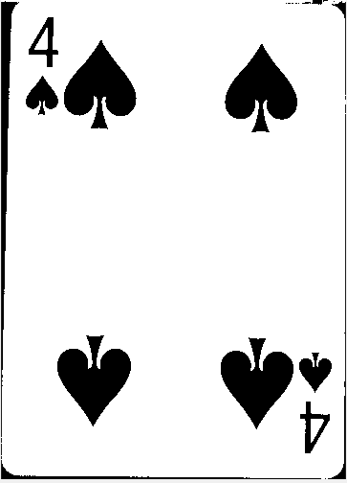

Fig. 3 Bounding Box

##### References

1. BİM472-03 Processing in Spatial Domain( Part1/ Part2)
2. BİM472-07 Image Segmentation
3. https://en.wikipedia.org/wiki/Hough_transform
4. Nobuyuki Otsu (1979). "A threshold selection method from gray-level histograms". IEEE Trans. Sys. Man. Cyber. 9 (1): 62–66.
5. Nobuyuki Otsu (1979). "A threshold selection method from gray-level histograms". IEEE Trans. Sys. Man. Cyber. 9 (1): 62–66.M. Young, The Technical Writer's Handbook. Mill Valley, CA: University Science, 1989.

[6] Matlab tutorial/help/answer