**Use of visualization tools to improve financial knowledge: An experimental approach**

**Abstract**

This study examined the use of data visualization to improve financial literacy in adults. Using financial knowledge questions as test items (Lusardi, 2007a) this study used an experimental approach. One-third of respondents were assigned to a text-only group explaining a financial concept, one-third to group that received a visualization plus text explanation of the concept, and one-third to a control group with no intervention. The findings suggest visualization of data assist in assimilation of financial knowledge compared to no intervention and to text interventions. The study has implications for financial literacy programs attempting to implement interventions in order to improve financial knowledge.

*Keywords:* data visualization, financial literacy, personal finance, financial education, financial counseling, financial planning

Visualization and Financial Knowledge

Financial independence is at the heart of healthy adult life. Basic numeracy and foundational financial knowledge are required for financial independence. Yet many adults struggle with acquiring and maintaining financial independence. This can lead to a host of personal problems ranging from evictions and divorce to costly expenses associated with poor credit histories (Lusardi & Mitchell, 2007).

Public concern about general levels of adult financial knowledge was highlighted in relation to the use of interest-only mortgages prior to the financial crisis (Seay, Preece & Le, 2017). That crisis resulted in part from consumers’ beliefs that they could sustain the payments on mortgages approved by their lender without understanding the underwriting process or the terms of the mortgages they were obtaining (Nguyen & Pontell, 2010).

Consumers also need a minimum level of financial knowledge and numeracy in order to make informed decisions about other financial products including credit cards (Robb & Sharpe, 2009) and personal loans as well as investments such as stocks, bonds, or annuities. Only when the general public has a solid foundation of basic financial knowledge, can the gap between those who have and those who do not be reduced.

Introduction

Life involves many financial decisions (Martin, 2002). At the same time, financial tools and products, and the markets in which they operate, are increasingly complex. Yet, many in the general public lack the financial knowledge and literacy required to be good consumers of these tools (Byrne, 2006). Too many find simple financial and numeracy tasks such as a computing interest difficult (Lusardi & Mitchell, 2007a, 2009, 2011). In recent studies, only 18% of participants were able to compute compound interest (Lusardi & Mitchell, 2008) and only 33% were able to demonstrate they understood investment risk diversification (Lusardi & Mitchell, 2007b). The lack of basic financial literacy skills can contribute to financial problems and anxiety about financial security (Lusardi, Mitchell, & Curto, 2010).

While financial literacy and education programs are available, they are time-intensive and may not be easily accessible for those consumers who need it most (Lusardi & Mitchell, 2012). Also, although business leaders may recognize the importance of a financially literate workforce, they often do not invest in work-place financial education programs (Prawitz & Garman, 2009). Finally, while an assessment of a program in California illustrated financial literacy programs increase perception of knowledge (Xu, 2018), many financial education programs may have limited efficacy or have effects that are short-lived (Willis, 2009; Schuchardt et al., 2009; Kim, Gutter, & Spangler, 2017).

Literacy and education programs focusing on personal finance are important to an informed public. Improving the delivery of financial education is important, and the effects should be significant, and include positive behavior change (Lyons, Chang & Scherpf, 2006; Mandell & Klein, 2009). Financial educators should always seek to improve the quality of instruction (Schuchardt et. al., 2009). Financial planners are better able to assist clients with financial plans when their clients understand basic financial information. Financial therapists and counselors can address client problems more efficiently if the clients understand financial concepts. Policy makers working with an informed public can craft legislation that will keep regulations less onerous if the public has a stronger financial foundation. What can be done?

Modern instructional design techniques combined with the visual display of financial information may improve consumers’ comprehension of financial concepts. This study explores whether or not financial information represented visually can increase financial knowledge. With software advances and increased computing power, the construction of visual representations of financial data is easier than in the past. Using modern tools, appropriately constructed visual information as part of financial education instructional design can be helpful in transmitting information to learners.

Overarching Research Question

Human pattern recognition and visual information research can be used to conduct studies on what would work to improve financial knowledge. The overarching research question for this study is: do visual plus text-based financial literacy interventions improve financial knowledge? A second research questions follows from the first: are these interventions superior to text-only interventions?

Hypotheses

Given the research questions, two hypotheses were investigated. They were:

H1: Respondents who receive financial knowledge interventions with text-only explanations will have higher financial knowledge scores, as defined by five common financial questions, than those who receive no intervention.

H2: Respondents who receive text based financial knowledge interventions combined with a visual explanation will have higher financial knowledge scores, as defined by five common financial questions, than respondents who receive text-only interventions or no intervention at all.

**Literature Review**

There is little practical information or empirical research on the use of data visualizations in financial literacy education and financial decision-making. Some thought leaders in the field of data visualization have presented examples of personal finance visualizations, but they are limited and lack empirical support (Azzam, Evergreen, Germuth, & Kistler 2013). Much of the literature describes opinions on “best practices” and has been popularized with the increased focus on Big Data and data science academic programs (Miller, 2012). Emerging evidence indicates visual representation of data can assist with processing of information and has been increasingly included in software development (Ware, Hue, & Franck, 1993; Ware, Neufeld, & Bartram, 1993).

Thought Leaders

Tufte, Few, and Evergreen are among the thought leaders who regularly publish on data visualization best practices. Tufte has published many books and articles but most of his work describes his opinions on what is aesthetically pleasing (design principles), and less on cognitive processing (Tufte, 1983; 1997; 2006).

Few (2012) posits why many visualizations fail, and what role neuroscience plays in how humans interpret information. Examples in his book, *Show Me the Numbers* (Few, 2012), illustrate why three-dimensional graphics are rarely appropriate and why pie charts are never appropriate. These principles are reiterated by Tufte, who expands on the fact that pie charts are not effective because humans do not perceive angles well (Tufte, 2006).

Practical applications using open source tools for creating visualizations has helped businesses. Evergreen (2017) uses research-based methods for visualizing data as it relates to quantitative information. She further expands on the use of Excel-based graphics and the use of Statistical programming languages to produce these visuals. She pushes back against the absolute negation of pie charts.

Foundational Research

Work on visual limitations and cognitive load has been done at the Visual Cognition Laboratory at Northwestern University in Evanston (Liverance & Franconeri, 2015). They apply cognitive load theory as a basis for applying a “simplest is best” framework to visual information representations. Their research describes the bounds of visual attention and working memory. Their work highlights how visual perception is limited and provides a hypothesis on how making the visual easily accessible can reduce cognitive load. Using simple visuals in conjunction with text may allow the visual attention resource, filtering “necessary” information, and visual working memory which work together in order to store the relevant information.

Given the mathematical nature of financial knowledge, research conducted in mathematical problem-solving is foundational and helpful. Evidence from studies of teachers using interactive visualization for math problems is promising (Gomez-Chacon, 2013). In addition, researchers have tested the ability of teachers to solve more advanced math problems using spatial visualizations (Sevimli & Delice, 2011). Further research in psychology indicates a relationship between visualization and working memory as it relates to problem-solving (Egitim, 2011).

Personal Finance Visualizations

Financial information using box and whisker plots in economic supply and demand graphs can help students process the information better (Siluvairajah, 2011), as these types of graphs are able to illustrate averages ranges and can show how outliers may have outsized influence. Connected scatterplots presenting time series asset pricing has been shown to cause the viewer to inspect the data more closely than with traditional scatterplots (Haroz, Kosara, & Fanconeri, 2014). Typical financial visualizations, such as those in personal finance software, often use pie or “donut” charts in asset allocation. Evidence from multiple objects research suggests that bar charts would be more appropriate in these cases (Scimeca, Jonathan, & Franconeri, 2016).

Most financial visualizations appear to be in the business context and include bar, pie and time series charts associated with business financial metrics. One published book in this area, focuses on complex investment instruments and avoids personal finance (Rodriguez & Kaczmarek, 2016). No peer-reviewed empirical research could be located that investigated the effect of visualization on basic personal financial knowledge and understanding. Advanced visuals for competent financial professionals can be important, but combating financial illiteracy is a larger problem**.**

Theoretical Framework

Education and learning theories should be included in any attempt to increase financial knowledge. One common misconception is that individuals possess “learning styles.” That is, persons may be more inclined to learn visually, in an auditory fashion or kinesthetically. However, the evidence does not bear this out (Pashler, McDaniel, Rohrer & BJork, 2009). Multiple studies have been unable to find any evidence where an individual learnings style should be catered to (Kraemer, Rosenberg & Thomson-Schill, 2009; Rogowsky, Calhoun & Tallal, 2015; Knoll, Otani, Skeel & Van Horn, 2017).

More likely is the notion that the subject matter determines the best way to learn (Howard-Jones, 2014). Thus, if an individual is attempting to perfect a foreign accent, then they would need to hear (auditory) that accent. Many tasks must be learned using multiple instructional techniques. For example, playing a score on a violin requires both listening for the right sound (auditory) and placing fingers and bow in the right place (kinesthetic). Financial knowledge may be best acquired with multiple instructional techniques as well.

The cognitive theory of multi-media learning (CTML) posits that the human brain uses dual-pathways to develop working memory and long-term memory (Mayer, 1997). In particular, this dual-processing is a way to combat heavy cognitive load. Using a combination of sounds other than words, verbal speech, images and pictorial representations are a way to reduce the load in one channel or share the load which will aid in processing (see question on Figure 1). There is evidence that when words are read, the person “hears” the word, placing load on the auditory channel (Pilotti, Gallo, & Roediger, 2000). One study found that using visual information in conjunction with text increased long-term memory over words alone by 92% (Brady, Konkle, Alvarez, & Oliva, 2008).

Cognitive load theory (CLT) also applies to visual research. Researchers in instructional design concur that reducing cognitive load, particularly visual working memory, assists in learning (Kirschner, Ayres, & Chandler, 2010). Because the CTML uses CLT, these theories are often examined in conjunction with one another. Applying research in CLT on limits of cognitive load, CTML can suggest ways to reduce the load in any one channel if applied appropriately (Liverance & Franconeri, 2015).

Method

Subjects

This study examined the financial knowledge of persons aged 18-65, representing the adult population. Previous studies have utilized various age cohorts, but the group used here allowed the researchers to examine the population across ages. Subjects received this survey via online survey administration through SurveyMonkey®. Subjects were recruited and were compensated by SurveyMonkey® . The survey was designed to take no longer than 10 minutes, in accordance with best practices in survey design (Fowler, 2009).

Survey Design

The use of financial knowledge questions in research was pioneered by Lusardi and Mitchell (2007a, 2007b) and has been used by others (for example, Mimura, Koonce, Plunkett, & Pleskus, 2015). This study also used financial knowledge questions. These consisted of five, multiple-choice questions (see Appendix I). Three groups were surveyed and answered these questions and additional demographic questions. One group, prior to seeing each financial knowledge question, received an explanation of concepts contained within the question and then answered the question. A second group received a visual and text explanation and then answered the financial knowledge question. The third group received no intervention and simply answered the questions .

An estimated 10-15 minutes was required to complete this survey. In addition, respondents were required to read and e-sign an honor code statement at the beginning and end of the survey signifying that they used no external sources (persons, internet search, etc.) to answer the questions. This has been shown to reduce cheating from 79% to 37% (Shu, et. al., 2012). Data were cleaned and incomplete observations (less than 5% of all responses) were deleted from the combined dataset. This method of list-wise deletion is shown to have virtually no effect when trying to analyze any data (Allison, 2012).

Measurements

This study was quantitative in nature and only post-test answers were collected. Because the purpose of the study was to test whether or not a visual intervention prior to receiving a question provides a higher financial knowledge score (FKS) the response or dependent variable is the FKS. The independent variable of interest was the actual intervention. That is, no intervention (control group), a text explanation of the concept prior to answering the question, or a visual representation of the concept with explanatory text. Additional independent variables included were (a) age, (b) level of education, (c) relationship status, (d) trace and ethnicity, (e) whether or not they have taken one or more financial classes in the past year, (f) biological sex, and (g) income.

Respondents were asked to enter their year of birth to assess age.  Relationship status, ethnicity, biological sex and level of education were asked. Whether or not someone has taken financial classes was asked as well. Respondents responded yes or no to the question, but the timeframe of when such a class might have been taken had to have been within a year. The reasoning behind this was to determine if recent learning may have reduced the difficulty in accessing knowledge (Mayer, 1997). However, random assignment and the power of the sample eliminated the need to use this control (Jaynes, 2003). The final demographic question detailed respondent individual personal income (not household income). The participants were asked to enter the numerical value of their annual income (e.g., $50,000).

Research design

This quantitative randomized control trial contained two intervention conditions: (a) text only presentation of a financial concept; (b) text plus visual explanation of financial concept, and c) a control condition (i.e., no intervention). Consenting participants were randomly assigned to one of these three conditions. Those in the intervention condition were presented one of the two interventions. The random control trial controls for internal threats to validity associated with repeated testing, that may be present if a pre-post quasi- experimental design were used (Jaynes, 2003).

Analysis and Results

Descriptive sample statistics are detailed in Table 1. Data were analyzed by performing multiple bi-variate tests across age cohorts, income, racial and gender characteristics as well as multi-variate regression. Cursory examination of the means revealed the mean financial knowledge score for the control group was 3.29, for the text-only condition it was 3.57 and for the text plus visualization it was 3.87 (Table 2). Analysis of variance (ANOVA) for a between groups comparison was conducted and the difference in means was significant at the .01 level (see Tables 3 & 4).

Data were examined visually and it was determined that the data formed a Poisson distribution, as each correct answer is independent of the others. Count data such as interval scores is more appropriately modeled using a Poisson regression (Hutchison & Holtman, 2007). OLS treats count data as continuous and assumes the data is multi-variate normal and by definition is non-discrete. Therefore, it is inappropriate to use linear regression to model these type of data. Results from the Poisson model, including the control, and both treatments are shown in Table 5.

Treatment was shown to be significant at the .01 level for both the text-only and the text plus visualization. Poisson regression output is interpreted in two ways. The first is using the coefficients as a function of the log of expected counts and the second is using the Incident Rate Ratio (IRR) (Hutchison & Holtman, 2007). Given there is not a time component applied to this analysis, the log of expected counts interpretation is the most appropriate. The coefficients can thus be interpreted as for every one unit change in the predictor variable, the difference in the log of expected counts (essentially the log difference in scores) of outcome variable (in this case, financial knowledge score) changes by that predictor variable, all other predictor variables being held constant. Specifically, there is a 0.11 difference in the log of expected counts between the text intervention and the control group, while there is a 0.86 difference in the log of expected counts between the visual plus text intervention and the control group.

Being male was significant at the .01 level and there was a 0.13 difference in the log of expected counts between male respondents versus female respondents. White respondents demonstrated a difference in the log of expected counts of 0.31, when compared to other race and ethnic groups.  Having a graduate or professional degree corresponded to a 0.27 and 0.25 difference respectively compared to those who did not complete high school.

Discussion

Previous research on financial literacy suggests most interventions are very helpful in improving financial knowledge (Lusardi, 2008; Carpena, Cole, Shapiro, & Zia, 2011) though few comparisons between techniques have been evaluated (Lusardi, Mitchell, & Curto 2010; Lusardi & Mitchell, 2014). Text-only interventions use only a single type of learning, and financial information can be complicated, inhibiting the ability to learn the information.

Based on the analysis reported here, there appears to be an effect when using text and visual plus text interventions. Results suggest cognitive load is lessened considerably and performance improves when information is applied in the visual plus text intervention. The visual plus text intervention outperforms the text-only. Both outperform the control.

This research suggests there is a positive effect in using visualizations in financial education. Although foundational in nature, this research could be the catalyst for future research involving varying visuals for the same item, resulting in even larger improvements. Preliminary findings within groups assessed in this study suggest different demographic groups respond differently to the two interventions. Additional types of visual stimuli not used in this study may produce differently results.

With further confirmatory research, policy makers and government agencies such as the Consumer Financial Protection Bureau can use the results in public service announcements and legislative drafts. Ways of presenting information to consumers can be mandated of financial organizations, so as not to obfuscate information that otherwise may not be readily understood by consumers. A more informed public could actually lead to less regulation and oversight as financial knowledge can provide them with skills and confidence, making them less likely to be taken advantage of through predatory practices.

Applying these findings to retirement planning, persons will have a better grasp of their financial situation when speaking to financial planners and may be better able to assist in securing of their retirement. This can reduce the cost of constructing a financial plan and maintaining it, as advisors can use visual concepts in their practices to reduce the time spent teaching financial concepts. Further, this can be viewed as effective communication because the person receiving the information is able to decode and synthesize the information. This can help create trust in financial professionals (Sharpe, Anderson, White, Galvan & Siesta, 2007). Financial therapists and counselors can spend less time explaining financial information and more time treating financial problems by incorporating visuals into their practices.

Educational programs and financial educators can benefit from this research. Increasing the efficacy of such programs by applying the insights from this research can assist with program development and continued delivery. Programs that rely on private donations will be able to illustrate how their programs work. Those that rely on public funding would be able to make a case for monies to be provided to their program. Empirical evidence on the efficacy of visual methods could provide the needed push to make financial education a priority in public primary and secondary schools. If students can be shown to benefit from such interventions, educators can use them to assist in preparing students for post-school life.

Limitations

As this study took place at one moment in time, there is no way to measure retention of information. Future studies may explore a pre- and post-test experimental design to determine if there is a change in financial knowledge score using a questionnaire with no intervention and then using the intervention to determine if a score improves. These post-tests could be given at different time intervals to determine the rate of knowledge decay.

Despite the honor code requirement and timed responses, cheating may still occur which may bias the FKS reported here upwards. A study where the survey is administered in person with a proctor may help to reduce cheating. Restrictions to not bring smartphones into the testing area and a survey program that prevented web searches could mostly eliminate cheating.

While these particular financial knowledge questions have been used frequently and have been found to be both valid and reliable (Lusardi& Mitchell, 2015), this was the first time these specific interventions were used. The visuals used may not have been the best or the text explanation insufficient. Use of other types of visuals drawn from other academic research may assist in perhaps dialing-in the “best” interventions. The internal validity threat of repeated testing is avoided with the between group comparison and the threat of selection bias was mitigated with the random assignment to one of the three groups. Due to the experimental nature of the study, most threats to external validity were eliminated. However, people who volunteer for these panels may introduce idiosyncrasies not eliminated via randomization.

Not all colors used in visualizations were color-blind friendly. While blue and orange are typically colors used in visualizations to differentiate, the gray used in the diversification question is not. In addition, the disconnected legend may have caused some confusion to the viewer.

Despite these limitations, this research is a starting point for the inclusion of visuals in financial literacy programs and products. A strong visual component may lessen the cognitive load of students who may already be depleted from either work or other school areas. New avenues of both research and financial literacy instruction can be explored using visualization to boost individual financial knowledge.

**References**

Amoateng, K. A. (2002). Do stock and home ownership influence US personal savings? *Managerial Finance*, *28*(4), 1-11.

Azzam, T., Evergreen, S., Germuth, A. A., & Kistler, S. J. (2013). Data visualization and evaluation. *New Directions for Evaluation*, *2013*(139), 7-32.

Brady, T. F., Konkle, T., Alvarez, G. A., & Oliva, A. (2008). Visual long-term memory has a massive storage capacity for object details. *Proceedings of the National Academy of Sciences*, *105*(38), 14325-14329.

Brust-Renck, P. G., Royer, C. E., & Reyna, V. F. (2013). Communicating numerical risk human factors that aid understanding in health care. *Reviews of Human Factors and Ergonomics*, *8*(1), 235-276.

Byrne, K. (2005). How do consumers evaluate risk in financial products? *Journal of Financial Services Marketing*, *10*(1), 21-36.

Evergreen, S. (2016). *Effective data visualizations.* Sage Press.

Few, S. (2012). *Show me the numbers: Designing tables and graphs to enlighten*. Analytics Press.

Haroz, S., Kosara, R., & Franconeri, S. L. (in press). The connected scatterplot for presenting paired time series. *Transactions on Visualization and Computer Graphics.*

Hung, A., Parker, A. M., & Yoong, J. (2009). Defining and measuring financial literacy. RAND Working Paper Series WR-708.

Hutchison, M. K., & Holtman, M. C. (2007). Analysis of count data using Poisson regression. *Research in nursing & health*, *28*(5).

Jaynes, E.T. (2003). *Probability Theory.* Springer.

Kim, J., Gutter, M. S., & Spangler, T. (2017). Review of family financial decision making: Suggestions for future research and implications for financial education. *Journal of Financial Counseling and Planning*, 28(2), 253-267.

Kirschner, P. A., Ayres, P., & Chandler, P. (2011). Contemporary cognitive load theory research: The good, the bad and the ugly. *Computers in Human Behavior*, *27*(1), 99-105.

Knoll, M. A., & Houts, C. R. (2012). The financial knowledge scale: An application of item response theory to the assessment of financial literacy. *Journal of Consumer Affairs*, *46*(3), 381-410.

Kosara, R., Drury, F., Holmquist, L. E., & Laidlaw, D. H. (2008). Visualization criticism. *IEEE Computer Graphics and Applications*, *28*(3), 13-15.

Kosara, R., & Mackinlay, J. (2013). Storytelling: The next step for visualization. *Computer*, *5*, 44-50.

Liverence, B. M. & Franconeri, S. L. (2015). Resource limitations in visual cognition**.** *Emerging Trends in the Social and Behavioral Sciences,*(Eds.) Robert Scott and Stephen Kosslyn, Hoboken, NJ: John Wiley and Sons.

Lusardi, A., & Mitchell, O. S. (2007a). Baby boomer retirement security: The roles of planning, financial literacy, and housing wealth. *Journal of Monetary Economics*, *54*(1), 205-224.

Lusardi, A., & Mitchelli, O. (2007b). Financial literacy and retirement preparedness: Evidence and implications for financial education. *Business Economics*, *42*(1), 35-44.

Lusardi, A., & Mitchell, O. S. (2008). *Planning and financial literacy: How do women fare?* (No. w13750). National Bureau of Economic Research.

Lusardi, A., Mitchell, O. S., & Curto, V. (2010). Financial literacy among the young. *Journal of Consumer Affairs*, *44*(2), 358-380.

Lusardi, A., & Mitchell, O. S. (2011). Financial literacy around the world: an overview. *Journal of Pension Economics and Finance*, *10*(04), 497-508.

Lyons, A.C., Chang, Y. & Scherpf. (2006). Translating financial education into behavior change for low-income populations. *Journal of Financial Counseling and Planning, 17*(2), 27-45.

Martin, R. (2002). *Financialization of daily life*. Temple University Press.

Mayer, R. E. (1997). Multimedia learning: Are we asking the right questions? *Educational Psychologist*, *32*(1), 1-19.

Mandell, L. & Klein, L.S. (2009). The impact of financial literacy education on subsequent financial behavior. *Journal of Financial Counseling and Planning, 20*(1), 15-24.

Mimura, Y., Koonce, J., Plunkett, S. W., & Pleskus, L. (2015). Financial information source, knowledge, and practices of college students from diverse backgrounds. *Journal of Financial Counseling and Planning*, 26(1), 63-78.

Nguyen, T. H., & Pontell, H. N. (2010). Mortgage origination fraud and the global economic crisis. *Criminology & Public Policy*, *9*(3), 591-612.

Parker, G., Franck, G. and Ware, C. (1998). Visualization of large nested graphs in 3D. Special issue of the *Journal of Visual Languages and Computing*. *9*(4), 299-317.

Pilotti, M., Gallo, D. A., & Roediger, H. L. (2000). Effects of hearing words, imaging hearing words, and reading on auditory implicit and explicit memory tests. *Memory & Cognition*, *28*(8), 1406-1418.

Porter, S. R., & Whitcomb, M. E. (2003). The impact of contact type on web survey response rates. *The Public Opinion Quarterly*, *67*(4), 579-588.

Prawitz, A. D., & Garman, E. T. (2009). It’s time to create a financially literate workforce to improve the bottom line. *Benefits Compensation Digest*, *46*(4), 1.

Reyna, V. F. (2008). A theory of medical decision-making and health: Fuzzy trace theory. *Medical Decision Making*, *28*(6).

Robb, C. A., & Sharpe, D. L. (2009). Effect of personal financial knowledge on college students’ credit card behavior. *Journal of Financial Counseling and Planning, 20*(1), 25-43.

Rodriguez, J., & Kaczmarek, P. (2016). Visualizing financial data, Wiley & Sons.

Schuchardt, J., Hanna, S., Hira, T., Lyons, A. C., Palmer, L., & Xiao, J. J. (2009). Financial literacy and education research priorities. *Journal of Financial Counseling and Planning*, 20(1), 84-95.

Scimeca, J. M., Jonathan, S. & Franconeri, S. L. (under revision). Maintaining selection of multiple objects.

Seay, M.C., Preece, G.L. & Le, V.C. (2017). Financial literacy and the use of interest-only mortgages. *Journal of Financial Counseling and Planning, 28*(2), 168-180.

Sharpe, D.L., Anderson, C., White, A., Galvan, S., & Siesta, M. (2007). Specific elements of communication that affect trust and commitment in the financial planning process. *Journal of Financial Counseling and Planning, 18*(1), 2-17.

Shu, L. L., Mazar, N., Gino, F., Ariely, D., & Bazerman, M. H. (2012). Signing at the beginning makes ethics salient and decreases dishonest self-reports in comparison to signing at the end. *Proceedings of the National Academy of Sciences*, *109*(38), 15197-15200.

Siluvairajah, M. (2011). Supply and demand vs. price driven graphs financial data visualization. *International Journal on Computer Science and Engineering*, *3*(8), 2935.

Soloway, E., Jackson, S. L., Klein, J., Quintana, C., Reed, J., Spitulnik, J., Stratford, S., Studer, S., Jul, S., Eng, J., & Scala, N. (1996, April). Learning theory in practice: Case studies of learner-centered design. In *Proceedings of the SIGCHI conference on Human factors in computing systems* (pp. 189- 196).

Tufte, E. R., & Graves-Morris, P. R. (1983). *The visual display of quantitative information* (Vol. 2, No. 9). Cheshire, CT: Graphics press.

Tufte, E. R., & Weise Moeller, E. (1997). *Visual explanations: images and quantities, evidence and narrative* (Vol. 36). Cheshire, CT: Graphics Press.

Tufte, E. R. (2006). *Beautiful evidence*. New York.

Ware, C., Hui, D., & Franck, G. (1993, October). Visualizing object oriented software in three dimensions. In *Proceedings of the 1993 conference of the Centre for Advanced Studies on Collaborative Research: Software Engineering-Volume 1* (pp. 612-620). IBM Press.

Ware, C., Neufeld, E., & Bartram, L. (1999, October). Visualizing causal relations. In *Proceedings of IEEE Information Visualization*, *99*(1).

Willis, L. E. (2009). Evidence and ideology in assessing the effectiveness of financial literacy education. *San Diego Law Review*, *46*, 415.

Xu, X. (2018). Assessing a community-based financial literacy program: A case study in California’s Silicon Valley. *Journal of Financial Counseling and Planning, 29(*1), 142-153.

Appendix I

Financial knowledge questions

* 1) Suppose you had $100 in a savings account and the interest rate was 2 percent per year. After five years, how much do you think you would have in the account if you left the money to grow?
  1. More than $102
  2. Exactly $102
  3. Less than $102
  4. Do not know
* 2) Imagine that the interest rate on your savings account was 1 percent per year and inflation was 2 percent per year. After one year, would you be able to buy more than, exactly the same as, or less than today with the money in this account?

1. More than today
2. Exactly the same as today
3. Less than today
4. Do not know

* 3) Do you think that the following statement is true or false? "Buying a single company stock usually provides a safer return than a stock mutual fund."

1. True
2. False
3. Do not know

* 4) Suppose you had $100 in a savings account and the interest rate is 20 percent per year and you never withdraw money or interest payments. After five years, how much would you have on this account in total?

1. More than $200
2. Exactly $200
3. Less than $200
4. Do not know

* 5) If the interest rate falls, what should happen to bond prices?

1. Rise
2. Fall
3. Stay the same
4. Do not know

Visualizations of financial concepts

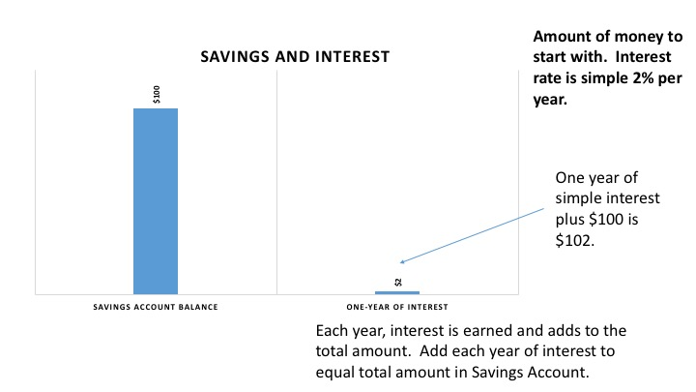

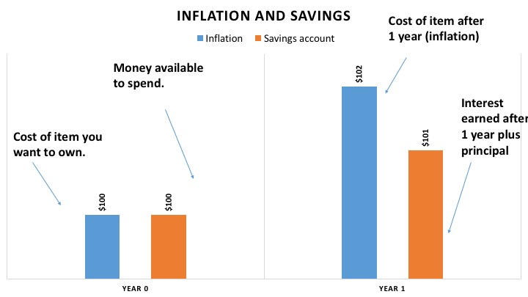

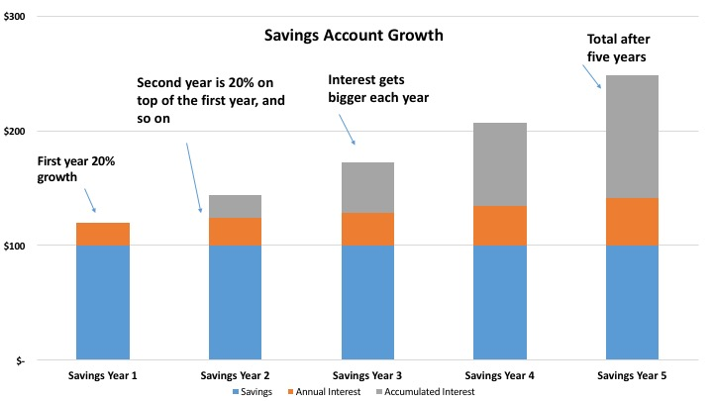

Diversification

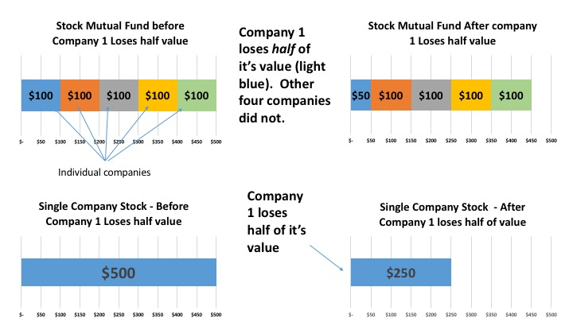

Bonds and interest rates

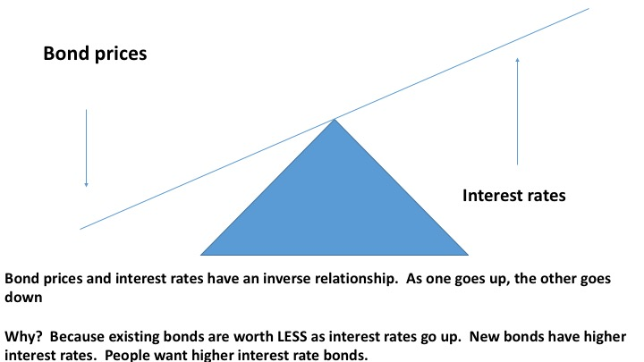

|  |  |  |  |  |
| --- | --- | --- | --- | --- |
| Table 1 |  |  |  |  |
|  | Descriptive Statistics (N=1797) | |  | |
| Variable |  | Percent | Count |  |
| Treatment |  |  |  |  |
|  | Control | 33.61% | 604 |  |
|  | Text-only | 33.22% | 597 |  |
|  | Visualization plus text | 33.17% | 596 |  |
| Biological Sex |  |  |  |  |
|  | Female | 53.31% | 958 |  |
|  | Male | 44.91% | 807 |  |
|  | Prefer not to answer | 1.78% | 32 |  |
|  |  |  |  |  |
| Race and ethnicity |  |  |  |  |
|  | Black | 6.91% | 124 |  |
|  | Hispanic | 5.01% | 90 |  |
|  | Asian/Pacific Islander | 4.23% | 76 |  |
|  | White | 79.78% | 1432 |  |
|  | Other | 4.07% | 73 |  |
| Education |  |  |  |  |
|  | High School Dropout | 2.67% | 48 |  |
|  | High School Grad | 10.35% | 186 |  |
|  | Some College | 29.60% | 532 |  |
|  | College Grad | 26.54% | 477 |  |
|  | Some Graduate | 8.51% | 153 |  |
|  | Graduate School | 16.53% | 297 |  |
|  | Professional Degree (JD, MD) or Ph.d. | 5.79% | 104 |  |
| Financial class |  |  |  |  |
|  | Yes | 93.32% | 1677 |  |
|  | No | 6.68% | 120 |  |
| Age |  |  |  |  |
|  | 18-29 | 21.15% | 380 |  |
|  | 30-44 | 27.60% | 496 |  |
|  | 45-59 | 31.94% | 574 |  |
|  | 60+ | 19.31% | 347 |  |
|  | Continuous variables |  |  |  |
| Annual Income |  |  |  |  |
|  | Mean | $ 72,000.00 |  |  |
|  | Median | $ 50,000.00 |  |  |

Table 2

|  |  |  |  |
| --- | --- | --- | --- |
| *Mean Financial Knowledge Score by Treatment* | | | |
| Variable | Control *n*=604 | Text *n*=597 | Vis *n*=596 |
| Financial Knowledge Score | 3.29 | 3.57 | 3.87 |
|  | α = 0.05; model p<.0001 | | |

Table 3

|  |  |  |  |  |  |
| --- | --- | --- | --- | --- | --- |
| *Results of One-way ANOVA of Mean Financial Knowledge Score and Treatment* | | | | | |
|  | Df | Sum Sq | Mean Sq | F | Pr(>F) |
| Treatment | 2 | 100.1 | 50.062 | 26.669 | 1.02e-11*** |
| Residuals | 1794 | 3498.8 | 1.95 |  |  |

Table 4

|  |  |  |  |  |
| --- | --- | --- | --- | --- |
| *Tukey's HSD Results for Multiple Comparisons ANOVA* | | | | |
|  | Diff | Lower bound | Upper bound | P(adj) |
| Text-Control | 0.28 | 0.1 | 0.47 | 0.0012*** |
| Viz-Control | 0.58 | 0.39 | 0.77 | <0.001*** |
| Viz-Text | 0.29 | 0.10 | 0.48 | <0.001*** |

Table 5

|  |  |  |  |  |  |
| --- | --- | --- | --- | --- | --- |
| *Poisson Regression Results for All Variables Predicting Financial Knowledge Scores* | | | | | |
|  |  |  |  |  |  |
| Variable |  | Coefficient | SE | z | Pr(>|z|) |
| Income |  | 0.00000015 | 9E-10 | 1.81 | .07* |
| Gender Male |  | 0.13 | 0.025 | 5.2 | <.001*** |
| Treatment |  |  |  |  |  |
|  | Text | 0.11 | 0.031 | 3.62 | <.001*** |
|  | Visual | 0.86 | 0.03 | 6.04 | <.001*** |
| Education |  |  |  |  |  |
|  | High School | -0.064 | 0.12 | -0.534 | .06* |
|  | Some college | 0.13 | 0.11 | 1.1 | 0.27 |
|  | Bachelors | 0.22 | 0.11 | 1.93 | .05* |
|  | Some Graduate | 0.20 | 0.12 | 1.63 | 0.1 |
|  | Masters | 0.27 | 0.12 | 2.31 | .02** |
|  | Professional | 0.25 | 0.12 | 2.06 | 0.04** |
| Race |  |  |  |  |  |
|  | White | 0.31 | 0.07 | 5.28 | <.001*** |
|  | Hispanic | 0.062 | 0.08 | 0.73 | 0.46 |
|  | Asian/Pacific Islander | 0.11 | 0.09 | 1.32 | 0.19 |
|  | Other | 0.093 | 0.09 | 1.05 | 0.29 |
| Intercept |  | 0.67 | 0.13 | 5.316 |  |
| Sig. codes | <.001 '***', .05 '**', .10'*' | |  |  |  |

Figure 1

Cognitive theory of multi-media learning

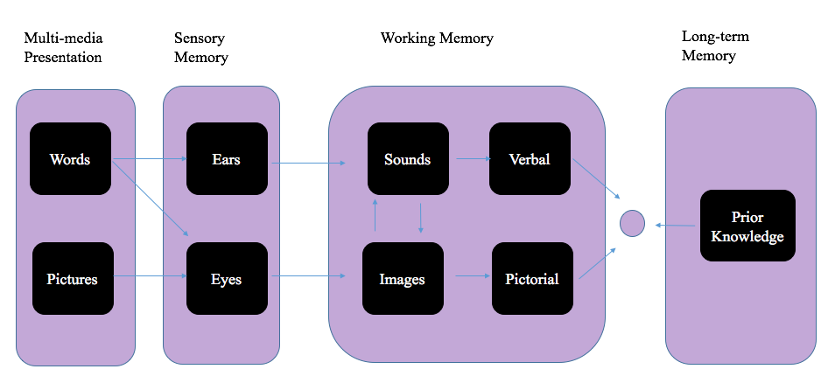

Adapted from *The Theory of Multi-Media Learning* (Mayer, 1997)