Technion, Israel Institute of Technology

Department of Mechanical Engineering

Robot Navigation

Final Project

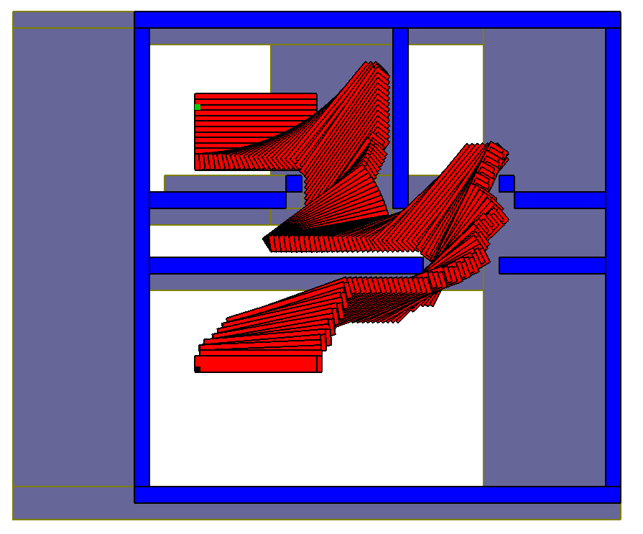

Jonathan Spitz – 324599430

Elias Cohenca – 302025358

#### Introduction

We built a computer program for path planning based on the given robot and environment geometries (see figure 1). The problem we were required to solve is the “bed movers” problem, where an apartment plan, a bed, its initial position and the desired target position are given.

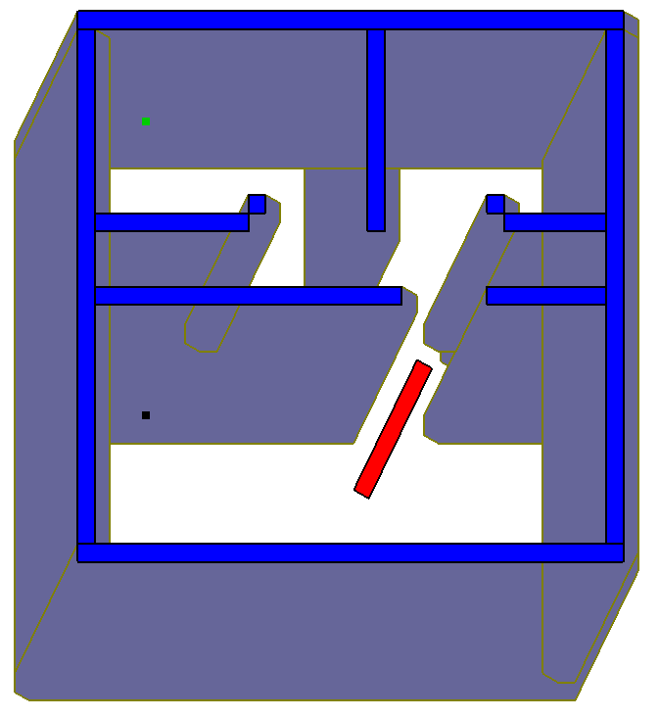

Figure

We used the A* path planning algorithm to find the route from Start to Target. In order to do so, we first find the robot’s free space by calculating the geometry of each c-obstacle. This free space was then discretized and transformed into a three-dimensional grid (x, y, theta). Each element in the grid is a node in the search graph. Each free neighbor cell (up/down, left/right, theta+/theta-) is considered as a neighbor in the graph. The heuristics function used calculates the distance (cell-wise) to the Target taking into account x, y and theta.

#### Grid resolution

The ad-hoc resolution of 32x32x32 is too coarse for the theta axis. We calculated the needed resolution so that no c-obstacle edge moves more than one cell between two consecutive theta layers. We considered the robot’s longest vector as our reference and obtained the following relationship for the number of theta layers *N*:



where *L* is the robot’s longest vector and *Resolution* is the amount of grid cells in one unit length. For the given robot, we had *L = 8.06* => *N ≥ 51 x Resolution*.

#### Program implementation

We implemented our program in C++ using OpenGL to draw the environment and results. The keyboard can be used to move the bed around the apartment (Keys: ‘W’,’A’,’S’,’D’,’Q’,’E’ or Arrows). The bed’s movement is constrained to the free space (Key: ‘C’). The bed’s position can be saved as the start and the target points from the right-click menu. The display can be switched to show the discretized grid (Key: ‘G’) or the original environment (Key: ‘O’). The camera can be moved by holding the left button and dragging the mouse. In order to zoom in (out), hold the middle button and drag the mouse up (down). To reset the camera press ‘R’.

The path planning algorithm can be run from the right-click menu or by pressing ‘T’. After a path is found, a simulation of bed’s movement can be run step by step, forward (Key: ‘+’) or backwards (Key: ‘-‘), while choosing whether to see the trail of the path (Key: ‘P’). Furthermore, the nodes remaining in the closed and open groups can be seen in the grid. To exit the program press ‘Esc’.

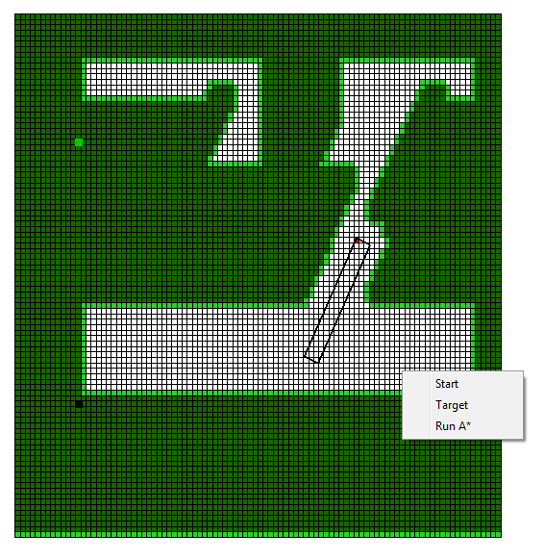

Figure