1. **KANONİK İFADE**

F = B'D' + A'BD + AD' + A'BC'

1. **GRUPLANDIRMALAR**

Gruplar: (m0, m4, m12, m8), (m0, m8, m2, m10), (m5, m7), (m12, m8, m14, m10), (m4, m5).

1. **MAXTERMLER**

F = PRODUCT(M1, M3, M6, M9, M11, M13, M15)

1. **POS GÖSTERİMİ**

F = (A+B+C+D')(A+B+C'+D')(A+B'+C'+D)(A'+B'+C+D')(A'+B'+C'+D')(A'+B+C+D')(A'+B+C'+D')

1. **MINTERMLER**

f= SUM (m0, m2, m4, m5, m7, m8, m10, m12, m14)

1. **SOP GÖSTERİMİ**

F = A'B'C'D' + A'BC'D' + ABC'D'+ AB'C'D'+ A'BC'D + A'BCD + A'B'CD' + ABCD' + AB'CD'

1. **MODÜL KODLARI**
   1. **Expression Modülü**

module exp (x_e,a,b,c,d);

input a,b,c,d;

output x_e;

wire not_a,not_b,not_c,not_d;

wire w_1,w_2,w_3,w_4;

not(not_a,a);

not(not_b,b);

not(not_c,c);

not(not_d,d);

and(w_1,not_b,not_d);

and(w_2,not_a,b,d);

and(w_3,a,not_d);

and(w_4,not_a,b,not_c);

or(x_e,w_1,w_2,w_3,w_4);

endmodule

* 1. **SOP Modülü**

module sop(x_out,a,b,c,d);

input a,b,c,d;

output x_out;

wire w_1,w_2,w_3,w_4,w_5,w_6,w_7,w_8,w_9;

wire not_a,not_b,not_c,not_d;

not (not_a, a);

not (not_b, b);

not (not_c, c);

not (not_d, d);

and(w_1, not_a,not_b,not_c,not_d);

and(w_2, not_a,b,not_c,not_d);

and(w_3, a,b,not_c,not_d);

and(w_4, a,not_b,not_c,not_d);

and(w_5, not_a,b,not_c,d);

and(w_6, not_a,b,c,d);

and(w_7, not_a,not_b,c,not_d);

and(w_8, a,b,c,not_d);

and(w_9, a,not_b,c,not_d);

or (x_out,w_1,w_2,w_3,w_4,w_5,w_6,w_7,w_8,w_9);

endmodule

* 1. **POS Modülü**

module pos(x_out,a,b,c,d);

input a,b,c,d;

output x_out;

wire w_1,w_2,w_3,w_4,w_5,w_6,w_7;

wire not_a,not_b,not_c,not_d;

not (not_a, a);

not (not_b, b);

not (not_c, c);

not (not_d, d);

or(w_1,a,b,c,not_d);

or(w_2,a,b,not_c,not_d);

or(w_3,a,not_b,not_c,d);

or(w_4,not_a,not_b,c,not_d);

or(w_5,not_a,not_b,not_c,not_d);

or(w_6,not_a,b,c,not_d);

or(w_7,not_a,b,not_c,not_d);

and(x_out,w_1,w_2,w_3,w_4,w_5,w_6,w_7);

endmodule

* 1. **Testbench**

module tb();

reg a,b,c,d;

wire x_e, x_s,x_p;

exp exp1(x_e, a, b, c, d);

sop sop1(x_s, a, b, c, d);

pos pos1(x_p, a, b, c, d);

initial

begin

#100

a=1'b0;

b=1'b0;

c=1'b0;

d=1'b0;

#100

a=1'b0;

b=1'b0;

c=1'b0;

d=1'b1;

#100

a=1'b0;

b=1'b0;

c=1'b1;

d=1'b0;

#100

a=1'b0;

b=1'b0;

c=1'b1;

d=1'b1;

#100

a=1'b0;

b=1'b1;

c=1'b0;

d=1'b0;

#100

a=1'b0;

b=1'b1;

c=1'b0;

d=1'b1;

#100

a=1'b0;

b=1'b1;

c=1'b1;

d=1'b0;

#100

a=1'b0;

b=1'b1;

c=1'b1;

d=1'b1;

#100

a=1'b1;

b=1'b0;

c=1'b0;

d=1'b0;

#100

a=1'b1;

b=1'b0;

c=1'b0;

d=1'b1;

#100

a=1'b1;

b=1'b0;

c=1'b1;

d=1'b0;

#100

a=1'b1;

b=1'b0;

c=1'b1;

d=1'b1;

#100

a=1'b1;

b=1'b1;

c=1'b0;

d=1'b0;

#100

a=1'b1;

b=1'b1;

c=1'b0;

d=1'b1;

#100

a=1'b1;

b=1'b1;

c=1'b1;

d=1'b0;

#100

a=1'b1;

b=1'b1;

c=1'b1;

d=1'b1;

end

endmodule

1. 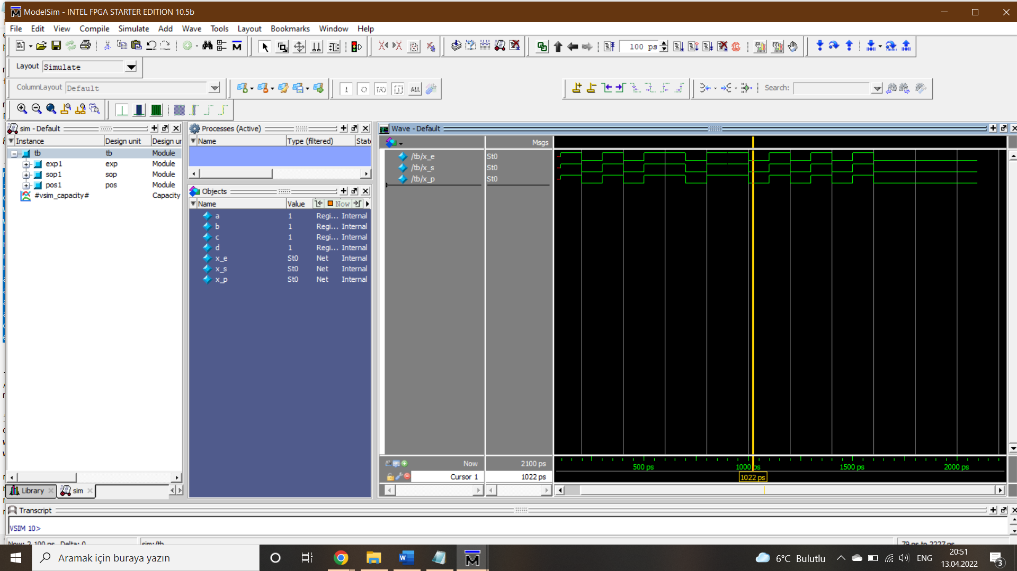**MODELSİM SİMÜLASYONU**

Farklı giriş kombinasyonları için çıkışlar aynı sinyalleri vermektedir.