3 Specific Req - This section of the Software Requirements Specification of Safety for Everyone

is designed according to the user class template, Appendix-A.3 of IEEE Std. 830-1998,

IEEE Recommended Practice for Software Requirements Specifications.

3.1 External Interface Requirement

3.1.1 User Interfaces

3.1.1.1 Common Functions for All Users

The Safety for Everyone shall authenticate user to enter to the system

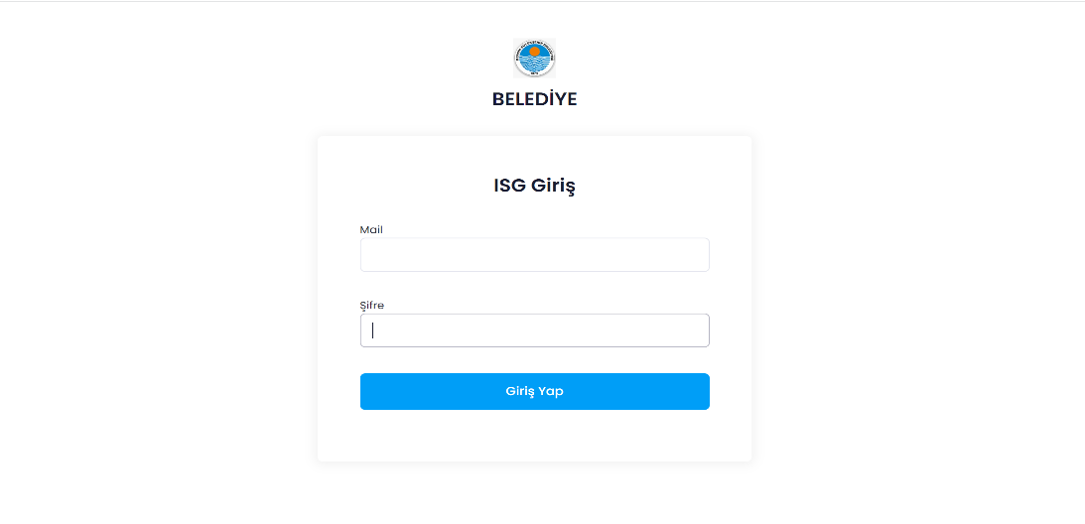 a)

(Authentication Screen)

The detailed description of items of authentication screen:

1. **Name of item**: User_mail text box

**Description of purpose**: To enter the mail of the user for whom authentication to the Safety for Everyone shall be given.

**Source of input**: Keyboard.

**Valid Range**: The User_mail shall be maximum 100 characters long and cannot be zero.

**Units of measure**: -

**Timing**: -

**Relationship to other inputs**: -

**Screen formats/organizations**: As seen in Figure 1.

**Window formats/organization**: -

**Data formats**: The User_mail shall consist of alphanumeric characters only and shall be compatible with ISO 8859-1 character set.

**Command formats**: -

**End messages**: -

1. **Name of item**: Password text box.

**Description of purpose**: To enter the password of the user for whom authentication to the Safety for Everyone shall be given.

**Source of input**: Keyboard.

**Valid Range**: The password shall be maximum 20,minimum 8 characters long.

**Units of measure**: -

**Timing**: -

**Relationship to other inputs**: -

**Screen formats/organizations**: As seen in Figure 1.

**Window formats/organization**: -

**Data formats**: The password shall consist of alphanumeric characters only and shall be compatible with ISO 8859-1 character set.

**Command formats**: -

**End messages**: -

1. **Name of item**: Submit_button.

**Description of purpose**: To send the entered inputs to the server software

**Source of input**: Keyboard.

**Valid Range**:.-

**Units of measure**: -

**Timing**: -

**Relationship to other inputs**: The Mail and password of the user shall be entered in the user-mail text box and password text box respectively before initiating authentication functionality.

**Screen formats/organizations**: As seen in Figure 1.

**Window formats/organization**: -

**Data formats**:-

**Command formats**: -

**End messages**: -

tablo içeren bir resim

Açıklama otomatik olarak oluşturuldub) The Safety for Everyone shall inform user about the all personal.

Figüre 2. Personal list

The detailed description of items of listPerson screen:

1. **Name of item**: AddNewPersonal_button.

**Description of purpose**: To add new personel.

**Source of input**: -

**Valid Range**: -

**Units of measure**: -

**Timing**: -

**Relationship to other inputs**: -.

**Screen formats/organizations**: As seen in Figure 2.

**Window formats/organization**: -

**Data formats**:-

**Command formats**: -

**End messages**: -

1. **Name of item**: SearchPersonal_button.

**Description of purpose**: To search a personel.

**Source of input**: Keyboard.

**Valid Range**: -

**Units of measure**: -

**Timing**: -

**Relationship to other inputs**: -.

**Screen formats/organizations**: As seen in Figure 2.

**Window formats/organization**: -

**Data formats**: The SearchPersonal_button shall consist of alphanumeric characters only and shall be compatible with ISO 8859-1 character set.

**Command formats**: -

**End messages**: -

1. **Name of item**: Transaction_button.

**Description of purpose**: To make some operation for a personal.

**Source of input**: Keyboard or mouse.

**Valid Range**: -

**Units of measure**: -

**Timing**: -

**Relationship to other inputs**: -.

**Screen formats/organizations**: As seen in Figure 2.

**Window formats/organization**: -

**Data formats**:-.

**Command formats**: -

**End messages**: -

c ) The Safety for Everyone system shall information about personal life.

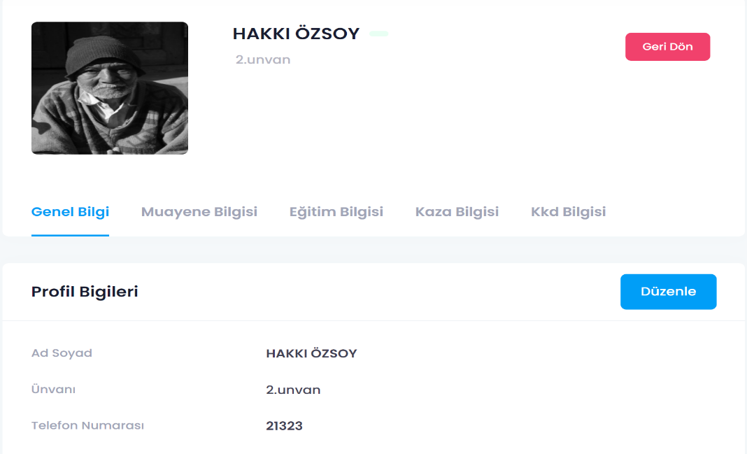

Figure 3. Personnel private information

The detailed description of items of main administration screen:

1. **Name of item**: Back_button.

**Description of purpose**: Used to return the list of all personnel.

**Source of input**: Mouse.

**Valid Range**: -

**Units of measure**: -

**Timing**: -

**Relationship to other inputs**: -.

**Screen formats/organizations**: As seen in Figure 3.

**Window formats/organization**: -

**Data formats**:-.

**Command formats**: -

**End messages**: -

1. **Name of item**: Edit_button.

**Description of purpose**: Used to change of personnel information.

**Source of input**: Mouse.

**Valid Range**: -

**Units of measure**: -

**Timing**: -

**Relationship to other inputs**: -.

**Screen formats/organizations**: As seen in Figure 3.

**Window formats/organization**: -

**Data formats**:-.

**Command formats**: -

**End messages**: -

1. **Name of item**: GeneralInformation_button.

**Description of purpose**: Used to show general information of personnel.

**Source of input**: Mouse.

**Valid Range**: -

**Units of measure**: -

**Timing**: -

**Relationship to other inputs**: -.

**Screen formats/organizations**: As seen in Figure 3.

**Window formats/organization**: -

**Data formats**:-.

**Command formats**: -

**End messages**: -

1. **Name of item**: InspectionInformation_button.

**Description of purpose**: Used to show inspection information of personnel.

**Source of input**: Mouse.

**Valid Range**: -

**Units of measure**: -

**Timing**: -

**Relationship to other inputs**: -.

**Screen formats/organizations**: As seen in Figure 3.

**Window formats/organization**: -

**Data formats**:-.

**Command formats**: -

**End messages**: -

1. **Name of item**: EducationInformation_button.

**Description of purpose**: Used to show education information of personnel.

**Source of input**: Mouse.

**Valid Range**: -

**Units of measure**: -

**Timing**: -

**Relationship to other inputs**: -.

**Screen formats/organizations**: As seen in Figure 3.

**Window formats/organization**: -

**Data formats**:-.

**Command formats**: -

**End messages**: -

1. **Name of item**:AccidentInformation_button.

**Description of purpose**: Used to show accident information of personnel.

**Source of input**: Mouse.

**Valid Range**: -

**Units of measure**: -

**Timing**: -

**Relationship to other inputs**: -.

**Screen formats/organizations**: As seen in Figure 3.

**Window formats/organization**: -

**Data formats**:-.

**Command formats**: -

**End messages**: -

1. **Name of item**: KKDInformation_button.

**Description of purpose**: Used to show personal protective equipment information of personnel.

**Source of input**: Mouse.

**Valid Range**: -

**Units of measure**: -

**Timing**: -

**Relationship to other inputs**: -.

**Screen formats/organizations**: As seen in Figure 3.

**Window formats/organization**: -

**Data formats**:-.

**Command formats**: -

**End messages**: -

* + - 1. Functions for Admin

1. The Safety for Everyone shall allow admin to make basic operations such as ADD, DELETE and UPDATE for personnel .

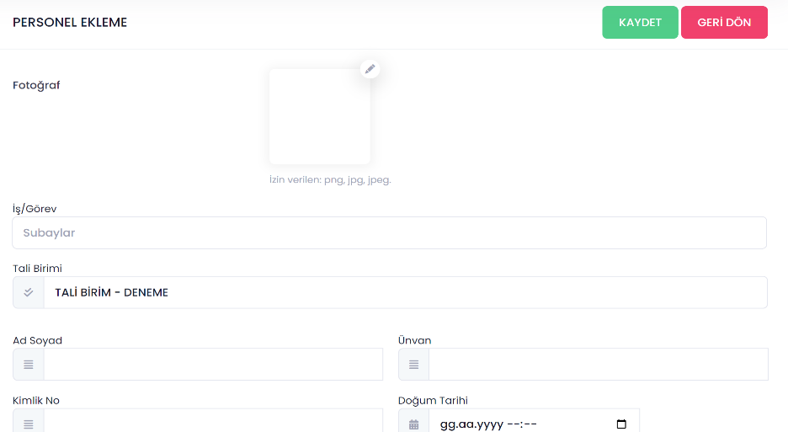

Figure 4. Add new personnel screen

The detailed description of items of main administration screen:

1. **Name of item**: SearchPhoto_button.

**Description of purpose**: It searches the computer to add photos.

**Source of input**: Mouse.

**Valid Range**: Maksimum 10 MB in size.

**Units of measure**: -

**Timing**: -

**Relationship to other inputs**: -.

**Screen formats/organizations**: As seen in Figure 4.

**Window formats/organization**: -

**Data formats**:JPG,PNG,JPEG.

**Command formats**: -

**End messages**: -

1. **Name of item**: Duty_input.

**Description of purpose**: Enter duty of personnel.

**Source of input**: Keyboard..

**Valid Range**: The Duty_input shall be maximum 20 characters long and cannot be zero.

**Units of measure**: -

**Timing**: -

**Relationship to other inputs**: -.

**Screen formats/organizations**: As seen in Figure 4.

**Window formats/organization**: -

**Data formats**: The Duty_input shall consist of alphanumeric characters only and shall be compatible with ISO 8859-1 character set..

**Command formats**: -

**End messages**: -

1. **Name of item**: NameSurname_input.

**Description of purpose**: Enter name and surname of personnel.

**Source of input**: Keyboard..

**Valid Range**: The NameSurname_input shall be maximum 30 characters long and cannot be zero.

**Units of measure**: -

**Timing**: -

**Relationship to other inputs**: -.

**Screen formats/organizations**: As seen in Figure 4.

**Window formats/organization**: -

**Data formats**: The NameSurname_input shall consist of alphanumeric characters only and shall be compatible with ISO 8859-1 character set..

**Command formats**: -

**End messages**: -

1. **Name of item**: Degree_input.

**Description of purpose**: Enter degree of personnel.

**Source of input**: Keyboard..

**Valid Range**: The Degree_input shall be maximum 30 characters long and cannot be zero.

**Units of measure**: -

**Timing**: -

**Relationship to other inputs**: -.

**Screen formats/organizations**: As seen in Figure 4.

**Window formats/organization**: -

**Data formats**: The Degree_input shall consist of alphanumeric characters only and shall be compatible with ISO 8859-1 character set..

**Command formats**: -

**End messages**: -

1. **Name of item**: TCKno_input.

**Description of purpose**: Enter identification number of personnel.

**Source of input**: Keyboard..

**Valid Range**: The TCKno_input must be 11 integer long.

**Units of measure**: -

**Timing**: -

**Relationship to other inputs**: -.

**Screen formats/organizations**: As seen in Figure 4.

**Window formats/organization**: -

**Data formats**: The TCKno_input shall consist of alphanumeric integers only and shall be compatible with ISO 8859-1 character set.

**Command formats**: -

**End messages**: -

1. **Name of item**: BirthdaySelect_button.

**Description of purpose**: To select birthday of personnel .

**Source of input**: Mouse.

**Valid Range**: The date to select must be between January 1,1930 and January 1,2004 .

**Units of measure**: -

**Timing**: -

**Relationship to other inputs**:-.

**Screen formats/organizations**: As seen in Figure 4.

**Window formats/organization**: -

**Data formats**: Must be date data type.

**Command formats**: -

**End messages**:-.

1. **Name of item**: Save_button.

**Description of purpose**: To save new personnel into database..

**Source of input**: Mouse.

**Valid Range**: -.

**Units of measure**: -

**Timing**: -

**Relationship to other inputs**: Duty_input , NameSurname_input,Degree_input,TCKno_input must be filled.

**Screen formats/organizations**: As seen in Figure 4.

**Window formats/organization**: -

**Data formats**:-.

**Command formats**: -

**End messages**: “New personnel added successfully”.

1. The Safety for Everyone shall allow admin to see risk analysis of personnel.

tablo içeren bir resim

Açıklama otomatik olarak oluşturuldu

Figure 5. Risk analysis screen

The detailed description of items of add user screen:

1. **Name of item**: AddNewRisk_button.

**Description of purpose**: To add new risk .

**Source of input**: Mouse.

**Valid Range**: -.

**Units of measure**: -

**Timing**: -

**Relationship to other inputs**:-.

**Screen formats/organizations**: As seen in Figure 5.

**Window formats/organization**: -

**Data formats**:-.

**Command formats**: -

**End messages**:-.

1. **Name of item**: SearchRisk_input.

**Description of purpose**: To search risk .

**Source of input**: Keyboard.

**Valid Range**: maximum 30 character.

**Units of measure**: -

**Timing**: -

**Relationship to other inputs**:-.

**Screen formats/organizations**: As seen in Figure 5.

**Window formats/organization**: -

**Data formats**: The SearchRisk_input shall consist of alphanumeric characters only and shall be compatible with ISO 8859-1 character set.

**Command formats**: -

**End messages**:-.

1. **Name of item**: Transactions_Button.

**Description of purpose**: To see transactions risk .

**Source of input**: Mouse.

**Valid Range**:-.

**Units of measure**: -

**Timing**: -

**Relationship to other inputs**:-.

**Screen formats/organizations**: As seen in Figure 5.

**Window formats/organization**: -

**Data formats**:-.

**Command formats**: -

**End messages**:-.

3.2 Functional Requirements

3.2.1 Common Functions for All Users

3.2.1.1 User Authentication Function:

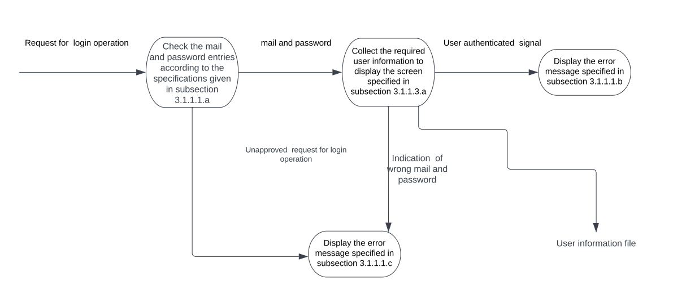

3.2.2 Functions for Root

3.2.2.1 User Addition Function: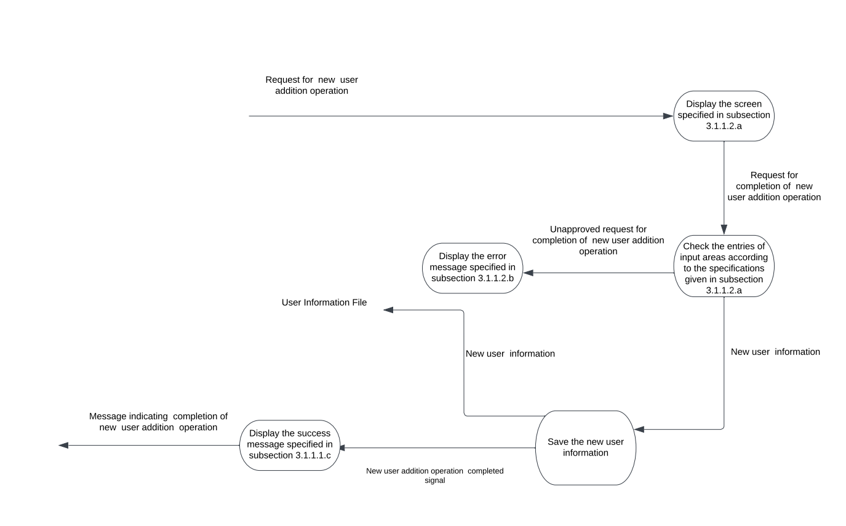

3.2.2.2 User Deletion Function:

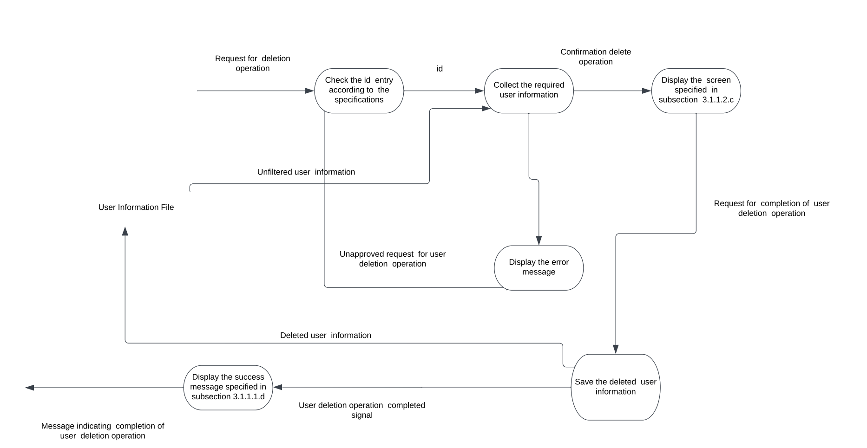

3.2.2.3 User Update Function:

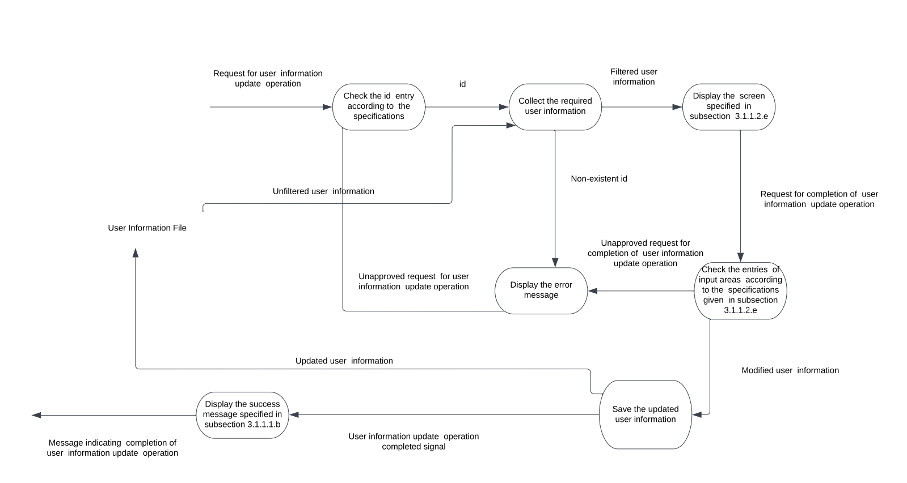

3.2.2.4 Risk Analysis Addition Function:

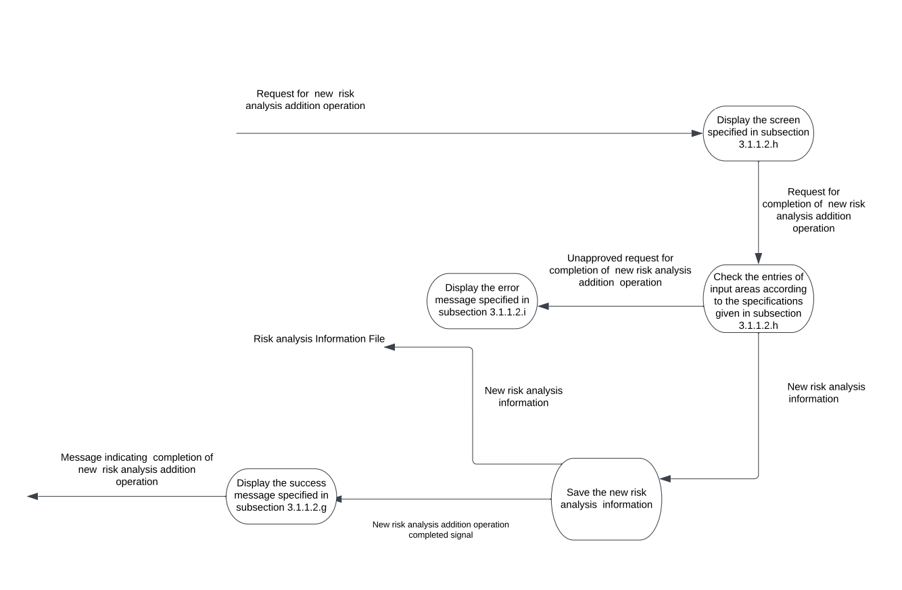

3.2.2.5 Risk Analysis Delete Function:

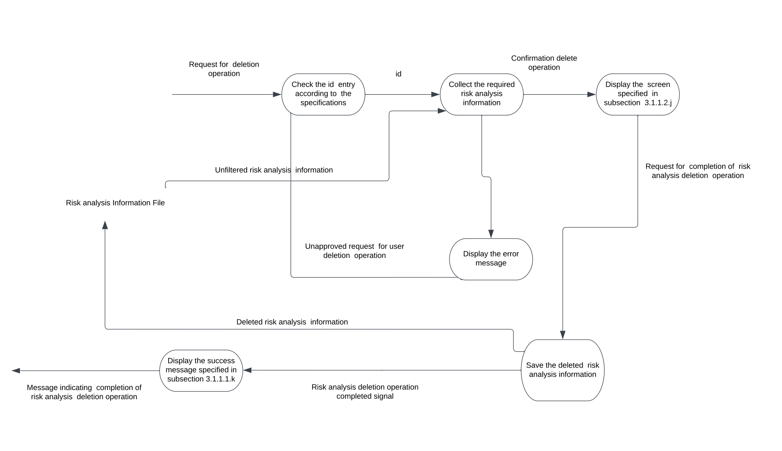

3.2.2.6 Risk Analysis UpdateFunction:

