***SOFTWARE REQUIREMENTS SPECIFICATION***

***for***

**Safety for Everyone**

*Prepared By*

**CengHall**

*Ayşegül Sofuoğlu*

*Bedirhan Budak*

*Deniz Parlar*

*Elif Erten*

*Nesteren Gözükızıl*

*Rabia Kurt*

October 31th 2022

**CHANGE HISTORY**

This document is the first version (version 1.0) of Safety for Everyone, Software Requirements Specification that was released on October 31th, 2022. The subsequent changes will be mentioned in this part of the SRS.

**PREFACE**

The document contains the Software Requirements Specification of Safety for Everyone. The mission of the project is to develop a web-based occupational health and safety system for Mersin municipality.

The goal of the SRS is to describe the requirements of the Safety for Everyone. This document is prepared according to IEEE standard [7,8,9,10].

**TABLE OF CONTENTS**

**LIST OF FIGURES**

Figure 1: Authentication Screen 8

Figure 2**:** Personnel list 10

Figure 3**:** Add new personnel screen 11

Figure 4: Add new personnel error message screen 14

Figure 5**:** There is already someone like this error screen 15

Figure 6: Are you sure you want to delete personnel screen 16

Figure 7**:** Success message about delete button screen 17

Figure 8: All risk analysis screen 18

Figure 9: Add new risk screen 19

Figure 10**:** Are you sure you want to delete risk screen 24

Figure 11**:** Success of delete risk operation screen 25

Figure 12**:** Machine equipment list screen 26

Figure 13: Add new equipment screen 27

Figure 14**:** Are you sure you want to delete equipment screen 32

Figure 15**:** Success of delete equipment operation screen 33

Figure 16**:** Add new examination 34

Figure 17**:** DFD for user authentication 39

Figure 18**:** DFD for New user addition function 39

Figure 19**:** DFD for User delete function 40

Figure 20: DFD for user update function 40

Figure 21**:** DFD for New risk analysis addition function 41

Figure 22**:** DFD for risk analysis delete function 41

Figure 23**:** DFD for risk analysis update function 42

Figure 24**:** DFD for New machine equipment addition function 42

Figure 25**:** DFD for machine equipment delete function 43

Figure 26**:** DFD for machine equipment update function 43

**LIST OF TABLES**

Table 1: Software Interfaces 4

* **INTRODUCTION**
* ***Purpose of the SRS***

The purpose of the Software Requirements Specification (SRS) is

* to identify what the Safety for Everyone is supposed to do,
* to provide better communication among the CengHall and the acquirers, who are the intended audience of the SRS,
* to provide a basis for controlling the evolution of the Safety For Everyone and system verification

in a correct, complete, unambiguous and verifiable manner.

* ***Scope of the Product***

The software product to be produced is the Safety for Everyone, which aims to provide a recording system for officers that responsible of occupational and safety ensures to create a less dangerous environment for workers.

This document presents the detailed software requirements analysis for the Safety for Everyone. The scope includes the functional, performance and operational requirements of the Safety for Everyone.

The software requirements analysis is based on Safety for Everyone Initial Plan.

The scope of the Safety for Everyone is:

* The Safety for Everyone will be a text-based system. Any kind of audio-visual extensions are out of scope.

The objectives of the Safety for Everyone are:

* To satisfy for the members of the Safety for Everyone.That the user information, risk analysis, machine equipment is the workers of any institution and the officers are responsible from occupational safety system.
* To satisfy the above-mentioned need in a platform independent manner.
* To satisfy the above-mentioned needs considering the basic security issues.
* ***Definitions, Acronyms and Abbreviations***

**Board Meeting:**A formal periodic gathering of a board of directors.

**CengHall:**Software development team of OHS SYSTEM.

**CengHall’s e-mail address:**This corresponds to the e-mail address of the CengHall members stated in table 3.

**Gather:**to come or bring together.

**HTTP:** Hyper Text Transform Protocol

**IEEE:** Institute of Electrics & Electronics Engineering

**Machine Equipment:**A set of tools or devices which the systems functions need.

**Municipalities:**A city, town, or district local self-government.

**Occupational Safety:** Aim to prevent injury, and accident due to working conditions.

**OS:**Occupational Safety.

**RiskAnalysis:**The process of identifying and analyzingpotential issues that could negatively impact key businessinitiatives or projects.

**SPMP:** Software project management plan. The controlling document for managing the software project.

**SRS**: Software requirements specification.

**System group**: A group of users, which have a common set of access restrictions to the Safety for Everyone.

**User:** The occuptional safety specilast,managers and the root.

**User_id:** A set of characters that identifies the user.

**User Interface**: The interface that the users will see while using the Safety for Everyone.

* ***References***
* Safety For Everyone Initial Plan, version 1.1, October 1st, 2022.
* IEEE Std 1058-1998, IEEE Standard for Software Project Management Plans
* IEEE Std 830-1998, IEEE Recommended Practice for Software Requirements Specifications
* IEEE Std 1016-1998, Recommended Practice for Software Design Descriptions
* IEEE Std 1063-1998, IEEE Standard for Software User Documentation
* ***Overview***

The SRS is organized in three sections.

* *Introduction Section* in which purpose, scope, definitions, references and an overview of the SRS are given.
* *Overall Description Section* describes the general factors that affect the product and its requirements. This section does not state specific requirements. Instead, it provides a background for those requirements, which are defined in detail in specific requirements part, and makes them easier to understand.
* *Specific Requirements Section* contains all of the software requirements to a level of detail sufficient to enable CengHall to design the Safety for Everyone to satisfy those requirements, and testers (both CengHall and acquirers) to test that the system satisfies those requirements.
* **OVERALL DESCRIPTION**
* ***Product perspective***
* **System interfaces**

Safety for Everyone shall be a stand-alone system. The system shall not have an interface with any existing database system.

* **User interfaces**
* All of the user interfaces shall be web-based.
* The format of the screens may differ depending on the operating system, the window manager and the HTTP client used by the user.
* There shall be 5 different types of user interfaces. These are
* authentication,
* add,
* delete,
* update,
* view operations.
* **Hardware interfaces**

Safety for Everyone has no hardware interfaces.

* **Software interfaces**

|  |  |  |  |  |
| --- | --- | --- | --- | --- |
| **Software Interface** | **Name** | **Mnemonic** | **Version** | **Source** |
| Operating System | Microsoft Windows | Windows | Windows 10 | Microsoft |
| DBMS | Microsoft SQL Server Management Studio 18 | SQL | 14.0.2042.3 | Microsoft |
| Web Server | ISS | ISS | 10.0 | ISS |
| Runtime Platform | Visual Studio 2019 | Visual Studio 2019 | 16.10.3 | Microsoft |

Table 1: Software Interfaces

* **Communication interfaces**

In order to execute both client software and server software, the TCP and IP protocols shall be installed both at the client site and server site respectively.

* **Memory Constraints**

The primary and secondary memory requirements of the client partition are the largest of the primary and secondary memory requirements of Netscape Communicator and Microsoft Internet Explorer, respectively.

* **Operations**

There is no backup and recovery interface in the Safety for Everyone.

* Functions of occupational specialist
* can access machine equipment information
* Functions of super admin
* have access to the entire system
* Functions of admin
* have access to the whole system but cannot add person and machine equipment
* **Site adaptation requirements**

Since the server software shall only be installed to a unique location, namely the server site, and since no installation is required for the client software, there are no site adaptation requirements for the Safety for Everyone.

* ***Product Functions:***

The general functions that the system will perform, can be categorized as follows:

* User Functions:
* User Addition Function: Adds a new user to the system.
* User Authentication Function: Determines that user's jurisdiction. Authorizes according to mail and password.
* User Deletion Function: Deletes user for whom the Id is specified.
* User Update Function: Updates user information for whom the Id is specified.
* Machinery Equipment Function:
* Equipment Addition Function: Adds machines and its features.
* Equipment Deletion Function: Deletes required machine and its features.
* Equipment Update Function: Updates new features added to machines.
* Equipment View Function: Shows a list about machines and its features.
* Risk Analysis Function:
* Risk Analysis Addition Function: Adds risk analysis and its features.
* Risk Analysis Deletion Function: Deletes risk analysis and its features.
* Risk Analysis Update Function: Updates new features added to risk analysis.
* Risk Analysis View Function: Shows a list about risk analysis and its features.
* ***User Characteristics:***

The Safety for Everyone is intended to use by occupational specialist, super admin and admin.

The Safety for Everyone shall be designed such that a any user shall be able to learn using it after 20 minutes of continuous training

* ***Constraints:***

**1.** The Safety for Everyone shall be a standalone system since no authorization to access to system is given.

**2.** The Safety for Everyone shall be a web-based, platform independent system.

**3.** The Safety for Everyone shall log information such as educational background, personal information.

**4.** The screen shots of the Safety for Everyone are prepared by Visual Studio 2019.

Therefore, the real screen may not match with them exactly.

**5.** The system can be fully used by the authorized person who is the superadmin, and the admin, OHS specialist, will be able to use the areas reserved for them.

* ***Assumptions and Dependencies:***
* The users must have computers and must be connected to the Internet to use the system.
* The application program will run on Windows 10 Platform.
* IIS Server shall be installed at the server site.
* CengHall shall not be responsible for acquisition, installation, configuration or maintenance of Windows 10 Platform and IIS Server for the server site.
* CengHall shall not be responsible for acquisition, installation, configuration or maintenance of Google Chrome for Windows 11/10/8.1/8/7 or Microsoft Internet Explorer version 11.10 for the client site.
* ***Apportioning of Requirements:***

The Safety for Everyone has no requirements that may be delayed until future versions of the Safety for Everyone.

* **SPECIFIC REQUIREMENTS**

This section of the Software Requirements Specification of the Safety for Everyone is designed according to the user class template, Appendix-A.3 of IEEE Std. 830-1998, IEEE Recommended Practice for Software Requirements Specifications.

* ***External Interfaces***
* **User Interfaces**
* **Common Functions for All Users**

a) The Safety for Everyone shall authenticate user to enter to the system

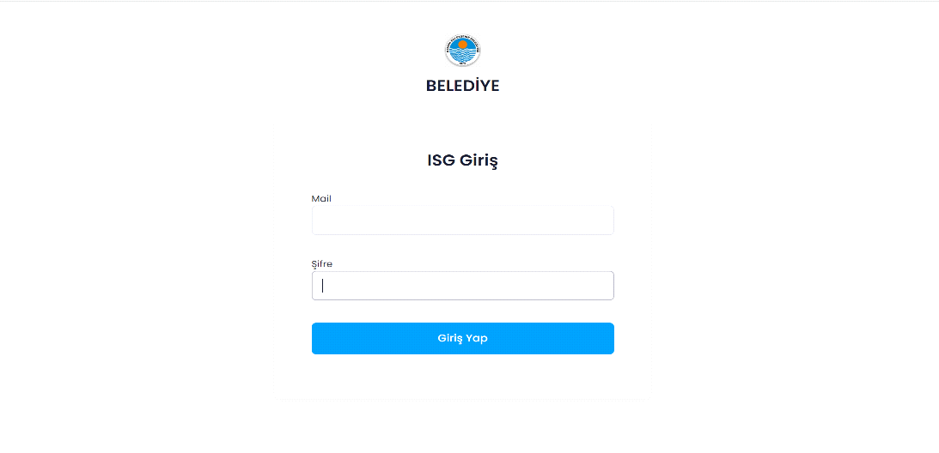

Figure 1: Authentication Screen

The detailed description of items of authentication screen:

* **Name of item**: User_mail text box

**Description of purpose**: To enter the mail of the user for whom authentication to the Safety for Everyone shall be given.

**Source of input**: Keyboard.

**Valid Range**: The User_mail shall be maximum 100 characters long and cannot be zero.

**Units of measure**: -

**Timing**: -

**Relationship to other inputs**: -

**Screen formats/organizations**: As seen in Figure 1.

**Window formats/organization**: -

**Data formats**: The User_mail shall consist of alphanumeric characters only and shall be compatible with ISO 8859-1 character set.

**Command formats**: -

**End messages**: -

* **Name of item**: Password text box.

**Description of purpose**: To enter the password of the user for whom authentication to the Safety for Everyone shall be given.

**Source of input**: Keyboard.

**Valid Range**: The password shall be maximum 20, minimum 8 characters long.

**Units of measure**: -

**Timing**: -

**Relationship to other inputs**: -

**Screen formats/organizations**: As seen in Figure 1.

**Window formats/organization**: -

**Data formats**: The password shall consist of alphanumeric characters only and shall be compatible with ISO 8859-1 character set.

**Command formats**: -

**End messages**: -

* **Name of item**: Submit_button.

**Description of purpose**: To send the entered inputs to the server software

**Source of input**: Keyboard.

**Valid Range**: -

**Units of measure**: -

**Timing**: -

**Relationship to other inputs**: The Mail and password of the user shall be entered in the user-mail text box and password text box respectively before initiating authentication functionality.

**Screen formats/organizations**: As seen in Figure 1.

**Window formats/organization**: -

**Data formats**: -

**Command formats**: -

**End messages**: -

b) The Safety for Everyone shall inform user about the all personnels.

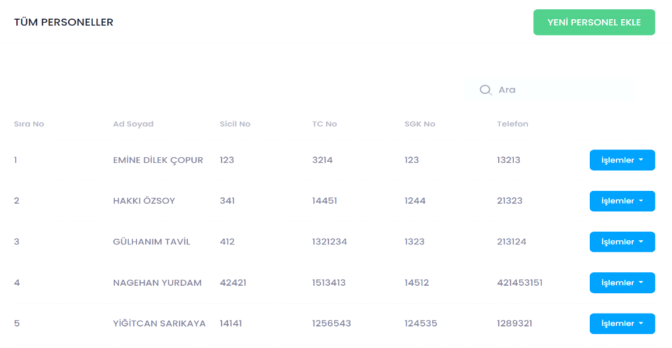

Figure 2**:** Personnel list

The detailed description of items of listPerson screen:

* **Name of item**: AddNewPersonal_button.

**Description of purpose**: To add new personnel.

**Source of input**: -

**Valid Range**: -

**Units of measure**: -

**Timing**: -

**Relationship to other inputs**: -

**Screen formats/organizations**: As seen in Figure 2.

**Window formats/organization**: -

**Data formats**: -

**Command formats**: -

**End messages**: -

* **Name of item**: SearchPersonal_button.

**Description of purpose**: To search a personnel.

**Source of input**: Keyboard.

**Valid Range**: -

**Units of measure**: -

**Timing**: -

**Relationship to other inputs**: -

**Screen formats/organizations**: As seen in Figure 2.

**Window formats/organization**: -

**Data formats**: The SearchPersonal_button shall consist of alphanumeric characters only and shall be compatible with ISO 8859-1 character set.

**Command formats**: -

**End messages**: -

* **Name of item**: Transaction_button.

**Description of purpose**: To make some operation for a personnel.

**Source of input**: Keyboard or mouse.

**Valid Range**: -

**Units of measure**: -

**Timing**: -

**Relationship to other inputs**: -

**Screen formats/organizations**: As seen in Figure 2.

**Window formats/organization**: -

**Data formats**: -

**Command formats**: -

**End messages**: -

* ***3.1.1.2 Functions for Admin and Superadmin***
* The Safety for Everyone system shall information about add new personnel.

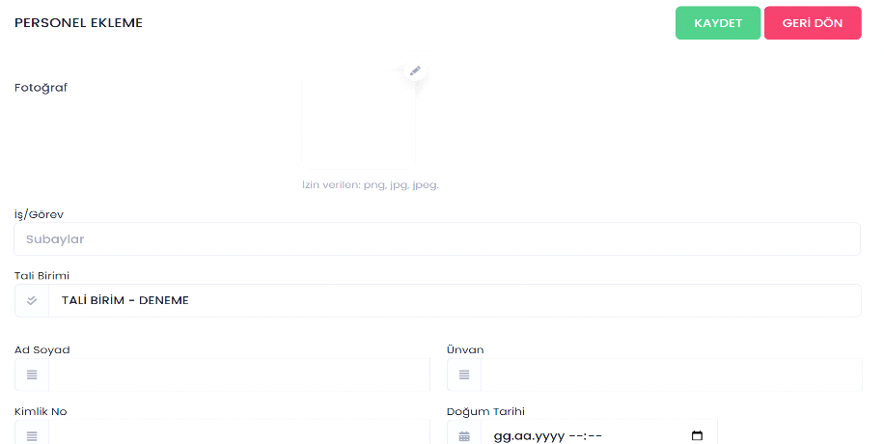

Figure 3**:** Add new personnel screen

The detailed description of items of main administration screen:

* **Name of item**: SearchPhoto_button.

**Description of purpose**: It searches the computer to add photos.

**Source of input**: Mouse.

**Valid Range**: Maximum 10 MB in size.

**Units of measure**: -

**Timing**: -

**Relationship to other inputs**: -

**Screen formats/organizations**: As seen in Figure 3.

**Window formats/organization**: -

**Data formats**: JPG, PNG, JPEG.

**Command formats**: -

**End messages**: -

* **Name of item**: NameSurname_input.

**Description of purpose**: Enter name and surname of personnel.

**Source of input**: Keyboard..

**Valid Range**: The NameSurname_input shall be maximum 30 characters long and cannot be zero.

**Units of measure**: -

**Timing**: -

**Relationship to other inputs**: -

**Screen formats/organizations**: As seen in Figure 3.

**Window formats/organization**: -

**Data formats**: The NameSurname_input shall consist of alphanumeric characters only and shall be compatible with ISO 8859-1 character set..

**Command formats**: -

**End messages**: -

* **Name of item**: Degree_input.

**Description of purpose**: Enter degree of personnel.

**Source of input**: Keyboard.

**Valid Range**: The Degree_input shall be maximum 30 characters long and cannot be zero.

**Units of measure**: -

**Timing**: -

**Relationship to other inputs**: -

**Screen formats/organizations**: As seen in Figure 3.

**Window formats/organization**: -

**Data formats**: The Degree_input shall consist of alphanumeric characters only and shall be compatible with ISO 8859-1 character set.

**Command formats**: -

**End messages**: -

* **Name of item**: TCKno_input.

**Description of purpose**: Enter identification number of personnel.

**Source of input**: Keyboard..

**Valid Range**: The TCKno_input must be 11 integer long.

**Units of measure**: -

**Timing**: -

**Relationship to other inputs**: -

**Screen formats/organizations**: As seen in Figure 3.

**Window formats/organization**: -

**Data formats**: The TCKno_input shall consist of alphanumeric integers only and shall be compatible with ISO 8859-1 character set.

**Command formats**: -

**End messages**: -

* **Name of item**: BirthdaySelect_button.

**Description of purpose**: To select birthday of personnel.

**Source of input**: Mouse.

**Valid Range**: - .

**Units of measure**: -

**Timing**: -

**Relationship to other inputs**: -

**Screen formats/organizations**: As seen in Figure 4.

**Window formats/organization**: -

**Data formats**: Must be date data type.

**Command formats**: -

**End messages**: -

* **Name of item**: Save_button.

**Description of purpose**: To save new personnel into database.

**Source of input**: Mouse.

**Valid Range**: -

**Units of measure**: -

**Timing**: -

**Relationship to other inputs**: NameSurname_input, Degree_input,TCKno_input must be filled.

**Screen formats/organizations**: As seen in Figure 3.

**Window formats/organization**: -

**Data formats**: -

**Command formats**: -

* **End messages**: “New personnel added successfully”
* If all informations are right, the Safety for Everyone shall allow admin and superadmin information about save personnel.

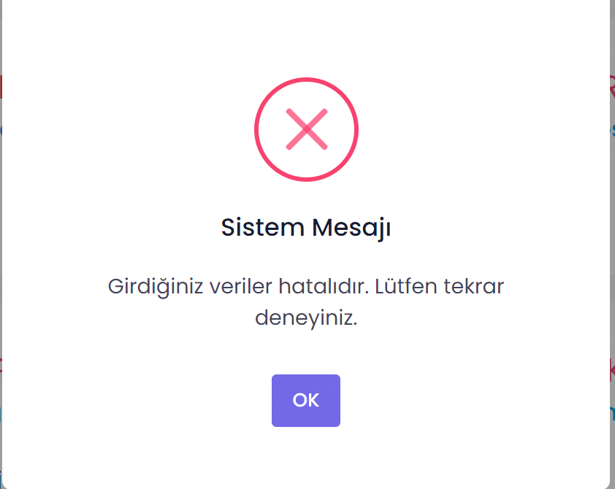

Figure 4: Add new personnel error message screen

The detailed description of items of main administration screen:

* **Name of item**: OK_button.

**Description of purpose**: To pass error screen.

**Source of input**: Mouse.

**Valid Range**: -

**Units of measure**: -

**Timing**: -

**Relationship to other inputs**: -

**Screen formats/organizations**: As seen in Figure 4.

**Window formats/organization**: -

**Data formats**: -

**Command formats**: -

**End messages**: -

* The Safety for Everyone shall allow admin and superadmin information about there is already someone like this error.

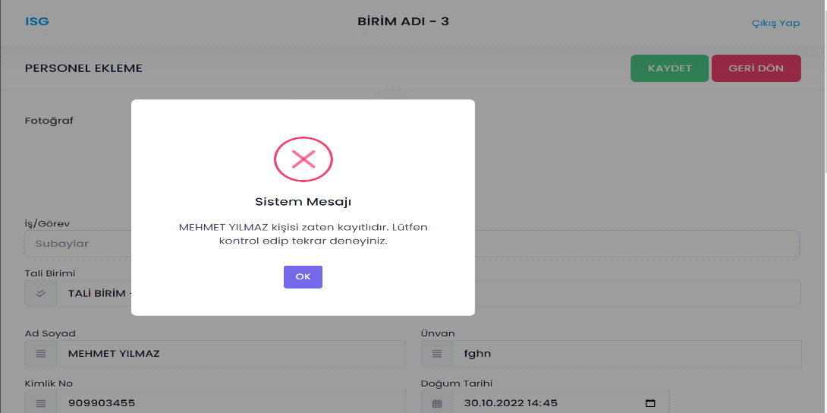

Figure 5**:** There is already someone like this error screen

The detailed description of Risk analysis screen:

* **Name of item**: OK_button.

**Description of purpose**: Used to return to add new personnel page.

**Source of input**: Mouse.

**Valid Range**: -

**Units of measure**: -

**Timing**: -

**Relationship to other inputs**: -

**Screen formats/organizations**: As seen in Figure 5.

**Window formats/organization**: -

**Data formats**: -

**Command formats**: -

**End messages**: -

* The Safety for Everyone shall allow admin and superadmin information about want to delete personnel.

Figure 6: Are you sure you want to delete personnel screen

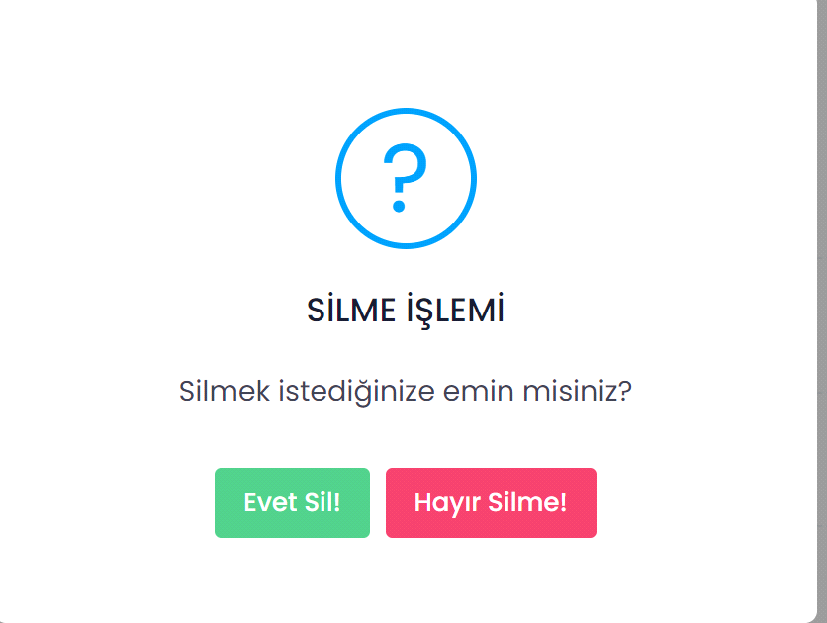

The detailed description of items of add user screen:

* **Name of item**: Delete_Button.

**Description of purpose**: To delete personnel record.

**Source of input**: Mouse.

**Valid Range**: -

**Units of measure**: -

**Timing**: -

**Relationship to other inputs**: -

**Screen formats/organizations**: As seen in Figure 6.

**Window formats/organization**: -

**Data formats**: -

**Command formats**: -

**End messages**: -

* **Name of item**: DontDelete_Button.

**Description of purpose**: To not delete personnel record.

**Source of input**: Mouse.

**Valid Range**: -

**Units of measure**: -

**Timing**: -

**Relationship to other inputs**: -

**Screen formats/organizations**: As seen in Figure 6.

**Window formats/organization**: -

**Data formats**: -

**Command formats**: -

**End messages**: -

* The Safety for Everyone shall allow admin and superadmin information about success message of delete button.

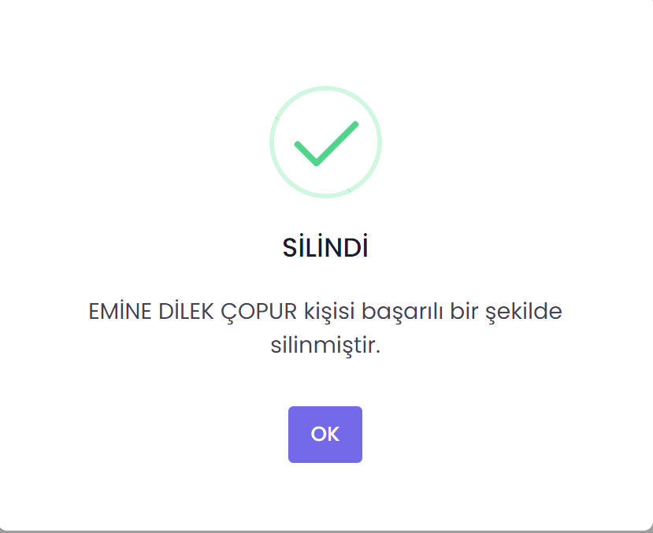

Figure 7**:** Success message about delete button screen

The detailed description of items of add user screen:

* **Name of item**: OK_Button.

**Description of purpose**: Used to return personnel list.

**Source of input**: Mouse.

**Valid Range**: -

**Units of measure**: -

**Timing**: -

**Relationship to other inputs**: -

**Screen formats/organizations**: As seen in Figure 7.

**Window formats/organization**: -

**Data formats**: -

**Command formats**: -

**End messages**: -

* ***Functions for Admin and Superadmin***
* The Safety for Everyone shall allow admin and superadmin to see all risk analysis of personnel.

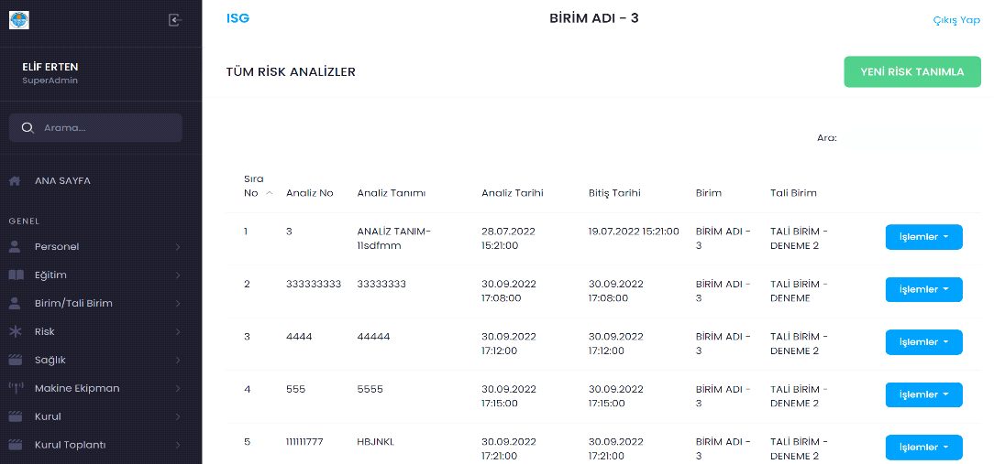

Figure 8: All risk analysis screen

The detailed description of items of main administration screen:

* **Name of item**: AddNewRisk_Button.

**Description of purpose**: To add new risk.

**Source of input**: Mouse.

**Valid Range**: -

**Units of measure**: -

**Timing**: -

**Relationship to other inputs**: -

**Screen formats/organizations**: As seen in Figure 8.

**Window formats/organization**: -

**Data formats**: -

**Command formats**: -

**End messages**: -

* **Name of item**: Transactions_Button.

**Description of purpose**: To make new transaction about personnel.

**Source of input**: Mouse.

**Valid Range**: -

**Units of measure**: -

**Timing**: -

**Relationship to other inputs**: -

**Screen formats/organizations**: As seen in Figure 8.

**Window formats/organization**: -

**Data formats**: -

**Command formats**: -

**End messages**: -

* The Safety for Everyone shall allow admin and superadmin to add new risk.

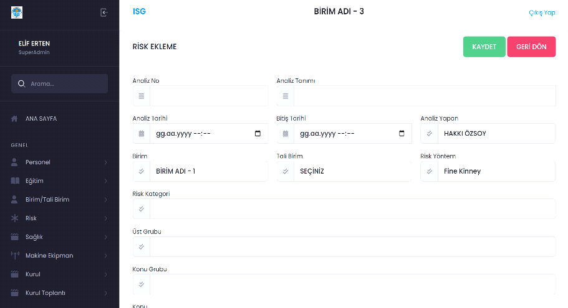

Figure 9: Add new risk screen

The detailed description of items of main administration screen:

* **Name of item**: AnalysisNo_Input.

**Description of purpose**: To describe analysis no.

**Source of input**: Keyboard.

**Valid Range**:Maximum 10 digit.

**Units of measure**: -

**Timing**: -

**Relationship to other inputs**: -

**Screen formats/organizations**: As seen in Figure 9.

**Window formats/organization**: -

**Data formats**: The AnalysisNo_Input shall consist of integer only and shall be compatible with ISO 8859-1 character set.

**Command formats**: -

**End messages**: -

* **Name of item**: DescribeAnalysis_Input.

**Description of purpose**: To describe Analysis.

**Source of input**: Keyboard.

**Valid Range**: The DescribeAnalysis_Input shall be maximum 30 characters long and cannot be zero.

**Units of measure**: -

**Timing**: -

**Relationship to other inputs**: -

**Screen formats/organizations**: As seen in Figure 9.

**Window formats/organization**: -

**Data formats**: The AnalysisNo_Input shall consist of character only and shall be compatible with ISO 8859-1 character set.

**Command formats**: -

**End messages**: -

* **Name of item**: AnalysisDate_Input.

**Description of purpose**: To determine of analysis time.

**Source of input**: Mouse and keyboard.

**Valid Range**: It can’t be next days.

**Units of measure**: -

**Timing**: -

**Relationship to other inputs**: -

**Screen formats/organizations**: As seen in Figure 9.

**Window formats/organization**: -

**Data formats**: Date data type.

**Command formats**: -

**End messages**: -

* **Name of item**: DeadlineOfAnalysis_Input.

**Description of purpose**: To deterime deadline of analysis.

**Source of input**: Mouse or keyboard.

**Valid Range**: Can’t be today and the days before.

**Units of measure**: -

**Timing**: -

**Relationship to other inputs**: -

**Screen formats/organizations**: As seen in Figure 9.

**Window formats/organization**: -

**Data formats**: Date data type.

**Command formats**: -

**End messages**: -

* **Name of item**: NameOfAnalyzer_Input.

**Description of purpose**: To determine who is analayzing.

**Source of input**: Keyboard.

**Valid Range**: The NameOfAnalyzer_Input shall be maximum 30 characters long and cannot be zero.

**Units of measure**: -

**Timing**: -

**Relationship to other inputs**: -

**Screen formats/organizations**: As seen in Figure 9.

**Window formats/organization**: -

**Data formats**: The NameOfAnalyzer_input shall consist of alphanumeric characters only and shall be compatible with ISO 8859-1 character set.

**Command formats**: -

**End messages**: -

* **Name of item**: UnitName_Input.

**Description of purpose**: To determine name of unit.

**Source of input**: Keyboard.

**Valid Range**: The UnitName_Input shall be maximum 30 characters long and cannot be zero.

**Units of measure**: -

**Timing**: -

**Relationship to other inputs**: -

**Screen formats/organizations**: As seen in Figure 9.

**Window formats/organization**: -

**Data formats**: The UnitName_Input shall consist of alphanumeric characters only and shall be compatible with ISO 8859-1 character set.

**Command formats**: -

**End messages**: -

* **Name of item**: SubUnit_Option.

**Description of purpose**: To select subunit.

**Source of input**: Mouse.

**Valid Range**: -

**Units of measure**: -

**Timing**: -

**Relationship to other inputs**: -

**Screen formats/organizations**: As seen in Figure 9.

**Window formats/organization**: -

**Data formats**: -

**Command formats**: -

**End messages**: -

* **Name of item**: RiskMethod_Input.

**Description of purpose**: To determine method of risk.

**Source of input**: Keyboard.

**Valid Range**: The RiskMethod_Input shall be maximum 30 characters long and cannot be zero.

**Units of measure**: -

**Timing**: -

**Relationship to other inputs**: -

**Screen formats/organizations**: As seen in Figure 9.

**Window formats/organization**: -

**Data formats**: The RiskMethod_Input shall consist of alphanumeric characters only and shall be compatible with ISO 8859-1 character set.

**Command formats**: -

**End messages**: -

* **Name of item**: RiskCategory_Input.

**Description of purpose**: To determine risk category.

**Source of input**: Keyboard.

**Valid Range**: The RiskCategory_Input shall be maximum 30 characters long and cannot be zero.

**Units of measure**: -

**Timing**: -

**Relationship to other inputs**: -

**Screen formats/organizations**: As seen in Figure 9.

**Window formats/organization**: -

**Data formats**: The RiskCategory_Input shall consist of alphanumeric characters only and shall be compatible with ISO 8859-1 character set.

**Command formats**: -

**End messages**: -

* **Name of item**: SubjectGroup_Input.

**Description of purpose**: To determine subject of group.

**Source of input**: Keyboard.

**Valid Range**: The SubjectGroup_Input shall be maximum 30 characters long and cannot be zero.

**Units of measure**: -

**Timing**: -

**Relationship to other inputs**: -

**Screen formats/organizations**: As seen in Figure 8.

**Window formats/organization**: -

**Data formats**: The SubjectGroup_Input shall consist of alphanumeric characters only and shall be compatible with ISO 8859-1 character set.

**Command formats**: -

**End messages**: -

* **Name of item**: UpperGroup_Input.

**Description of purpose**: To determine upper group.

**Source of input**: Keyboard.

**Valid Range**: The UpperGroup_Input shall be maximum 30 characters long and cannot be zero.

**Units of measure**: -

**Timing**: -

**Relationship to other inputs**: -

**Screen formats/organizations**: As seen in Figure 9.

**Window formats/organization**: -

**Data formats**: The UpperGroup_Input shall consist of alphanumeric characters only and shall be compatible with ISO 8859-1 character set.

**Command formats**: -

**End messages**: -

* **Name of item**: SaveRisk_Button.

**Description of purpose**: To save new risk.

**Source of input**: Mouse.

**Valid Range**: -

**Units of measure**: -

**Timing**: -

**Relationship to other inputs**: Depends on AnalysisNo_button.

**Screen formats/organizations**: As seen in Figure 9.

**Window formats/organization**: -

**Data formats**: -

**Command formats**: -

**End messages**: -

* **Name of item**: GoBack_Button.

**Description of purpose**: To return previous page.

**Source of input**: Mouse.

**Valid Range**: -

**Units of measure**: -

**Timing**: -

**Relationship to other inputs**: -

**Screen formats/organizations**: As seen in Figure 9.

**Window formats/organization**: -

**Data formats**: -

**Command formats**: -

**End messages**: -

* The Safety for Everyone shall allow admin and superadmin to delete



Figure 10**:** Are you sure you want to delete risk screen

The detailed description of items of add user screen:

* **Name of item**: Delete_Button.

**Description of purpose**: To delete risk record.

**Source of input**: Mouse.

**Valid Range**: -

**Units of measure**: -

**Timing**: -

**Relationship to other inputs**: -

**Screen formats/organizations**: As seen in Figure 10.

**Window formats/organization**: -

**Data formats**: -

**Command formats**: -

**End messages**: -

* **Name of item**: DontDelete_Button.

**Description of purpose**: To not delete risk record.

**Source of input**: Mouse.

**Valid Range**: -

**Units of measure**: -

**Timing**: -

**Relationship to other inputs**: -

**Screen formats/organizations**: As seen in Figure 10.

**Window formats/organization**: -

**Data formats**: -

**Command formats**: -

**End messages**: -

* The Safety for Everyone shall allow admin and superadmin to success of delete risk operation.

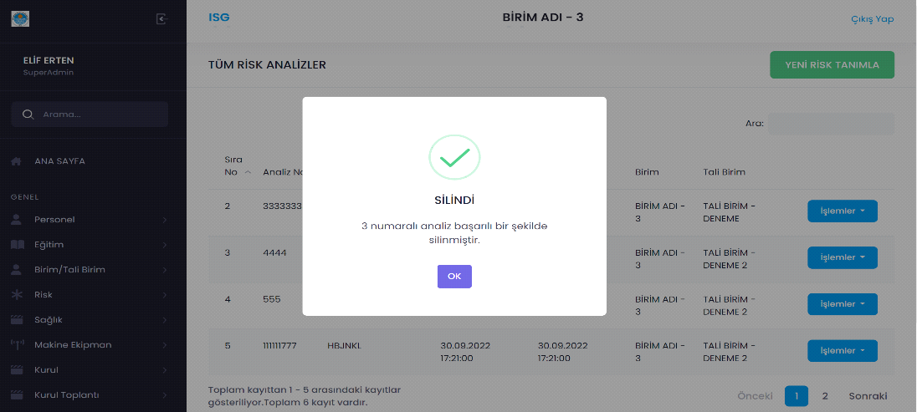

Figure 11**:** Success of delete risk operation screen

The detailed description of Risk analysis scree:

* **Name of item**: OK_button.

**Description of purpose**: Used to return all risk analysis screen.

**Source of input**: Mouse.

**Valid Range**: -

**Units of measure**: -

**Timing**: -

**Relationship to other inputs**: -

**Screen formats/organizations**: As seen in Figure 11.

**Window formats/organization**: -

**Data formats**: -

**Command formats**: -

**End messages**: -

* ***Functions for ohs expert, Admin and Superadmin***

The Safety for Everyone shall allow ohs expert, admin and superadmin information about machine equipment list.

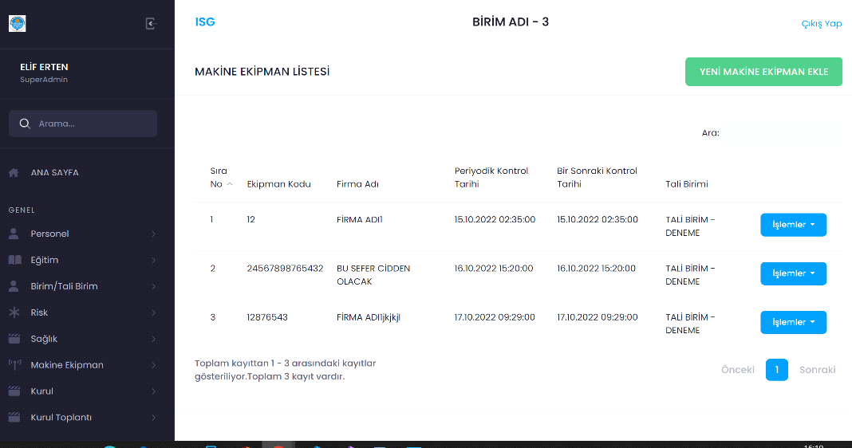

Figure 12**:** Machine equipment list screen

The detailed description of Risk analysis machine equipment screen:

* **Name of item**: AddNewMachineEquipment_button.

**Description of purpose**:To add new equipment.

**Source of input**: Mouse.

**Valid Range**: -

**Units of measure**: -

**Timing**: -

**Relationship to other inputs**: -

**Screen formats/organizations**: As seen in Figure 12.

**Window formats/organization**: -

**Data formats**: -

**Command formats**: -

**End messages**: -

* **Name of item**: SearchEquipment_Input.

**Description of purpose**:To search equipment.

**Source of input**: Keyboard.

**Valid Range**: The SearchEquipment_Input shall be maximum 30 characters long and cannot be zero.

**Units of measure**: -

**Timing**: -

**Relationship to other inputs**: Search by Company_name.

**Screen formats/organizations**: As seen in Figure 12.

**Window formats/organization**: -

**Data formats**: The SearchEquipment_Input shall consist of alphanumeric characters only and shall be compatible with ISO 8859-1 character set.

**Command formats**: -

**End messages**: -

* **Name of item**: Transactions_Options.

**Description of purpose**:To see transactions options.

**Source of input**: Mouse.

**Valid Range**: -

**Units of measure**: -

**Timing**: -

**Relationship to other inputs**: -

**Screen formats/organizations**: As seen in Figure 12.

**Window formats/organization**: -

**Data formats**: -

**Command formats**: -

**End messages**: -

* The Safety for Everyone shall allow ohs expert and superadmin to add new equipment.

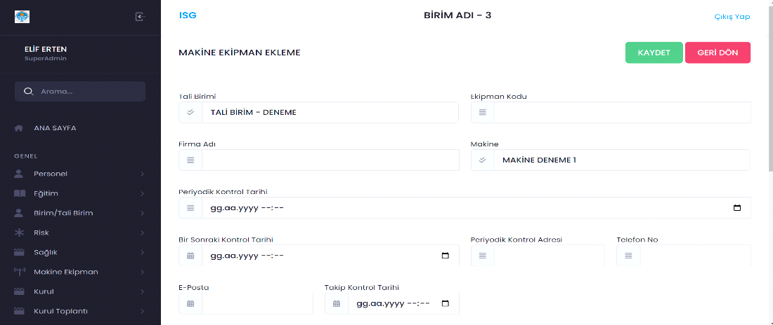

Figure 13: Add new equipment screen

The detailed description of add new equipment screen:

* **Name of item**: SubUnit_Input.

**Description of purpose**:To determine subunit of equipment.

**Source of input**: Keyboard.

**Valid Range**: The SubUnit_Input shall be maximum 30 characters long and cannot be zero.

**Units of measure**: -

**Timing**: -

**Relationship to other inputs**: -

**Screen formats/organizations**: As seen in Figure 13.

**Window formats/organization**: -

**Data formats**: The SubUnit_Input shall consist of alphanumeric characters only and shall be compatible with ISO 8859-1 character set.

**Command formats**: -

**End messages**: -

* **Name of item**: EquipmentCode_Input.

**Description of purpose**:To determine equipment code.

**Source of input**: Keyboard.

**Valid Range**:Maximum 10 digit.

**Units of measure**: -

**Timing**: -

**Relationship to other inputs**: -

**Screen formats/organizations**: As seen in Figure 13.

**Window formats/organization**: -

**Data formats**: The EquipmentCode_Input shall consist of integer only and shall be compatible with ISO 8859-1 character set.

**Command formats**: -

**End messages**: -

* **Name of item**: CompanyName_Input.

**Description of purpose**:To determine company name.

**Source of input**: Keyboard.

**Valid Range**: The CompanyName_Input shall be maximum 30 characters long and cannot be zero.

**Units of measure**: -

**Timing**: -

**Relationship to other inputs**: -

**Screen formats/organizations**: As seen in Figure 13.

**Window formats/organization**: -

**Data formats**: The CompanyName_Input shall consist of alphanumeric characters only and shall be compatible with ISO 8859-1 character set.

**Command formats**: -

**End messages**: -

* **Name of item**: MachineName_Input.

**Description of purpose**:To determine machine name.

**Source of input**: Keyboard.

**Valid Range**: The MachineName_Input shall be maximum 30 characters long and cannot be zero.

**Units of measure**: -

**Timing**: -

**Relationship to other inputs**: -

**Screen formats/organizations**: As seen in Figure 13.

**Window formats/organization**: -

**Data formats**: The MachineName_Input shall consist of alphanumeric characters only and shall be compatible with ISO 8859-1 character set.

**Command formats**: -

**End messages**: -

* **Name of item**: PeriodicControlDate_Input.

**Description of purpose**:To determine periodic control time.

**Source of input**: Mouse or keyboard.

**Valid Range**: -

**Units of measure**: -

**Timing**: -

**Relationship to other inputs**: -

**Screen formats/organizations**: As seen in Figure 13.

**Window formats/organization**: -

**Data formats**: Date data type.

**Command formats**: -

**End messages**: -

* **Name of item**: NextControlDate_Input.

**Description of purpose**:To determine next control date.

**Source of input**: Mouse or keyboard.

**Valid Range**: -

**Units of measure**: -

**Timing**: -

**Relationship to other inputs**: -

**Screen formats/organizations**: As seen in Figure 13.

**Window formats/organization**: -

**Data formats**: Date data type.

**Command formats**: -

**End messages**: -

* **Name of item**: PeriodicControlAdress_Input.

**Description of purpose**:To determine periodic control adress.

**Source of input**: Keyboard.

**Valid Range**: The PeriodicControlAdress_Input shall be maximum 30 characters long and cannot be zero.

**Units of measure**: -

**Timing**: -

**Relationship to other inputs**: -

**Screen formats/organizations**: As seen in Figure 13.

**Window formats/organization**: -

**Data formats**: The PeriodicControlAdress_Input shall consist of alphanumeric characters only and shall be compatible with ISO 8859-1 character set.

**Command formats**: -

**End messages**: -

* **Name of item**: Phone_Input.

**Description of purpose**:To determine company phone number.

**Source of input**: Keyboard.

**Valid Range**: Maximum 11 digit.

**Units of measure**: -

**Timing**: -

**Relationship to other inputs**: -

**Screen formats/organizations**: As seen in Figure 13.

**Window formats/organization**: -

**Data formats**: The Phone_Input shall consist of integer only and shall be compatible with ISO 8859-1 character set.

**Command formats**: -

**End messages**: -

* **Name of item**: Mail_Input.

**Description of purpose**:To determine mail address of company.

**Source of input**: Keyboard.

**Valid Range**: The Mail_Input shall be maximum 50 characters long and cannot be zero.

**Units of measure**: -

**Timing**: -

**Relationship to other inputs**: -

**Screen formats/organizations**: As seen in Figure 13.

**Window formats/organization**: -

**Data formats**: The Mail_Input shall consist of alphanumeric characters only and shall be compatible with ISO 8859-1 character set.

**Command formats**: -

**End messages**: -

* **Name of item**: FollowUpChechDate_Input.

**Description of purpose**:To follow-up check date.

**Source of input**: Mouse or keyboard.

**Valid Range**: -

**Units of measure**: -

**Timing**: -

**Relationship to other inputs**: -

**Screen formats/organizations**: As seen in Figure 13.

**Window formats/organization**: -

**Data formats**: Date data type.

**Command formats**: -

**End messages**: -

* **Name of item**: Save_Button.

**Description of purpose**:To save new equipment.

**Source of input**: Mouse.

**Valid Range**: -

**Units of measure**: -

**Timing**: -

**Relationship to other inputs**: Depends on EquipmentCode_Input.

**Screen formats/organizations**: As seen in Figure 13.

**Window formats/organization**: -

**Data formats**: -

**Command formats**: -

**End messages**: -

* **Name of item**: GoBack_Button.

**Description of purpose**:To return main page.

**Source of input**: Mouse.

**Valid Range**: -

**Units of measure**: -

**Timing**: -

**Relationship to other inputs**: -

**Screen formats/organizations**: As seen in Figure 13.

**Window formats/organization**: -

**Data formats**: -

**Command formats**: -

**End messages**: -

* The Safety for Everyone shall allow ohs expert, admin and superadmin to delete equipment.

Figure 14**:** Are you sure you want to delete equipment screen



The detailed description of Machine Equipment screen:

* **Name of item**: Delete_Button.

**Description of purpose**: To delete equipment record.

**Source of input**: Mouse.

**Valid Range**: -

**Units of measure**: -

**Timing**: -

**Relationship to other inputs**: -

**Screen formats/organizations**: As seen in Figure 14.

**Window formats/organization**: -

**Data formats**: -

**Command formats**: -

**End messages**: -

* **Name of item**: DontDelete_Button.

**Description of purpose**: To not delete equipment record.

**Source of input**: Mouse.

**Valid Range**: -

**Units of measure**: -

**Timing**: -

**Relationship to other inputs**: -

**Screen formats/organizations**: As seen in Figure 14.

**Window formats/organization**: -

**Data formats**: -

**Command formats**: -

**End messages**: -

* The Safety for Everyone shall allow ohs expert and superadmin to success of delete machine equipment operation.

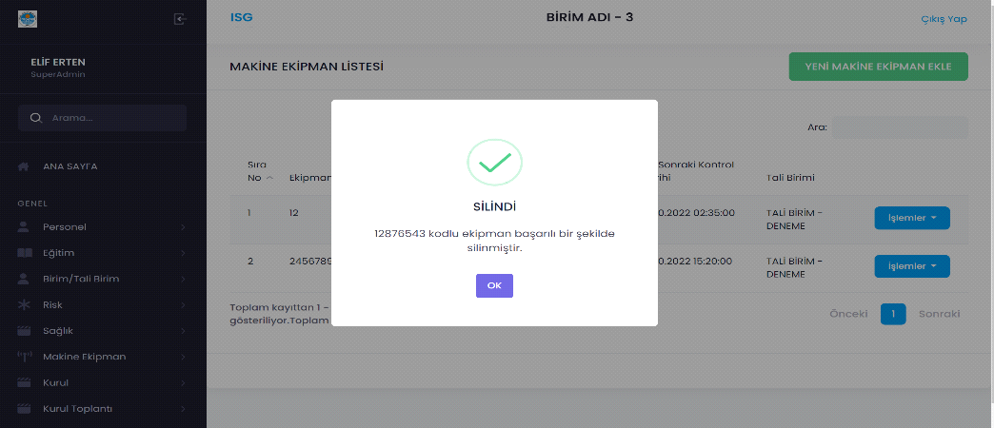

Figure 15**:** Success of delete equipment operation screen

The detailed description of delete equipment operation screen:

* **Name of item**: OK_button.

**Description of purpose**: Used to return all equipment screen.

**Source of input**: Mouse.

**Valid Range**: -

**Units of measure**: -

**Timing**: -

**Relationship to other inputs**: -

**Screen formats/organizations**: As seen in Figure 15.

**Window formats/organization**: -

**Data formats**: -

**Command formats**: -

* **Hardware Interfaces**

As mentioned in subsection 2.1.3 there is no defined hardware interface requirements for the Safe for Everyone.

* **Software Interfaces**

Since all software interfaces of the Safety for Everyone are well-documented as described in subsection 2.1.4, no additional details shall be specified.

* **Communications Interfaces**

Since all communication interfaces of the Safety for Everyone are well documented as described in subsection 2.1.5, no additional details shall be specified.

* ***Functional Requirements***
* **Common Function for All Users**
* **User Authentication Function**

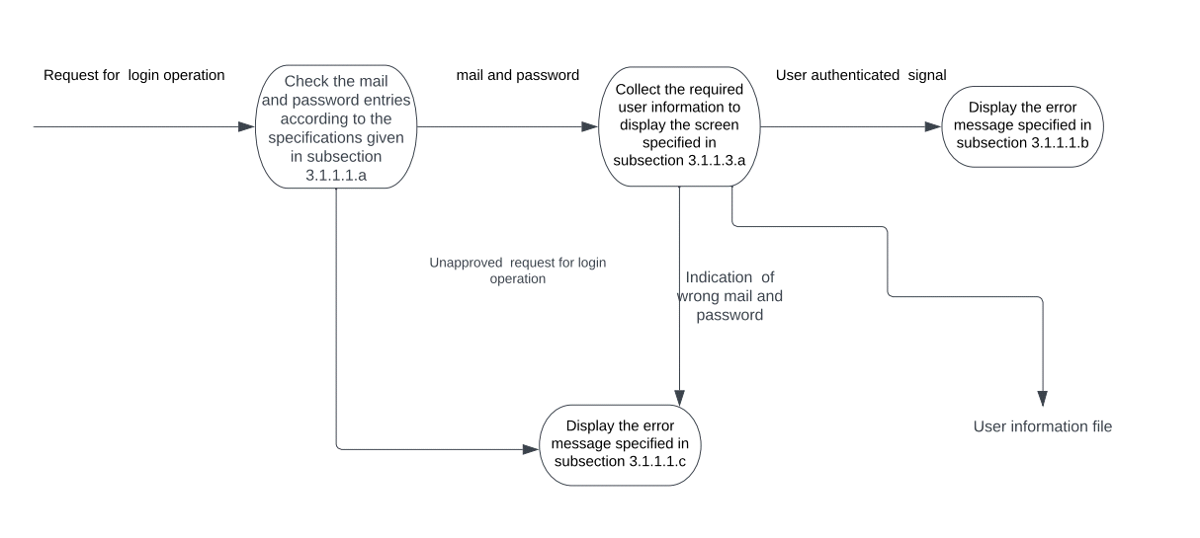

Figure 17**:** DFD for user authentication

* **Functions for Root**
* **User Addition Function**

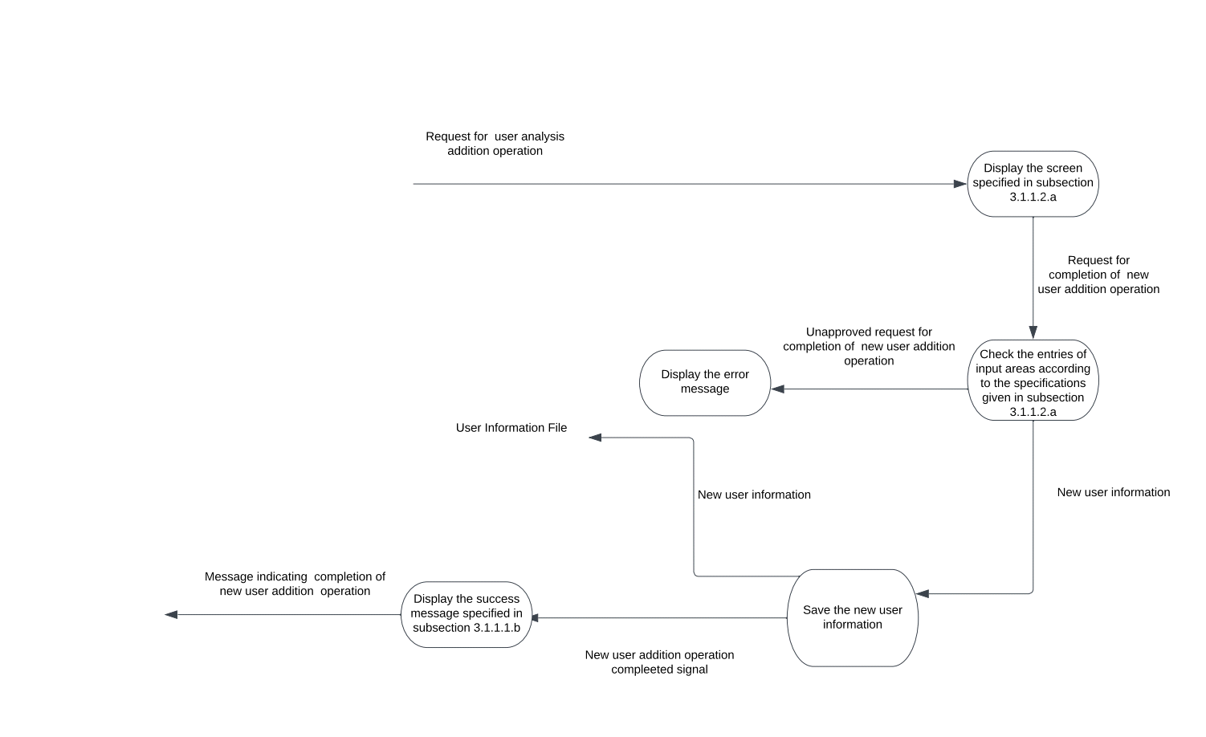

Figure 18**:** DFD for New user addition function

* **User Deletion Function**

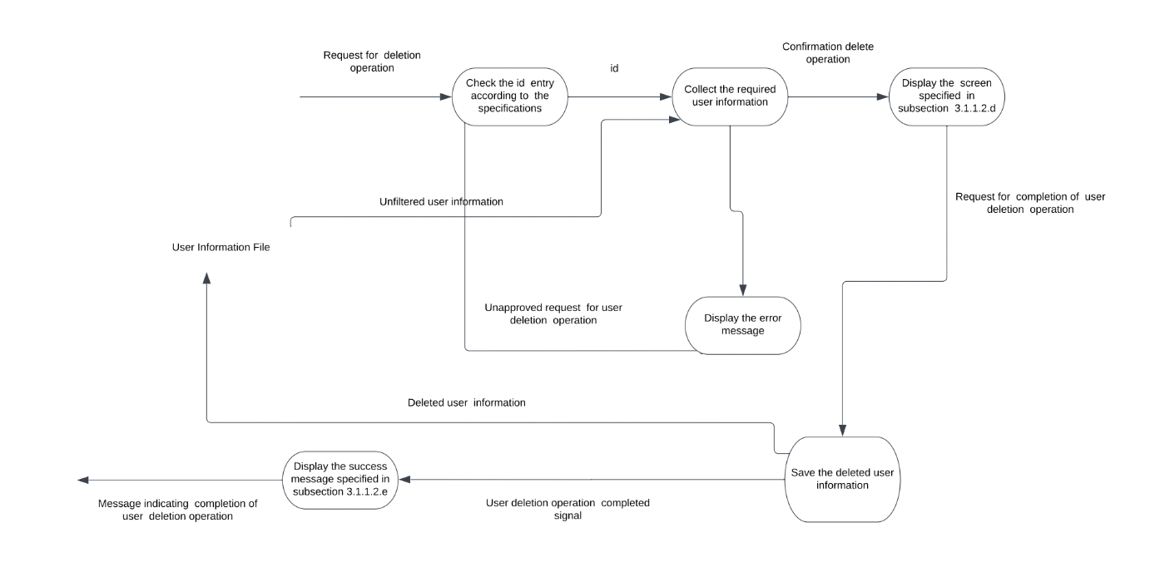

Figure 19**:** DFD for User delete function

* **User Update Function**

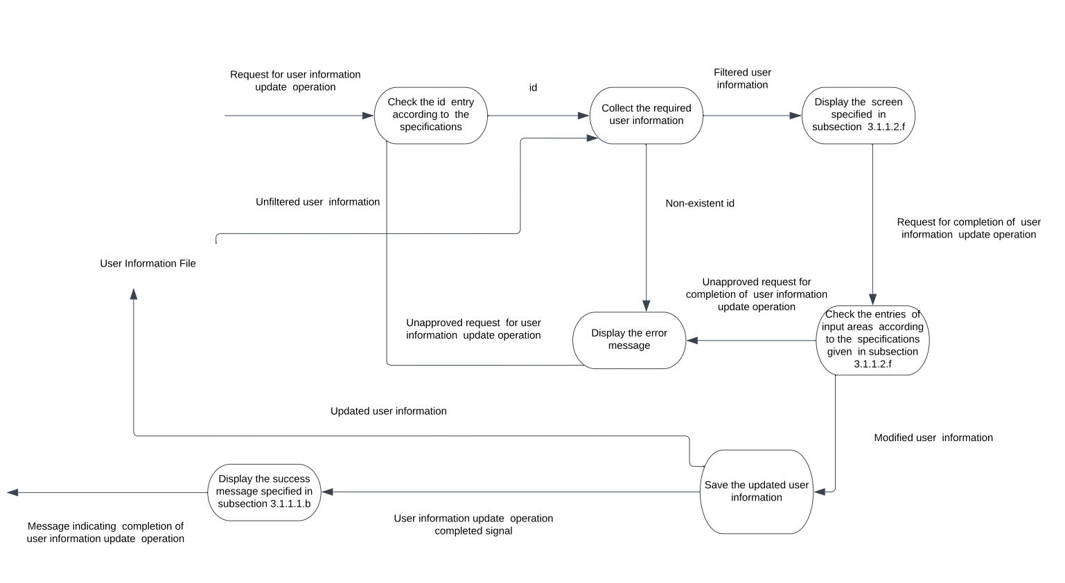

Figure 20: DFD for user update function

* **Risk Analysis Addition Function**

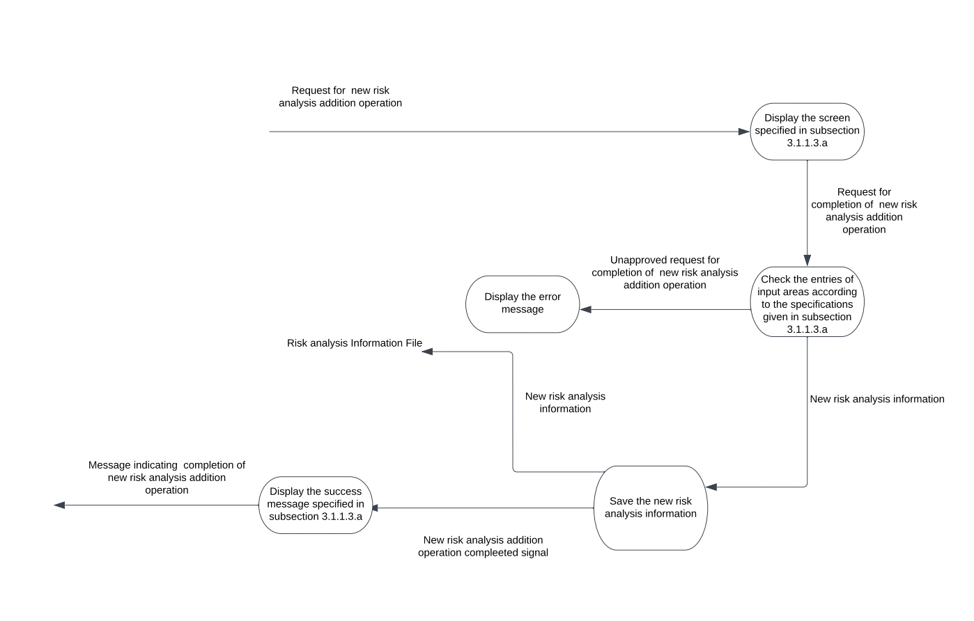

Figure 21**:** DFD for New risk analysis addition function

* **Risk Analysis Delete Function**

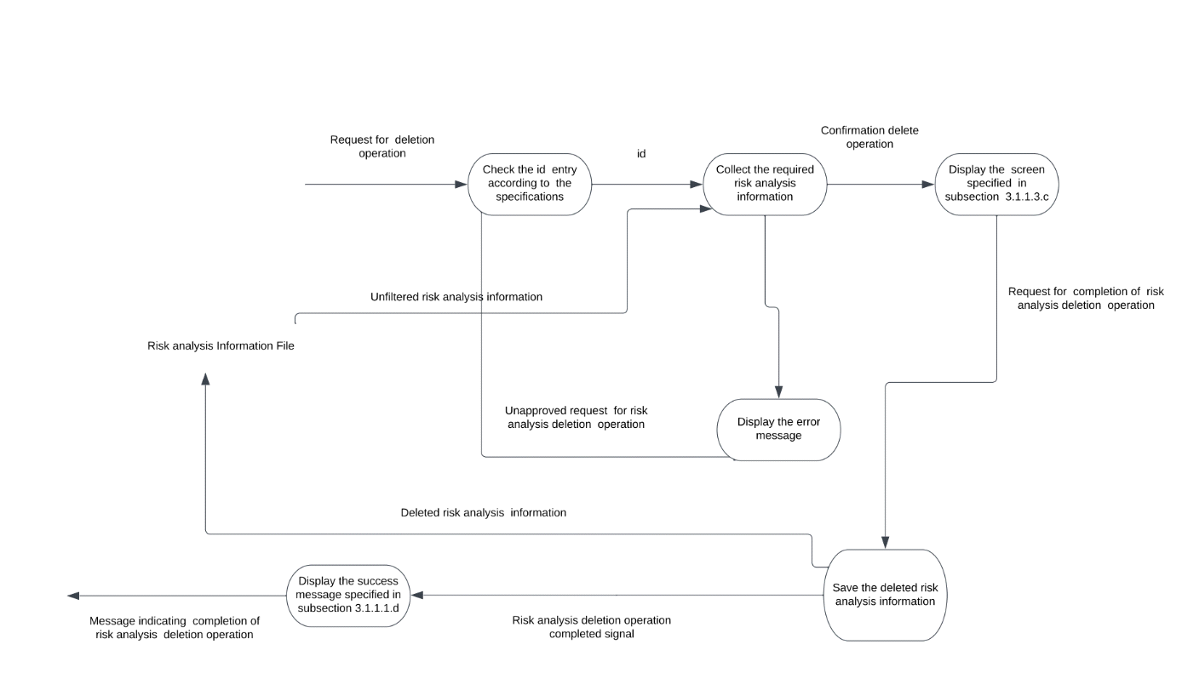

Figure 22**:** DFD for risk analysis delete function

* **Risk Analysis Update Function**

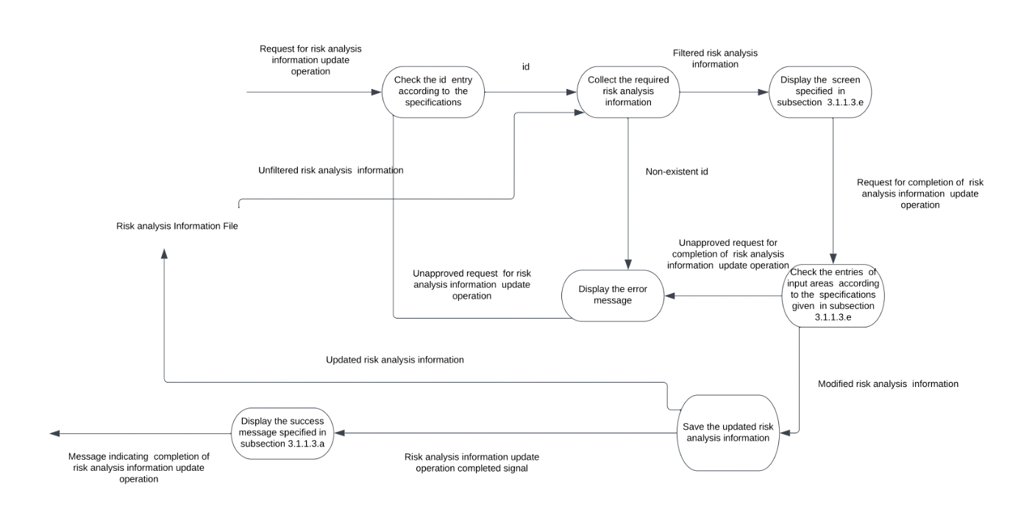

Figure 23**:** DFD for risk analysis update function

* **Machine Equipment Addition Function**

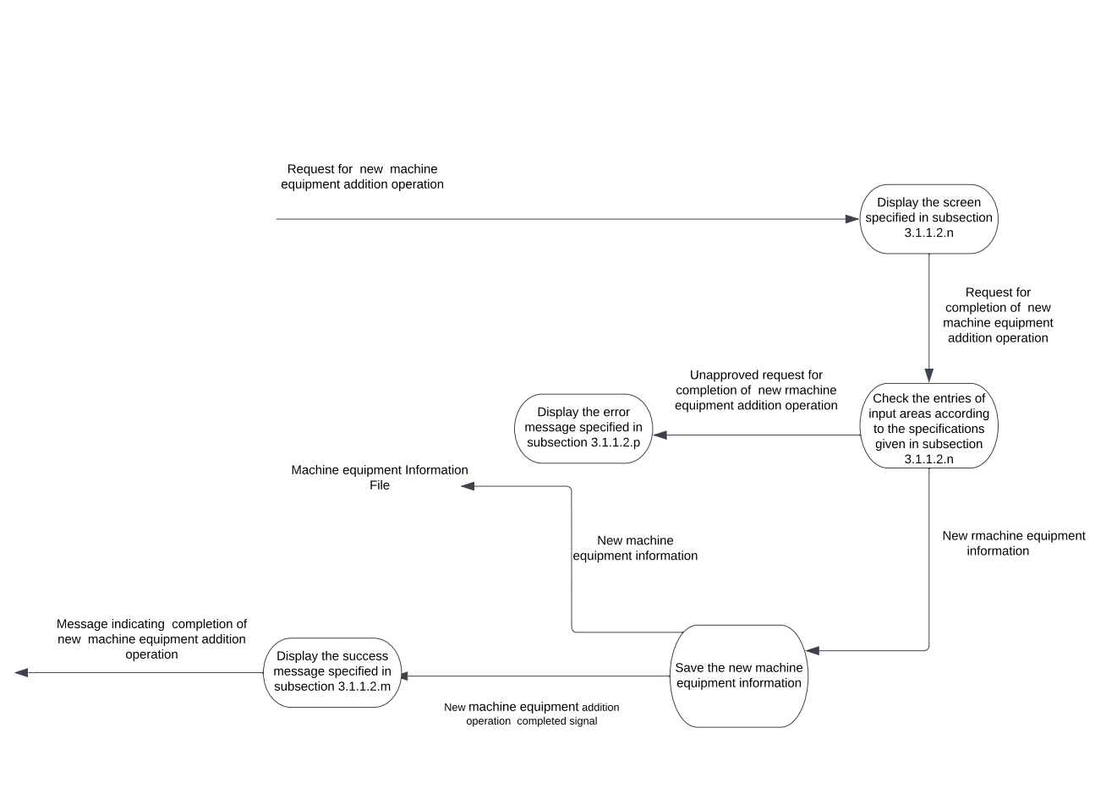

Figure 24**:** DFD for New machine equipment addition function

* **Machine Equipment Delete Function**

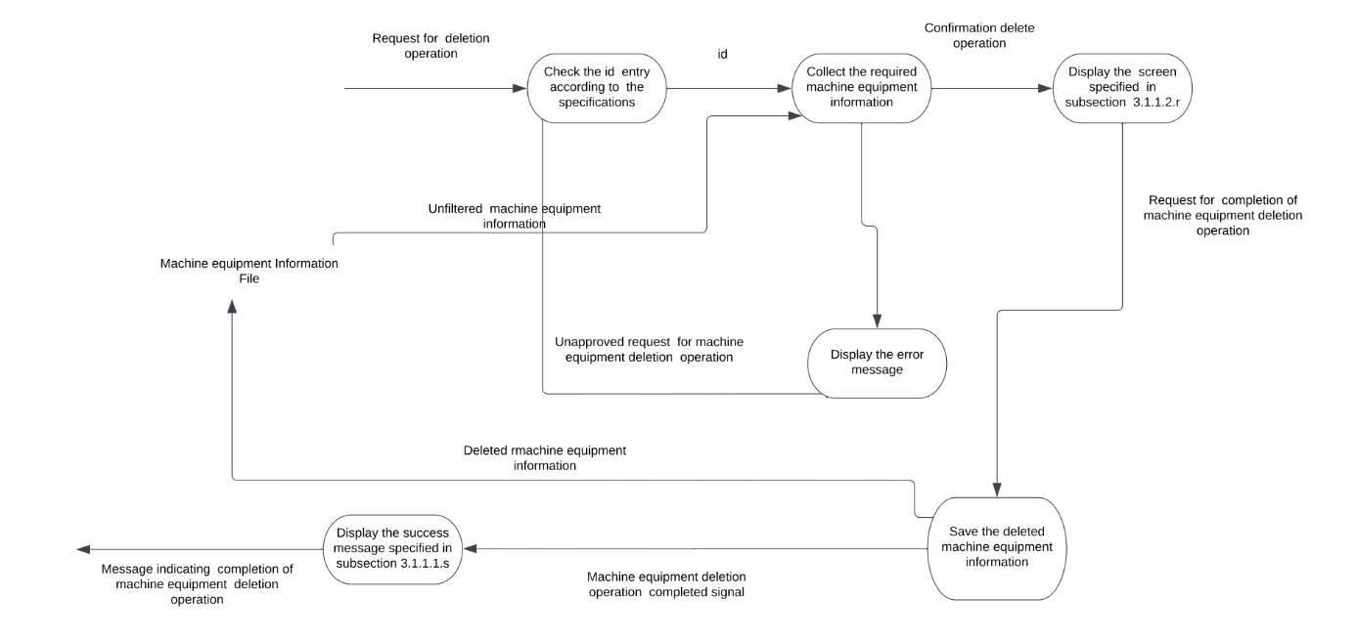

Figure **:** DFD for machine equipment delete function

* **Machine Equipment Update Function**

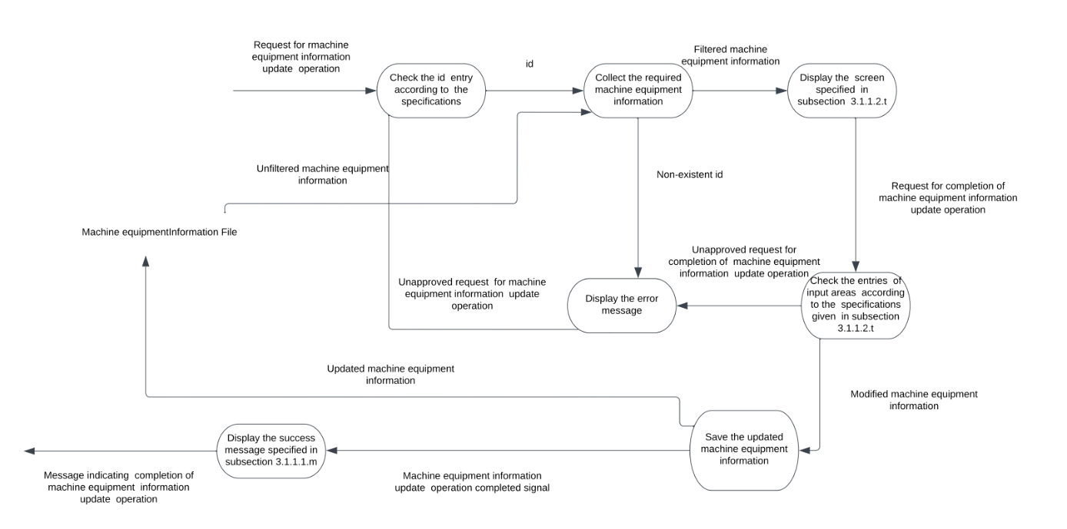

Figure **:** DFD for machine equipment update function

* ***Performance Requirements:***

This subsection should specify both the static and the dynamic numerical requirements placed on the software or human interaction with the software as a whole. Static numerical requirements may include the following:

* The number terminals to be supported,
* The number of simultaneous users to be supported,
* Amount and type of information to be handled.

Static numerical requirements are sometimes identified under a separate section entitled Capacity.

Dynamic numerical requirements may include, for example, the number of transactions and tasks and the amount of data to be processed within certain time periods for both normal and peak workload conditions.

All of these requirements should be in measurable terms. For example: 95% of the transactions shall be processed in less than 1 s. rather than an operator shall not have to wait for the transaction to complete.

**Note:** Numerical limits applied to one specific function are normally specified as a part of processing subparagraph description of that function.

* ***Logical Database Requirements***

This should specify the logical requirements for any information that is to be placed into a database (You can use ER diagram).

* ***Design Constraints***

This should specify design constraints that can be imposed by other standards, hardware limitations, etc.

* **Standards Compliance**

This subsection should specify the requirements derived from existing standards or regulations. They may include the following:

* Report format
* Data naming
* Accounting procedures
* Audit tracing
* ***Software System Attributes***
* **Reliability**

This should specify the factors required to establish the required reliability of the software system at time of delivery.

* **Availability**

This should specify the factors required to guarantee a defined availability level for the entire system.

* **Security**

This should specify the factors that protect the software from accidental or malicious access, use, modification, destruction, or disclosure.

* **Maintainability**

This should specify attributes of software that relate to the ease of maintenance of the software itself.

* **Portability**

This should specify attributes of software that relate to the ease of porting the software to other host machines and/or operating systems.