INITIAL PLAN

*for*

**Safety for Everyone**

*Prepared By*

CengHall

*Ayşegül Sofuoğlu*

*Bedirhan Budak*

*Deniz Parlar*

*Elif Erten*

*Nesteren Gözükızıl*

*Rabia Kurt*

*Due Date:* October 17th, 2022

CHANGE HISTORY

The document is the first version (version 1.0) of Safety for Everyone, Initial Plan that was released on October 17th, 2022. The subsequent changes will be mentioned in this part of the Initial Plan.

PREFACE

The document contains the Initial Plan of Safety for Everyone. The mission of the project is to develop a web-based occupational health and safety system for Mersin municipality

The Goal of the initial plan is to describe overall picture of the Safety for Everyone. This system is prepared according to IEEE standard [1]. The initial plan is in content compliance with the IEEE standard 1058-1998 in which the contents of this standard are rearranged and a mapping is provided. That is, the content compliant initial plan is mapped into various clauses and subclauses of the IEEE standard 1058-1998.

In addition to the IEEE standards, functions of project are discussed in section 1.1.3.

**TABLE OF CONTENTS**

CHANGE HISTORY i

PREFACE ii

TABLE OF CONTENTS iii

1 OVERVIEW 1

1.1 Project Summary 1

1.1.1 Purpose, Scope and Objectives 1

1.1.2 Assumptions and Constraints 1

1.1.3 Project Deliverables 2

1.1.4 Schedule and Budget Summary 3

1.2 Evolution of the SPMP 4

2 References 5

3 Definitions 6

4 Project Organization 7

4.1 External Interfaces 4

4.2 Internal structure 8

4.3 Roles and Responsibilities 8

5 Managerial Process Plans 10

5.1 Staffing Plan 10

5.2 Resources Acquisition Plan 11

5.3 Project Staff Training Plan 11

LIST OF FIGURES

Figure 1: External Interfaces of the Safety for Everyone ................................................... 7

Figure 2: The Internal Structure of the Project Developing Organization ......................... 8

Figure 3: Staffing for Safety for Everyone ........................................................................ 10

LIST OF TABLES

Table 1: Schedule of the Project ........................................................................................ 3

Table 2: Update Plan of the Initial Plan ............................................................................. 4

Table 3: Roles and Responsibilities of CengHall Members .............................................. 9

Table 4: Staff Training Plan .............................................................................................. 11

# OVERVIEW

## Project Summary

### Purpose, Scope and Objectives

The purpose of the project is to develop a web-based occupational health and safety system for Mersin municipality. The name of the project is Safety for Everyone and this is also the name of the final product to be delivered.

The objectives of the Safety for Everyone are:

* To provide a safe work environment for the member of company.
* To control the training of working personnel on health and work safety.
* To prevent future accidents by making risk analysis.

The scope of the Safety for Everyone is:

* The intended target users of the project are employee, business owners and many government offices.
* The Safety for Everyone will bring together many different control-intensive jobs.
* The Safety for Everyone will have more than one admin.

### Assumptions and Constraints

*The assumptions of the project are;*

* + Staff will receive mandatory training on occupational safety.
  + Training received will be checked.
  + Employees' health status and machine learning will be monitored.
  + Authorized people will supply the maintenance of the Safety for Everyone.
  + The correspondence of the documentation produced to the IEEE Standards [1,2,3,4] is subcontracted.

*The constraints of the project are;*

* + Only authorized municipalities will use the project.
  + This project will be for a municipality but there will be no payment.
  + The software development processes and any kind of documentation will be in compliance with the IEEE Standards [1, 2, 3, 4].
  + Only 6 user types will be able to use this project, which are admin, superadmin, ohs specialist, occupational physician, unit manager, sub-unit manager.

### Project Deliverables

* + *Initial plan:* The document will be prepared and submitted to [esinunal@gmail.com](mailto:esinunal@gmail.com) e-mail address.
  + *Updated Initial Plan:* CengHall will update the Initial Plan until October 21st, 2022 and will be presented to the acquirer
  + *SRS:* The document will be prepared and submitted to [esinunal@gmail.com](mailto:esinunal@gmail.com) e-mail address until October 31st, 2022.
  + Updated SRS: CengHall will update SRS until November 4th, 2022 and will be presented to acquirer.
  + *SPMP:* The document will be prepared and submitted to [esinunal@gmail.com](mailto:esinunal@gmail.com) e-mail address until October 21th, 2022.
  + *Updated SPMP:* CengHall will update SPMP until October 25th, 2022 and will be presented to the acquirer.
  + *SDD:* The document will be prepared and submitted to [esinunal@gmail.com](mailto:esinunal@gmail.come) e-mail address until December 12th, 2022.
  + *Updated SDD:* CengHall will update SDD until December 16th, 2022 and will be presented to the acquirer.
  + *Delivery of Product:* The product will be delivered on December 23th, 2022.
  + *Project Presentation:* The presentation will be made on December 26th, 2022.

### Schedule and Budget Summary

|  |  |
| --- | --- |
| **Due Date** | **Document / Activity Name** |
| 10 October 2022 | Initial Plan |
| 21 October 2022 | Updated Initial Plan |
| 31 October 2022 | SRS |
| 4 November 2022 | Updated SRS |
| 21 October 2022 | SPMP |
| 25 October 2022 | Updated SPMP |
| 12 December 2022 | SDD |
| 16 December 2022 | Updated SDD |
| 23 December 2022 | Delivery of Product |
| 26 December 2022 | Project Presentation |

**Table 1: Schedule of the Project**

As explained in subclause 1.1.2, no budget is associated with Safety for Everyone. For hardware and software need existing resources of CengHall will be used.

## Evolution of the SPMP

This is the first version of the Initial Plan where subsequence changes will be mentioned in this part of the Updated Initial Plan. The table below shows the updates which are planned to be done to the Initial Plan.

|  |  |
| --- | --- |
| **Due Date** | **Document/Review Type** |
| 10 October 2022 | Initial Plan |
| 21 October 2022 | Updated Initial Plan |

**Table 2: Update Plan of the Initial Plan**

# References

**[1]** IEEE Std 1058-1998, IEEE Standard for Software Management Plans

**[2]** IEEE Std 830-1998. IEEE Recommended Practice for Software Requirements Specifications

**[3]** IEEE Std 1016-1998, IEEE Recommended Practice for Software Design Descriptions

**[4]** IEEE Std 1063-1998, IEEE Standard for Software User Documentation

**[5]** Fatih Çakıroğlu, https://www.udemy.com/course/asp-net-core-api-web-cok-katmanli-mimari-api-best-practices, 2022

**[6]** Alper Tunga, https://www.udemy.com/course/net5aspnetcore5blog, 2022

**[7]** Murat Baseren, https://www.udemy.com/course/uygulamali-modern-web-gelistirme-egitimi, 2019

# Definitions

**Board Meeting:** A formal periodic gathering of a board of directors.

**CENGHALL:** Software development team of OHS SYSTEM.

**CENGHALL’s e-mail address:** This corresponds to the e-mail address of the CENGHALL members stated in table 3.

**Dispersed:** Something has been spread-out.

**Emergency Drill:** Practicing what to do if an urgent event happens.

**Gather:** To come or bring together.

**IEEE:** Institute of Electrics & Electronics Engineering.

**Machinery Equipment:** A set of tools or devices which the systems functions need.

**Municipalities:** A city, town, or district local self-government.

**Occupational Health and Safety:** Aim to prevent illness, injury, and disease due to working conditions.

**OHS:** Occupational Health and Safety

**Risk Analysis:** The process of identifying and analyzing potential issues that could negatively impact key business initiatives or projects.

**SPMP:** Software project management plan. The controlling document for managing the software project.

# Project Organization

## External Interfaces

Figure 1 indicates the external interfaces of the Safety for Everyone System.

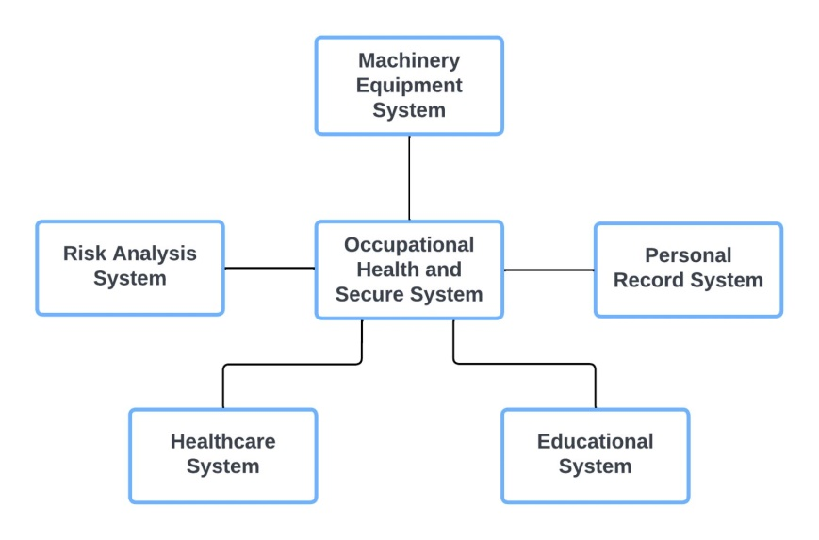

**Figure 1: External Interfaces of the Safety for Everyone System.**

***List of Responsible People to Contact:***

*Risk Analysis System:* Risk analysis measurement

*Healthcare System:* Access to people's health information

*Educational System:* Access to people's educational information

*Personal Record System:* Keeping records of personnel

*Machinery Equipment System:* Machine equipment information recording, their maintenance and controls

## Internal structure

Responsibility for the project is shared among CengHall members. The internal structure of the project organization is given in Figure 2.

**Figure 2: The Internal Structure of the Project Developing Organization**

## Roles and Responsibilities

|  |  |  |
| --- | --- | --- |
| **Name** | **E-mail address** | **Roles & Responsibilities** |
| Elif Erten | [eliferrten@icloud.com](mailto:eliferrten@icloud.com) | Programmer  Project manager  Member of documentation team |
| Nesteren Gözükızıl | [nesteren.ngzkzl@gmail.com](mailto:nesteren.ngzkzl@gmail.com) | Programmer  Project manager  Member of documentation team |
| Ayşegül Sofuoğlu | [aysegulsfglu@gmail.com](mailto:aysegulsfglu@gmail.com) | Programmer  Project manager  Member of documentation team |
| Deniz Parlar | [dparlar23@gmail.com](mailto:dparlar23@gmail.com) | Programmer  Project manager  Member of documentation team  Presenter |
| Bedirhan Budak | [bedirhan.bbudak@gmail.com](mailto:bedirhan.bbudak@gmail.com) | Programmer  Project manager  Member of documentation team |
| Rabia Kurt | [2018555044@ogr.cu.edu.tr](mailto:2018555044@ogr.cu.edu.tr) | Programmer  Project manager  Member of documentation team  Presenter |

# Table 3: Roles and Responsibilities of CengHall Members

# Board of Directors: is responsible from setting corporate strategy, overall direction, mission and vision.

**Customer Relations Department:** is responsible from managing the high-end relations with the customers.

**Project Management Department:**

**Requirements Analysis Team:** is responsible from collecting and documenting the system requirements as a whole.

**Design Team:** is responsible from planning how the required system functionality is to be provided.

**Coding Team:** is responsible from realizing the products designed.

**Testing Team:** is responsible from verifying that the developed system represents the requirements in a complete and correct manner.

**Documentation Team:** is responsible from preparing the system documentations intended for different audiences.

# Managerial Process Plans

## Staffing Plan

CengHall has six members, all members will work in every phase of the project. The Safety for Everyone phases are shown in Table 1.

The estimated monthly staff requirement is shown in Figure 3.

**Figure 3: Staffing plan for Safety for Everyone**

## Resources Acquisition Plan

* Since all six members of CengHall located in Cukurova Campus, there will be no transportation cost for meetings.
* Training part of the Safety for Everyone does not need any payment. Since CengHall members will do training internally.
* For any kind of hardware and software needs the existing resources of CengHall will be used.

## Project Staff Training Plan

|  |  |  |  |  |
| --- | --- | --- | --- | --- |
| Subject | Start | End | Trainer | Method |
| Object Oriented Programming | 01.09.2022 | 01.11.2022 | Rabia Kurt  Deniz Parlar  Ayşegül Sofuoğlu | Lectures |
| SQL | 02.08.2022 | 12.09.2022 | Bedirhan Budak  Nesteren Gözükızıl | Lectures |
| C# | 01.10.2022 | 01.11.2022 | Ayşegül Sofuoğlu  Elif Erten | Lectures |
| Web Design | 22.09.2022 | 20.10.2022 | Elif Erten  Bedirhan Budak | Lectures |
| System Analysis and Design | 16.09.2022 | 26.12.2022 | All members of CengHall | Lectures |

**Table 4: Staff Training Plan**