Report of Homework 3

In this assignment, we were asked to write a C program for a Virtual ATM. First, I defined the required functions in the assignment:

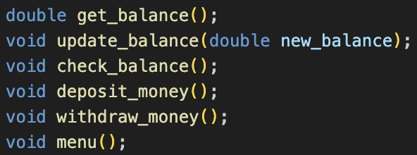

Then I implemented them one by one. First, get_balance simply retrieves the balance from the file “account.txt”. If the file is not present, I create a new file with a balance of 100. To achieve this, I try to open the file in “r” (read) mode, because fopen() returns NULL if the file does not exist. If the file exists, I read its content and return the balance. If it doesn’t exist, I use fopen() in “w” (write) mode, which creates the file if it’s missing but overwrites its content if it exists. I then use fscanf() to get the balance and return its value.

Second, update_balance updates (overwrites) the contents of the file “account.txt” with the new balance provided as a parameter. I used fopen() in “w” mode to overwrite the file's content. Note that update_balance is always called after get_balance, so the file will exist before update_balance is executed. Both functions are called within other functions.

Third, check_balance uses get_balance to print the current balance.

Fourth, deposit_money gets the balance using get_balance and then asks the user how much money they want to deposit. If the user enters a valid number (number > 0 or a digit), the function adds the deposit amount to the current balance, updates the file using update_balance, and prints the new balance to the console.

Fifth, withdraw_money gets the balance using get_balance and asks the user to enter the amount to withdraw. It then checks if the input is valid. If the balance is less than the withdrawal amount, the withdrawal process does not proceed, and a warning is printed: “Insufficient funds! Your balance is only (balance) TRY.” However, if there are sufficient funds, the amount is deducted from the balance, and a message is printed: “Withdraw successful! New balance: (new balance) TRY (Saved to account.txt).”

Lastly, menu prints the ATM menu.

In my main function, I used the option variable as an int and implemented if-else statements to execute the corresponding functions based on the user's input.

Here are the outputs of my homework:

