**drgMaster**

drgMaster performs basic analysis of spike and LFP data acquired by the Restrepo lab. Data are acquired with the Data Translation DT3010 or Intan RHD2000 boards. After reading the header with drta you can perform LFP analysis with drgMaster. In order to perform spike analysis you need to sort spikes using wave_clus. drgMaster will read header and spike information from a jt_times file generated by drta/wave_clus and will read LFP recordings from .dg (DT3010) or .rhd (Intan) files.

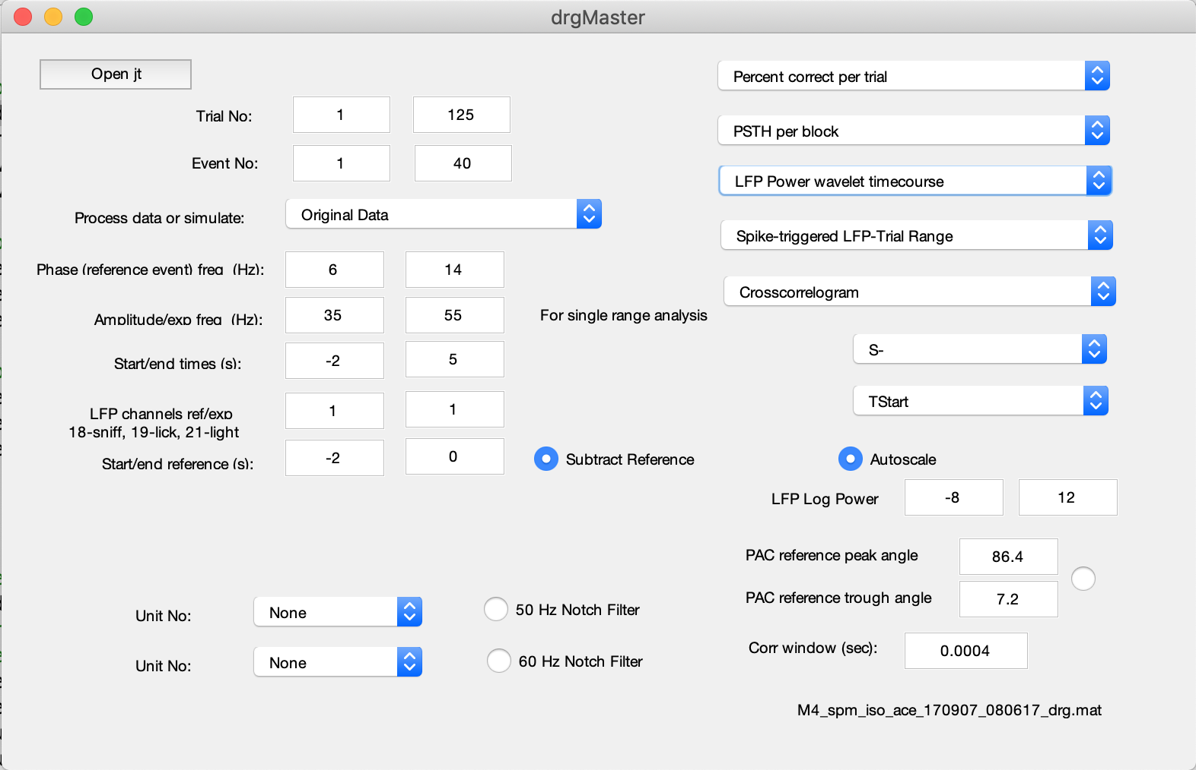

You should install the following MATLAB toolboxes:

Wavelet

Statistics and Machine Learning

Bioinformatics toolbox (for the “suptitle” command)

In addition, you will need the following downloads:

Circular Statistics Toolbox (<https://www.mathworks.com/matlabcentral/fileexchange/10676-circular-statistics-toolbox-directional-statistics>)

ROC_calc (<https://www.mathworks.com/matlabcentral/fileexchange/69883-roc_calc>)

**Analysis of behavior**

Percent correct per trial. Calculates percent correct (PC) in a window of 20 trials. Blue denotes PC<=65, red PC>=80.

**LFP analysis**

Phase amplitude coupling. Calculates PAC according to Tort. The amplitude frequency band is set by “Amplitude frq. (Hz)” and the phase reference frequency band is set by “Phase reference freq (Hz)”. The PAC is calculated in the window set by “Start/end time (s)”.

**Spike analysis**

PSTH in phase event 1 vs 2

Computes the PSTH convolved with the spike phase histogram generated by “Spike phase in LFP-Trial Range”. You must run Spike phase in LFP-Trial range first. You need to specify: events 1 and 2 (e.g. S+ and S-), Start/end time(s), UnitNo and Amplitude freq (Hz). Make sure that Amplitude freq (Hz) is the same frequency bandwidth used to calculate “Spike phase in LFP-Trial Range”.

**drgPlexToJt**

Generates a jt_times file that can be read using drgMaster using data acquired with Plexon by Anan Li’s. laboratory.

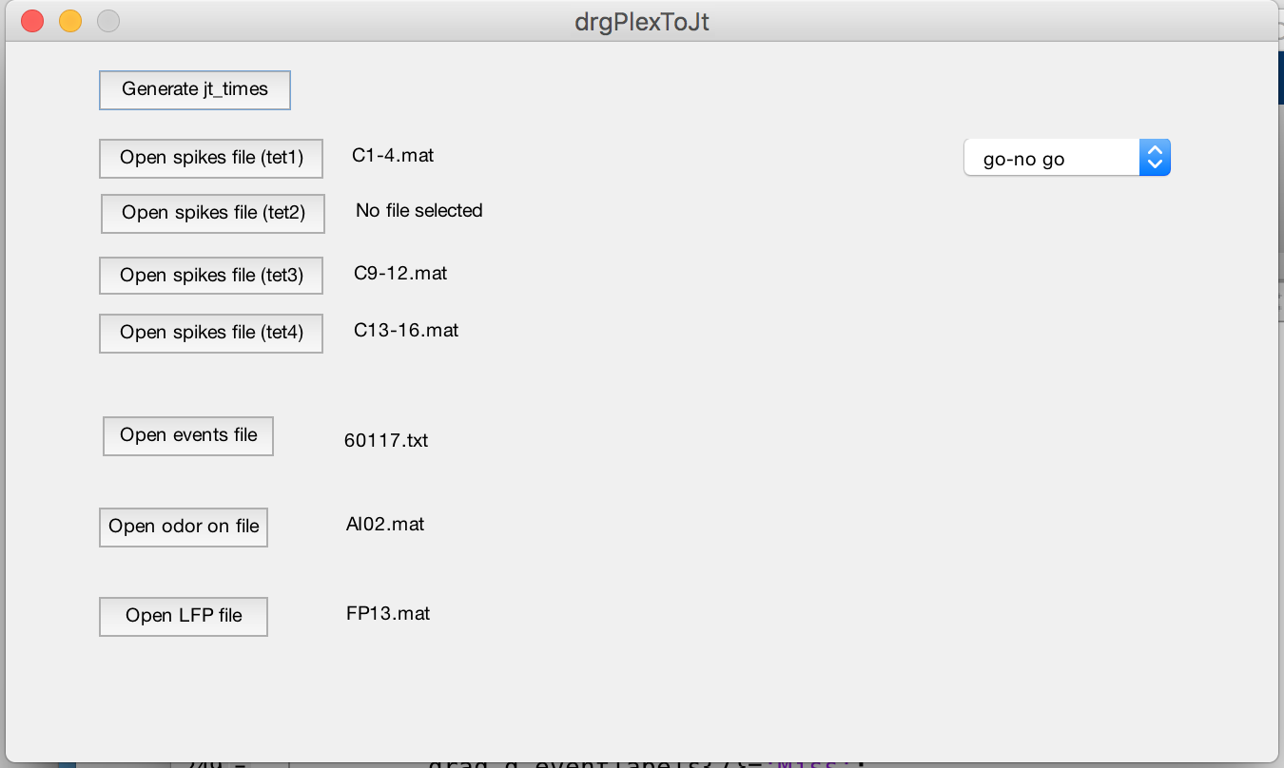

**drgRunBatchLFPpar**

This code performs power and PAC analysis for a batch of files. It requires a drgbChoices file that specifies the path and file names for each file, which experimental group they belong to, the time windows, and events that will be used. We include an example file drgbChoicesLFPexample.m. The program takes several hours, days for analysis of several files. The code saves a .mat output file. The data can be displayed with drgAnalysisBatchLFP code.

handles.drgbchoices.analyses chooses the analysis performed

1 PAC for cases 19 (MI, angle, etc) and 23 (peak and trough power through Hilbert) in drgAnalysisBatchLFP, vetted

2 LFP power for case 20 in drgAnalysisBatchLFP, vetted

3 Lick-related LFP analysis (fourier transform LFP power)

4 power for LFP wavelet analysis

5 event-related LFP wavelet analysis for case 22 of drgAnalysisBatchLFP, vetted

6 phase comparison analysis

7 phase comparison analysis

8 LFP wavelet power computed at the peak and through of the low frequency wave

phase is calculated with a Hilbert transform (PAC)

**drgAnalysisBatchLFP**

drgAnalysisBatchLFP displays the LFP power and PAC data processed by drgRunBatchLFPpar.

drgAnalysisBatchLFP will ask for a file with the parameters for the analysis (drgLFPBatchAnalPars_*.m) and for the output file from drgRunBatchLFPpar.

Which analysis is performed is determined by the value entered in the variable which_display:

1 ERP analysis compare auROC in the last few trials of pre with first few trials of post. Analyzed per session

2 Generate delta LFP power and auROC for reversal figure for Daniel's paper. Analyzed per session

3 For a subset of first files for events 1 and 2 plot the LFP bandwide spectrum,

LFP power histograms for different bandwidths for each electrode and LFP auROCs.

To generate Fig. 2 for Daniels' LFP power paper enter the proficient files

Analyzed per session

4 Generate LFP power auROC for Fig. 3 for Daniel's paper. first vs last. Analyzed per session

5 Compare auROC in the last few trials of pre with first few trials of post

Used for old Fig. 4 of Daniel's paper with acetoethylben_electrode9202017.mat. Analyzed per session

6 For a subset of first files for events 1 and 2 plot the ERP LFP bandwide spectrum,

ERP LFP power histograms for different bandwidths for each electrode and ERP LFP auROCs.

Analyzed per session

7 Generate ERP LFP power auROC. first vs last. . Analyzed per session

8 Compare auROC for ERP LFP in the last few trials of pre with first few trials of post

Used for New Fig. 7 of Daniel's paper. Analyzed per session

9 Compare auROC for power LFP for two events in two percent windows for

all of the files. Analyzed per session

10 Compare auROC for power LFP for two groups (e.g. NRG1 vs control)

within one precent window. Analyzed per session

11 Compare auROC for ERP LFP powerin between two percent correct windows. Analyzed per session

12 Justin's analysis of LFP power differences for naive and proficient

mice. Analyzed per session

13 Compare auROC for ERP wavelet LFP power between two percent correct

windows at different ERP delta t values. Analyzed per session

14 Justin's multiclass ROC analysis of LFP power differences for naive and proficient

mice for different epochs (concentrations or S+ vs. S-). Analyzed per mouse

15 Justin's fitlm analysis of LFP power differences for naive and proficient

mice. Analyzed per mouse

16 Justin's fitglm analysis of LFP power differences for naive and proficient

mice. Analyzed per mouse

17 Justin's PAC analysis for events (concentrations or S+/S-) for naive and proficient

Analyzed per mouse (all trials for all sessions for each mouse are used

in the analysis)

18 Multiclass ROC analysis for mean angle for PAC for multiple epochs and proficient

vs naive

19 PAC MI analysis for events (concentrations or S+/S-) for naive and proficient

Analyzed per mouse for groups defined by the user

20 Multiclass ROC analysis of LFP power differences for naive and proficient

mice for different epochs (concentrations or S+ vs. S-) and different groups. Analyzed per mouse

21 Multiclass ROC analysis of coherence for naive and proficient

mice for different epochs (concentrations or S+ vs. S-) and different groups. Analyzed per mouse

22 Event (lick)-related wavelet analysis for LFP power

23 Oscillatory power calculated from the amplitude of the Hilbert envelope of the high

frequency at the peak and trough of the low frequency phase

24 Oscillatory wavelet power calculated at the peak and trough of the low frequency PAC phase

**drgLFPDiscriminantBatch**

Batch discriminant and PCA analysis for LFP data

It takes as input a choices file such as drgbChoicesDiscriminantJustin_spm_perfom_LFP_20180215

handles.drgbchoices.which_discriminant chooses the analysis:

1 Perceptron for power LFP (very slow and has not been troublehsot)

2 Linear discriminant analysis (LDA) for power LFP

3 Principal component analysis (PCA) for power LFP

4 Linear discriminant analysis (LDA) for phase in phase amplitude coupling (PAC)

5 Principal component analysis for PAC

6 LDA for subsets of electrodes for power LFP

**drgAnalyzeLFPDiscriminantBatch**

Analyzes the linear discriminant analysis performed by drgLFPDiscriminantBatch.

Takes as input the 'Discriminant_*.mat' output file from drgLFPDiscriminantBatch.

Performs an analysis of the timecourse for percent correct for LDA and for the PCA for naïve and proficient mice

**drgAnalyzeLFPDiscriminantMultiBatch**

Analyzes multiple output files of the linear discriminant analysis performed by drgLFPDiscriminantBatc.

**drgRunBatchLFPxLFPpar**

This code does batch analysis for interactions between LFPs. A choices file such as drgbChoicesDanielNRG1heptanol11919 is required

Which analysis is performed is chosen with handles.drgbchoices.analyses

8 Does LFP coherence analysis

The data in the output file can then be analyzed using case 21 of drgAnalysisBatchLFP