YAML title: create word layout template (= title style)

YAML author (= author style)

YAML data (= date style)

This template is saved as "newTemplate" Note that formatAuthors output (with results='asis') yields body text style

# Heading 1 (not used)

Paragraph text ("first paragraph")

Another paragraph ("body text")

## Heading 2 (used for section breaks: abstract, intro etc)

Paragraph text

### Heading 3 (used for figure / table names)

#### Heading 4 (used for subsections)

##### Heading 5 (not used)

Heading 5 inserts a page break

###### Heading 6 (used for comments etc)

Here is a paragraph with a link in it <http://a.link.com>.

Here is some **bold** text.

Here is some *italic* text.

Here comes n R code chunk producing a table:

pander::pander(summary(cars))

|  |  |
| --- | --- |
| speed | dist |
| Min. : 4.0 | Min. : 2.00 |
| 1st Qu.:12.0 | 1st Qu.: 26.00 |
| Median :15.0 | Median : 36.00 |
| Mean :15.4 | Mean : 42.98 |
| 3rd Qu.:19.0 | 3rd Qu.: 56.00 |
| Max. :25.0 | Max. :120.00 |

the echoed commands (summary(cars)) map to KeywordTok / NormalTok styles in word template

Here is a plot: 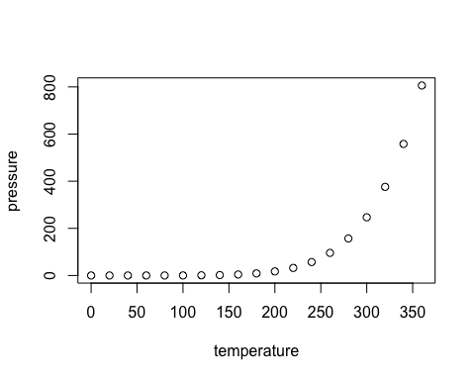

Here is some inline code inlineCode = TRUE in a sentence.

a quoted paragraph (="block text"), used for figure / table legends

another code block (specified with 4 spaces, template = "source code")

A paragraph

A code block using 3 backtick notation

A list:

* a thing
* another thing

A numbered list:

1. a thing
2. another thing

## Changes made to styles in word:

* Title: fontsize 14, black
* Normal: helvetica font (propagates through to body text & first paragraph styles)
* Heading 1: colour automatic, fontsize 12, all caps (still bold)
* Heading 2: colour automatic, fontsize 12, all caps, italic (still bold)
* Heading 3: colour automatic, fontsize 12, italic (still bold)
* Heading 4: colour automatic (still bold, fontsize 12)
* Block text: indent before 0.4", cambria (serif), fontsize 12
* Footnote options: letters starting with a