Revision History
Date | Version | Description | Author
23/10/2018 | 1.0 | User Requirements Specifications added. | Ege Bilir
24/10/2018 | 1.1 | System Overview, Abbreviations and System Requirements Specification added. | Elif Gocumoglu
25/10/2018 | 1.2 | Use Cases and Usage Scenarios added. | Ahmet Gokce
26/10/2018 | 1.3 | System Requirements Specification edited. | Ege Bilir
26/10/2018 | 1.4 | SRS edited. | Ahmet Gokce, Elif Gocumoglu, Ege Bilir
05/11/2018 | 1.5 | User requirements edited. | Ege Bilir, Alp Demirezen, Ataberk Ozek, Ahmet Gokce
09/11/2018 | 1.6 | Edited Use cases and Usage scenarios according to the feedback. | Ege Bilir, Ataberk Ozek
09/11/2018 | 1.7 | System Architecture added. | Ahmet Gokce

TABLE OF CONTENTS
Revision History 1
1 INTRODUCTION 3
1.1 Document overview 3
1.2 System overview 3
1.3 Abbreviations 3
1.4 References 3
1.5 Conventions 3
2 REQUIREMENTS 4
2.1 User Requirements Specification 4
2.2 System Architecture 6
2.3 Use Cases and Usage Scenarios 7
2.4 System Requirements Specification 9

INTRODUCTION

Document overview

This document presents the software requirements specifications of REP software development project. It describes functional requirements, quality requirements, constraints, use cases, and usage scenarios. It also provides an overview of the system architecture.

System overview

Main goal of REP is to ease both REA’s and customers experience while they are looking for appropriate real estates. People generally having a hard time while they are searching for their future places, with REP we aim to give them maximum efficiency while they do so.

Abbreviations
These are the abbreviations that we will be using in the rest of the document:
REA: Real Estate Agent
REP: Real Estate Program
RED: Real Estate Dealer
UML: Unified Modeling Language
IDE: Integrated Development Environment
JDK: Java Development Kit
SRS: Software Requirement Specification
STP: Software Test Plan
SDD: Software Design Document
STR: Software Test Report

References

# | Document Identifier | Document Title
[R1] | ID | Add your documents references.  One line per document.

Conventions
Requirements listed in this document are constructed according to the following structure:

SRS-XXX-000
Description of XXX-000 requirement
Version of XXX-000

Every system requirement id includes the id of the corresponding user requirement as a prefix.

SRS-XXX-000.1
Description of XXX-000.1 system requirement, which is related to the user requirement XXX-000
Version of XXX-000.1

REQUIREMENTS

User Requirements Specification

SRS-REP-001
REP should start without any problems.
Version of REP-001
SRS-REP-001.1
PC should be booted up and ready to work.
Version of REP-001.1

SRS-REP-002
GUI should be interactable.
Version of REP-002
SRS-REP-002.1
REP should be started.
Version of REP-002.1

SRS-REP-003
User shall login with parameters: username and password.
Version of REP-003
SRS-REP-003.1
REP should be started.
Version of REP-003.1

SRS-REP-004
User shall select one of the two options: Add a house or search for a house.
Version of REP-003
SRS-REP-004.1
User must be logged in.
Version of REP-003.1

SRS-REP-005
User should pick, for rent or for sale from the checkboxes.
Version of REP-004
SRS-REP-005.1
User must be logged in.
Version of REP-004.1

SRS-REP-006
REP software shall compute the search parameters with the area, price, number of rooms and location as input parameters.
Version of REP-005
SRS-REP-006.1
One of the checkboxes must be chosen by the user.
Version of REP-005.1

SRS-REP-007
REP should receive the expected results from the database.
Version of REP-006
SRS-REP-007.1
REP and Database should be working correctly, and search algorithm should have been executed correctly.
Version of REP-006.1

SRS-REP-008
REP shall be always available to real estate agents during normal working hours.

SRS-REP-009
REP software shall be fast enough for the user with the help of efficient algorithms, avoiding nested loops etc.

SRS-REP-010
REP software shall be secure, only administer has to be able to reach the database and information’s about real estates with the password given.

SRS-REP-011
REP software’s size shall be small enough for every real estate agent to be able to use in their computers without needing too much storage.

SRS-REP-012
REP software shall be reliable, we as a team are going to test our program with every possible scenario in order to reach minimum rate of failure occurrence.

System Architecture

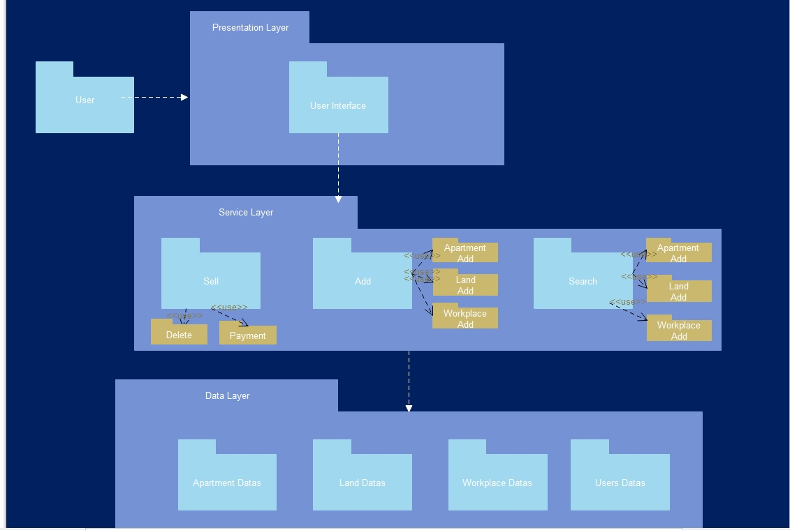

Use Cases and Usage Scenarios

Use Case Diagram:

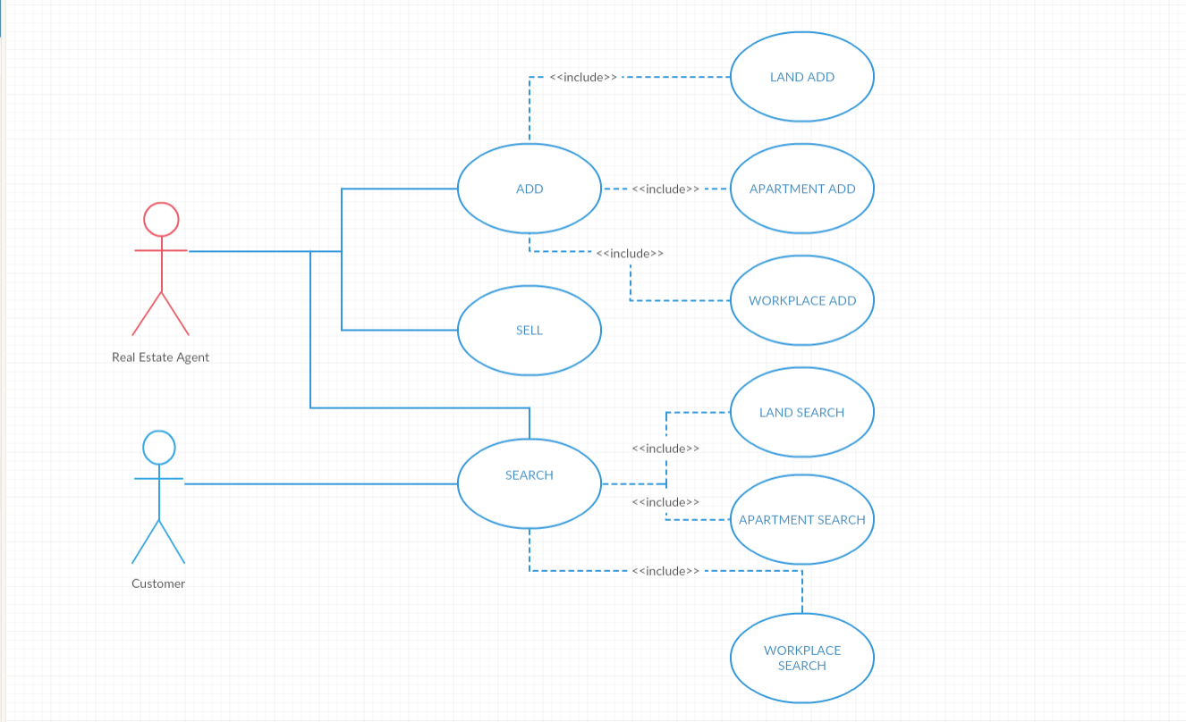

Sequence Diagram:

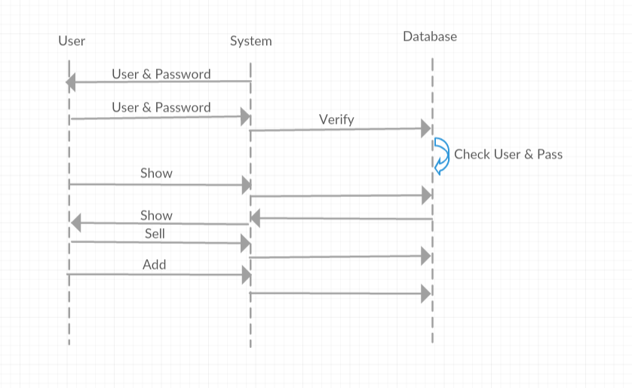

System Requirements Specification

SRS-REP-003
REP shall give an error message if any of the login information was provided wrong.

SRS-REP-005
REP shall allow to choose only one of the checkboxes.

SRS-REP-006
REP shall give an error message if area or price or number of rooms entered negative.

