Revision History
Date | Version | Description | Author
23/10/2018 | 1.1 | User Requirements Specifications added. | Ege Bilir
24/10/2018 | 1.2 | System Overview, Abbreviations and System Requirements Specification added. | Elif Gocumoglu
25/10/2018 | 1.3 | Use Cases and Usage Scenarios added. | Ahmet Gokce
26/10/2018 | 1.4 | System Requirements Specification edited. | Ege Bilir
26/10/2018 | 1.5 | SRS edited. | Ahmet Gokce, Elif Gocumoglu, Ege Bilir

TABLE OF CONTENTS
Revision History 1
1 INTRODUCTION 3
1.1 Document overview 3
1.2 Abbreviations 3
1.3 References 3
1.4 Conventions 3
2 REQUIREMENTS 5
2.1 User Requirements Specification 5
2.2 System Architecture 5
2.3 Use Cases and Usage Scenarios 5
2.4 System Requirements Specification 5

INTRODUCTION

Document overview

This document presents the software requirements specifications of REP software development project. It describes functional requirements, quality requirements, constraints, use cases, and usage scenarios. It also provides an overview of the system architecture.

System overview
System Requirements:
The system shall search the desired house choices and shall filter and list all the houses on sale regards to the desired specifications. When the real estate sells a house, The system shall remove the sold house from the database. The system shall add the entered available houses on sale.

Abbreviations
These are the abbreviations that we will be using in the rest of the document:
REP: Real Estate Program
RED: Real Estate Dealer
UML: Unified Modeling Language
IDE: Integrated Development Environment
JDK: Java Development Kit
SRS: Software Requirement Specification
STP: Software Test Plan
SDD: Software Design Document
STR: Software Test Report

References

# | Document Identifier | Document Title
[R1] | ID | Add your documents references.  One line per document.

Conventions
Requirements listed in this document are constructed according to the following structure:

SRS-XXX-000
Description of XXX-000 requirement
Version of XXX-000

Every system requirement id includes the id of the corresponding user requirement as a prefix.

SRS-XXX-000.1
Description of XXX-000.1 system requirement, which is related to the user requirement XXX-000
Version of XXX-000.1

REQUIREMENTS

User Requirements Specification

SRS-REP-001
REP (Real Estate software) shall be always available to real estate agents during normal working hours.

SRS-REP-002
REP software shall be fast enough for the user with the help of efficient algorithms, avoiding nested loops etc.

SRS-REP-003
REP software shall be secure, only administer has to be able to reach the database and information’s about real estates with the password given.

SRS-REP-004
REP software’s size shall be small enough for every real estate agent to be able to use in their computers without needing too much storage.

SRS-REP-005
REP software shall be reliable, we as a team are going to test our program with every possible scenario in order to reach minimum rate of failure occurrence.

System Architecture

This chapter should present a high-level overview of the anticipated system architecture, showing the distribution of functions across system modules.

Use Cases and Usage Scenarios

Use Case Diagram:

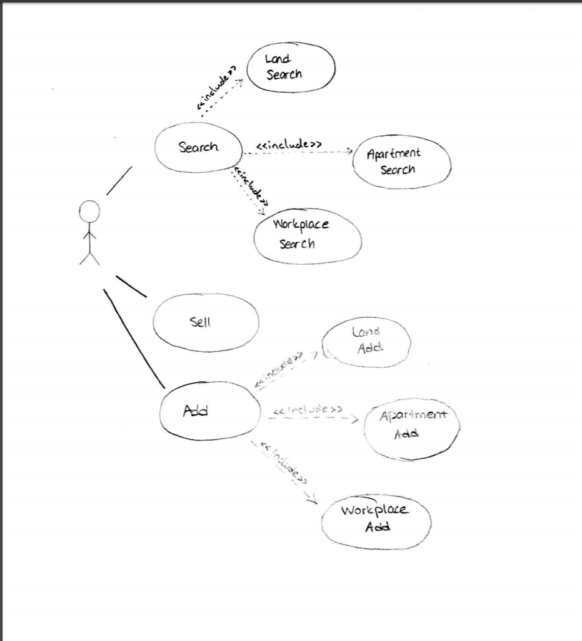

Sequence Diagram:

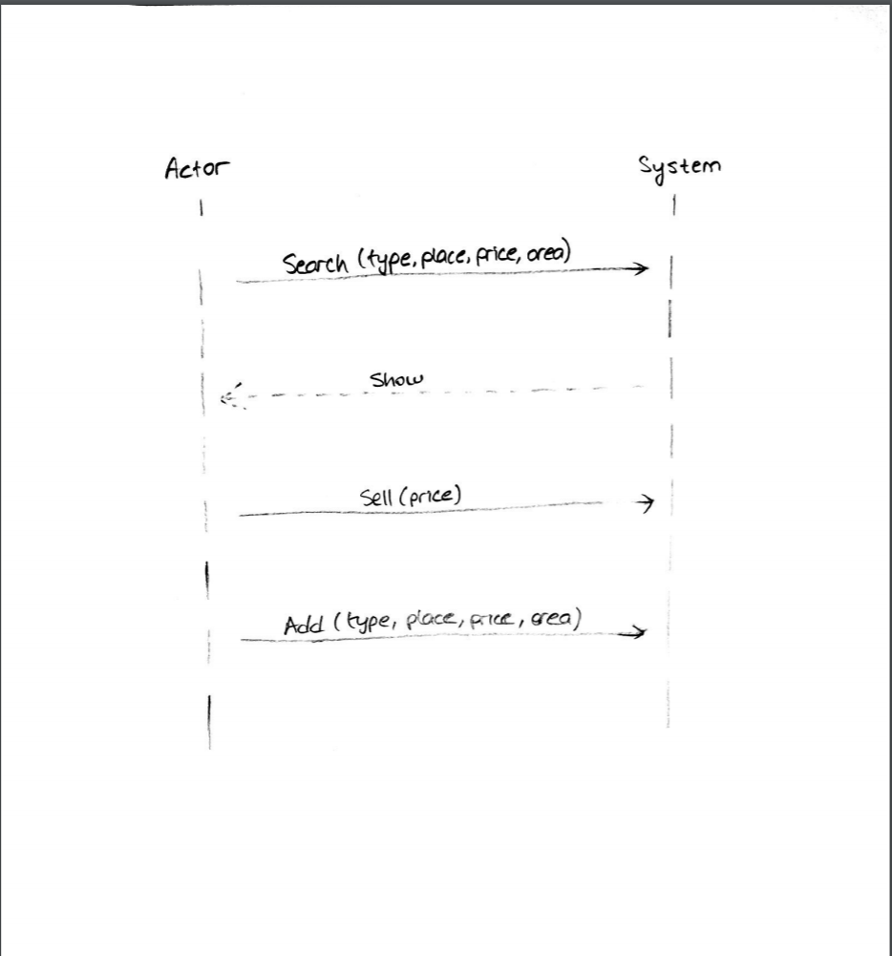

System Requirements Specification

SRS-REP-006
REP ensures that the displayed Properties’ data are the same as read in the input files.
The properties’ data are:
- Price,
- Rent,
- Area,
- Where it is located,
- Subscription Fee.
V1.0

SRS-REP-007
REP generates a log file containing:
- The state of the application and the steps performed to reach that state,
- List of sold properties,
- List of added properties,
- The possible error logs, if any.
V1.0

