Revision History
Date | Version | Description | Author
07/10/2018 | 1.0 | Software Development Plan | All group members
10/10/2018 | 1.1 | Finished Responsibilities tab | Ataberk Ozek, Ahmet Gokce
10/10/2018 | 1.2 | Added Gantt chart | Ahmet Gokce, Ataberk Ozek
17/10/2018 | 1.3 | Edited according to feedback | All group members

TABLE OF CONTENTS

Revision History 1
1 Identification 3
1.1 Document overview 3
1.2 Abbreviations 3
1.2.1 Abbreviations 3
1.3 References 3
1.3.1 Project References 3
2 Software Development Activities 3
2.1 Software development process 3
2.1.1 Overview of process phases 3
2.1.2 Technical documentation 4
2.1.3 Deliverables 4
2.2 Software development tools 4
2.2.1 Workstation 4
2.2.2 Requirements management and documentation 4
2.2.3 Software Design 5
2.2.4 Coding and automated tests 5
2.2.5 Configuration management 5
2.3 Software development rules and standards 5
3 Responsibilities 5
3.1 Activities and responsibilities 5
4 Risk Assessment 6
4.1 Risk Analysis 6
4.2 Risk Planning 6

Identification

Document overview
This document contains the software development plan of REP.
Our software is aiming to ease the business lives of real-estate agencies. It is supposed to list all the estate choices which meets with the requested features (such as turn-key, range of square meters, range of the budget etc.) that real estate fills in to their customers. The program will be used by real estate dealers specifically.

Abbreviations

Abbreviations
These are the abbreviations that we will be using in the rest of the document:
REP: Real Estate Program
RED: Real Estate Dealer
UML: Unified Modeling Language
IDE: Integrated Development Environment
JDK: Java Development Kit
SRS: Software Requirement Specification
STP: Software Test Plan
SDD: Software Design Document
STR: Software Test Report

References

Project References

# | Document Identifier | Document Title
[R1] | ID | //Can you explain this, please?

Software Development Activities

The section lists and describes the software development activities of REP software development project.

Software development process

This is a course project, which adopts the waterfall model as the software development process.

Overview of process phases

The software development process for the project will be composed of the following phases:
- Planning
- Requirements Analysis
- Design
- Database Design
- GUI Design
- Implementation
- GUI implementation
- Business logic implementation
- Testing

These phases will follow each other sequentially, where each phase starts just after the completion of the previous one. The following Gantt chart depicts the planned start date and duration for the phases.

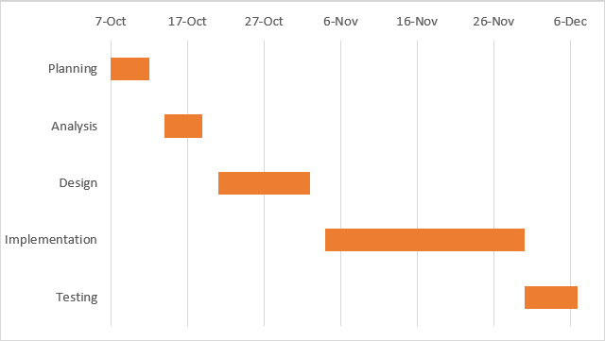

Technical documentation

The following documentation is produced during the software development phases:
- Software specification: SRS, STP
- Software detailed conception: SDD
- Software tests phases: STR

Deliverables

The following items will be delivered at the end of the process:
- Technical documentation as outlined in Section 2.1.2
- Software and its configuration files
- Github Records

Software development tools

Workstation
Cpu: i7 (6700HQ)
Ram: 16 GB DDR4
Gpu: GTX 1060 (6GB)
Operating System: Windows 10

We will be mainly using IntelliJ and Eclipse, in addition to Microsoft Excel.

Requirements management and documentation

We will be using Microsoft Word primarily with the help of Microsoft Excel.

Software Design

Argo UML open source tool will be used for designing.

Coding and automated tests
- We will use java programming language.
- We will use eclipse and IntelliJ for coding the project.
- We will use JSON for managing database.

Configuration management
GitHub will be used for software configuration management and tracking issues regarding the software development. A public repository will be created for this purpose.

Software development rules and standards
- UML will be used for software design documentation.
- Comment convention;(https://iis.uibk.ac.at/public/piater/courses/Coding-Style/ar01s02.html)
- Indentation convention;(https://www.oracle.com/technetwork/java/javase/documentation/codeconventions-136091.html)
- Naming convention:(https://www.oracle.com/technetwork/java/javase/documentation/codeconventions-135099.html)
- White space convention:
- https://www.oracle.com/technetwork/java/javase/documentation/codeconventions-141388.html#475

Responsibilities

Activities and responsibilities

Activity | Responsibility | Comment
Project management | All Members
Configuration tools management | Alp Demirezen | GitHub
Setting up the Development tools | All Members
Software specifications | Ege Bilir, Mert Buyukiz, Alp Demirezen
Database design | Ahmet Gokce, Ataberk Ozek
Data gathering | Ataberk Ozek, Ahmet Gokce, Elif Gocumoglu
Requirement Analysis | Elif Gocumoglu, Mert Buyukiz
Implementation Details | Ahmet Gokce, Alp Demirezen, Ataberk Ozek, Ege Bilir
Testing | Ege Bilir, Alp Demirezen

Risk Assessment

Risk Analysis

Risk | Probability | Effects
The time required to develop the software is underestimated. | Moderate | Serious
The time need to bug fixing is underestimated. | Moderate | Tolerable
Not able to meet with the users’ expectations | High probability | Serious
Possible health issues of the group members | Low probability | Tolerable
The time which every member allocated for the project may change because of the circumstances (Finals, midterms etc.) | High probability | Serious

Risk Planning

Risk | Strategy
The time required to develop the software is underestimated. | The process will be speeded up when needed.
The time need to bug fixing is underestimated. | Can result in extra working hours.
Not able to meet with the users’ expectations | Presenting the steps to the customer before the process by analyzing all the problems, steps and the consequences at first.
Possible health issues of the group members | Rearranging the team in case of the illness of one of us so we can catch with the schedule.
The time which every member allocated for the project may change because of the circumstances (Finals, midterms etc.) | Yielding the responsibility to another team member.

http://www.github.com
http://www.uml.org/

