1) Data Collection. Have any data been collected for this study already?
- Yes, we already collected the data.
- No, no data have been collected for this study yet.
- It's complicated. We have already collected some data but explain in Question 8 why readers may consider this a valid preregistration nevertheless.
Note: 'Yes' is not an accepted answer.
2) Background. Briefly summarise the relevant research and explain how it motivates the study.
Example: Academic performance can decline during the summer holidays, particularly among children from disadvantaged backgrounds. Structured academic activities during this period may help maintain learning. This study examines whether offering a month-long academic summer programme can reduce this decline.
3) Research Question & Hypothesis. What's the main question being asked or hypothesis being tested in this study?
Example: A month-long academic summer program for disadvantaged kids will reduce the drop in academic performance that occurs during the summer.
4) Dependent Variables. Describe the key dependent variable(s) specifying how they will be measured.
Example: Simple average GPA across all courses during the first semester after the intervention.
5) Experimental Design. Describe the task, experimental manipulations, and conditions. Specify whether participants complete all conditions or are assigned to separate groups. Report the number of blocks, trials per block, and total trials per participant, including the number of trials per condition. Include a figure illustrating the trial sequence.
Example 1: Two conditions: Offering summer program: yes vs no.
Example 2: 12 conditions in a mixed design lab study. Participants will be assigned to one of four conditions: math training, verbal training, memory task, or control (4 between-subject conditions). Each participant will complete a math test, a verbal test, and a memory test (3 within-subject conditions).
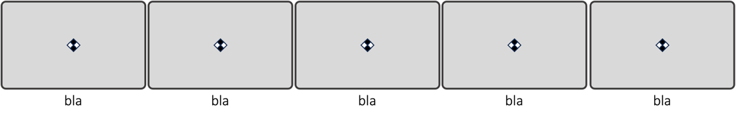

6) Analyses. Specify the analyses and comparisons you will use to test each hypothesis.
Example. Linear regression predicting the simple average GPA in the semester after the intervention with a dummy variable indicating whether the participant was offered the summer program or not (intention-to-treat analysis). We will also conduct the same regression controlling for simple average GPA during the semester before the intervention, gender, & household income (an 8-point scale ranging from 1 = below $20,000 and 8 = above $150,000).
7) Predicted Results. Describe the results you expect based on your hypotheses.
Example. We predict that children offered the summer programme will have a higher average GPA in the first semester after the intervention than children who were not offered the programme, controlling for their GPA before the intervention.
8) Outliers and Exclusions. Describe exactly how outliers will be defined and handled, and your precise rule(s) for excluding observations.
Example 1. We will compute the overall mean and standard deviation across all conditions, and exclude trials with a 2.5 SD above/below the mean.
Example 2: We will exclude participants who incorrectly answer at least 2 of our 3 attention check questions.
Example 3. We will exclude any participants who complete the survey in less than 30 seconds.
9) Sample Size. How many observations will be collected or what will determine sample size?
No need to justify decision, but be precise about exactly how the number will be determined.
Example: We will offer the program until 500 people have agreed to participate in it or until June 30, 2016 (whichever comes first).
10) Other. Anything else you would like to pre-register?
(e.g., secondary analyses, variables collected for exploratory purposes, unusual analyses planned?)
Example: We will include a battery of questions for exploratory purposes, including life satisfaction, amount of videogame playing, and family activity. We will also provide an additional survey with 24 questions assessing achievement orientation. We will not report the results of those analyses for the project being pre-registered.
NOTE: If you leave this blank it will read: Nothing else to pre-register.
11) Name. Give a title for this AsPredicted pre-registration
Suggestion: use the name of the project, followed by study description.
Example: SUMMER PROGRAMS - GPA performance, Chicago, July 2018
12) Type of study.
- Class project or assignment
- Experiment
- Survey
- Observational/archival study
- Other: ___________________________
13) Data source
- Prolific
- MTurk
- Cloud Research
- University lab
- Field experiment / RCT
- Other: ___________________________

