**What is PUB-SUB and Its Real Life Applications**

Publish-Subscribe, or Pub-Sub, is an architectural pattern that is used in distributed systems to allow communication between various components without requiring that they be in direct contact with one another. The two roles that make up the Pub-Sub model's components are publishers and subscribers. Building scalable, loosely coupled systems that can effectively manage real-time events and messaging is a common use for this pattern.

**Pub-Sub Mechanisms**

1. **Publishers:** Message creation and broadcasting to the message broker fall under the responsibility of publishers. Usually, these messages summarize events or information that other components might find pertinent. Publishers just need to send messages to the appropriate channels or topics; they don't need to know the subscribers' identities or locations.
2. **Subscribers:** By subscribing to channels or topics, subscribers indicate their interest in particular kinds of messages or events. Subscribers simply indicate interest in the content that matters to them; they do not need to be aware of publishers' existence. The message broker distributes relevant messages to all interested subscribers as soon as they are published.
3. **Message Broker:** Publishers and subscribers are connected through the message broker. It gets messages from publishers and makes sure that everyone who subscribes is interested in the related topics or channels receives them. In accordance with the subscribers' declared interests, the broker oversees message routing and keeps a register of them.

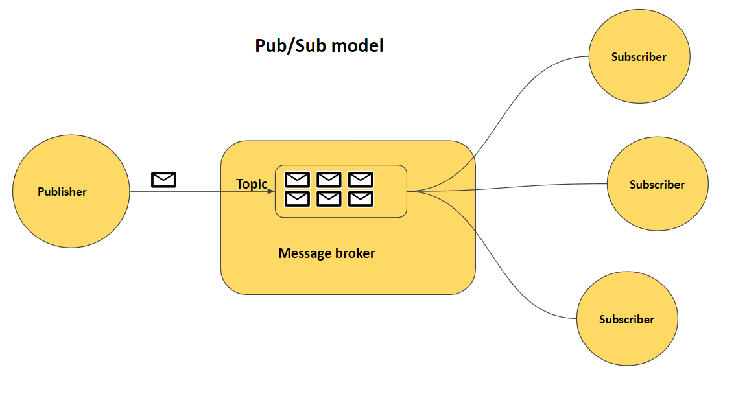

**Advantages of Pub-Sub:**

1. **Loose Coupling:** Subscriptions and publishers are not connected to one another. Subscribers do not need to know the publishers' personal information, and publishers do not need to know who their subscribers are.
2. **Scalability:** Infrastructures based on pub-sub can be very scalable. The message broker can be built to effectively manage the rising message volume as publishers and subscribers grow in number.
3. **Flexibility:** It is simple to add new components to the system without having to modify the already-existing ones. As a result, the system is more adaptive to changes and flexible.
4. **Real-Time Communication:** For situations involving real-time communication, pub-sub works well. Updates can be sent to subscribers as soon as messages are published, which makes it appropriate for applications that need information quickly.

**Use Cases:**

1. **Financial Systems:** Financial systems frequently use pub-sub to broadcast trade executions, stock market updates, and other financial events to interested subscribers.
2. **IoT (Internet of Things):** Devices can operate as publishers and subscribers in Internet of Things applications, exchanging information about sensor data, status updates, and command updates.
3. **Chat Applications:** In chat programs, pub-sub is used to instantly distribute messages to a number of users. Users can sign up for interested chat rooms or channels.
4. **Social Media Notifications:** Social media platforms leverage Pub-Sub for delivering real-time notifications to users when they receive messages, likes, or other interactions.

**Real-Life Application: Apache Kafka**

Apache Kafka is a real-life application that exemplifies the use of the Pub-Sub pattern in the context of distributed data streaming. It is widely adopted for scenarios where real-time, scalable, and fault-tolerant data processing is essential, such as log aggregation, event sourcing, and stream processing.

Publishers: Producers of data streams (e.g., applications, servers, devices).

Subscribers: Consumers that want to process or analyze the data streams.

Message Brokers (Kafka Brokers): Centralized servers that act as message brokers. Each topic in Kafka represents a different data stream.

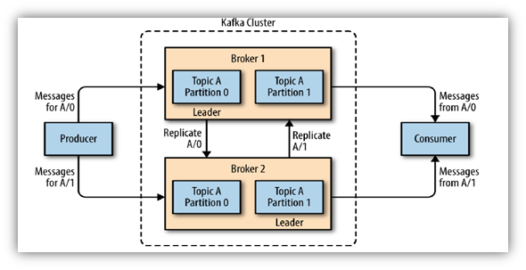

How Pub-Sub is Applied:

* Publishers (Producers): Applications, servers, or devices act as producers. They generate data streams that need to be distributed to interested consumers.
* Subscribers (Consumers): Consumers subscribe to specific topics or data streams they are interested in.
* Message Brokers (Kafka Brokers): Kafka brokers act as message brokers. Each topic in Kafka corresponds to a different data stream in the Pub-Sub model.
* Publishing Data Streams: A producer serves as a publisher when it creates a data stream (such as log entries or events). The data is published to a specific topic by the Kafka producer.
* Subscribing to Topics: Consumers subscribe to specific topics or data streams and they receive real-time updates related to those specific topics.
* Message Distribution: When new data is published for a specific topic, the Kafka broker distributes that data to all subscribers interested in that topic.
* Decoupling: Producers do not need to know who the consumers are. Consumers do not need to be aware of the identities of the producers or other consumers.

Advantages:

* Scalability: Because of its distributed architecture, Kafka can scale horizontally to handle high throughput and massive data volumes.
* Durability: By storing data streams on disk, Kafka ensures data durability by preventing message loss in the case of failures.
* Real-Time Stream Processing: Real-time stream processing is supported by Kafka, allowing users to evaluate and respond to data as it comes in.
* Fault Tolerance: Kafka's replication mechanism maintains multiple copies of data across broker nodes, thereby providing fault tolerance.