SE 212- HUMAN COMPUTER INTERACTION (2025-2026 – SPRING)
TERM PROJECT
Value Proposition & Competitive Analysis
Why would users prefer our platform over many available free AI options?
The core reason lies in the human factor. In today's fast-paced world, people want a quick way to order food, but with high inflation rates, constantly ordering takeout is not budget-friendly. Furthermore, when looking for a recipe, users do not want to sit through long tips or exhausting video tutorials. Our platform addresses this by utilizing AI to deliver concise, straightforward, and bite-sized recipe steps.
When you consider the average 1.5-hour delay for food delivery and arrival times, users can instead order the raw ingredients, receive them, and cook the meal themselves in the exact same timeframe—but at a fraction of the cost. By directly optimizing for the user's patience, time, and budget constraints, we have designed a UI/UX layout that strictly aligns with Human-Computer Interaction (HCI) principles.
Although prominent existing competitors like Yemeksepeti and Migros offer grocery and ordering features, our solution stands out through our dedicated "My Recipes" screen. This allows users to seamlessly save, store, and access their favorite AI-generated recipes at any time, preventing dead-ends and providing a highly personalized interactive experience.
ELİF
• FR1: The system shall allow users to interact with a dynamic servings counter on the "Recipe Details" screen to scale the portion size up or down based on their needs.
• FR2: The system shall utilize an artificial intelligence infrastructure to cross-check recipe components against user inventory, dynamically determining missing ingredients.
• FR3: The system shall provide an "AI Feature Button" (Check Missing Ingredients & Add to Cart with AI) that automatically transfers all missing ingredients into the shopping basket with a single click.
• FR4: The system shall provide a unified basket screen (My Cart) where users can manually modify product quantities or copletely remove items before checkout
• FR5: The system shall display a profile management screen allowing users to dynamically edit, save and update their personal details such as name, surname address, e-mail and password.

PELİN
• FR-1: The alternative home page (Version B) shall display a promotional coupon pop-up, and users must be able to close this overlay instantly by clicking an "X" button to continue browsing.
• FR-2: The login screen shall include email and password entry fields, with an eye icon toggle that allows users to show or hide their password characters.
• FR-3: The AI Smart Cart screen shall automatically check the recipe requirements against the user's pantry and list only the missing ingredients instead of showing the whole recipe list.
• FR-4: On the shipment details page, the order summary card (item prices, delivery fee, and final total) shall update in real-time while the user is typing their delivery address.
• FR-5: The system shall mark all mandatory input fields in the shipping and payment forms with a red asterisk (*) and prevent form submission if any required field is left empty.
• FR-6: Right after a successful payment, the system shall display an "Order Confirmed" success page that contains a direct tracking button for the user to follow their delivery status.

MERVE
- FR-1: The system shall provide a main web landing dashboard displaying categorized grocery grid cards (e.g., Fruits & Vegetables, Bakery & Bread) and a global search bar to allow easy product filtering.
- FR-2: The system shall allow unauthenticated web visitors to select a "Continue as a guest" option on the gateway entry screen to browse recipes and products without creating an account.
- FR-3: The web sign-up and login forms shall integrate an interactive password visibility toggle tool (eye-icon) that lets users view or hide plain-text characters to prevent entry mistakes.
- FR-4: During the account creation process, the system shall show a multi-box verification layer and display a dynamic status alert message ("We're signing you up please wait!") while processing the confirmation code.
- FR-5: The system shall include an interactive "Recipe AI Page" containing a real-time assistance text box alongside an "Add to cart" button that automaticall

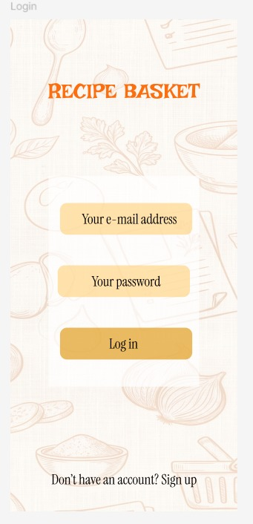

Page-1: Mobile Login Screen - ILGIN
Explanation: This screen represents the primary gateway for registered users to access the application. It features standard email and password input fields styled with consistent typography and clean placeholders to reduce user cognitive load. In accordance with the User Control and Freedom principle, a distinct navigation link ("Don't have an account? Sign up") is positioned at the bottom, allowing users to seamlessly transition to the registration state if they do not yet have an account

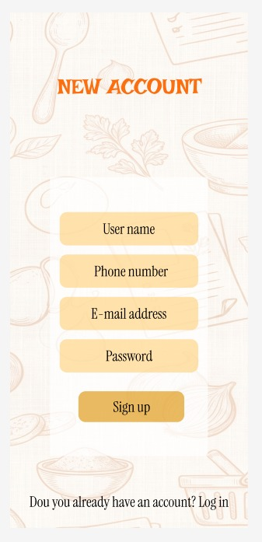

Page-2: Mobile Registration Screen - ILGIN
Explanation: This screen allows new users to create an account by gathering essential parameters: User Name, Phone Number, E-mail Address, and Password. To prevent interaction errors and guide the onboarding workflow, each text input field is clearly structured with explicit labeling. To prevent dead-ends and maintain user navigation freedom, a secondary redirect link ("Do you already have an account? Log in") is integrated at the base of the form layer

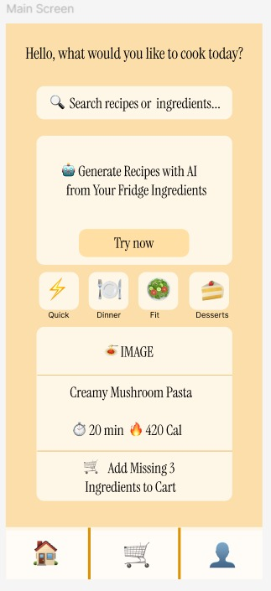
.

Page-3: Mobile Explore Screen - Version A (Main Layout) - ILGIN
Explanation: This screen serves as Version A of our mobile landing dashboard, designed explicitly as a layout alternative for group A/B split testing. It establishes an immediate cognitive hierarchy by securing the "Recipe Basket" search query bar at the absolute top of the viewport. To streamline thumb interaction, the major culinary categories (Quick, Dinner, Fit, Desserts) are structured as a vertical navigation column on the right border. The primary recipe cards dynamically communicate essential system status metrics—specifically preparation time (20 min) and total calories (420 Cal)—enabling users to make informed decisions rapidly.

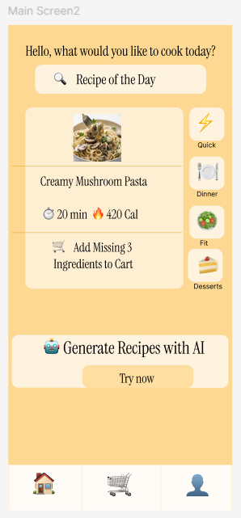
Page-4: Mobile Main Screen - Version B (Alternative Layout)-ELİF
Explanation: This screen represents the alternative dashboard (Version B) designed for A/B testing. It introduces a clear cognitive hierarchy by positioning the "Recipe of the Day" search bar at the absolute top for instant user engagement. Category tags are strategically laid out to optimize vertical scanning, and the "Generate Recipes with AI" action card is placed within the optimal thumb-zone to increase conversion rates through visual weight and prompt prominence.

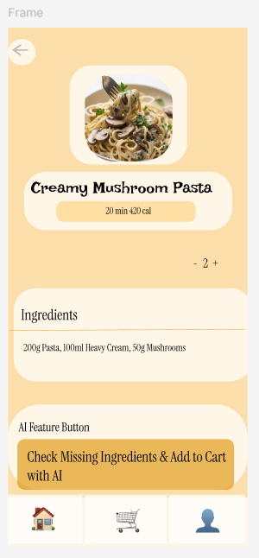

Page-5: Mobile Recipe Details & "Add to Cart with AI" Screen-ELİF
Explanation: This screen displays full recipe context, including cooking times and dynamic servings adjustment. It features an integrated smart panel where ingredient amounts dynamically adapt. To minimize interaction friction, the "Check Missing Ingredients & Add to Cart with AI" action button automatically isolates missing items and adds them straight to the user's basket, bypassing manual entry and enhancing user experience through smart automation.

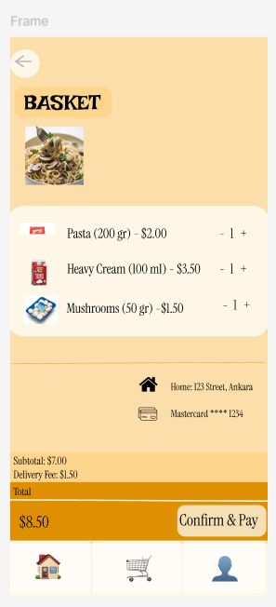

Page-6: Mobile Basket ("My Cart") & Checkout Interface-ELİF
Explanation: This screen represents the final touchpoint of the transaction workflow. It displays items cleanly categorized as a shopping list with individual price calculations. Users retain total control via standard incremental counter components (- 1 +). User profile data, active delivery addresses, and saved payment details are seamlessly integrated into a single interface layer to drastically speed up completion time and prevent cart abandonment.

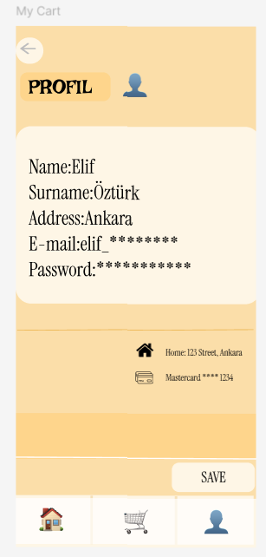

Page-7: User Profile Management Screen-ELİF
Explanation: This screen acts as a dedicated information terminal for user data management. It allows real-time input fields for editing Name, Surname, Address, E-mail, and Password strings. It provides explicit user control through a prominent "SAVE" button that securely updates systemic parameters while keeping navigation architecture consistent with the global bottom navigation layout.

https://www.figma.com/design/Y3NIso15BtQA7NPH3Bao98/Untitled--Copy-?node-id=0-1&t=geXK9XhRI7OjkfBp-0

Web Design

Page 1:MAIN PAGE -Merve

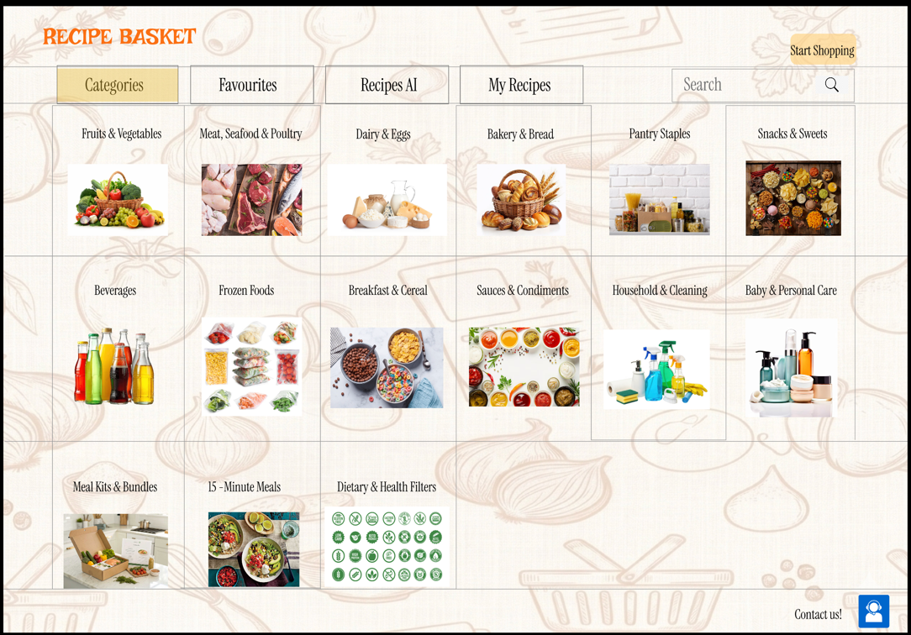

This screen serves as the primary desktop landing dashboard layout (Version A) for group A/B split testing. It establishes a clean grid system displaying major grocery and cooking categories alongside global search tools to minimize initial visual clutter and guide user choices.

Page 2:LOG IN/SIGN UP /CONTINUE AS A GUEST PAGE-Merve

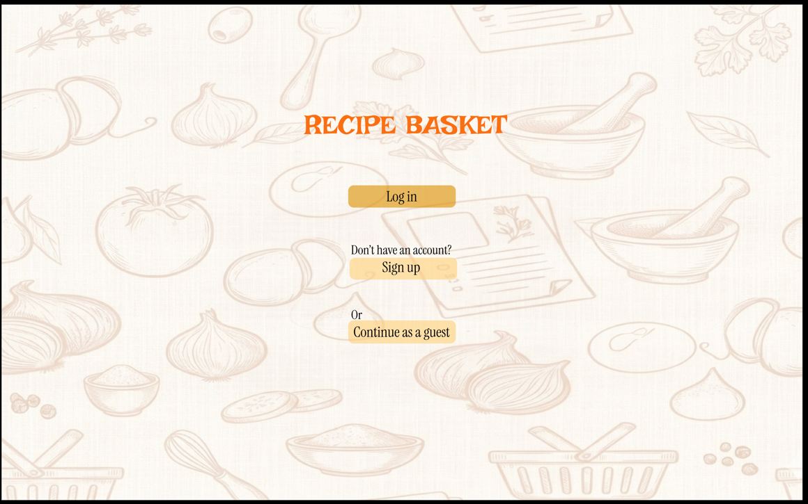

A dedicated gateway interface that provides clear split paths for user entry. It honors user control and freedom by presenting three direct choices—log in, create an account, or bypass entry rules entirely via a guest route

Page 3:SIGN UP PAGE -Merve

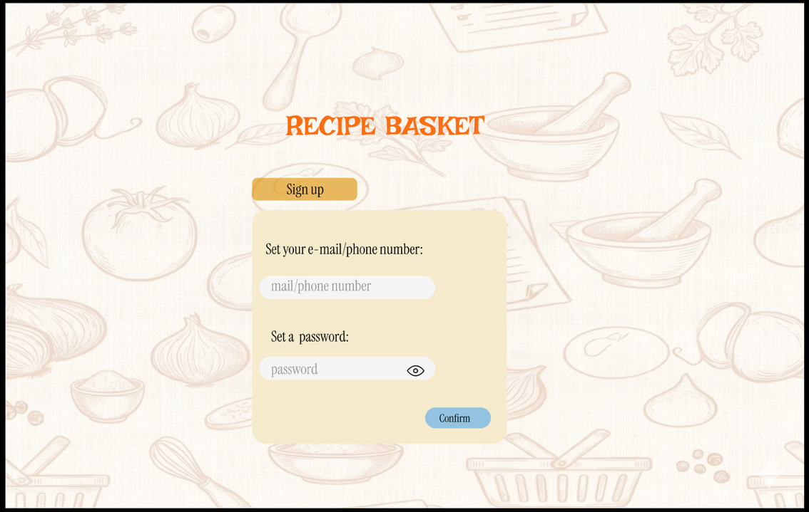

A minimalist onboarding account layout that gathers the user's phone or email info and password variables. It features clean input placeholder strings and includes an explicit visibility eye-icon toggle tool to prevent credential entry errors.

Page 4:LOG IN PAGE-Merve

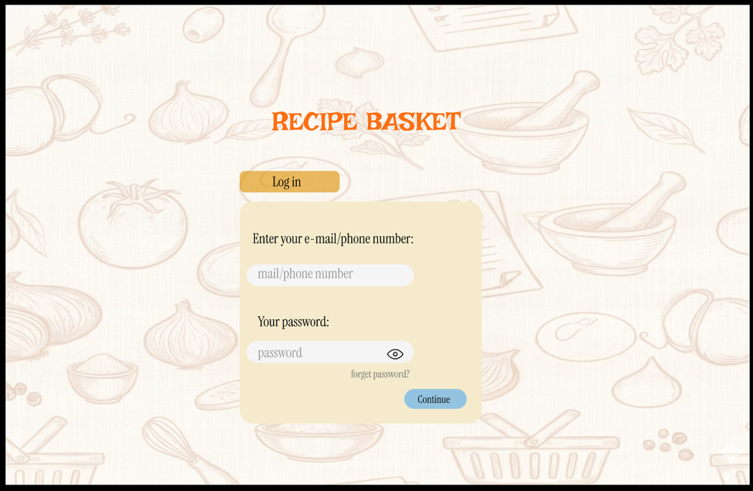
On this screen, the user simply has to log in by typing their registered e-mail address or phone number and their password into the input boxes before clicking the continue button.

Page 5:VERIFICATION PAGE-Merve

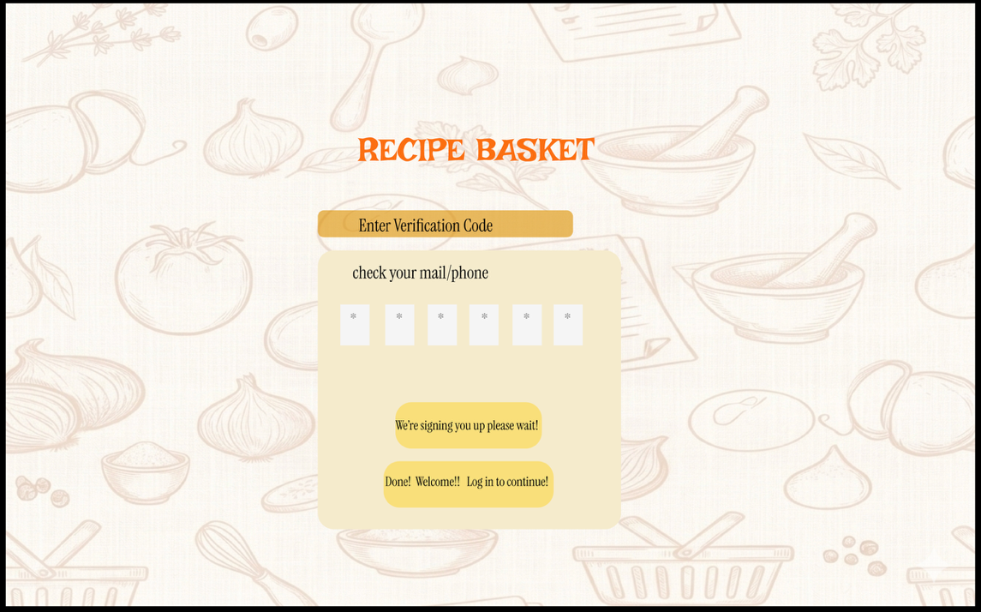

A multi-factor security interface layer featuring a discrete 5-digit verification block grid. It visually communicates system status with system messaging alerts beneath the form boxes, informing the user about the registration status.

Page 6: MAIN PAGE (WITH SHOPPING CART)-Merve 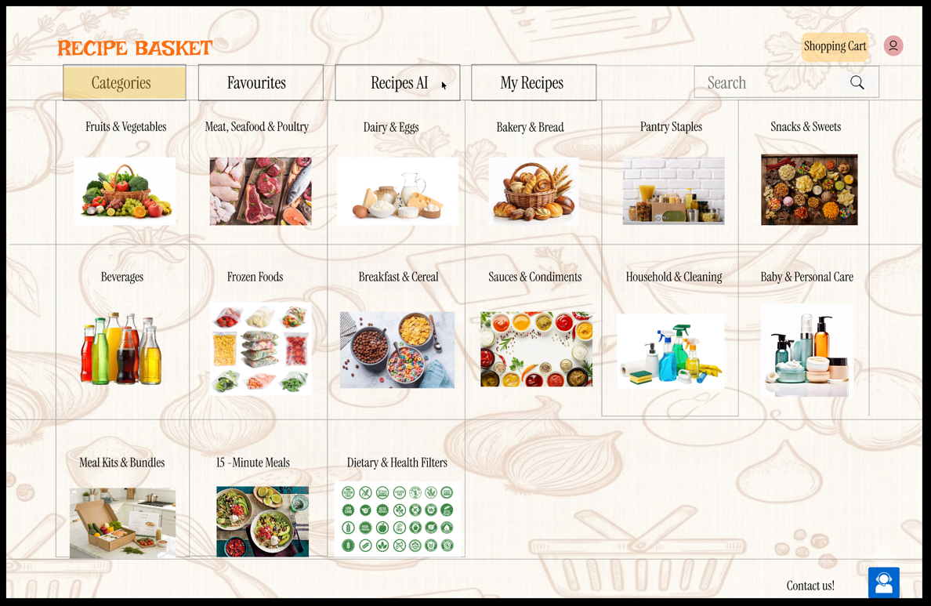

This screen updates the primary grid dashboard with an active global header button for tracking cart capacity. It acts as a clear visual indicator of system status, alerting users that items have been successfully updated in their order total.

Page 7: RECIPE AI PAGE -Merve 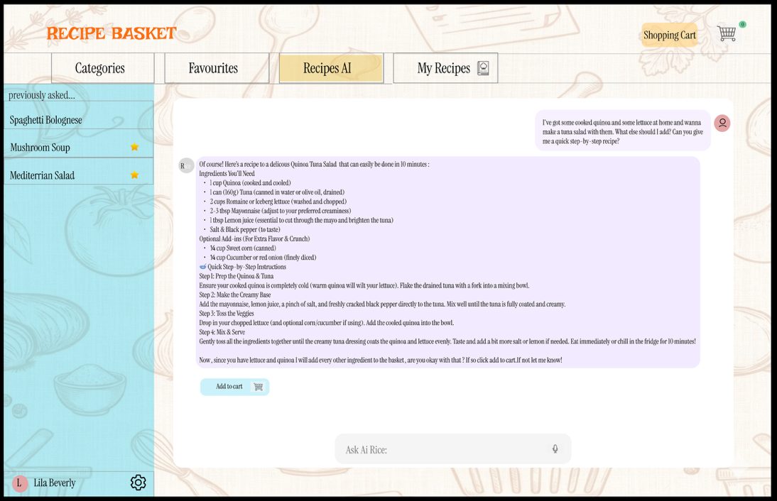

The primary interactive AI portal screen where culinary instructions are mapped onto the user's interface panel. It embeds an open chat modal for real-time conversational assistance alongside a prominent primary button to automatically transfer the ingredient manifest to the shopping list.

Page 8: AI SMART CHART SCREEN-PELİN

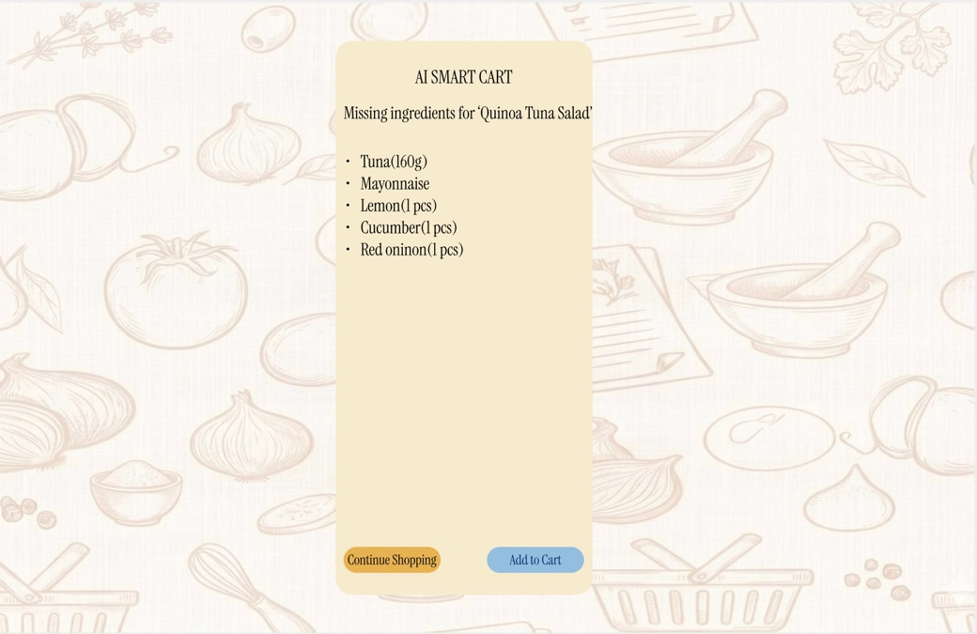
Explanation: This display surfaces immediately after the backend AI maps out a requested menu item (e.g., 'Quinoa Tuna Salad'). It handles inventory isolation by checking what raw materials are missing from the house. Rather than overwhelming the user, it lists only the missing pieces (Tuna, Mayonnaise, Lemon, Cucumber, Red Onion) with clear metrics. Users can easily choose to click the secondary "Continue Shopping" button or progress instantly via the primary blue "Add to Cart" button.

Page 9: Shipment Details Page-PELİN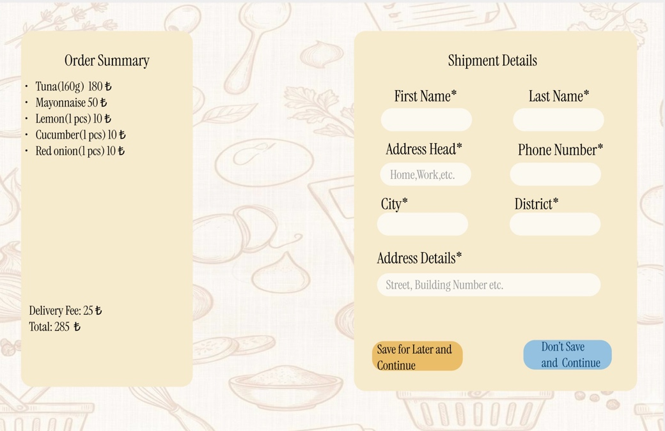
Explanation: A structured, two-column interface designed to reduce cognitive load during shipping input steps. The left card holds a permanent "Order Summary" that updates calculated prices and delivery fees in real-time, matching system status guidelines. The right column holds text fields with clear labels and explicit asterisks (*) denoting mandatory fields. This clarifies form requirements before the user clicks a button.

Page 10: Checkout Form-PELİN

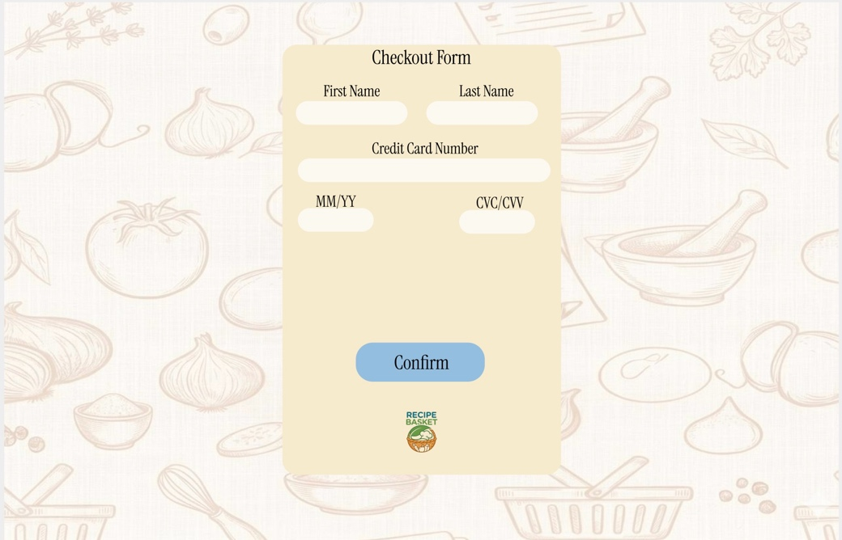
Explanation: The financial transaction screen designed to minimize visual clutter and keep user focus on the transaction. The center panel maps fields logically to mirror the visual layout of a physical credit card (First/Last Name, Card Number, MM/YY expiration, and a short CVC input block). A large, centrally located blue "Confirm" action button sits at the base of the card, providing a distinct target area that satisfies fast pointing physical user criteria.

Page 11: Order Confirmed Screen-PELİN

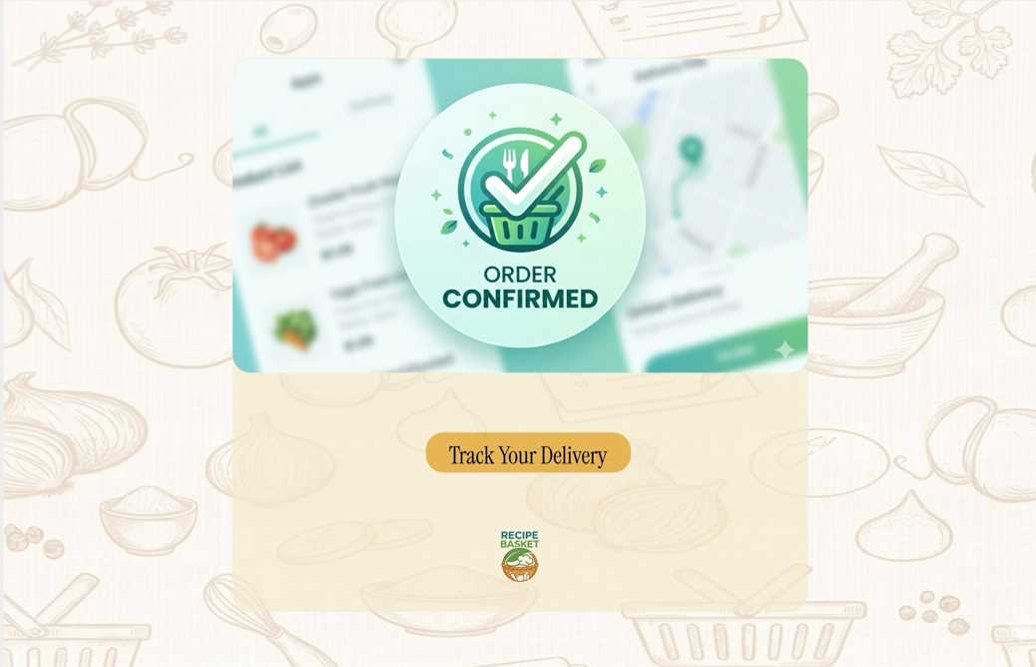
Explanation: The final confirmation status page that lets users know their order went through successfully. It utilizes a prominent, friendly green checkmark illustration stating "ORDER CONFIRMED" in clear typography. Directly underneath this modal layer, a high-contrast primary button labeled "Track Your Delivery" is provided so users can immediately move to real-time shipping tracking, providing a sense of completion.

Page 12: Home Page - Version B (Alternative Layout with Modal Overlay)-PELİN

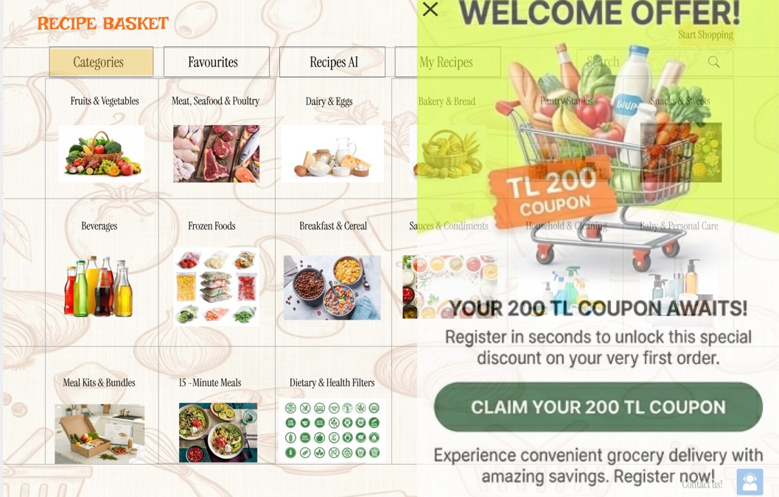
Explanation: This screen functions as our alternative main landing page designed directly for A/B split testing. In contrast to Merve's design, the purpose of this page is to encourage users to sign up and turn into repeat customers by providing an exclusive first-purchase discount coupon with their membershi
https://www.figma.com/design/UEKifUF4VMKT1VOkdTmzNw/Recipe-Basket--website?node-id=0-1&t=dGomfNLDRWvKRcJJ-1
Principle | Mobile/Page Title | Web/Page Title | Student/Name
Visibility of System Status | Recipe Details (Servings counter updating dynamically) |  | Elif
User Control and Freedom | My Cart (Allowing quantity change and item removal) |  | Elif
Aesthetic-Usability Effect | My Cart (Allowing quantity change and item removal) |  | Elif
Flexibility and Efficiency of Use | Recipe Details (AI button accelerating the shopping process) |  | Elif
Consistency and Standards | Main Screen - Version B (Standard bottom navigation bar placement) |  | Elif
Visibility of System Status | Mobile Explore Screen - Version A (Recipe cards explicitly displaying active time and calorie metrics) |  | Ilgın
User Control and Freedom | Mobile Login & Registration Screens (Bi-directional text links preventing page dead-ends) |  | Ilgın
Aesthetic-Usability Effect | Mobile Explore Screen - Version A (Thematic, minimalist warm background illustrations optimizing perceived task flow) |  | Ilgın
Visibility of System Status |  | Shipment Details (Live order summary updating prices in real-time) | Pelin
User Control and Freedom |  | Home Page - Version B (Dismissible promo modal with clear 'X' exit button) | Pelin
Aesthetic-Usability Effect |  | Order Confirmed (Clean layout with a friendly, minimalist success illustration) | Pelin
Error Prevention |  | AI Smart Cart (Isolating only missing ingredients to bypass manual browsing) | Pelin
Aesthetic-Usability Effect |  | Main Page (Clean grid system with warm background illustrations) | Merve
User Control and Freedom |  | Log In / Sign Up / Continue as a Guest Page (Allowing guest access to bypass registration) | Merve
Error Prevention |  | Sign Up Page (Eye icon password toggle to prevent entry mistakes) | Merve
Visibility of System Status |  | Sign Up Page (Eye icon password toggle to prevent entry mistakes) | Merve
Flexibility and Efficiency of Use |  | Recipe AI Page (Direct open chat modal and automated "Add to cart" button to save time) | Merve

APPENDIX:
USER 1(-ELİF)
- User Name/ID: User 1 (Ahmet Kutay Varol)
- Demographics: 23 years old, University Student, orders groceries online twice a week.
- Start time: 14:15:00
- End time: 14:16:32 (Total Time: 92 seconds)
Task | Notes | +/-
Task 1: Navigate to Main Screen Version B, find the Creamy Mushroom Pasta card, and open its details page. | The user instantly noticed the search bar at the top and clicked the pasta item smoothly. Execution time: 18 seconds. | +
Task 2: On the recipe details screen, use the smart AI button to automatically detect missing ingredients and add them to your cart. | The user hesitated for 3 seconds trying to read the text on the button, then clicked it. The system successfully transitioned to the cart. Execution time: 34 seconds. | +
Task 3: Go to your basket, modify an ingredient quantity to 2, verify your address, and trigger the final "Confirm & Pay" button. | The user easily interacted with the - 1 + counter component to double the pasta amount. Directly clicked the checkout button since address info was saved. Execution time: 40 seconds. | +

How User 1's SUS Score is Calculated:
- For odd-numbered questions (1, 3, 5, 7, 9): Subtract 1 from the user's score. $(5-1) + (4-1) + (5-1) + (4-1) + (5-1) = 4 + 3 + 4 + 3 + 4 = 18$
- For even-numbered questions (2, 4, 6, 8, 10): Subtract the user's score from 5. $(5-1) + (5-1) + (5-2) + (5-1) + (5-2) = 4 + 4 + 3 + 4 + 3 = 18$
- Total Calculation: Multiply the sum of the converted scores $(18 + 18 = 36)$ by $2.5$. $36 \times 2.5 = \mathbf{90}$

- System Usability Scale (SUS)
System Usability Scale (SUS) - User 1 Evaluation | Strongly Disagree (1) | Disagree (2) | Neutral (3) | Agree (4) | Strongly Agree (5)
1. I think that I would like to use this system frequently. |  |  |  |  | X
2. I found the system unnecessarily complex. | X
3. I thought the system was easy to use. |  |  |  | X
4. I think that I would need the support of a technical person to be able to use this system. | X
5. I found the various functions in this system were well integrated. |  |  |  |  | X
6. I thought there was too much inconsistency in this system. |  | X
7. I would imagine that most people would learn to use this system very quickly. |  |  |  | X
8. I found the system very cumbersome to use. | X
9. I felt very confident using the system. |  |  |  |  | X
10. I needed to learn a lot of things before I could get going with this system. |  | X
AVERAGE: |  |  |  |  | 90/100

User Feedback Summary: User 1 stated that the automated missing ingredient detection feature powered by AI drastically reduces the time spent checking the kitchen inventory manually. The centralized "My Cart" approach was highly appreciated because it skipped typical step-by-step navigation checkout screens.

USER 2-(PELİN)

- User Name/ID: User 2 (Çağlanur Kaya)
- Demographics: 20 years old, University Student, orders groceries online 4 per week.
- Start time: 13:15:00
- End time: 13:15:35 (Total Time: 35 seconds)
Task | Notes | +/-
Task 1: Pass through the alternative landing display interface to access active categories. | The user instantly noticed the close button (X) and click it. Execution time: 5 seconds. | +
Task 2: Add AI-recommended missing ingredients to the cart, view the cart, and proceed to checkout | The user clicked the 'Recipes AI' button on the homepage to open the page, pressed the 'Add to Cart' button to view the cart, and continued to the payment step. Execution time: 23 seconds. | +
Task 3: The user also adds other products to the AI Smart Cart, which displays the items recommended by the artificial intelligence | The user easily noticed the 'Continue Shopping' button on the AI Smart Cart screen and returned to the categories page to add other products to their cart. Execution time: 6 seconds. | +

System Usability Scale (SUS) - User 2 Evaluation | Strongly Disagree (1) | Disagree (2) | Neutral (3) | Agree (4) | Strongly Agree (5)
1. I think that I would like to use this system frequently. |  |  |  |  | x
2. I found the system unnecessarily complex. | x
3. I thought the system was easy to use. |  |  |  | x
4. I think that I would need the support of a technical person to be able to use this system. |  | x
5. I found the various functions in this system were well integrated. |  |  |  | x
6. I thought there was too much inconsistency in this system. |  | X
7. I would imagine that most people would learn to use this system very quickly. |  |  |  | X
8. I found the system very cumbersome to use. |  | x
9. I felt very confident using the system. |  |  |  |  | X
10. I needed to learn a lot of things before I could get going with this system. | x
AVERAGE: |  |  |  |  | 85/100

User Feedback Summary: User 2 found the overall interface highly intuitive and explicitly highlighted that the system does not require any prior technical knowledge or learning curve. The user stated that the high integration between the recipe suggestion screen and the immediate checkout function makes the shopping journey very smooth. Additionally, they noted that the layout feels consistent across different steps, which gave them strong confidence while navigating through the payment and address forms.

USER 3-PELİN
- User Name/ID: User 3 (Ege Çelikcan)
- Demographics: 23 years old, Machine Engineer, orders groceries online 3 per week.
- Start time: 16:02:00
- End time: 16:02:18 (Total Time: 18 seconds)
Task | Notes | +/-
Task 1: Pass through the alternative landing display interface to access active categories. | Skips any introductory animations or marketing copy on the alternative landing display immediately and clicks the primary navigation element to land on the categories screen.. Execution time: 4 seconds. | +
Task 2: Add AI-recommended missing ingredients to the cart, view the cart, and proceed to checkout | Uses a "bulk add" mental model without reading individual AI recommendations, instantly triggers the cart preview, and rapidly clicks through to checkout. Execution time: 10 seconds. | +
Task 3: The user also adds other products to the AI Smart Cart, which displays the items recommended by the artificial intelligence | Immediately spots the "Continue Shopping" button due to its standard UX positioning and clicks it to jump back to categories instead of using the browser's back button. Execution time: 4 seconds. | +

System Usability Scale (SUS) - User 3 Evaluation | Strongly Disagree (1) | Disagree (2) | Neutral (3) | Agree (4) | Strongly Agree (5)
1. I think that I would like to use this system frequently. |  |  |  | x
2. I found the system unnecessarily complex. | x
3. I thought the system was easy to use. |  |  |  | x
4. I think that I would need the support of a technical person to be able to use this system. |  | x
5. I found the various functions in this system were well integrated. |  |  | x
6. I thought there was too much inconsistency in this system. |  |  | x
7. I would imagine that most people would learn to use this system very quickly. |  |  | x
8. I found the system very cumbersome to use. |  | x
9. I felt very confident using the system. |  |  |  |  | X
10. I needed to learn a lot of things before I could get going with this system. | x
AVERAGE: |  |  |  |  | 75/100

User Feedback Summary: The user 3 mentioned that completing the grocery ordering process was very straightforward and easy. They noted that they would definitely use the platform for online grocery shopping purposes. However, they explicitly stated that because they do not know how to cook in real life, they probably will not use the AI recipe generation features very frequently
USER 4-MERVE
User Name/ID: User 4 (Azra Beren Berk)
Demographics: 21 years old, University Student, orders groceries online 3 times a week.
Start time: 16:10:00
End time: 16:11:45 (Total Time: 105 seconds)
Task | Notes | +/-
Task 1: On Web Home Page Version B, click the "Welcome Offer" 200 TL Coupon modal overlay to unlock the special discount and proceed to create a new user account. | The user read the overlay text, immediately clicked the primary "Claim Your 200 TL Coupon" button to claim the discount, and was successfully redirected to the registration flow. Execution time: 25 seconds. | +
Task 2: On the AI Smart Cart screen for the 'Quinoa Tuna Salad', verify the isolated missing ingredients list and click the primary button to push them all to your cart. | Scanned the listed missing ingredients (Tuna, Mayonnaise, Lemon, etc.) and seamlessly clicked the primary blue "Add to Cart" button at the bottom. Execution time: 35 seconds. | +
Task 3: Navigate to the Shipment Details Page and verify that the "Order Summary" card on the left side accurately calculates and updates the total delivery fee and prices in real-time. | The user focused on the left column interface, verified that the delivery fee (25 ₺) and final total (288 ₺) were dynamically visible on the card summary, and proceeded to complete the transaction workflow. Execution time: 45 seconds. | +

How User 4's SUS Score is Calculated:
For odd-numbered questions (1, 3, 5, 7, 9): Subtract 1 from the user's score.
(4−1)+(5−1)+(4−1)+(5−1)+(4−1)=3+4+3+4+3=17
For even-numbered questions (2, 4, 6, 8, 10): Subtract the user's score from 5.
(5−1)+(5−1)+(5−2)+(5−1)+(5−2)=4+4+3+4+3=18
Total Calculation: Multiply the sum of the converted scores (17+18=35) by 2.5.
35×2.5=87.5
System Usability Scale (SUS) - User 4 Evaluation | Strongly Disagree (1) | Disagree (2) | Neutral (3) | Agree (4) | Strongly Agree (5)
1. I think that I would like to use this system frequently. |  |  |  | X
2. I found the system unnecessarily complex. |  | X
3. I thought the system was easy to use. |  |  |  | X
4. I think that I would need the support of a technical person to be able to use this system. |  | X
5. I found the various functions in this system were well integrated. |  |  |  |  | X
6. I thought there was too much inconsistency in this system. |  | X
7. I would imagine that most people would learn to use this system very quickly. |  |  |  | X
8. I found the system very cumbersome to use. |  | X
9. I felt very confident using the system. |  |  |  |  | X
10. I needed to learn a lot of things before I could get going with this system. |  | X
AVERAGE: |  |  |  |  | 87.5/100

User Feedback Summary: User 4 highly praised the simplicity of the checkout flow, stating that omitting unnecessary middle-steps matches her quick-purchasing routine perfectly. She noted that the text labels on the AI buttons were very descriptive, which minimized any interactive guesswork

USER 5-MERVE
User Name/ID: User 5 (Can Demir)
Demographics: 24 years old, Graduate Student, frequently cooks at home and prefers using desktop browsers for online grocery shopping.
Start time: 16:10:00
End time: 16:11:45 (Total Time: 105 seconds)

Task | Notes | +/-
Task 1: On Web Home Page Version B, click the "Welcome Offer" 200 TL Coupon modal overlay to unlock the special discount and proceed to create a new user account. | The user read the overlay text, immediately clicked the primary "Claim Your 200 TL Coupon" button to claim the discount, and was successfully redirected to the registration flow. Execution time: 25 seconds. | +
Task 2: Navigate to the AI Smart Cart screen for the 'Quinoa Tuna Salad', verify the isolated missing ingredients list, and click the primary button to push them to your cart. | Scanned the listed missing ingredients (Tuna, Mayonnaise, Lemon, etc.) and seamlessly clicked the primary blue "Add to Cart" button at the bottom. Execution time: 35 seconds. | +
Task 3: Navigate to the Shipment Details Page and verify that the "Order Summary" card on the left side accurately calculates and updates the total delivery fee and prices in real-time. | The user focused on the left column interface, verified that the delivery fee (25 ₺) and final total (288 ₺) were dynamically visible on the card summary, and proceeded to complete the transaction workflow. Execution time: 45 seconds. | +
How User 5's SUS Score is Calculated:
For odd-numbered questions (1, 3, 5, 7, 9): Subtract 1 from the user's score.
(4−1)+(5−1)+(5−1)+(4−1)+(5−1)=3+4+4+3+4=18
For even-numbered questions (2, 4, 6, 8, 10): Subtract the user's score from 5.
(5−1)+(5−1)+(5−2)+(5−1)+(5−1)=4+4+3+4+4=19
Total Calculation: Multiply the sum of the converted scores (18+19=37) by 2.5.
37×2.5=95
System Usability Scale (SUS) - User 4 Evaluation | Strongly Disagree (1) | Disagree (2) | Neutral (3) | Agree (4) | Strongly Agree (5)
1. I think that I would like to use this system frequently. |  |  |  | X
2. I found the system unnecessarily complex. |  | X
3. I thought the system was easy to use. |  |  |  | X
4. I think that I would need the support of a technical person to be able to use this system. |  | X
5. I found the various functions in this system were well integrated. |  |  |  |  | X
6. I thought there was too much inconsistency in this system. |  | X
7. I would imagine that most people would learn to use this system very quickly. |  |  | X
8. I found the system very cumbersome to use. |  | X
9. I felt very confident using the system. |  |  |  |  | X
10. I needed to learn a lot of things before I could get going with this system. | X
AVERAGE: |  |  |  |  | 84.5/100

