Tic-Tac-Toe | Nguyen Van An – 10423004

Class Diagram
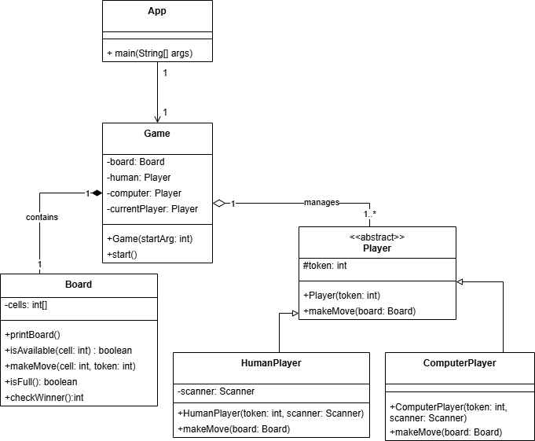

Activity Diagram
