Testing Your Code – Notes

Purpose of Testing
- Testing ensures your code works as expected for all intended inputs.
- Helps catch errors before users encounter them.
- Allows safe modification and expansion of code without breaking existing behavior.
- Every programmer makes mistakes → frequent testing is essential.

Chapter Focus:
- Test your code using tools in Python’s unittest module
- Build a test case and check that a set of inputs results in the output you want
- Observe what a passing / failing test looks like
- Learn how failing test can help improve your code
- Test functions and classes

Testing a Function

Example Function

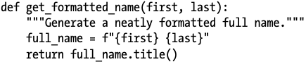

The function get_formatted_name() combines the first and last name with a space in between to complete a full name, and then capitalizes and returns the full name. To check that get_formatted_name() works, let’s make a program that uses this function. The program names.py lets users enter a first and last name, and see a neatly formatted full name:

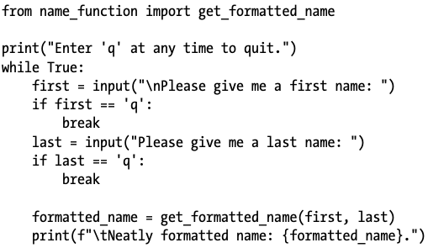

This program imports get_formatted_name() from name_function.py. The user can enter a series of first and last names, and see the formatted full names that are generated:

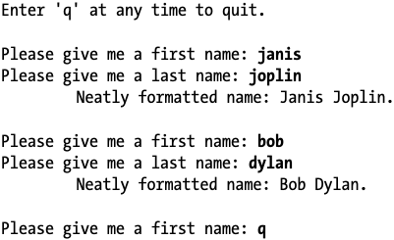

We can see that the names generated here are correct. But let’s say we want to modify get_formatted_name() so it can also handle middle names. As we do so, we want to make sure we don’t break the way the function handles names that have only a first and last name. We could test our code by running names.py and entering a name like Janis Joplin every time we modify get_formatted_name(), but that would become tedious. Fortunately, Python provides an efficient way to automate the testing of a function’s output. If we automate the testing of get_formatted_name(), we can always be confident that the function will work when given the kinds of names we’ve written tests for.

Unit Tests & Test Cases

The module unittest from the Python standard library provides tools for testing your code.
- A unit test verifies that one specific aspect of a function’s behavior is correct.
- A test case is a collection of unit tests that together prove that a function behaves as it’s supposed to, within the full range of situations you expect it to handle.

A good test case considers all the possible kinds of input a function could receive and includes tests to represent each of these situations. A test case with full coverage includes a full range of unit tests covering all the possible ways you can use a function. Achieving full coverage on a large project can be daunting. It’s often good enough to write tests for your code’s critical behaviors and then aim for full coverage only if the project starts to see widespread use.

Passing Test
Steps for writing a test case for a function:
- Import the unittest module and the function you want to test
- Create a class that inherits from unittest.TestCase
- Write a series of methods to test different aspects of the function’s behavior
- Use assert methods to verify results.
- Run with:
if __name__ == '__main__':
unittest.main()

Here’s a test case with one method that verifies that the function get_formatted_name() works correctly when given a first and last name:

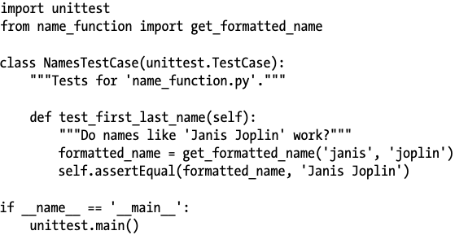

Step 1) First we import the unittest module and the function we want to test.

Step 2) Create class called NamesTestCase which contains a series of unit tests for get_formatted_name()

- The class must inherit from the class unittest.TestCase so python knows how to run the tests

Step 3) Write a series of methods:
NameTestCase contains a single method that tests one aspect of get_formatted_name()
test_first_last_name() verifies that names with only a first and last name are formatted correctly.
- Any method that starts with test_
will be run automatically when we run test_name_function.py (the file of the test)
- In the method test_first_last_name(self), we call the function we want to test
- We call get_formatted_name() with the arguments “janis” and “joplin” and assign the result formatted_name.

Step 4) We use the unittest most useful feature: an assert method

- The assert method verifies that a result you received matches the result you expect to receive.
- Because we know get_formatted_name() is supposed to return a capitalized, properly full name, we expect the value of formatted_name to be Janis Joplin.
- To check if this is TRUE, we use the unittest’s assertEqual() method and pass it formatted_name and “Janis Joplin”
- The line: self.assertEqual(formatted_name, “Janis Joplin”)
Says “compare the value in formatted_name to the string “Janis Joplin”.
If they are equal as expected, fine. But if they don’t match, LET ME KNOW!
Step 5) if __name__ == “__main__"

- We run this file directly, however many testing frameworks import your test files before running them.
- When a file is imported, the interpreter executes the file as it is being imported.
- The if block looks a special variable, __name__ which is set when the program is executed. If the file is being run as the main program, the value of __name__ is set to __main__
- In this case, we call unittest.main() which runs the test case.
- When a testing framework imports this file, the value of __name__ wont be __main__ and this block will not be executed.
When we run test_name_function.py, we get the following output:

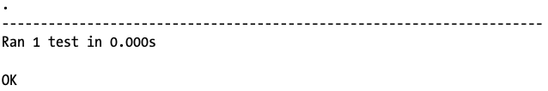

- The dot on the first line of the output tells us that a single test passed.
- The next line tells us that Python ran one test, and it took less than 0.001 seconds to run.
- The final OK tells us that all unit tests in the test case passed.

This output indicates that the function get_formatted_name() will always work for names that have a first and last name unless we modify the function. When we modify get_formatted_name(), we can run this test again, if the test case passes, we know the function will still work for names like Janis Joplin.
Assert Methods (Common Ones)
Method | Purpose
assertEqual(a, b) | a == b
assertNotEqual(a, b) | a != b
assertTrue(x) | x is True
assertFalse(x) | x is False
assertIn(item, list) | item in list
assertNotIn(item, list) | item not in list

Test Output Indicators
- . → Test passed
- E → Error occurred
- F → Failed assertion
- Summary shows:
  - Number of tests run
  - Time taken
  - Overall result (OK or FAILED)

Failing Tests
- Do NOT change the test (if it's correct).
- Fix the code that caused failure.
- Use error message + traceback to identify issue.
- Failed tests help pinpoint broken behavior quickly.

What does a failing test look like? Let’s modify get_formatted_name() so it can handle middle names, but we’ll do so in a way that breaks the function for names with just a first and last name, like Janis Joplin.

Here’s a new version of get_formatted_name() that requires a middle name argument:

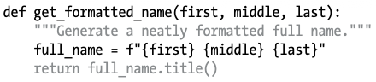

This version should work for people with middle names, but when we test it, we see that we’ve broken the function for people with just a first and last name. This time, running the file test_name_function.py gives this output:

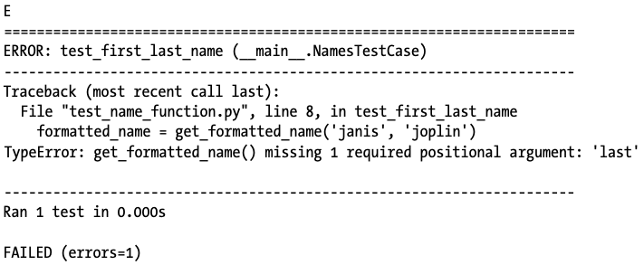

Error Messages
- The output ‘E’ tells us that one unit in the test case resulted in an error
- test_first_last_name() in NamesTestCase caused an error
- Traceback that reports that the function call get_formatted_name() no longer works
This is because it is missing 1 required positional argument
- We see that one unit test was run
- Message that the overall test case failed and that one error occurred when running the test case

Responding to a Failed Test
What do you do when a test fails? Assuming you’re checking the right conditions, a passing test means the function is behaving correctly and a failing test means there’s an error in the new code you wrote. So when a test fails, don’t change the test. Instead, fix the code that caused the test to fail. Examine the changes you just made to the function, and figure out how those changes broke the desired behavior.

In this case get_formatted_name() used to require only two parameters: a first name and a last name. Now it requires a first name, middle name, and last name. The addition of that mandatory middle name parameter broke the desired behavior of get_formatted_name(). The best option here is to make the middle name optional. Once we do, our test for names like Janis Joplin should pass again, and we should be able to accept middle names as well. Let’s modify get_formatted_name() so middle names are optional and then run the test case again. If it passes, we’ll move on to making sure the function handles middle names properly.

To make middle names optional, we move the parameter middle to the end of the parameter list in the function definition and give it an empty default value. We also add an if test that builds the full name properly, depending on whether or not a middle name is provided:

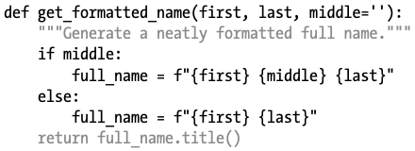

In this new version of get_formatted_name(), the middle name is optional. If a middle name is passed to the function, the full name will contain a first, middle, and last name. Otherwise, the full name will consist of just a first and last name. Now the function should work for both kinds of names.
To find out if the function still works for names like Janis Joplin, let’s run test_name_function.py again:

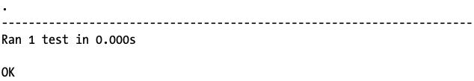

The test case passes now. This is ideal; it means the function works for names like Janis Joplin again without us having to test the function manually. Fixing our function was easy because the failed test helped us identify the new code that broke existing behavior.

Making Parameters Optional
When updating a function:
Broken Version (requires middle name):
def get_formatted_name(first, middle, last):
Fixed Version (optional middle name):
def get_formatted_name(first, last, middle=''):
if middle:
full_name = f"{first} {middle} {last}"
else:
full_name = f"{first} {last}"
return full_name.title()

Adding Additional Tests
- Add more methods beginning with test_.
- Use descriptive names.
- Each test should verify one behavior.

Now that we know get_formatted_name() works for simple names again, let’s write a second test for people who include a middle name. We do this by adding another method to the class NamesTestCase:

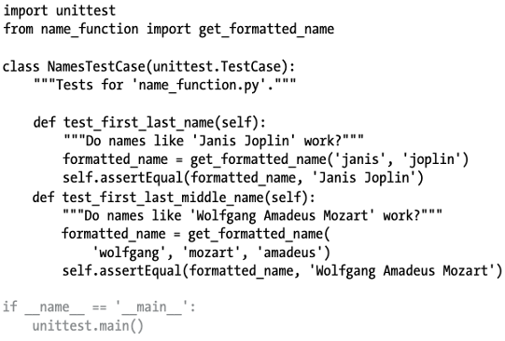

We name this new method test_first_last_middle_name(). The method name must start with test_ so the method runs automatically when we run test_name_function.py. We name the method to make it clear which behavior of get_formatted_name() we’re testing. As a result, if the test fails, we know right away what kinds of names are affected. It’s fine to have long method names in your TestCase classes. They need to be descriptive so you can make sense of the output when your tests fail, and because Python calls them automatically, you’ll never have to write code that calls these methods.

To test the function, we call get_formatted_name() with a first, last, and middle name u, and then we use assertEqual() to check that the returned full name matches the full name (first, middle, and last) that we expect. When we run test_name_function.py again, both tests pass:

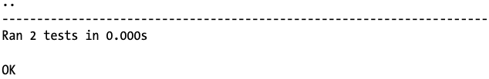

Testing a Class
Testing classes focuses on testing methods and object behavior.

A Variety of Assert Methods
Python has a number of assert methods in the unittest.TestCase class.

Python assert methods test whether a condition you believe is true at a specific point in your code is indeed true. If the condition is true as expected, your assumption about how that part of your program behaves is confirmed; you can be confident that no errors exist. If the condition you assume is true is actually not true, Python raises an exception.

Method | Purpose
assertEqual(a, b) | a == b
assertNotEqual(a, b) | a != b
assertTrue(x) | x is True
assertFalse(x) | x is False
assertIn(item, list) | item in list
assertNotIn(item, list) | item not in list

A Class to Test
Testing a class is similar to testing a function—much of your work involves testing the behavior of the methods in the class. But there are a few differences, so let’s write a class to test. Consider a class that helps administer anonymous surveys:

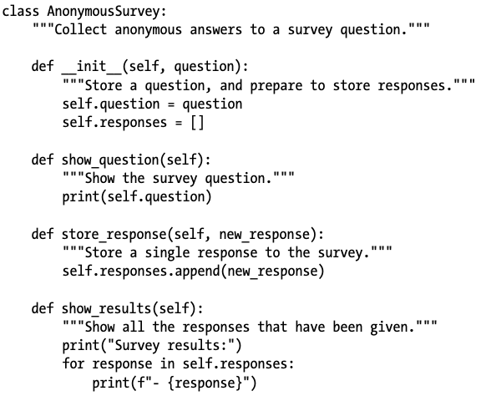

This class starts with a survey question that you provide and includes an empty list to store responses. The class has methods to print the survey question, add a new response to the response list, and print all the responses stored in the list. To create an instance from this class, all you have to provide is a question. Once you have an instance representing a particular survey, you display the survey question with show_question(), store a response using store_response(), and show results with show_results().

To show that the AnonymousSurvey class works, let’s write a program that uses the class:

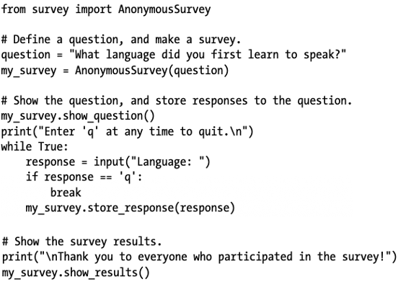

This program defines a question ("What language did you first learn to speak?") and creates an AnonymousSurvey object with that question. The program calls show_question() to display the question and then prompts for responses. Each response is stored as it is received. When all responses have been entered (the user inputs q to quit), show_results() prints the survey results:

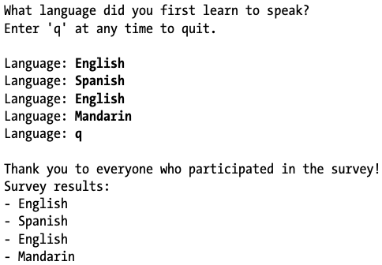

This class works for a simple anonymous survey. But let’s say we want to improve AnonymousSurvey and the module it’s in, survey. We could allow each user to enter more than one response. We could write a method to list only unique responses and to report how many times each response was given. We could write another class to manage nonanonymous surveys.

Implementing such changes would risk affecting the current behavior of the class AnonymousSurvey. For example, it’s possible that while trying to allow each user to enter multiple responses, we could accidentally change how single responses are handled. To ensure we don’t break existing behavior as we develop this module, we can write tests for the class

Testing the AnonymousSurvey Class

Let’s write a test that verifies one aspect of the way AnonymousSurvey behaves. We’ll write a test to verify that a single response to the survey question is stored properly. We’ll use the assertIn() method to verify that the response is in the list of responses after it’s been stored:

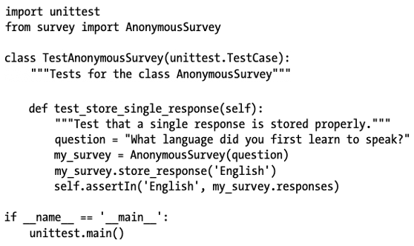

We start by importing the unittest module and the class we want to test, AnonymousSurvey. We call our test case TestAnonymousSurvey, which again inherits from unittest.TestCase. The first test method will verify that when we store a response to the survey question, the response ends up in the survey’s list of responses. A good descriptive name for this method is test_store_single_response(). If this test fails, we’ll know from the method name shown in the output of the failing test that there was a problem storing a single response to the survey.

To test the behavior of a class, we need to make an instance of the class. We create an instance called my_survey with the question "What language did you first learn to speak?" We store a single response, English, using the store_response() method. Then we verify that the response was stored correctly by asserting that English is in the list my_survey.responses.

When we run test_survey.py, the test passes:

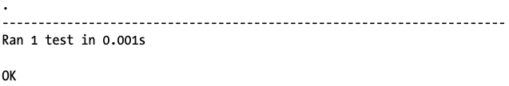

This is good, but a survey is useful only if it generates more than one response. Let’s verify that three responses can be stored correctly. To do this, we add another method to TestAnonymousSurvey:

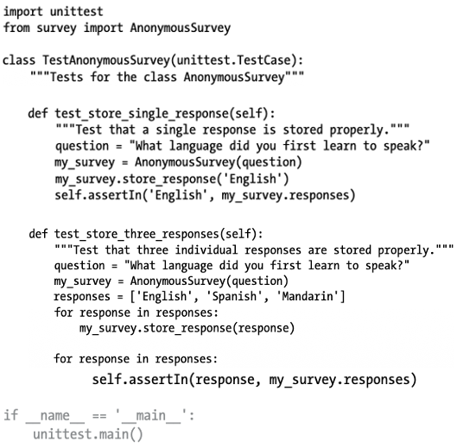

We call the new method test_store_three_responses(). We create a survey object just like we did in test_store_single_response(). We define a list containing three different responses, and then we call store_response() for each of these responses. Once the responses have been stored, we write another loop and assert that each response is now in my_survey.responses.

When we run test_survey.py again, both tests (for a single response and for three responses) pass:

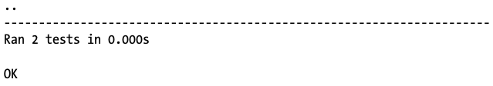

This works perfectly. However, these tests are a bit repetitive, so we’ll use another feature of unittest to make them more efficient.

The setUp() Method
In test_survey.py we created a new instance of AnonymousSurvey in each test method, and we created new responses in each method. The unittest.TestCase class has a setUp() method that allows you to create these objects once and then use them in each of your test methods. When you include a setUp() method in a TestCase class, Python runs the setUp() method before running each method starting with test_. Any objects created in the setUp() method are then available in each test method you write.

Let’s use setUp() to create a survey instance and a set of responses that can be used in test_store_single_response() and test_store_three_responses():

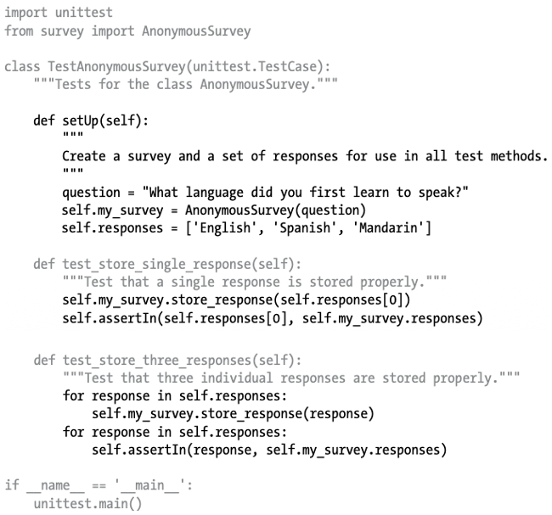

The method setUp() does two things: it creates a survey instance, and it creates a list of responses. Each of these is prefixed by self, so they can be used anywhere in the class. This makes the two test methods simpler, because neither one has to make a survey instance or a response. The method test_store_single_response() verifies that the first response in self.responses—self.responses[0]—can be stored correctly, and test_store _three_responses() verifies that all three responses in self.responses can be stored correctly.

When we run test_survey.py again, both tests still pass. These tests would be particularly useful when trying to expand AnonymousSurvey to handle multiple responses for each person. After modifying the code to accept multiple responses, you could run these tests and make sure you haven’t affected the ability to store a single response or a series of individual responses.

When you’re testing your own classes, the setUp() method can make your test methods easier to write. You make one set of instances and attributes in setUp() and then use these instances in all your test methods. This is much easier than making a new set of instances and attributes in each test method.

Example Class: AnonymousSurvey
class AnonymousSurvey:
def __init__(self, question):
self.question = question
self.responses = []
def store_response(self, new_response):
self.responses.append(new_response)

Testing a Class

Example Test
import unittest
from survey import AnonymousSurvey
class TestAnonymousSurvey(unittest.TestCase):
def test_store_single_response(self):
question = "What language did you first learn to speak?"
my_survey = AnonymousSurvey(question)
my_survey.store_response('English')
self.assertIn('English', my_survey.responses)

Testing Multiple Responses
def test_store_three_responses(self):
responses = ['English', 'Spanish', 'Mandarin']
for response in responses:
my_survey.store_response(response)
for response in responses:
self.assertIn(response, my_survey.responses)

Using setUp() Method

Purpose:
- Avoid repetitive code.
- Runs before each test method.
- Create shared test objects once.

Example:
def setUp(self):
question = "What language did you first learn to speak?"
self.my_survey = AnonymousSurvey(question)
self.responses = ['English', 'Spanish', 'Mandarin']
Benefits:
- Cleaner test methods.
- Reusable objects.
- Easier maintenance.

Best Practices
- Test critical behaviors first.
- Don’t aim for full coverage in early projects.
- Always test before and after modifying code.
- Never modify a correct test just to make it pass.
- Respond to failures immediately.

Why Testing Matters
- Increases confidence in code.
- Prevents breaking existing functionality.
- Makes collaboration easier.
- Required in professional/open-source projects.
- Easier to fix failures early than respond to user bug reports.

Key Takeaways
- Use unittest for automated testing.
- Each test method should check one behavior.
- Use assert methods to verify expectations.
- Use setUp() to simplify repetitive setup.
- Passing tests = confidence.
- Failing tests = valuable feedback.
- Testing becomes essential as projects grow.

