Set Solution Type

To set the Solution Type:

Select the menu item Maxwell 2D > Solution Type

Solution Type Window:

1.Geometry Mode: Cylindrical about Z

2.Choose Magnetic > Eddy Current

3.Click the OK button

To Assign Excitations

Select the object from history tree.

Select the menu item Maxwell 2D > Excitations > Assign > Current.

In Current Excitation window

Name: Current1

Value: 1 A

Type: Solid

Ref. Direction: Positive

Press OK

Note:

Choosing Solid specifies that the eddy effects in the coil will be considered. On the other hand, if stranded had been chosen, only the DC resistance would have been calculated and no AC effects in the coil would have been considered.

Assign Boundary

To Assign Boundary to Region Edges

Select the object Region from history tree.

Select the menu item Edit > Select > All Object Edges

Select the menu item Maxwell 2D > Boundaries > Assign > Balloon.

In Balloon Boundary window,

Press OK

Assign Matrix Parameters

To Calculate Impedance Matrix

Select the menu item Maxwell 2D > Parameters > Assign > Matrix.

In Matrix window,

For all current Sources

Include: ☑Checked

Press OK

AC Resistance Calculation

$$P_{copper}= I^{2}*R= J^{2}*A^{2}*ρ*\frac{l}{A}$$

$$P_{copper}= \iiint{\begin{aligned}J^{2}*ρ*dV=l*\iint{J^{2}*ρ*dS} \\ \end{aligned}}$$

$$R_{AC}=\frac{l}{I^{2}}* \iint{J^{2}*ρ*dS}$$

Observations:

* metin, yazı tipi, ekran görüntüsü, beyaz içeren bir resim

  Açıklama otomatik olarak oluşturuldumetin, yazı tipi, makbuz, beyaz içeren bir resim

  Açıklama otomatik olarak oluşturuldu First mistake done is to get the magnitude square of the current density. Accurate approach will be taking the dot product of the current density. Using Ansys documents, this is validated.
* If you add meshes while solving for high frequencies, you should be considering the skin effect. Select the mesh lengths according to the skin effect. Fout times smaller mashes are reasonable. You can use skin effect calculators.
* In the first try, resistance turn out to be very high like 100 ohms. Also, when the magnetic field distribution is observed, it is seen that almost all the B field is accumulated just near the circles and almost no field occurs inside the core. It seems that at high frequencies, as the m270 material has high bulk conductivity, effect of the eddy current increases significantly inside the core and reduces the resultant B field. To solve this issue, either the bulk conductivity of the material can be reduced to something like 1 or the material can be changed to ferrite whose bulk conductivity is very low compared to m270 steel. This increased the resistance drastically.
* Also do not make the excitation N*I because we calculate the resistance for all the turns individually.

Figure . Wrong simulation result (left) and a better simulation result (right)

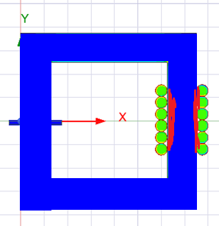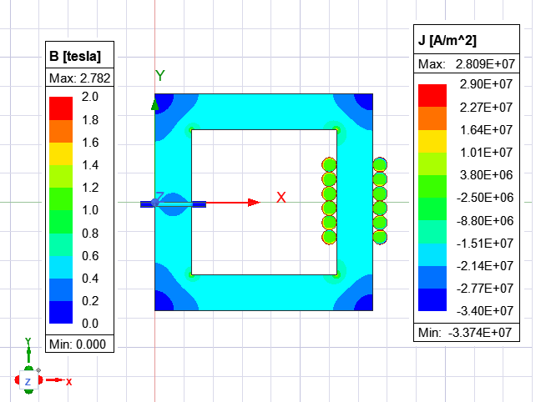

Results for current: 1.5 A

Scl : 0.00131874822715036

Scl : AC_resistance_12

Scl : 0.000690659152268625

Scl : AC_resistance_11

Scl : 0.000317450831802012

Scl : AC_resistance_10

Scl : 0.000320050466532963

Scl : AC_resistance_9

Scl : 0.000698344762843606

Scl : AC_resistance_8

Scl : 0.00132989124524067

Scl : AC_resistance_7

Scl : 0.000868399115552941

Scl : AC_resistance_6

Scl : 0.000543116457415936

Scl : AC_resistance_5

Scl : 0.000372301548702254

Scl : AC_resistance_4

Scl : 0.000349732959943301

Scl : AC_resistance_3

Scl : 0.000478015663844698

Scl : AC_resistance_2

Scl : 0.000774944987032423

Scl : AC_resistance_1