**Extra Information About The Project**

1. I used the chart shown below I found the internet to see the relations between tables, before starting the projet. <https://www.kaggle.com/rahullalu/hcdr-single-model-private-score-0-79167-catboost>

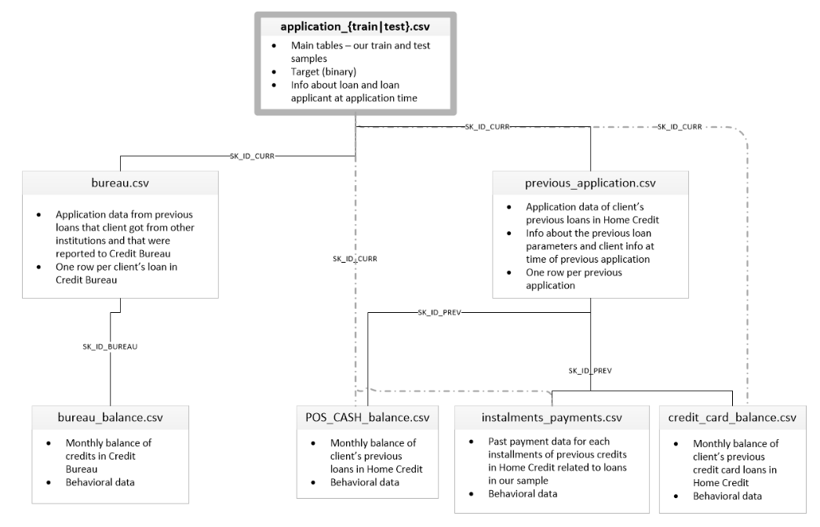

1. I used HomeCredit_columns_description file to understand the columns of each dataset. The description file is shown below

|  |  |  |  |
| --- | --- | --- | --- |
| **Table** | **Row** | **Description** | **Special** |
| application_{train|test}.csv | SK_ID_CURR | ID of loan in our sample |  |
| application_{train|test}.csv | TARGET | Target variable (1 - client with payment difficulties: he/she had late payment more than X days on at least one of the first Y installments of the loan in our sample, 0 - all other cases) |  |
| application_{train|test}.csv | NAME_CONTRACT_TYPE | Identification if loan is cash or revolving |  |
| application_{train|test}.csv | CODE_GENDER | Gender of the client |  |
| application_{train|test}.csv | FLAG_OWN_CAR | Flag if the client owns a car |  |
| application_{train|test}.csv | FLAG_OWN_REALTY | Flag if client owns a house or flat |  |
| application_{train|test}.csv | CNT_CHILDREN | Number of children the client has |  |
| application_{train|test}.csv | AMT_INCOME_TOTAL | Income of the client |  |
| application_{train|test}.csv | AMT_CREDIT | Credit amount of the loan |  |
| application_{train|test}.csv | AMT_ANNUITY | Loan annuity |  |
| application_{train|test}.csv | AMT_GOODS_PRICE | For consumer loans it is the price of the goods for which the loan is given |  |

1. I submitted my CatBoost predictions csv file. Score = 75.9%

CatBoost Score with 2000 iterations:

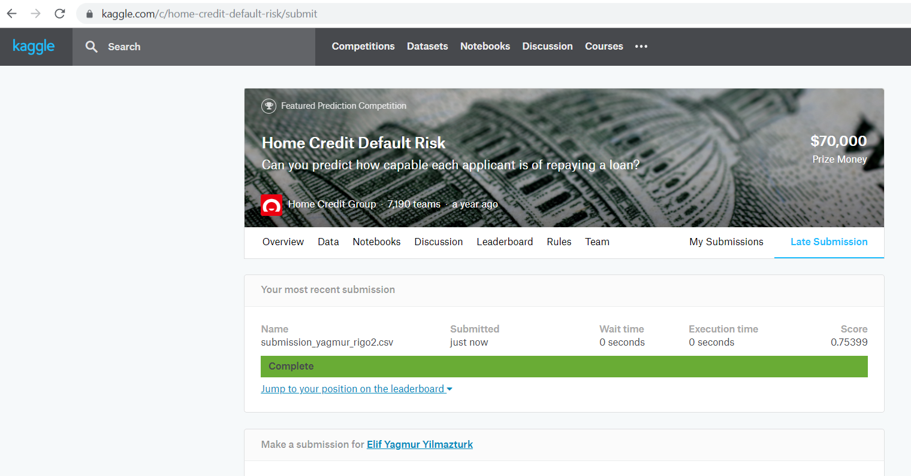

1. I submitted my Random Forest predictions csv file. Score = 66.6%

Random Forest Score:

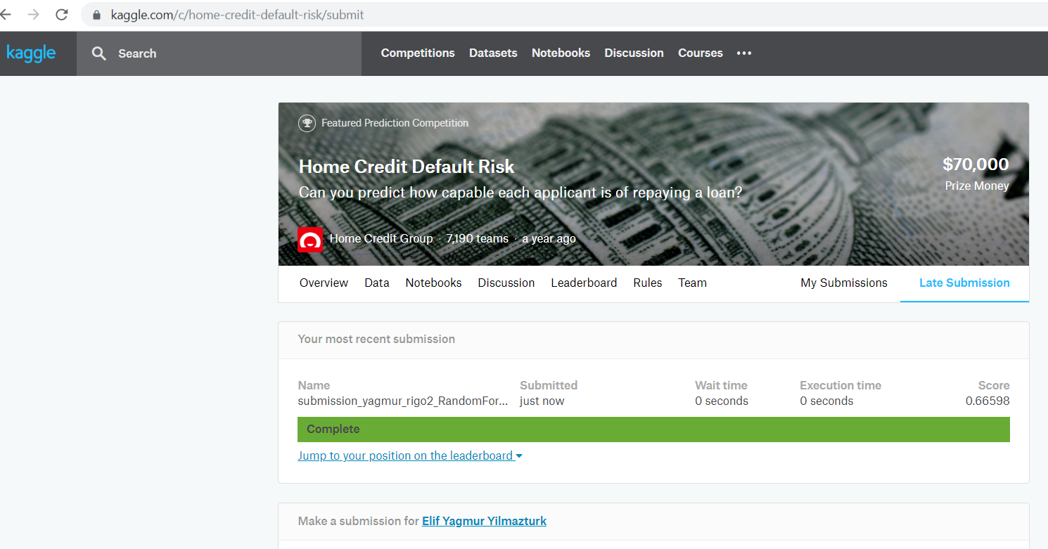

1. Things tat I would do if I had more time:

5.1) Examinig the all dataset if there are wrong entries.

5.2) Thinking of meaningful feature generation more deeply

5.3) Checking for outliers and deciding about removing them

5.4) Trying more ML algorithms with parameter tuning