1. Launch one ec2 using Amazon Linux 2 image and add script in user data to install Apache.

🡪cerate an instance

🡪systemctl status httpd

🡪public ip:80 (in your browser)

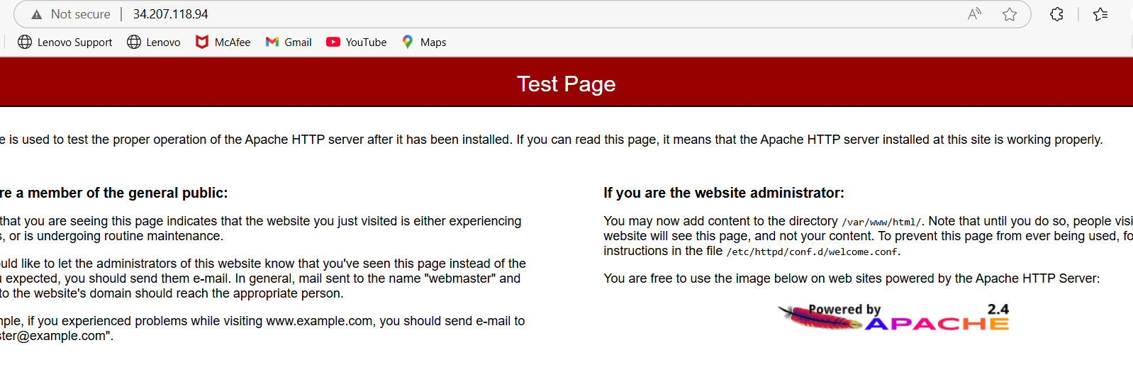

=====================

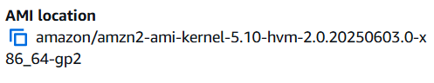

===========

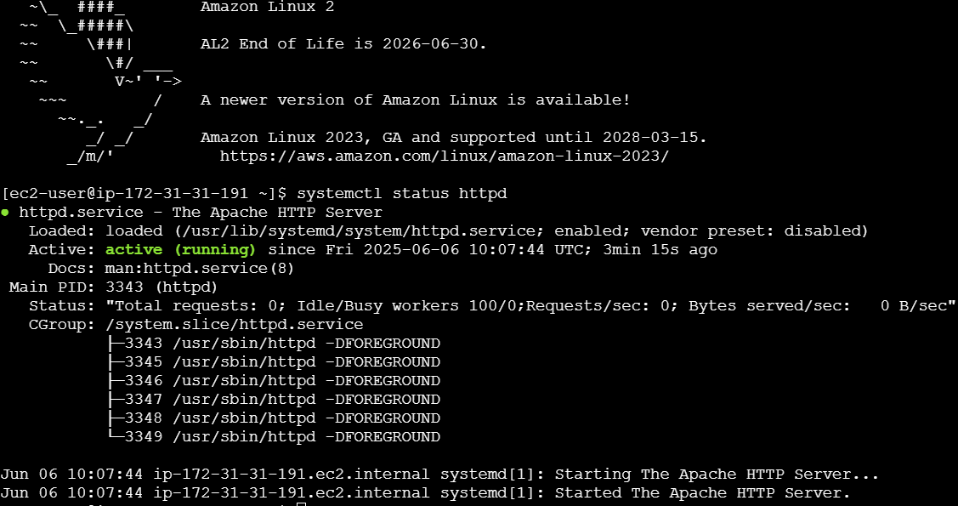

1. Launch one ec2 using Ubuntu image and add script in user data to install Nginx.

🡪create an instance then connect

🡪systemctl status nginx

🡪public ip:80 (in your browser)

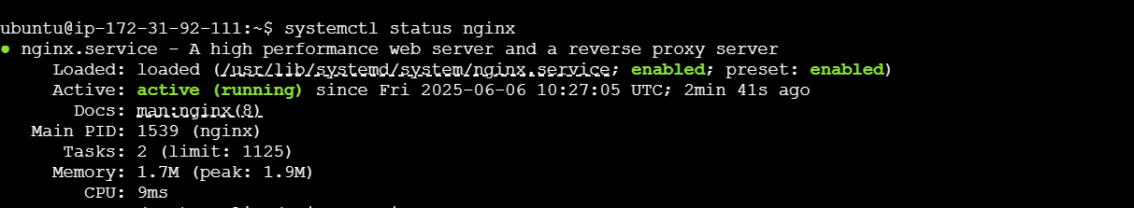

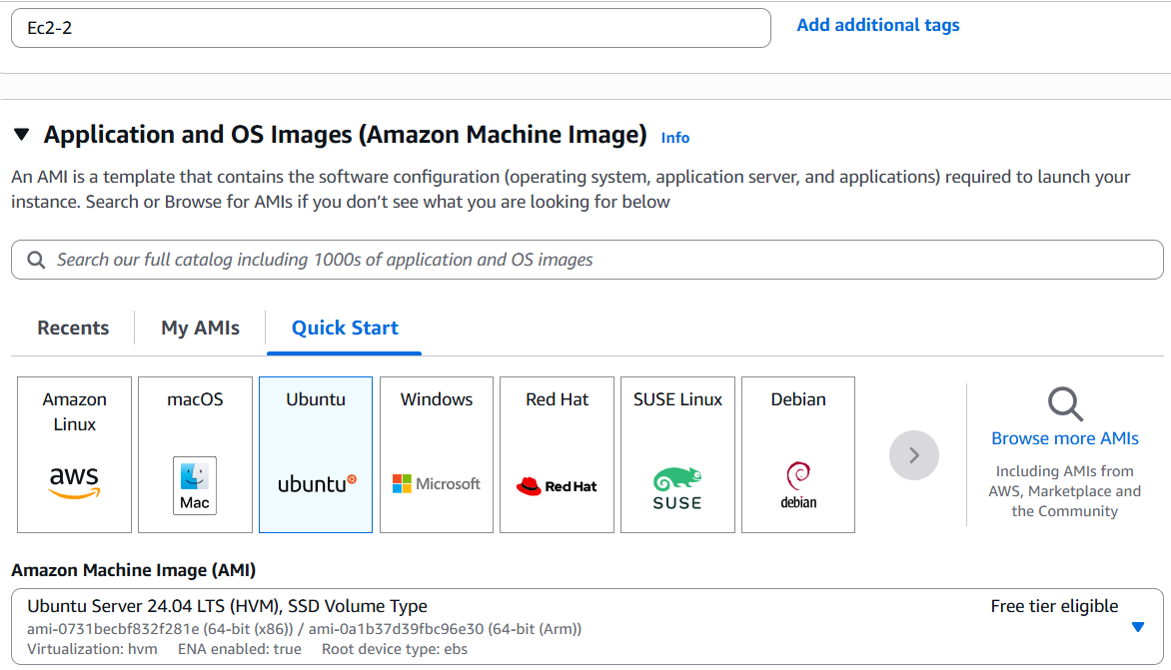

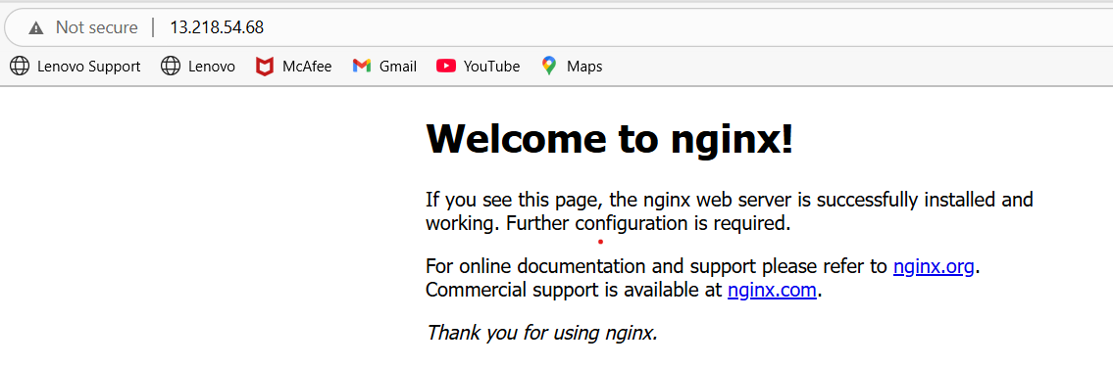

1. Launch one windows server and install tomcat in windows.

🡪launch one instance with Microsoft windows image

🡪hit connect button in this “**RDP client**”

🡪you can directly download remote system after this you have to paste the **pem** key to get the password and then connect to remote system by entering **username and password**

**🡪**then in remote system download apache and jdk apps. After installing apps

🡪in file manager app c\program files\apache foundation\bin\ hit startup

🡪now check in browser with Localhost:8080 (in remote system)

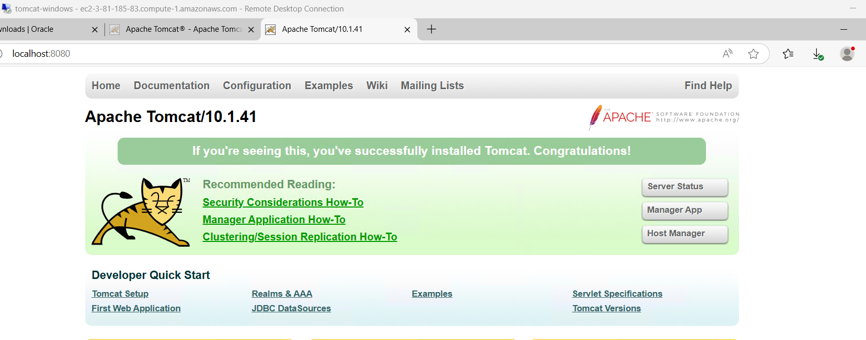

4) Take snapshot of the instance created in Task 1.

🡪click on Actions button

🡪click on create image and templates

🡪now create image 🡺 assign name

🡪then launch

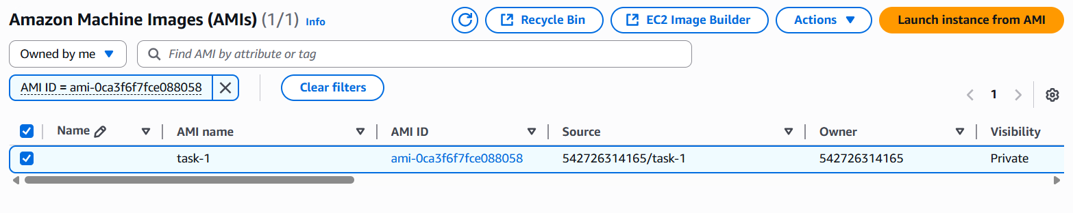

1. Assign password less authentication for ec2 created on Task 2.

🡪ssh-keygen

🡪cat /c/Users/elige/.ssh/id_rsa.pub

🡪 ssh -i linux-testing.pem ec2-user@35.172.213.134

🡪 [ec2-user@35.172.213.134](mailto:ec2-user@35.172.213.134)

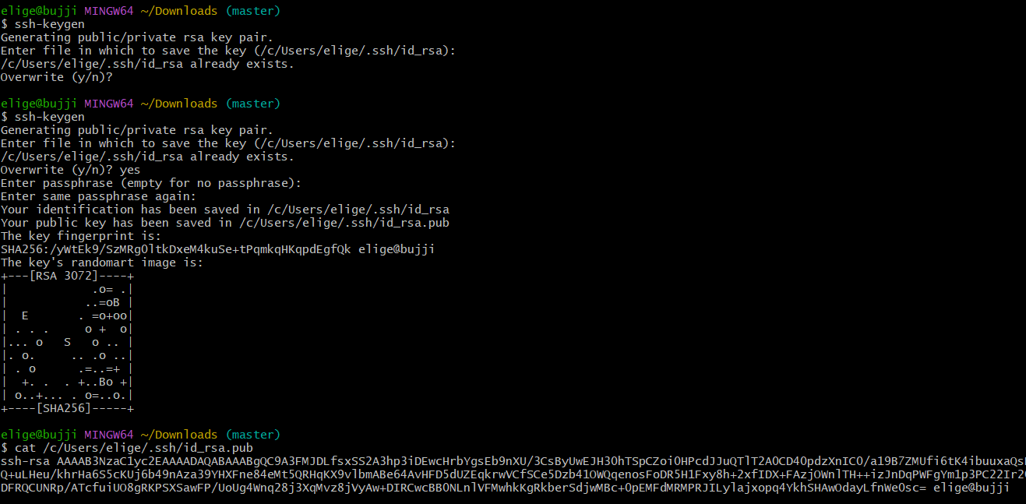

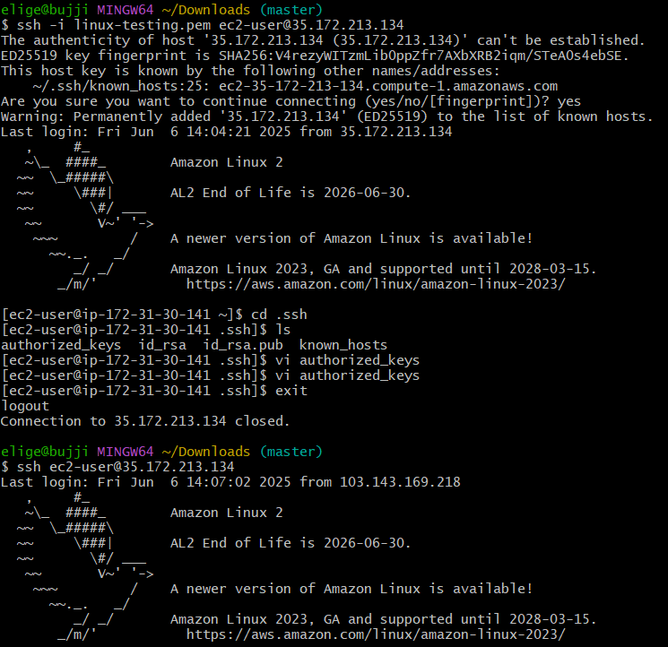

1. Launch any ec2 using spot purchasing option.

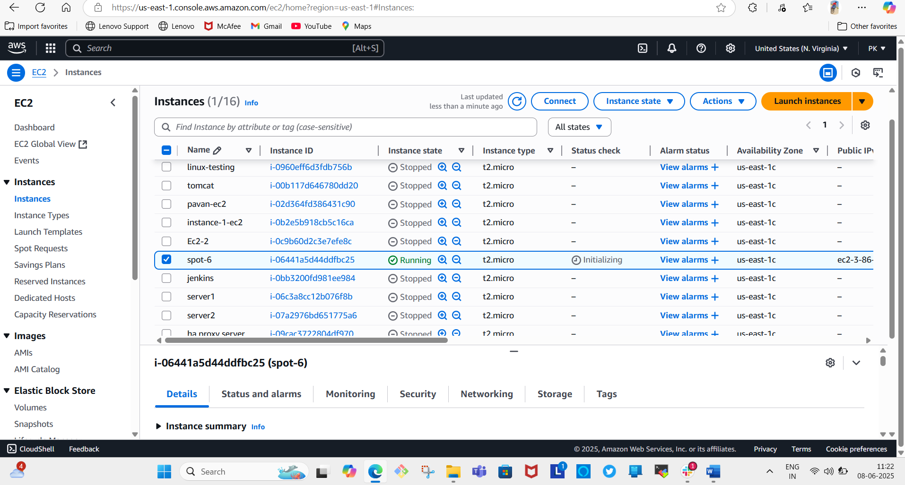

7) Enable Termination policy on ec2 created in Task 2.

🡪click on Actions then instance settings

🡪change termination settings

🡪tick the enable checkbox then hit save

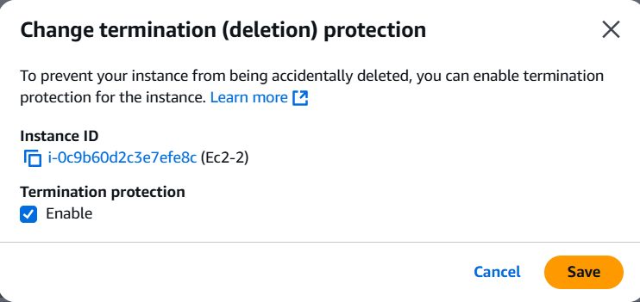

8) Launch one ec2 using Aws CLI.

aws ec2 run-instances \  
 --image-id ami-0e9bbd70d26d7cf4f \  
 --count 1 \  
 --instance-type t2.micro \

--key-name server1 \  
 --security-group-ids sg-0d028b0fe6bbad5fb \  
 --tag-specifications 'ResourceType=instance,Tags=[{Key=Name,Value=cli1}]’

