1. Create mariadb db on ec2.

🡪connect to ec2 server 🡪sudo -I 🡪 yum -y install mariadb-server wget

🡪systemctl enable mariadb 🡪systemctl start mariadb🡪systemctl status mariadb

🡪sudo mysql -u root -p—it will asks for password then password(new-one)

🡪CREATE DATABASE mariadb; 🡪 CREATE USER 'PAVAN'@'%' IDENTIFIED BY 'user1234';

🡪GRANT ALL PRIVILEGES ON mariadb.* TO 'PAVAN'@'%'; 🡪 FLUSH PRIVILEGES;

🡪exit; 🡪SHOW databases;

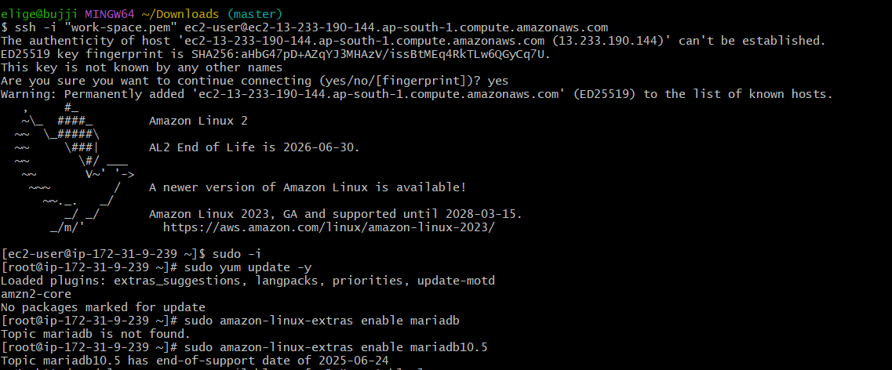

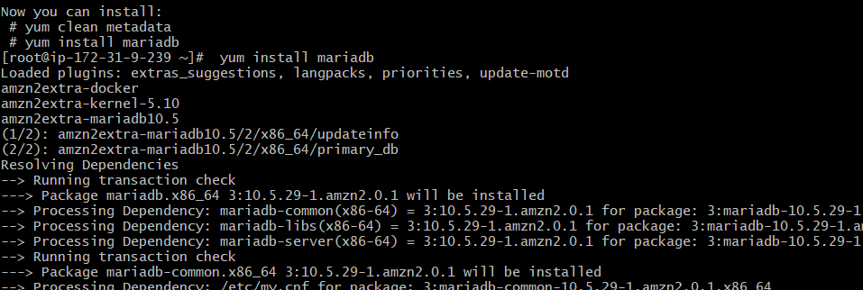

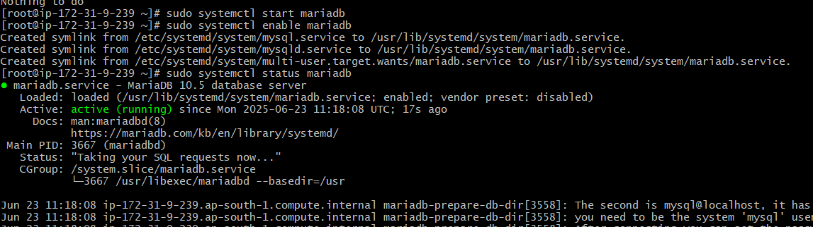

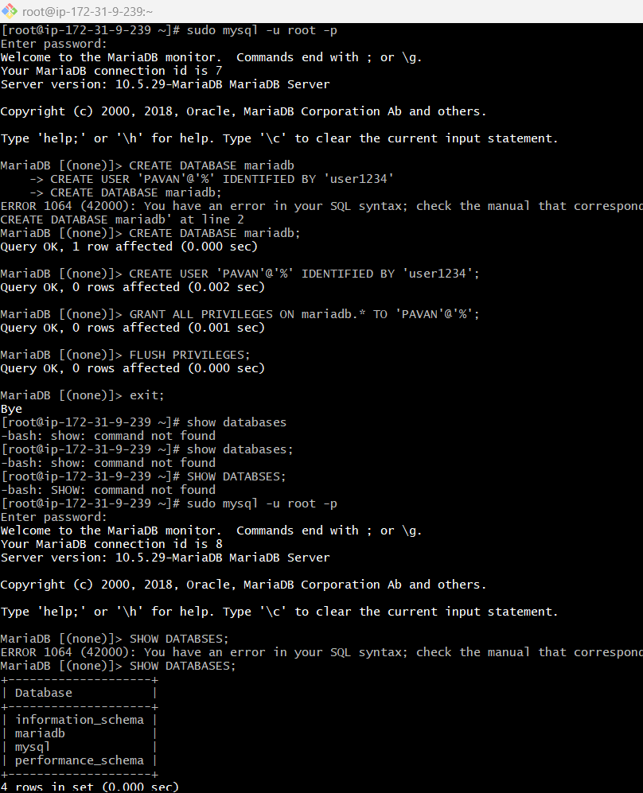

1. Insert some dummy data

🡪USE mariadb

🡪 CREATE TABLE cricket_team ( id INT PRIMARY KEY AUTO_INCREMENT, name VARCHAR(50));

🡪 INSERT INTO cricket_team (name) VALUES

('Virat Kohli'),

('Rohit Sharma'),

('MS Dhoni'),

('Jasprit Bumrah'),

('Shubman Gill');

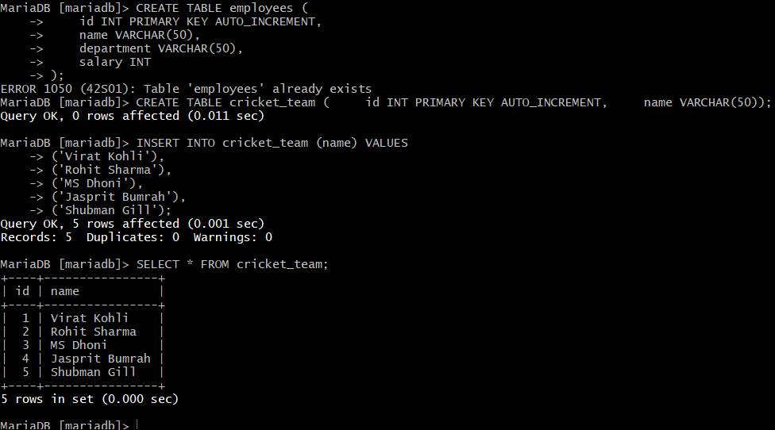

1. Take the backup of dummy data on ec2

🡪go to root user

🡪mysqldump -u root -p mariadb > mariadb_backup.sql—it will asks for password(user123)

🡪 ls -l mariadb_backup.sql

-rw-r--r-- 1 root root 2739 Jun 23 12:21 mariadb_backup.sql

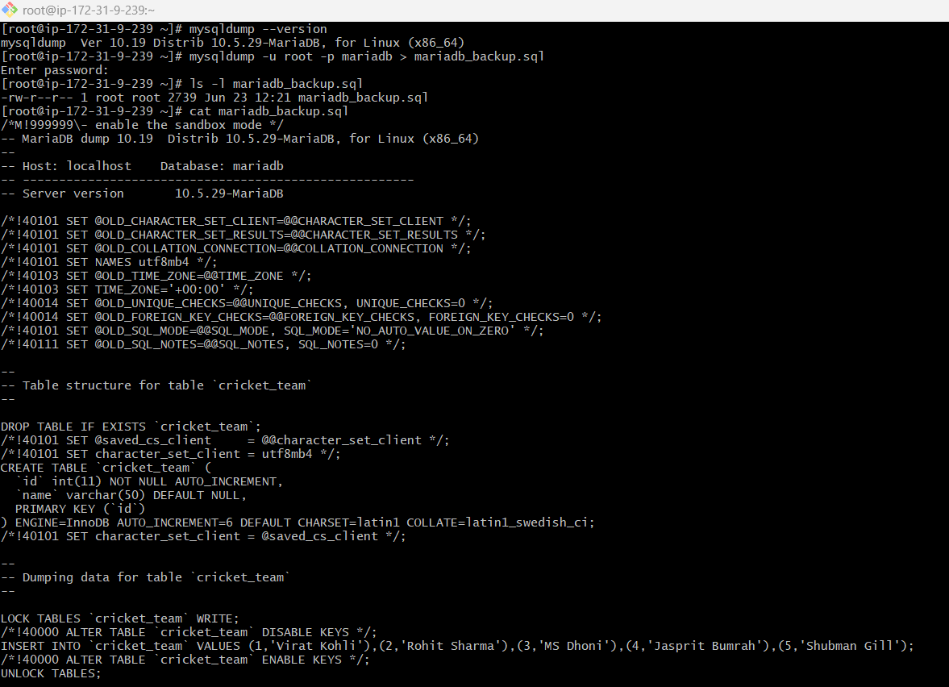

1. launch Mariadb RDS instance.

🡪go to Aurora and RDS—create—standard create—mariaDB—select engine version—free tier—DB instance identifier(MariaDB)—credential settings(master username—admin—master password--password)—instance config(select burstable classes—db-t3.micro)—disable(enable storage auto scaling)—do not connect(ipv4)—select vpc—subnet group(default)—no—selct SG—select AZ(ap-south-1)—disable(enable enhanced monitoring)—additional config(disable(enable automated backups))—maintainence(disable(enable auto minor version upgrade—no preference))—create dtabase.

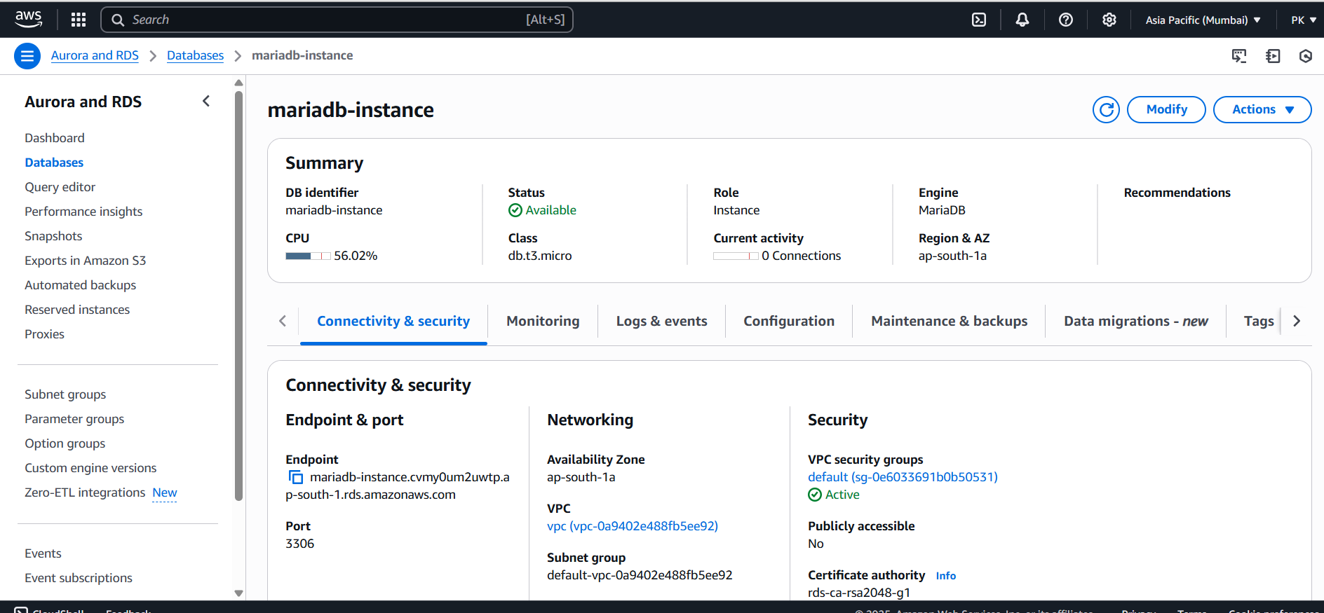

1. Migrate database from ec2 to RDS.

🡪 mysql -h mariadb-instance.cvmy0um2uwtp.ap-south-1.rds.amazonaws.com -u admin -p

🡪 CREATE DATABASE mariadb; 🡪exit;

🡪 mysql -h mariadb-instance.cvmy0um2uwtp.ap-south-1.rds.amazonaws.com -u admin -p

🡪 USE mariadb 🡪 SHOW TABLES; 🡪 SELECT * FROM cricket_team;

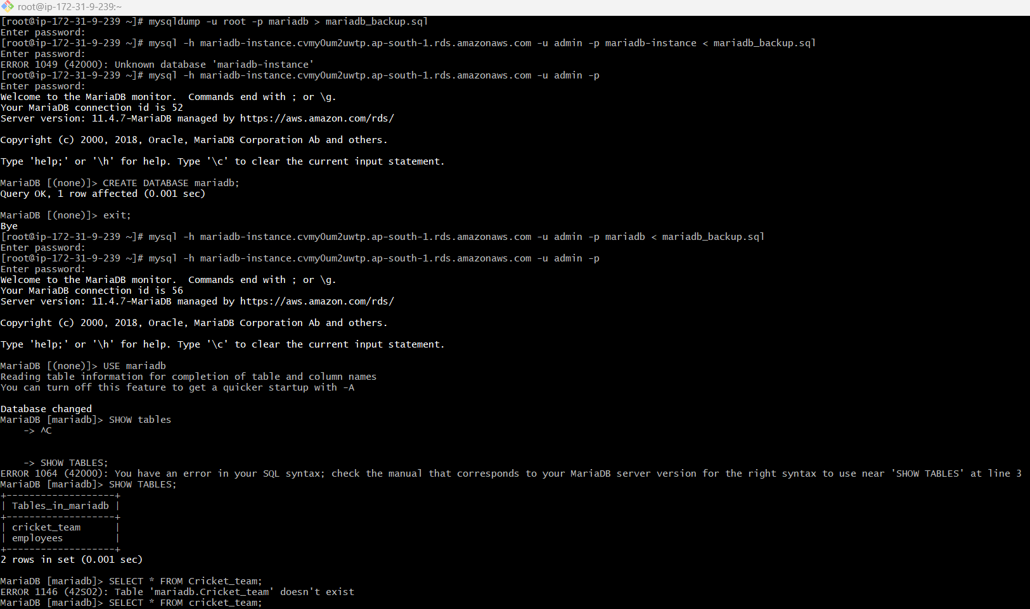

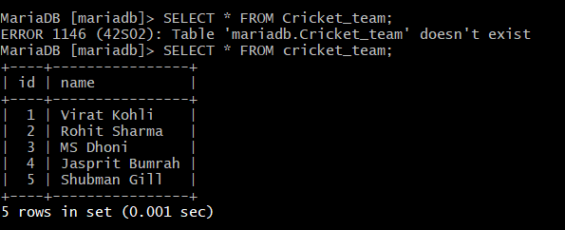

1. Install mysql db on ec2

🡪go to root user

🡪 yum install -y mysql-server

🡪 systemctl start mysqld

🡪systemctl enable mysqld

🡪 systemctl status mysqld

(I am installed in the beginning)

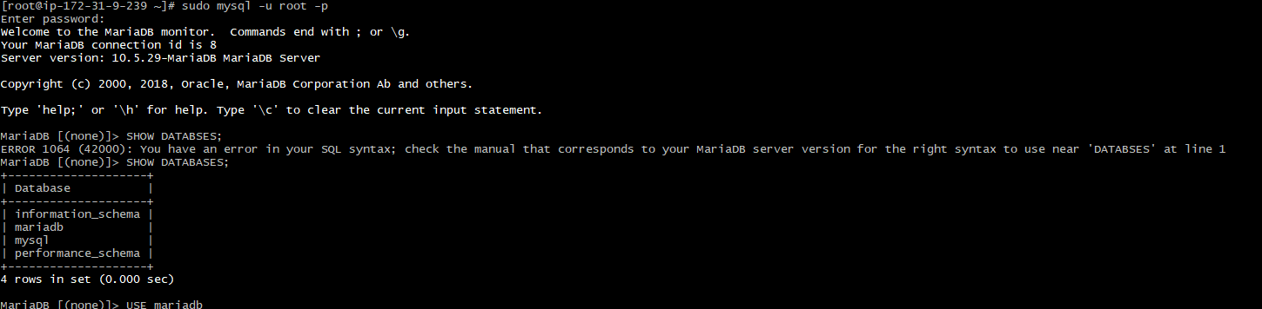

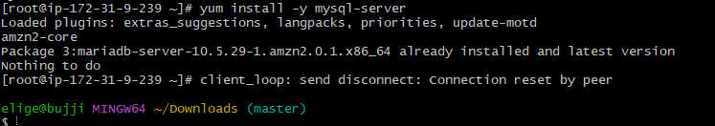

1. Launch mysql RDS image

🡪go to Aurora and RDS—create—standard create—mariaDB—select engine version—free tier—DB instance identifier(Mysql)—credential settings(master username—admin—master password--password)—instance config(select burstable classes—db-t3.micro)—disable(enable storage auto scaling)—do not connect(ipv4)—select vpc—subnet group(default)—no—selct SG—select AZ(ap-south-1)—disable(enable enhanced monitoring)—additional config(disable(enable automated backups))—maintainence(disable(enable auto minor version upgrade—no preference))—create dtabase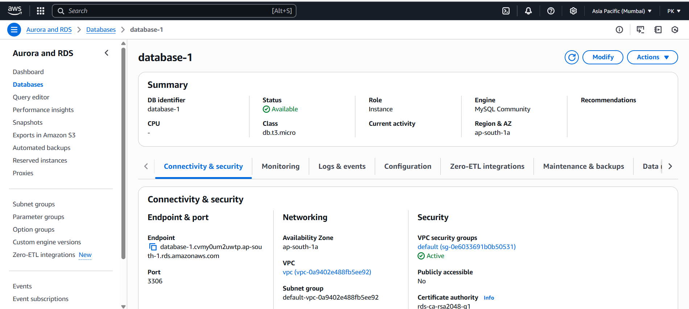

1. Configure multi AZ

🡪 select database—click on actions—click on convert to multi-AZ Depoyement—click onconvert to multi-AZ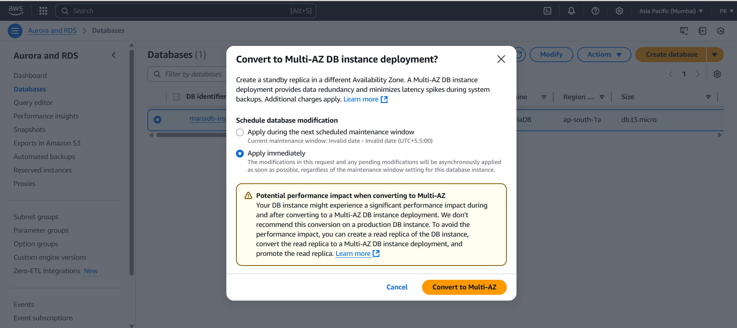

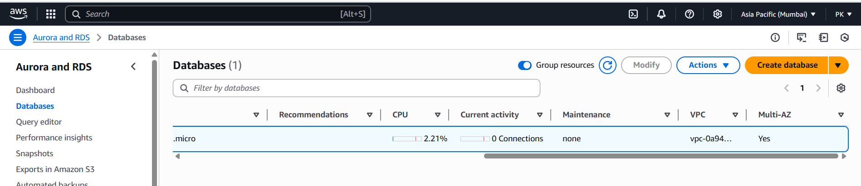

1. Take Backup of db and restore the DB

🡪go to database—select database—click on actions—take snapshot—check on snapshot tab

🡪go to snapshot tab—select snapshot—click on actions—click on restore snapshot

🡪come back & check in databases tab

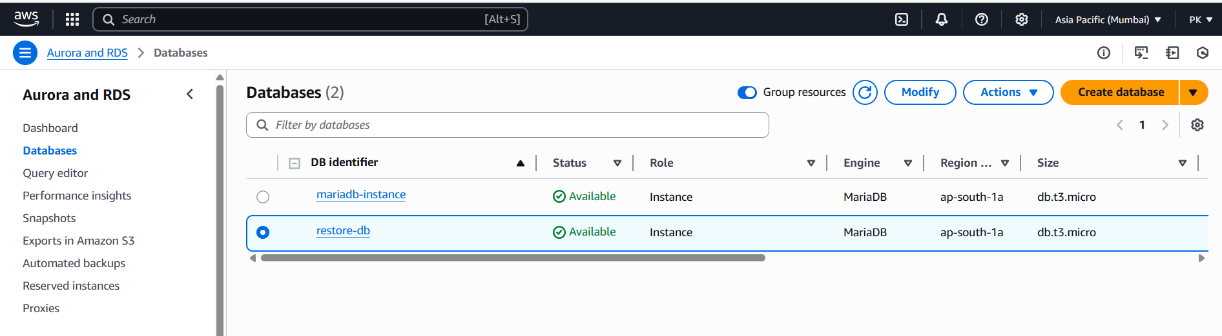

1. Create ReadRepIlca

🡪go to database—select database—click on actions—create read replica

