1. Configure VPC peering in cross regions.

🡪created one vpc in N. Virginia and one in ohio regions

🡪peering connection is requested from N. Virginia to ohio region

🡪accepted in ohio region

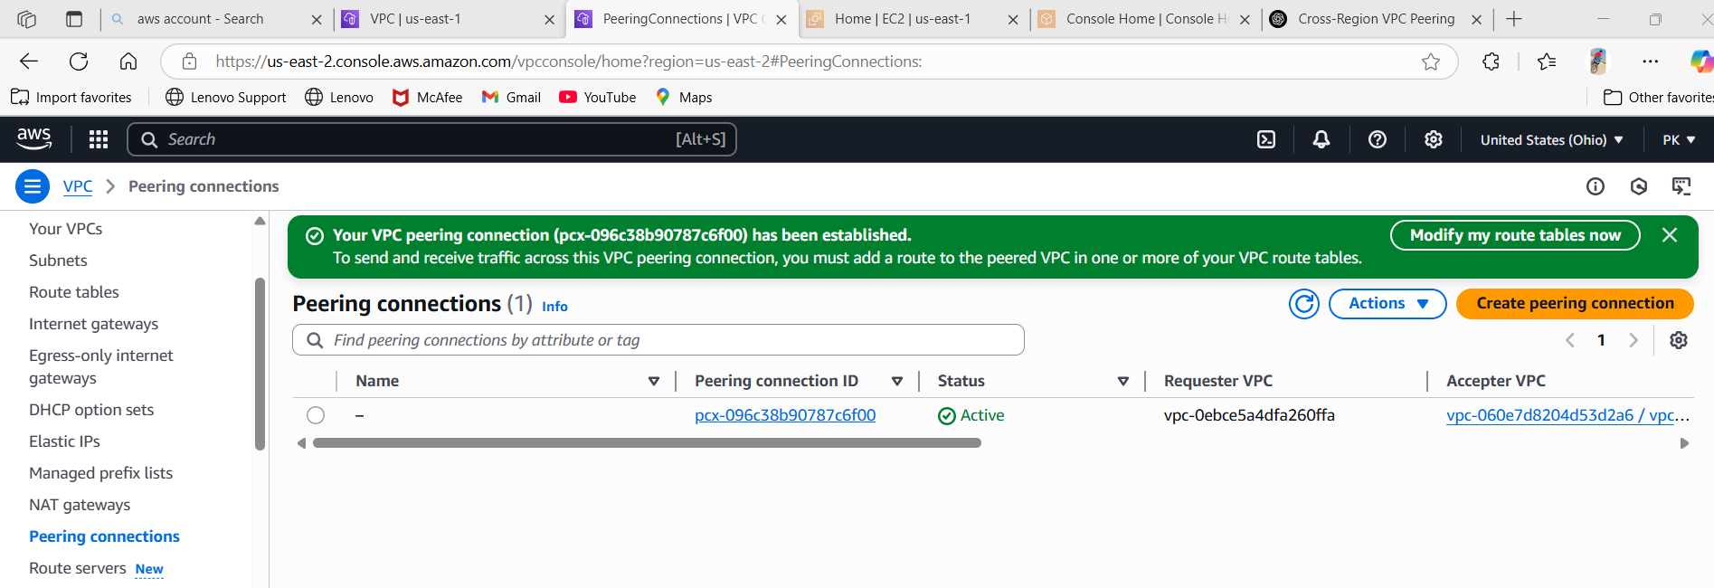

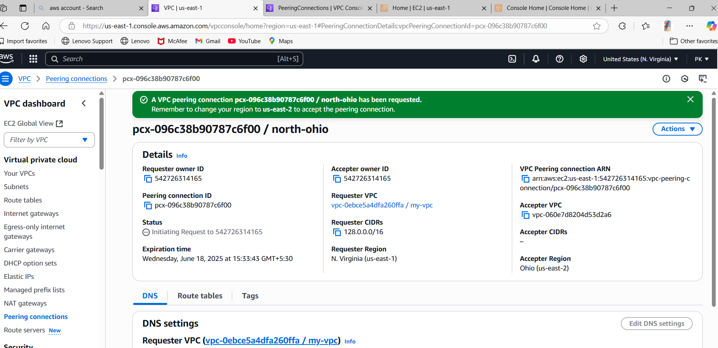  
2) Purchase one domain from godaddy.

🡪open godaddy.com create an account

🡪search for websites with your name

🡪give details and purchase one domain.

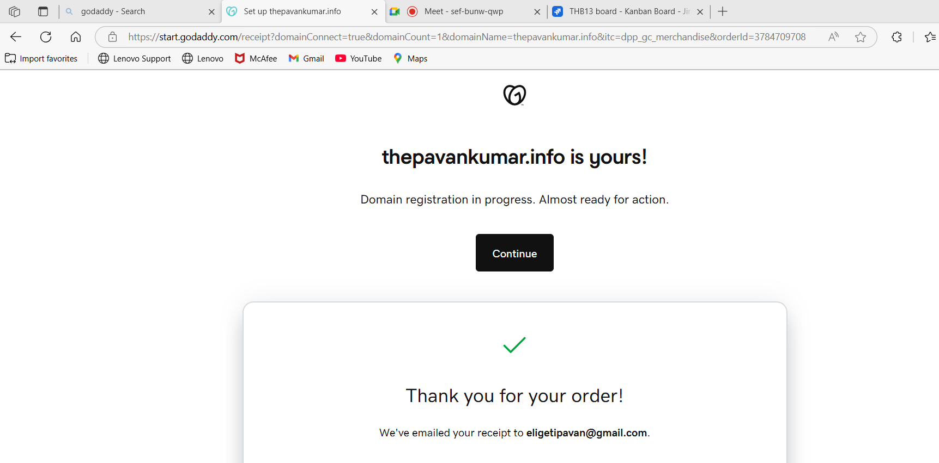

3) Deploy static webiste in s3.

🡪go to s3 in aws console

🡪click on create bucket—name ur bucket as ur domain name—upload 2 files—save

🡪open ur bucket—properties tab—scroll down—static website hosting—edit—edit—upload index.html, error.html files—save.

🡪now copy the url and go to browser check ur website.

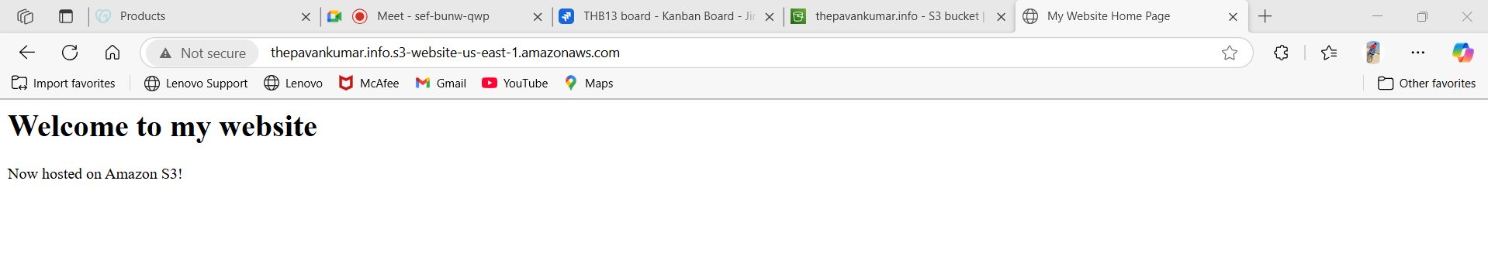

4) Create CDN and attach one SSL certificate.

🡪go to cloudfront(distributions)—create distribution—give details—add ssl certificate—create distribution

🡪go to route53(hosted zones)—create hosted zone(with domain name)—it will show 2 configs(ns & soa) after this go to certificate(ssl) tab—create a record then in hosted zones **cname** will be added.

🡪go to hosted zones—create a record—use record type(A)—enable **Alias** (cloudfront & value)—create record.

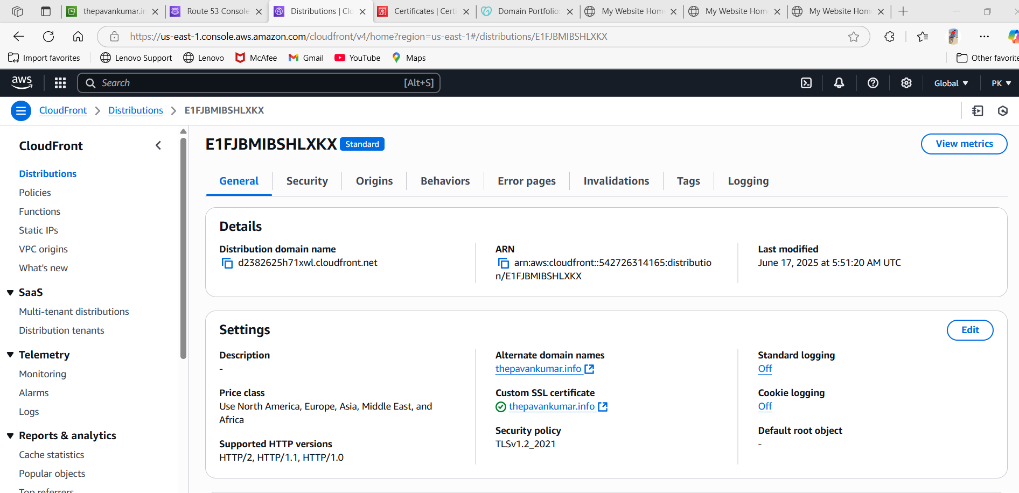

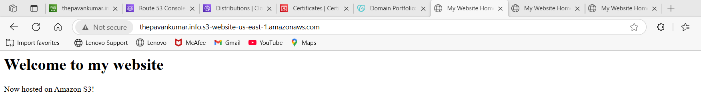

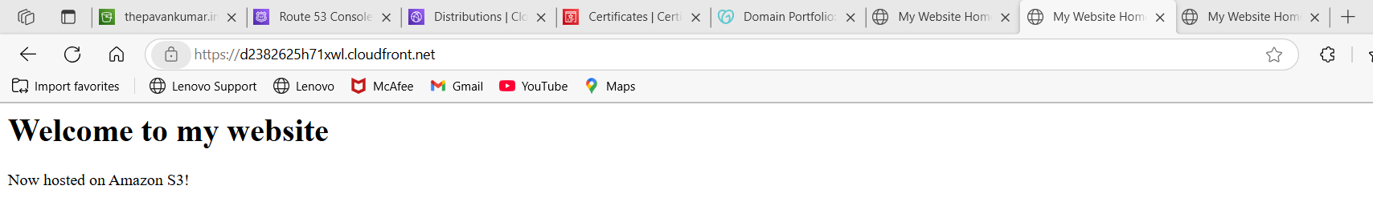

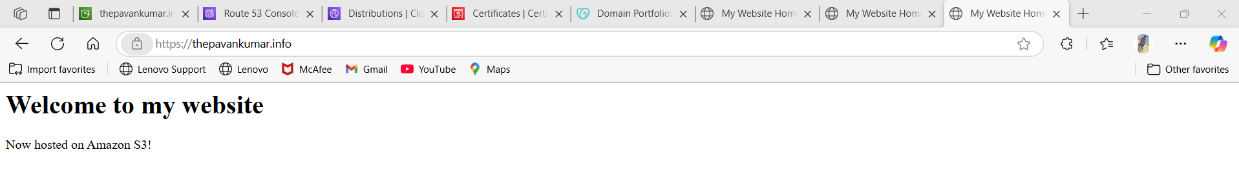

5) Create Route53 hosted zone and MAP the domain with CDN.

🡪already created hosted zone and mapped with domain in hosted zone with record type--A

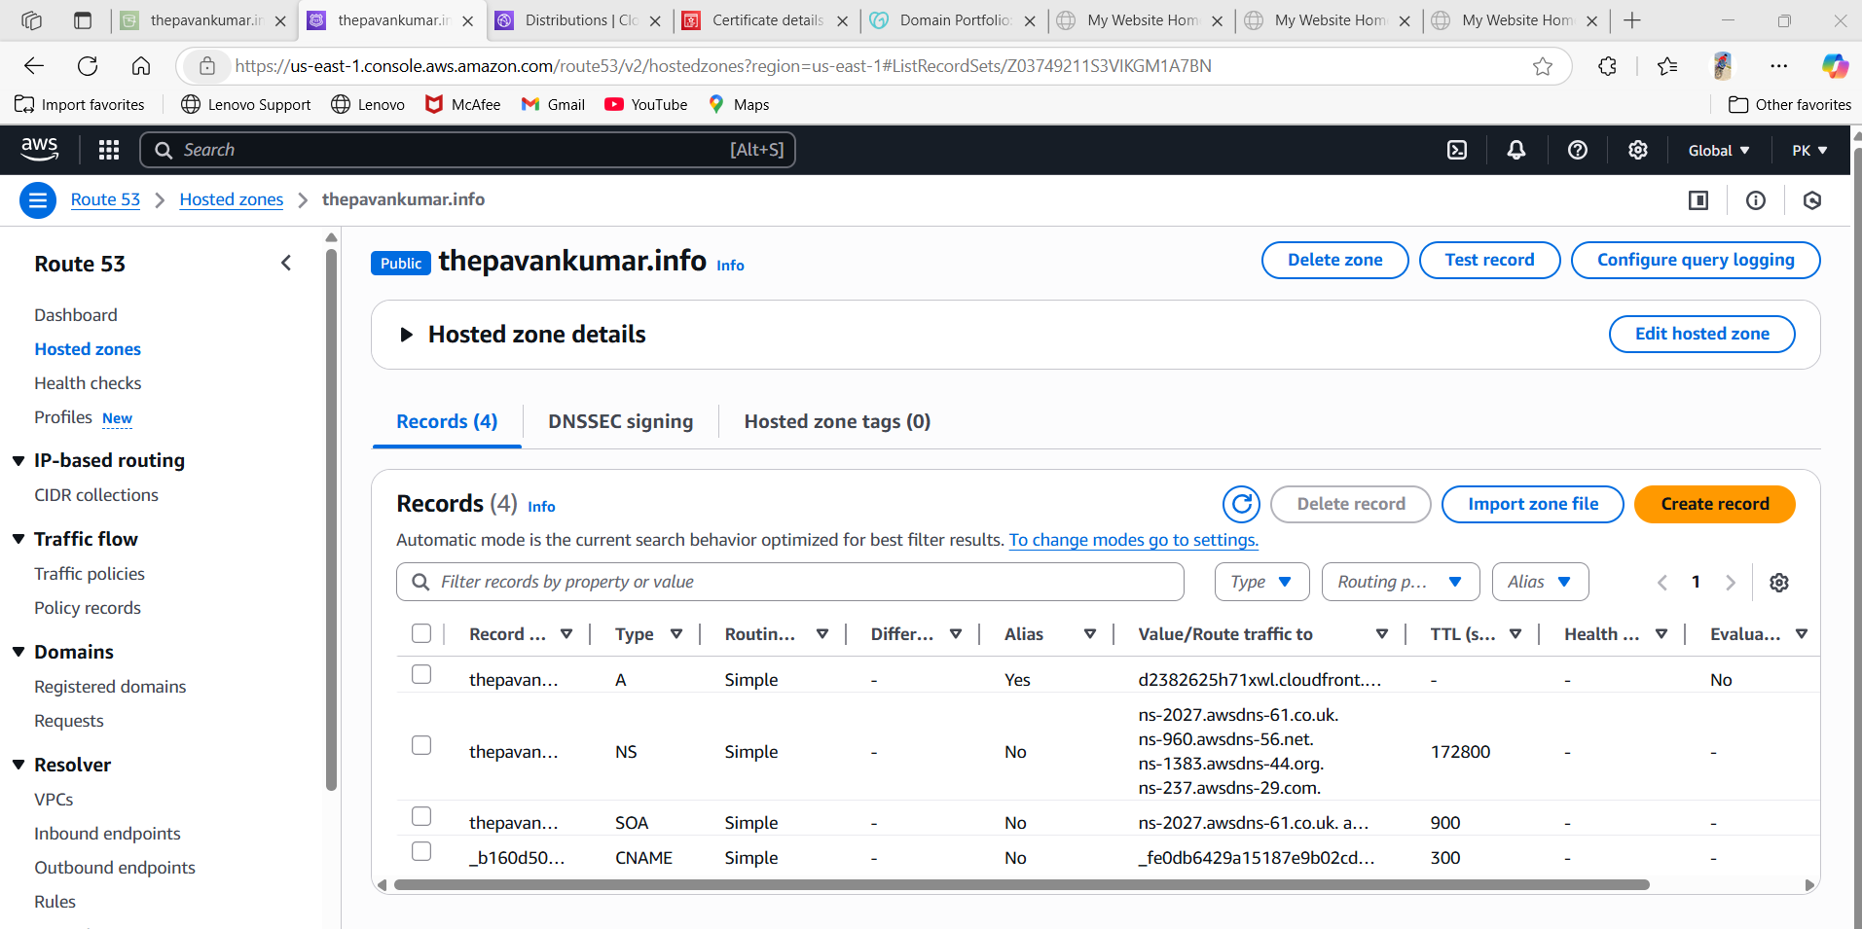

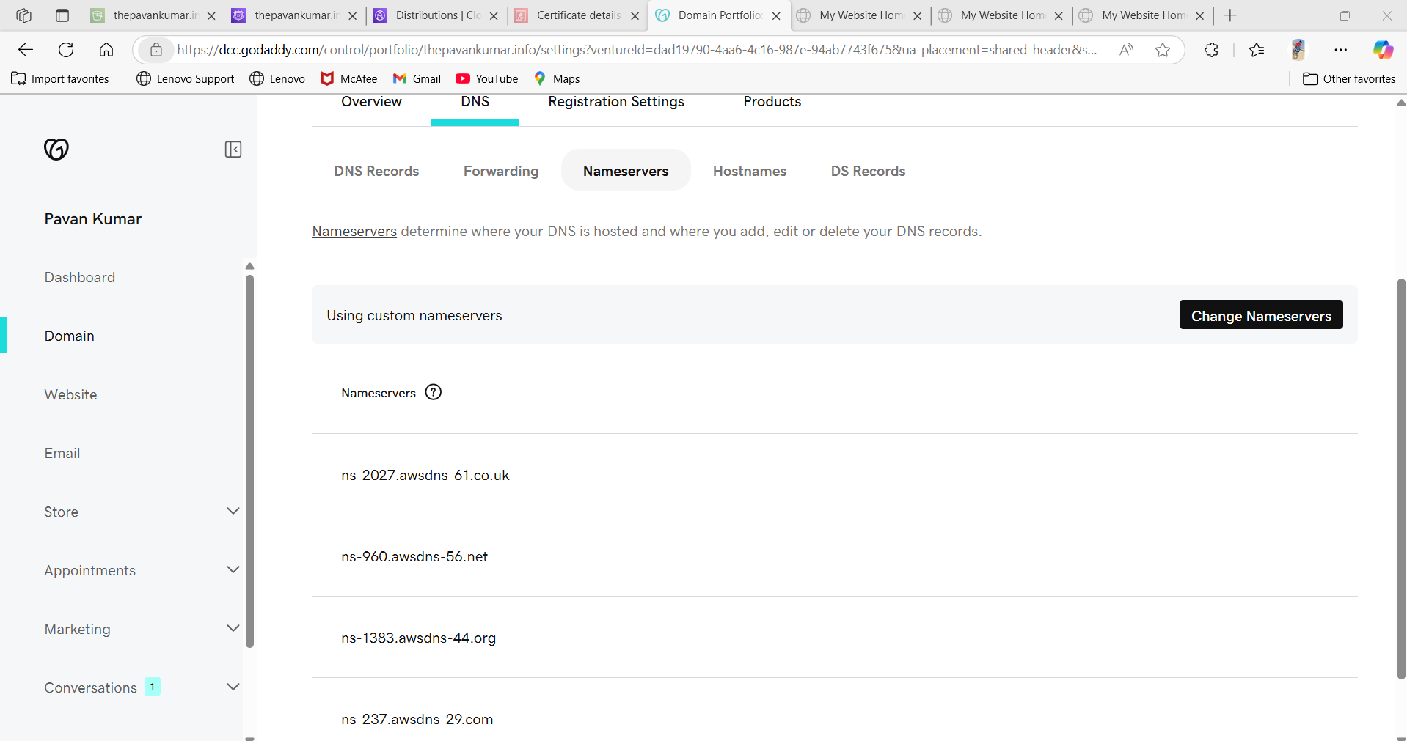

6) Update the index.html in s3 bucket and the updated file should be accessible by using domain name.

🡪update content in website.html via gitbash

🡪upload the file again and make public accessible

🡪search with ur domain name

🡪it will show the updated content

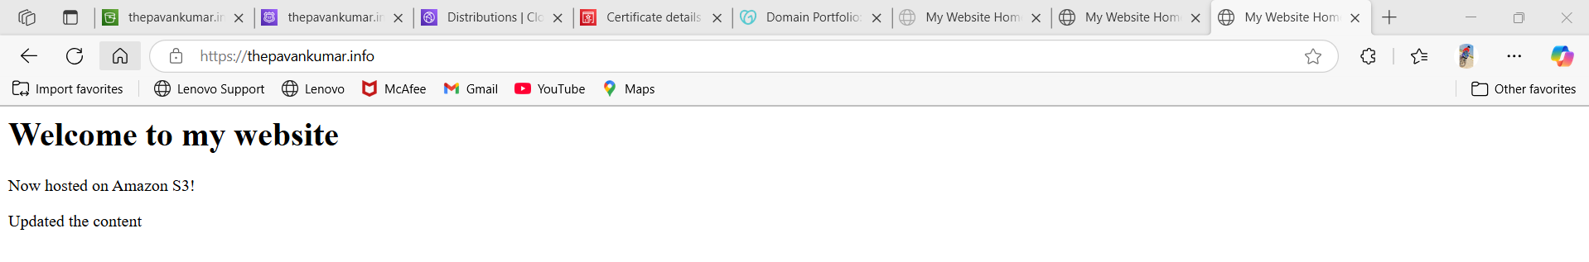

  
7) Share the Domain name in slack to test the connetivity.

🡪shared [My Website Home Page](https://thepavankumar.info/)