1) Create VPC with 2 private and 2 public subnets.

🡪create a vpc in your vpcs tab

🡪create a 2 public & 2 private subnets in subnet tab

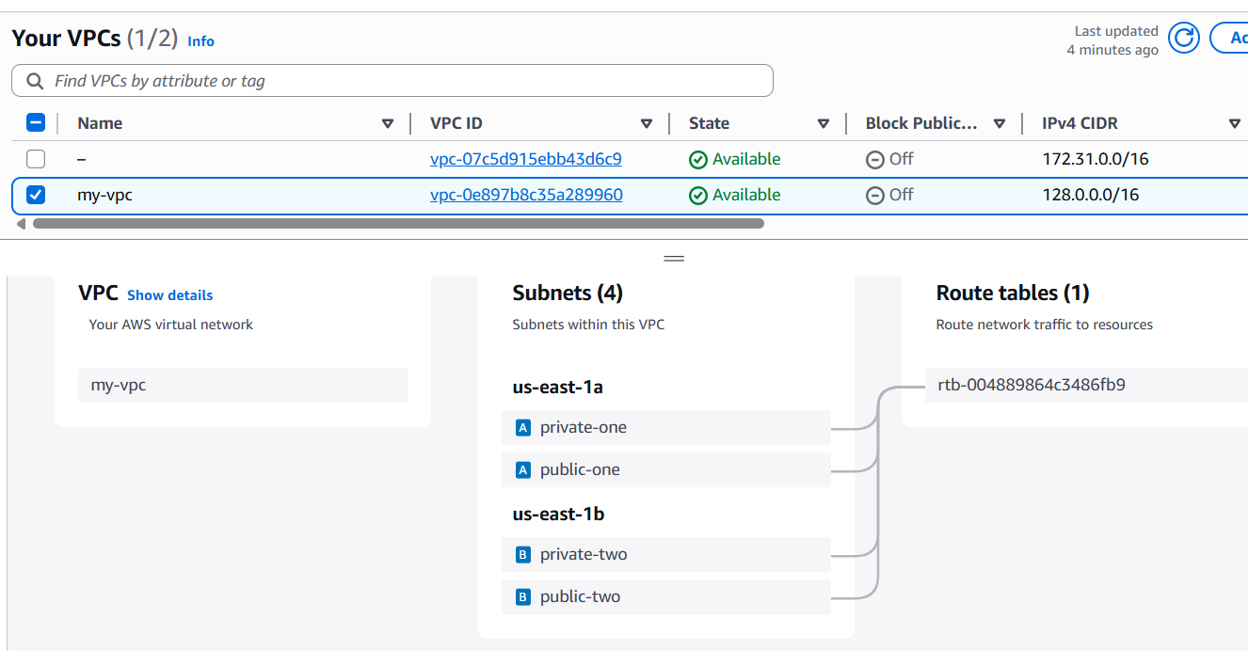

2) Enable DNS Hostname in VPC.

🡪select your vpc then click on **Actions** then **edit vpc settings**

**🡪**Tick the checkbox in **DNS settings** then save

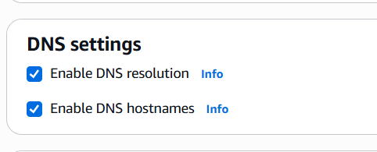

3) Enable Auto Assign Public ip in 2 public subnets.

🡪select public subnet then click on **Actions** then **Edit subnet settings**

🡪in **Auto assign ip settings** tick the checkbox then **save**

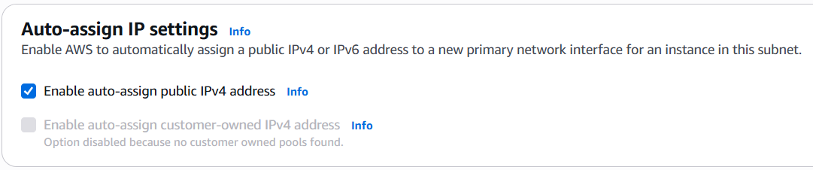

4) Add 2 private subnets in private route table.

🡪click on route table tab then create a route table**(private-RT)**

🡪then select 2 private subnets then add

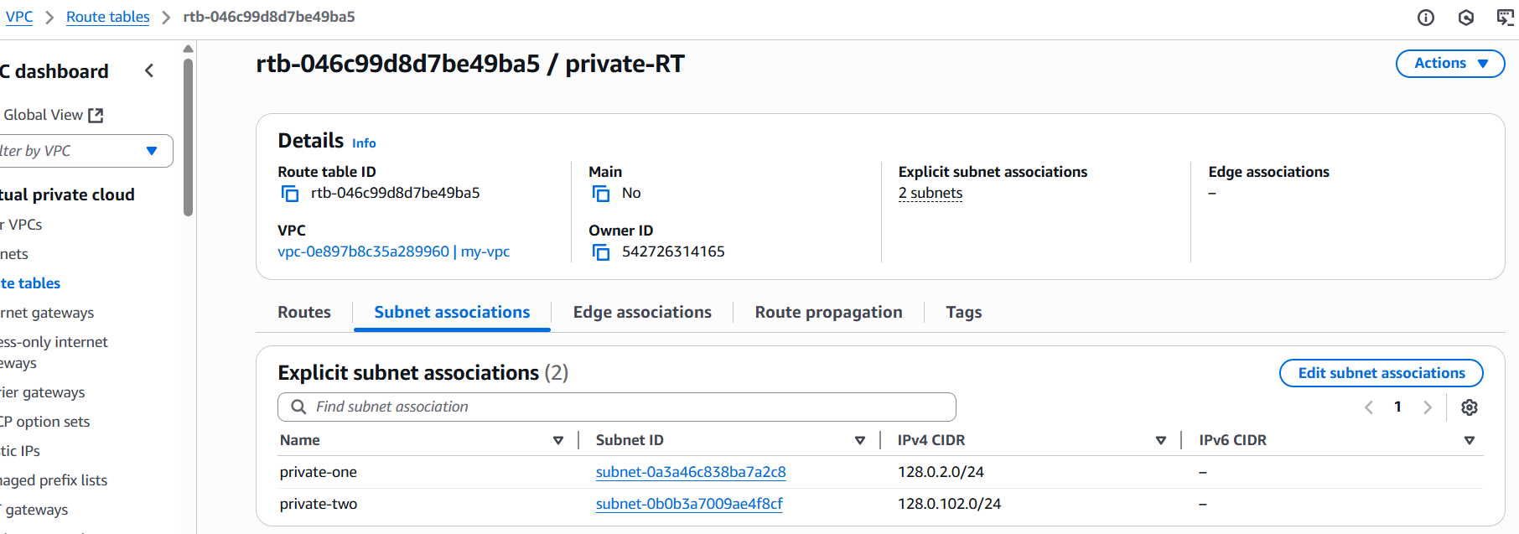

5) Add 2 public subnets in public route table.

🡪click on route table tab then create a route table**(public-RT)**

🡪then select 2 public subnets then add

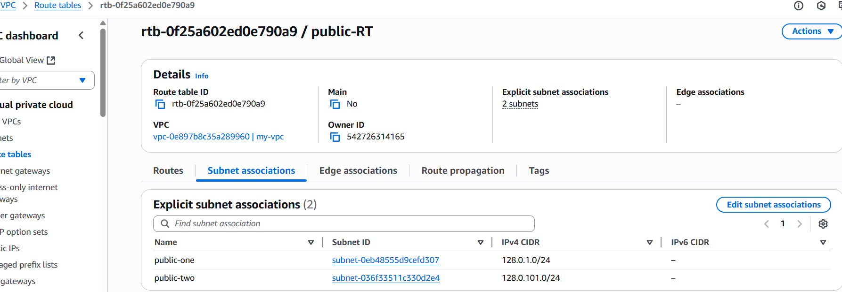

6) Public route table will have the routes to internet and local.

🡪create a internet gateway in internet gateways tab

🡪then go to **root tables** then select **public root** table then **edit routes**

**🡪**add route 0.0.0.0 and my-IGW then save

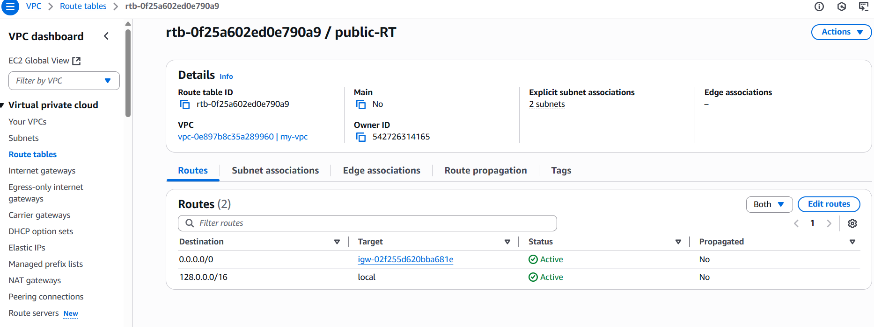

7) Create Ec2 in public subnet with t2micro and install php.

🡪launch one ec2 using public subnet by selecting in network settings

🡪then connect to ec2 server

🡪change inbound rules to all-traffic

🡪yum update -y

🡪yum install php

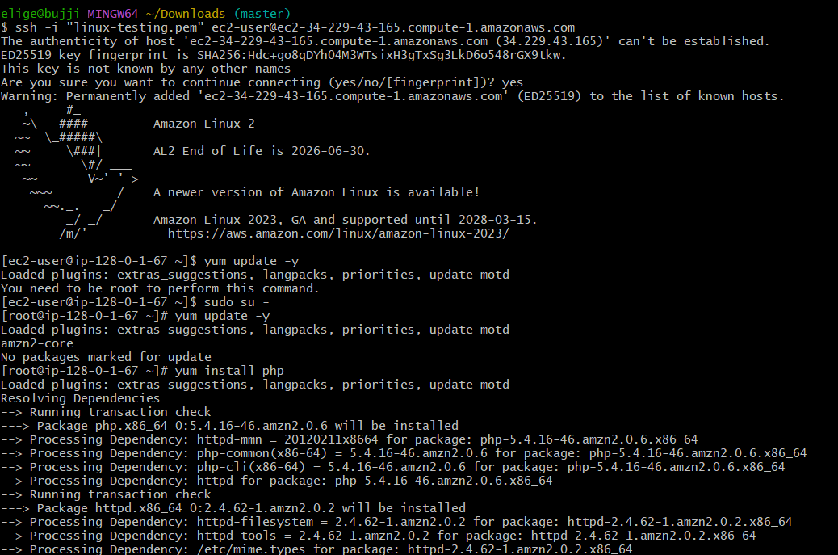

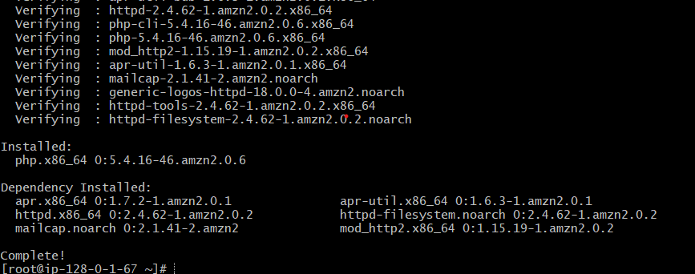

8) COnfigure Nat gateway in public subnet and connect to private Instance

🡪nat gateway is deployed in public subnet and configured in private route table

Which is associated with private subnet

🡪then cat the pem key

🡪then connect to public ec2. now (vi test.pem) paste in this and save

🡪now connect to private ec2 using (ssh -I test.pem ec2-user@private ip of private ec2)

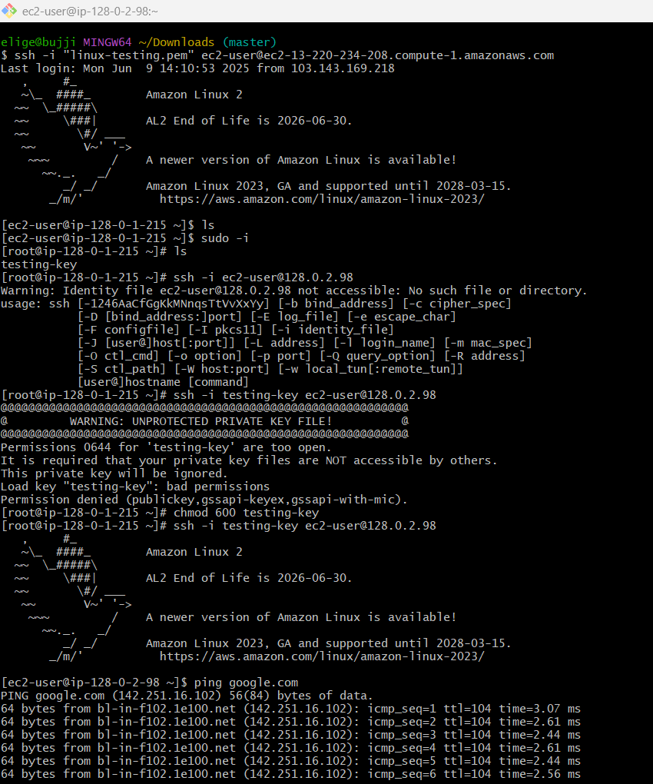

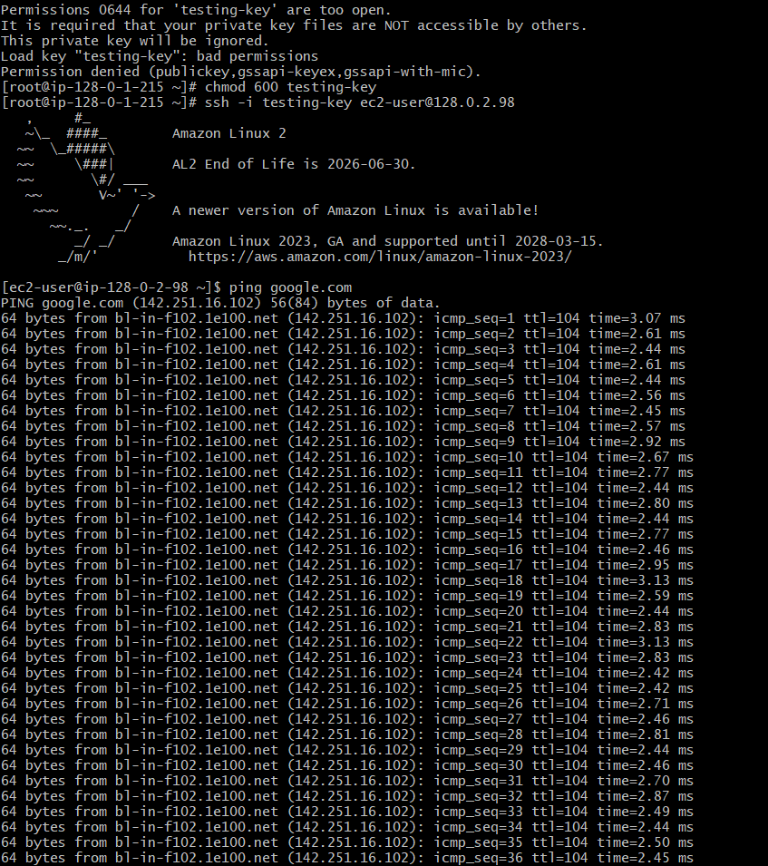

9) Install Apache Tomcat in private ec2 and deploy a sample app.

🡪in private ec2 yum update -y

🡪sudo wget tomcat url

🡪tar xvf apache-tomcat

🡪mv apache-tomcat tomcat

🡪change dir to webapps

🡪wget sample.war

🡪ll

🡪private ip:8080

🡪Since it is a private ec2 we can not access it.



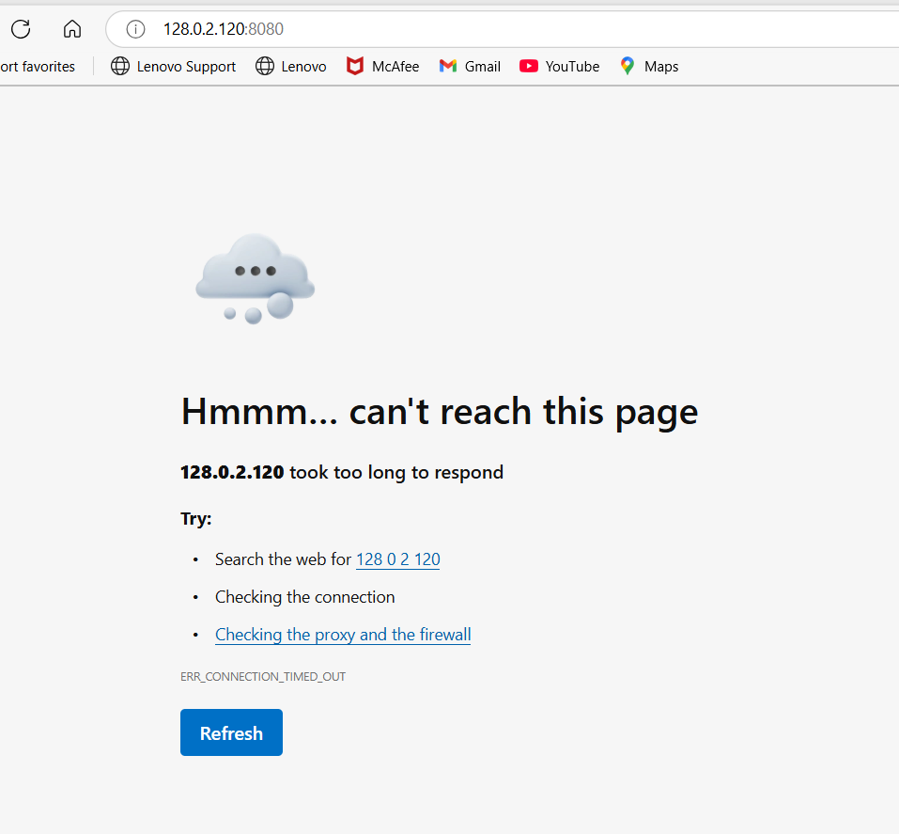

10) Configure VPC flow logs and store the logs in s3 and cloudwatch.

🡪launch one ec2 using public subnet by selecting in network settings

🡪then connect to ec2 server

🡪then connect to private ec2 instance

🡪in aws console go to vpc and create flow logs in this create s3 bucket, then do some operations

🡪check logs in bucket list

🡪 For cloud-watch flow log, in cloud-watch create log file for this log create one policy and one log group for security purpose then save

For s3

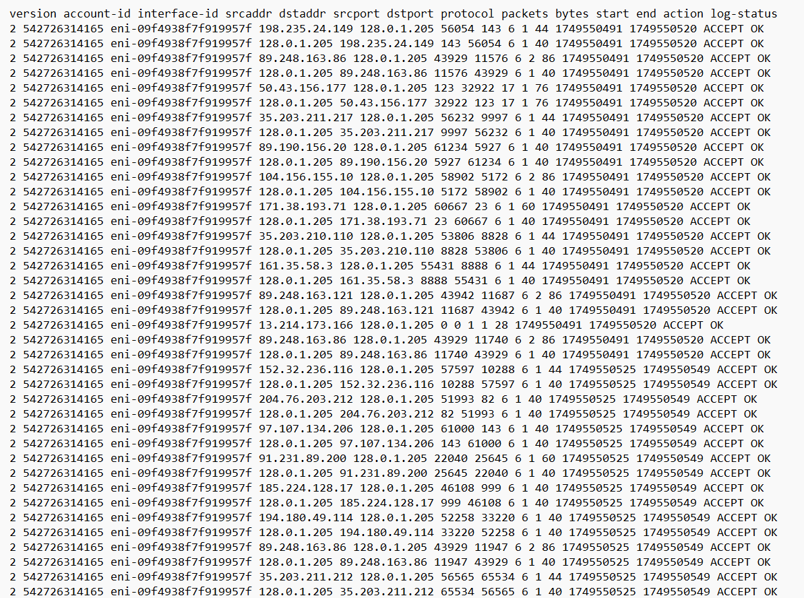

===============

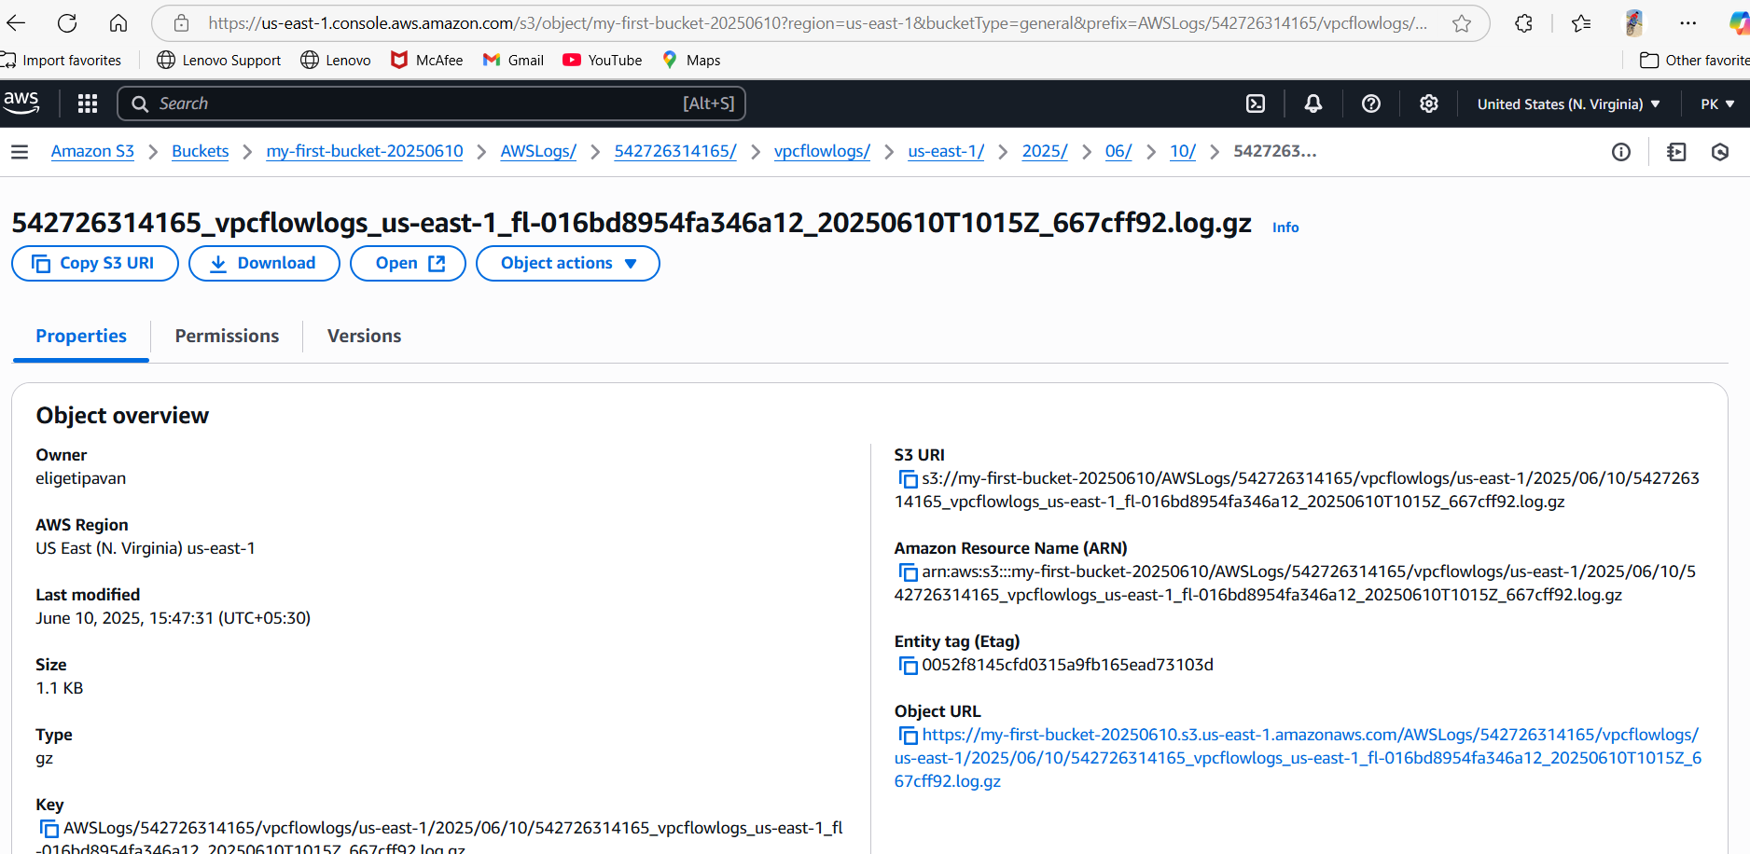

For Cloud-watch

