1. Configure Classic Load balancer.

🡪got o ec2--create one target group with this create one classic-load-balancer in load balancer tab

🡪launch 2 ec2 instances with public subnets and connect—switch to root(sudo -i)

🡪yum install httpd -y 🡪systemctl start httpd 🡪systemctl status httpd 🡪cd /var/www/html

🡪echo “welcome server-1 images” >> index.html 🡪access with dns <url:80(find> it on load balancer) 🡪access it ec2 public or private ip:80

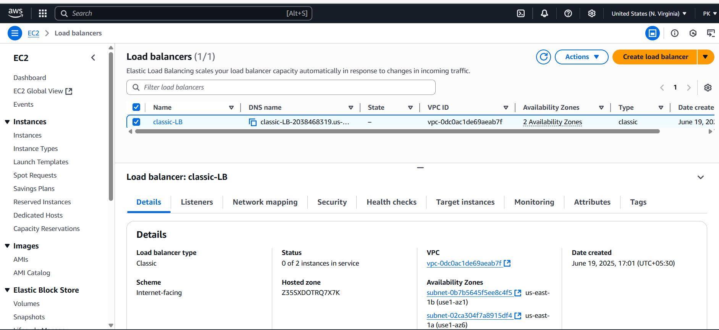

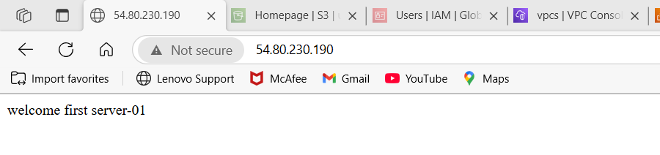

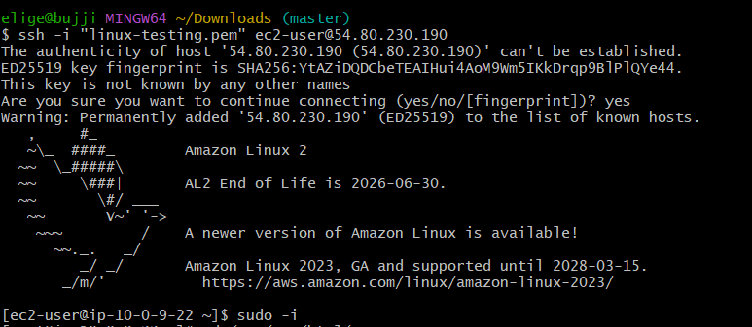

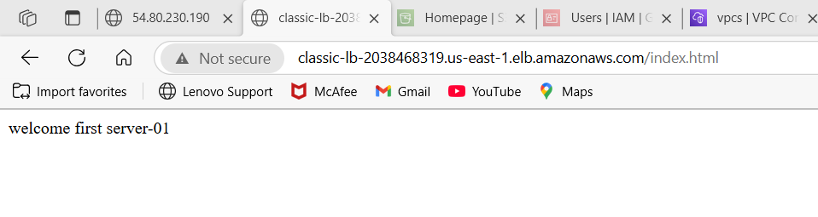

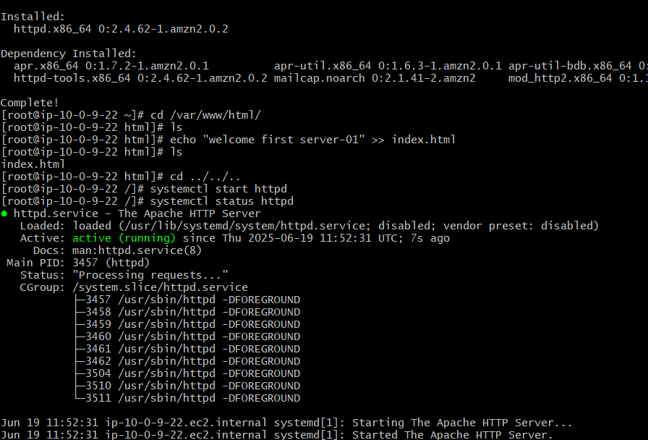

2) Configure Application Load balancer.

🡪 got o ec2--create one target group with this create one application-load-balancer in load balancer tab

🡪launch 2 ec2 instances with public subnets and connect—switch to root(sudo -i)

🡪yum install httpd -y 🡪systemctl start httpd 🡪systemctl status httpd 🡪cd /var/www/html

🡪echo “welcome server-1 images” >> index.html 🡪access with dns <url:80(find> it on load balancer) 🡪access it ec2 public or private ip:80

Foe server-1

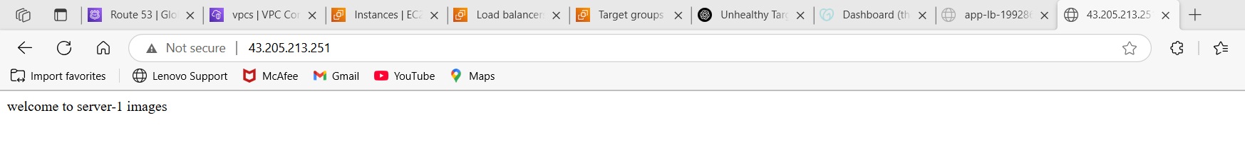

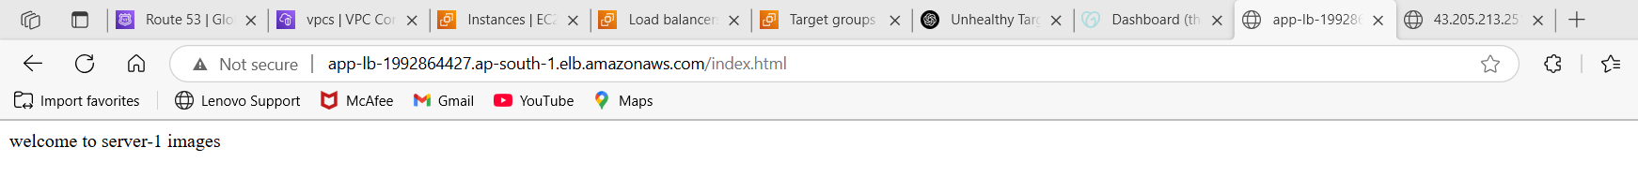

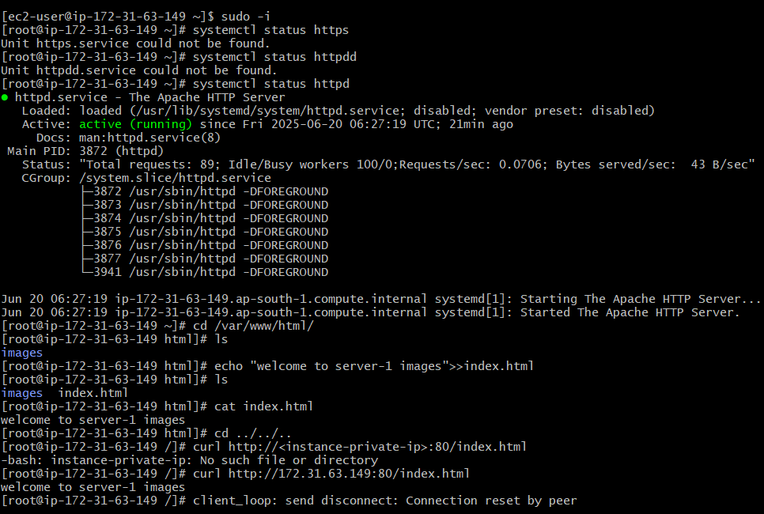

For server-2

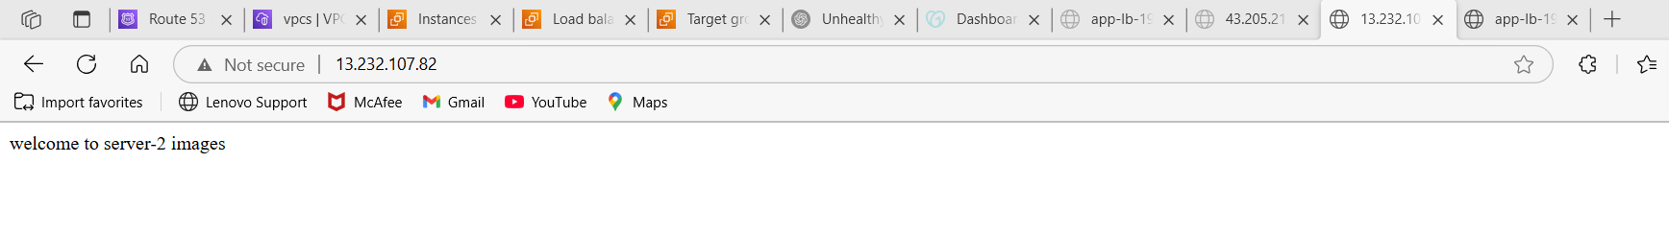

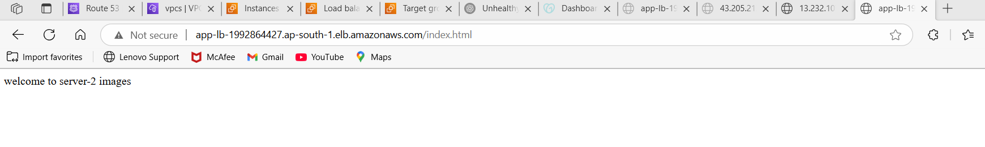

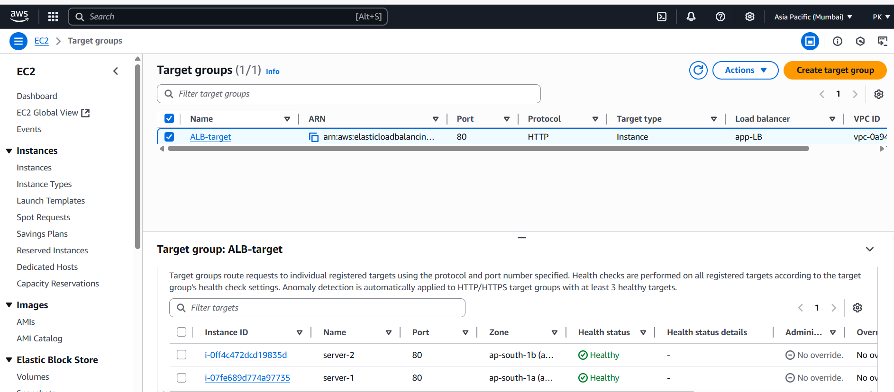

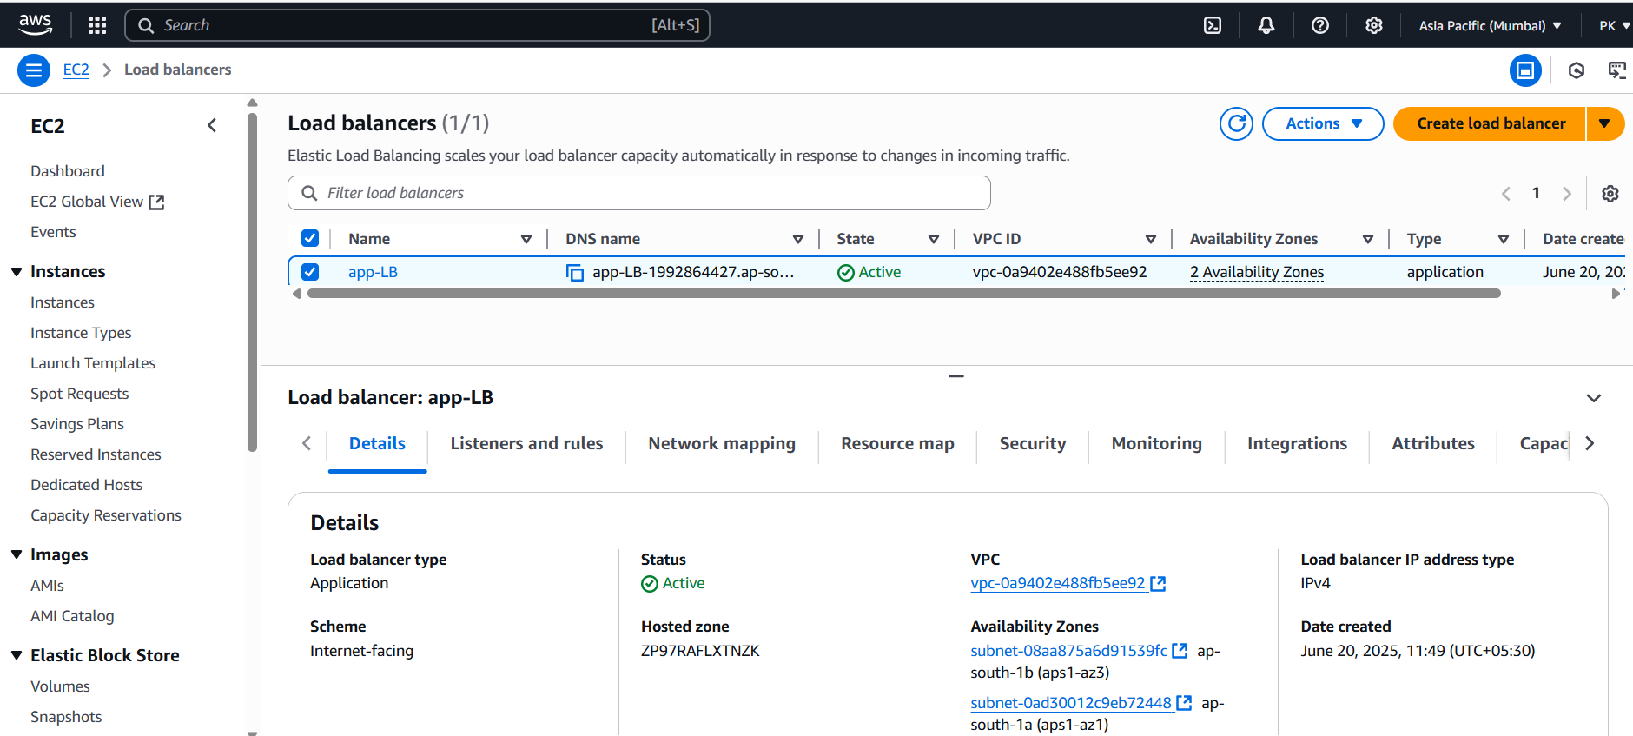

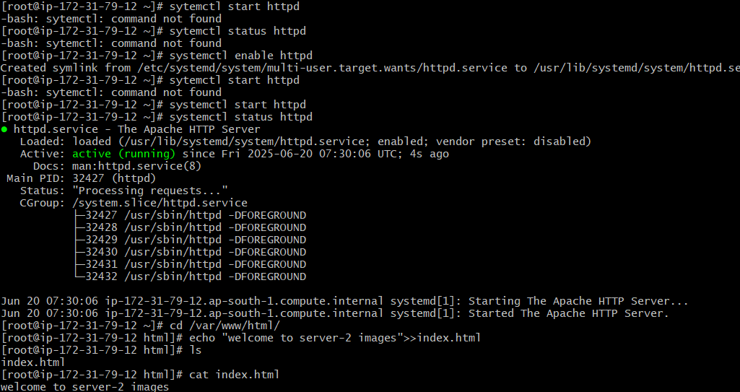

3) Configure Network Load balancer.

🡪 got o ec2--create one target group with this create one network-load-balancer in load balancer tab

🡪launch 2 ec2 instances with public subnets and connect—switch to root(sudo -i)

🡪yum install httpd -y 🡪systemctl start httpd 🡪systemctl status httpd 🡪cd /var/www/html

🡪echo “welcome server-1 images” >> index.html 🡪access with dns <url:80(find> it on load balancer) 🡪access it ec2 public or private ip:80

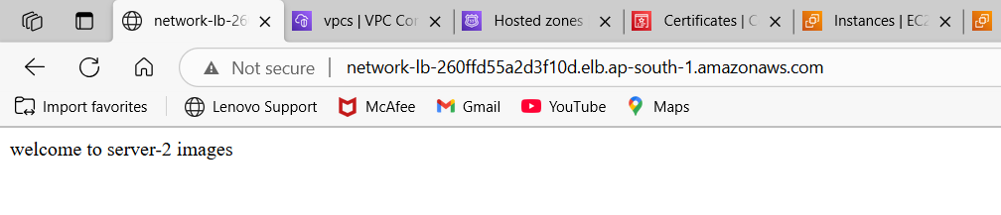

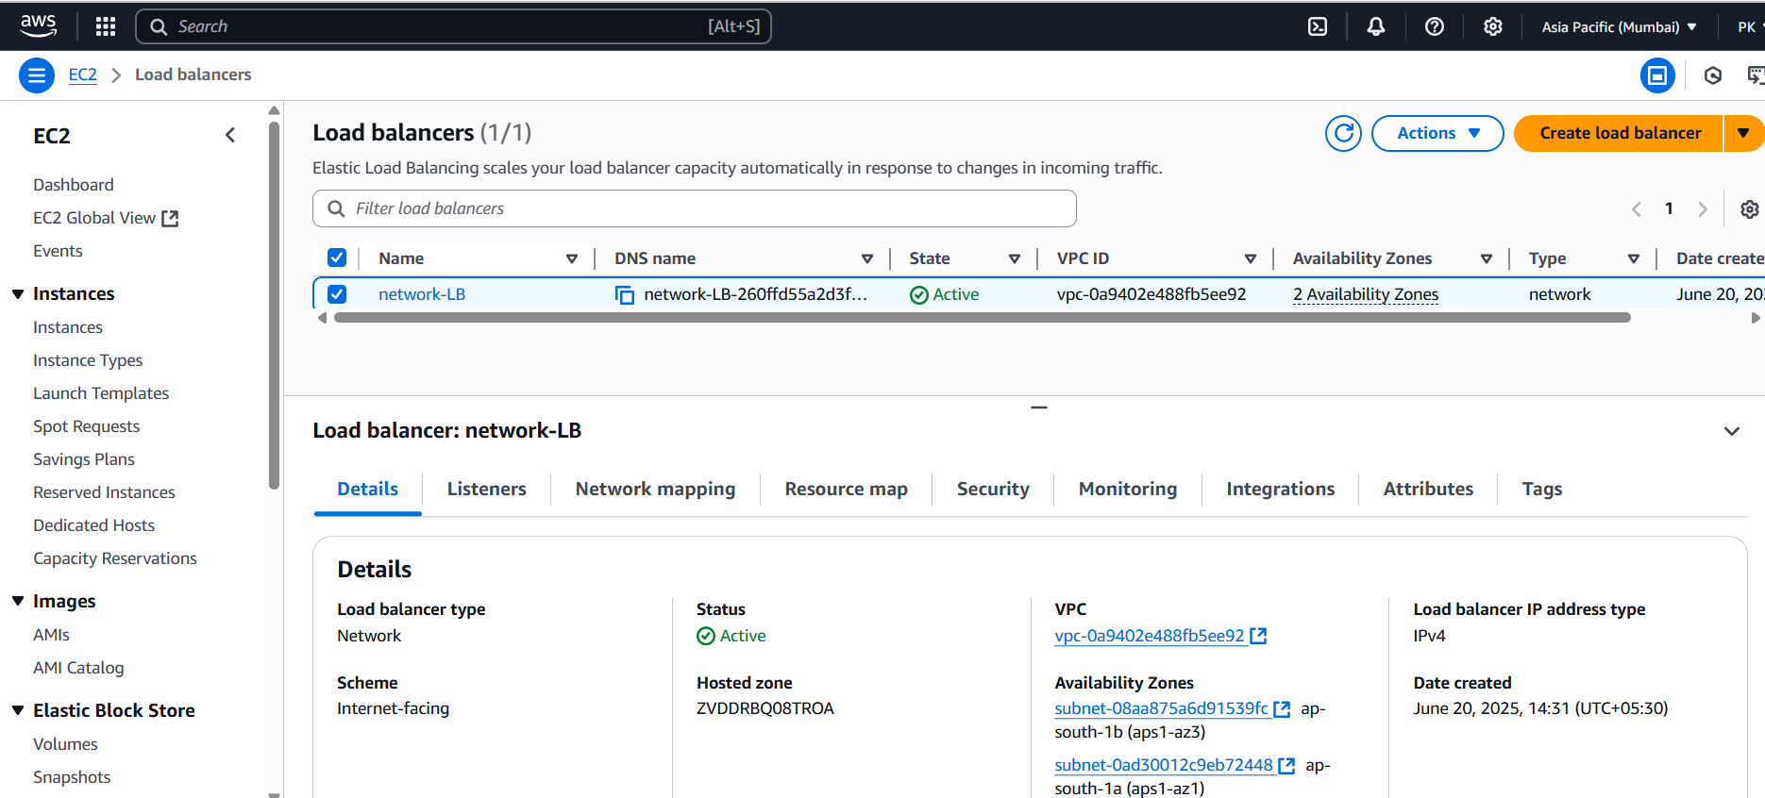

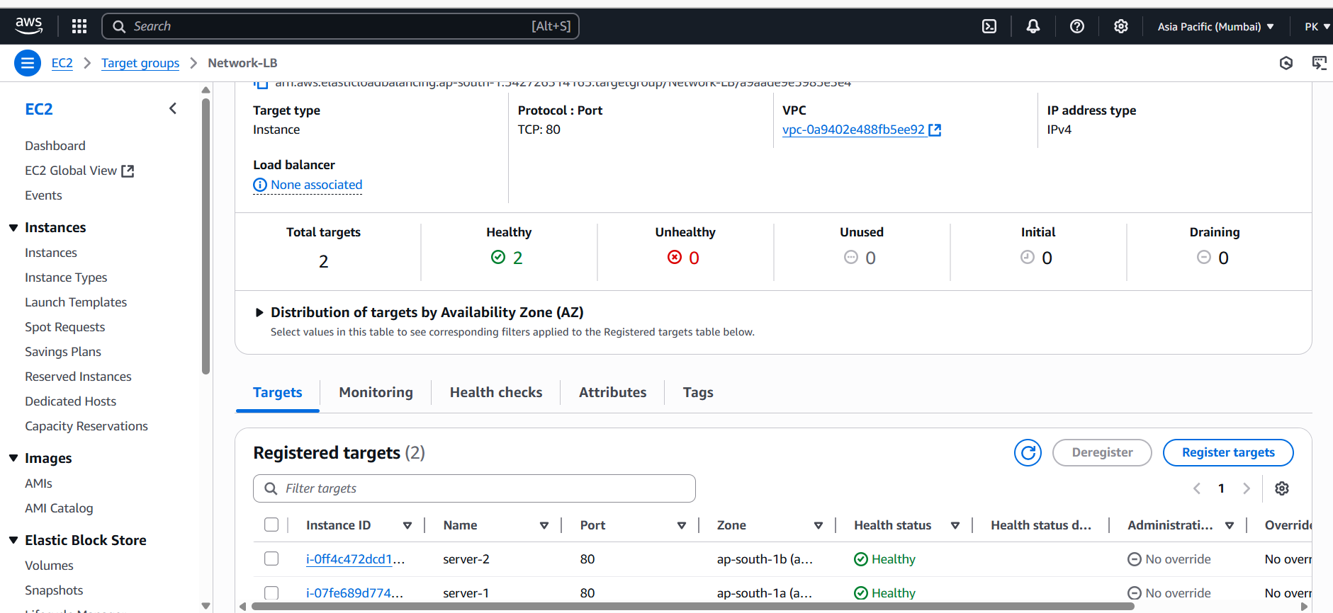



4) Attach SSL for application load balancer.

🡪request one ssl certificate from SSL-cretificates service

🡪go to load-balancer tab—listeners & rules tab—add listener—name—redirect to url—create

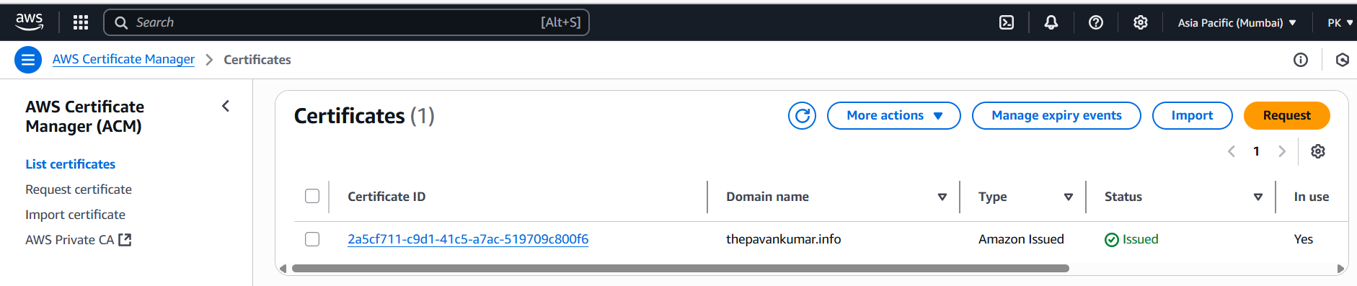

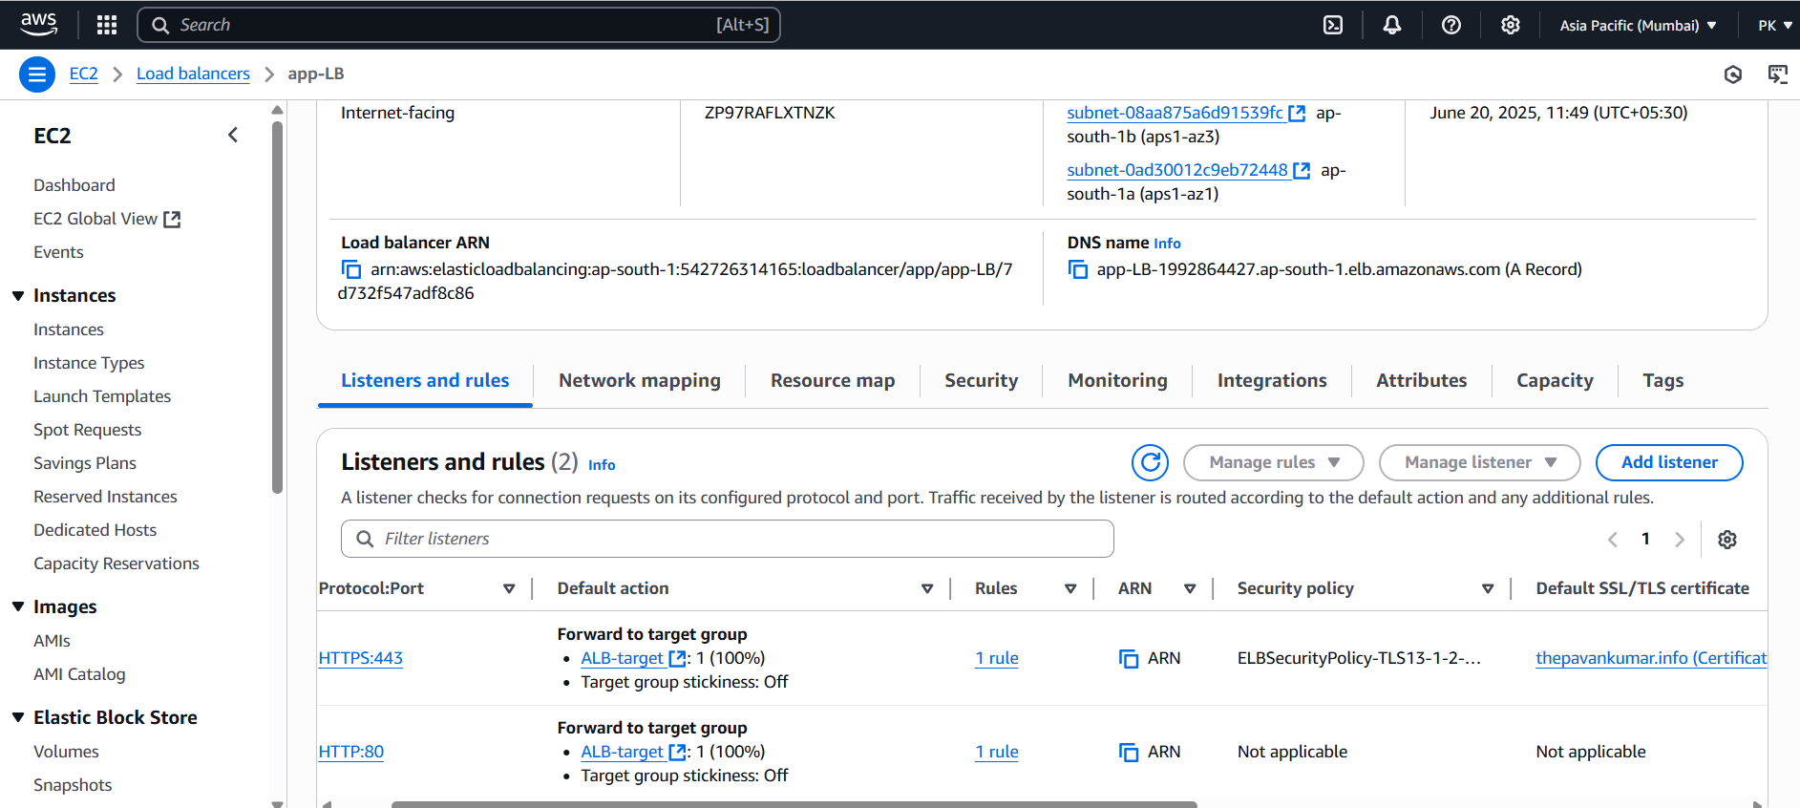

5) Map Application load balancer to R53.

🡪after attaching ssl-certificate to application-load-balancer

🡪go to route53—create record—record type(A-ipv4 address)—from dropdown select(alias application or classic load balancer)—create record

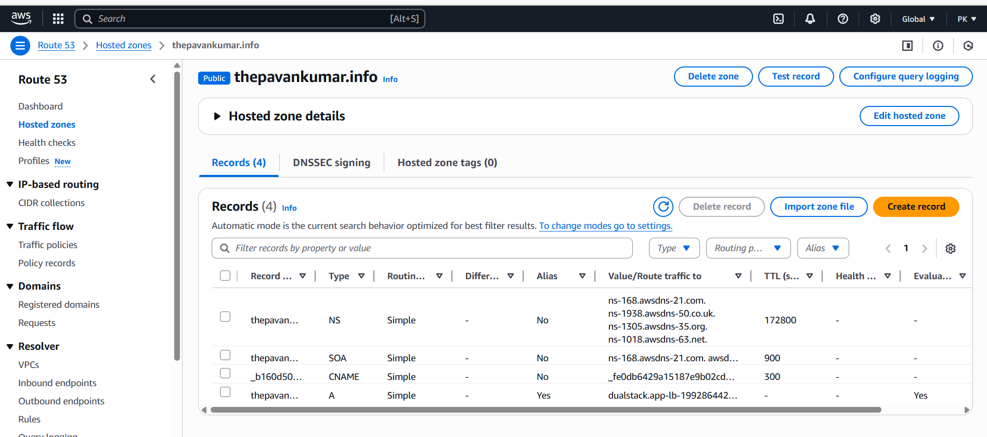

6) Push the application load balancer logs to s3.

🡪select application-load-balancer—Attributes tab—scroll down—monitoring(access logs) it will be off—click on edit—attach s3 bucket url--save

