1. Create s3 bucket and upload some objects to s3.

🡪go to s3—click on general purpose buckets—create bucket—name-acl enabled—create

🡪create 2 files in git bash(it will automatically saves the files in downloads)—come to buckets(select bucket)—click on **upload** select files—upload.

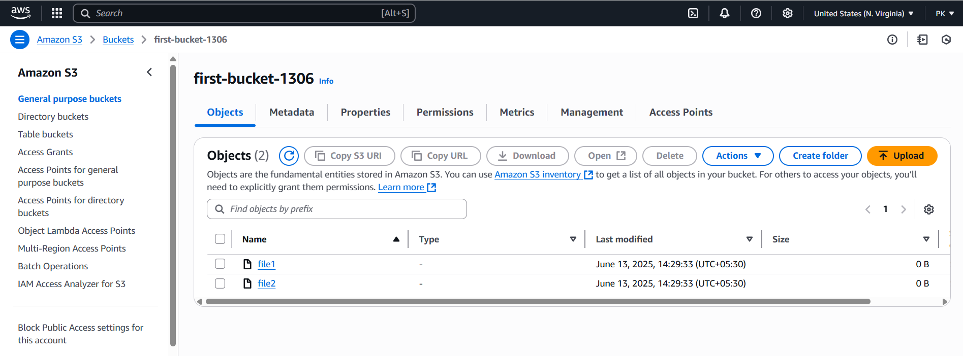

1. Deploy static website in s3 bucket.

🡪select bucket—go to properties(scroll down)—edit static website hosting(enable it)—upload index doc, error doc—save changes.(uploaded files in bucket and in static website are must be same).

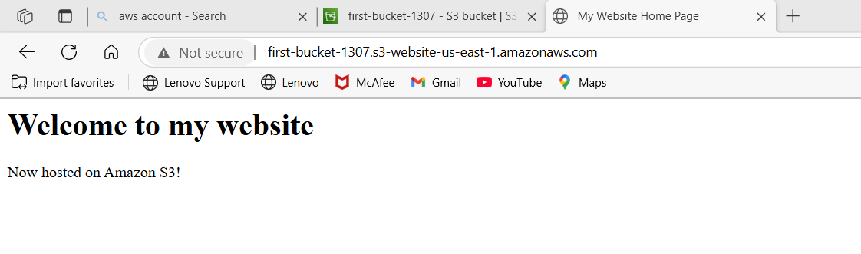

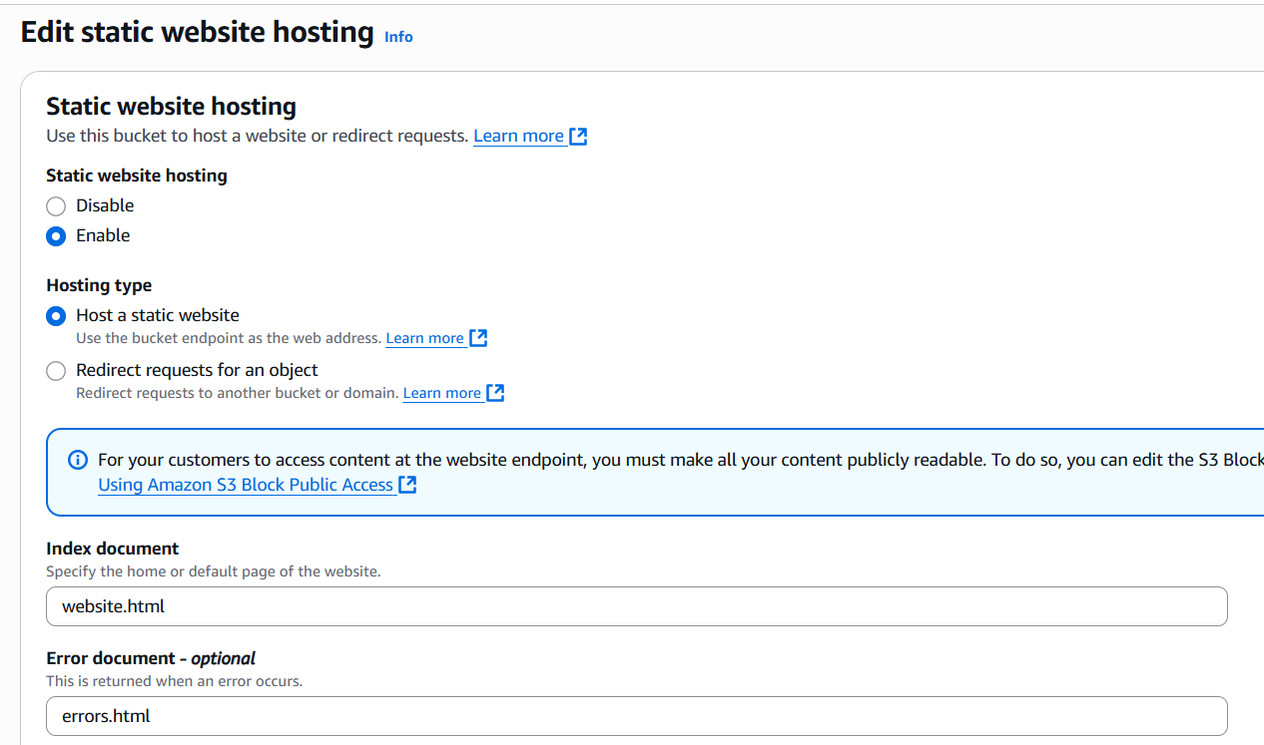

1. Enable cross region replication on s3 buckets.

🡪create a buckets in 2 diff regions

🡪open one bucket—go to management tab—replication rule(edit replication rules)—give details—save changes.

🡪upload 1 file in first bucket then go to second bucket click on **show versions**.

🡪it will shows the recently uploaded file.

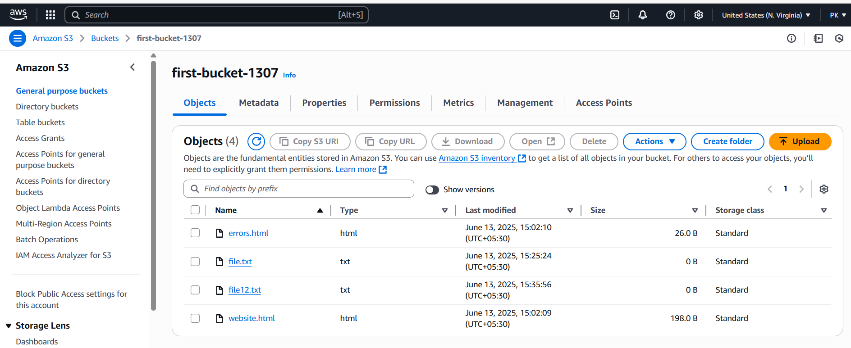

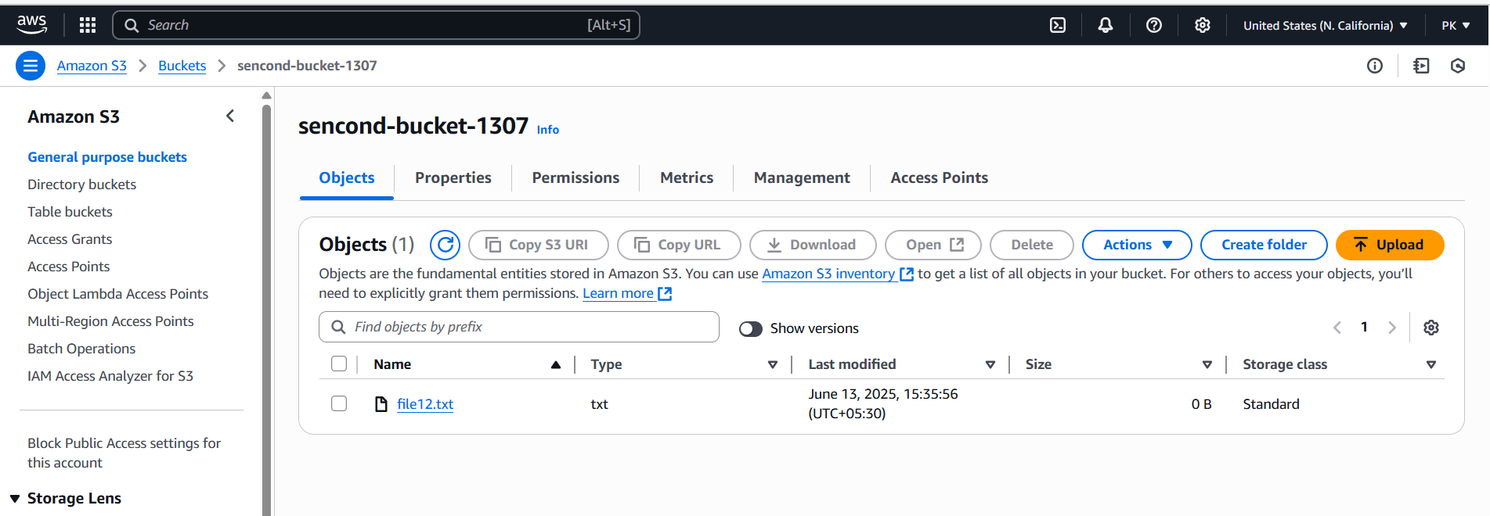

1. Configure bucket policy, only Admin user can see the objects of s3 bucket.

🡪created a user(Admin (attach policy—administrator access))—permissions—gave bucket policy permissions.

🡪login to admin user and go to s3 check there you have

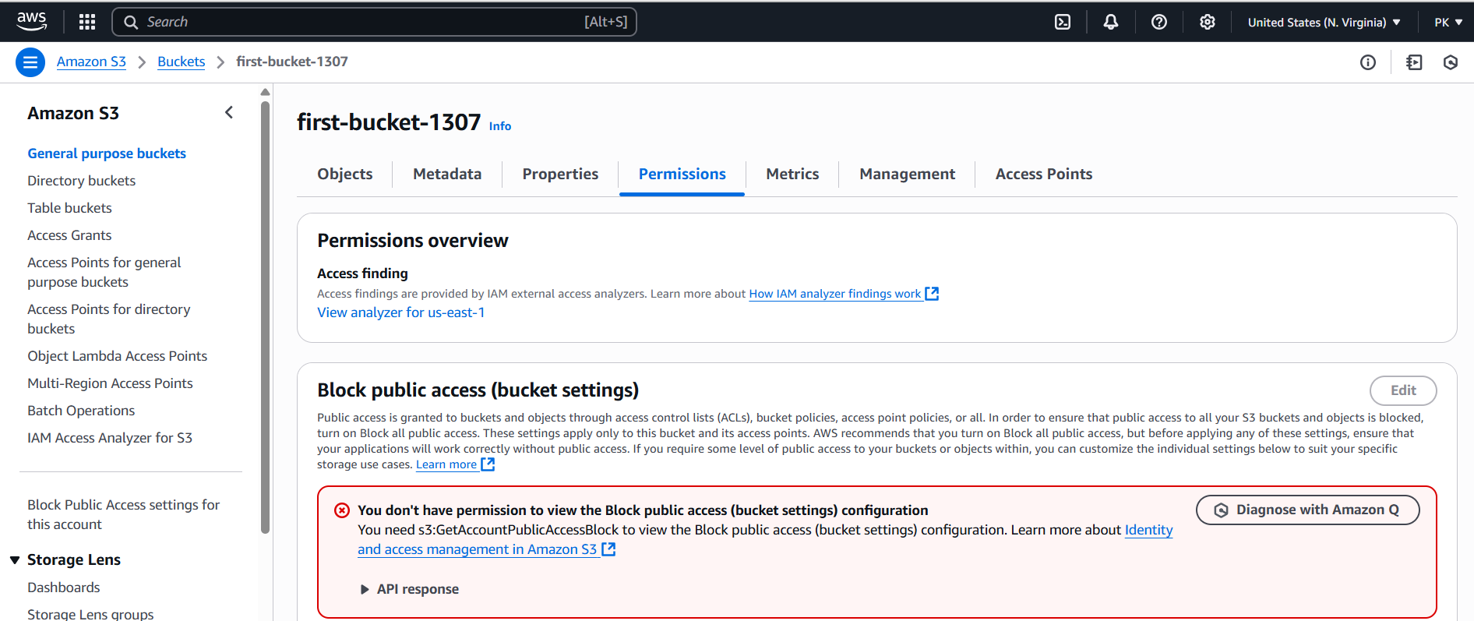

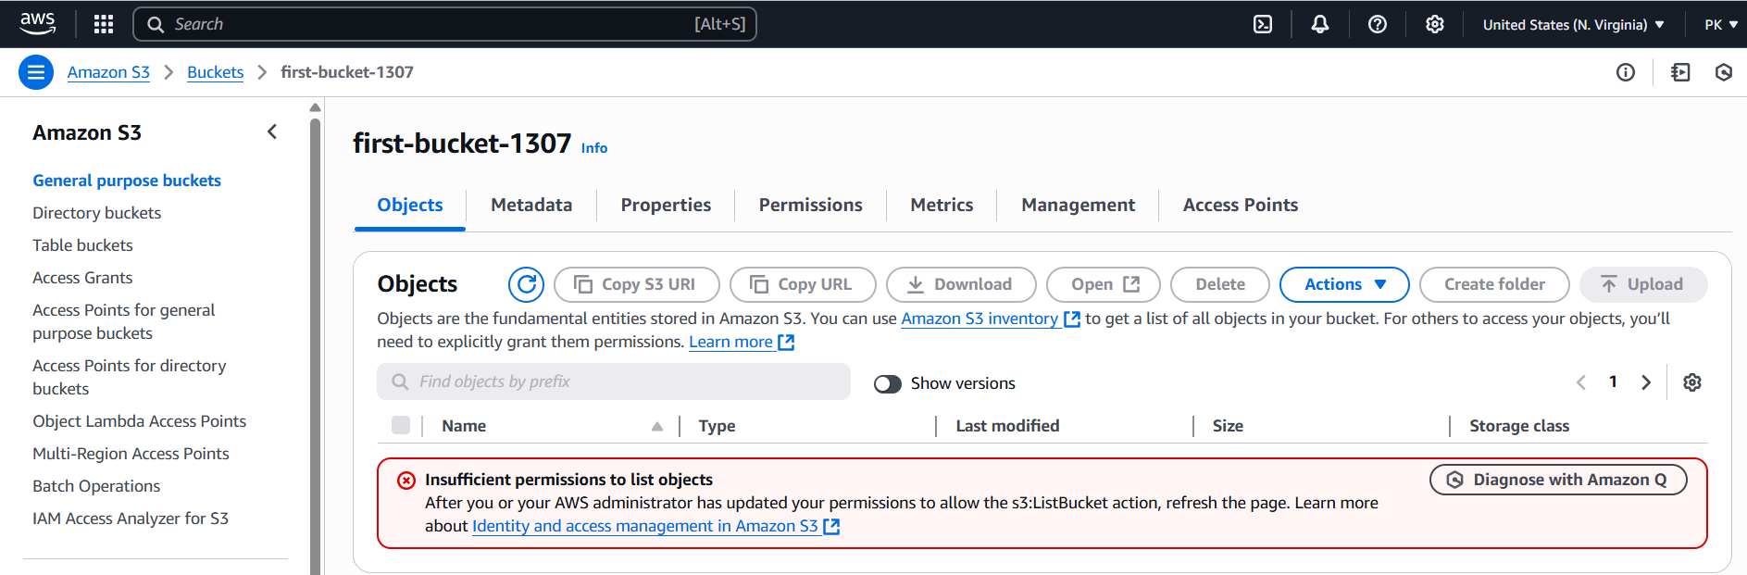

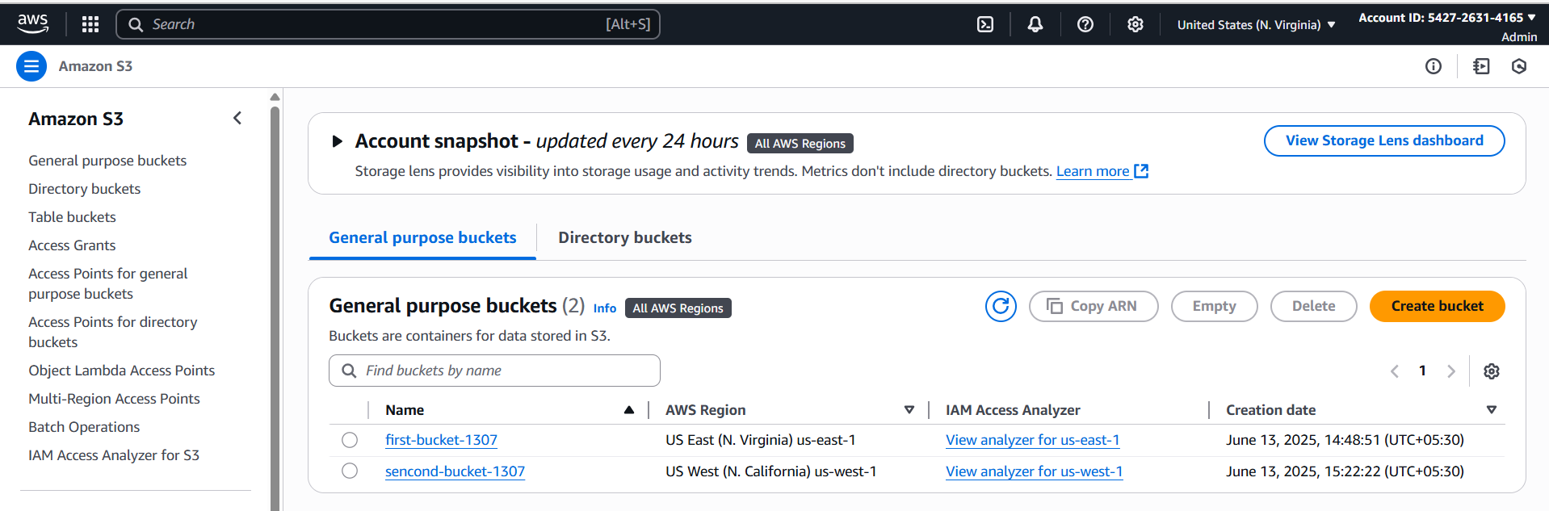

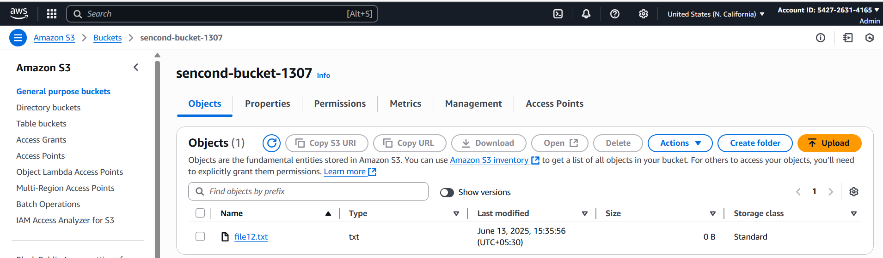

1. Setup lifecycle policies to automatically transition or delete objects based on specific criteria.

🡪select bucket—go to management tab—life cycle rules(edit life cycle rules)—give wanted details—create.

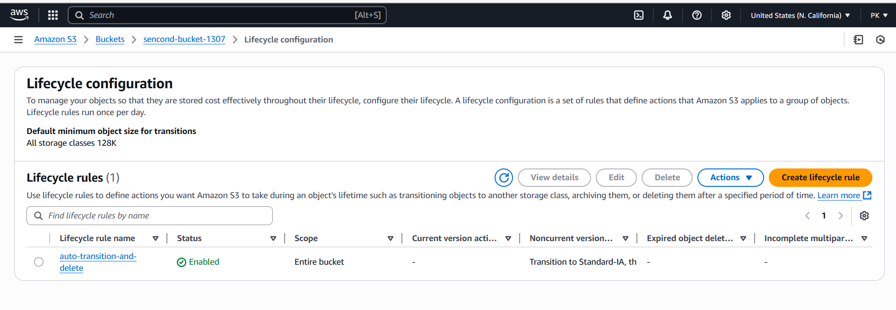

1. Push some objects in s3 using AWS CLI.

🡪download amazon CLI in gitbash and install in local windows then

🡪 echo 'export PATH="/c/Program Files/Amazon/AWSCLIV2/bin:$PATH"' >> ~/.bash_profile

source ~/.bash_profile

🡪aws configure 🡪aws s3 ls 🡪aws s3 la -a

🡪touch pavan.txt

🡪 aws s3 cp pavan.txt s3://sencond-bucket-1307/

🡪go to aws console and s3 then check in second-bucket-1307

🡪you will see added file pavan.txt.

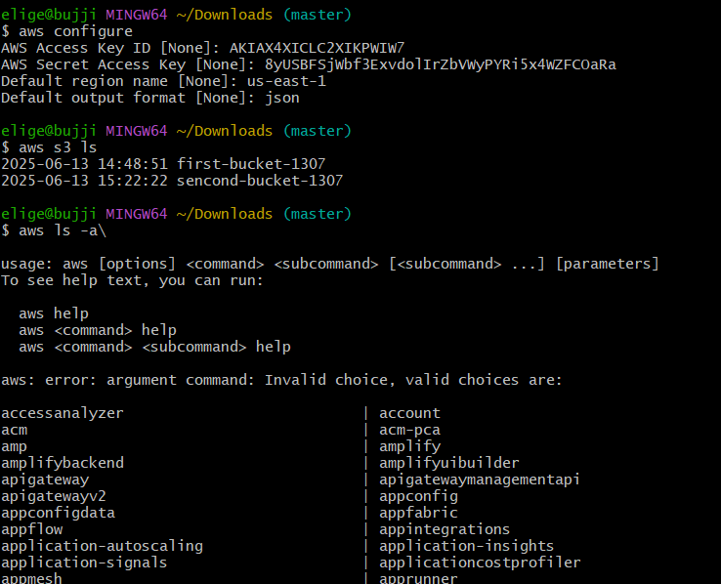

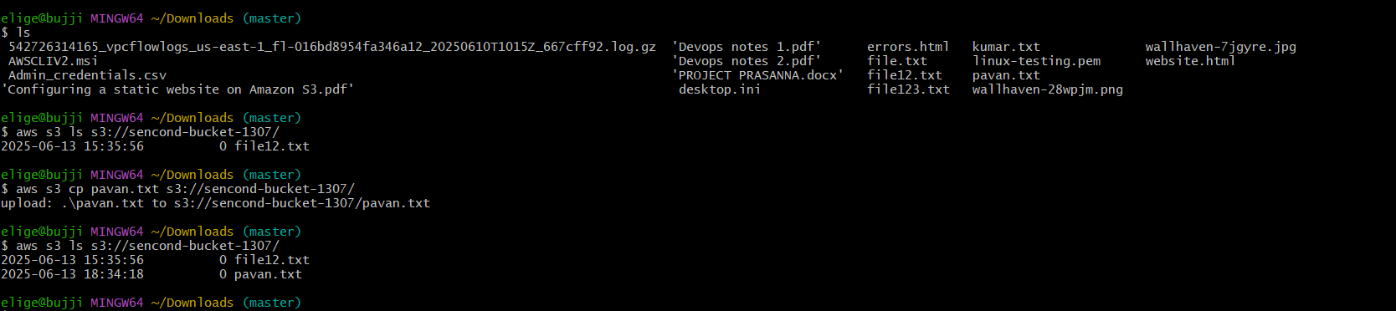

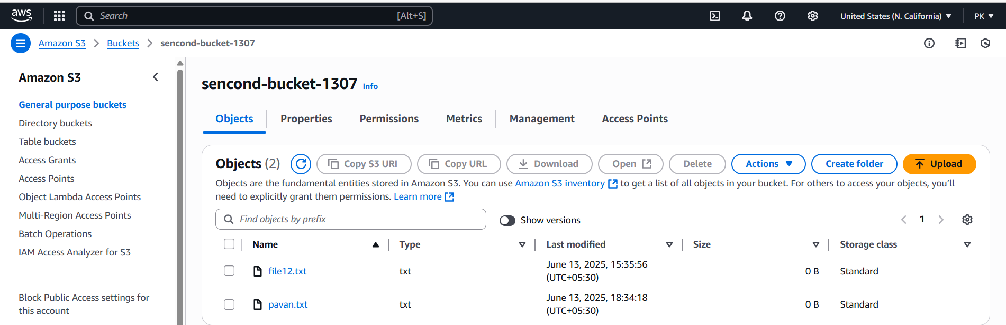

1. Write a bash script to create s3 bucket.

🡪vi my-bucket-1307 🡪add bash script

🡪chmod +x my-bucket-1307 🡪./my-bucket-1307

🡪go check in the s3 console

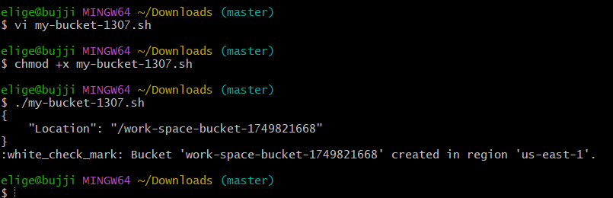

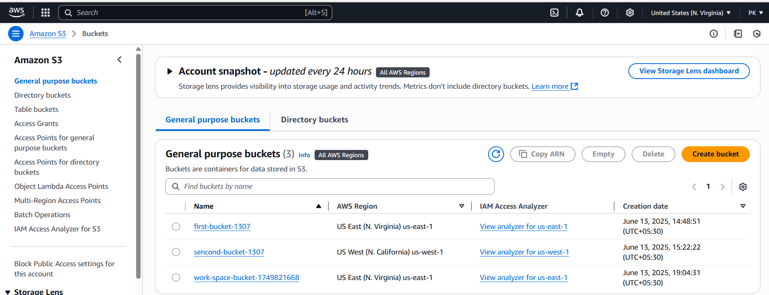

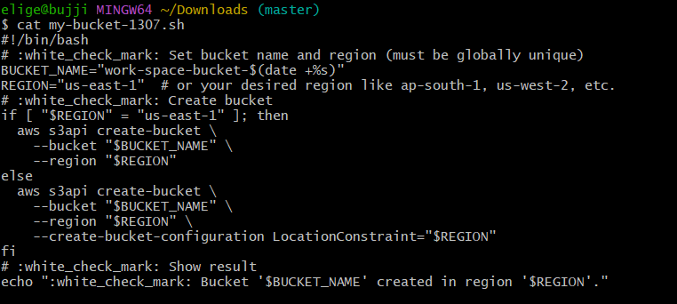

1. Upload one 1 gb of file to s3 using cli.

🡪 aws s3 cp '/c/Users/elige/Downloads/serhat durmas.mp4' s3://sencond-bucket-1307/

