1. Create one VPC,with 1 one public subnet and 1 private subnet.

🡪created one(my-vpc) on **your vpc’s**, then created one private and one public subnets on **subnets**. Assigned private to **private-RT**, public to **public-RT**.

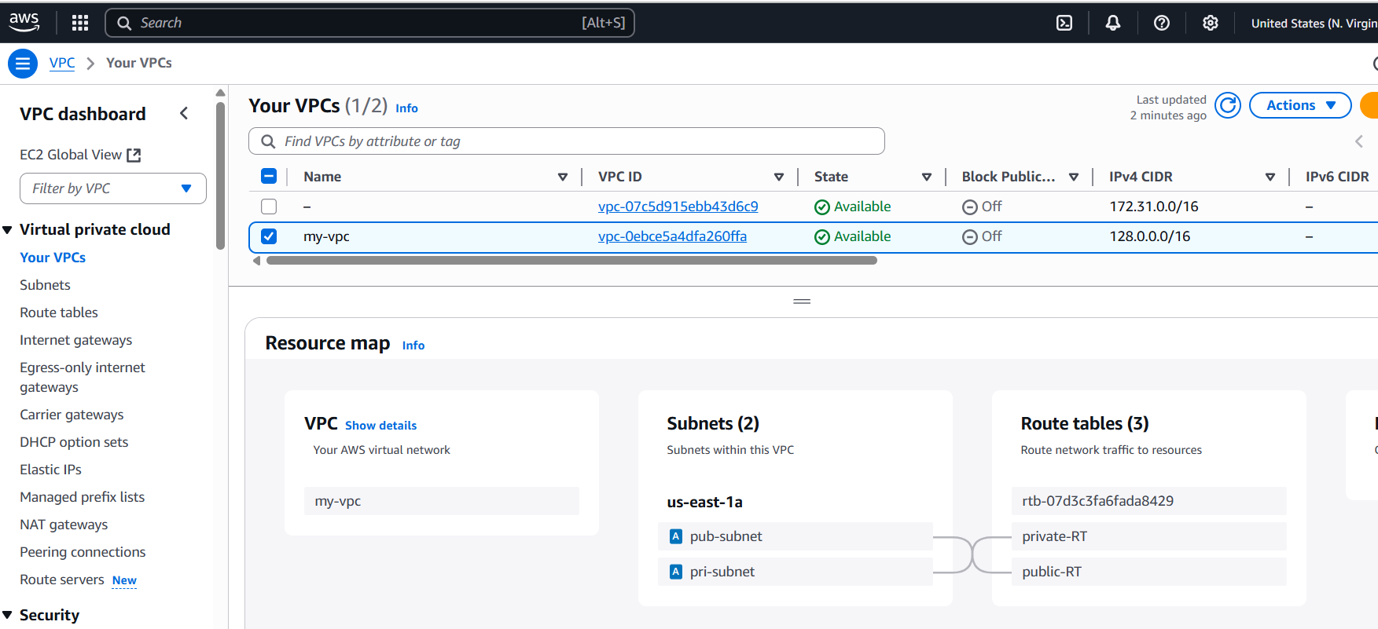

1. Enable VPC peering for cross region.

🡪created one vpc in N. Virginia and one in ohio regions

🡪peering connection is requested from N. Virginia to ohio region

🡪accepted in ohio region

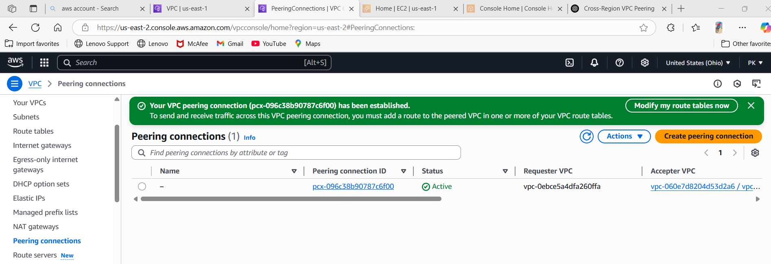

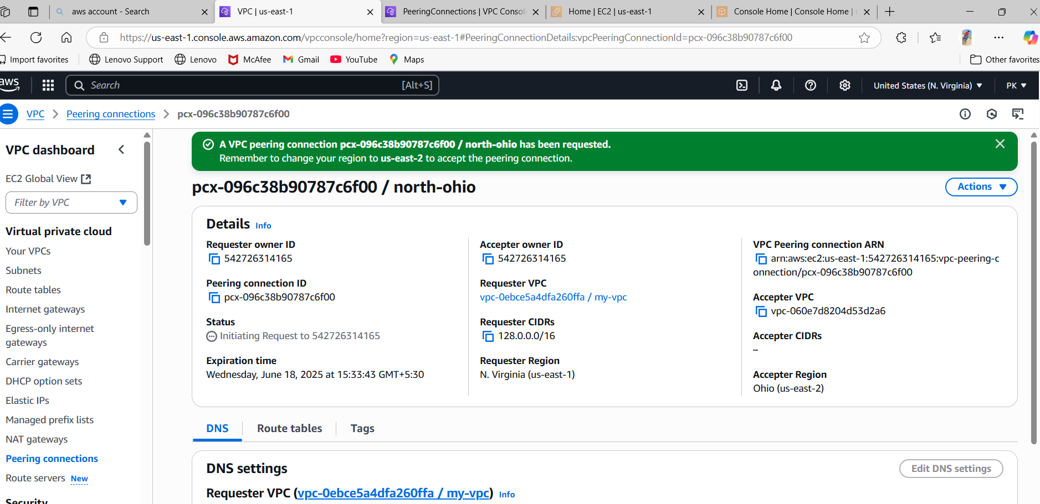

1. Enable VPC peering for cross account. (You can collaborate with your friend and do this task).

🡪created a peering request from my account(my-vpc) to tinu-account using us-east-01 region

🡪he accepted the request in peering connections tab.

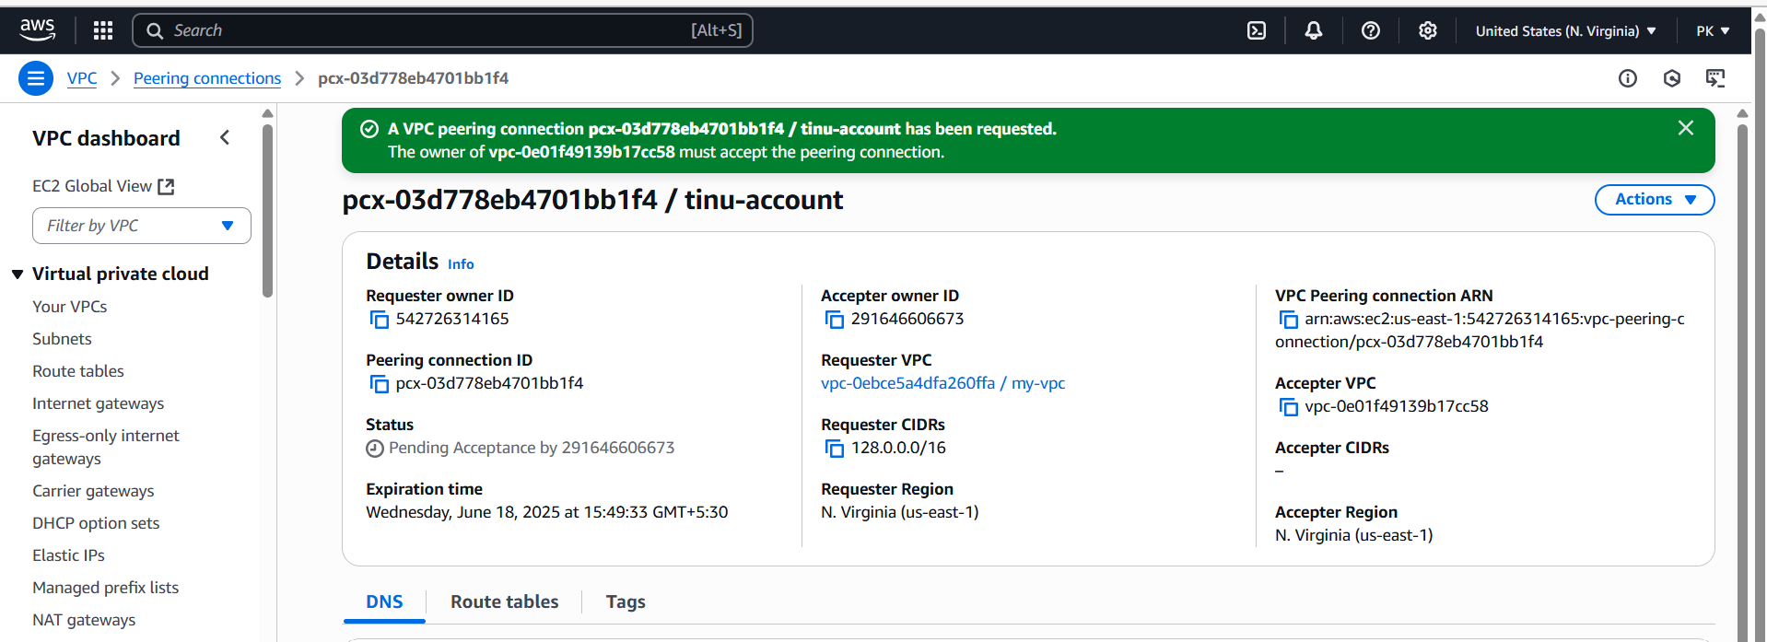

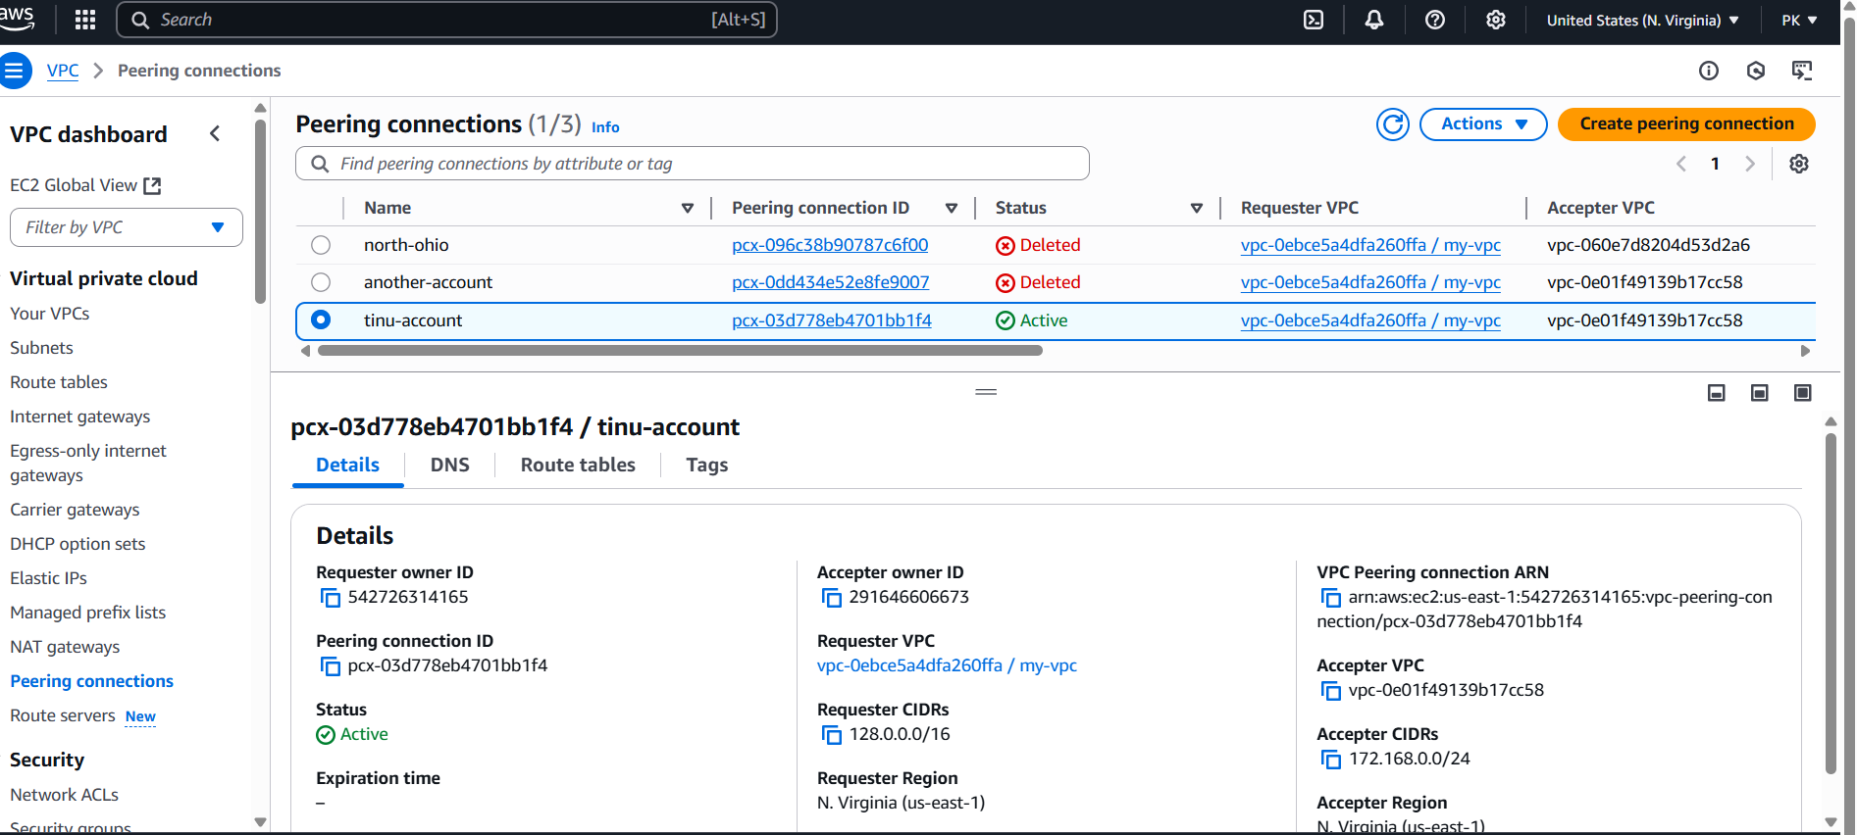

1. Setup VPC Transit gateway.

🡪

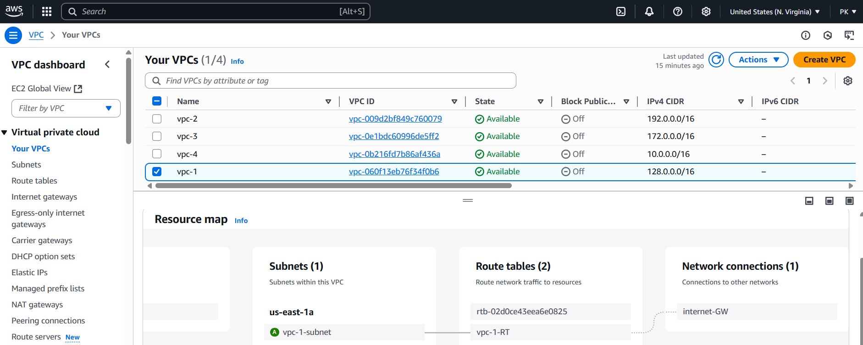

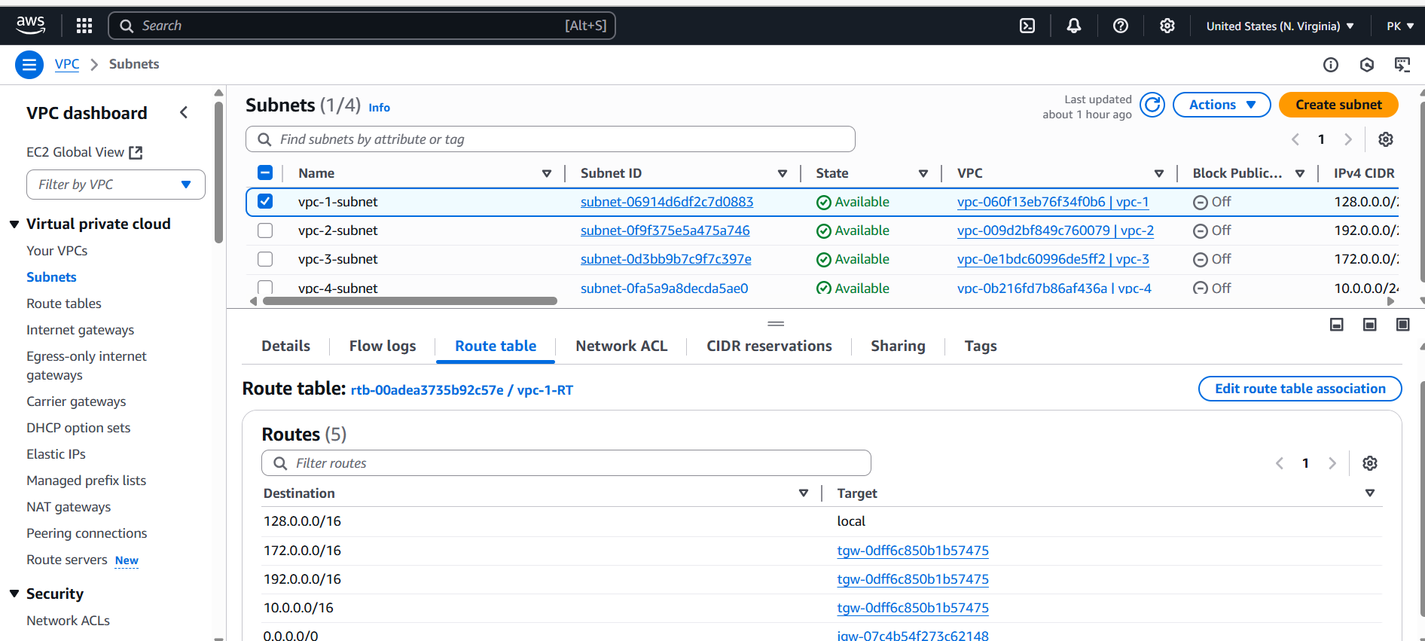

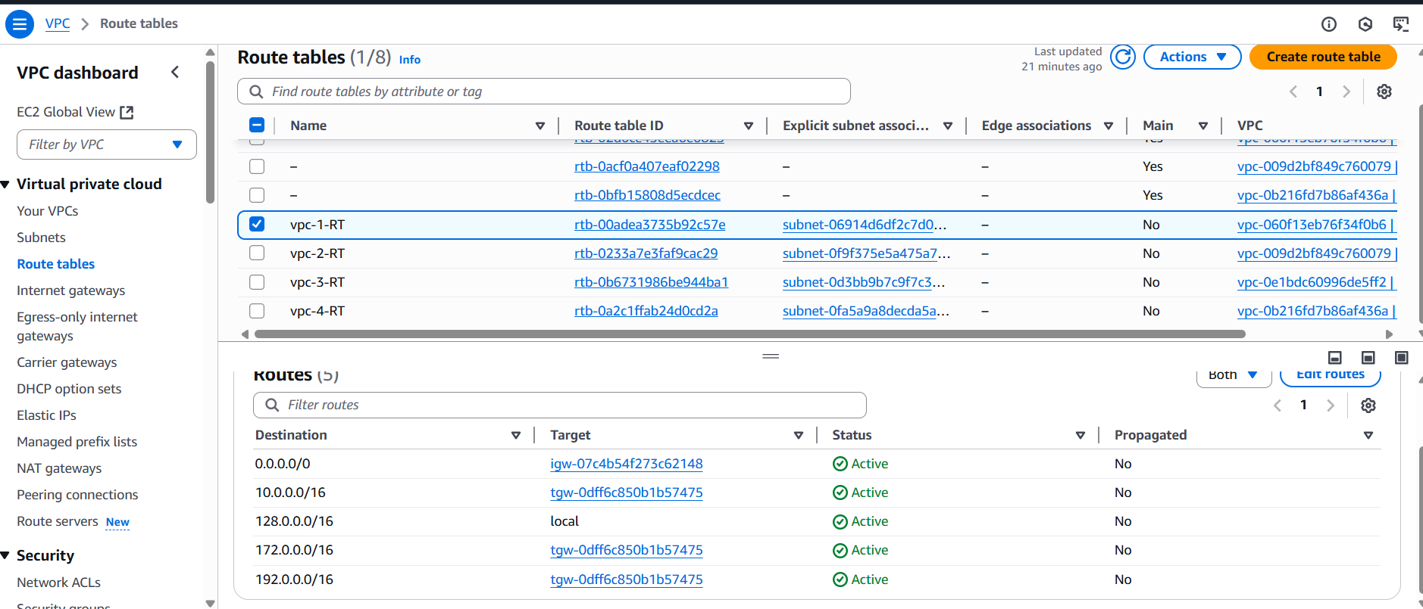

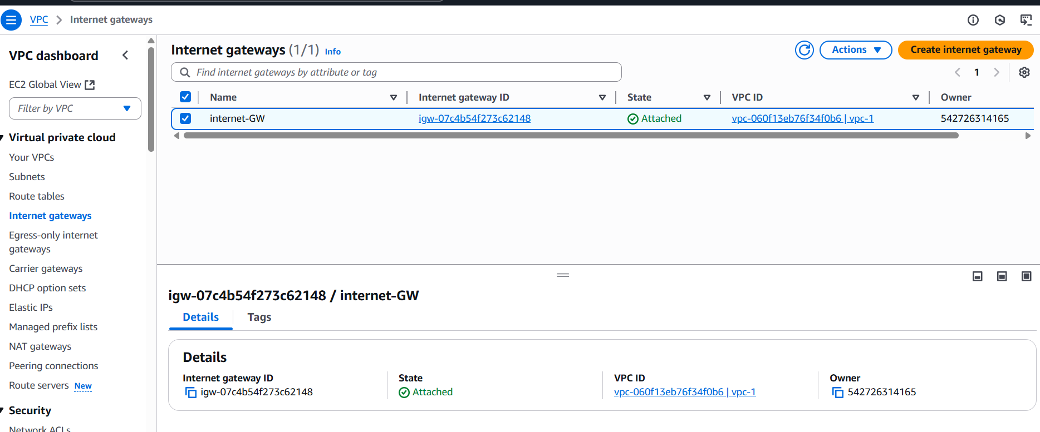

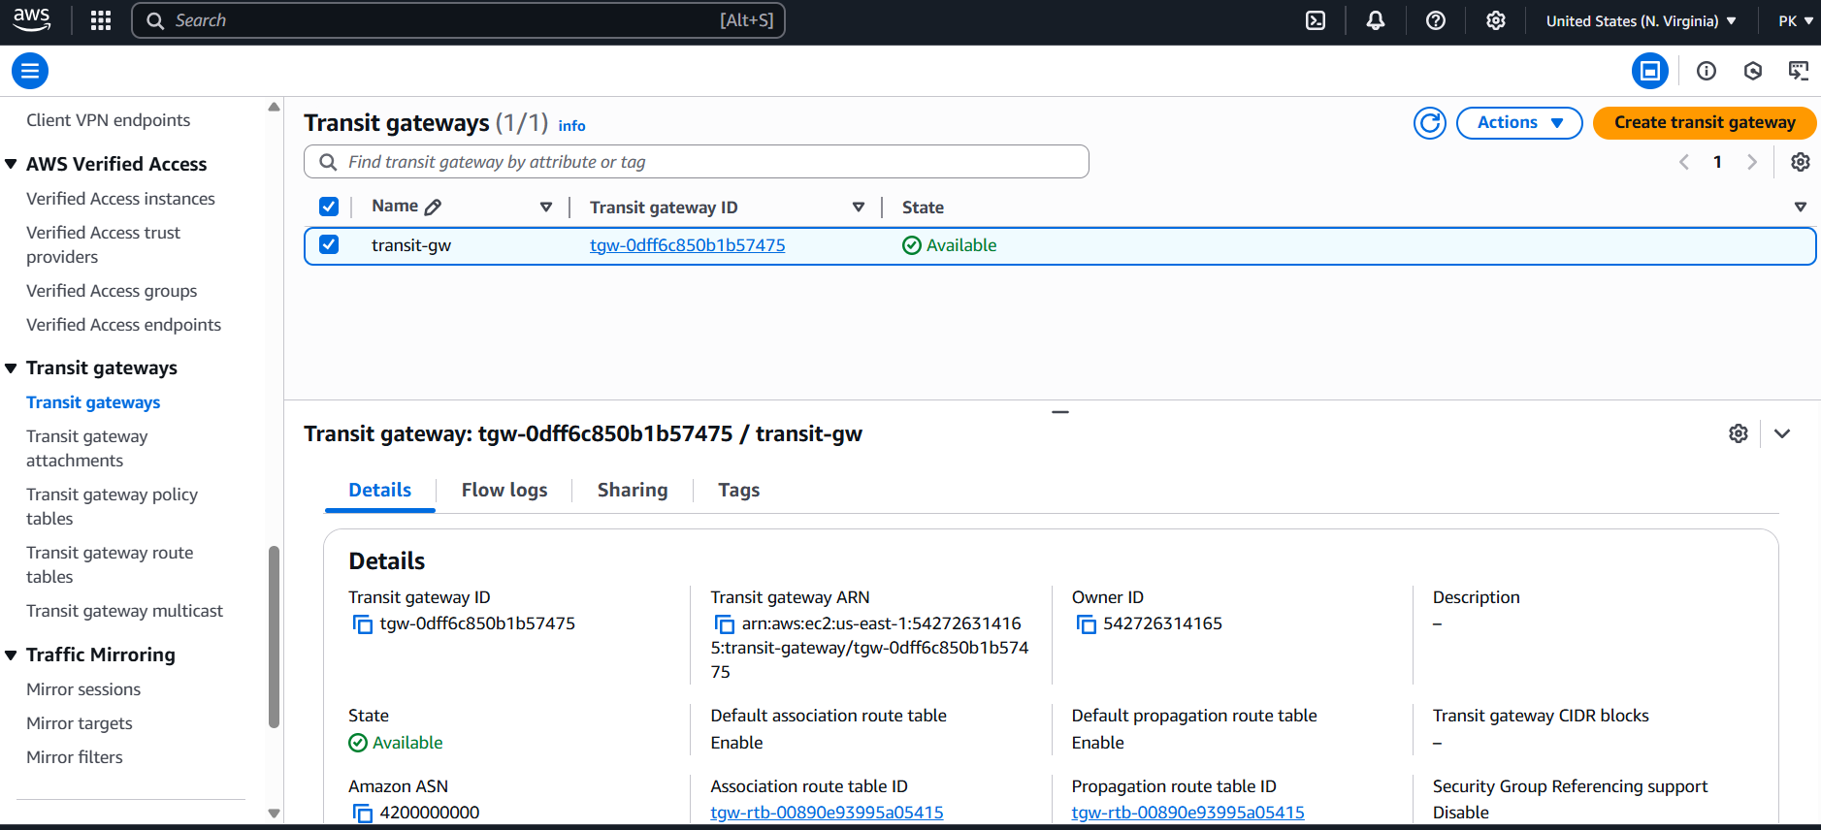

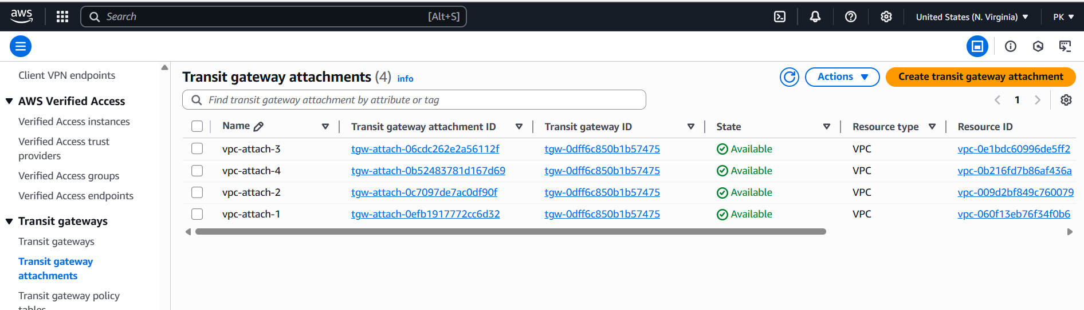

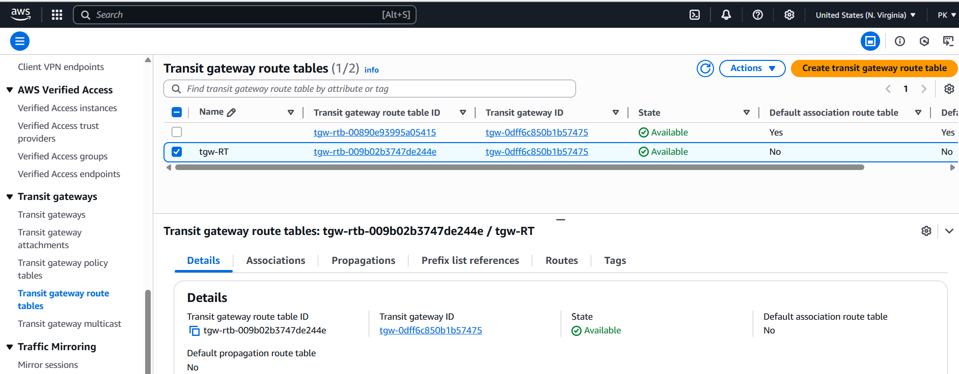

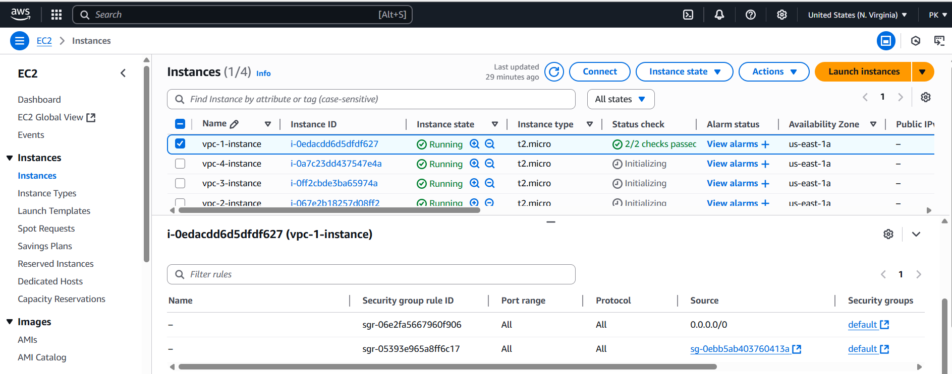

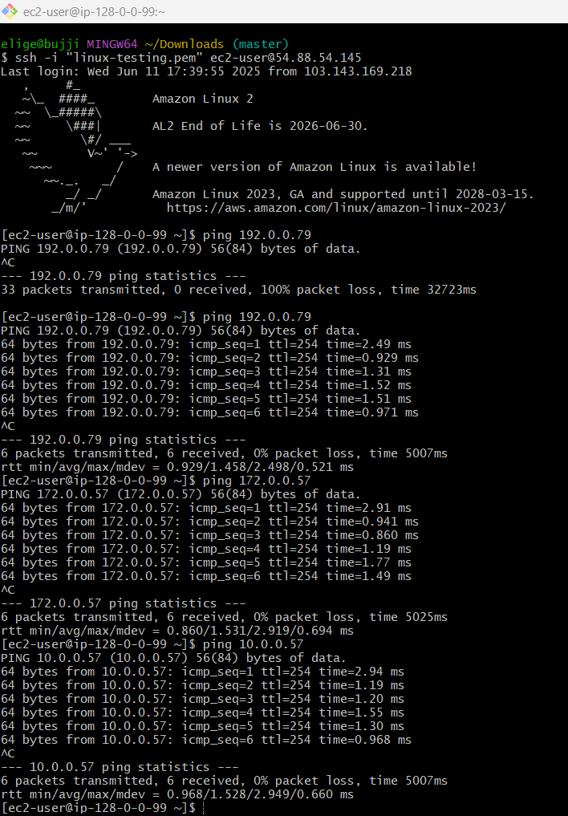

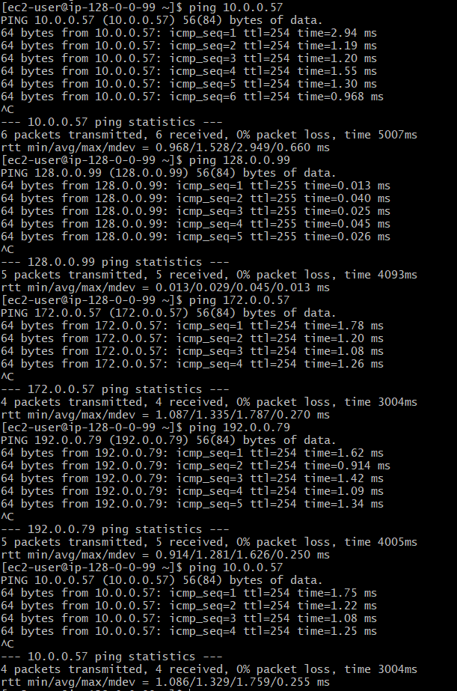

1. Setup VPC End Point.

🡪create a endpoint in endpoints service

🡪launch one instance with public subnet and one with private subnet

🡪change inbound rules to all traffic(0.0.0.0) then save

🡪connect to public ec2, then (vi test.pem) in this save the copied pem key

🡪chmod 400 test.pem

🡪ssh -i test.pem ec2-user@private ip

