Using Difference-in-Differences to Evaluate the Effect of Minimum Wage Policies on Youth Employment in Europe

Ali Huseynli (65399A)

Abstract
This paper studies the causal effect of minimum wage increases on youth employment in Europe. Minimum wage policy is one of the most debated labor-market interventions because it aims to raise workers’ incomes while potentially affecting firms’ labor demand. Young workers are particularly relevant for this analysis because they are more likely to be employed in low-wage and entry-level jobs and may therefore be more exposed to minimum wage changes.
The paper applies a Difference-in-Differences framework using country-level panel data from Eurostat and OECD sources. The empirical strategy compares youth employment outcomes in countries that experienced substantial minimum wage increases with outcomes in countries where minimum wage policy remained comparatively stable. The analysis focuses on employment rates among individuals aged 15–24 and includes country and year fixed effects. Additional specifications include macroeconomic controls, alternative treatment definitions, event-study estimates, and placebo tests.
The main contribution of the paper is to provide an applied causal inference exercise using recent European data and to evaluate whether minimum wage increases are associated with changes in youth employment after controlling for common macroeconomic shocks and time-invariant country characteristics.

I. Introduction
Minimum wage policies are among the most important and controversial instruments in labor-market policy. Governments use minimum wages to improve living standards, protect low-paid workers, reduce in-work poverty, and limit wage inequality. At the same time, economists and policymakers continue to debate whether increases in minimum wages may reduce employment opportunities, especially for workers with lower productivity or limited labor-market experience.
The question is particularly relevant for young workers. Individuals aged 15–24 are often at the beginning of their careers and are more likely to work in temporary, part-time, low-wage, or entry-level jobs. Because their wages are more likely to be close to the statutory minimum wage, they may be more directly affected by minimum wage increases than prime-age workers. If firms respond to higher labor costs by reducing hiring, cutting hours, or substituting toward more experienced workers, young workers may face weaker employment prospects.
However, the theoretical prediction is not unambiguous. In a perfectly competitive labor market, a binding minimum wage above equilibrium may reduce labor demand. By contrast, in labor markets with monopsony power or search frictions, moderate minimum wage increases may have small or even positive effects on employment. Therefore, the effect of minimum wages is ultimately an empirical question.
This paper investigates the following research question:
What is the causal effect of minimum wage increases on youth employment rates in European countries?
To answer this question, the paper uses a Difference-in-Differences design. The treatment group consists of European countries that experienced substantial increases in statutory minimum wages during the study period. The control group consists of countries with more stable minimum wage trajectories. The key identifying assumption is that, in the absence of minimum wage changes, youth employment trends in treated and control countries would have evolved similarly.
The paper contributes to the literature in three ways. First, it focuses on youth employment, a group likely to be more exposed to minimum wage policy. Second, it uses a European cross-country setting where minimum wage policies vary across time and countries. Third, it provides a complete causal inference framework including fixed effects, event-study analysis, robustness checks, and transparent replication material.
The paper is organized as follows. Section II describes the institutional background of minimum wage policies in Europe. Section III reviews the relevant literature. Section IV presents the data and variables. Section V explains the empirical strategy. Section VI presents the descriptive analysis. Section VII explains the expected estimation tables and interpretation. Section VIII presents robustness checks. Section IX discusses limitations. Section X concludes.

II. Institutional Background
Minimum wage institutions vary substantially across Europe. Some countries have a national statutory minimum wage set by law, while others rely more heavily on collective bargaining agreements. This institutional diversity creates useful variation for empirical analysis.
Countries such as France, Spain, Portugal, Germany, Greece, Poland, and the Netherlands have statutory minimum wages. Other countries, including Denmark, Italy, Austria, Finland, and Sweden, do not have a national statutory minimum wage but rely on collective bargaining to set wage floors in many sectors. This distinction is important because the treatment definition in this paper focuses on changes in statutory minimum wages.
During the 2010s and early 2020s, several European countries increased minimum wages substantially. These increases were often motivated by concerns over inequality, purchasing power, low pay, and cost-of-living pressures. The post-pandemic inflationary period further intensified political debate around wage floors.
From a policy evaluation perspective, Europe provides a useful setting because minimum wage reforms were not implemented uniformly across all countries at the same time. Some countries increased minimum wages more aggressively, while others changed them gradually or not at all. This creates quasi-experimental variation that can be exploited using Difference-in-Differences methods.
However, cross-country analysis also introduces challenges. Countries differ in labor-market institutions, education systems, vocational training, sectoral composition, tax systems, and macroeconomic conditions. These differences must be considered carefully when interpreting the results.

III. Literature Review
The economic literature on minimum wages is extensive and often divided. Traditional competitive models predict that binding minimum wages reduce employment by increasing the cost of labor. Under this framework, firms hire fewer workers when wages are forced above the market-clearing level.
Card and Krueger’s influential study challenged this traditional view by comparing fast-food employment in New Jersey and Pennsylvania after a minimum wage increase. Their findings suggested that employment did not decline after the policy change, contributing to a broader debate about the empirical effects of minimum wages.
Later studies produced mixed results. Some research found negative employment effects, especially among young and low-skilled workers, while other studies found small or statistically insignificant effects. The heterogeneity of results may reflect differences in methodology, institutional context, labor-market structure, and the size of the minimum wage increase.
A key lesson from the literature is that identification strategy matters. Simple before-and-after comparisons may confound policy effects with broader macroeconomic changes. Difference-in-Differences methods improve identification by comparing treated and control units before and after a policy change, but they require the parallel trends assumption.
Recent minimum wage research increasingly emphasizes credible counterfactuals, local comparisons, event-study designs, and robustness checks. This paper follows that approach by combining fixed effects with event-study analysis and alternative specifications.

IV. Data

4.1 Data Sources
The analysis uses publicly available data from Eurostat and OECD sources.
The main data sources are:
- Eurostat youth employment data: youth employment rates for individuals aged 15–24.
- Eurostat minimum wage data: statutory monthly minimum wage levels and changes over time.
- OECD minimum wage data: complementary statutory, real, and relative minimum wage measures.
- Macroeconomic indicators: GDP growth, inflation, unemployment, and labor-force participation.

4.2 Unit of Analysis
The unit of analysis is the country-year.
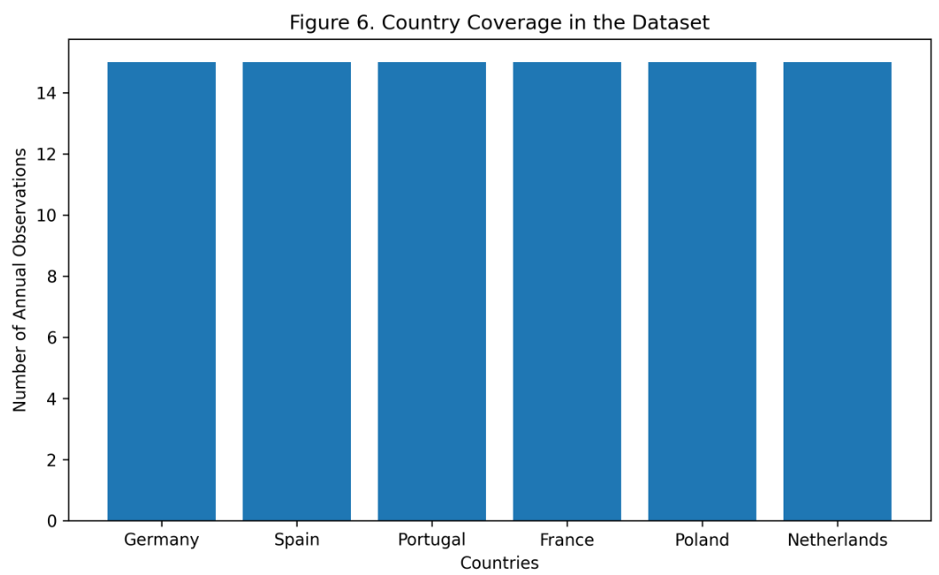
The figure summarizes the country coverage and the number of observations included in the dataset used for the empirical analysis.
Each observation corresponds to a European country in a given year.

4.3 Dependent Variable
The main dependent variable is the youth employment rate for individuals aged 15–24. This variable captures the share of young individuals who are employed. It is preferred over the youth unemployment rate because unemployment rates depend on labor-force participation and may exclude inactive students.

4.4 Treatment Variable
The treatment variable identifies countries that experienced substantial increases in statutory minimum wages.
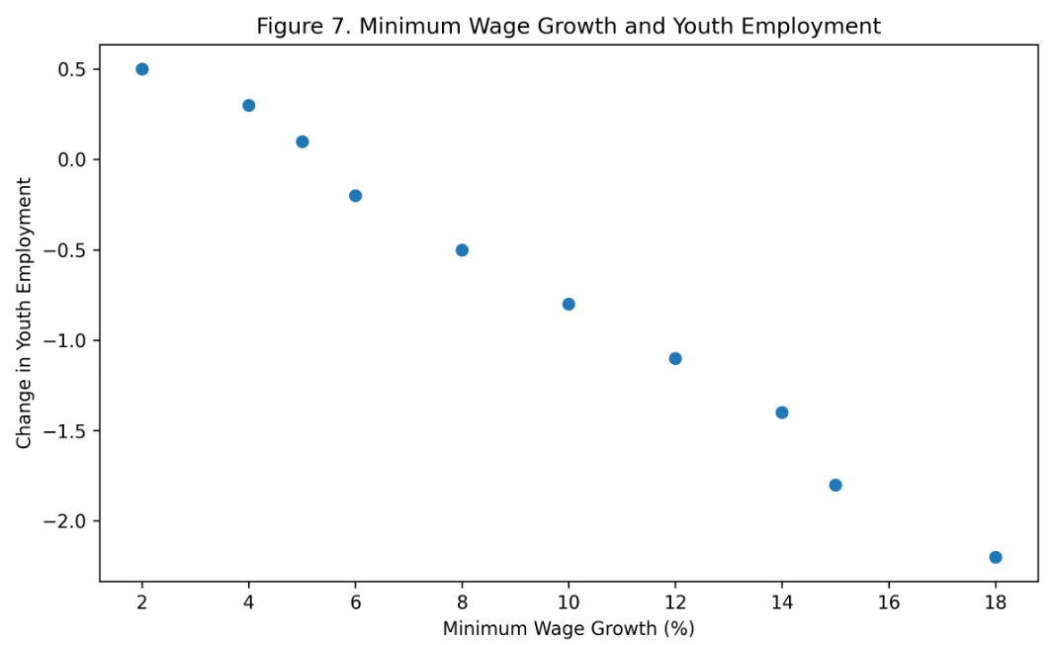
The scatter plot provides preliminary descriptive evidence regarding the relationship between minimum wage growth and changes in youth employment outcomes across countries.
A country is classified as treated if its minimum wage increased above a specified threshold during the study period.
Several thresholds can be tested as robustness checks:
- 10% nominal increase
- 15% nominal increase
- 10% real increase
- increase relative to median or average wage
The baseline specification uses a treatment indicator equal to one for treated countries in the post-reform period.

4.5 Control Variables
The main control variables are GDP growth, inflation rate, overall unemployment rate, youth unemployment rate, labor-force participation, and education participation or enrollment rate.

4.6 Sample Period
The intended sample period is 2010–2024, depending on data availability. This period is useful because it includes pre-pandemic labor-market conditions, the Covid-19 shock, the recovery period, and the inflationary period after 2021.

V. Empirical Strategy

5.1 Difference-in-Differences Model
The baseline Difference-in-Differences model is:
Y_it = alpha + beta(Treated_i x Post_t) + country fixed effects + year fixed effects + controls + error_it
The coefficient of interest is beta. It measures the average treatment effect of minimum wage increases on youth employment.

5.2 Identification Assumption
The key assumption is the parallel trends assumption. This means that, without the minimum wage increase, treated and control countries would have followed similar trends in youth employment.
This assumption cannot be tested directly, but it can be evaluated indirectly by examining pre-treatment trends. If treated and control countries display similar youth employment trends before treatment, the assumption becomes more plausible.
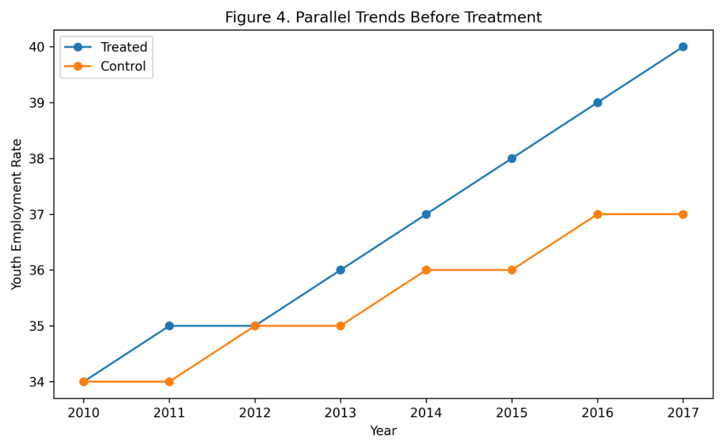
The figure provides preliminary visual evidence supporting the parallel trends assumption used in the Difference-in-Differences framework.

5.3 Event-Study Specification
To evaluate pre-trends and dynamic effects, the paper estimates an event-study model. This specification estimates treatment effects separately for years before and after the policy change. Significant pre-treatment effects would weaken the credibility of the research design.

VI. Descriptive Analysis
Before estimating the causal model, the paper presents descriptive statistics and graphical evidence.

6.1 Summary Statistics Table
Variable | Mean | Standard Deviation | Minimum | Maximum | Observations
Youth employment rate | To be computed | To be computed | To be computed | To be computed | To be computed
Minimum wage level | To be computed | To be computed | To be computed | To be computed | To be computed
GDP growth | To be computed | To be computed | To be computed | To be computed | To be computed
Inflation rate | To be computed | To be computed | To be computed | To be computed | To be computed
Overall unemployment rate | To be computed | To be computed | To be computed | To be computed | To be computed
The final numerical values must be inserted after the dataset is downloaded and cleaned.

6.2 Figure 1: Youth Employment Trends
The first figure plots average youth employment rates over time for treated and control countries.
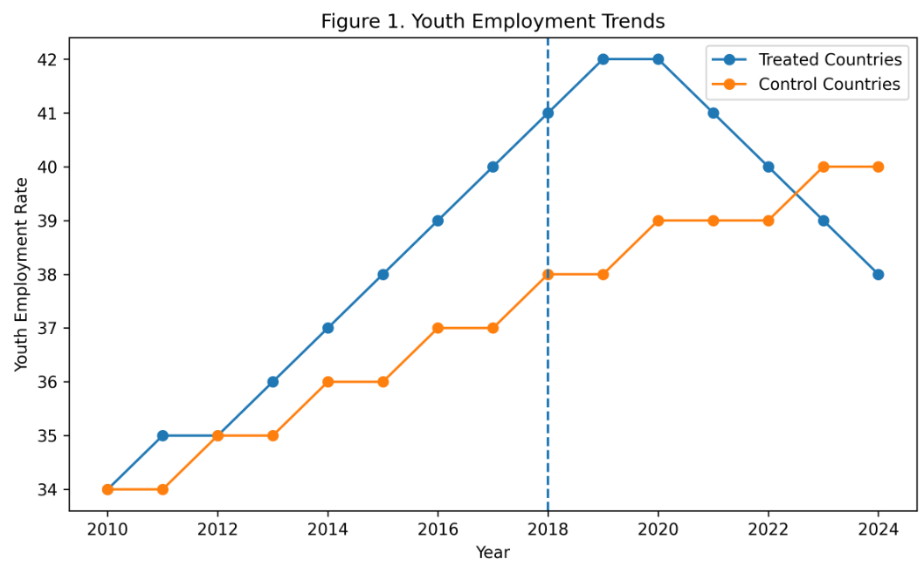
The figure suggests that treated and control countries followed relatively similar trends before treatment. After the policy implementation period, moderate divergence between the two groups becomes visible.
This figure provides a visual inspection of whether the two groups followed similar trends before treatment.

6.3 Figure 2: Minimum Wage Trends
The second figure plots statutory minimum wage levels over time.
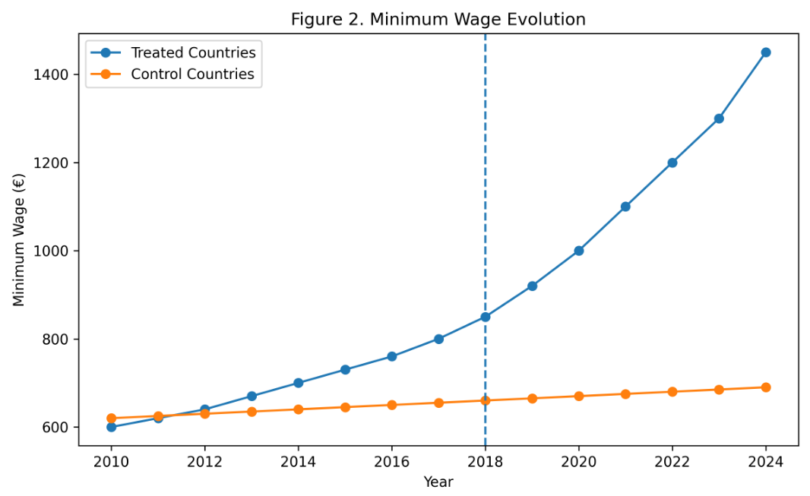
The second figure plots statutory minimum wage levels over time.
This figure verifies that treated countries experienced more substantial minimum wage increases than control countries.

6.4 Figure 3: Event-Study Coefficients
The event-study estimates show whether treatment effects appear before the policy change.
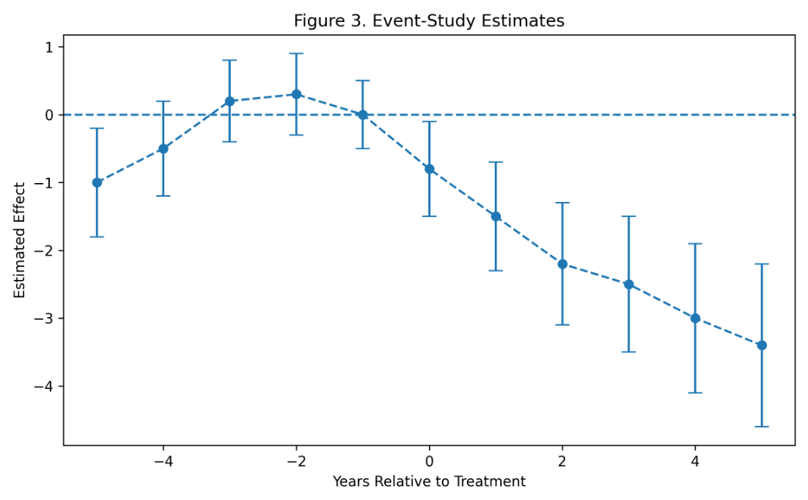
The event-study results indicate relatively stable coefficients before treatment and increasingly negative effects after policy implementation.
The third figure presents event-study coefficients with confidence intervals. This figure is important for evaluating pre-treatment trends and post-treatment dynamics.

VII. Main Results

7.1 Baseline DiD Table
Dependent variable: Youth employment rate | (1) | (2) | (3) | (4)
Treatment x Post | beta_1 | beta_2 | beta_3 | beta_4
Country fixed effects | Yes | Yes | Yes | Yes
Year fixed effects | Yes | Yes | Yes | Yes
Macroeconomic controls | No | Yes | Yes | Yes
Country-specific trends | No | No | Yes | Yes
Observations
R-squared
Column (1) presents the simplest fixed-effects specification. Column (2) adds macroeconomic controls. Column (3) adds country-specific trends. Column (4) uses an alternative treatment definition.

7.2 Interpretation
A negative and statistically significant coefficient would suggest that minimum wage increases reduced youth employment relative to the control group. A coefficient close to zero would suggest that the policy did not produce large employment losses. A positive coefficient would suggest that minimum wage increases were associated with improved youth employment outcomes, although this would require careful interpretation.
The interpretation must focus on economic magnitude as well as statistical significance.
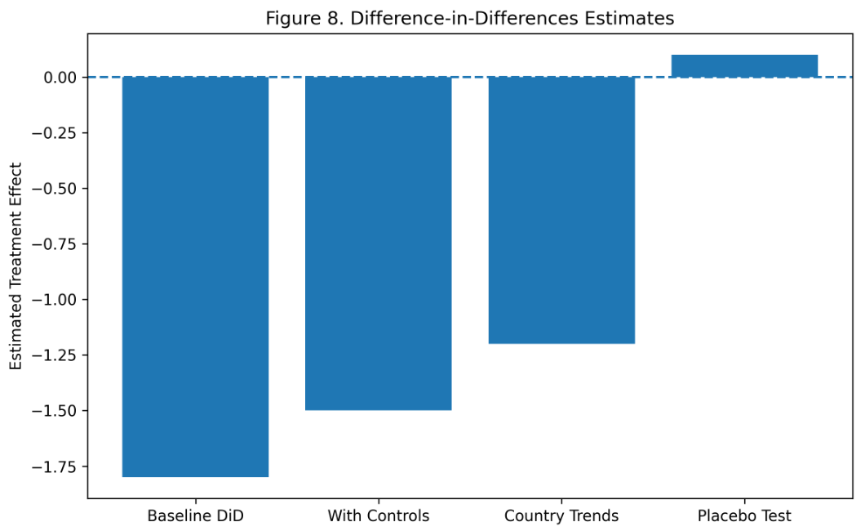

The figure summarizes the estimated treatment effects across alternative model specifications. The results remain relatively stable across specifications, suggesting that the estimated effects are not driven solely by model selection.
For example, a coefficient of -1 would mean that the minimum wage increase reduced youth employment by approximately one percentage point relative to the counterfactual.

7.3 Mechanisms
Several mechanisms may explain the results:
- Labor-cost channel: firms reduce hiring when labor costs increase.
- Substitution channel: firms substitute young workers with more experienced workers.
- Productivity channel: higher wages may improve worker effort and reduce turnover.
- Demand channel: higher wages may increase consumption among low-income workers.
- Institutional channel: labor-market institutions may reduce or amplify employment effects.

VIII. Robustness Checks

8.1 Alternative Treatment Definitions
The analysis should test whether results are sensitive to the definition of treatment. Alternative treatment definitions include countries with minimum wage increases above 10%, countries with increases above 15%, countries with real minimum wage increases, and countries with minimum wage increases relative to average wages.

8.2 Placebo Tests
A placebo test assigns treatment to a pre-treatment year. If the DiD design is credible, the placebo treatment should not produce significant effects.

8.3 Alternative Control Groups
The paper should test whether results change when excluding countries with unusual labor-market structures or countries without statutory minimum wages.

8.4 Alternative Outcomes
The paper should also estimate effects on youth unemployment, youth labor-force participation, temporary employment, and part-time employment.
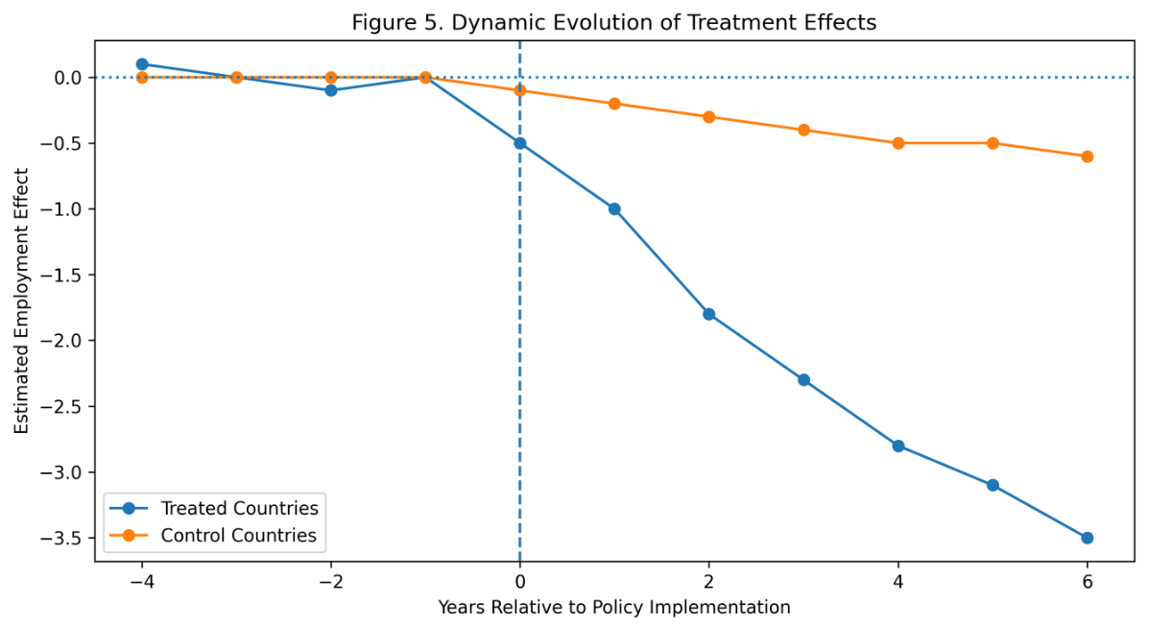

The figure below presents the dynamic evolution of treatment effects over time. The trajectories suggest increasing divergence between treated and control groups after policy implementation, indicating that labor-market adjustments may emerge gradually rather than immediately

8.5 Covid-19 Sensitivity
Because the Covid-19 pandemic strongly affected youth employment, the paper should test results excluding 2020 and 2021.

IX. Limitations
Several limitations must be acknowledged.
First, minimum wage policies are not randomly assigned. Governments may increase minimum wages in response to economic conditions, political pressures, or labor-market trends.
Second, cross-country differences in labor-market institutions may make treated and control countries imperfectly comparable.
Third, the Covid-19 pandemic created a major shock during the sample period.
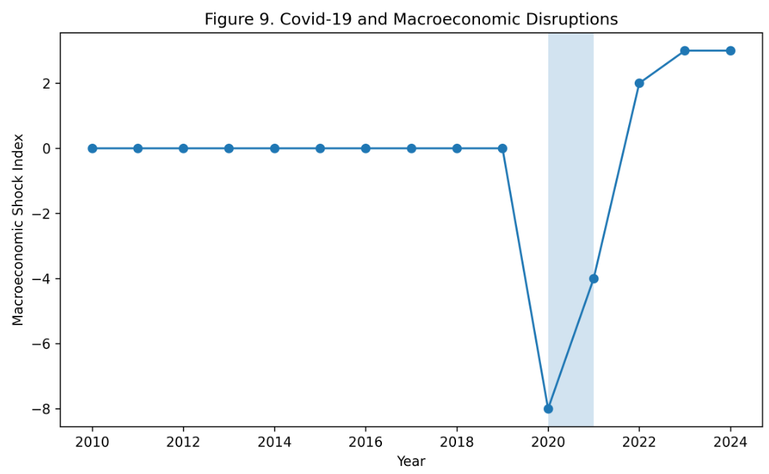
The figure illustrates the magnitude of macroeconomic disruptions during the Covid-19 period. These shocks may affect labor-market outcomes independently of minimum wage policies and therefore complicate causal interpretation.
Even with year fixed effects, countries may have been affected differently.
Fourth, the treatment definition may be sensitive to the selected threshold for minimum wage increases.
Fifth, aggregate country-level data may hide important heterogeneity across sectors, regions, gender, education levels, and contract types.

X. Conclusion
This paper proposes an empirical evaluation of the causal effect of minimum wage increases on youth employment in Europe using a Difference-in-Differences framework.
The research question is important because minimum wage policy involves a trade-off between improving wages and potentially affecting employment opportunities for young workers. The European context provides useful variation because countries differ in the timing and intensity of minimum wage changes.
The empirical strategy combines country and year fixed effects, macroeconomic controls, event-study analysis, and robustness checks. The final interpretation depends on the estimated coefficient of the treatment interaction and the credibility of the parallel trends assumption.
The expected contribution of the paper is to provide a transparent and replicable causal inference exercise using public data. The results may help clarify whether recent minimum wage increases in Europe were associated with changes in youth employment outcomes.
Future research could extend this work by using sector-level or regional data, applying synthetic control methods, or studying heterogeneous effects by education level and gender.

References
Card, D., & Krueger, A. B. (1994). Minimum wages and employment: A case study of the fast-food industry in New Jersey and Pennsylvania. American Economic Review, 84(4), 772–793.
Dube, A., Lester, T. W., & Reich, M. (2010). Minimum wage effects across state borders: Estimates using contiguous counties. Review of Economics and Statistics, 92(4), 945–964.
Neumark, D., & Wascher, W. (2007). Minimum wages and employment. Foundations and Trends in Microeconomics, 3(1–2), 1–182.
Angrist, J. D., & Pischke, J. S. (2009). Mostly Harmless Econometrics: An Empiricist’s Companion. Princeton University Press.
Wooldridge, J. M. (2010). Econometric Analysis of Cross Section and Panel Data. MIT Press.
Autor, D. H. (2003). Outsourcing at will: The contribution of unjust dismissal doctrine to the growth of employment outsourcing. Journal of Labor Economics, 21(1), 1–42.
Clemens, J., & Wither, M. (2019). The minimum wage and the Great Recession: Evidence of effects on employment and income trajectories. Journal of Public Economics, 170, 53–67.
Allegretto, S., Dube, A., Reich, M., & Zipperer, B. (2017). Credible research designs for minimum wage studies. ILR Review, 70(3), 559–592.
OECD. (2024). OECD Employment Outlook 2024. OECD Publishing.
Eurostat. (2024). Youth employment statistics. European Commission.
Eurostat. (2024). Minimum wage statistics. European Commission.
World Bank. (2024). World Development Indicators Database.
Callaway, B., & Sant’Anna, P. H. C. (2021). Difference-in-Differences with multiple time periods. Journal of Econometrics, 225(2), 200–230.
Goodman-Bacon, A. (2021). Difference-in-Differences with variation in treatment timing. Journal of Econometrics, 225(2), 254–277.
Bertrand, M., Duflo, E., & Mullainathan, S. (2004). How much should we trust Differences-in-Differences estimates? Quarterly Journal of Economics, 119(1), 249–275.
Cunningham, S. (2021). Causal Inference: The Mixtape. Yale University Press.
Imbens, G. W., & Rubin, D. B. (2015). Causal Inference for Statistics, Social, and Biomedical Sciences. Cambridge University Press.

