HRL Holdings Vs. Urban Development Authority: Legal Notes
Table of Contents

1 Abstract
First Steps: Empirical Study of Sri Lanka’s Apex Courts with a Focus on Public Law Litigation
Elijah Hoole, Dinesha Samararatne, Yanitra Kumaraguru and Amanda Halliday
What is the impact of the day to day issuance of judgements by a court on the development of the law and on the legal system more broadly? How should that impact be identified and examined? This article is an early attempt to use computational methods to answer these questions. We have compiled a database to interpret the jurisprudence of Sri Lanka’s appellate courts between 2012 – 2022. The corpus, CDTextLK, contains 1278 Supreme Court decisions and 7314 Court of Appeal decisions. By applying computational methods to CDTextLK we identify six key insights that enable us to present a more granular, realistic account of the work of Sri Lanka’s appellate courts. They include descriptive statistics and visualisations on the performance of the courts such as average time taken for a decision, average length of decision, and proportion of allowed and dismissed cases as well as mutual information analysis and topic modelling to reveal some latent themes in decision texts. These insights help us to reveal and demonstrate the ordinary life and effect of the appellate courts, challenge received wisdom on how to study courts, where to look for knowledge and ultimately, disrupts our traditional assessment of court decision. These findings and implications, we argue, provide a necessary corrective to the knowledge that has hitherto been generated through reliance on judicial precedent and landmark cases in Sri Lanka.
Key take aways:
- The Court of Appeal delivers nearly six times more judgments than the Supreme Court annually, yet its jurisprudence remains systematically understudied – raising questions about where doctrinal development actually occurs and whether scholarly focus on Supreme Court precedent alone provides an accurate account of appellate judicial impact.
- Writ petitions vastly outnumber fundamental rights petitions (1,741 CA writ decisions vs. 361 SC fundamental rights rulings during 2012-2022), yet writ jurisprudence remains comparatively underdeveloped. The Court of Appeal serves as the effective final forum in the overwhelming majority of writ cases. During the study period, the Supreme Court decided only 31 appeals from Court of Appeal writ judgments whereas the Court of Appeal pronounced verdicts on 1,741 writ application.
- Fundamental rights petitions take an average of 4.17 years to resolve, despite a constitutional mandate of two months. Court of Appeal writs resolve faster (mean 3.15 years) despite having no constitutional time mandate – an inversion suggesting that formal rules matter less than institutional capacity and procedural culture.
- Topic modelling identifies land disputes and state employment matters as the dominant themes in appellate jurisprudence, not the constitutional questions typically featured in legal scholarship – suggesting that discourse on judicial reform and case management may be addressing the wrong problems.
- Variations in Supreme Court output between 2012–2015 and 2016–2022 correlate with constitutional developments affecting judicial independence, particularly the 19th Amendment – demonstrating that empirical patterns can expose relationships between institutional and political contexts and judicial performance.
- Linguistic patterns and decision length empirically confirm doctrinal hierarchies: Supreme Court decisions employ the language of error and formal citation practices that reflect apex court authority, while fundamental rights judgments are substantially longer than writ decisions, revealing the differential judicial labour allocated to constitutional versus administrative disputes.
Keywords: empirical legal research; computational methods; judicial statistics; Sri Lanka; Supreme Court; Court of Appeal; fundamental rights; writ jurisdiction; topic modelling; legal empiricism; appellate courts; access to justice; case law analysis; judicial performance

2 Introduction
In common-law jurisdictions, judicial precedents – formally understood as appellate rulings that bind lower courts on questions of law – determine the content of the law. In practice, however, precedent is often conflated with a narrower set of influential ‘landmark’ judgments that come to dominate how the law is perceived and interpreted. Sri Lanka, as a common-law jurisdiction, reflects this pattern. Computational methods – the use of data science and artificial intelligence to identify patterns across large datasets – offer a way to move beyond this narrow focus by enabling systematic analysis of the full corpus of case law. These methods enable analysis of large corpora that would be impractical to undertake manually. In doing so, they generate new forms of knowledge that extend beyond jurisprudence driven by landmark rulings. Such knowledge has the potential to unsettle received assumptions and ingrained perceptions about the workings of courts. Put differently, computational analysis can make visible dimensions of judicial activity that landmark-focused approaches often obscure.
This article is a first attempt to bring such empirical analysis into the doctrinal and normative study of Sri Lanka’s appellate courts. We apply computational methods to analyse judgments of the Supreme Court and Court of Appeal from 2012 to 2022, drawing on a corpus derived from judgments made available online by each court. Using exploratory data analysis, mutual information analysis, and topic modelling, we address several questions: Does the landmark judgment paradigm accurately represent the substance and volume of appellate work? How effectively do Sri Lanka’s apex courts function as institutions for access to justice? What can patterns in judicial output reveal about the relative institutional significance of each court, and about the effects of constitutional change on judicial independence?
Section 2 situates this study within the tradition of legal empiricism and judicial statistics research, describes Sri Lanka’s mixed legal system and the structure of its Superior Courts, and examines the judicial branch from 2012 to 2022 in the context of constitutional developments. Section 3 describes the compilation of the CDTextLK corpus and the technical challenges encountered. Section 4 presents empirical patterns identified through our computational analysis, covering the quantitative dominance of the Court of Appeal, the prevalence of writ petitions, systematic delays in delivering judgments, the dominance of land and employment disputes, and variations in judicial output correlating with constitutional developments. Section 5 addresses the methodological, temporal, archival, and technical limitations that constrain this study and discusses their implications for the claims advanced. Section 6 concludes by summarising the contribution of CDTextLK and acknowledging the preliminary nature of these findings, while Section 7 identifies directions for future empirical research.

3 Empirical Study of Sri Lankan Courts
Legal empiricism has been defined as research that includes ‘systematic, observational study of law, whether quantitative or qualitative, contemporary or historical, direct or archival’. Within this broad area of legal research, the study of ‘judicial behavior’ hasearly days. Data on court cases has been described as ‘judicial statistics’ and early efforts at reporting on such statistics is dated back to 1872, in the United States. An early example of research on judicial statistics is The Business of the Supreme Court: A Study in the Federal Judicial System. This type of research has also been described as the study of judicial behaviour and broadly covers judicial personalities, judicial attitudes and case load. Realists took the view that ‘judgments were influenced by personal and social factors, and ought therefore to be analysed not only with reference to statute, precedent, and established legal principle, but also with reference to judges’ social backgrounds and political beliefs.’ One of the aims of an empirical approach here is to test received wisdom on theories about the work of the appellate courts in Sri Lanka.
The study of jurisprudence of the Sri Lankan apex courts has rarely been supplemented with quantitative analysis. Kishali Pinto Jayawardene’s work on the writ of habeas corpus and the work of one of our authors with regard to fundamental rights judgments are two early examples.[^8] In her work, Jayawardene offers a quantitative and qualitative analysis of 644 habeas corpus writ petitions. Jayawardene’s work established that the habeas corpus writ is ineffective in Sri Lanka, despite the influential jurisprudence in this jurisdiction such as the Leeda Violet case and the Plantation Point camp case.[^9] In Leeda Violet, the Court of Appeal held that where a person has been taken into custody and can no longer be found, the state will be held responsible and ordered that compensation be paid. The Court relied on the well-known case of Velasquez Rodriguez v Honduras in developing its reasoning. A similar approach was followed in the Plantation Point case. These two cases represent a significant development of jurisprudence. However, Jayawardene’s empirical study demonstrates that for more than 90% of petitioners (mostly family members of disappeared persons), the writ of habeas corpus has been ineffective. This finding raises significant questions about how we define jurisprudence and judicial precedent. We return to these questions later in this article. The empirical approach established by Jayawardene for habeas corpus petitions—examining quantitative patterns alongside doctrinal significance—informs our broader analysis of writ jurisdiction across the Court of Appeal’s Article 140 docket.
Similarly, through a simple descriptive analysis of the type of fundamental right most commonly invoked in judgments on fundamental rights since 2006, one of our authors has established two key findings. One is that the most commonly invoked fundamental right is Art 12, that is the right to equality. The second is that this Article is overwhelmingly invoked by public servants to challenge recruitments, transfers or promotions.[^10] Here too, there is an interesting contrast between jurisprudence and judicial precedent as interpreted through the conventional approach to law and the empirical examination of cases. Jurisprudentially, significant developments have been achieved by the Sri Lankan judiciary with regard to several fundamental rights. For instance, courts have recognized that the right to be free from torture includes the right to be free from sexual violence. Courts have recognized new rights, such as the rights of persons with disabilities and rights to the environment. However, the empirical study of Sri Lanka’s fundamental rights case-law reveals that this remedy is sought overwhelmingly by public servants and much of the Court’s time and resources are spent on reviewing decisions of the public service regarding recruitment, transfers and promotions. The distinction between fundamental rights jurisdiction and writ jurisdiction—often treated as blending in scholarly discourse—is confirmed empirically by differences in volume, forum, timing, and outcomes, as demonstrated in Section 4. A more recent example is the work by Sandani Abeyawardene on topic modelling of judgments of two supreme courts: that of Sri Lanka (2013-2020) and the United Kingdom (2009 – 2022). Abeyawardene uses Latent Dirichlet Allocation (LDA) with Machine Learning for Language Toolkit (MALLET) to identify the most significant topics in the jurisprudence of each jurisdiction.
Beyond these contributions, empirical legal research in Sri Lanka has been rare. Neelan Tiruchelvam’s work on mediation boards is perhaps an early example of empirical legal work.[^13] Tiruchelvam’s work is also identified as an example of the induction of the law and society approach to the law in Sri Lanka. More recent examples of this approach would be one of our author’s work on pioneering women in Sri Lanka’s legal profession and on Sri Lanka’s first Election Commission.[^14]
Empirical legal research confronts methodological constraints: unlike in natural sciences, we cannot establish causal inference from observational data. What we can offer are descriptive statistical inferences and a publicly available dataset for verification and further study. A point of comparison may be the US Supreme Court Database. This database is supported by the American National Science Foundation. It contains the cases decided by the US Supreme Court 1791 – 2022 and offers over ‘two hundred pieces of information about each case’ including the votes of the justices. Another point of reference is the Concourtstats of South Africa, a project which provides empirical analysis of the jurisprudence and work of the Constitutional Court of South Africa.
The quantitative perspective we offer here can be interpreted only when combined with doctrinal analysis. The analysis offered here is exploratory and descriptive, not normative. The triangulation of quantitative analysis with qualitative analysis remains for future research. For a fuller discussion of the methodological and data-related constraints affecting this study, see Section 5.

3.1 The Legal System
Sri Lanka’s modern legal system has been shaped by its encounters with colonialism. Today it is one of the three mixed legal systems in the world. Between 1505 CE to 1948 CE, a long period of 443 years, Sri Lanka was under partial colonial rule of the Portuguese, the Dutch, and, finally, under the complete control of the British. In 1972, it became a republic. During this time, the colonisers established court systems, introduced their laws and established legal institutions. The Portuguese had the least amount of territorial as well as political control whereas the Dutch had significant control over Sri Lanka’s maritime provinces.[^28] The British, unlike the other two colonial powers, gained and maintained total control over the whole island for over 130 years. Sri Lanka was a crown colony since 1802. Sri Lanka’s Supreme Court, established in 1801 is known to be one the oldest in the region and Sri Lanka was the first crown colony to have a jury system.
Due to the establishment of a court system by the Dutch, the Roman-Dutch law was established as Sri Lanka’s common law. Today, the Roman-Dutch law applies in relation to property and persons while English common law is recognized as the law that may be used to fill in lacunae in legislation. During its long colonial rule, the British laid a firm foundation for Sri Lanka’s legal system. The Dutch recognized, codified and applied what was described as ‘personal laws’ or laws/customs of distinct ethnic/religious communities in the Island; the Tesawalamai, Muslim law and the Kandyan law.[^29] In keeping with their general policies, the British continued to recognize these laws and the Roman-Dutch law that had been introduced by the Dutch. Selectively and systematically, the British introduced legislation and English common law during their rule. This resulted in a complex and mixed legal system that continues to remain in place. Sri Lanka declared itself a Republic in 1972 and has since then had two constitutions. The current Constitution, enacted in 1978 has been amended 21 times.

3.2 Development of Law
In this context, the law in Sri Lanka is developed through multiple avenues: constitutional reform, legislation, case law, regulations and sometimes even through policies. Case law is the primary means of developing the law in several areas including constitutional law, administrative law, criminal law, land law, family law and the law of damages. In the case of public law, judicial precedent determines how the relevant legal basis (constitution, legislation or the common law) is applied. In the case of land law and family law, legislation applies along with the Roman Dutch law. The law of damages is governed primarily by the Roman Dutch law. Case law is central to the development of the law both in the substantive and procedural sense in Sri Lanka.
However, the way in which these laws are developed by the courts differs. In the case of Priyani Soysa v Arsecularatne, the Supreme Court observed that even following British occupation of Dutch territories in Sri Lanka, Roman-Dutch Law continued to be in force, only subject to structural alteration by the legislature, and not the judiciary, due to the Proclamation of 23 September 1799. English Common Law on the other hand, has a marked presence in several areas of law, including Criminal, Contract, Commercial, Constitutional and Administrative Law. As a result of the widespread influence of English Common Law in Sri Lanka, several English Law principles, notably that of judicial precedent, characterises Sri Lankan jurisprudence. Customary Laws in Sri Lanka have limited application in the spheres of marriage, divorce and succession, and are applicable only to Sri Lankans whose ethnicity corresponds with one of the several customary laws (Tesawalamai, Kandyan or Muslim Law).
As a result of this complex composition, case law is significant in Sri Lanka. Sri Lanka’s highest appellate courts, the Supreme Court and the Court of Appeal, are the final arbiters on questions relating to the application and interpretation of Roman-Dutch Law, English Common Law, the Customary Laws as well as the interpretation of the Constitution. To assess how Sri Lanka’s ‘apex courts’ resolve questions relating to three different legal frameworks that comprise Sri Lanka’s legal system, analysis of judgments is required. Bearing this aspect in mind is essential when employing empirical methods, including computational methods, for the study of Sri Lanka’s jurisprudence.

3.3 The Courts
Sri Lanka’s court structure is presented in the figure below. The Supreme Court is the apex court and the only court that may interpret the Constitution. It is the only court that may determine petitions that allege violations of fundamental rights. Alternative methods of dispute resolution are recognized in Sri Lanka but in each of these, a final appeal lies to the Supreme Court. The structure of the Supreme Court and the Court of Appeal are presented in the figures below. Subsequent to the 20th Amendment, the number of judges of both courts was expanded.[^32]
Sri Lankans have been described as ‘litigious,’ though this perception has not been scrutinized or tested. However, delays in the Sri Lanka court system are extensive. In 2017, a Parliamentary Select Committee found that it takes an average of 17 years for a criminal case to be concluded. The lower courts are under the authority of Sri Lanka’s Judicial Service Commission. In its annual report, the JSC records the number of cases filed, concluded etc. However, similar reports are not available for the Court of Appeal and Supreme Court. Therefore, data regarding the number of cases before the superior courts is not available for study.

3.4 Superior Courts and Access to Judgments
Sri Lanka’s superior courts are the Supreme Court and the Court of Appeal. These courts are located in the superior courts complex in Hulftsdorp, in the capital of the country. The Judicature Act identifies the courts of record in Sri Lanka. However, only select judgments of the Supreme Court are published officially in Sri Lanka’s case reports, the Sri Lanka Law Reports (Sri L R) starting from the year 1978.

3.4.1 Publication and Reporting History
Judgments of the Supreme Court and the Court of Appeal from the years 1809 to 1978 are recorded in volumes titled the ‘Ceylon New Law Reports’. Although Sri Lanka gained independence from Britain in 1948, it remained under the Dominion of the British Crown and was known as the Dominion of Ceylon. It was only in 1972 upon the adoption of an autochthonous Republican Constitution, that Sri Lanka gained complete independence from the British Crown and became the Democratic Socialist Republic of Sri Lanka. Starting from 1978, upon the adoption of the Second Republican Constitution, select judgments of the Supreme Court were published in volumes titled the ‘Sri Lanka Law Reports’. The judgments that would be reported in this way were selected by a committee of Justices of the Court, headed by the Chief Justice. Physical copies of judgments recorded in both the Ceylon New Law Reports and the Sri Lanka Law Reports are available at the National Library in Colombo, and digital copies are available on the website run by the Ministry of Justice (https://www.lawnet.gov.lk).

3.4.2 Digitization and Contemporary Access
Since 2012, all judgments of both apex courts are also available as digital copies, accessible on the official government websites of the Supreme Court (https://www.supremecourt.lk) and the Court of Appeal (https://www.courtofappeal.lk). This was a significant milestone in the improvement of access to the jurisprudence of the apex courts. Prior to this, accessing judgments presented practical challenges. Until a case was reported, access to the judgment could only be through a party to the case or through a formal application to the relevant court registry along with the payment of the required fees. Unreported judgments were not accessible except through personal knowledge of such case or through media reports.
The official government websites for both the Supreme Court and the Court of Appeal have published judgments made by the apex courts from 2009 onwards. Sri Lanka Law Reports continue to be published and the judgments reported in those volumes continue to exert influence in judicial decision making. Under the present Constitution, both the Supreme Court and the Court of Appeal are each, a ‘superior court of record’. Accordingly, they are courts whose acts and judicial proceedings are to be ‘permanently maintained and recorded’. It is questionable whether Sri Lanka’s apex courts have functioned as courts of record from 1809 to 2011. Furthermore, even post-2011, judgments on leave to proceed or appeal are not comprehensively recorded digitally.

3.4.3 Barriers to Comprehensive Study
Two significant barriers impede comprehensive assessment of Sri Lanka’s apex courts. First, prior to 2012, only judgments selected by an editorial committee were published in the Law Reports; no comprehensive record exists of judgments from 1809 to 2011. Second, filing statistics are not publicly available, leaving researchers with access only to the number of judgments delivered, and only post-2011. These archival and transparency gaps are discussed further in Section 5.
This raises important questions: (1) how does the law develop if the database of judgments is incomplete in a legal system that is reliant on judicial precedent, (2) is the jurisprudence that guides landmark decisions of the apex courts today an accurate representation of the cumulative jurisprudence that is unrecorded? and (3) can a discovery of these inadequacies through the use of computational methods change our perception of what we believe to be the content of the law?

3.5 Judicial Context 2012-2022
When examining the work of the Sri Lankan appellate courts for this time period, it is necessary to bear in mind the constitutional developments of the time period. The enactment of the 18th Amendment in 2010 had established the strongest Executive Presidency that Sri Lanka has had so far. The 18th Amendment removed the two-year term limit of the President, repealed the Constitutional Council and replaced it with a Parliamentary Council. The President, who had full immunity during office, appointed justices of the appellate courts. From 2010 to 2015, the Government enjoyed a 2/3 majority in Parliament, the support required for amending the constitution as well as for enacting laws that are inconsistent with the constitution except the entrenched clauses.
In 2012, the then Chief Justice was impeached despite resistance by the domestic legal community and international criticism.[^38] The Chief Justice who was appointed thereafter was considered to be an unsuitable appointment. Among other factors, that nominee was serving as an advisor to the Cabinet.[^39] During this time, the number of judgments issued by the Court under Article 126 was low, as shown in Table 1.
Table 1: Fundamental Rights Judgments Delivered 2011-2015
 | 2011 | 2012 | 2013 | 2014 | 2015
FR judgments | 09 | 09 | 13 | 19 | 16
Writs judgments
With the change of government in 2015, the 19th Amendment was enacted. Among other things, it recognized the right to information, provided that fundamental rights petitions may be filed to challenge the actions of the President and re-introduced a revised Constitutional Council.[^40] The issue related to the purported impeachment of the Chief Justice was addressed through executive action. Several of the appointments to the superior courts during this period received widespread acceptance. In contrast to the number of judgments on fundamental rights issued 2011 to 2015, the number is higher under the 19th Amendment as evidenced in Table 2.
Table 2: Fundamental Rights Judgments Delivered 2016-2020
 | 2016 | 2017 | 2018 | 2019 | 2020
FR judgments | 44 | 62 | 43 | 50 | 28
Writs judgments
The political cohabitation that was established between the President and the Prime Minister in 2015 eventually broke down during this time, as evidenced by the constitutional crisis of 2018.[^42] The President unconstitutionally removed the Prime Minister and appointed former President Mahinda Rajapaksa. Parliament was dissolved by the President prematurely. Two petitions were filed, in the Court of Appeal and Supreme Court respectively. The writ petition sought a writ of quo warranto against the new and purported Prime Minister while a fundamental rights petition was filed by the then Opposition claiming that the unconstitutional dissolution was a violation of the right to equality. In both cases, the claims were upheld and the status quo ante was restored by January 2019. However, in April 2019, the Easter Sunday attacks took place. Soon thereafter the Prime Minister alleged that he had not been invited to attend the meetings of the National Security Council.[^43] Due to these developments, the 19th Amendment was perceived to be unworkable and unsuitable for Sri Lanka. Presidential candidate Gotabaya Rajapaksa pledged to repeal it and restore the Executive Presidency as it was established under the 1978 Constitution. Soon after winning the elections that year, President Gotabaya Rajapaksa’s government proposed the repeal of the 19th Amendment and the 20th Amendment was enacted in its place. Among other things, the 20th Amendment repealed the Constitutional Council and returned a Parliamentary Council.[^44] The data on judgments during this period are shown in Table 3.
Table 3: Fundamental Rights and Writs Judgments 2021-2024
 | 2021 | 2022 | 2023 | 2024
FR judgments
Writs judgments
During this same time, the Covid-19 pandemic spread, becoming a catalyst for another crisis in Sri Lanka which reached its peak in 2022 when the country defaulted on its foreign debt payments.[^45] 2022 was a year of significant suffering across Sri Lanka due to shortages in electricity and LPG cooking gas among others. It was also a time of political and public unrest. These developments led to the unprecedented mobilization of the public who made many political demands, broadly described as demands for a ‘system change.’[^46] The then President, Prime Minister and the Cabinet were compelled to resign. A new President was elected from Parliament as required by the Constitution.

3.6 Use of Computational Methods for Study of Courts
Where empirical legal research is rare and data-driven studies of apex court jurisprudence scarce in Sri Lanka, the use of computational methods for the study of courts in the country remains untapped; with the exception of the work done in topic modelling the judgments of the Supreme Court by Sandani Abeyawardene and the recent efforts by the authors of this paper. The constraints imposed by limited digitization are addressed in Section 5.
In contrast, computational methods have already been used to study courts of several jurisdictions.[^20] Some researchers have drawn from the data processed to formulate recommendations for court reform.[^21] Yet, in several ways, researchers and court watchers are at the early stages of exploring the utility of computational methods.
Computational Social Science enables the collection and analysis of data at a scale previously unattainable.
Application of computational methods within a ‘law as data’ approach.
These methods promise the same benefits that general quantitative legal research prioritises, but on a scale that is unparalleled and previously unattainable manually. The potential that computational methods hold for data analysis pertaining to a judicial system, however, must be evaluated with caution. These methods carry the same methodological constraints as quantitative empirical research generally: correlation cannot be assumed to indicate causation.[^24] The sheer volume of data processable via computational methods runs the risk of concealing these limitations. The methodological constraints are discussed in Section 5.
With due recognition of the constraints discussed in Section 5, the potential that computational methods hold for the study of courts is substantial. While failing to demonstrate causal relations, the ability to process data in quantities far beyond what would be possible manually produces results that can both reveal the realities of the judicial system and discern patterns in judicial workload and output on a scale that would have previously been impossible. In doing so, the findings of research by way of computational methods could serve to confirm concerns or characteristics already suspected of the court system or provide direction towards areas warranting further investigation. Collectively, it holds promise to pave the path towards judicial and legal system reform where required. The necessity of interpreting the empirical alongside the normative and doctrinal, and not in isolation, only increases in importance during the formulation of any such reform.

4 CDTextLK: Court Decision Texts Sri Lanka Dataset
We compiled the CDTextLK dataset by scraping the official websites of Sri Lanka’s Supreme Court and Court of Appeal for judgments delivered between 1 January 2012 and 31 December 2022. The resulting corpus comprises 1278 Supreme Court judgments and 7314 Court of Appeal judgments. Data availability determined our choice of time period. Although the Supreme Court website lists judgments from 2009 onwards, the years 2009–2011 contain incomplete data, likely due to retrospective uploading practices. The Court of Appeal entries begin in 2012.

4.1 Data Collection and Processing
Scraping the two court websites presented minimal technical barriers, as both are static sites without rate limiting or IP-blocking mechanisms. The primary challenges were extended server downtimes that interrupted scraping routines and expired SSL certificates that generated runtime warnings. We converted the downloaded PDF files using PDFMiner with default parameters, preserving document structure while extracting text content. A small number of judgments (fewer than 10 across the entire collection) required OCR conversion; we excluded these to maintain consistency in text extraction methodology and data quality.
Both websites contained substantial duplicate entries. Following deduplication based on case number and decision date, the corpus comprised 1278 Supreme Court judgments and 7314 Court of Appeal judgments, as shown in Table 4. The deduplication process identified duplicates through exact matching of case numbers combined with decision dates; in instances where the same case number appeared with different dates, we retained the entry with the more complete judgment text.
Table 4: CDTextLK dataset composition and descriptive statistics (SD = standard deviation)
 | Number of | Mean token
 | judgments | count (SD)
Supreme Court | 1278 | 3646 (3038)
Court of Appeal | 7314 | 1688 (2091)
Full corpus | 8592 | 1979 (2361)

4.2 Dataset Structure
The dataset contains eight fields for each judgment: decision date (str), case number (str), court name (str), case filed year (str), judge (str), bench (str), link to original decision (str), and decision text (str). The ‘judge’ field identifies the justice who authored the judgment, while ‘bench’ lists all justices who constituted the bench during hearings. These fields enable analysis of individual judicial contribution and bench composition patterns over time.
Extracting structured data from the court websites presented several challenges. Case numbers follow non-standardised formats that vary by court, case type, and year, requiring custom parsing rules. Judge and bench information, while generally present, appears inconsistently across judgments – sometimes in formal headers, sometimes within the judgment text itself. We extracted this information using a combination of regular expressions and manual validation of a sample subset.

4.3 Descriptive Statistics and Characteristics
The token count statistics in Table 1 reveal marked differences between the two courts. Supreme Court judgments average 3646 tokens with substantial variation (SD = 3038), reflecting the court’s role in addressing complex constitutional matters and questions of law alongside its appellate functions. Court of Appeal judgments average 1688 tokens (SD = 2091), consistent with a higher-volume appellate court addressing a broader range of routine matters. The high standard deviations in both courts indicate considerable heterogeneity in judgment length, ranging from brief orders to extensive reasoned judgments spanning dozens of pages.
The numerical dominance of Court of Appeal judgments (7314 versus 1278) reflects the courts’ different positions in Sri Lanka’s judicial hierarchy and their distinct jurisdictional mandates, as discussed in Section 2. This 5.7:1 ratio has implications for understanding the relative contribution of each court to the development of case law, a pattern we explore further in Section 4.

4.4 Limitations
The dataset confronts several constraints including temporal scope, data quality, digitization challenges, and coverage gaps. For a detailed discussion of these limitations and their implications for the analysis presented in this article, see Section 5. Despite these constraints, CDTextLK represents the most comprehensive corpus of Sri Lankan appellate judgments assembled to date and provides sufficient coverage for meaningful empirical analysis of recent trends in the Superior Courts.

5 Computational Insights from CDTextLK

5.1 Introduction: Patterns Beyond Precedent
The study of judicial decisions in Sri Lanka has traditionally focused on landmark cases and constitutional developments—Supreme Court determinations on fundamental rights, special determinations on bills, and appellate decisions on questions of law. This approach privileges doctrinal significance and treats courts primarily as sites of legal interpretation. Yet this perspective captures only part of what courts do. The empirical analysis of CDTextLK reveals patterns that challenge received assumptions about the nature and distribution of judicial work in Sri Lanka’s appellate courts.
This section presents six key insights organized around four themes: quantitative dominance, temporal dysfunction, substantive concentration, and overlooked jurisprudence. These insights emerge from both descriptive statistics—the volume, timing, and length of decisions—and computational methods including topic modeling and mutual information analysis. Together, they provide a corrective to the landmark case-focused understanding of judicial work by making visible the patterns that structure day-to-day judicial practice.
The findings demonstrate that the Court of Appeal’s numerical dominance far exceeds its doctrinal recognition; that writ petitions vastly outnumber fundamental rights petitions yet remain understudied, with the Court of Appeal serving as the effective final forum in the overwhelming majority of writ cases; that constitutional time mandates are systematically violated while courts without such mandates perform better; that land disputes and state employment matters dominate appellate dockets; and that linguistic patterns confirm hierarchies embedded in judicial practice. These patterns have significant implications for access to justice, legal scholarship, and institutional reform.

5.2 Quantitative Dominance and the Overlooked Court

5.2.1 The Six-to-One Pattern
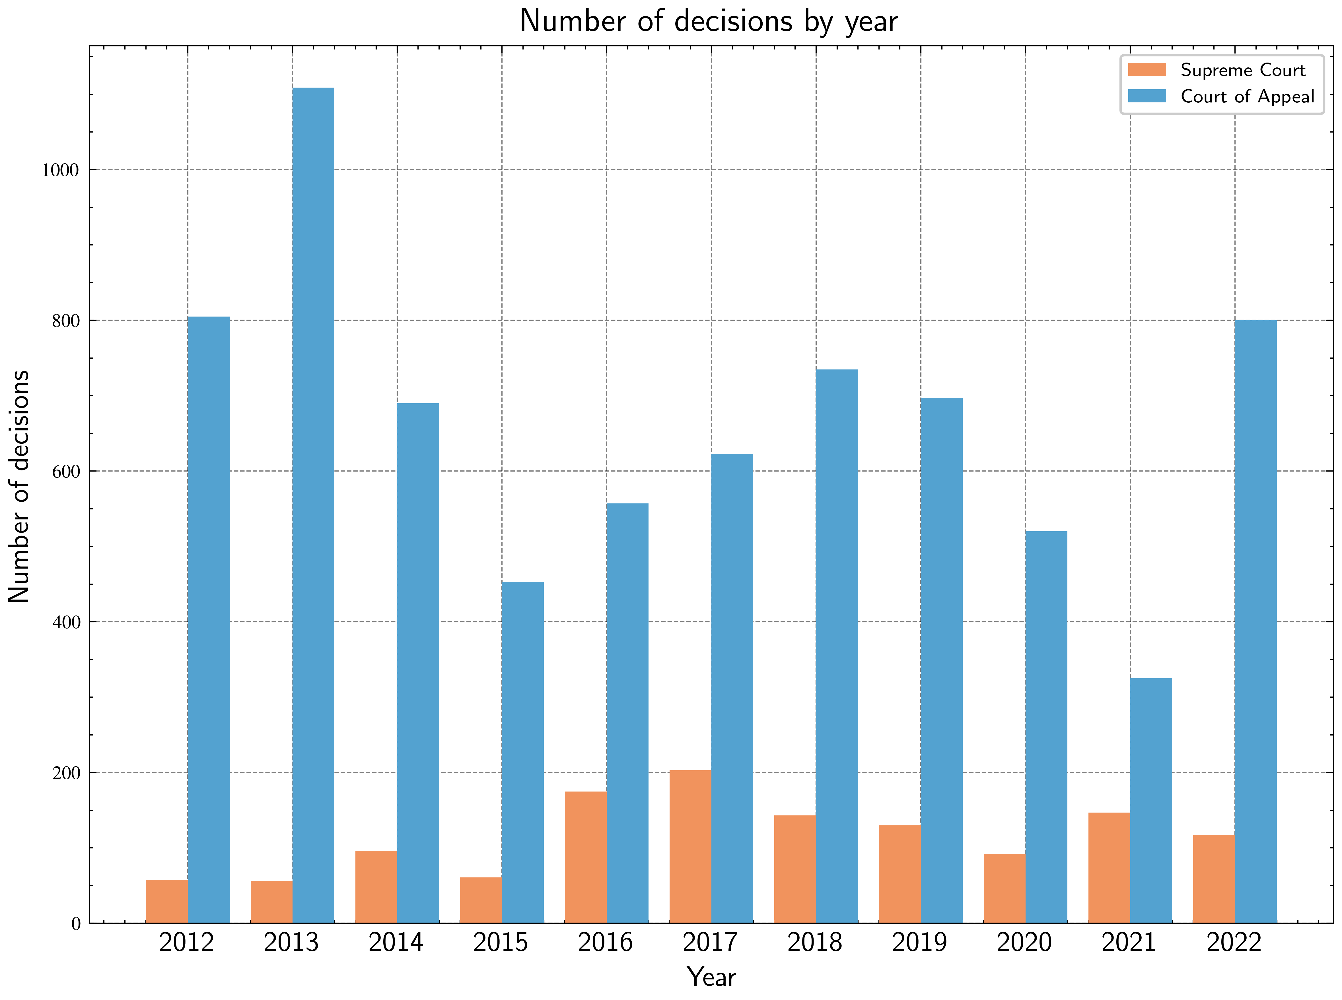
Figure 1: The Court of Appeal issued nearly 6 times as many decisions as the Supreme Court in a given year.
The Court of Appeal issued nearly six times as many judgments as the Supreme Court in a given year. As demonstrated in Figure 1, this pattern holds consistently across the decade under study. The Court of Appeal averaged 665 decisions per year compared to the Supreme Court’s 116 decisions.
This quantitative disparity has structural explanations. The Court of Appeal has a greater number of justices than the Supreme Court. More significantly, it is a court of first instance for writ applications under Article 140, whereas the Supreme Court primarily exercises appellate jurisdiction with the exception of its original jurisdiction under Article 126 (fundamental rights) and Article 129 (election petitions). The Court of Appeal thus handles both original writ petitions and appeals from lower courts across civil, criminal, and administrative matters.

5.2.2 Implications for Jurisprudential Authority
The numerical dominance of Court of Appeal judgments stands in stark contrast to their doctrinal treatment. Jurisprudentially, decisions of the Court of Appeal are given far less significance than Supreme Court decisions. The Supreme Court is the apex court and therefore determines judicial precedent. Because it is the final court of appeal, its decisions are examined and debated more extensively in legal scholarship and practice.
This numerical dominance translates into greater practical impact in dispute resolution. Empirical analysis confirms that most disputes are effectively resolved at the Court of Appeal level, with the Supreme Court rarely reviewing writ decisions on appeal. This finding has significant implications: if the Court of Appeal is the practical forum where writ remedies are determined, the doctrinal and normative interpretation of judicial decisions in Sri Lanka should systematically include Court of Appeal jurisprudence rather than focusing predominantly on Supreme Court precedent.
Currently, the Court of Appeal’s contribution is understood only in an ad hoc manner by judiciary, practitioners, academics, and other court observers. There was a brief period in which decisions of the Court of Appeal were published as an unofficial court report by a non-government organization, Law & Society Trust.[^48] However, no systematic effort has been made to study Court of Appeal jurisprudence as a body of law with its own patterns and significance. The quantitative data point to the need for such systematic study, particularly given the court’s role in both writ jurisdiction and criminal appeals—areas that, as subsequent sections demonstrate, dominate appellate dockets but remain understudied in legal scholarship.
The Court of Appeal’s quantitative dominance—and the low rate of appeals to the Supreme Court—raises a further question: what types of cases account for this output? The answer lies in the distribution between writ petitions and fundamental rights petitions, and in the Supreme Court’s extremely limited role in reviewing Court of Appeal writ decisions.

5.3 The Writ Puzzle: Pervasive but Understudied

5.3.1 Jurisdictional Distribution: SC vs CA
The constitutional framework establishes distinct forums for public law remedies. Article 140 confers on the Court of Appeal jurisdiction to issue prerogative writs—certiorari, mandamus, prohibition, and others—for judicial review of administrative action, tribunal decisions, and jurisdictional errors. Article 126 vests the Supreme Court with exclusive jurisdiction over fundamental rights petitions alleging constitutional violations. The Supreme Court’s original writ jurisdiction, by contrast, is narrowly circumscribed: Article 104H limits such jurisdiction to election-related matters.
The empirical distribution confirms this constitutional design. Of the 1,278 Supreme Court decisions in the dataset, only 4 (0.3%) were original writ petitions under Article 104H. The Court of Appeal, by contrast, issued 1,741 writ decisions (23% of its docket) during the same period. In original writ jurisdiction, the Court of Appeal handles 435 times more cases than the Supreme Court. This stark disparity reflects the constitutional allocation of writ jurisdiction to the Court of Appeal as the primary forum for administrative law and judicial review.

5.3.2 Quantitative Disparity
The disparity between writ petitions and fundamental rights petitions is substantial. Of the 7,314 Court of Appeal decisions in the dataset, 1,741 (23%) were judgments on writs. Of the 1,278 Supreme Court decisions, 361 (28%) were judgments on fundamental rights petitions. While writ petitions substantially outnumber fundamental rights petitions in absolute terms, these remedies are administered by different courts: writs predominantly by the Court of Appeal under Article 140, and fundamental rights exclusively by the Supreme Court under Article 126.
The Supreme Court’s engagement with writ jurisdiction is minimal. Of the 1,278 Supreme Court decisions, 4 were original writ petitions under Article 104H (election-related writs) and 31 were appeals from Court of Appeal writ decisions (identified through normalized pattern matching for case references to Court of Appeal writ applications)—together comprising only 2.7% of the Supreme Court’s docket. The Court of Appeal’s 1,741 writ decisions thus vastly outnumber not only the Supreme Court’s original writ jurisdiction but also subsequent appellate review.
The temporal patterns reveal an additional dimension to this disparity. The average time taken for writ decisions in the Court of Appeal was 3.15 years (2.80 SD) against 4.17 years (3.05 SD) for fundamental rights petitions in the Supreme Court. 25% of writs in the Court of Appeal were decided within a year of filing compared to only 20% of fundamental rights petitions in the Supreme Court resolved within one year. This performance is particularly notable given that, unlike fundamental rights petitions, no constitutional or common law time limit exists for writ determinations.
The outcome patterns also differ. Of the decisions on writs in the Court of Appeal that were fully adjudicated, 55% were allowed and 45% were dismissed. In the Supreme Court, 62% of fundamental rights decisions were allowed and 38% were dismissed. After petitions clear the leave to proceed stage in either jurisdiction, the probability favours the petitioner—but fundamental rights petitions show a slightly higher success rate than writs.

5.3.3 The Court of Appeal as Effective Final Arbiter
The Court of Appeal’s dominance in writ jurisdiction extends beyond volume to practical finality. During the period 2012-2022, the Supreme Court decided only 31 appeals from Court of Appeal writ decisions—compared to 1,741 writ decisions issued by the Court of Appeal during the same period, as shown in Table 5.
Table 5: Court of Appeal Writ Decisions vs Supreme Court Appeals (2012-2022)
Metric | Value
CA Writ Decisions | 1,741
SC Appeals from CA Writs | 31
Implied Appeal Rate | 1.8%
Average SC Appeals per Year | 2.8
Average CA Writs per Year | 158
The ratio of SC appeals to CA writ decisions (31:1,741) suggests an appeal rate around 1.8%. This ratio remained consistently low across the decade, with an average of 2.8 appeals annually. While we cannot track individual case cohorts through the appellate system, the low ratio of SC appeals to CA writ decisions indicates that the Court of Appeal functions as the effective final arbiter in the overwhelming majority of writ cases.
This finding answers empirically the question posed earlier: whether the Court of Appeal’s numerical dominance translates into greater practical impact in dispute resolution. The data confirm that it does. Based on the relative volumes during this period, for the vast majority of litigants seeking writ remedies, the Court of Appeal is not merely the first forum but the only forum. The Supreme Court’s appellate jurisdiction over Court of Appeal writs, while constitutionally available under Articles 127-128, is rarely invoked in practice.
Three non-exclusive explanations may account for this low ratio. First, litigants may be satisfied with Court of Appeal writ determinations and choose not to pursue further appeal. Second, the Supreme Court’s leave requirements for appeals may present a significant barrier, filtering out cases that do not meet the threshold for further review. Third, Court of Appeal writ remedies may effectively resolve the underlying disputes, rendering further litigation unnecessary or impractical. Determining which explanation predominates would require further investigation into leave applications, reasons for grant or refusal of leave, and longitudinal tracking of individual cases from the Court of Appeal through potential Supreme Court appeals.
From an access to justice perspective, these findings have significant implications. The Court of Appeal provides regular, accessible, and functionally final review of administrative action and jurisdictional errors. With an average of 158 writ decisions annually, it serves as the primary mechanism for judicial review in Sri Lanka. The low ratio of Supreme Court appeals suggests that Court of Appeal writ remedies effectively resolve disputes in most cases, making this jurisdiction a more substantial avenue for access to justice than its current doctrinal recognition acknowledges.

5.3.4 The Doctrinal Paradox
Despite this numerical dominance and practical finality, writ jurisprudence remains underdeveloped in Sri Lankan legal scholarship and practice. Academic study of Sri Lanka’s public law focuses predominantly on the fundamental rights jurisprudence of the Supreme Court with little attention paid to writ jurisprudence qua writ jurisprudence.[^56] This raises questions about why doctrinal scholarship privileges fundamental rights over writs when writs quantitatively dominate and the Court of Appeal serves as the effective final forum for the overwhelming majority of writ remedies.
The empirical data provide an alternative account to the view that writs and fundamental rights are blending in practice. Fundamental rights petitions remain the exception; writs are the norm. Moreover, these remedies operate in different forums with different rates of finality. The Supreme Court’s exclusive fundamental rights jurisdiction under Article 126 makes it the apex court for constitutional violations, but the Court of Appeal’s near-exclusive resolution of writ petitions under Article 140 makes it the apex court for administrative law and judicial review. Yet the doctrinal weight afforded to these two jurisdictions inverts their quantitative relationship and obscures their functional separation.
The empirical-doctrinal gap reveals a structural issue in how public law scholarship understands judicial work. Courts adjudicate more writs than fundamental rights petitions, writs resolve more quickly on average, and writ decisions are rarely subject to appellate review—yet legal education, scholarly analysis, and professional discourse privilege fundamental rights jurisprudence. If writs provide more routine access to justice than the constitutionally privileged fundamental rights jurisdiction, their comparative neglect has distributive consequences. As demonstrated in the topic modelling analysis below, writ petitions disproportionately concern state employment disputes and administrative actions affecting public servants. The neglect of writ jurisprudence may thus reflect whose claims receive doctrinal attention and whose claims are treated as routine administrative matters.
The law on writs remains comparatively underdeveloped, and no systematic effort has been made to study writ jurisprudence as a distinct body of doctrine deserving scholarly attention in its own right. The quantitative and qualitative data presented here suggest that such systematic study is overdue—not merely as a complement to fundamental rights scholarship but as a necessary correction to received assumptions about where judicial impact occurs and which remedies structure day-to-day access to justice in Sri Lanka.
The prevalence of writs and their functional finality raise practical questions about judicial performance across both remedies. How long do these cases take to resolve? The Constitution mandates that fundamental rights petitions be resolved within two months, but the empirical reality diverges sharply from this constitutional promise—creating an instructive contrast with writ jurisdiction, which operates without constitutional time mandates yet resolves more quickly.

5.4 Temporal Dysfunction: The Constitutional Time Mandate and Its Failure
As shown in Figure 2, 37% of Supreme Court decisions and 48% of Court of Appeal decisions took more than five years to be delivered.
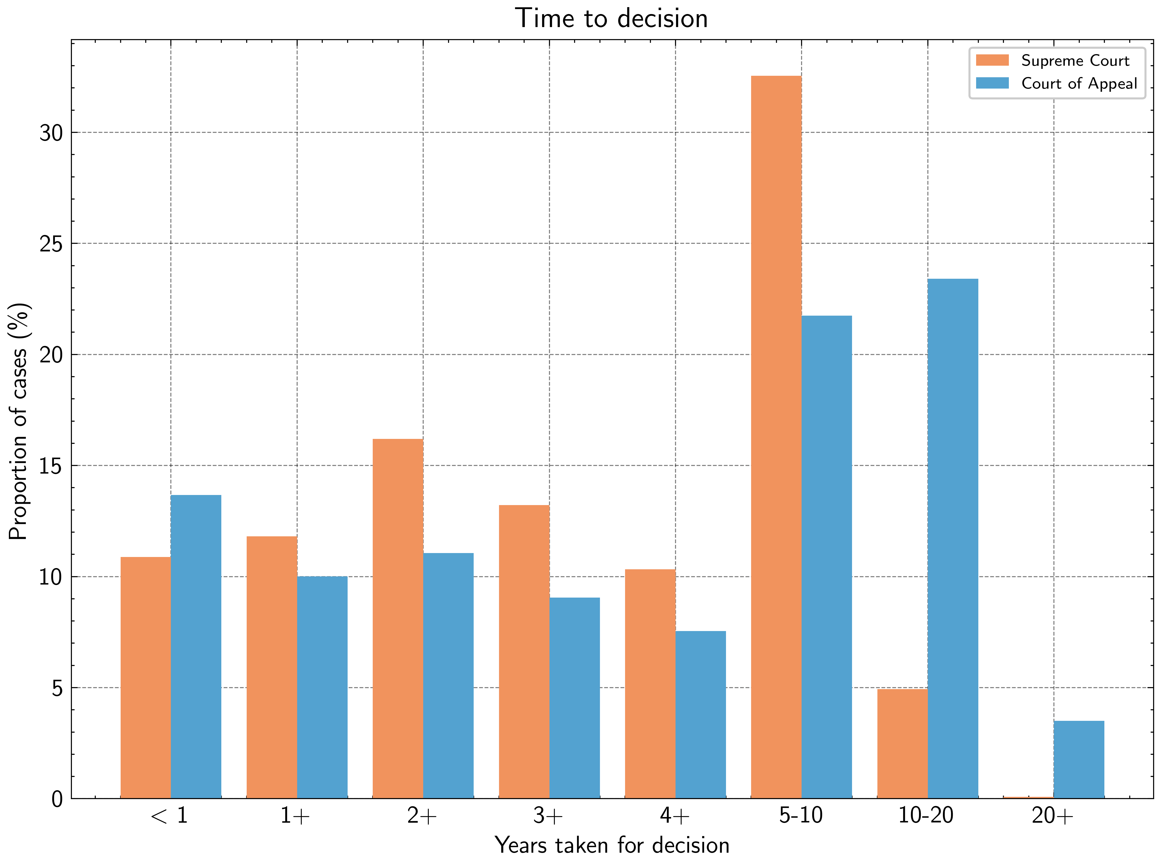
Figure 2: 37% of Supreme Court decisions and 48% of Court of Appeal decisions took more than five years to be delivered.

5.4.1 Methodology Note
The Supreme Court website lists the date on which each decision was issued. The Court of Appeal website, on the other hand, groups decisions by the month and the year and does not list the date. Further, since the registries of both courts are not digitised, for both courts, there is no way of knowing the date on which an application related to a decision was filed. Under these constraints, calculating the exact time taken to deliver decisions is not possible.
To approximate the date on which an application was filed, we extracted the year in which the application related to a decision was filed from the application (or case) number. For example, the case number SC/FR/123/2012 indicates that the application was filed in 2012. Assuming that filing of applications is distributed uniformly through the year, we approximated the date of filing as {extracted_year}-June-30 for all cases across the two courts. Making the same assumption, we approximated the date of decision delivery in the Court of Appeal as {given_year}-{given_month}-15. We then calculated the time taken to deliver a decision as the difference between the date of decision delivery and the date of application filing.

5.4.2 Supreme Court Fundamental Rights: The Two-Month Fiction
The Constitution mandates that fundamental rights petitions be determined within two months of filing (Article 126(5)). However, the Supreme Court has held that this requirement is directory rather than mandatory.[^54]
As illustrated in Figure 3, the data confirm serious concerns about delays in the court system.
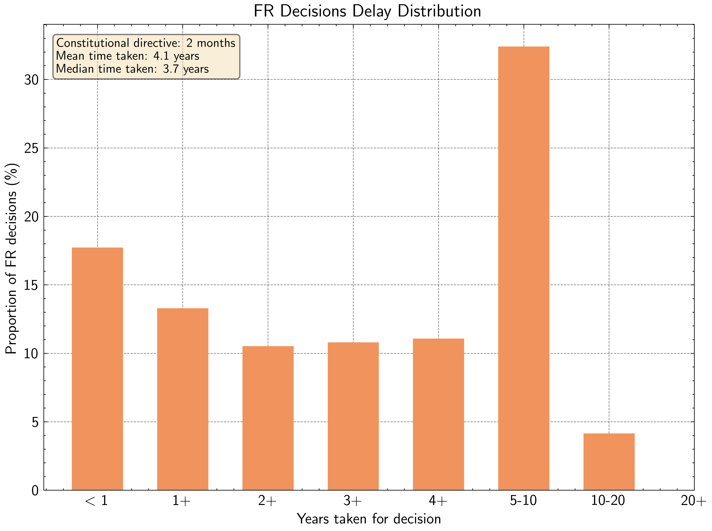
Figure 3: 37% of FR petitions took five or more years for resolution
Of the 361 fundamental rights petitions in the dataset, 332 took 3 to 15 years for resolution. Of these, 140—almost half—took 10 to 15 years to be concluded. Around 37% of fundamental rights petitions took five or more years for resolution. Only 20% resolved within one year of filing. The mean time taken was 4.17 years (3.05 standard deviation)—a substantial variation from the constitutional requirement of two months.
Two months is insufficient to accommodate the practical steps involved in fundamental rights litigation, which includes filing, service, objections, counter-affidavits, reply, oral submissions, and judgment writing.
The reasons for these delays require further investigation. Contributing factors may include caseload, absence of strict time allocation for oral submissions, postponements sought by parties, and the time required to write judgments.

5.4.3 Court of Appeal Writs: Faster Despite No Mandate
As demonstrated in Figure 4, Court of Appeal writ petitions resolve faster than Supreme Court fundamental rights applications.
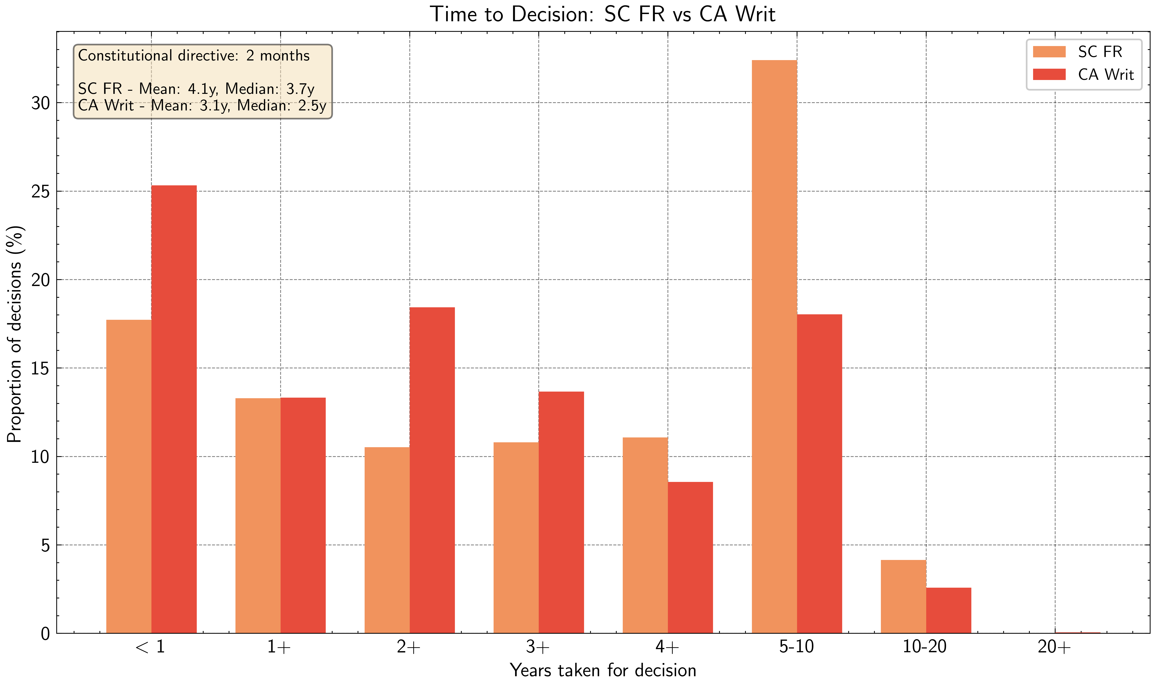
Figure 4: Court of Appeal writs petitions resolve faster than Supreme Court FR applications
Unlike fundamental rights petitions, no constitutional or common law time limit governs writ determinations. Time or delay is considered when determining whether to grant leave to proceed,[^55] but no broader principles guide completion of writ petitions.
The Court of Appeal’s experience provides an instructive comparison. Of the 7314 Court of Appeal decisions, 1741 (23%) were judgments on writs. Writ decisions took considerably less time to resolve than other matters in the same court. The average time taken for writ decisions was 3.15 years (2.80 SD) against 8.01 years (6.43 SD) for other matters. 25% of writs were decided within a year of filing.
The Court of Appeal thus resolves writs faster (mean 3.15 years) than the Supreme Court resolves fundamental rights petitions (mean 4.17 years), despite having no constitutional time mandate. The practical procedures are comparable in both jurisdictions, yet the court without a stipulated time limit performs better.

5.4.4 Implications for Access to Justice
As per recent reports, 5,785 cases are pending before the Supreme Court and 4,572 before the Court of Appeal. The figures are worse in lower courts: 27,324 cases pending before High Courts and 262,665 before District Courts. The total number of cases pending is 1,131,818.
The time taken to determine fundamental rights petitions fundamentally undermines the constitutional mandate. As demonstrated above, over a third of cases took five or more years for resolution—against a constitutional requirement of two months. These findings clarify the quality of access to justice available to petitioners who approach the appellate courts.
This comparative puzzle raises questions about structural causes: backlog, judicial resources, and procedural culture. Why does the Court of Appeal, handling a larger volume of cases, resolve writs faster than the Supreme Court resolves fundamental rights petitions? The answer likely lies in a combination of factors including case complexity, the nature of constitutional adjudication, and institutional practices—but these require further investigation.
The systematic delays demand investigation and institutional responses tailored to the types of cases that dominate the dockets. The constitutional time mandate for fundamental rights is meaningless in practice, while the court without such a mandate performs better. This inversion suggests that formal rules matter less than institutional capacity, resource allocation, and procedural culture.
The timing data reveal how long disputes take to resolve but not what those disputes are about. Topic modeling provides an answer.

5.5 Substantive Concentration: What the Courts Actually Decide

5.5.1 Computational Method: Topic Modeling
To understand the latent topics and their word distributions present in court decisions, we applied Latent Dirichlet Allocation (LDA) to CDTextLK. We used the Gensim implementation of LDA with the following parameters: 20 topics and random seed of 0 with all other values set to defaults. In addition to tokenizing and stemming, we removed all tokens that appeared in less than 20 documents as well as tokens that recurred in more than 50% of documents. We also removed all tokens that were less than 3 characters long.
To find the three most common topics across Supreme Court and Court of Appeal decisions, we first ran LDA on the entirety of CDTextLK under the experiment conditions described above. Then, we computed the average probability score for each of the 20 topics identified by LDA under the two sub corpora, independently, by summing the document-topic probability for a given topic for each document in the sub corpus and dividing by the total number of documents in the sub corpus. We obtained the three most common topics by summing the average probability scores for each topic across the two sub corpora and selecting the three topics with the highest scores, as shown in Table 6.
Table 6: Top-3 Topics with Highest Average Probability and Top-40 Tokens
Topic 1 | Topic 2 | Topic 3
defend | decis | accus
plaintiff | writ | sentenc
land | mark | trial
district | offic | wit
action | servic | high
titl | public | polic
deed | board | prosecut
possess | author | convict
trial | letter | offenc
lot | appoint | year
claim | univers | charg
plan | commiss | statement
partit | certiorari | incid
plaint | mandamu | victim
mark | secretari | code
owner | circular | defenc
share | member | offic
prescript | inquiri | imprison
substitut | post | commit
road | administr | hous
decre | committe | impos
corpu | director | ground
silva | quash | inform
right | ministri | crimin
properti | document | count
answer | requir | consid
entitl | year | indict
schedul | natur | call
disput | depart | complain
prove | power | day
perera | minist | find
enter | petit | doubt
transfer | promot | punish
origin | approv | deceas
posit | observ | place
deceas | recommend | found
proceed | council | arrest
surveyor | duti | penal
year | regul | examin
procedur | examin | prove

5.5.2 Topic 1: Land and Property Disputes
Topic 1 concerns land and property disputes, denoted by terms such as ‘defend’, ‘plaintiff’, ‘land’, ‘district’, ‘action’, ‘titl’, ‘deed’, ‘possess’, ‘lot’, ‘claim’, ‘plan’, ‘partit’, ‘owner’, ‘prescript’, ‘road’, ‘silva’, ‘properti’, ‘disput’, ‘perera’, ‘transfer’, ‘surveyor’, and ‘procedur’. These terms reflect the vocabulary of land litigation—title disputes, prescriptive rights, partition actions, and ownership claims.
When we ran LDA on decisions that took ten or more years for resolution (num_topics=5 and random_seed=0), the most common topic was land and property disputes. Given that 81% of land in Sri Lanka is state-owned, the state’s role as dominant landowner generates extensive litigation over state land alienation, encroachment, competing claims, and administrative decisions regarding land use and allocation.
In terms of addressing case load and delay, this data points to land disputes as an area requiring substantive attention and institutional infrastructure. Current state interventions regarding delays—such as fast-tracking commercial disputes and promoting alternative dispute resolution—may be misplaced if they do not address the types of cases that actually dominate appellate court dockets. If land disputes are both pervasive and slow-moving, institutional reform must target this specific substantive area. This might include specialized tribunals, streamlined procedures for particular categories of land disputes, or administrative reforms to reduce the generation of land-related litigation in the first instance.

5.5.3 Topic 2: State Employment and Administrative Disputes
Topic 2 captures state employment and administrative disputes, denoted by terms such as ‘decis’, ‘writ’, ‘mark’, ‘offic’, ‘servic’, ‘public’, ‘board’, ‘author’, ‘letter’, ‘appoint’, ‘univers’, ‘commiss’, ‘certiorari’, ‘mandamu’, ‘secretari’, ‘circular’, ‘member’, ‘inquiri’, ‘post’, ‘administr’, ‘committe’, ‘director’, ‘quash’, ‘ministri’, ‘document’, ‘depart’, ‘minist’, ‘promot’, ‘approv’, ‘recommend’, and ‘council’. This vocabulary reflects administrative law and public sector employment disputes—appointments, promotions, transfers, disciplinary inquiries, administrative circulars, and challenges to decisions by public boards, commissions, and ministries.
The dominance of state employment disputes, particularly visible in fundamental rights petitions, suggests that the public sector places substantial burden on the court system. This finding tracks with earlier empirical work showing that Article 12 (equality) is overwhelmingly invoked by public servants challenging recruitments, transfers, or promotions. Public servants constitute a significant proportion of litigants before the appellate courts, using both writ jurisdiction and fundamental rights jurisdiction to challenge administrative decisions affecting their employment.
This pattern raises questions about administrative and quasi-judicial mechanisms. Are they functioning effectively, or do courts primarily provide access to justice for public servants rather than the broader public? If administrative tribunals, Public Service Commission procedures, and departmental appeal mechanisms were functioning effectively, fewer employment disputes would reach the appellate courts. The prevalence of such cases in the appellate dockets suggests either that administrative mechanisms are inadequate or that they are systematically bypassed in favor of judicial review. This has distributional consequences: if courts spend substantial time adjudicating public sector employment disputes, other types of claims—particularly those brought by marginalized communities or private citizens without institutional resources—may receive less attention.

5.5.4 Topic 3: Criminal Proceedings
Topic 3 covers criminal proceedings, denoted by terms such as ‘accus’, ‘sentenc’, ‘trial’, ‘wit’, ‘high’, ‘polic’, ‘prosecut’, ‘convict’, ‘offenc’, ‘charg’, ‘statement’, ‘incid’, ‘victim’, ‘code’, ‘defenc’, ‘imprison’, ‘commit’, ‘hous’, ‘impos’, ‘ground’, ‘inform’, ‘crimin’, ‘count’, ‘indict’, ‘complain’, ‘find’, ‘punish’, ‘deceas’, ‘place’, ‘found’, ‘arrest’, ‘penal’, and ‘examin’. This is the vocabulary of criminal appeals—charges, indictments, convictions, sentences, witnesses, evidence, and grounds of appeal.
The dominance of criminal proceedings as one of the three major topics reflects the Court of Appeal’s role in hearing criminal appeals. This finding is unsurprising given the jurisdictional structure, but it confirms empirically what is known doctrinally: criminal appeals constitute a substantial portion of the Court of Appeal’s workload.

5.5.5 Topic Distribution Analysis
A study of non-intersecting top 10 topics between the two sub corpora corroborates what we know about the structure of the legal system in the country. For instance, while appeals on criminal matters are heard by the Court of Appeal, appeals on civil matters, following the institution of the Civil Appeal High Court, are no longer heard by the Court of Appeal. The fifth and sixth most common topics in the Court of Appeal decisions—denoted by terms such as ‘vehicl’, ‘owner’, ‘offenc’, ‘confisc’, ‘charg’, ‘forest’, ‘websit’, ‘accus’, ‘polic’, ‘regist’, ‘transport’, ‘station’, ‘driver’, ‘prove’, ‘timber’, ‘illeg’, ‘deceas’, ‘murder’, ‘injuri’, and ‘stab’—do not appear in the top 10 topics in the Supreme Court decisions. These terms reflect specific categories of criminal appeals (vehicle offences, forest offences, violent crimes) that fall within the Court of Appeal’s jurisdiction.
Similarly, disputes between central government and administrative powers such as provincial councils and pradeshya sabhas are heard by the Supreme Court. The ninth most common topic in the Supreme Court decisions—denoted by terms such as ‘council’, ‘member’, ‘writ’, ‘elect’, ‘sabha’, ‘provinci’, ‘pradeshiya’, ‘constitut’, ‘articl’, ‘power’, ‘minist’, ‘chairman’, ‘local’, ‘presid’, ‘governor’, ‘uva’, ‘appoint’, and ‘central’—does not appear in the top 10 topics in the Court of Appeal decisions. This topic captures the Supreme Court’s constitutional jurisdiction over disputes involving provincial councils, local government bodies, and the distribution of powers between central and provincial authorities.
The topic distribution analysis thus confirms empirically the jurisdictional divide between the two courts and reveals the substantive areas that dominate their respective dockets. Land disputes, state employment disputes, and criminal appeals constitute the bread and butter of appellate adjudication in Sri Lanka—yet these areas receive far less scholarly and policy attention than high-profile constitutional cases.
Topic modeling reveals what courts decide. Mutual information analysis reveals how courts write—and what those linguistic choices encode about institutional hierarchies and judicial authority.

5.6 Linguistic Patterns: What Mutual Information Reveals

5.6.1 Method and Salient Terms
We performed mutual information analysis on the Supreme Court and Court of Appeal decisions to identify the most salient words in each corpus. Mutual information analysis quantifies the presence or absence of words within a corpus. The frequency of the words used can reveal attributes of the jurisprudence of both courts, providing helpful entry points for further jurisprudential analysis. We tokenized decisions and stemmed each token. We used a simple add 1 smoothing scheme to avoid zero probabilities.

5.6.2 Interpreting Linguistic Choices
The most salient word was ‘grant’, which appeared in 91% of Supreme Court decisions but only in 32% of Court of Appeal decisions. The underlying reason is procedural: Supreme Court decisions routinely reference the granting of leave to appeal—both the grounds on which leave was granted and the date—in the decision text. This reflects a procedural practice rather than a substantive legal distinction but nonetheless marks a clear linguistic difference between the two courts.
The words ‘answer’, ‘question’, and ‘law’ appear frequently in Supreme Court decisions because the court is called upon to answer questions of law. Although the Court of Appeal is also an appellate court, the same words have a lower prevalence in its decisions. This linguistic pattern reflects the Supreme Court’s role as the final court of appeal on questions of law and its function in establishing legal precedent through reasoned answers to legal questions.
The word ‘err’ appears in 24% of Supreme Court decisions but only in 1% of Court of Appeal decisions. On closer inspection, we observed that the word appears in the context of Supreme Court justices holding a lower court judge to have erred in their judgement. Such language is almost never used in Court of Appeal decisions despite the court’s appellate jurisdiction. This is a striking finding. Both courts exercise appellate jurisdiction and review decisions of lower tribunals. Yet the Supreme Court routinely employs the language of error—stating explicitly that a judge erred—while the Court of Appeal rarely does so. This may reflect the Supreme Court’s hierarchical position at the apex of the judicial system, where it exercises supervisory authority not only over outcomes but over legal reasoning itself. The Court of Appeal, positioned between the High Courts and the Supreme Court, may adopt a less overtly corrective tone even when reversing lower court decisions.
The high prevalence of the words ‘paragraph’ and ‘refer’ in Supreme Court decisions arises from the court’s practice of referring to specific sections of petitions, the Constitution, and other legislation. This reflects a more formal writing style in the Supreme Court compared to the Court of Appeal. Supreme Court decisions are more citation-heavy, more explicitly structured, and more systematically organized through numbered paragraphs and cross-references. This linguistic formality aligns with the court’s institutional role as the authoritative interpreter of law and the generator of binding precedent.
These linguistic patterns reflect hierarchical position and institutional culture. The Supreme Court writes as the apex court—correcting error, answering questions of law, formally citing and cross-referencing legal materials. The Court of Appeal, despite its substantial caseload and significant role in dispute resolution, writes in a less formally structured style that reflects its intermediate position in the judicial hierarchy. Linguistic choices are not merely stylistic; they encode institutional roles, hierarchical relationships, and conceptions of judicial authority.
Linguistic patterns reveal how courts write, but volume patterns reveal when and how much they produce. The Supreme Court’s output varied significantly across the decade under review, with notable peaks and troughs that correlate with constitutional developments affecting judicial independence.

5.7 Variations in Supreme Court Output: Independence and Productivity

5.7.1 The 2016-2017 Peak and the Low Years
The Supreme Court’s output varied substantially across the decade. The court delivered 175 decisions in 2016 and 203 in 2017—the two highest annual totals in the period. Between 2012-2015, the court averaged 68 decisions per year. Between 2016-2022, it averaged 144 decisions per year, as shown in Figure 5.
Figure 5: Supreme Court and Court of Appeal decision output 2012-2022

5.7.2 The Independence Hypothesis
This pattern suggests a correlation between judicial output and actual as well as perceived independence. The constitutional developments of this period may have impacted the court’s work. The dramatic increase in Supreme Court output following 2015 coincides with constitutional reforms aimed at enhancing judicial independence, particularly the 19th Amendment which restored the Constitutional Council and reformed the process for judicial appointments.
The relationship between judicial independence and judicial productivity is complex. Enhanced independence may increase a court’s willingness to hear cases, may improve litigant confidence in seeking relief, or may reflect institutional changes that increase court capacity. Conversely, periods of judicial crisis or perceived lack of independence may depress both filing rates and adjudication rates. The 2013-2015 period, marked by the purported impeachment of the Chief Justice and broader concerns about judicial independence under the 18th Amendment, saw depressed output. The post-2015 period, marked by constitutional reforms enhancing independence, saw dramatic increases in output.
However, correlation does not establish causation, and this requires further investigation beyond the current data. Multiple factors influence judicial output including the number of justices, case filing rates, procedural reforms, administrative efficiency, and judicial attitudes. The constitutional developments of this period provide one plausible explanation for the observed patterns, but a fuller account would require analysis of additional variables including appointment patterns, case filing statistics, and institutional resources.

5.7.3 Court of Appeal: Different Pattern
The Court of Appeal does not exhibit a comparable trend. Its best performing year was 2013, when the court delivered 1109 decisions. The high output in 2013 may reflect litigants having more confidence in the Court of Appeal than the Supreme Court during the purported impeachment. If litigants perceived the Supreme Court as compromised during the judicial crisis but viewed the Court of Appeal as relatively insulated, they may have filed more cases in the Court of Appeal or pursued remedies there rather than appealing to the Supreme Court. This would explain why the Court of Appeal’s output peaked precisely when the Supreme Court’s output was depressed.
Overall, in the period under review, the Court of Appeal averaged 665 decisions per year compared to the Supreme Court’s 116 decisions. The Court of Appeal has consistently delivered more judgments than the Supreme Court throughout the decade, suggesting a different institutional dynamic less sensitive to constitutional crises or reforms affecting the apex court, as illustrated in Figure 6.
Figure 6: Court of Appeal decision output showing 2013 peak
Variation in output reveals institutional responsiveness to political and constitutional context. Decision length, by contrast, reveals something different: the doctrinal weight courts assign to different types of disputes. Fundamental rights cases receive significantly more extensive judicial treatment than writs, empirically confirming doctrinal hierarchies.

5.8 Decision Length: Doctrinal Weight Made Visible

5.8.1 Quantitative Patterns
We tokenized decisions using the regex pattern [A-Za-z]+, discounting all punctuation and numbers. The mean length of a Supreme Court decision is 3646 tokens (3038 SD) and that of a Court of Appeal decision is 1688 tokens (2091 SD). Although Supreme Court decisions are, on average, longer, the longest decision in the corpus was a Court of Appeal decision. This judgment on an appeal of a determination by the Tax Appeal Commission against Unilever Sri Lanka Limited (CA/TAX/04/2013) is 35,630 tokens long. The longest Supreme Court decision, at 29,620 tokens, was on the fundamental rights petition SC/FR/141/2015 filed by Centre for Environment and Nature Studies against Northern Power Company (Pvt) Ltd which operated a thermal power plant in Chunnakam, Jaffna and was accused of contaminating the village’s groundwater.

5.8.2 Judgment Length by Court and Case Type
Judgment length varies systematically across courts and case types. Supreme Court decisions are, on average, substantially longer than those of the Court of Appeal, and exhibit greater dispersion in length, as shown in Figure 7. Across all Supreme Court cases, the median judgment length is 2,856 words, with a mean of 3,646 words and a standard deviation of 3,038 words, indicating a strongly right-skewed distribution. Court of Appeal decisions are markedly shorter, with a median length of 1,184 words, a mean of 1,688 words, and a lower standard deviation of 2,091 words, suggesting more constrained variation in judicial writing.
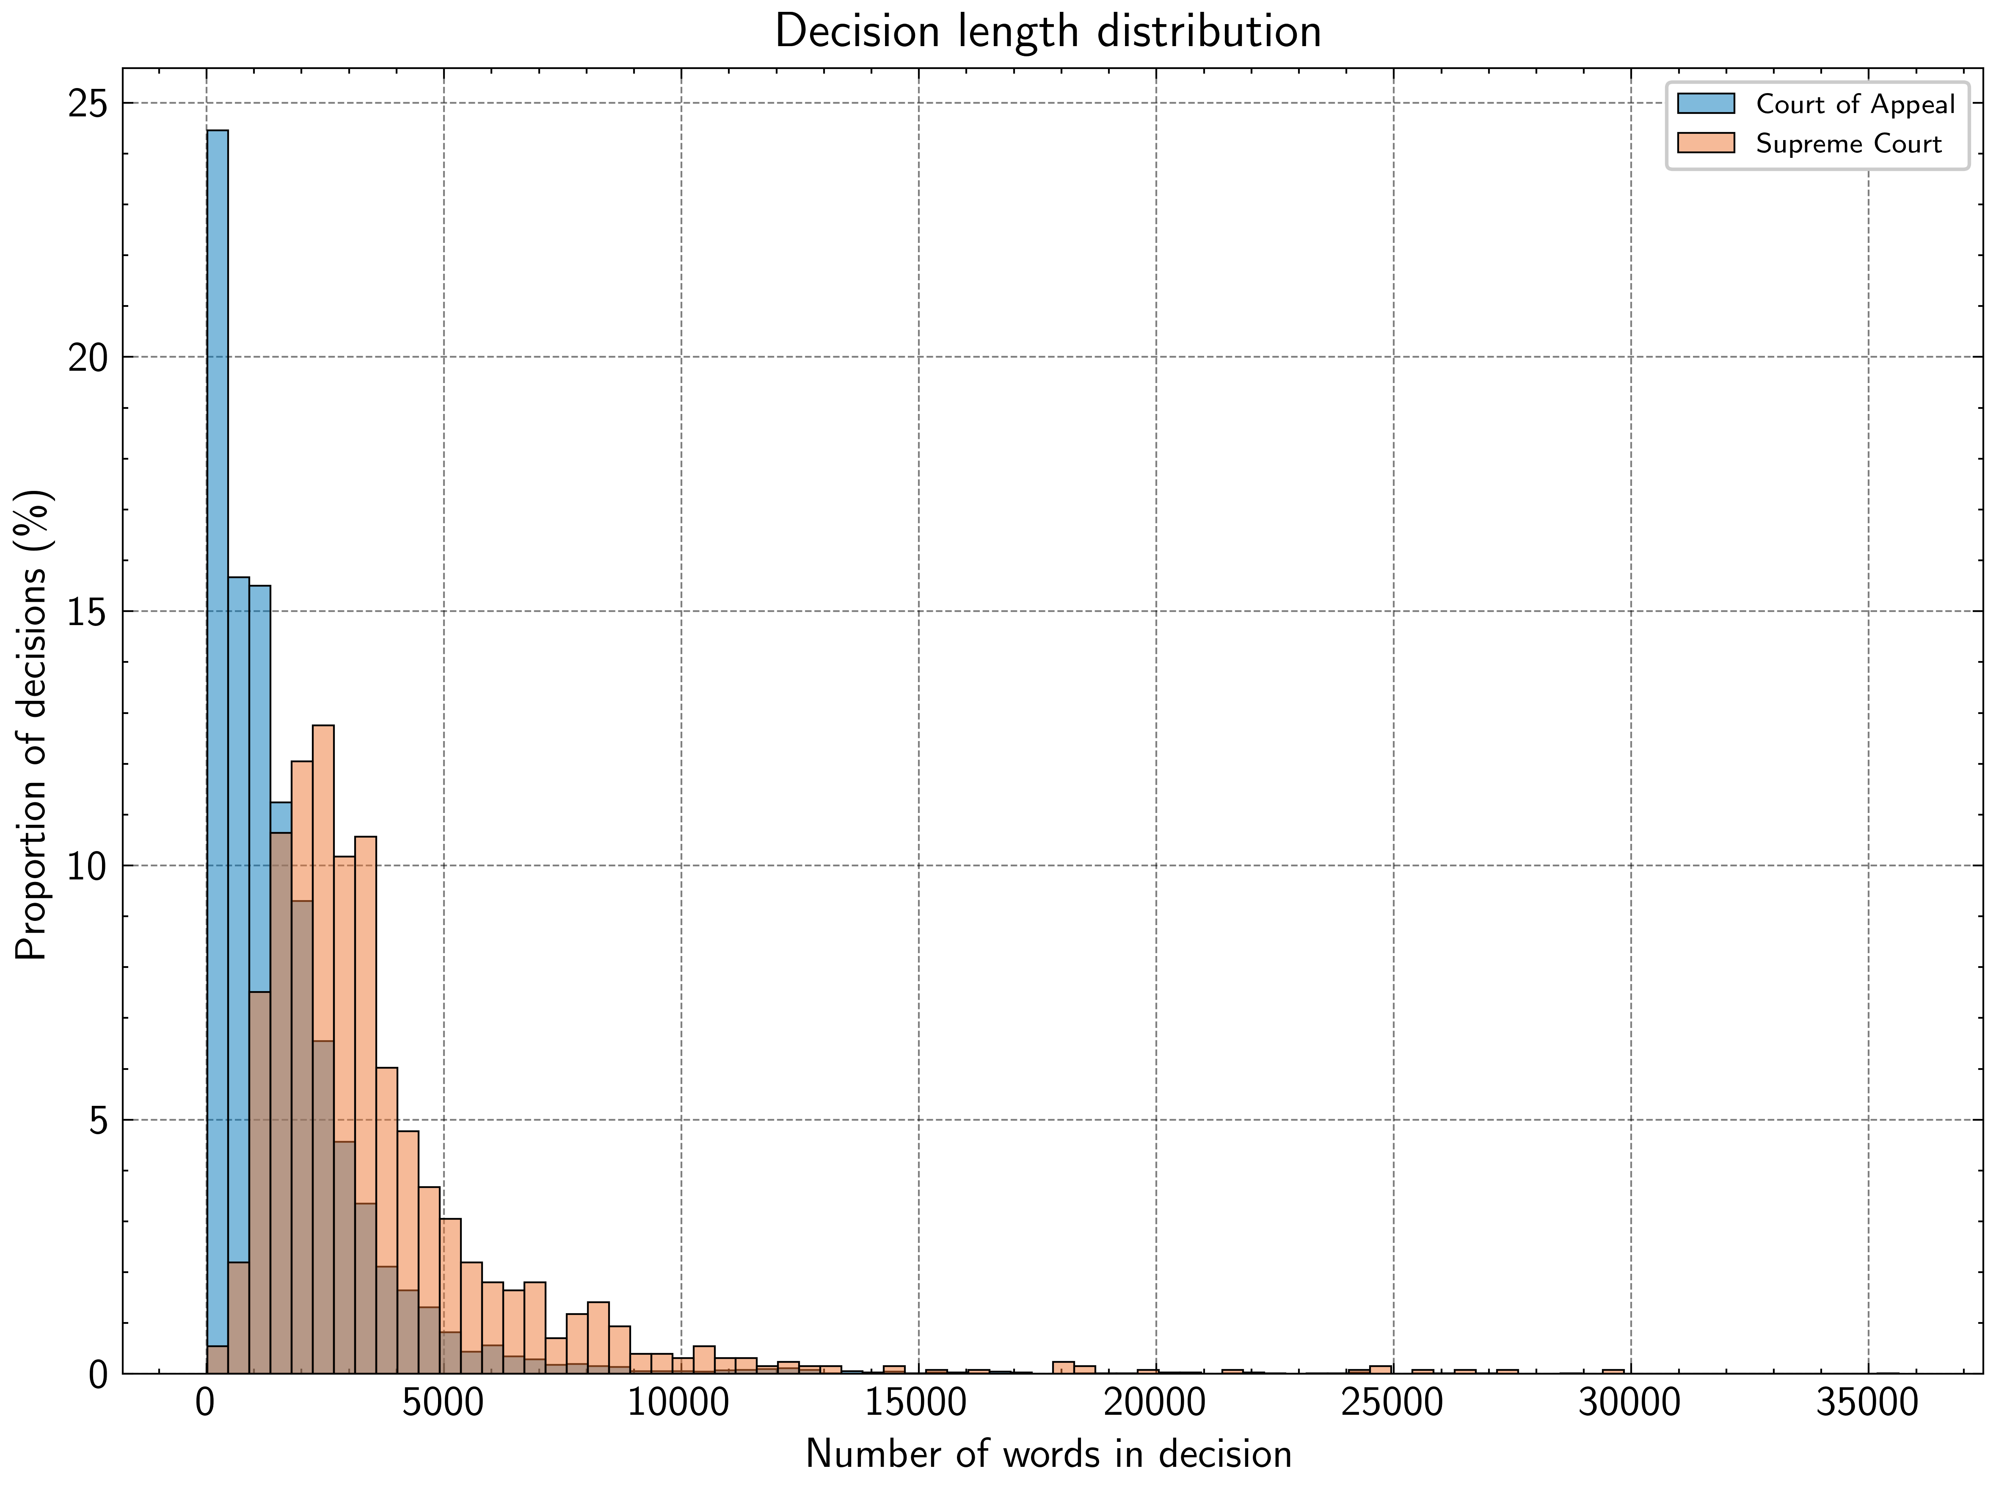
Figure 7: Supreme Court judgments are, on average, longer than Court of Appeal ones
These structural differences persist within the principal public law jurisdictions of each court. Fundamental Rights (FR) judgments of the Supreme Court are longer than the Court’s overall baseline, with a median length of 3,022 words, a mean of 3,805 words, and a standard deviation of 3,157 words, reflecting both doctrinal density and substantial variation in judicial treatment. Court of Appeal writ decisions are marginally longer than the Court of Appeal average (median 1,303; mean 1,836), but remain comparatively concise and less dispersed (standard deviation 1,970). Over time, average judgment length has increased in both courts, with the most pronounced growth observed in Supreme Court Fundamental Rights cases, as illustrated in Figure 8.
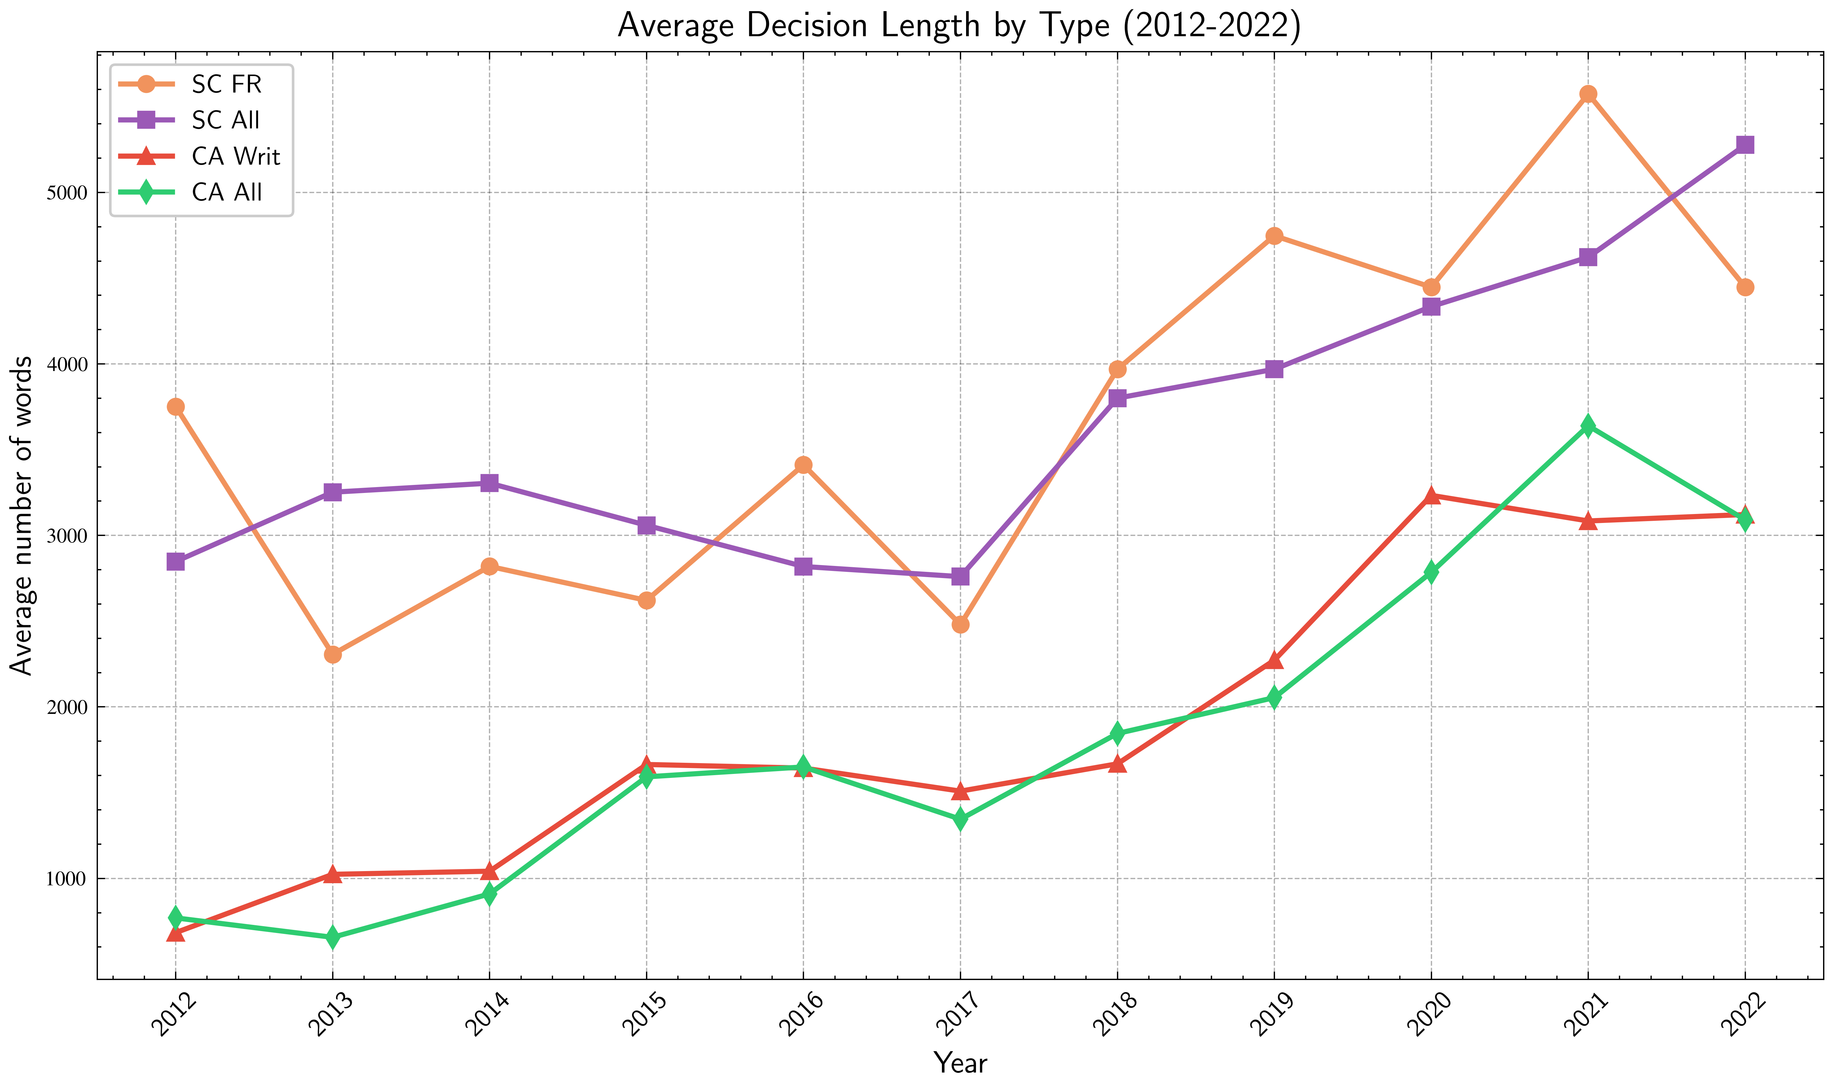
Figure 8: Average judgment length increased over time across courts and jurisdiction

5.8.3 Interpretation
There are no apparent formal guidelines or standards governing the length of judicial decisions, and length itself should not be confused with quality. The persuasiveness and authority of a judgment depend on accurate identification of material facts, engagement with relevant precedent, and coherent application of law to fact. Nonetheless, the increasing length of judgments—particularly in the Supreme Court—does reflect a growing volume of judicial labour, including more extensive factual narration, doctrinal exposition, and engagement with comparative or constitutional reasoning.
More importantly, variation in judgment length mirrors entrenched doctrinal hierarchies within Sri Lanka’s public law system. Fundamental Rights petitions, though fewer in number than writ applications, receive significantly more extensive judicial treatment, underscoring their elevated constitutional status. Similarly, Supreme Court decisions consistently exhibit greater length and variability than those of the Court of Appeal. The empirical patterns thus reinforce doctrinal expectations: constitutional adjudication commands deeper and more discursive reasoning than administrative review, and apex court judgments function as primary sites of legal exposition and norm-setting. Together with earlier findings on caseload composition, temporal delay, and output variation, judgment length provides a further window into how institutional role, jurisdiction, and doctrinal priority shape judicial practice.[^56]
The patterns identified thus far—quantitative dominance, writ prevalence, temporal dysfunction, substantive concentration, linguistic hierarchies, output variations, and decision length—describe how courts work. Outcome data provide a final empirical lens: how often do courts dismiss versus allow petitions?

5.9 Outcomes: Dismissals and Allowances
Proportion of decisions dismissed vs. allowed.

5.9.1 Data Limitations
Dismissal, in this section, means dismissal after a full hearing. Writs and fundamental rights petitions proceed in two stages: an initial leave determination followed by a full hearing if leave is granted. CDTextLK does not include data on dismissals at the leave stage, as these are typically not recorded as written judgments. The actual dismissal rates are therefore higher than the data suggests. For a fuller discussion of dataset scope and coverage limitations, see Section 5.

5.9.2 Observed Patterns
Table 7: Proportion of Decisions Dismissed vs Allowed
 | Dismissed | Allowed
Supreme Court | 532 (41.63%) | 746 (58.37%)
Court of Appeal | 3651 (49.92%) | 3663 (50.08%)
In Table 7, we can observe that about half of the decisions in the Court of Appeal dismissed their petitions or appeals. In the Supreme Court, however, the majority of decisions (58%) allowed the petition or appeal to stand. Of the decisions on writs in the Court of Appeal, 55% were allowed and 45% were dismissed. In the Supreme Court, 62% of the decisions on fundamental rights petitions were allowed and 38% were dismissed.
Figure: total number of FR judgments in favour of petitioners and dismissed; total number of writs in SC in favour of petitioner or dismissed, total number of writs in CA in favour of petitioner or dismissed

5.9.3 Interpretation
Whether a petition is upheld or dismissed depends on multiple factors: the strength of the petitioner’s claim, the applicable legal or constitutional doctrine, the quality of submissions, and the exercise of judicial discretion. Outcomes cannot be predicted based solely on empirical patterns.
While this data does not directly reveal jurisprudential trends, perceptions abound about judicial attitudes toward petitions—whether courts are prone to dismiss or allow claims. Empirical methods can be used to test these perceptions. The observed patterns suggest rough parity: neither court is systematically biased toward dismissal or allowance. The Court of Appeal maintains near parity (50% allowed versus 49% dismissed), while the Supreme Court shows only a slight tendency to allow petitions.
After petitions clear the leave to proceed stage, the probability favors the petitioner. This suggests that the leave stage functions as a significant filter: petitions that survive this threshold have reasonable prospects of success. The slightly higher success rate for fundamental rights petitions (62%) compared to Court of Appeal writs (55%) may reflect either the nature of constitutional claims or the additional scrutiny applied at the leave stage in fundamental rights jurisdiction.
These findings—quantitative dominance, writ prevalence, temporal dysfunction, substantive concentration, linguistic patterns, output variations, decision length, and outcome distributions—collectively reveal patterns that challenge received assumptions about appellate jurisprudence in Sri Lanka. What do these patterns mean for legal scholarship and judicial reform?

5.10 Synthesis: Implications for Legal Scholarship and Reform

5.10.1 Six Core Insights
The empirical analysis of CDTextLK reveals patterns that challenge received assumptions about the work of Sri Lanka’s appellate courts. These findings expose the gap between doctrinal debates and the empirical realities of judicial practice.
1. Quantitative versus doctrinal significance. The Court of Appeal numerically dominates—issuing nearly six times as many judgments as the Supreme Court—yet remains jurisprudentially neglected. This quantitative contribution is understood only in an ad hoc manner by judiciary, practitioners, academics, and court observers.
2. The writ-fundamental rights gap. Writ petitions vastly outnumber fundamental rights petitions in both courts, yet writ jurisprudence remains understudied. Fundamental rights petitions are the exception; writs are the norm. This empirical pattern suggests that academic study of Sri Lanka’s public law, which focuses predominantly on fundamental rights jurisprudence, overlooks the more common exercise of writ jurisdiction. The data provide an alternative account to the view that writs and fundamental rights are blending in practice.
3. Temporal dysfunction. The constitutional mandate for fundamental rights determination within two months is systematically violated. 37% of fundamental rights petitions took five or more years for resolution, with a mean time of 4.17 years. Only 20% resolved within one year of filing. Yet the Court of Appeal resolves writs faster (mean 3.15 years) despite having no constitutional time limit. This inversion suggests that formal rules matter less than institutional capacity, resource allocation, and procedural culture. The structural causes remain unknown and demand investigation.
4. Land and employment concentration. Topic modeling identifies land disputes and state employment disputes as dominant themes. Given that 81% of land in Sri Lanka is state-owned, the state’s role as landowner and employer dominates appellate dockets. Reform must address these areas specifically. Current interventions—fast-tracking commercial disputes, promoting alternative dispute resolution—may be misplaced if they do not address the types of cases that actually dominate the courts.
5. Linguistic and length patterns confirm hierarchies. Mutual information analysis and decision length data empirically confirm doctrinal hierarchies embedded in judicial practice. The Supreme Court writes as the apex court—correcting error, answering questions of law, formally citing legal materials. Fundamental rights judgments are longer than writ judgments. These patterns reflect institutional roles and doctrinal weight, but they also reveal what receives attention and what does not.
6. Independence and output. Supreme Court productivity increased following constitutional reforms enhancing judicial independence (19th Amendment). The 2013-2015 period, marked by judicial crisis, saw depressed output. The post-2015 period saw substantial increases. The Court of Appeal’s output, by contrast, peaked in 2013 during the impeachment crisis, suggesting litigants had more confidence in the intermediate court. While correlation does not establish causation, the suggestive relationship between independence and output warrants further study.

5.10.2 Methodological Contribution
Computational methods make visible patterns obscured by the landmark case focus that dominates legal scholarship and professional discourse. CDTextLK enables systematic study of appellate jurisprudence that was previously impossible. By analyzing the entirety of decisions issued over a decade rather than selecting landmark cases, this approach reveals what courts actually do—not just what they say in celebrated constitutional moments.
Topic modeling identifies the substantive areas that dominate dockets. Mutual information analysis reveals linguistic patterns that encode institutional hierarchies. Quantitative analysis of decision volumes, timing, length, and outcomes provides empirical grounding for claims about judicial work, independence, and access to justice. These methods do not replace doctrinal analysis but complement it by revealing the empirical realities within which doctrine operates.
The findings are preliminary but sufficient to challenge received assumptions and warrant attention in reform debates. Further research should investigate: (1) the relationship between Court of Appeal decisions and Supreme Court appeals to determine how many disputes are effectively resolved at the intermediate level; (2) the causes of systematic delays, including case complexity, judicial resources, and procedural practices; (3) the outcomes of land disputes and state employment disputes in greater detail; and (4) the relationship between constitutional developments, judicial independence, and court productivity across a longer time horizon.

5.10.3 What This Means for Access to Justice
These findings have direct implications for debates about judicial reform and access to justice in Sri Lanka. First, the quantitative dominance of the Court of Appeal challenges persistent policy assumptions that treat the Supreme Court as the primary appellate institution requiring investment and reform. If meaningful access to justice for the majority of litigants depends on the Court of Appeal, reform conversations must reorient accordingly.
Second, the prevalence and understudied nature of writ jurisprudence suggests a fundamental misalignment between scholarly attention and the disputes that dominate dockets. Extraordinary writs are not exceptional or peripheral—they are the mechanism through which ordinary disputes about land, employment, and state administration are adjudicated. Understanding writ jurisprudence is essential to understanding access to justice in practice.
Third, systematic delays undermine the rule of law regardless of ultimate outcomes. Two months is fiction. The gap between procedural promise and empirical reality imposes costs on litigants—costs that fall disproportionately on those with fewer resources to sustain protracted litigation. Addressing delays requires confronting institutional capacity, case management practices, and procedural realities that quantitative analysis makes visible.
Finally, substantive concentration in land disputes and state employment cases reveals that appellate courts function primarily as forums for resolving disputes with the state or its instrumentalities. This pattern raises questions about the accessibility and effectiveness of lower courts for resolving such disputes and the role of appellate courts in managing state-citizen relations. Whether this concentration represents institutional design, litigation incentives, or systemic dysfunction warrants further investigation.
CDTextLK does not resolve these questions, but it provides an empirical foundation for engaging them. The patterns identified here—quantitative dominance, temporal dysfunction, substantive concentration—are not speculative. They are measurable features of appellate jurisprudence that demand explanation and, where warranted, reform.

6 Limitations
This study confronts limitations inherent to empirical legal research generally and to the specific constraints of legal system digitization in Sri Lanka. These limitations operate at multiple levels: methodological, temporal, archival, technical, and analytical. We address each in turn, noting how they constrain the claims advanced in this article and the research questions they leave open for future investigation.

6.1 Methodological Limitations
The limitations of empirical legal research are well established. Unlike in natural sciences, even with data, we cannot establish causal inference and we cannot study the counterfactual. What we can offer, in this instance, are descriptive statistical inferences and making our dataset publicly available for verification and further study. Statistical pictures illustrate correlation but cannot be assumed to indicate causation, and therefore are inadvisable to be considered in isolation. The sheer amount of data that can be captured and processed via computational methods, however, runs the risk of concealing these limitations, resulting in a greater likelihood of researchers neglecting to recognize or address them.
The quantitative perspective we offer here of the jurisprudence of the Sri Lankan Courts 2012-2022 can be interpreted only when combined with doctrinal analysis. The limited empirical analysis we offer here does not probe the way in which legal or constitutional doctrine is developed or affected, nor does it query the normative approaches adopted in jurisprudence. The analysis offered here is exploratory and descriptive. The triangulation of quantitative analysis with qualitative analysis remains for future research. There are further prospects for this type of research, which we note here. The empirical assessment may be analysed in relation to qualitative influences on judicial decision making (known in language studies as content analysis) - whether it be specific legal doctrines, judicial dispensations, role of litigators or types of petitioners.

6.2 Temporal Scope
The dataset’s temporal scope (2012-2022) represents only a fraction of Sri Lankan legal history and excludes significant earlier periods that shaped the country’s jurisprudence. Although the Supreme Court website lists judgments from 2009 onwards, the years 2009-2011 contain incomplete data, likely due to retrospective uploading practices. The Court of Appeal entries begin in 2012. Data availability thus determined our choice of time period. Due to the limitations in the digitization of judgments and court documents in Sri Lanka, any immediate use of computational methods for the study of courts is inherently confined to the judgments of the apex courts of the country that were issued during a limited period of time.

6.3 Data Availability and Archival Gaps
One of the barriers to a comprehensive assessment of the judicial approaches of Sri Lanka’s apex courts is the incomplete reporting of judgments prior to 2012. From 1809 to 2011, the Law Reports feature judgments selected by an editorial committee under the Chief Justice of the Supreme Court and the President of the Court of Appeal. As a consequence of this, there is no source or database in Sri Lanka which captures the entire gamut of judgments issued by the apex courts from 1809 to 2011. What is available to the public, from this 200 year period prior to digitization, are only those judgments which the editorial committee, based on opaque processes, determined worthy of inclusion in the Law Reports.
Another barrier to a comprehensive study is the lack of information on how many cases or petitions are filed before the apex courts. Presumably, the Court Registrars are aware of this number; however, it is not released to the public. Consequently, the public only has access to the number of judgments a court delivers, and only post-2011. Without filing statistics, we cannot calculate dismissal rates, disposition rates, or the proportion of filed cases that result in published judgments. This gap significantly limits our ability to assess court performance comprehensively.
These two barriers to the detailed study of the work of the Supreme Court and Court of Appeal highlight the lack of transparency in court processes. This is particularly problematic given the courts in question are the apex courts in a mixed legal system.

6.4 Data Quality and Digitization Challenges
What is available digitally is not complete nor error-free. Both websites contained substantial duplicate entries. Following deduplication based on case number and decision date, the corpus comprised 1278 Supreme Court judgments and 7314 Court of Appeal judgments. The deduplication process identified duplicates through exact matching of case numbers combined with decision dates; in instances where the same case number appeared with different dates, we retained the entry with the more complete judgment text. While we conducted deduplication and quality checks, we cannot guarantee that all duplicates were identified or that all extracted text perfectly represents the original PDF documents.
Case numbers are not standardized, and while some aspects of (re)standardization are easy - for instance, correcting the year substring ‘11’ to its standard form ‘2011’ is straightforward - others, such as errors in the application type part of the case number, can only be manually fixed. Some judgments are image-only or scanned pdfs and needed to be read via OCR systems which invariably introduce further corrupting artefacts. A small number of judgments (fewer than 10 across the entire collection) required OCR conversion; we excluded these to maintain consistency in text extraction methodology and data quality. This exclusion, while maintaining data quality, may introduce slight bias if these judgments differ systematically from those successfully converted.
There are other deeper and more technical challenges. For instance, even though the apex courts function in English, judgments often quote substantial passages of vernacular text from lower court decisions. Sri Lankan names confound best-in-class named entity recognition models. Critical metadata is buried within unstructured judgment texts.
Extracting structured data from the court websites presented several challenges. Judge and bench information, while generally present, appears inconsistently across judgments - sometimes in formal headers, sometimes within the judgment text itself. We extracted this information using a combination of regular expressions and manual validation of a sample subset. The dataset reflects the limitations of the courts’ digitization practices discussed above. Missing metadata fields, non-standardized case numbering, and inconsistent formatting constrain certain types of analysis.
Our scraping captured judgments as they appeared at the time of collection (February 2023 to April 2023); subsequent corrections or amendments to published judgments would not be reflected in the dataset. Although we have attempted to address several of these challenges in our present work, the findings therefore may remain affected by their residuary impact and other unknown issues.

6.5 Dataset Scope and Coverage
The corpus captures only those judgments that the courts chose to publish on their official websites; unpublished judgments, orders, and procedural decisions remain beyond our scope. The empirical data is the data available on the official websites of the Supreme Court and Court of Appeal. The paper relies on the official websites for the coverage of these judgments. However, courts issue many different orders, including interlocutory orders, interim relief, enjoining orders, and final judgments. To get a full picture, one would need to look at all of these, but our empirical study only looks at judgments.
Furthermore, there is an inconsistency in how the courts use “orders” versus “judgments”. The Court of Appeal website currently has separate sections for judgments and orders, and often final judgments are published under the “Orders” section. This means that a portion of the court’s output might be missed if only the “judgments” section is scraped.
In the case of writs and fundamental rights petitions, proceedings are in two stages. When a petition has been filed, the Court initially conducts a hearing to determine whether leave to proceed will be granted. At this stage, it is possible for a petition to be dismissed. However, whether or not a judgment or order is issued to record a dismissal, is at the discretion of the Courts. Where leave to proceed is granted, Court may also grant interim relief sought by the petitioner. In such instances, Court issues an order.
The CDTextLK does not include data on dismissals at the leave to proceed stage as that data is not produced as a written record. To that extent the data on dismissal have a significant limitation as it does not depict the accurate number of dismissals by courts. The actual dismissal rates are therefore higher than the data suggests, since many petitions are dismissed at the leave stage without a written judgment being issued. This limitation affects our analysis of outcomes in Section 4.

6.6 Implications
Despite these limitations, CDTextLK represents the most comprehensive corpus of Sri Lankan appellate judgments assembled to date and provides sufficient coverage for meaningful empirical analysis of recent trends in the Superior Courts. The findings are preliminary but sufficient to challenge received assumptions and warrant attention in reform debates. The necessity of interpreting the empirical alongside the normative and doctrinal, and not in isolation, only increases in importance during the formulation of any such reform.

7 Conclusion
In this paper, we introduced CDTextLK – a text corpus containing 1278 Supreme Court decisions and 7314 Court of Appeal decisions from Sri Lanka. We also presented some descriptive statistics on the performance of the country’s apex courts, identified most salient words in the corpus, and modelled most common topics and their word distributions. As mentioned at the beginning, the primitive stage of digitalisation of Sri Lanka’s legal system necessarily entails that the work of this paper, although a significant contribution in the compilation and sharing of the decision text corpus and initial insights, is also preliminary in nature. The computational methods used even at this stage, however, have yielded findings demonstrative of the functioning of the superior courts of Sri Lanka –- often exposing or confirming trends within the justice system that merit further investigation, and in some cases, urgent solutions. For instance, the low ratio of Supreme Court appeals to Court of Appeal writ decisions (31:1,741 during 2012-2022) confirms empirically that the Court of Appeal serves as the practical forum for writ remedies, a structural reality obscured by doctrinal scholarship’s focus on Supreme Court precedent. While the immediate next steps in relation to the corpus and computational analysis are clear and have been detailed above, they serve then not just to explore other features of the decision making process in the Superior Courts, but also to further build on and explore some of the findings already highlighted in this paper.

8 Future Work
The empirical patterns identified in this study point toward concrete directions for further research. The limitations of CDTextLK – particularly the absence of precise filing and decision dates, incomplete records of dismissals at the leave stage, and the lack of systematic appeal data – define immediate priorities. Beyond addressing these data constraints, the substantive findings warrant targeted investigation into judicial performance, doctrinal development, and institutional dynamics.

8.1 Improving Temporal Analysis
The approximation method employed in this study – treating filing dates as June 30 of the filing year and Court of Appeal decision dates as the 15th of the decision month – introduces substantial measurement error. Obtaining precise dates would enable accurate calculation of case duration and reveal patterns currently obscured by aggregated estimates. This requires either digitisation of court registries or systematic manual extraction from case files.
More precise temporal data would permit analysis of whether delays concentrate in particular case types, whether they correlate with specific judicial panels, and whether procedural reforms have measurable effects. It would also enable survival analysis to identify the point at which cases are most likely to resolve and the factors that predict prolonged litigation. The constitutional mandate for two-month determination of fundamental rights petitions cannot be meaningfully evaluated without knowing when petitions were actually filed and when preliminary orders, interim relief, and final judgments were issued.

8.2 Mapping Appellate Pathways
The current dataset cannot distinguish Supreme Court decisions exercising original jurisdiction from those hearing appeals from the Court of Appeal. Coding decisions by jurisdictional basis would reveal how many Court of Appeal judgments are appealed, which substantive areas generate appeals, and what proportion of Court of Appeal decisions effectively resolve disputes without further review.
This analysis would test the hypothesis that the Court of Appeal’s numerical dominance translates into practical authority because most disputes terminate there. If appeal rates are low, the jurisprudential neglect of Court of Appeal decisions constitutes a significant gap between doctrinal attention and institutional impact. If appeal rates are high in particular areas – land disputes, state employment matters, or criminal convictions – that pattern would warrant investigation into why certain categories of decisions are more contestable or less authoritative.
Longitudinal tracking of individual cases across judicial levels would also reveal patterns in case disposition: which cases are remanded, which are reversed, and which are affirmed. This would provide empirical grounding for claims about error correction, doctrinal consistency, and the division of labour between appellate levels.

8.3 Capturing Dismissals at Leave Stage
The dataset excludes cases dismissed at the leave to proceed stage because such dismissals often generate no written judgment. The actual dismissal rate is therefore substantially higher than the 41% (Supreme Court) and 49% (Court of Appeal) rates calculated from decided cases. Understanding judicial gatekeeping requires systematic collection of leave stage outcomes, including both grants and refusals.
This data exists in court registries but is not publicly accessible. Obtaining it would require either institutional cooperation to access registry records or systematic extraction from court databases. With this data, researchers could analyse: what proportion of filed petitions obtain leave; what distinguishes cases granted leave from those refused; whether leave grant rates vary across substantive areas, time periods, or judicial panels; and how the leave stage functions as a filter for substantive adjudication.
Leave grant rates have direct implications for access to justice. If most petitions are dismissed at the threshold, the barrier to relief may lie less in substantive adjudication than in the preliminary screening process. This would redirect reform attention toward transparency in leave determinations and development of clear standards governing threshold access to appellate jurisdiction. This limitation is particularly significant for understanding writ jurisdiction, where leave stage gatekeeping may explain why only 55% of fully adjudicated Court of Appeal writs are allowed compared to 62% of Supreme Court fundamental rights petitions—and why different petitioners may strategically choose different forums despite overlapping grounds for relief.

8.4 Investigating Delay Through Case Studies
While aggregate temporal data reveal systematic delays, understanding causation requires qualitative investigation. Case studies of long-duration disputes – particularly those taking ten or more years – would identify procedural bottlenecks, patterns of postponement, complexities specific to particular dispute types, and institutional practices that contribute to delay.
Land disputes dominate the longest-duration category, but the underlying reasons remain unclear. Is delay attributable to evidentiary complexity, the need for surveys and site inspections, difficulties in serving parties, postponements sought by litigants, or the time required for judicial consideration? Criminal appeals may face different delay factors: witness availability, the need for translation of lower court records, or the volume of appeals awaiting hearing. State employment disputes may involve delays in obtaining administrative records or the participation of multiple government departments.
Targeted case studies would reveal whether delays concentrate at particular procedural stages: between filing and leave determination, between leave and hearing, or between hearing and judgment delivery. If delays cluster at the judgment-writing stage, interventions might focus on judicial resources and case management. If delays cluster at earlier stages, procedural reform or administrative capacity becomes the priority.

8.5 Substantive Analysis of Dominant Topics
The identification of land disputes, state employment matters, and criminal appeals as dominant topics warrants substantive doctrinal analysis. Land dispute jurisprudence in Sri Lanka has received limited scholarly attention despite dominating appellate dockets. Systematic study of land dispute decisions would reveal patterns in how courts resolve competing claims, apply prescriptive acquisition doctrine, interpret state land alienation schemes, and manage disputes arising from incomplete or conflicting title records.
State employment disputes – particularly appointments, promotions, transfers, and disciplinary proceedings – reveal the extent to which appellate courts function as forums for resolving internal public sector disputes. Are courts effectively reviewing administrative discretion or are they substituting their judgment for administrative decisions? Do patterns in state employment cases reveal substantive inequality in how similarly situated public servants are treated? What proportion of petitioners succeed, and does success correlate with particular grounds of challenge or particular administrative bodies?
Criminal appeal patterns warrant analysis of conviction and sentence affirmation rates, the grounds on which appeals succeed, and whether particular categories of offences generate disproportionate appeals. Vehicle offences and forest offences appear as distinct topics in Court of Appeal decisions, suggesting these categories generate substantial litigation. Understanding why requires analysis of the applicable legal framework, enforcement patterns, and the availability of defences.

8.6 Linguistic and Stylistic Analysis
The mutual information analysis identified salient terms but did not pursue detailed linguistic or stylistic analysis. Further work could employ computational linguistics methods to analyse citation practices, reasoning structures, and rhetorical patterns in judgments. Do Supreme Court decisions cite more precedent than Court of Appeal decisions? Do fundamental rights judgments cite more constitutional provisions than statutory ones? Do judgments cite foreign jurisprudence, and if so, from which jurisdictions?
Stylistic analysis could also examine variation across judicial panels. Do particular justices employ distinct linguistic patterns, reasoning structures, or citation practices? This would not assess the quality of individual justices’ work but would reveal whether judicial style varies systematically and whether such variation correlates with case outcomes or substantive areas.
Computational analysis of reasoning patterns – particularly the structure of legal arguments, the weight given to different sources of law, and the methods by which courts distinguish or apply precedent – would contribute to understanding how appellate courts develop doctrine. This requires more sophisticated natural language processing methods than employed in this preliminary study but is feasible with the existing corpus.

8.7 Comparative Institutional Analysis
The hypothesis that Supreme Court output correlates with judicial independence warrants rigorous testing through comparative analysis. This requires assembling additional variables: judicial appointment patterns, public statements by judges or judicial associations, legislative or executive actions affecting the judiciary, and external assessments of judicial independence from legal professional associations or civil society organisations.
Comparative analysis would also examine whether similar patterns exist in other common-law jurisdictions. Do courts exercising both original and appellate jurisdiction, like the Court of Appeal, consistently produce greater numerical output than apex courts exercising primarily appellate jurisdiction? Do constitutional mandates for expedited adjudication correlate with faster or slower resolution in practice? Do courts without such mandates perform better, and if so, what institutional or procedural factors explain the difference?
Such analysis would test whether the observed patterns are specific to Sri Lanka’s constitutional and institutional context or reflect broader dynamics common to appellate courts in similar legal systems.

8.8 Expanding the Temporal and Jurisdictional Scope
The dataset covers 2012–2022, but extending the temporal scope backward would reveal longer-term trends. How did the courts function before the 18th Amendment? Did output and delay patterns differ under previous constitutional frameworks? Extending forward would reveal whether post-2022 constitutional developments – particularly the 22nd Amendment – affected judicial performance.
Expanding the jurisdictional scope to include High Court decisions – where available in digitised form – would enable analysis of how disputes move through the judicial hierarchy. What types of cases generate appeals from High Courts to the Court of Appeal? Do particular High Court circuits generate disproportionate appeals, suggesting either greater caseload or distinct patterns in decision-making?
District Court and Magistrate Court decisions are not systematically digitised, but targeted collection of decisions in particular substantive areas would enable analysis of lower court jurisprudence and the extent to which appellate decisions align with or depart from lower court patterns.

8.9 Methodological Development
The computational methods employed in this study – topic modeling through LDA, mutual information analysis, and basic descriptive statistics – represent initial applications of established techniques. Further methodological development could employ more sophisticated approaches: dynamic topic modeling to reveal how topics shift over time, supervised machine learning to predict case outcomes based on textual features, and network analysis to map citation patterns among decisions.
Sentiment analysis – adapted to the specialized language of judicial decisions – could reveal whether particular dispute types or procedural contexts generate more emotive or more neutral judicial language. This would not assess the quality of decisions but would contribute to understanding how courts write about different categories of disputes.
Comparative corpus linguistics could analyse Sri Lankan judicial language against judgments from other jurisdictions, revealing distinctiveness or convergence in judicial style, citation practices, and reasoning structures.

8.10 Implications for Reform
The findings of this study point toward specific areas for institutional reform, but implementing such reforms requires additional empirical work. If land disputes dominate long-duration cases, would specialized land tribunals reduce the burden on appellate courts? If state employment disputes constitute a substantial proportion of writ petitions, would strengthening administrative appeal mechanisms reduce litigation?
Piloting procedural reforms – such as time limits for oral submissions, case management protocols for particular dispute types, or alternative dispute resolution mechanisms for specific categories of cases – would benefit from empirical baseline data against which to measure effectiveness. CDTextLK provides such baseline data for the appellate courts, but implementing and evaluating reform requires collaboration between researchers, judiciary, legal practitioners, and policymakers.
The constitutional mandate for two-month determination of fundamental rights petitions cannot be met under current conditions, but meaningful reform requires understanding what is feasible. Are there categories of fundamental rights petitions that could be resolved more quickly? Do particular procedural stages consume disproportionate time? Could interim relief mechanisms provide meaningful remedies while final adjudication proceeds?

8.11 Building Infrastructure for Empirical Legal Research
The limitations of this study reflect broader limitations in Sri Lanka’s legal system digitisation. Court registries are not digitised, case management systems are incomplete, and no centralised repository of judicial decisions exists. Building infrastructure for empirical legal research requires institutional investment in digitising records, standardising case numbering, and making data publicly accessible.
Such infrastructure would benefit not only researchers but also legal practitioners, policymakers, and the public. Searchable, systematically organised court decisions would improve access to justice by making legal knowledge more readily available. Digitised registries would enable better case management and reduce administrative burden on court staff. Publicly accessible data on case filings, dispositions, and timelines would enhance transparency and accountability.
The immediate priority is completing digitisation of decisions from all levels of the judicial hierarchy and making them accessible through stable, searchable platforms. CDTextLK demonstrates what is possible with publicly available data, but the dataset’s limitations reflect underlying gaps in legal system infrastructure. Addressing those gaps would enable far more comprehensive empirical analysis and, more importantly, would contribute to a more transparent, accessible, and accountable justice system.

The patterns identified in this study are preliminary but sufficient to warrant attention in both scholarly analysis and reform debates. The research directions outlined here are neither exhaustive nor speculative – they respond directly to gaps revealed by the empirical analysis of CDTextLK and address limitations in data, method, and scope that constrain present conclusions. Pursuing these directions would advance understanding of how appellate courts function, what disputes they resolve, and how judicial work relates to broader questions of access to justice, institutional design, and the rule of law.

9 Reference
This bibliography is automatically generated from citations in the text. All citations in the format [@citekey] are processed by Pandoc with the OSCOLA citation style and bibliography entries are drawn from references.bib.
Note: Some citations are marked “[To be filled by Dinesha]” as placeholders for incomplete references that will be added to references.bib at a later stage.
Abeywardena, Sandani Yapa. “Reading Supreme Courts from Afar: Topic Modelling Judgements of the Supreme Courts of Sri Lanka and the United Kingdom.” University of Colombo Review 4, no. 1 (2023): 1–1.
Baldwin, John, and Gwynn Davis. “Empirical Research in Law.” In The Oxford Handbook of Empirical Legal Research, edited by Peter Cane and Herbert M Kritzer. Oxford University Press, 2010.
Blei, David M, Andrew Y Ng, and Michael I Jordan. “Latent Dirichlet Allocation.” Journal of Machine Learning Research 3 (2003): 993–1022.
Cane, Peter, and Herbert M Kritzer, eds. The Oxford Handbook of Empirical Legal Research. Oxford University Press, 2010.
“ConCourtStats: Constitutional Court of South Africa Statistics.” ConCourtStats Project. https://concourtstats.co.za/.
Constitution of the Democratic Socialist Republic of Sri Lanka (1978).
Epstein, Lee, and Andrew D Martin. An Introduction to Empirical Legal Research. Oxford University Press, 2014.
Frankenreiter, Jens, and Michael A Livermore. “Computational Methods in Legal Analysis.” Annual Review of Law and Social Science 16 (2020): 39–57.
Frankfurter, Felix, and James M Landis. The Business of the Supreme Court: A Study in the Federal Judicial System. Macmillan, 1928.
Galligan, Denis J. “Legal Theory and Empirical Research.” In The Oxford Handbook of Empirical Legal Research, edited by Peter Cane and Herbert M Kritzer. Oxford University Press, 2010.
Judicature Act, Pub. L. 2 (1978).
“Justice Triumphs!” Daily FT, 2015.
Kritzer, Herbert M. “The (Nearly) Forgotten Early Empirical Legal Research.” In The Oxford Handbook of Empirical Legal Research, edited by Peter Cane and Herbert M Kritzer. Oxford University Press, 2010.
Lazer, David, Alex Pentland, Lada Adamic, et al. “Computational Social Science.” Science 323, no. 5915 (2009): 721–22.
Maveety, Nancy, ed. The Pioneers of Judicial Behaviour. University of Michigan Press, 2003.
“Over 01 Mn Pending Cases in the Judicial System.” Sri Lanka Mirror. https://srilankamirror.com/news/over-01-mn-pending-cases-in-the-judicial-system/.
Recommendations Pertaining to the Expeditious and Efficient Administration of Criminal Justice. Sectoral Oversight Committee on Legal Affairs (Anti-Corruption) & Media, Parliament of Sri Lanka, 2017.
Shapiro, Carolyn. “Coding Complexity: Bringing Law to the Empirical Analysis of the Supreme Court.” Hastings Law Journal 60 (2008): 477–77.
Suchman, Mark C, and Elizabeth Mertz. “Toward a New Legal Empiricisms: Empirical Legal Studies and New Legal Realism.” Annual Review of Law and Social Science 6 (2010): 555–63.
“Ten Places in Colombo and the Origins of Their Names.” Roar Media. Accessed April 3, 2024. https://archive.roar.media/english/life/history/ten-places-in-colombo-and-the-origins-of-their-names.
“The Supreme Court Database.” Washington University Law. Accessed April 18, 2024. http://scdb.wustl.edu/.

Mark C Suchman and Elizabeth Mertz, “Toward a New Legal Empiricisms: Empirical Legal Studies and New Legal Realism,” Annual Review of Law and Social Science 6 (2010): 563.
Peter Cane and Herbert M Kritzer, eds., The Oxford Handbook of Empirical Legal Research (Oxford University Press, 2010), 1.
Herbert M Kritzer, “The (Nearly) Forgotten Early Empirical Legal Research,” in The Oxford Handbook of Empirical Legal Research, ed. Peter Cane and Herbert M Kritzer (Oxford University Press, 2010), 877.
Felix Frankfurter and James M Landis, The Business of the Supreme Court: A Study in the Federal Judicial System (Macmillan, 1928); Kritzer, “The (Nearly) Forgotten Early Empirical Legal Research,” 891.
It further directs you to another sub field of research – judicial studies. See, (Nancy Maveety, ed., The Pioneers of Judicial Behaviour (University of Michigan Press, 2003))
John Baldwin and Gwynn Davis, “Empirical Research in Law,” in The Oxford Handbook of Empirical Legal Research, ed. Peter Cane and Herbert M Kritzer (Oxford University Press, 2010), 882.
For a discussion on the relationship between empirical legal research and theory, please see, (Denis J Galligan, “Legal Theory and Empirical Research,” in The Oxford Handbook of Empirical Legal Research, ed. Peter Cane and Herbert M Kritzer (Oxford University Press, 2010), 981)
Sandani Yapa Abeywardena, “Reading Supreme Courts from Afar: Topic Modelling Judgements of the Supreme Courts of Sri Lanka and the United Kingdom,” University of Colombo Review 4, no. 1 (2023): 1–1.
Suchman and Mertz, “Toward a New Legal Empiricisms.”
Lee Epstein and Andrew D Martin, An Introduction to Empirical Legal Research (Oxford University Press, 2014), 6–7.
Epstein and Martin, An Introduction to Empirical Legal Research, 11–12, 15.
http://scdb.wustl.edu/#:~:text=The%20Supreme%20Court%20Database,the%201791%20and%202022%20terms. Accessed 18 April 2024. For a discussion see (Carolyn Shapiro, “Coding Complexity: Bringing Law to the Empirical Analysis of the Supreme Court,” Hastings Law Journal 60 (2008): 477–77)
“The Supreme Court Database,” Washington University Law, accessed April 18, 2024, http://scdb.wustl.edu/.
“ConCourtStats: Constitutional Court of South Africa Statistics,” ConCourtStats Project, https://concourtstats.co.za/.
The other two mixed legal systems are Scotland and South Africa.
For an analysis of the role of the Dutch in this regard, see, [To be filled by Dinesha - Nadeera Rupesinghe]
Art 126
Check and confirm
Recommendations Pertaining to the Expeditious and Efficient Administration of Criminal Justice (Sectoral Oversight Committee on Legal Affairs (Anti-Corruption) & Media, Parliament of Sri Lanka, 2017), 4.
Chapter XVI of the Constitution.
This location is reported to have been named after a Dutch commander who had been shot dead by the Portuguese October 1655, during a siege of the Colombo fort held by the Portuguese. (“Ten Places in Colombo and the Origins of Their Names,” Roar Media, accessed April 3, 2024, https://archive.roar.media/english/life/history/ten-places-in-colombo-and-the-origins-of-their-names)
Judicature Act, Pub. L. 2 (1978).
Supreme Court and Court of Appeal sites have invalid SSL certificates at the time of writing.
“Justice Triumphs!” Daily FT, 2015.
David Lazer et al., “Computational Social Science,” Science 323, no. 5915 (2009): 721–22.
Jens Frankenreiter and Michael A Livermore, “Computational Methods in Legal Analysis,” Annual Review of Law and Social Science 16 (2020): 19, 42.
or provide direction towards areas warranting further investigation.
The official websites are available at supremecourt.lk and courtofappeal.lk. Scraping was conducted between February 2023 and April 2023 using custom Python scripts.
PDFMiner.six version [20221105] was used for PDF text extraction.
Constitution of the Democratic Socialist Republic of Sri Lanka (1978).
Constitution of the Democratic Socialist Republic of Sri Lanka.
Constitution of the Democratic Socialist Republic of Sri Lanka.
Constitution of the Democratic Socialist Republic of Sri Lanka.
Art 126
“Over 01 Mn Pending Cases in the Judicial System,” Sri Lanka Mirror, https://srilankamirror.com/news/over-01-mn-pending-cases-in-the-judicial-system/.
“Over 01 Mn Pending Cases in the Judicial System.”
“Over 01 Mn Pending Cases in the Judicial System.”
David M Blei et al., “Latent Dirichlet Allocation,” Journal of Machine Learning Research 3 (2003): 993–1022.
Epstein and Martin, An Introduction to Empirical Legal Research, 6–7.
Epstein and Martin, An Introduction to Empirical Legal Research, 11–12, 15.

