My Career & Learning Page
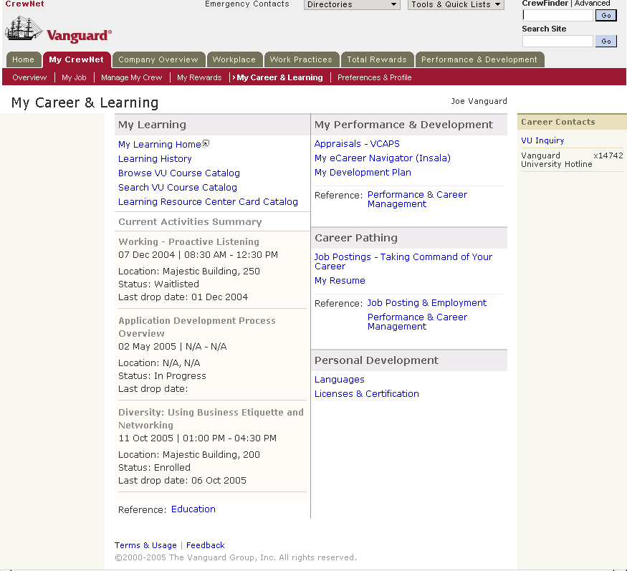
Vanguard Intranet Site: Edit My Contacts (Part of My Preferences)
    - Add contacts by using the CrewFinder (Employee Finder)
    - Remove and Rearrange contacts
- 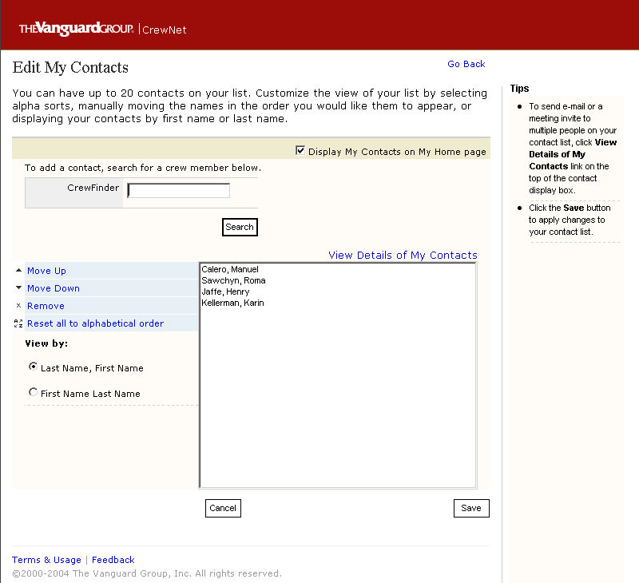

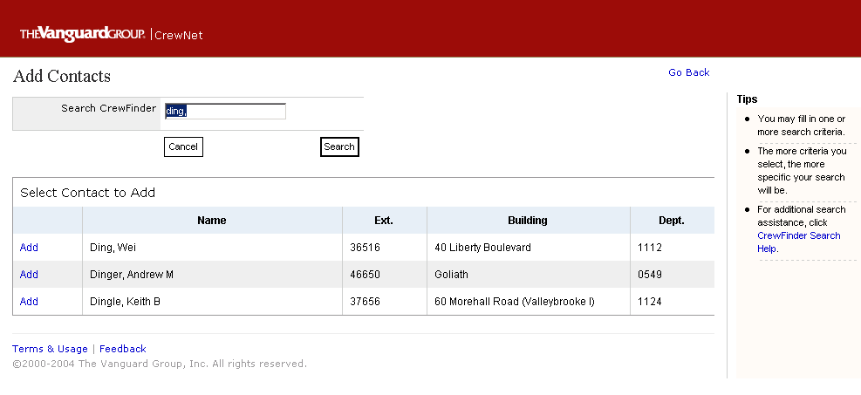

Vanguard.com: Personal Investors’ Site –Welcome Page
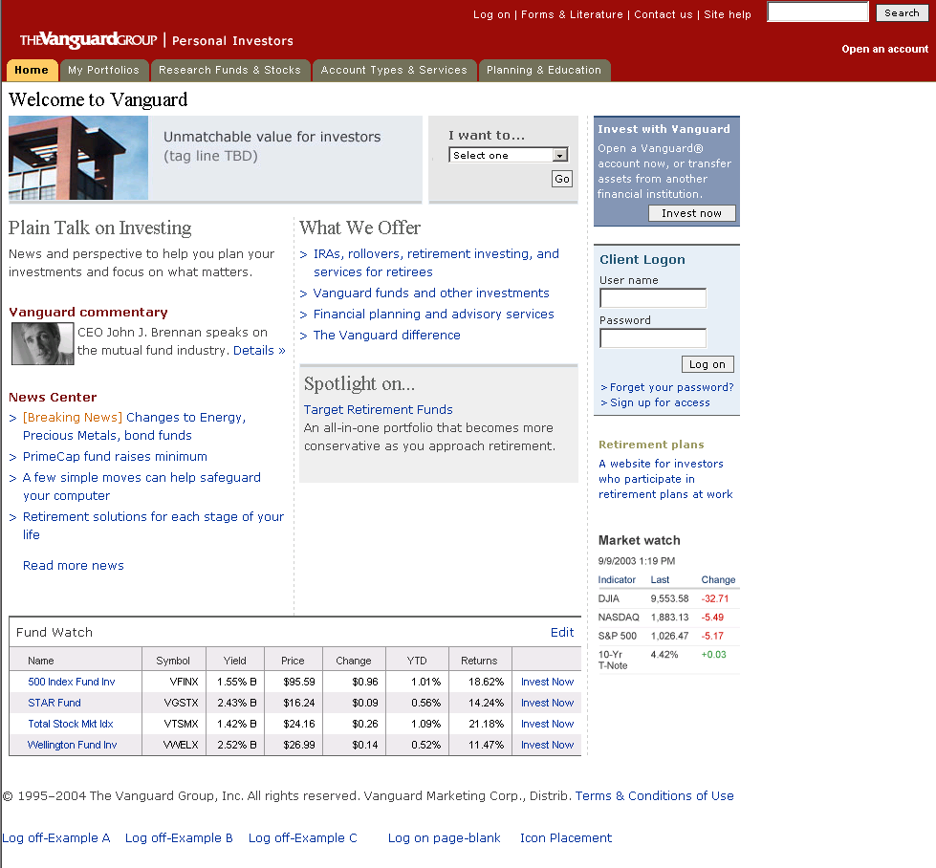

Vanguard.com: Individual Investors -- My Portfolios (Overview)
- This is an older version before applying the new UI Standards
- My Portfolios’ section is account specific and not publicly available
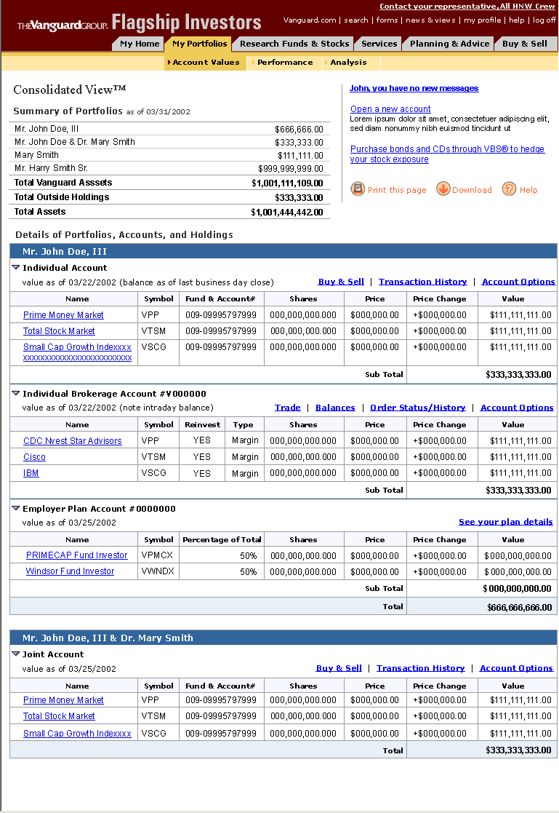
Vanguard.com: Individual Investors -- My Portfolios (holding detail)
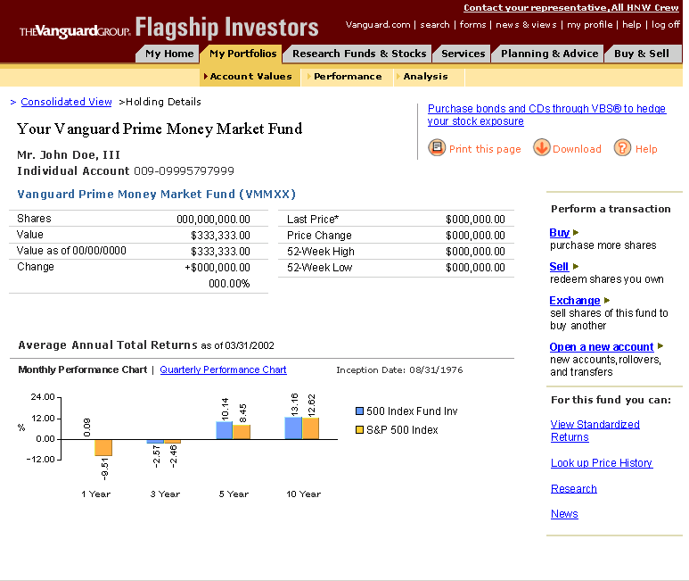

Vanguard.com: Individual Investors -- Research Funds & Stocks
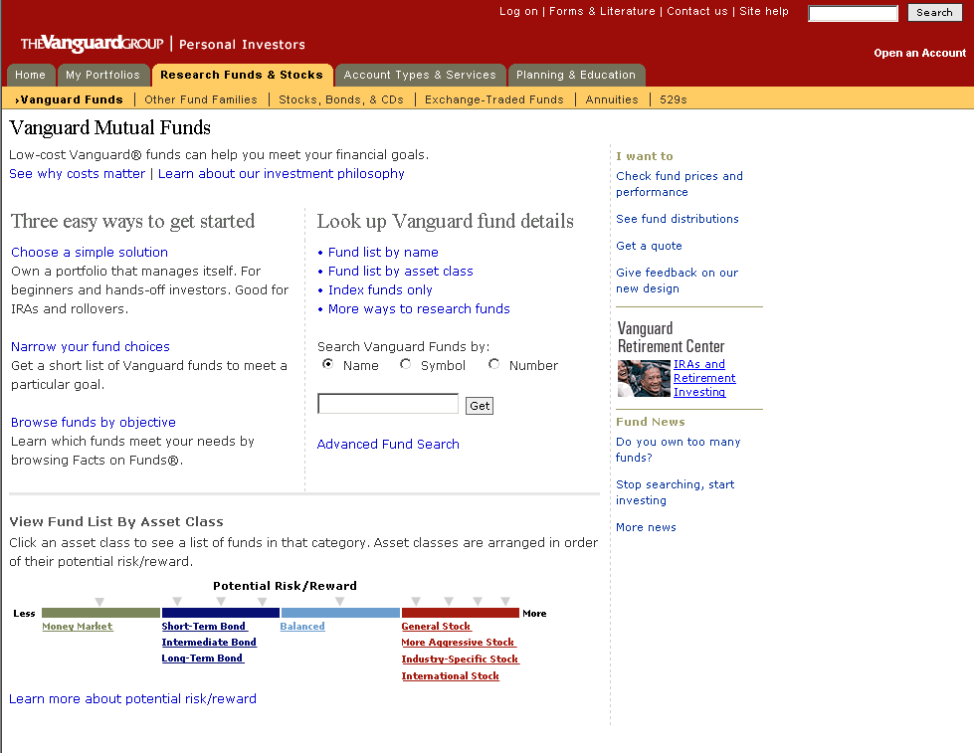

Enterprise Investment Product Desktop (EIP) – Reports Landing Page
- Internal application, to be launched from the Intranet.
- This is a step-by-step process (a hybrid of a wizard and a hub)
- The first piece of the application is to create Report Templates so that each report will be run based on the data/information structure specified in the Report Templates. 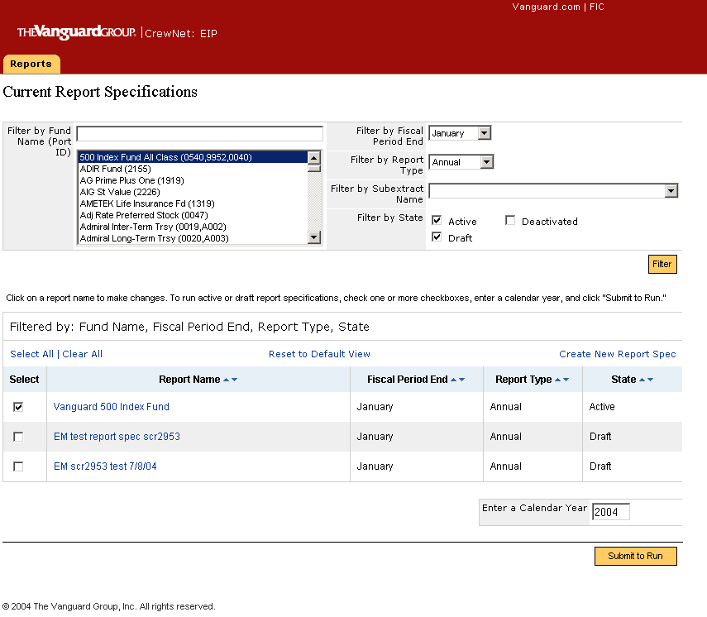
Internal Desktop Application – Create Report Template Steps
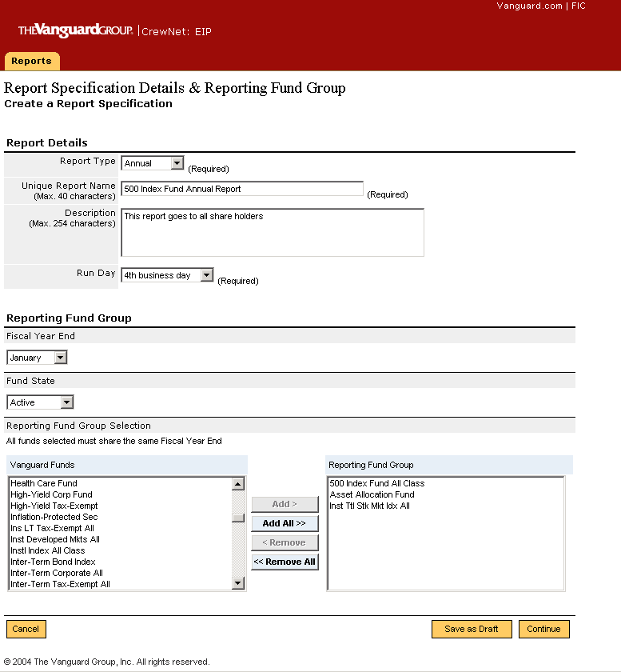

Internal Desktop Application – Create Report Template Steps
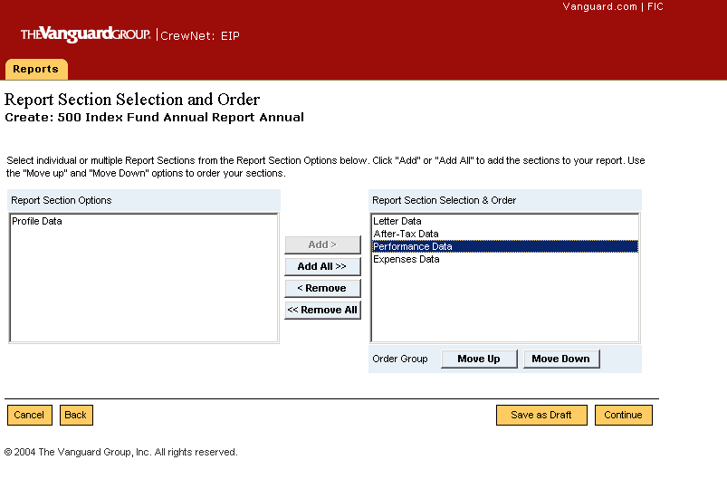

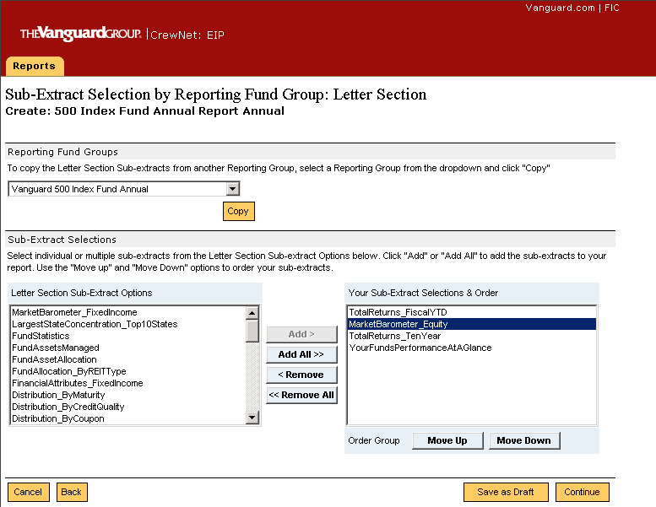

Internal Desktop Application – Create Report Template Steps
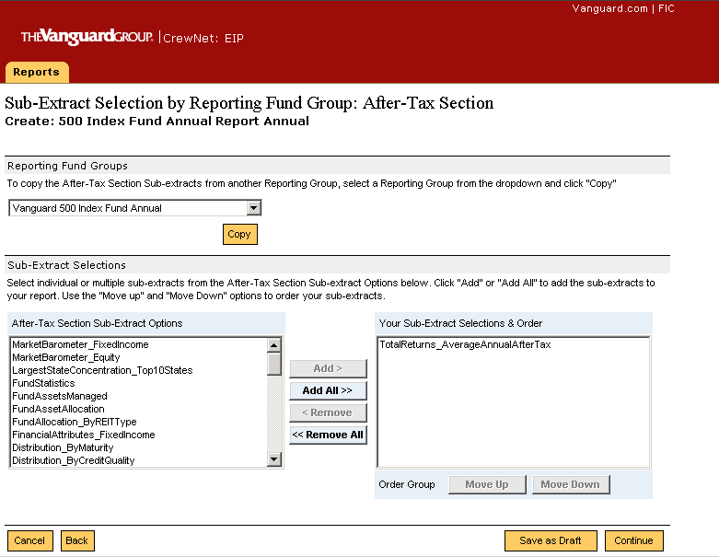

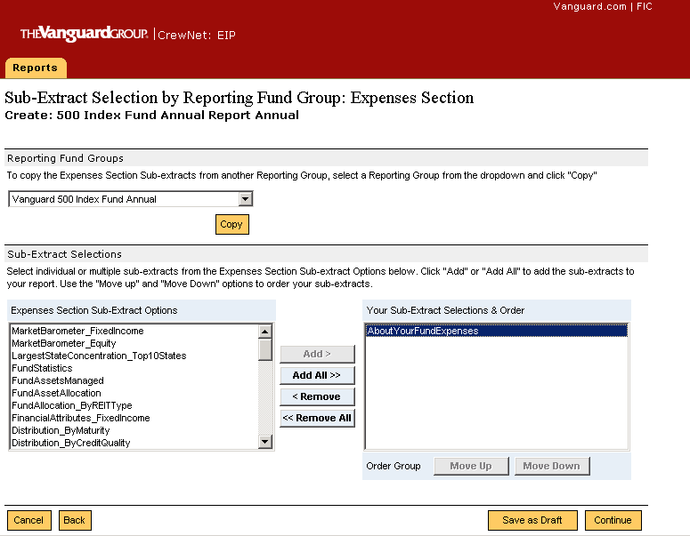

Desktop Application – Create Report Template Steps
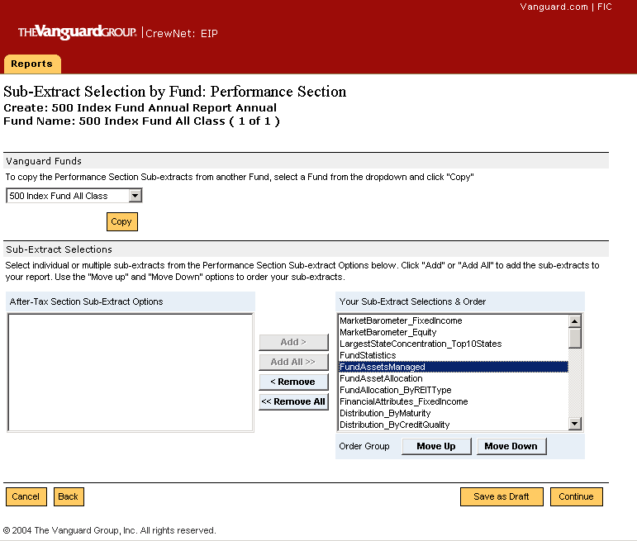
Desktop Application – Create Report Template: Verification Page
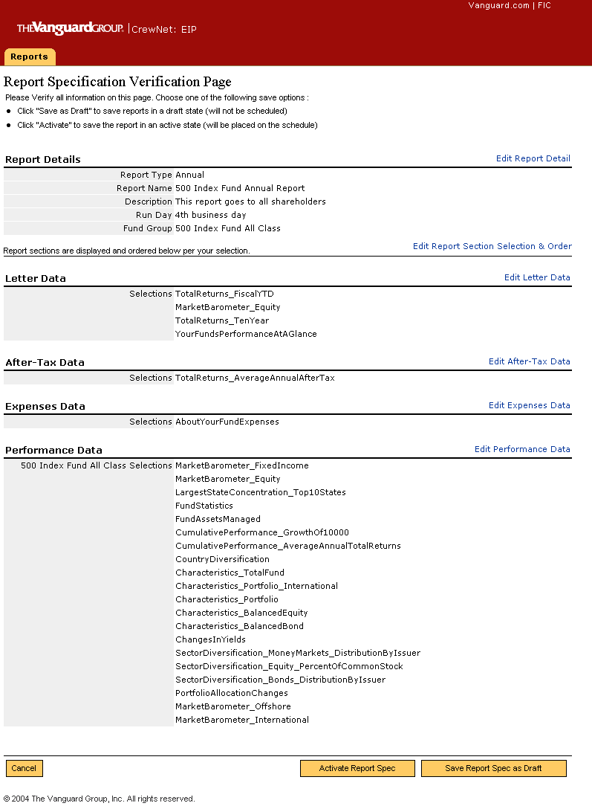

Desktop Application – Create Report Template: Confirmation Page
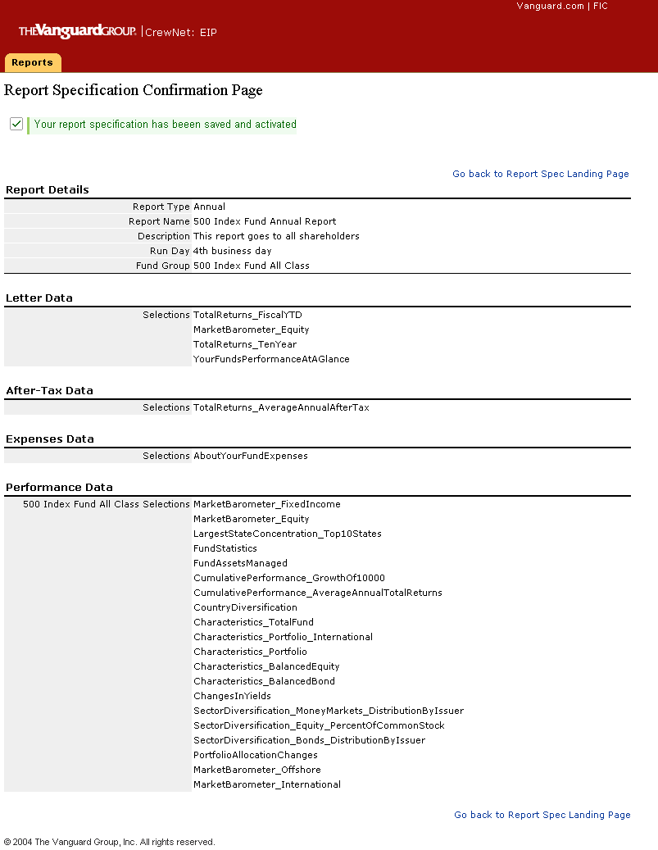

Desktop Application (EIP) – Maintain Attributes
- Another piece of the same application: Enterprise Investment Product Desktop
- Used to scrub mutual funds data before it goes public.
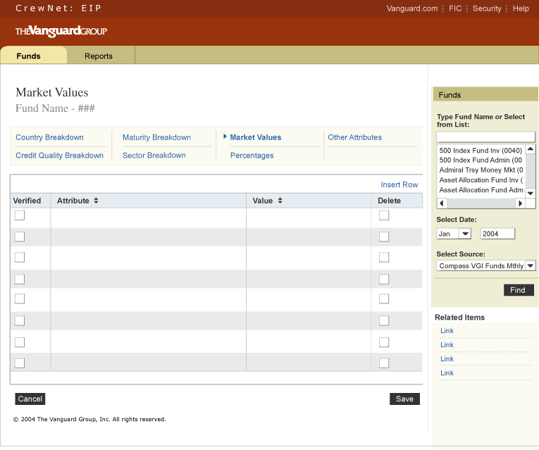
Desktop Application (EIP) – Maintain Attributes (2)
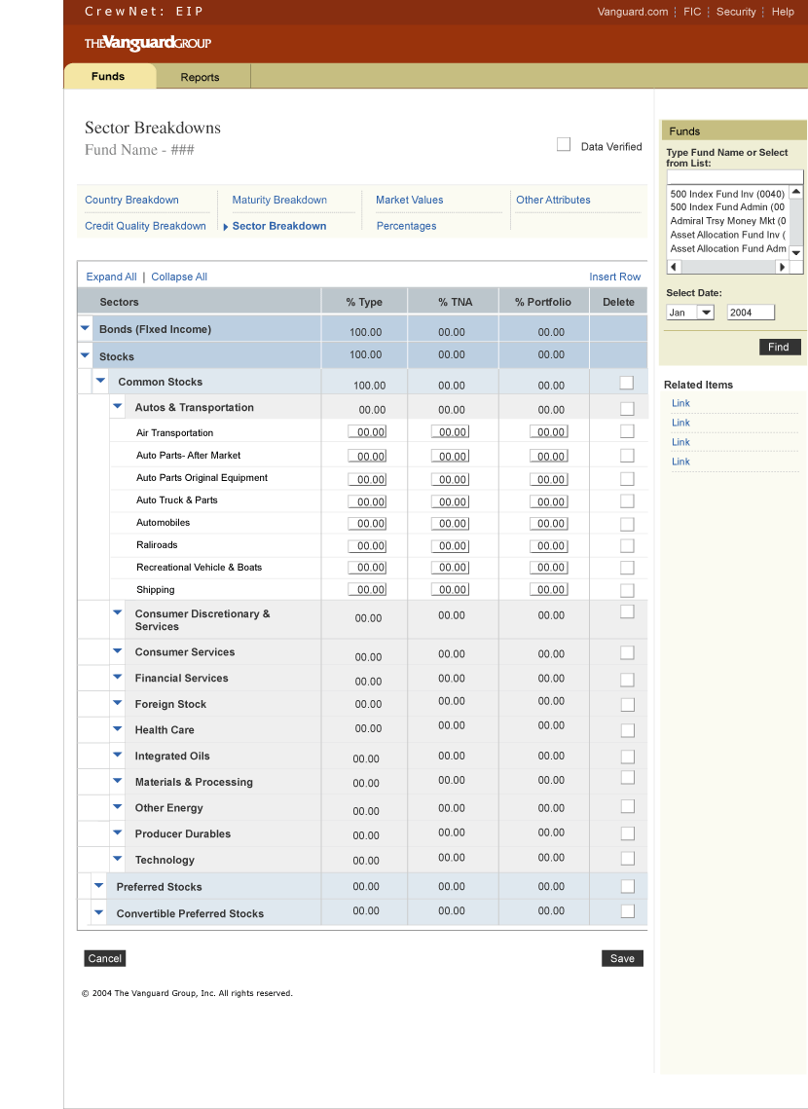

Desktop Application—Cash Flow Reporting
- An older design before applying the latest enterprise UI standards
- Sample pages from the application
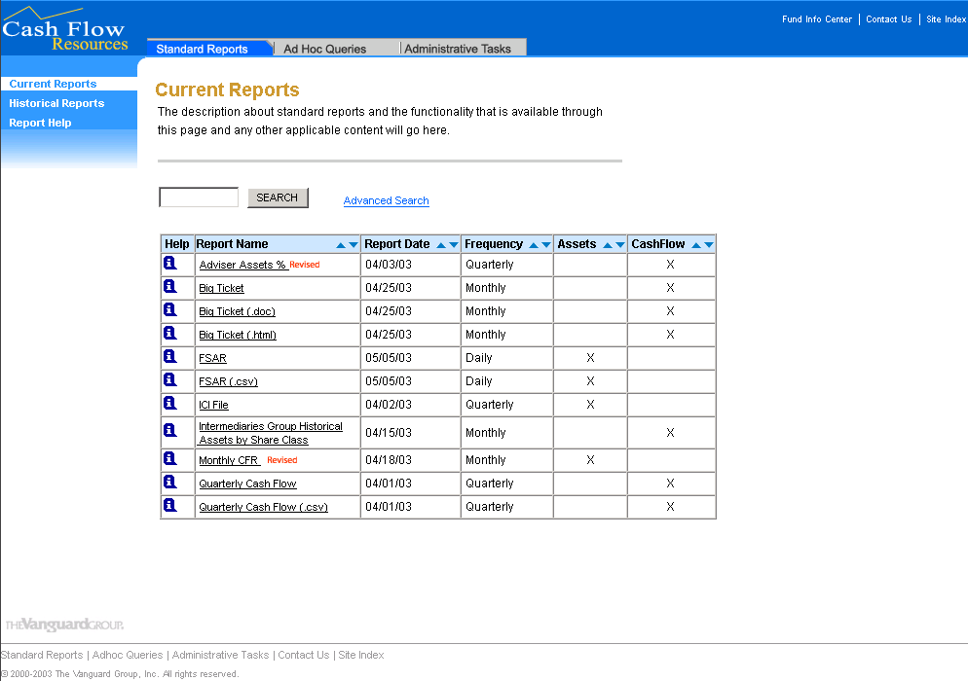

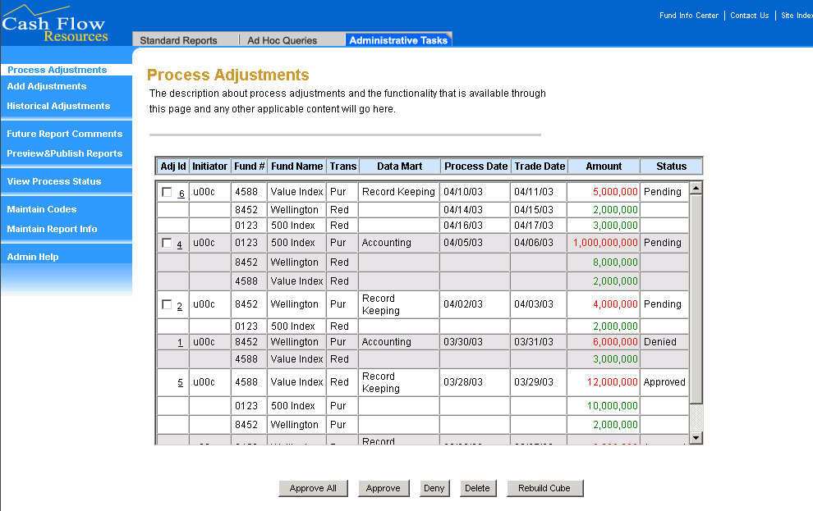

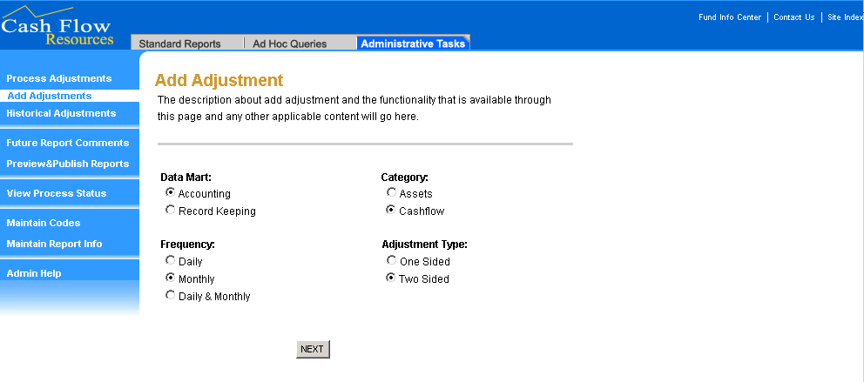

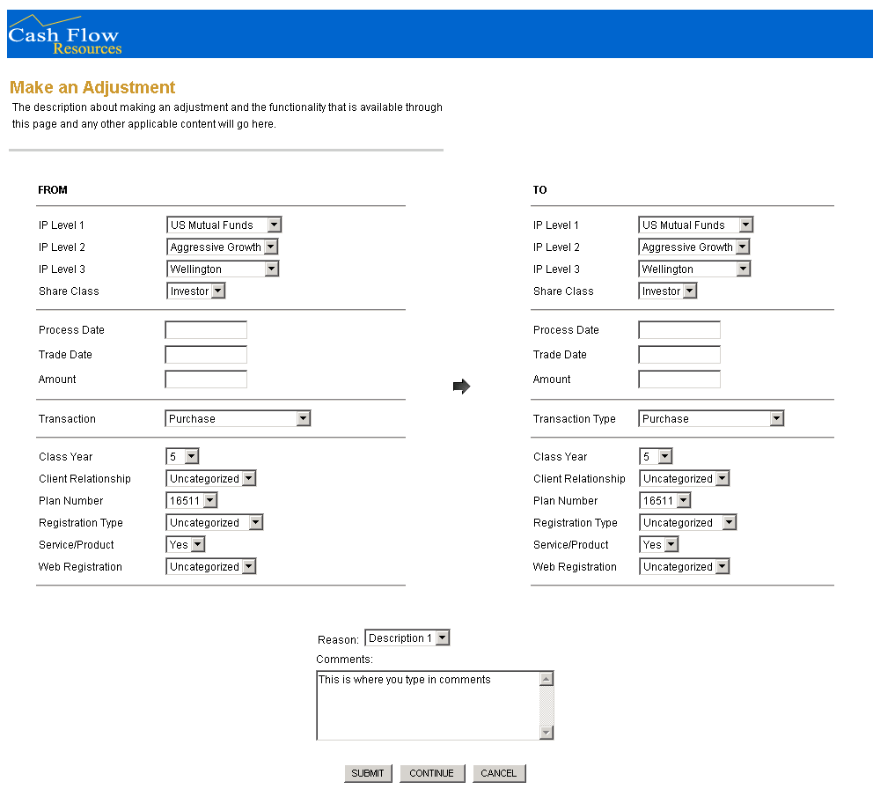

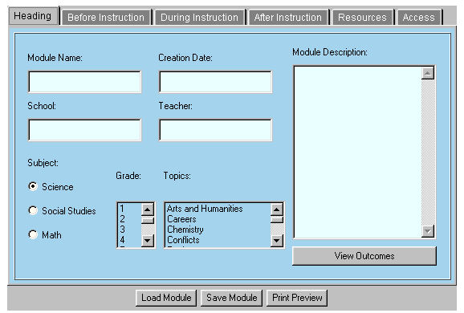
BLC: Lesson Plan Constructor

Baltimore Learning Community (BLC), 1995-1999
Toolkit for teachers to construct & present Lesson Plans
Built-in multimedia resource database
Visualization approach to UI design

n

BLC: Resource Explorer (1):
browsing in addition to search

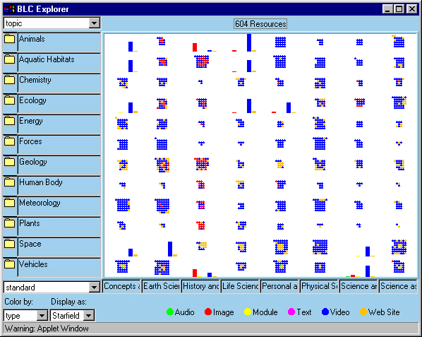
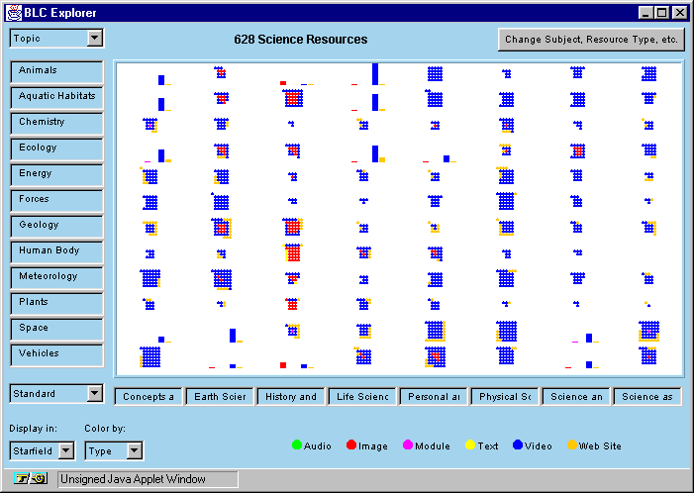
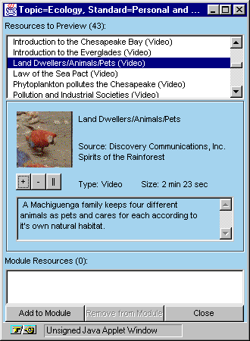
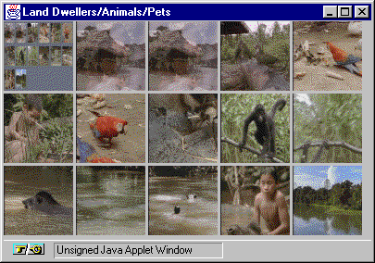
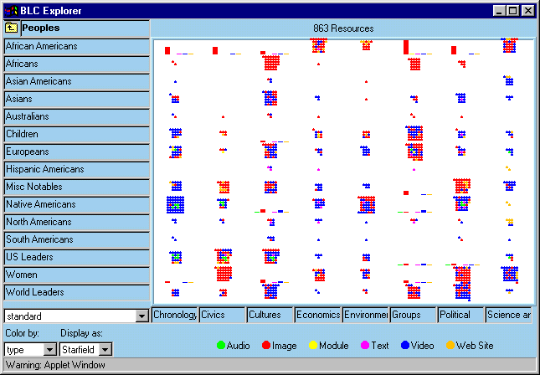
BLC Resource Explorer(2): Drilled down from the previous page

BLC Resource Explorer (3): Preview multimedia resource through “storyboard view” or “slide show”.

